Eurasian Water-milfoil (Myriophyllum spicatum)
Fall Bed Mapping Survey
Little Trade Lake – WBIC: 2639300
Burnett County, Wisconsin

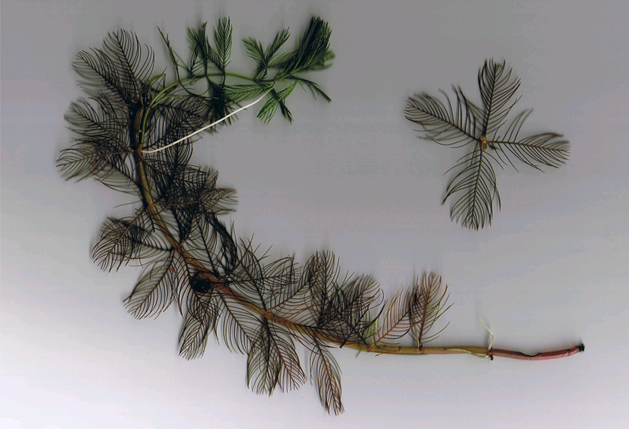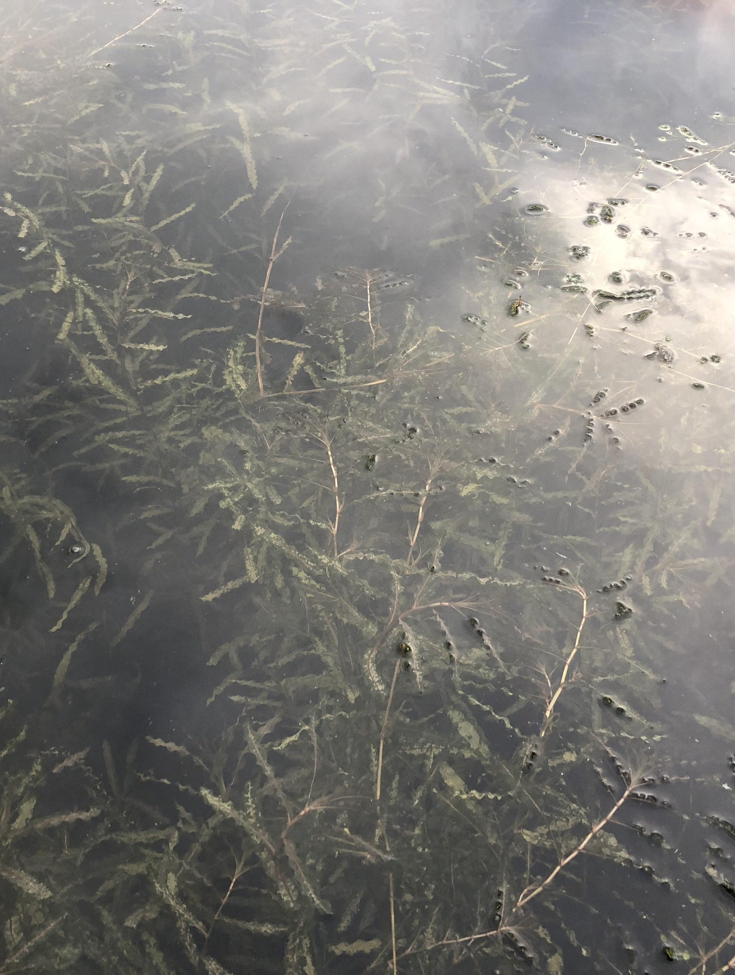
Eurasian water-milfoil (Berg 2007) Close up of canopied CLP 10/9/21

Project Initiated by: Round-Trade Lakes Improvement Association Inc., Lake Education and Planning Services, LLC, and the
Wisconsin Department of Natural Resources (Grant LPL175421)

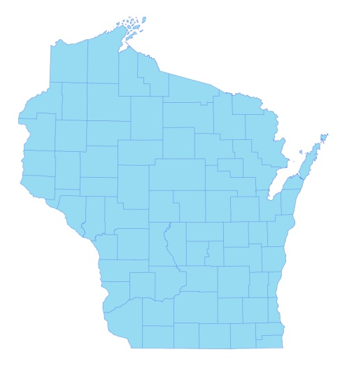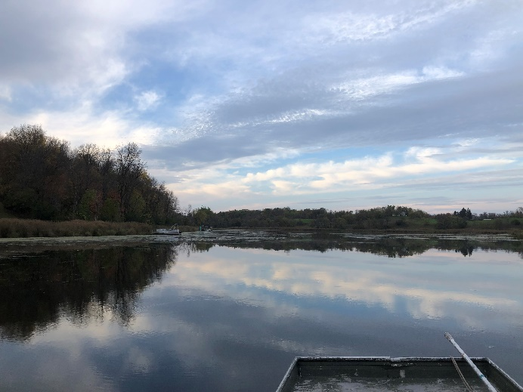
* Little Trade Lake
Mats of canopied Curly-leaf pondweed in the north bay 10/9/21

Survey Conducted by and Report Prepared by:
Endangered Resource Services, LLC
Matthew S. Berg, Research Biologist
St. Croix Falls, Wisconsin
October 9, 2021
TABLE OF CONTENTS

Page
LIST OF FIGURES AND TABLES.……..………………………………………………... ii

INTRODUCTION.……….…..……..……………………………………………………… 1

BACKGROUND AND STUDY RATIONALE…..……………………………………….. 1

METHODS……………………………………………………………….………………… 2

RESULTS AND DISCUSSION……………………………………………………………. 3

Fall Eurasian Water-milfoil Bed Mapping Survey ………………………………….. 3

Descriptions of Current and Former Eurasian Water-milfoil Beds…………………. 6

LITERATURE CITED……….……………………….……………………………………. 7

APPENDIXES……….…….………………………………………………….……………. 8

I: Late Summer 2020 and Fall 2021 EWM Bed Maps.………………………………… 8

LIST OF FIGURES AND TABLES

Page
Figure 1: Little Trade Lake Bathymetric Map…………………………………….……….. 1
Figure 2: Rake Fullness Ratings……………………………….…….…………………….. 2
Figure 3: October 9, 2021 EWM Littoral Zone Survey – GPS Tracks.. …………………... 3
Figure 4: Late-summer 2020 and Fall 2021 EWM Bed Maps …………………………….. 3
Table 1: Fall Eurasian Water-milfoil Bed Mapping Summary –
Little Trade Lake, Burnett County – October 9, 2021 ……………………………………… 4

Table 2: Historical Late-summer/Fall Eurasian Water-milfoil Bed Mapping Summary –
Little Trade Lake, Burnett County – 2012 – 2021………………………………………..… 5

INTRODUCTION:
Little Trade Lake (WBIC 2639300) is a 126-acre drainage lake in southwest/south-central Burnett County, Wisconsin in the Town of Trade Lake (T37N R18W S21). It reaches a maximum depth of 19ft in the central basin and has an average depth of approximately 9ft (the DNR’s stated depth average of 15ft combined depth data from Big Trade and Little Trade Lakes) (WDNR 2021). The lake is eutrophic in nature with intermittent Secchi disc readings from 2000-2021 ranging from 2.0-4.5ft and averaging 3.2ft (WDNR 2021). This very poor water clarity produced a littoral zone that extended to approximately 11.5ft in 2021. The bottom substrate is predominately organic muck with scattered gravel and sandy areas along the shoreline and around the island (Bush et al. 1968).

Figure 1: Little Trade Lake Bathymetric Map

BACKGROUND AND STUDY RATIONALE:
In 2009, the Wisconsin Department of Natural Resources (WDNR) confirmed the presence of Eurasian water-milfoil (EWM) (Myriophyllum spicatum) in Little Trade Lake. Following the development of a WDNR approved Aquatic Plant Management Plan (APMP) that outlined strategies to control EWM and Curly-leaf pondweed (Potamogeton crispus) (CLP), another invasive exotic species that dominates the lake’s spring littoral zone, the Round-Trade Lake Improvement Association, Inc. (RTLIA) began using manual removal and herbicide treatments to control these species.

Per WDNR expectations (Pamela Toshner/Alex Smith, WDNR – pers. comm.), whole-lake plant surveys on actively managed lakes are normally repeated every five to seven years to remain current. In anticipation of updating their plan in 2022, the RTLIA – under the direction of Dave Blumer (Lake Education and Planning Services, LLC - LEAPS) – applied for and receive a WDNR lake planning grant (LPL175421) to help cover the cost of surveys and to update the APMP. In anticipation of conducting these whole-lake surveys, treatment was suspended in 2021 with the expectation that some active management would likely resume in 2022. To help determine where these future control efforts might be considered, we were asked to complete a fall EWM bed mapping survey. This report is the summary analysis of that field survey conducted on October 9, 2021.

METHODS:
Fall Eurasian Water-milfoil Bed Mapping:
During the fall survey, we searched the visible littoral zone of the lake and mapped all known beds of EWM. A “bed” was determined to be any area where we visually estimated that EWM made up >50% of the area’s plants and was generally continuous with clearly defined borders. After we located a bed, we motored around the perimeter of the area, took GPS coordinates at regular intervals, and estimated both the range and mean rake fullness rating of EWM within the bed (Figure 2). Using the WDNR’s Forestry Tool’s Extension to ArcGIS 9.3.1, we plotted these coordinates to generate bed shapefiles and determine the acreage to the nearest hundredth of an acre. We also took waypoints of EWM plants outside these beds as they were generally few in number.

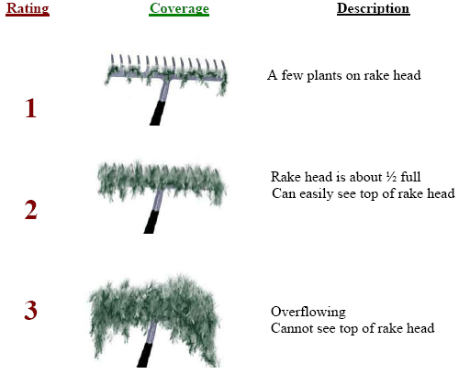
Figure 2: Rake Fullness Ratings

RESULTS AND DISCUSSION:
Fall Eurasian Water-milfoil Bed Mapping Survey:
On October 9, 2021, we searched 8.3km (5.2 miles) of transects throughout the lake’s visible littoral zone (Figure 3). Collectively, we mapped ten Eurasian water-milfoil beds that covered 1.11 acres (0.88% of the lake’s surface area) (Table 1). Outside of these areas, we marked and rake removed 16 additional isolated plants (Figure 4) (Appendix I). This total was a +593.75% increase from the four microbeds covering 0.16 acre (0.12% of the lake’s surface area) that we mapped in late August 2020 following a highly successful treatment that left EWM at undetectable levels in June. It was, however, still lower than the 1.59 acres (1.26% coverage) we mapped in 2019 and well below the peak of 12 beds covering 4.23 acres (3.36% coverage) in 2015 (Table 2).

Figure 3: October 9, 2021 EWM Littoral Zone Survey – GPS Tracks
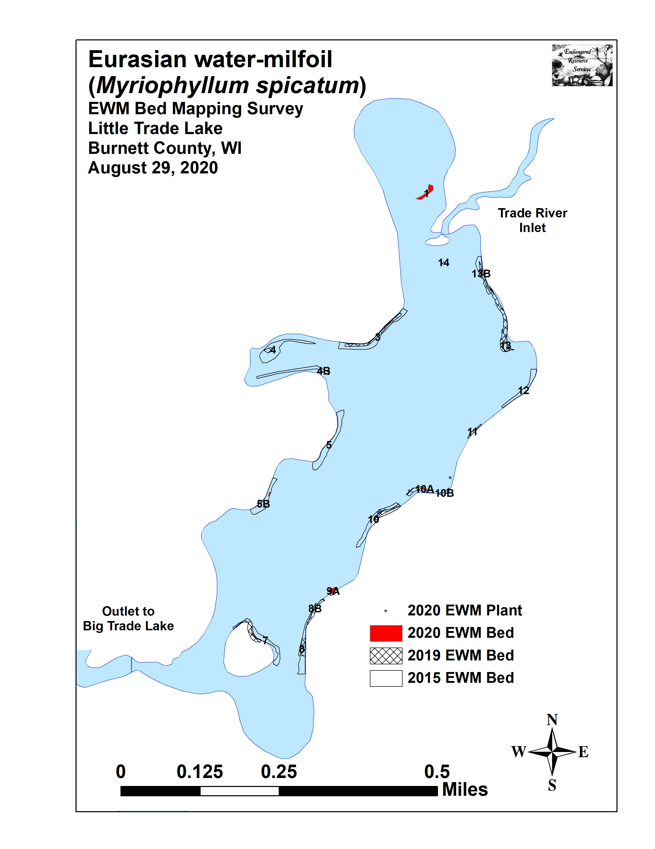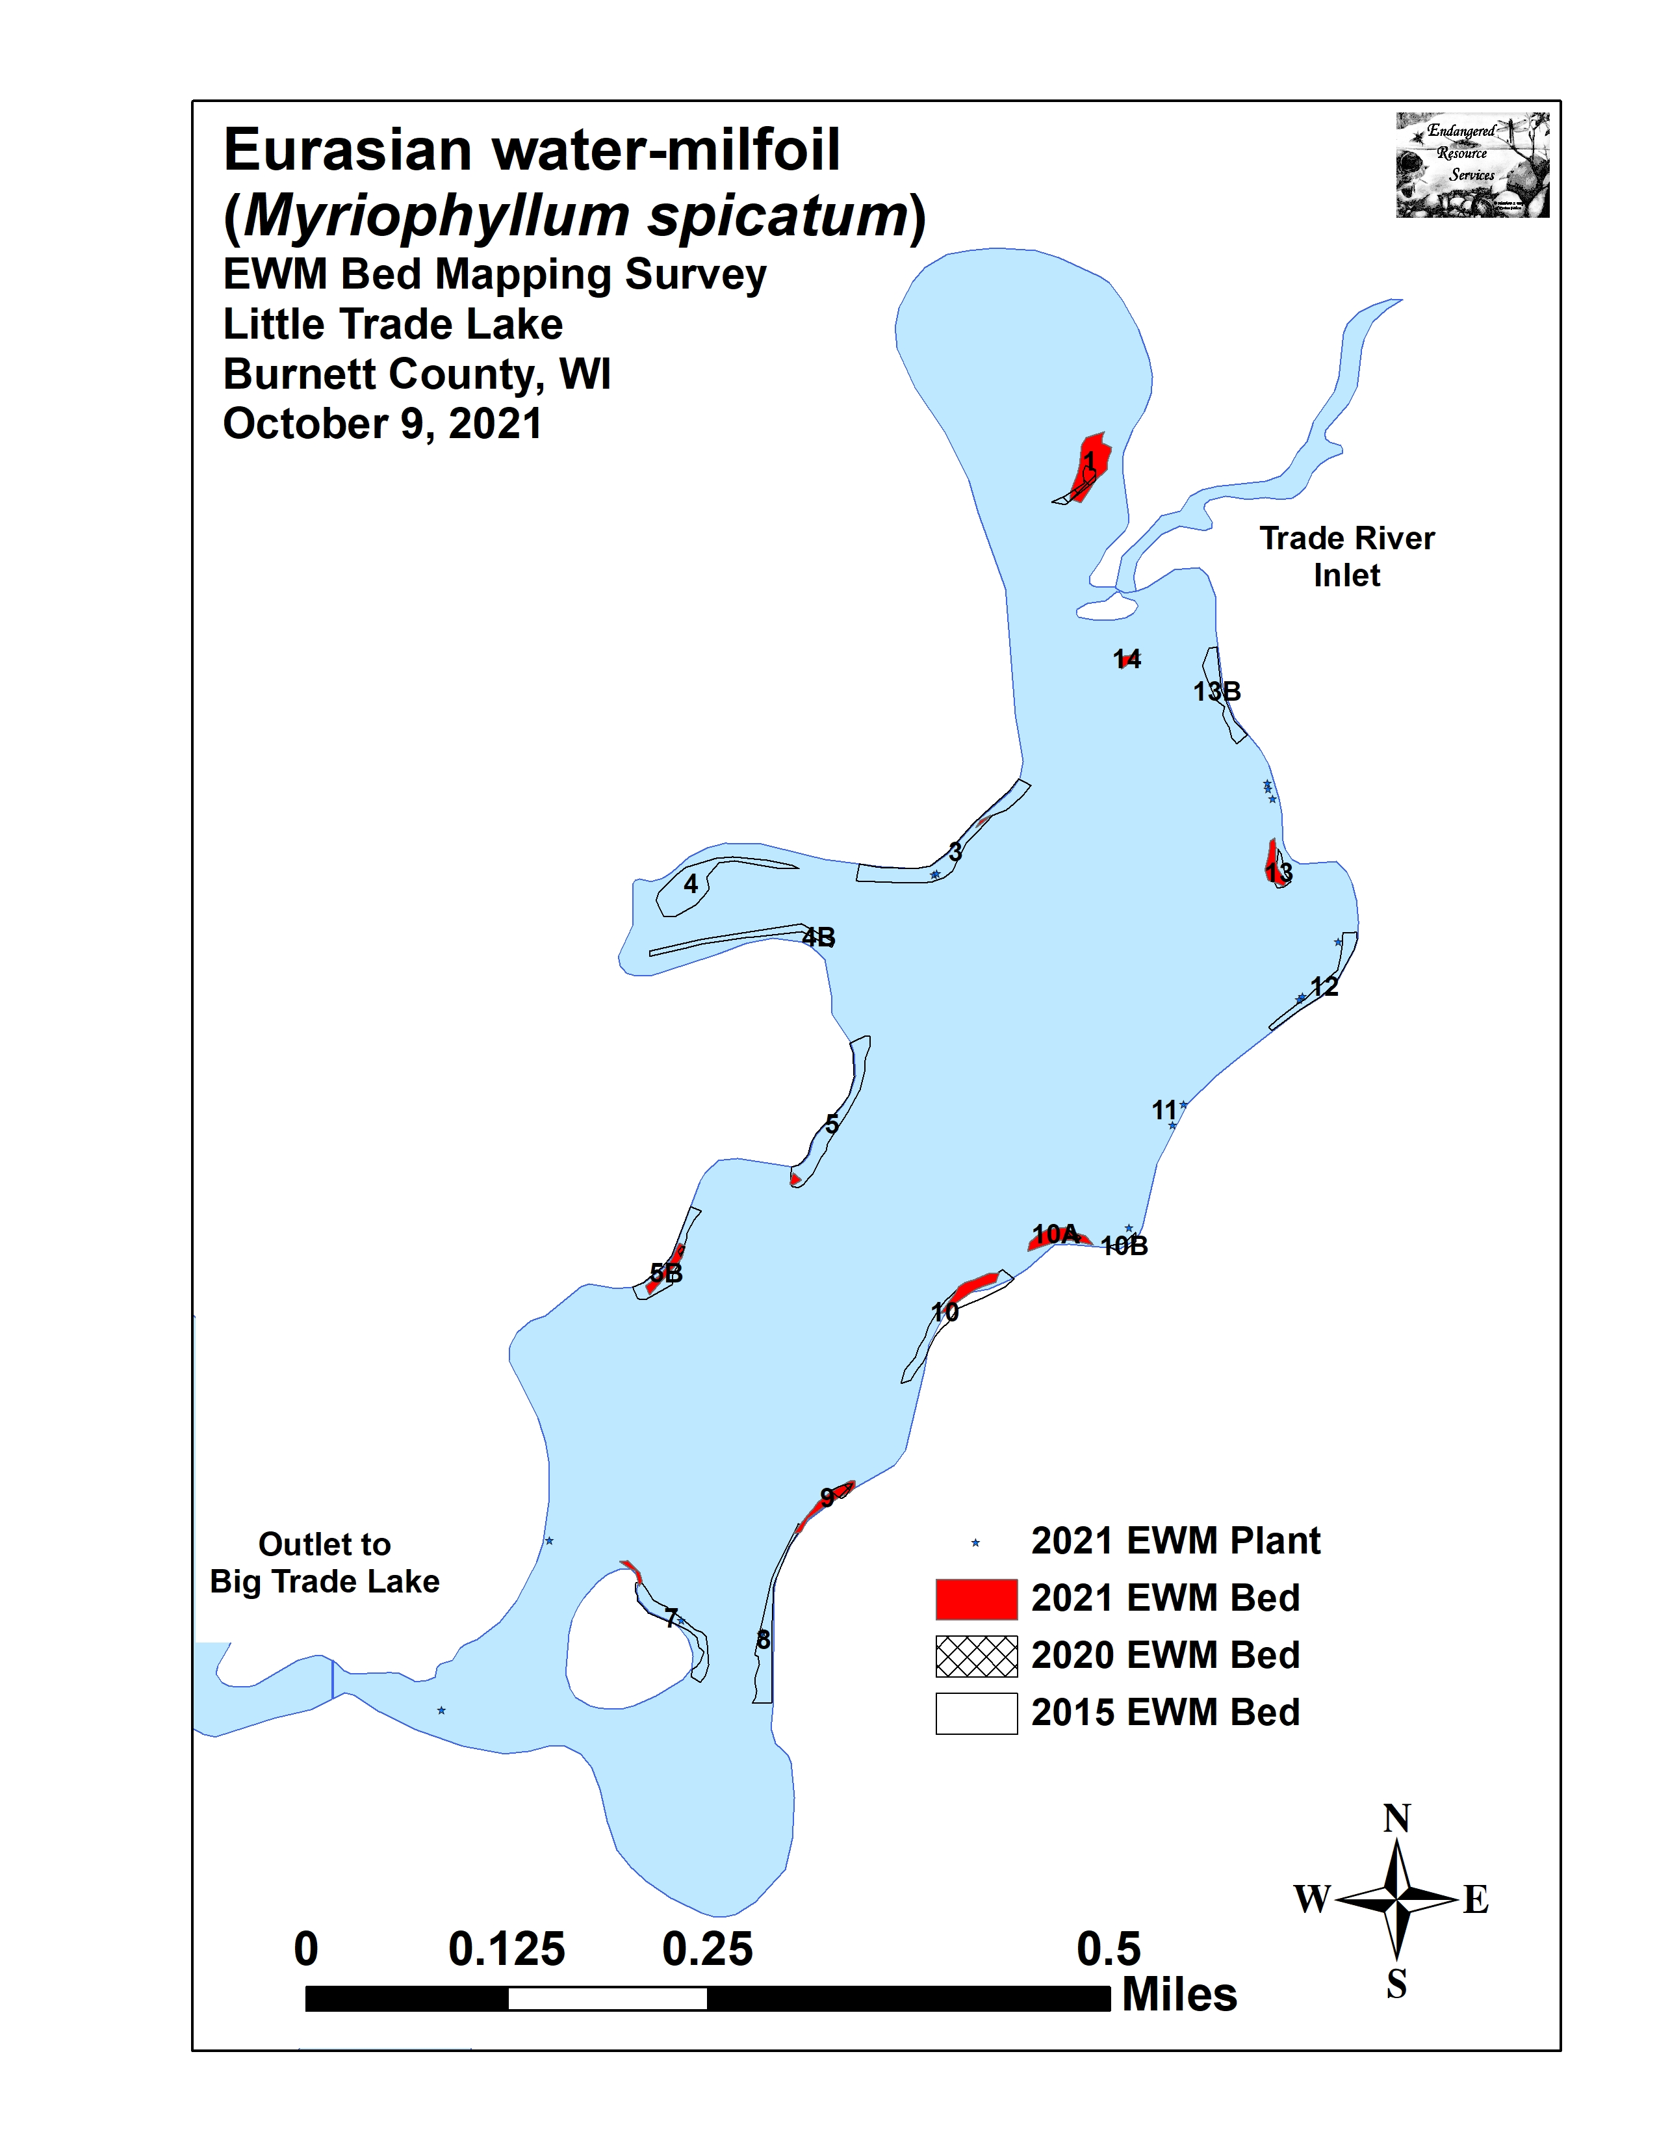
Figure 4: Late-summer 2020 and Fall 2021 EWM Bed Maps

Table 1: Fall Eurasian Water-milfoil Bed Mapping Summary
Little Trade Lake, Burnett County
October 9, 2021

Bed Number | 2021 Area in Acres | 2020 Area in Acres | 2021  Change in  Acreage | Rake Range;  Mean Rake Fullness | Depth Range and Mean Depth | Navigation Impairment | 2021  Field Notes
1 | 0.37 | 0.10 | 0.27 | <<<1-2; <1 | 2-6; 4 | None | More of an HDA – mixed with dense Coontail
1A | 0 | 0 | 0 | - | - | - | No EWM seen
2 | 0 | 0 | 0 | - | - | - | No EWM seen
3 | 0.01 | 0 | 0.01 | <<<1-1; <<1 | 2-4; 3 | None | Few regular clusters
4 | 0 | 0 | 0 | - | - | - | No EWM seen
4B | 0 | 0 | 0 | - | - | - | No EWM seen
5 and 5A | 0.02 | 0 | 0.02 | 2-3; 2 | 2-5; 3 | Minor | Dense microbed – too small to be mod. impair.
5B | 0.10 | <0.01 | 0.10 | <1-3; 2 | 2-5; 3 | Minor | Too close to shore to be moderate impairment
6 | 0 | 0 | 0 | - | - | - | No EWM seen
7 | 0.03 | 0 | 0.03 | <<<1-1; <<1 | 1-3; 2 | None | Scattered regular plants
8A and 8B | 0 | 0 | 0 | <<<1 | 4 | None | Two EWM plants – rake removed
9 and 9A | 0.12 | 0.04 | 0.08 | <1-3; 3 | 1-4; 2 | Severe | Canopied mat among docks-worst area on lake
10 | 0.15 | 0 | 0.15 | <<1-3; 2 | 2-5; 3 | Minor | Too narrow to be moderate impairment
10A | 0.17 | 0.02 | 0.15 | <1-3; 2 | 2-6; 3 | Minor | Too narrow to be moderate impair. - near dock
10B | 0 | 0 | 0 | <<<1 | 4 | None | Single EWM plant – rake removed
11 | 0 | 0 | 0 | <<<1 | 4 | None | Two EWM plants – rake removed
12 | 0 | 0 | 0 | <<<1 | 4 | None | Three EWM plants – rake removed
12B | 0 | 0 | 0 | - | - | - | No EWM seen
12C | 0 | 0 | 0 | - | - | - | No EWM seen
13 | 0.11 | 0 | 0.11 | <<1-2; 1 | 2-6; 3 | Minor | Mixed with Spatterdock and Coontail
13B | 0 | 0 | 0 | - | - | - | No EWM seen
14 | 0.03 | 0 | 0.03 | <1-3; 2 | 2-5; 3 | Moderate | Mixed with Spatterdock and Coontail
Total  Acres | 1.11 | 0.16 | +0.95
Table 2: Historical Late-summer/Fall Eurasian Water-milfoil Bed Mapping Summary
Little Trade Lake, Burnett County
2012-2021

Bed  Number | 2021 Area in Acres | 2020 Area in Acres | 2019  Area in Acres | 2018  Area in Acres | 2017  Area in Acres | 2016  Area in Acres | 2015 Area in Acres | 2014  Area in Acres | 2013  Area in Acres | 2012  Area in Acres
1 | 0.37 | 0.10 | 0 | 0.93 | 0 | 0.06 | 0 | 3.84 | 4.61 | 2.16
1A | 0 | 0 | 0 | 0.18 | 0.04 | 0 | 0 | 0 | 0 | 0
2 | 0 | 0 | 0 | 0 | 0 | 0.02 | 0 | Merged | Merged | Merged
3 | 0.01 | 0 | 0.22 | 0 | 0 | 0 | 0.65 | 0.23 | 0.03 | 0
4 | 0 | 0 | 0.04 | 0.06 | 0.07 | 0 | 0.58 | 0 | 0 | 0
4B | 0 | 0 | 0 | 0 | 0.07 | 0 | 0.26 | 0 | 0 | 0
5 and 5A | 0.02 | 0 | 0 | 0 | 0.01 | 0 | 0.52 | 0 | 0 | 0
5B | 0.10 | <0.01 | <0.01 | 0.02 | 0.07 | 0 | 0.33 | 0 | 0 | 0
6 | 0 | 0 | 0 | 0 | 0 | 0 | 0 | 0 | 0 | 0
7 | 0.03 | 0 | 0.22 | 0.06 | 0.04 | 0.02 | 0.31 | 0 | 0 | 0
8A and 8B | 0 | 0 | 0.19 | 0 | 0.10 | 0 | 0.42 | 0 | 0 | 0
9 and 9A | 0.12 | 0.04 | 0.07 | 0 | 0.01 | 0 | 0 | 0 | 0 | 0
10 | 0.15 | 0 | 0.11 | 0.05 | 0.05 | 0 | 0.51 | 0 | 0 | 0
10A | 0.17 | 0.02 | 0.15 | 0 | 0.10 | 0.11 | 0 | 0 | 0 | 0
10B | 0 | 0 | 0 | 0 | 0 | 0 | 0.05 | 0 | 0 | 0
11 | 0 | 0 | 0.05 | 0 | 0 | 0.01 | 0 | 0 | 0 | 0
12 | 0 | 0 | 0 | 0 | 0 | 0 | 0.26 | 0 | 0 | 0
12B | 0 | 0 | 0 | 0 | 0 | 0 | 0 | 0 | 0 | 0.02
12C | 0 | 0 | 0 | 0 | 0 | 0 | 0 | 0 | <0.01 | 0.08
13 | 0.11 | 0 | 0.53 | 0.10 | 0.27 | 0.05 | 0.08 | 0.14 | <0.01 | 0
13B | 0 | 0 | Merged | 0 | 0.16 | 0.02 | 0.26 | 0 | 0 | 0
14 | 0.03 | 0 | 0.01 | 0 | 0.10 | 0.05 | 0 | 0.10 | <0.01 | 0.31
Total  Acres | 1.11 | 0.16 | 1.59 | 1.40 | 1.09 | 0.34 | 4.23 | 4.32 | 4.65 | 2.57

Descriptions of Current and Former Eurasian Water-milfoil Beds:
Bed 1 – More “High Density Area” than true bed, Eurasian water-milfoil was again peppered among canopied mats of Coontail (Ceratophyllum demersum) and filamentous algae near the river inlet in the north bay. Surprisingly, there were also dense beds of canopied Curly-leaf pondweed – something we don’t normally see in the fall (see front cover of report).

Beds 1A and 2 – We saw no evidence of EWM anywhere along the north bay’s northern shoreline. We also didn’t find any EWM in the entrance to the north bay.

Bed 3 – A few EWM clusters were scattered around a microbed along the northwest shoreline. Elsewhere, we rake removed two isolated plants.

Beds 4 and 4B – Neither the western midlake bay, nor the rocky shoreline immediately south of the bay had any EWM.

Bed 5 – We mapped a small but dense canopied microbed on this sandy point. It was close enough to shore that it would not impact navigation, but wave action fragmentation at this exposed location seems likely.

Bed 6 – We found and rake removed a single EWM plant from in this area.

Bed 7 – A few scattered plants had reestablished on the north point of the island.

Bed 8 – We rake removed two EWM plants in these former narrow shoreline beds.

Bed 9 – This bed had expanded to form a dense canopied mat among the docks on this newly developed shoreline. It was easily the worst area on the lake.

Bed 10 – EWM had reestablished among the Spatterdock (Nuphar variegata) in this area, and plants were moderately dense although they grew in a narrow band.

Bed 10A – This bed showed expanded significantly since 2020, and we found it had almost merged with Bed 10. We again noted large amounts of Northern water-milfoil (Myriophyllum sibiricum) mixed in with EWM in this area.

Bed 10B – We rake removed a single EWM plant on the north end of the eastern midlake bay.

Beds 11 and 12 – We found and rake removed a handful of EWM plants along the northeast shoreline.

Beds 13 and 13B – EWM was firmly reestablished on the northeast point, and individual plants were starting to spread north along the shoreline.

Bed 14 – A small but moderately dense bed had reestablished southeast of the north bay entrance on the sandy flat. It was moderately dense and mixed with canopied Coontail and Spatterdock.

LITERATURE CITED

Busch, C., C. Olson, L. Sather, and C. Holt. [online]. 1968. Big/Little Trade Lake Map. Available from http://dnr.wi.gov/lakes/maps/DNR/2638700a.pdf (2021, November).

UWEX Lakes Program. [online]. 2010. Aquatic Plant Management in Wisconsin. Available from http://www.uwsp.edu/cnr-ap/UWEXLakes/Pages/ecology/aquaticplants/default.aspx (2021, November).

UWEX Lakes Program. [online]. 2010. Pre/Post Herbicide Comparison. Available from http://www.uwsp.edu/cnr-ap/UWEXLakes/Documents/ecology/Aquatic%20Plants/Appendix-D.pdf (2021, November).

WDNR. [online]. 2021. Little Trade Lake - Citizen Lake Water Quality Monitoring Database. Available from http://dnr.wi.gov/lakes/waterquality/Station.aspx?id=073121 (2021, November).

Appendix I: Late Summer 2020 and Fall 2021 EWM Bed Maps

