Eurasian Water-milfoil (Myriophyllum spicatum) Late-summer Bed Mapping Survey
Long Trade Lake – WBIC: 2640500
Polk County, Wisconsin

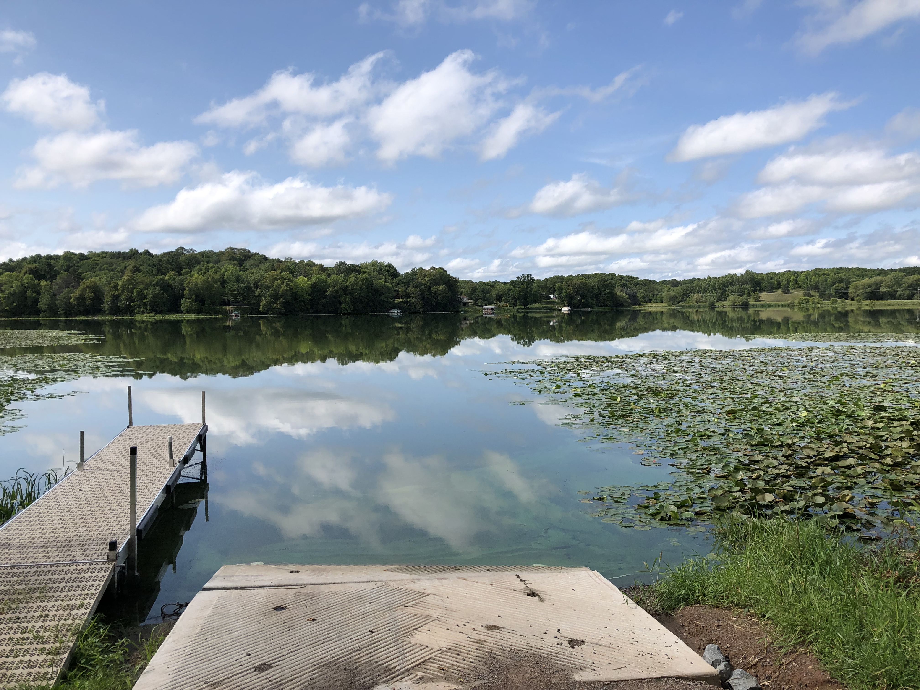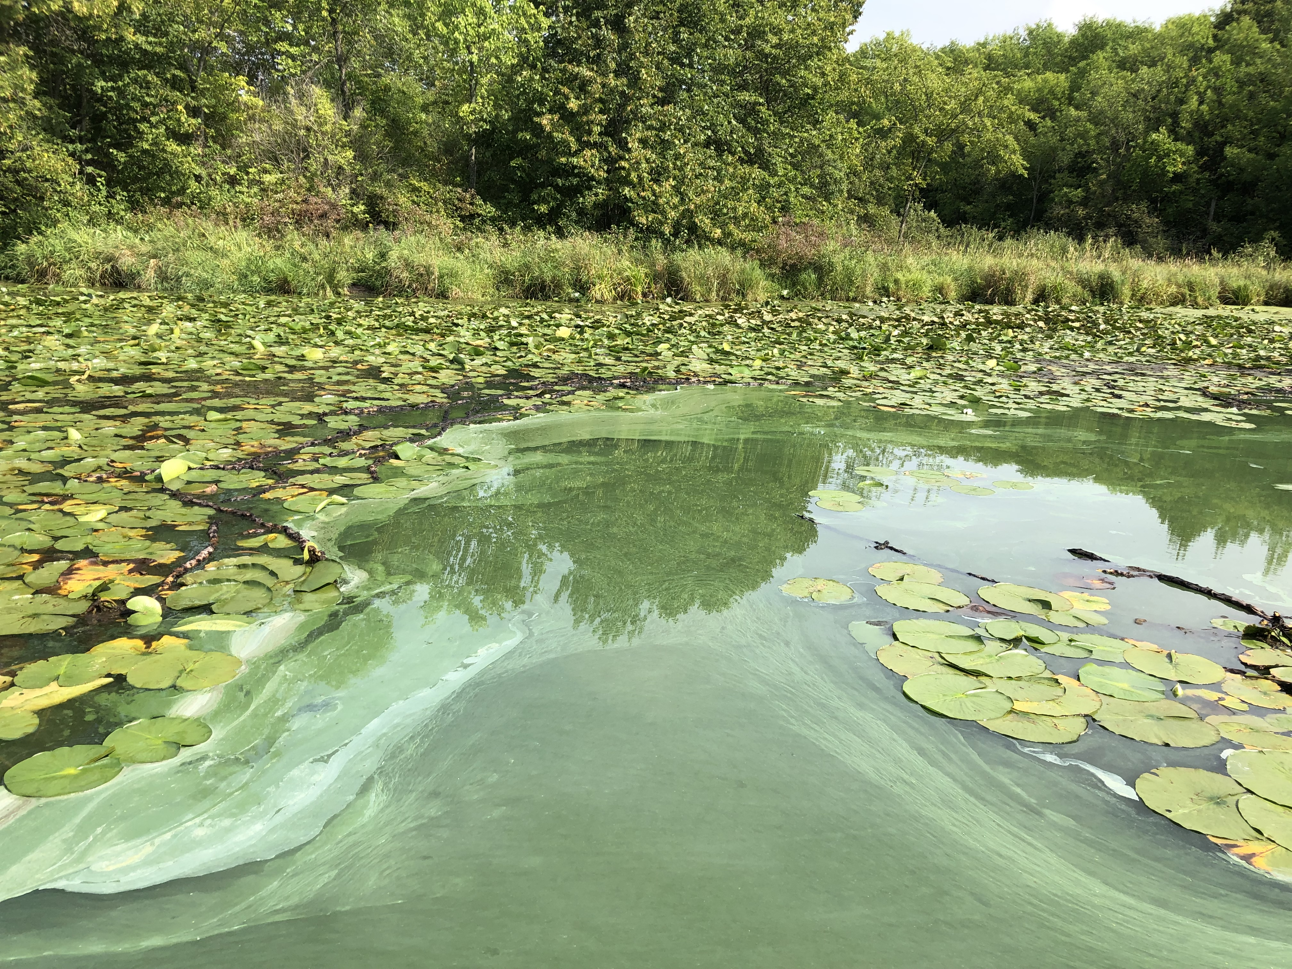
Low water drought conditions at Long Trade landing – 8/24/21 Blue-green algae bloom in southwest bay – 8/24/21

Project Initiated by: Round-Trade Lakes Improvement Association Inc., Lake Education and Planning Services, LLC, and the
Wisconsin Department of Natural Resources (Grant #LPL175421)

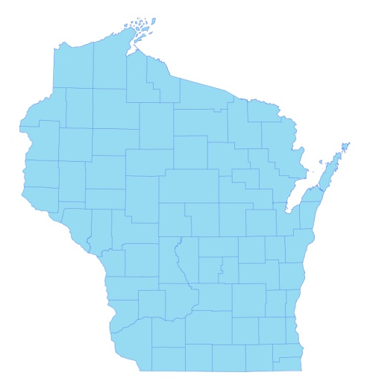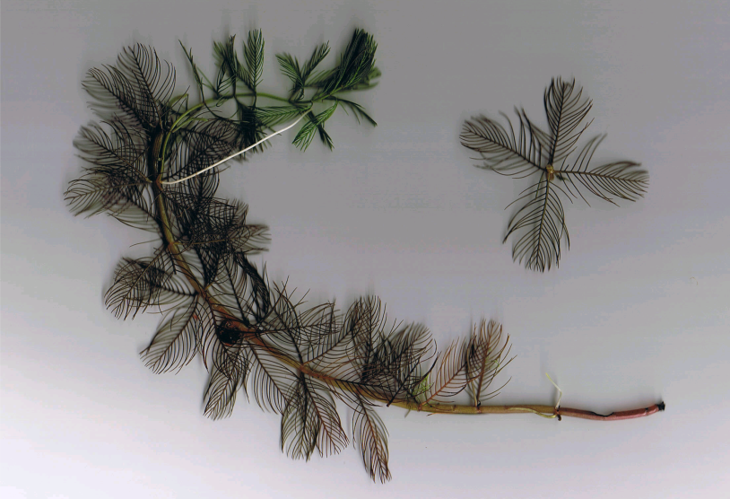
* Long Trade Lake
Eurasian water-milfoil (Berg 2007)

Survey Conducted by and Report Prepared by:
Endangered Resource Services, LLC
Matthew S. Berg, Research Biologist
St. Croix Falls, Wisconsin
August 24, 2021
TABLE OF CONTENTS

Page
LIST OF FIGURES AND TABLES..……..……………………………………………….. ii

INTRODUCTION.……….…..……..……………………………………………………… 1

BACKGROUND AND STUDY RATIONALE…..……………………………………….. 1

METHODS……………………………………………………………….………………… 2

RESULTS AND DISCUSSION……………………………………………………………. 3

Late-summer Eurasian Water-milfoil Bed Mapping Survey………………….….…. 3

Descriptions of Current and Former Eurasian Water-milfoil Beds…………………. 6

LITERATURE CITED……….……………………….……………………………………. 7

APPENDIXES……….…….………………………………………………….……………. 8

I: Late-summer 2020 and 2021 EWM Bed Maps……….………..…….………………. 8

LIST OF FIGURES AND TABLES

Page
Figure 1: 2021 CLP Treatment Areas…………….………………………………………... 1
Figure 2: Rake Fullness Ratings……………………………….…….…………………….. 2
Figure 3: August 24, 2021 EWM Littoral Zone Survey – GPS Tracks…………….……… 3
Figure 4: Late-summer 2020 and 2021 EWM Bed Maps….……………………………..... 3
Table 1: Late-summer Eurasian Water-milfoil Bed Mapping Summary –
Long Trade Lake, Polk County – August 24, 2021 ………………………………………… 4

Table 2: Historical Late-summer/Fall Eurasian Water-milfoil Bed Mapping Summary –
Long Trade Lake, Polk County – 2011 – 2021………………………………………..……. 5

Figure 5: EWM in Bed 3 with Blackened Stems and Dead Leaves – 8/24/21…..……….... 6

INTRODUCTION:
Long Trade Lake (WBIC 2640500) is a 150-acre drainage lake in northwest/north-central Polk County, Wisconsin in the Town of Laketown (T36N R18W S4/9). It reaches a maximum depth of 13ft in two spots in the south basin and has an average depth of approximately 8ft. The lake is eutrophic bordering on hypereutrophic in nature with summer Secchi readings from 1986 to 2021 ranging from 1.2-3.3ft and averaging 2.2ft (WDNR 2021). This very poor water clarity produced a littoral zone that extended to approximately 7ft in 2021. The bottom substrate is primarily sand and gravel in the main basin with organic muck in sheltered bays (Miller et al. 1965).

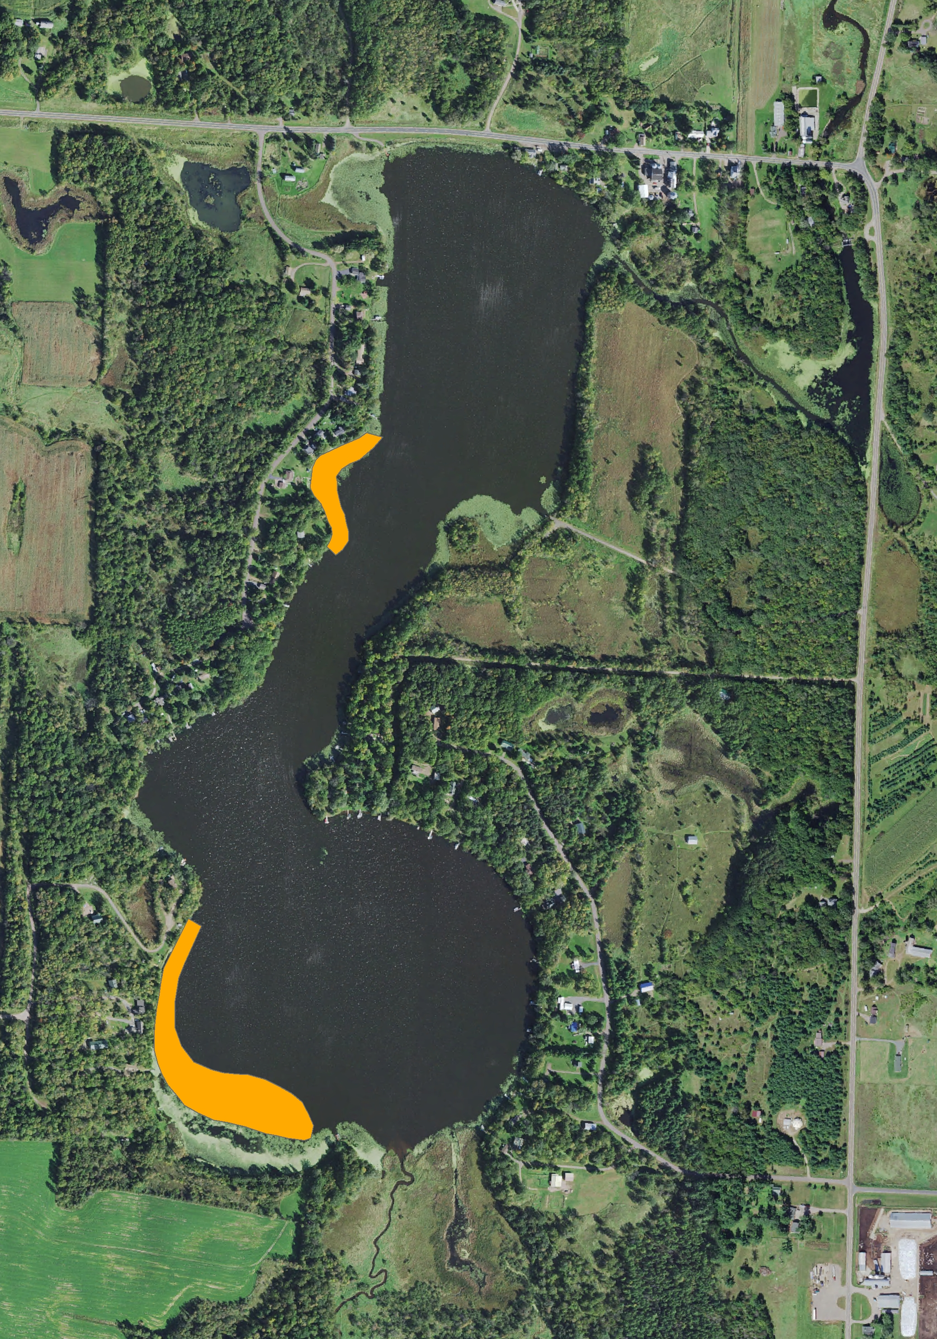
Figure 1: 2021 CLP Treatment Areas

BACKGROUND AND STUDY RATIONALE:
In 1995, the Wisconsin Department of Natural Resources (WDNR) identified the presence of Hybrid Water-milfoil – a cross between Northern and Eurasian Water-milfoils (Myriophyllum sibiricum X Myriophyllum spicatum) in Long Trade Lake. However, a 2006 WDNR point-intercept survey found no milfoil of any kind in the lake. By 2011, the situation had changed again with milfoil that morphologically looks like and grows like Eurasian Water-milfoil (EWM) having taken over most of the lake’s summer littoral areas. Following the development of a WDNR approved Aquatic Plant Management Plan (APMP) that outlined strategies to control EWM and Curly-leaf pondweed (Potamogeton crispus) (CLP) – another invasive exotic species that dominates the lake’s spring littoral zone, the Round-Trade Lake Improvement Association, Inc. (RTLIA) began treating the lake with herbicides to control these species.

In 2021, the RTLIA carried out a May 5th Curly-leaf pondweed treatment of 7.67 acres (5.11% of the lake’s total surface area) (Figure 1). Because it was not grant-funded, no pre/post treatment surveys occurred; however, the RTLIA – under the direction of Dave Blumer (Lake Education and Planning Services, LLC - LEAPS) – applied for and was awarded a WDNR lake planning grant (LPL175421) that included funding for a late-summer/fall bed mapping survey to determine where EWM control might be considered in 2022. This report is the summary analysis of that survey conducted on August 24, 2021.

METHODS:
Late-summer Eurasian Water-milfoil Bed Mapping:
During the late-summer survey, we searched the visible littoral zone of the lake and mapped all known beds of EWM. A “bed” was determined to be any area where we visually estimated that EWM made up >50% of the area’s plants and was generally continuous with clearly defined borders. After we located a bed, we motored around the perimeter of the area, took GPS coordinates at regular intervals, and estimated both the range and mean rake fullness rating of EWM within the bed (Figure 2). Using the WDNR’s Forestry Tool’s Extension to ArcGIS 9.3.1, we plotted these coordinates to generate bed shapefiles and determine the acreage to the nearest hundredth of an acre. We also took waypoints of EWM plants outside these beds as they were generally few in number. If these plants were isolated, we also did our best to rake remove them.

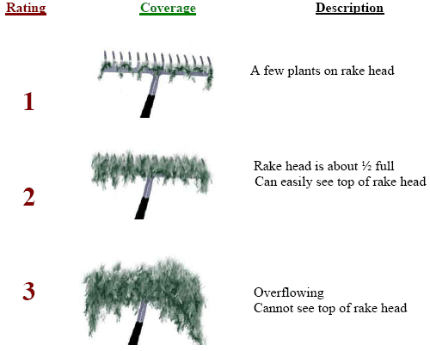
Figure 2: Rake Fullness Ratings

RESULTS AND DISCUSSION:
Late-summer Eurasian Water-milfoil Bed Mapping Survey:
On August 24, 2021, we searched 8.4km (5.2 miles) of transects throughout the lake’s visible littoral zone (Figure 3). Collectively, we mapped four beds that covered 0.84 acre (0.56% of the lake’s surface area) (Table 1). Outside of these areas, we marked and rake removed four additional isolated plants (Figure 4) (Appendix I). This was a sharp increase (+320.00%) in coverage from the two beds totaling 0.20 acre (0.13% coverage) and six additional plants we documented in 2020. It was, however, still below the five beds covering 0.97 acre (0.65% of the lake’s surface area) we found in 2019 (Table 2).

Figure 3: August 24, 2021 EWM Littoral Zone Survey – GPS Tracks
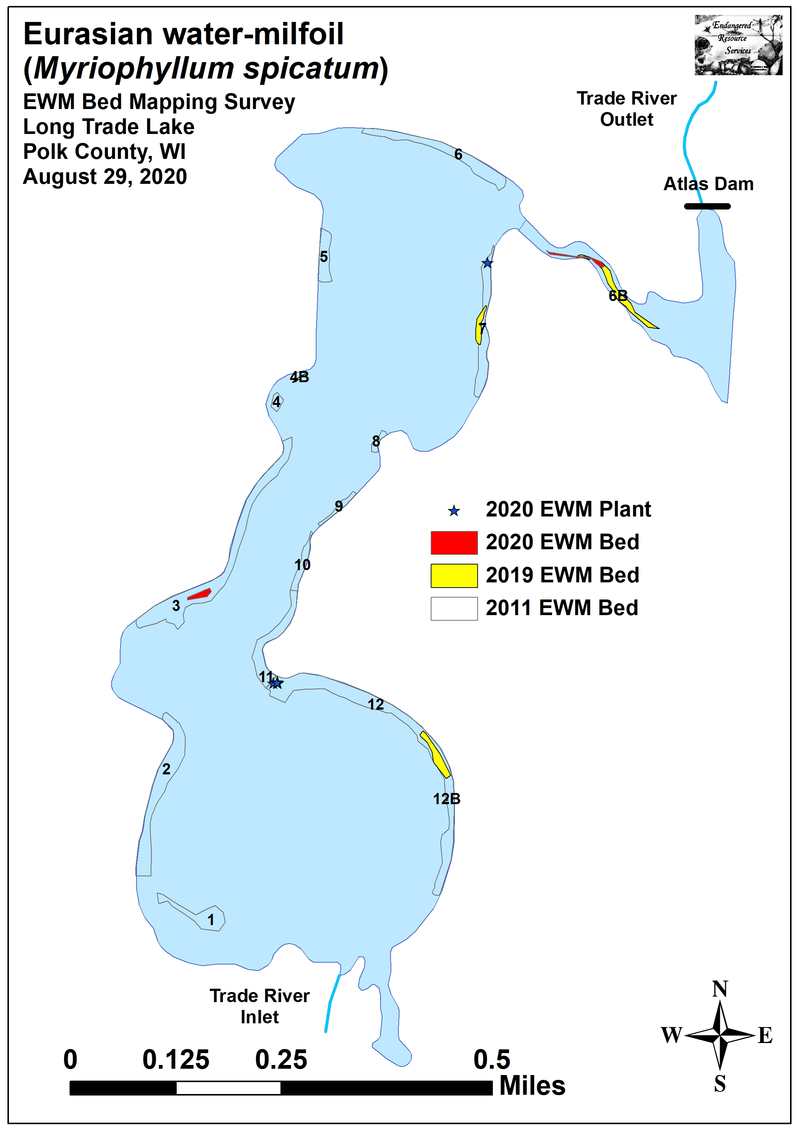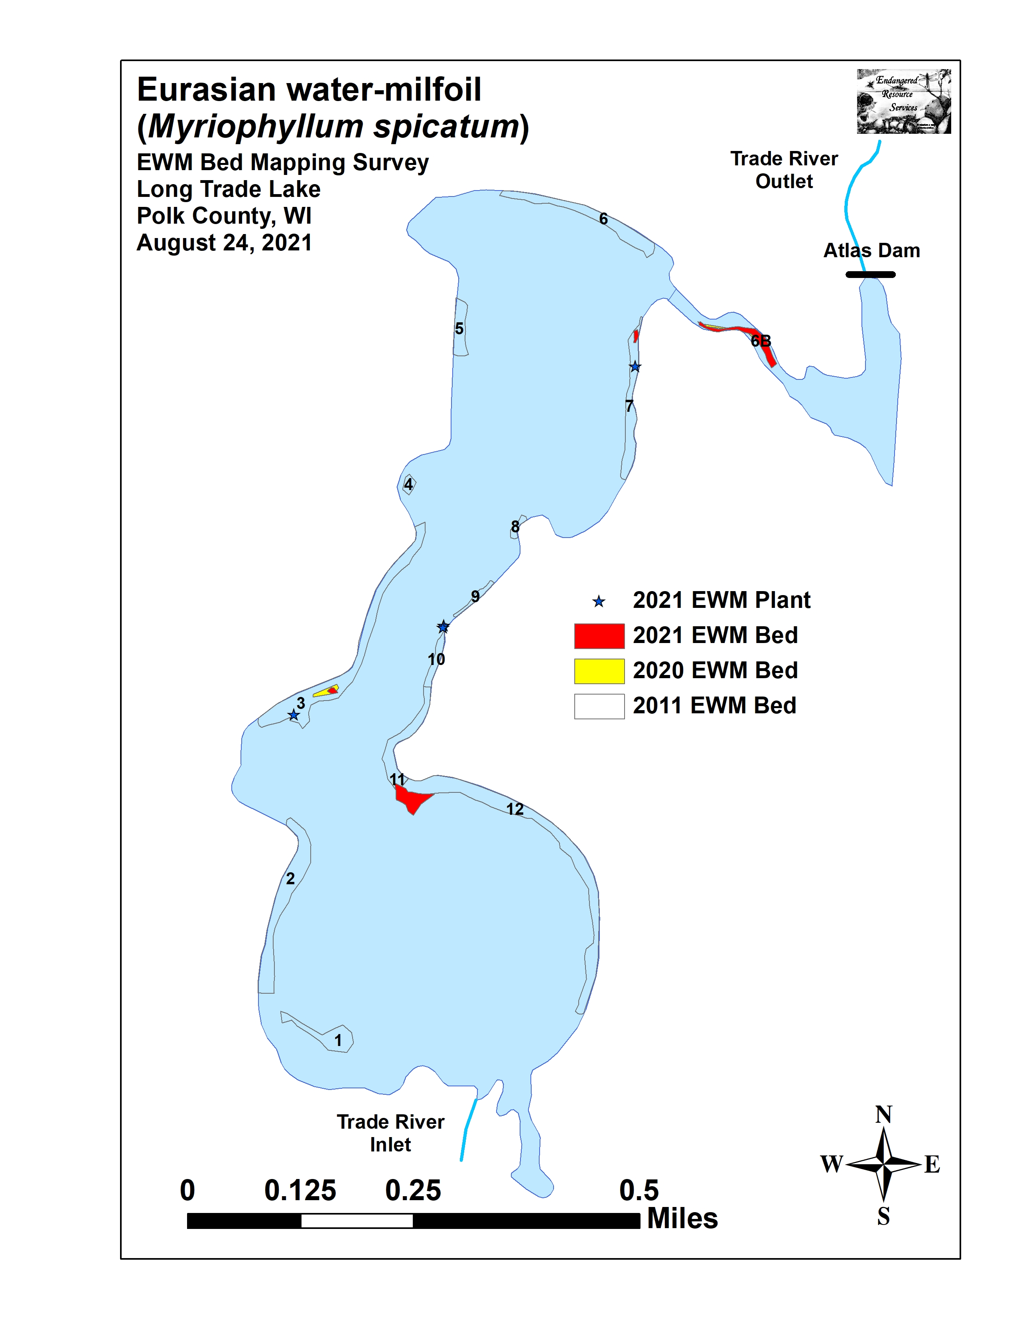
Figure 4: Late-summer 2020 and 2021 EWM Bed Maps

Table 1: Late-summer Eurasian Water-milfoil Bed Mapping Summary
Long Trade Lake, Polk County
August 24, 2021

Bed Number | 2021 Area in Acres | 2020 Area in Acres | 2021  Change in  Acreage | Rake Range and Mean Rake Fullness | Depth Range and Mean Depth | Navigation Impairment | 2021 Field Notes
1 | 0 | 0 | 0 | - | - | - | No EWM found
2 and 2A | 0 | 0 | 0 | - | - | - | No EWM found
3, 3A, and 3B | 0.03 | 0.11 | -0.08 | <<1-2, 1 | 2-6; 4 | Minor | EWM appears almost dead – mixed w/ Coon.
4 | 0 | 0 | 0 | - | - | - | No EWM found
4B | 0 | 0 | 0 | - | - | - | No EWM found
5 | 0 | 0 | 0 | - | - | - | No EWM found
6 | 0 | 0 | 0 | - | - | - | No EWM found
6B | 0.37 | 0.09 | 0.28 | 1-3; 2 | 1-3; 2 | Moderate | 100s of plants – canopied mat in outlet
Mill Pond | 0 | 0 | 0 | - | - | - | No EWM found
7 | 0.03 | 0 | 0.03 | <<1-1; <1 | 2-4; 3 | None | Low density regular plants - mixed w/ Coon.
8 | 0 | 0 | 0 | - | - | - | No EWM found
9 | 0 | 0 | 0 | - | - | - | No EWM found
10 | 0 | 0 | 0 | - | - | - | 2 EWM plants – rake removed
11 | 0 | 0 | 0 | - | - | - | No EWM found
12 and 12A | 0.40 | 0 | 0.40 | <<<1-2; <<1 | 1-5; 4 | None | Regular low density – mixed with Coontail
13 | 0 | 0 | 0 | - | - | - | No EWM found
Total  Acres | 0.84 | 0.20 | +0.64

Table 2: Historical Late-summer/Fall Eurasian Water-milfoil Bed Mapping Summary
Long Trade Lake, Polk County
2011-2021

Bed Number | 2021 Area in Acres | 2020 Area in Acres | 2019  Area in Acres | 2018  Area in Acres | 2017  Area in Acres | 2016  Area in Acres | 2015 Area in Acres | 2014  Area in Acres | 2013  Area in Acres | 2012  Area in Acres | 2011  Area in Acres
1 | 0 | 0 | 0 | 0 | 0.02 | 0 | 0.36 | 0 | 0 | 0.45 | 0.70
2 and 2A | 0 | 0 | 0 | 0 | 0.05 | 0 | 0.54 | 0 | 0 | 0 | 1.89
3, 3A, and 3B | 0.03 | 0.11 | 0.04 | 0 | 0.26 | 0 | 2.24 | 0 | 0 | 0.02 | 2.69
4 | 0 | 0 | 0 | 0 | 0 | 0 | 0 | 0 | 0 | 0 | 0.13
4B | 0 | 0 | 0.02 | 0 | 0.01 | 0 | 0.12 | 0 | 0 | 0.03 | 0
5 | 0 | 0 | 0 | 0 | 0 | 0 | 0 | 0 | 0 | 0 | 0.51
6 | 0 | 0 | 0 | 0 | 0.23 | 0 | 1.52 | 0 | 0 | 0.13 | 1.23
6B | 0.37 | 0.09 | 0.44 | 0.02 | 0.29 | 0 | 2.18 | 0.22 | 0 | 0.76 | 0
Mill Pond | 0 | 0 | 0 | 0 | 0 | 0 | 0 | 0 | 0 | 0 | 0
7 | 0.03 | 0 | 0.16 | 0 | 0 | 0 | 0.73 | 0 | 0 | 0.21 | 1.03
8 | 0 | 0 | 0 | 0 | 0 | 0 | 0.01 | 0 | 0 | 0 | 0.11
9 | 0 | 0 | 0 | 0 | 0.01 | 0 | 0 | 0 | 0 | 0 | 0.16
10 | 0 | 0 | 0 | 0 | 0.02 | 0 | 0 | 0 | 0 | 0 | 0.29
11 | 0 | 0 | 0 | 0 | <0.01 | 0 | 0.48 | 0 | 0 | 0 | 0.88
12 and 12A | 0.40 | 0 | 0.31 | 0 | 0.09 | 0 | 3.05 | 0 | 0 | 0 | 3.35
13 | 0 | 0 | 0 | 0 | 0.02 | 0 | 0.09 | 0 | 0 | 0 | 0
Total  Acres | 0.84 | 0.20 | 0.97 | 0.02 | 1.00 | 0.00 | 11.33 | 0.22 | 0.00 | 1.60 | 12.97

Descriptions of Current and Former Eurasian Water-milfoil Beds:
Beds 1 and 2 – We saw no evidence of Eurasian water-milfoil in either of these former beds. If there were a few plants here in the spring, the Endothall treatment for Curly-leaf pondweed may have knocked them out.

Bed 3 – The EWM bed in this area was smaller than it had been in 2020, and plants appeared to be in very poor health as many stems were brown and had almost no living leaves (Figure 5). Although several areas were canopied, because they weren’t directly in front of any residence, it seems unlikely it would be more than a minor impairment.

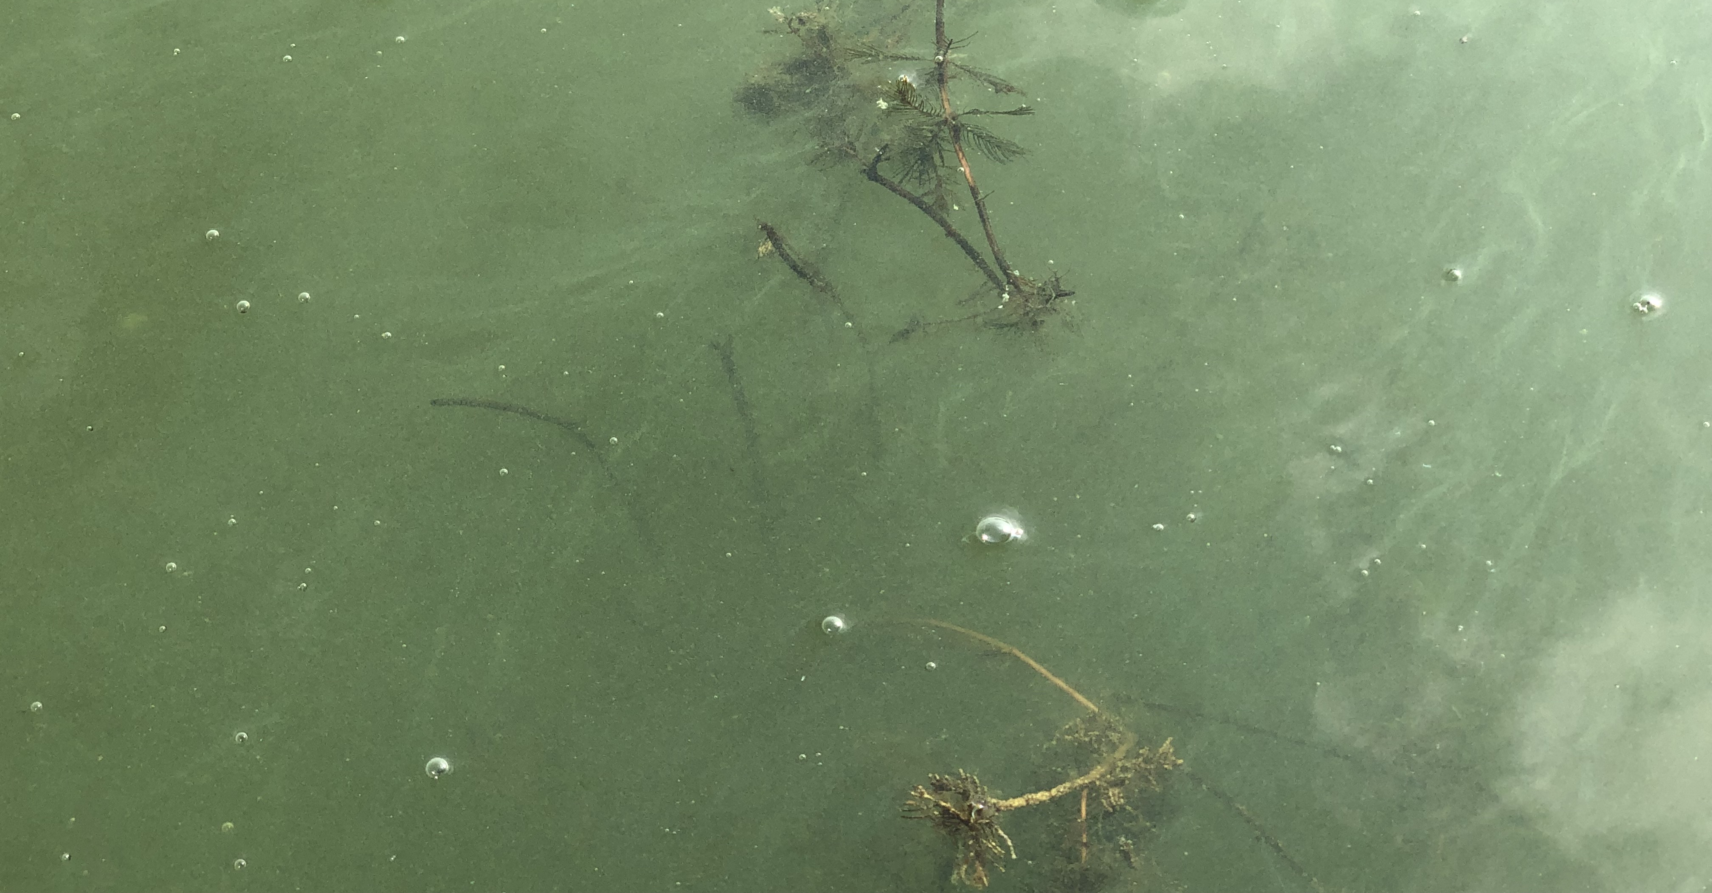
Figure 5: EWM in Bed 3 with Blackened Stems and Dead Leaves – 8/24/21

Beds 4, 4B, 5, and 6 – We saw no evidence of EWM anywhere in these former beds along the lake’s west-central, northwest, or northern shorelines.

Bed 6B and Mill Pond – A narrow but moderate to high density EWM bed again covered the shallow areas near the old bridge in the lake outlet. This spot seems to naturally filter out fragments as it’s always the first place in the channel to reestablish. With the exception of a few floating fragments, we saw no evidence of EWM in the Mill Pond.

Bed 7 – In the 2020 treatment area north of the public boat landing, we again found sparse, but regular EWM plants mixed with Coontail (Ceratophyllum demersum) and Sago pondweed (Stuckenia pectinata).

Beds 8-11 – Other than the two plants we found and rake-removed in Bed 10, we saw no evidence of EWM in these former beds.

Beds 12 and 12A – Regular low-density plants occurred on the rockbar projecting off the southeast point.

Bed 13 – We found no sign of EWM anywhere near the river inlet or in the slough inlet on the lake’s south/southeast shoreline.

LITERATURE CITED

Miller, G., M. Perkins, L. Sather, and E. Eaton [online]. 1965. Long Trade Lake Bathymetric Map.
http://dnr.wi.gov/lakes/maps/DNR/2640500a.pdf (2021, August).

UWEX Lakes Program. [online]. 2010. Aquatic Plant Management in Wisconsin. Available from http://www.uwsp.edu/cnr-ap/UWEXLakes/Pages/ecology/aquaticplants/default.aspx (2021, August).

UWEX Lakes Program. [online]. 2010. Pre/Post Herbicide Comparison. Available from http://www.uwsp.edu/cnr-ap/UWEXLakes/Documents/ecology/Aquatic%20Plants/Appendix-D.pdf (2021, August).

WDNR. [online]. 2020. Long Trade Lake - Citizen Lake Water Quality Monitoring Database. Available from http://dnr.wi.gov/lakes/waterquality/Station.aspx?id=493080 (2021, August).

Appendix I: Late-summer 2020 and 2021 EWM Bed Maps
