Eurasian Water-milfoil (Myriophyllum spicatum)
Fall Bed Mapping Survey
Round Lake – WBIC: 2640100
Burnett County, Wisconsin

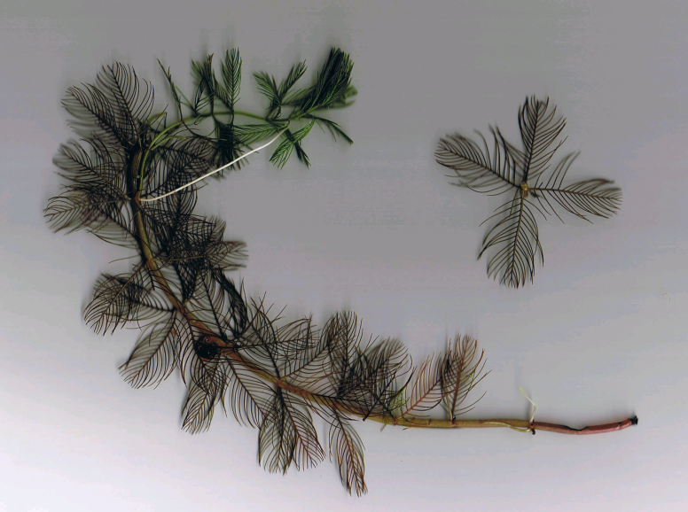
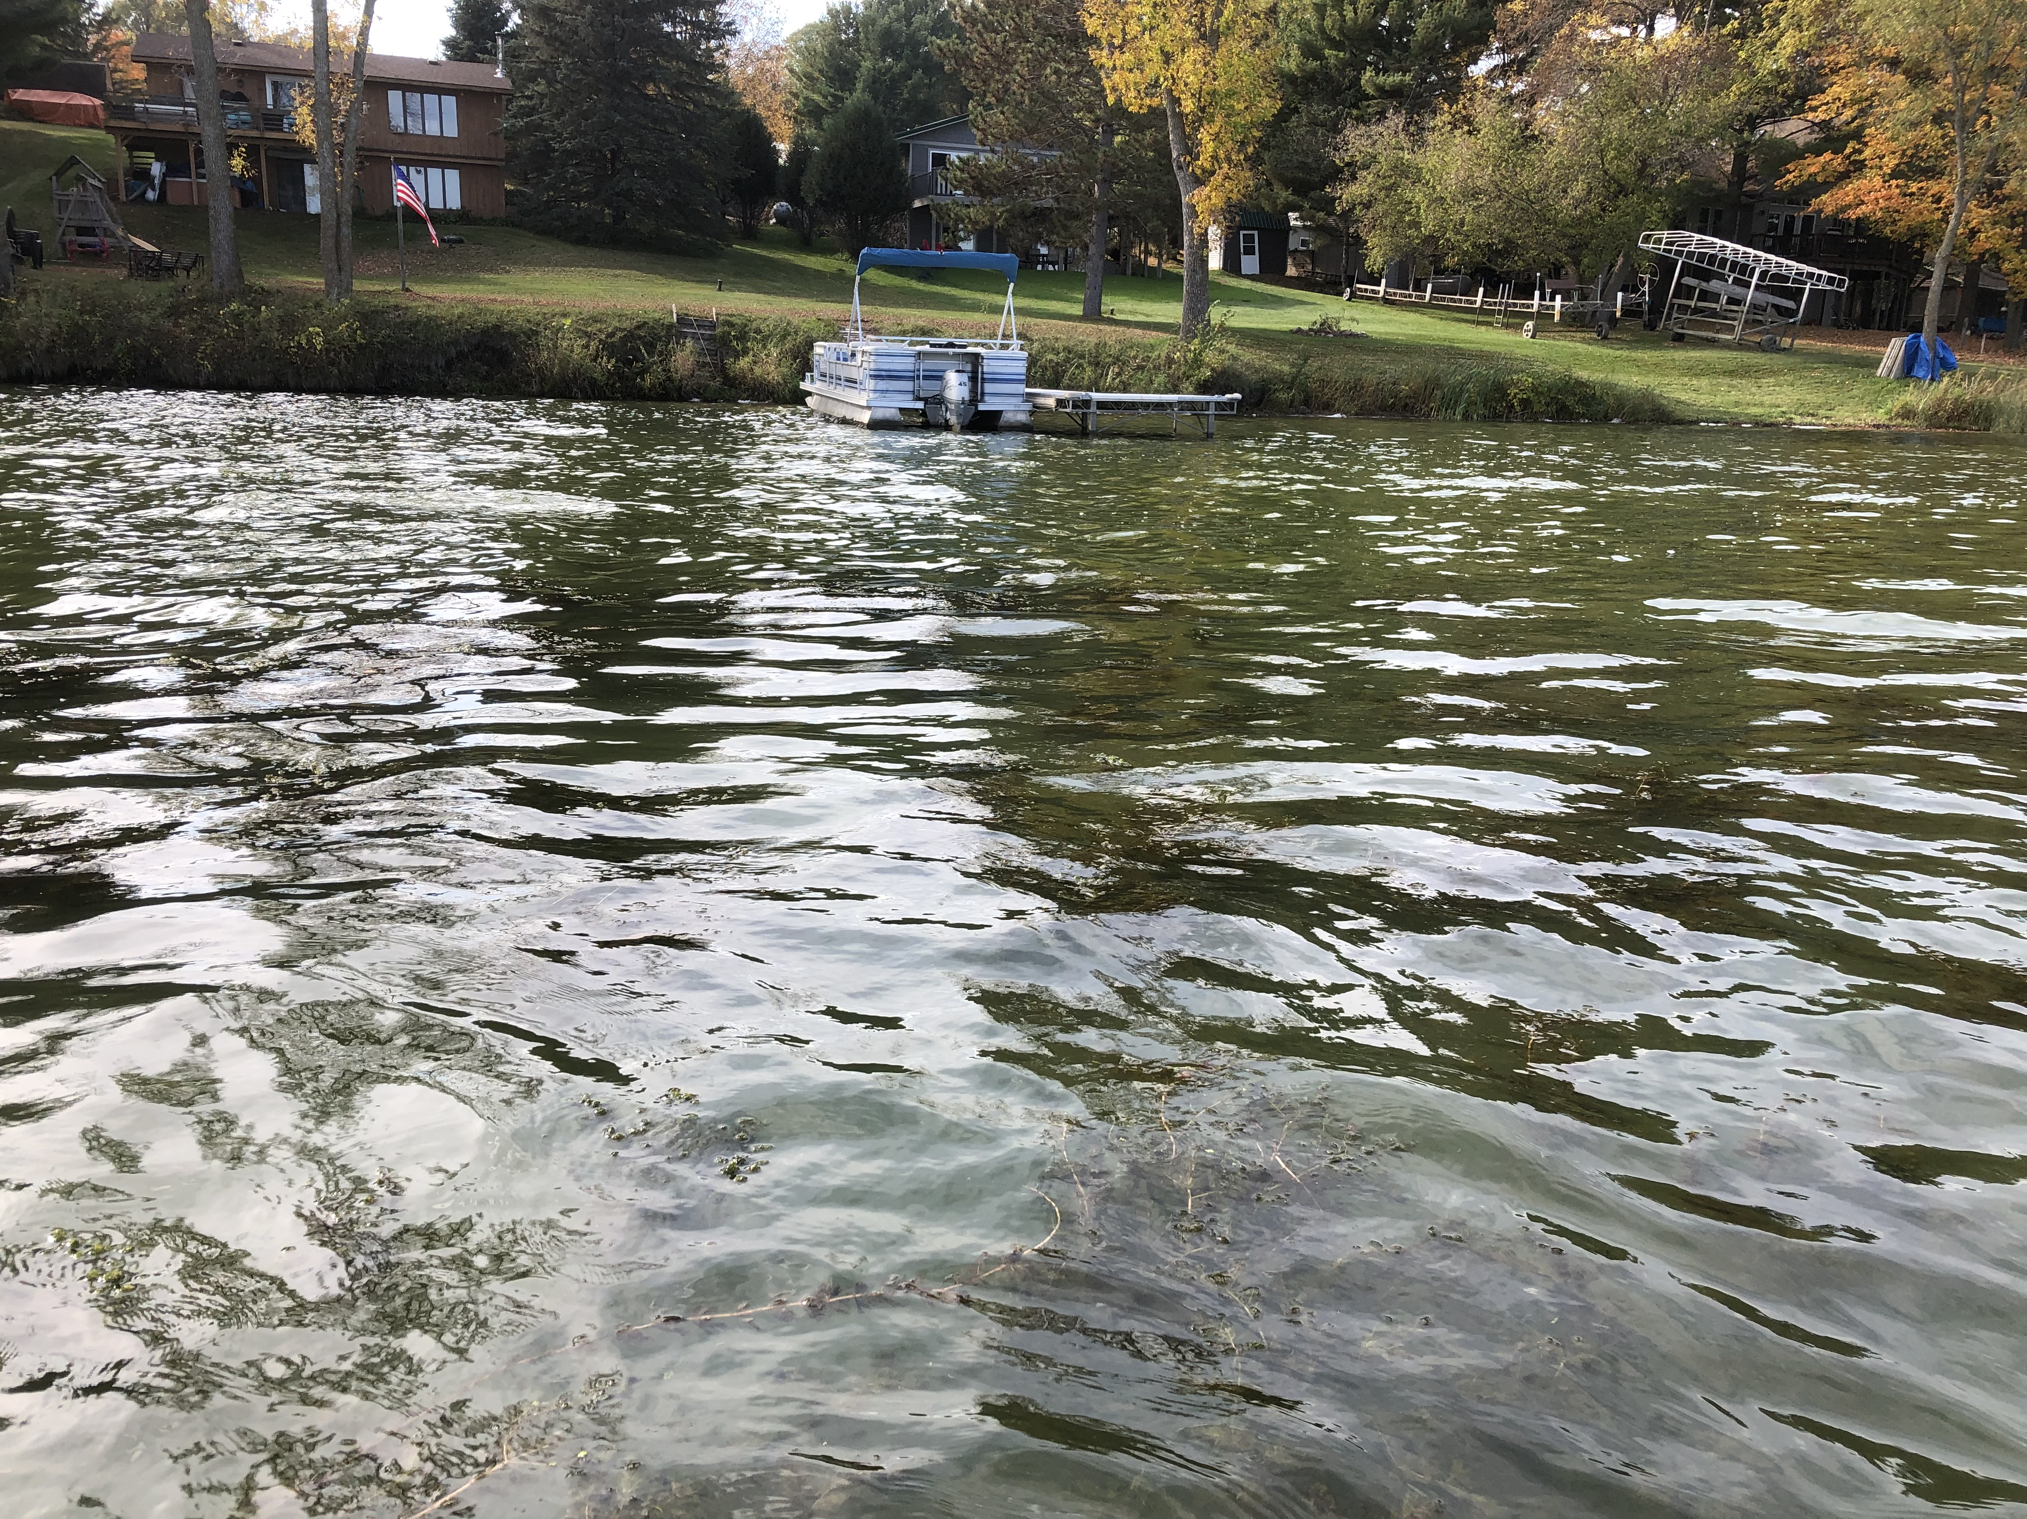
Canopied EWM bed on Round Lake’s west shoreline (10/9/21) Eurasian water-milfoil (Berg 2007)

Project Initiated by: Round-Trade Lakes Improvement Association Inc., Lake Education and Planning Services, LLC, and the
Wisconsin Department of Natural Resources (Grant LPL175421)

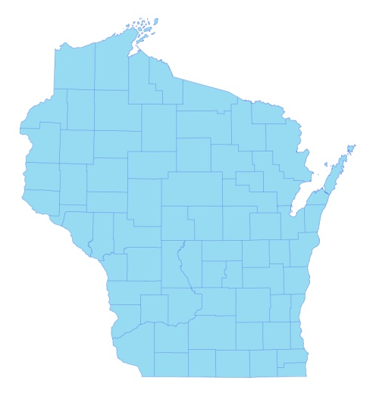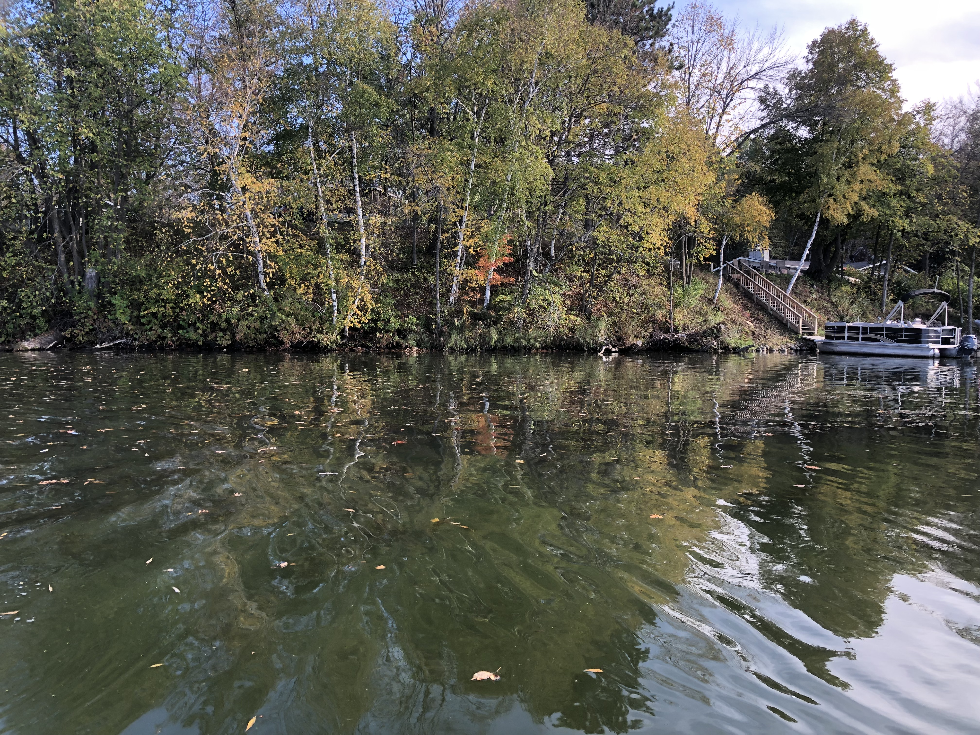
* Round Lake
Fall shoreline – Round Lake (10/9/21)

Survey Conducted by and Report Prepared by:
Endangered Resource Services, LLC
Matthew S. Berg, Research Biologist
St. Croix Falls, Wisconsin
October 9, 2021
TABLE OF CONTENTS

Page
LIST OF FIGURES AND TABLES.……..………………………………………………... ii

INTRODUCTION.……….…..……..……………………………………………………… 1

BACKGROUND AND STUDY RATIONALE…..……………………………………….. 1

METHODS……………………………………………………………….………………… 2

RESULTS AND DISCUSSION……………………………………………………………. 3

Fall Eurasian Water-milfoil Bed Mapping Survey ………………………………….. 3

Descriptions of Current and Former Eurasian Water-milfoil Beds…………………. 6

LITERATURE CITED……….……………………….……………………………………. 7

APPENDIXES……….…….………………………………………………….……………. 8

I: Late Summer 2020 and Fall 2021 EWM Bed Maps.………………………………… 8

LIST OF FIGURES AND TABLES

Page
Figure 1: 2021 Final EWM Treatment Areas…………………………………….………... 1
Figure 2: Rake Fullness Ratings……………………………….…….…………………….. 2
Figure 3: October 9, 2021 EWM Littoral Zone Survey – GPS Tracks.. …………………... 3
Figure 4: Late-summer 2020 and Fall 2021 EWM Bed Maps …………………………….. 3
Table 1: Fall Eurasian Water-milfoil Bed Mapping Summary –
Round Lake, Burnett County – October 9, 2021 …………………………………………... 4

Table 2: Historical Late-summer/Fall Eurasian Water-milfoil Bed Mapping Summary –
Round Lake, Burnett County – 2011 – 2021………………………………………..……… 5

INTRODUCTION:
Round Lake (WBIC 2640100) is a 208-acre drainage lake in southwest/south-central Burnett County, Wisconsin in the Town of Trade Lake (T37N R18W S27 NE SW). It reaches a maximum depth of 27ft in two spots near the eastern shoreline midlake and has an average depth of approximately 15ft. The lake is eutrophic in nature with summer Secchi disc readings from 1986 to 2020 (the most recent year data was available) ranging from 1.7-5.5ft and averaging 3.5ft (WDNR 2021). This very poor clarity produced a littoral zone that extended to approximately 8.0ft in 2021. The bottom substrate is predominately muck in the main basin and in the lake’s bays, while the shoreline and midlake bars and humps are dominated by gravel and sand (Sather et al. 1967).
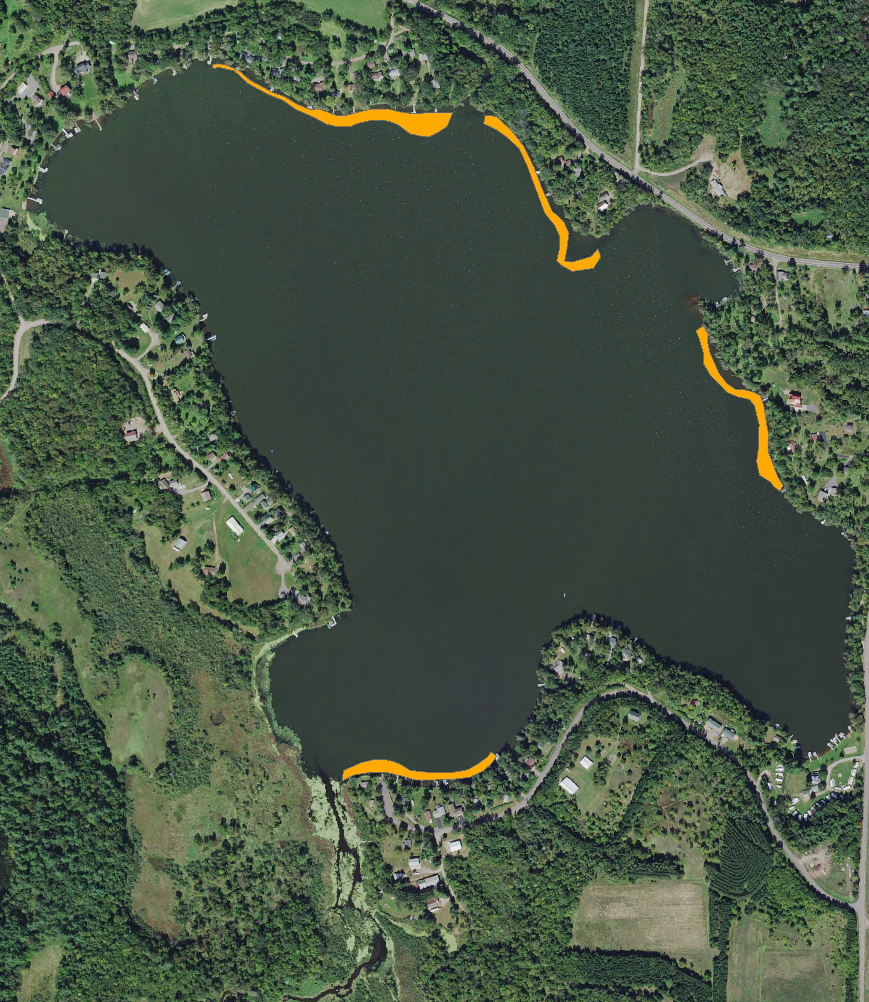
Figure 1: 2021 Final EWM Treatment Areas

BACKGROUND AND STUDY RATIONALE:
The Wisconsin Department of Natural Resources (WDNR) confirmed the presence of Eurasian water-milfoil (Myriophyllum spicatum) (EWM) in Round Lake in 2003. Following the development of a WDNR approved Aquatic Plant Management Plan (APMP) that outlined strategies to control EWM and Curly-leaf pondweed (Potamogeton crispus) (CLP), another invasive exotic species that occurs sporadically throughout the lake’s spring littoral zone, the Round-Trade Lake Improvement Association, Inc. (RTLIA) began using manual removal and herbicide treatments to control these species.

In 2021, the RTLIA carried out a June 3rd Eurasian water-milfoil treatment of 4.41 acres (2.12% of the lake’s total surface area) (Figure 1). During the treatment, the RTLIA – under the direction of Dave Blumer (Lake Education and Planning Services, LLC - LEAPS) – tested a limno barrier near the lake outlet, and, because of this, LEAPS conducted the pre/post monitoring of this area. However, after the RTLIA applied for and was awarded a WDNR lake planning grant (LPL175421) that included funding for a fall bed mapping survey, we were asked to help determine where EWM control might be considered in 2022. This report is the summary analysis of that survey conducted on October 9, 2021.

METHODS:
Fall Eurasian Water-milfoil Bed Mapping:
During the fall survey, we searched the visible littoral zone of the lake and mapped all known beds of EWM. A “bed” was determined to be any area where we visually estimated that EWM made up >50% of the area’s plants and was generally continuous with clearly defined borders. After we located a bed, we motored around the perimeter of the area, took GPS coordinates at regular intervals, and estimated both the range and mean rake fullness rating of EWM within the bed (Figure 2). Using the WDNR’s Forestry Tool’s Extension to ArcGIS 9.3.1, we plotted these coordinates to generate bed shapefiles and determine the acreage to the nearest hundredth of an acre. We also took waypoints of EWM plants outside these beds as they were generally few in number.

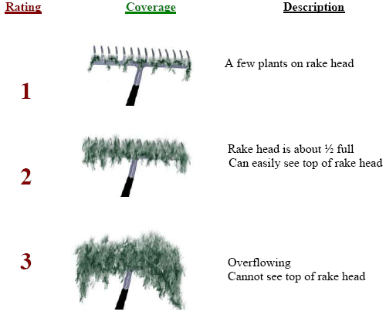
Figure 2: Rake Fullness Ratings

RESULTS AND DISCUSSION:
Fall Eurasian Water-milfoil Bed Mapping Survey:
On October 9, 2021, we searched 12.0km (7.5 miles) of transects throughout the lake’s visible littoral zone (Figure 3). Collectively, we mapped 14 beds that covered 5.31 acres (2.55% of the lake’s surface area) (Table 1). Outside of these areas, we marked 31 additional isolated plants (Figure 4) (Appendix I). This was an +80.00% increase from 2020 when we mapped 12 areas that covered 2.95 acres (1.42% of the lake’s surface area). It was, however, still lower than the recent high of 7.57 acres (3.64% coverage) mapped in 2016 (Table 2).
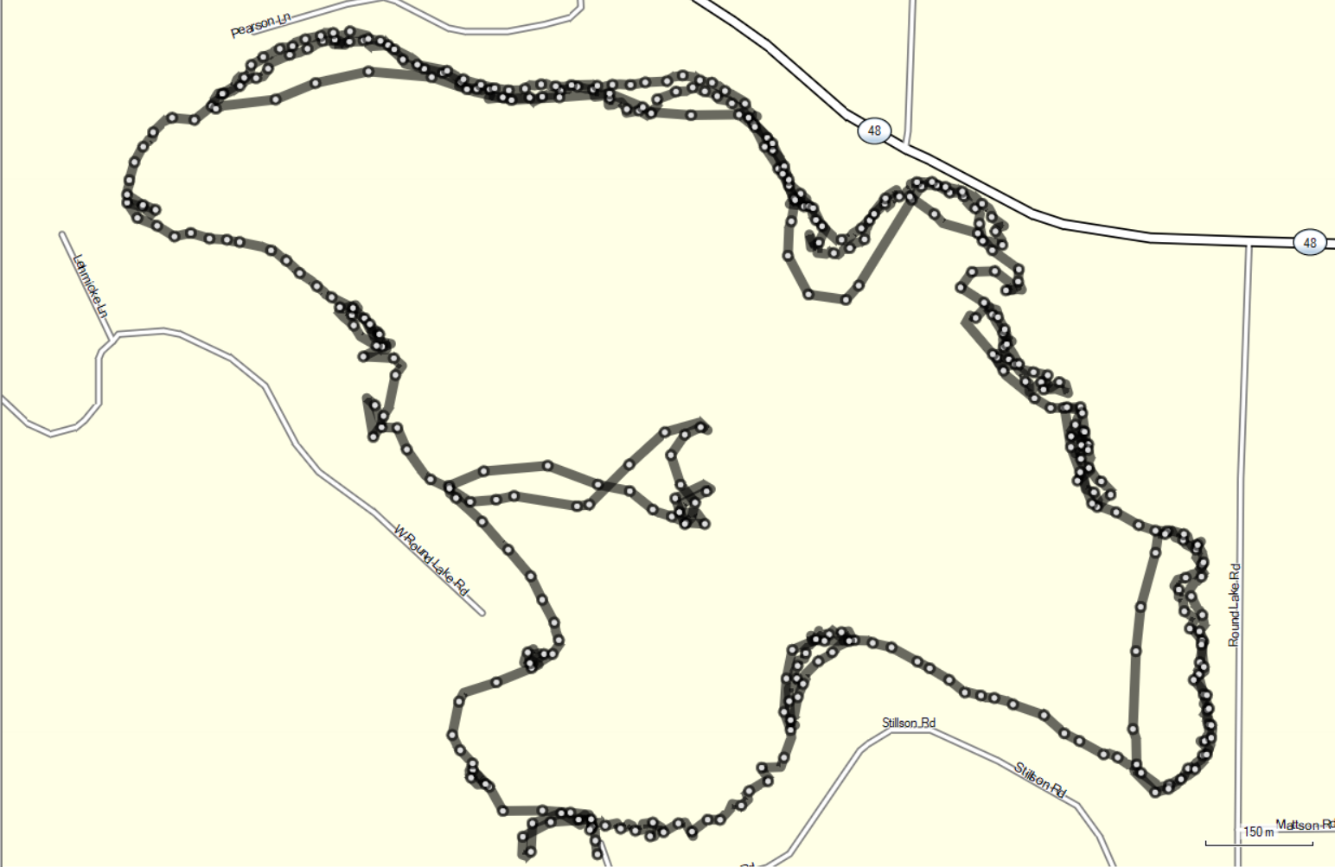
Figure 3: October 9, 2021 EWM Littoral Zone Survey – GPS Tracks
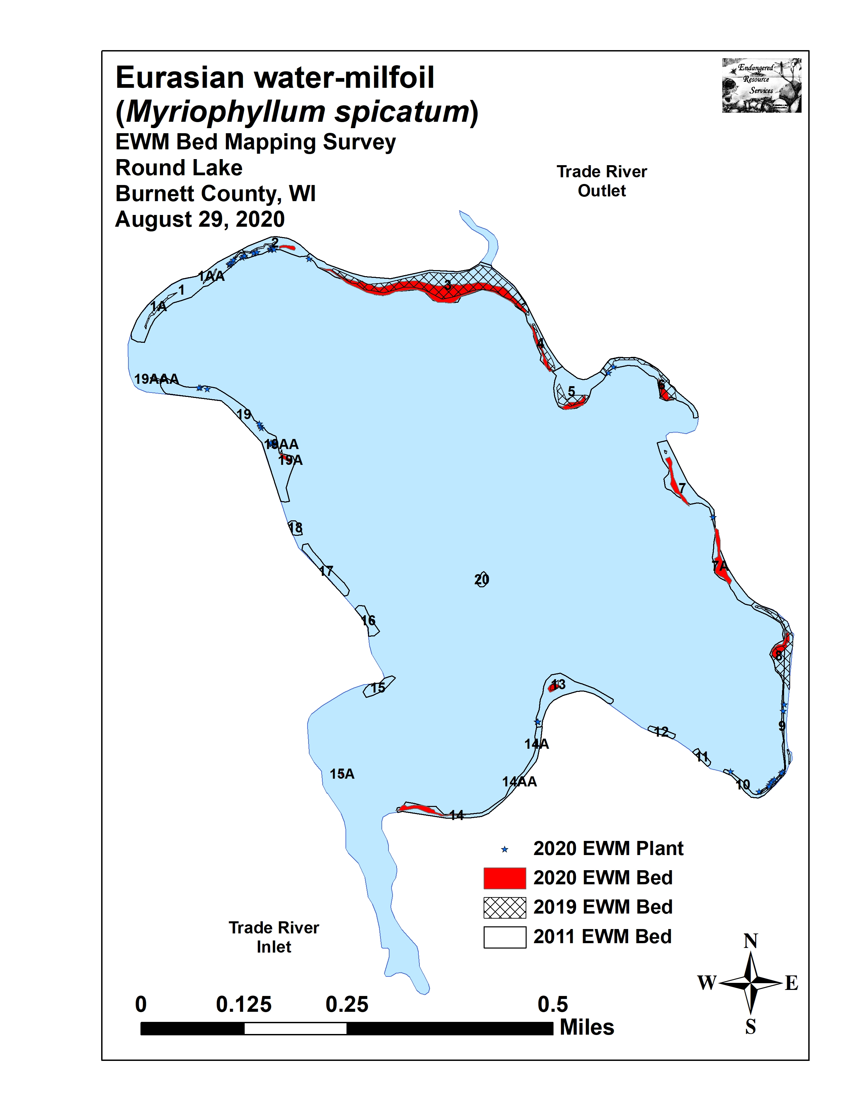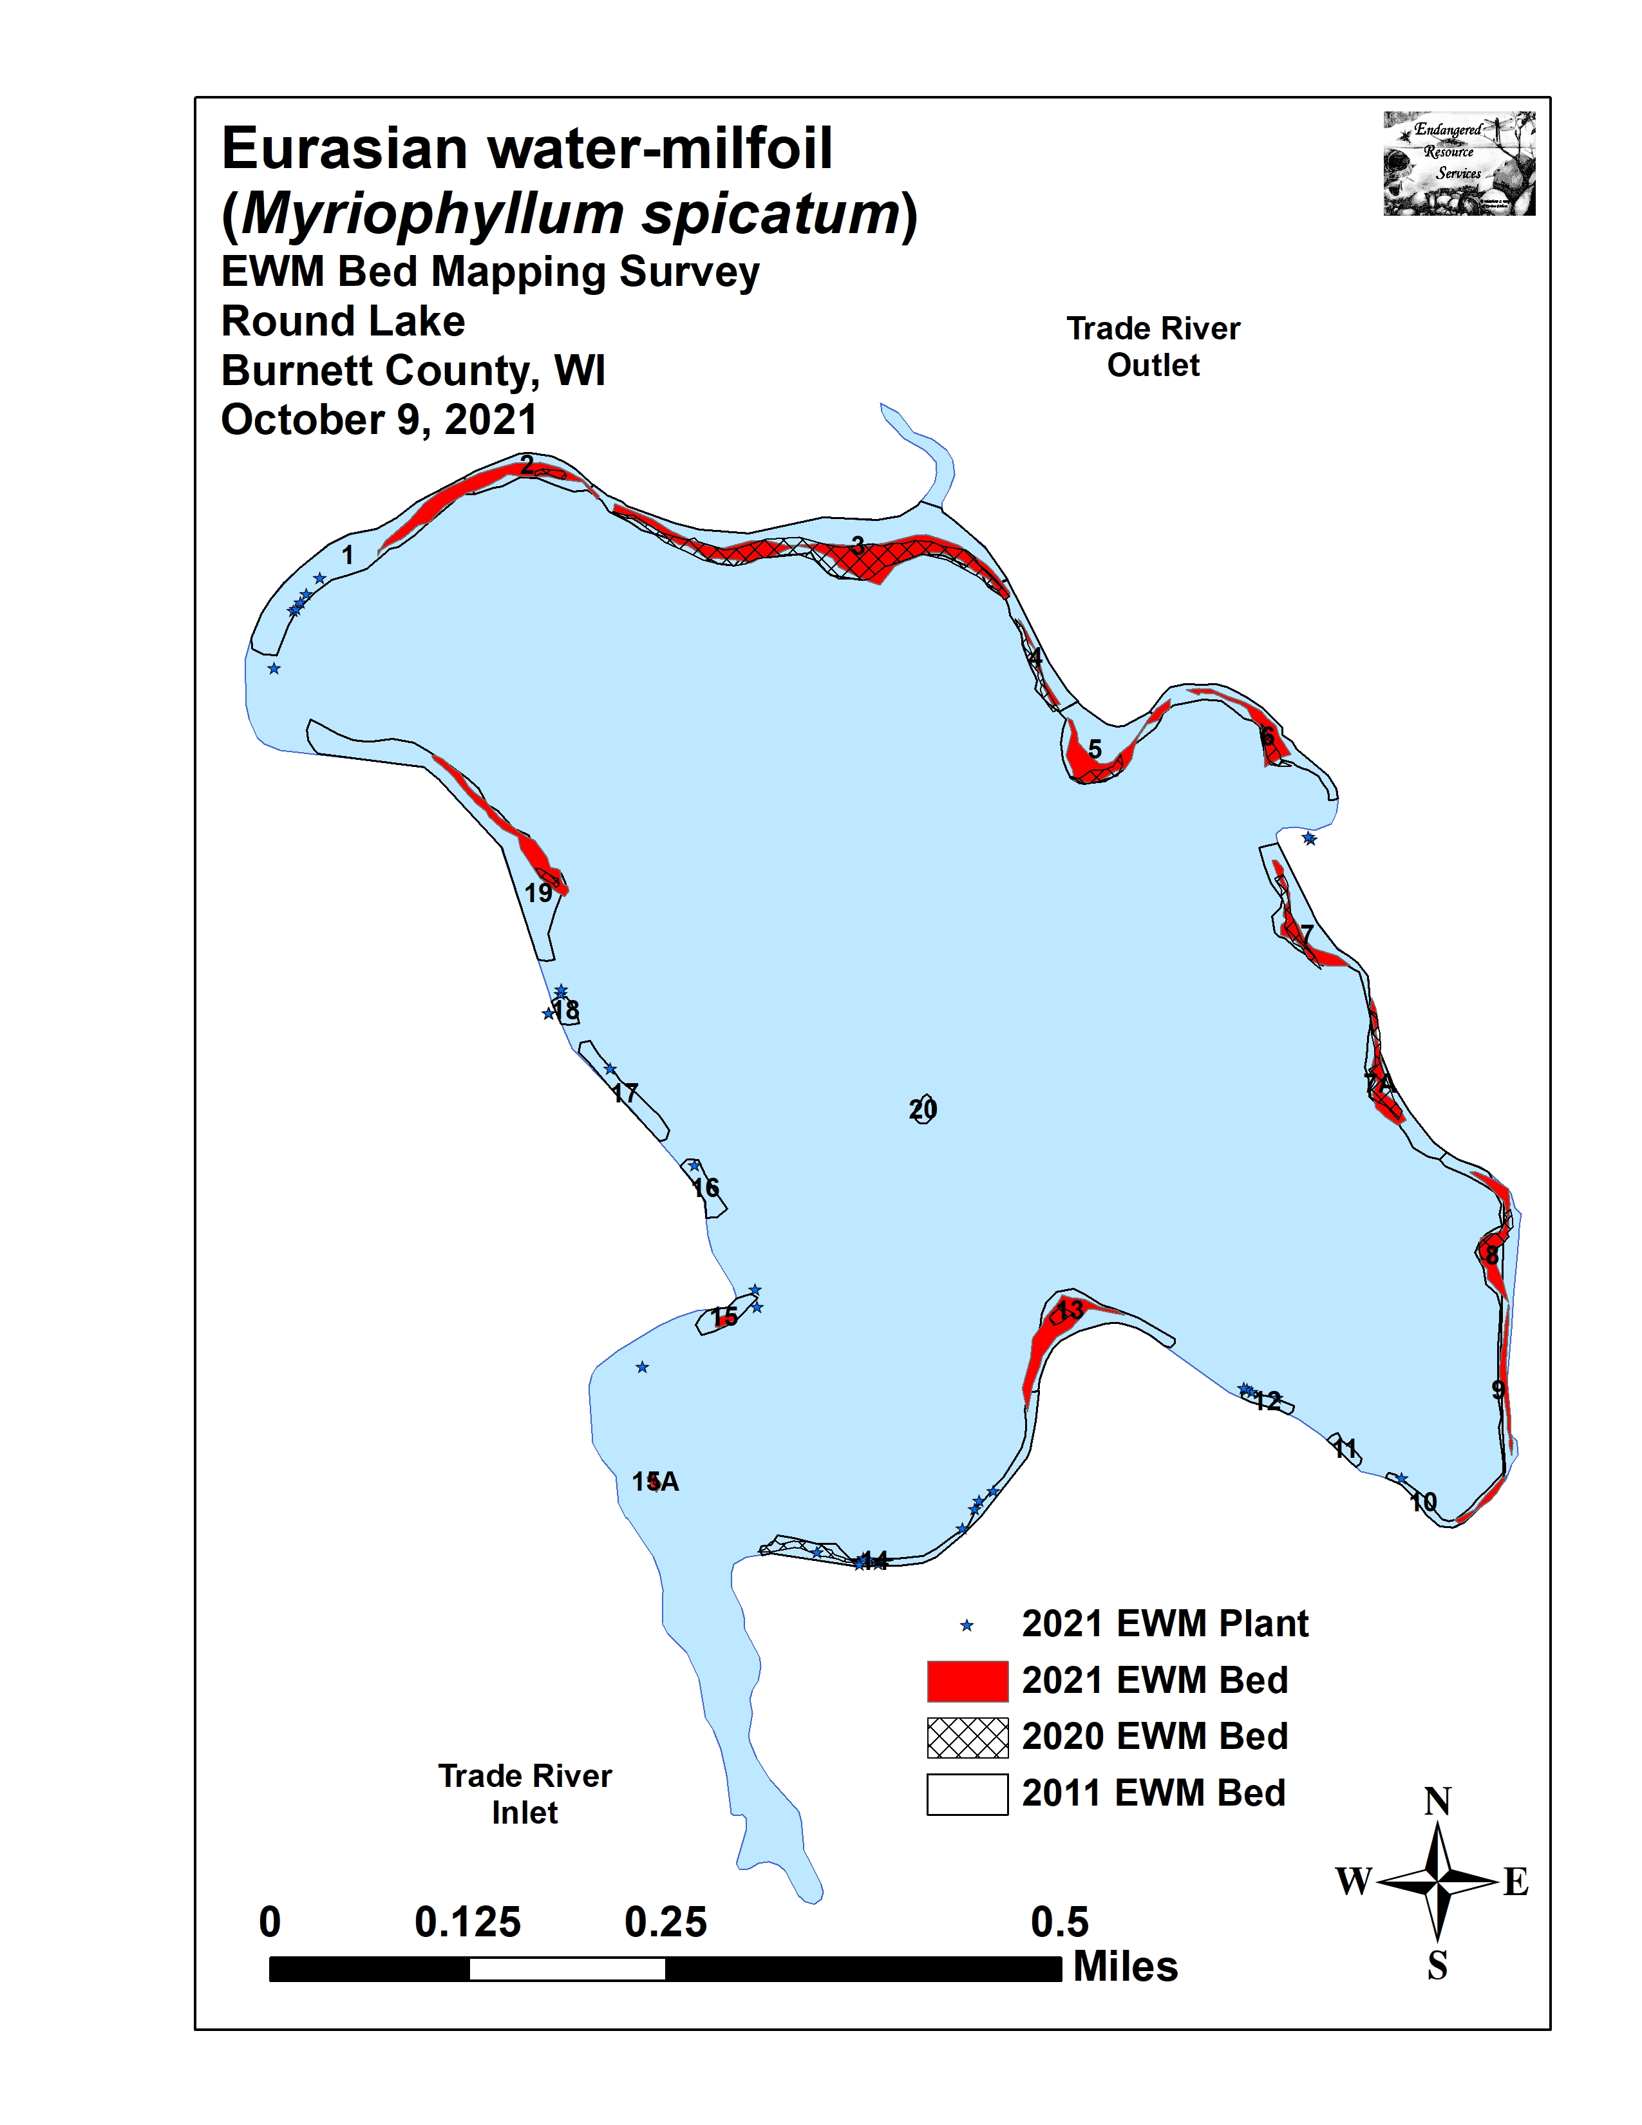
Figure 4: Late-summer 2020 and Fall 2021 EWM Bed Maps

Table 1: Fall Eurasian Water-milfoil Bed Mapping Summary
Round Lake, Burnett County
October 9, 2021

Bed Number | 2021 Area in Acres | 2020 Area in Acres | 2021  Change in  Acreage | Rake Range;  Mean Rake Fullness | Depth Range and Mean Depth | Navigation Impairment | 2021  Field Notes
Merged 1-6 | 3.03 | 2.06 | 0.97 | - | - | - | -----
1 and 1A/AA | 0 | 0 | 0 | <<<1 | 2-4; 3 | - | 5 EWM plants.
2 | 0.68 | 0.04 | 0.64 | <<<1-3; 1 | 1-6; 4 | Minor | Narrow strip of regular plants.
3 and 3A/AA | 1.51 | 1.67 | -0.16 | <<<1-3; 2 | 1-6; 4 | Moderate | Canopied mat near outlet – less dense on periphery.
4 | 0.08 | 0.13 | -0.05 | <<<1-3; 1 | 1-6; 3 | Minor | Narrow strip of regular plants.
5 | 0.46 | 0.12 | 0.34 | <<<1-3; 1 | 1-5; 3 | Minor | Regular clusters reestablishing on the point.
6 | 0.30 | 0.10 | 0.20 | <<<1-2; 1 | 1-5; 3 | Minor | Open bed mixed with Coontail.
7 and 7A | 0.58 | 0.46 | 0.12 | <<<1-2; 1 | 1-5; 3 | Minor | Open beds mixed with Coontail and Clasping-leaf.
8 | 0.37 | 0.16 | 0.21 | <<1-3; 2 | 1-5; 3 | Moderate | Canopied mat at core – fragmented on edge.
9 | 0.15 | 0 | 0.15 | <<<1-2; 1 | 1-5; 3 | Minor | Mixed with Coontail.
10 | 0.07 | 0 | 0.07 | <<<1-2; 1 | 1-5; 3 | Minor | Scattered EWM w/ native pondweeds and Coontail.
11 | 0 | 0 | 0 | - | - | - | No EWM seen.
12 | 0 | 0 | 0 | <<<1 | 2-4; 3 | - | 4 EWM plants.
13 | 0.56 | 0.06 | 0.50 | <<1-3; 2 | 2-7; 5 | Moderate | Nearly monotypic on the point.
14 and 14A/AA | 0 | 0.17 | -0.17 | <<<1 | 3-5; 4 | None | 8 scattered EWM plants.
15A | 0.03 | 0.01 | 0.02 | <<1-2; 1 | 3-5; 4 | Minor | Small bed mixed with Coontail in the river inlet.
15 | 0.04 | 0 | 0.04 | <<1-2; 1 | 3-5; 4 | Minor | Small bed mixed with Coontail.
16 | 0 | 0 | 0 | <<<1 | 2-4; 3 | - | 1 EWM plant.
17 | 0 | 0 | 0 | <<<1 | 2-4; 3 | - | 5 EWM plants.
18 | 0 | 0 | 0 | - | - | - | No EWM seen.
19A/AA/AAA | 0.47 | 0.04 | 0.43 | <<1-3; 2 | 3-6; 5 | Minor | Too narrow to be mod. impair. – mixed w/ Coontail
20 | 0 | 0 | 0 | - | - | - | No EWM seen
Total  Acres | 5.31 | 2.95 | +2.36
Table 6: Historical Late-summer/Fall Eurasian Water-milfoil Bed Mapping Summary
Round Lake, Burnett County
2011-2021

Bed  Number | 2021 Area in Acres | 2020 Area in Acres | 2019  Area in Acres | 2018  Area in Acres | 2017  Area in Acres | 2016  Area in Acres | 2015 Area in Acres | 2014  Area in Acres | 2013  Area in Acres | 2012  Area in Acres | 2011  Area in Acres
Merged 1-6 | 3.03 | 2.06 | 3.68 | 1.93 | 1.24 | 5.66 | 2.16 | - | - | - | -
1 and 1A/AA | 0 | 0 | 0.10 | 0 | 0.17 | Merged | 0 | 0 | 0 | 0.52 | 1.91
2 | 0.68 | 0.04 | 0.06 | 0 | 0.14 | Merged | 0 | 0.16 | 0.10 | 0.47 | 0.74
3 and 3A/AA | 1.51 | 1.67 | 2.66 | 1.82 | 0.59 | Merged | 1.55 | 1.81 | 1.00 | 2.58 | 3.57
4 | 0.08 | 0.13 | 0.19 | Merg. w/3 | Merg. w/3 | Merged | Merg. w/ 3 | Merg. w/ 3 | 0.11 | 0.68 | 0.63
5 | 0.46 | 0.12 | 0.26 | 0.02 | 0.06 | Merged | 0.49 | 0.26 | 0 | 0.46 | 1.21
6 | 0.30 | 0.10 | 0.41 | 0.09 | 0.28 | Merged | 0.11 | 0.06 | 0 | 0.43 | 0.61
7 and 7A | 0.58 | 0.46 | <0.01 | 0 | 0.28 | 0.78 | 0.65 | 0.05 | 0 | 0.80 | 1.73
8 | 0.37 | 0.16 | 0.71 | 0.25 | 0.52 | 0.57 | 0.43 | 0.23 | 0 | 0.19 | 0.55
9 | 0.15 | 0 | 0.02 | 0 | 0.06 | 0 | 0 | 0 | 0 | 0.20 | 0.26
10 | 0.07 | 0 | 0.08 | 0 | 0 | 0 | 0 | 0 | 0 | 0.06 | 0.11
11 | 0 | 0 | 0 | 0 | 0 | 0 | 0 | 0 | 0 | 0.06 | 0.11
12 | 0 | 0 | 0 | 0 | 0 | 0 | 0 | 0 | 0 | 0 | 0.13
13 | 0.56 | 0.06 | 0.05 | 0 | 0.25 | 0.08 | 0.28 | 0 | 0 | 0.44 | 1.04
14 and 14A/AA | 0 | 0.17 | 0.02 | 0 | 0.39 | 0.19 | 0.06 | 0.07 | 0 | 0.39 | 0.92
15A | 0.03 | 0.01 | 0 | 0 | 0 | 0.01 | 0.04 | 0 | 0 | 0 | 0
15 | 0.04 | 0 | 0 | 0 | 0 | 0 | 0 | 0 | 0 | 0.12 | 0.27
16 | 0 | 0 | 0 | 0 | 0 | 0 | 0 | 0 | 0 | 0.09 | 0.26
17 | 0 | 0 | 0 | 0 | 0 | 0 | 0 | 0.10 | 0 | 0.15 | 0.46
18 | 0 | 0 | 0 | 0 | 0 | 0 | 0 | 0 | 0 | 0 | 0.13
19A/AA/AAA | 0.47 | 0.04 | 0.04 | <0.01 | 0.03 | 0.27 | 0.03 | 0.46 | 0.19 | 1.15 | 2.27
20 | 0 | 0 | 0 | 0 | 0 | 0 | 0 | 0 | 0.01 | 0.05 | 0.10
Total  Acres | 5.31 | 2.95 | 4.60 | 2.18 | 2.76 | 7.57 | 3.65 | 3.20 | 1.41 | 8.84 | 17.01

Descriptions of Current and Former Eurasian Water-milfoil Beds:
Beds 1A, 1AA, and 2 – Bed 1 continued to have only a few scattered plants. The 2021 treatment just touched the eastern end of Bed 2 and it was little changed, but the west end of the bed saw significant expansion.

Bed 3 – The limno curtain did not prove to be particularly effective. We found little evidence a treatment had occurred as the acreage of Bed 3 was almost identical to what we found in late-summer 2020. This area was again the worst on the lake as it formed a solid canopied mat at its core.

Beds 4 and 5 – Similar to Beds 2 and 3, the EWM treatment areas east of the outlet showed little residual control. Bed 5 was actually almost four times larger than what we mapped in 2020 as EWM reestablished in the shallows inshore from the 2021 treatment area.

Bed 6 – No treatment occurred in the northeast bay, and, although growth wasn’t particularly dense, EWM predictably showed some expansion.

Beds 7 and 7A – Chemical control in this area didn’t holdup well either. Despite treating the entire shoreline, we found the area of these two beds had expanded compared to 2020.

Bed 8 – The entire flat was again covered with a moderately dense canopied mat of EWM. After the outlet, this was the second worst area on the lake.

Beds 9 and 10 – The narrow beds near the campground docks had regular, but often only scattered towers. Although not a significant impairment, the high level of in and out boat traffic might again warrant control in this area.

Beds 11 and 12 – Although we didn’t see any EWM in Bed 11, for the first time in several years, we found a handful of scattered plants in Bed 12. Despite this, neither of these areas northwest of the campground were likely to cause even minor impairment.

Beds 13 and 14 – EWM in Bed 13 on the south-central point showed a nearly tenfold expansion and it was the third worst area on the lake. In Bed 14 near the public landing, the treatment held up fairly well as we only found a handful of surviving plants in this area.

Beds 15A and 15 – Bed 15A was a microbed near the river inlet that encompassed a few clusters of plants along an uninhabited shoreline. Bed 15 was a similarly small bed, but it was established at the end of a dock. However, it was small and easily avoided.

Beds 16-18 – We found just a sprinkling of plants in these former beds.

Bed 19 – This bed was the fourth worst area on the lake, and we found EWM was canopied in up to 6ft of water. Density declined from the southeast to the northwest before plants disappeared completely.

Bed 20 – We again found no EWM plants on the midlake rock bars.

LITERATURE CITED

Sather, L, C. Busch, R. House, and C. Harrison [online]. 1967. Round Lake Map. Available from
http://dnr.wi.gov/lakes/maps/DNR/2640100a.pdf (2021, November).

UWEX Lakes Program. [online]. 2010. Aquatic Plant Management in Wisconsin. Available from http://www.uwsp.edu/cnr-ap/UWEXLakes/Pages/ecology/aquaticplants/default.aspx (2021, November).

UWEX Lakes Program. [online]. 2010. Pre/Post Herbicide Comparison. Available from http://www.uwsp.edu/cnr-ap/UWEXLakes/Documents/ecology/Aquatic%20Plants/Appendix-D.pdf (2021, November).

WDNR. [online]. 2021. Round Lake - Citizen Lake Water Quality Monitoring Database. Available from http://dnr.wi.gov/lakes/waterquality/Station.aspx?id=073039 (2021, November).

Appendix I: Late Summer 2020 and Fall 2021 EWM Bed Maps

