Curly-leaf pondweed (Potamogeton crispus)
Point-intercept and Bed Mapping Surveys, and
Warm-water Macrophyte Point-intercept Survey
Granite Lake - WBIC: 2100800
Barron County, Wisconsin

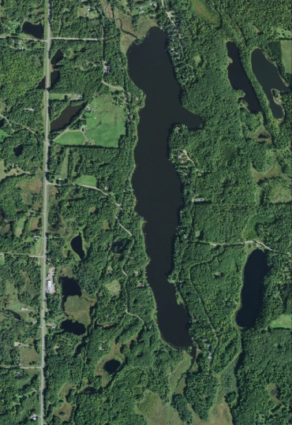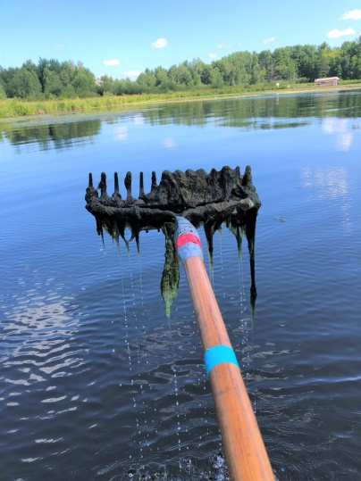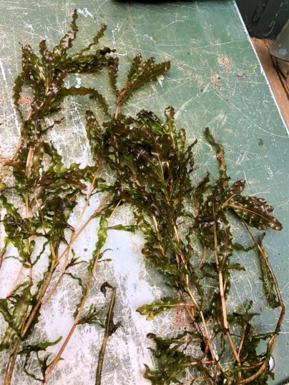
Granite Lake Aerial Photo (2015) Filamentous algae covering bottom at inlet Curly-leaf pondweed raked out 6/12/18

Project Initiated by:
The Granite Lake Association, the Wisconsin Department of
Natural Resources, and Lake Education and Planning Services, LLC

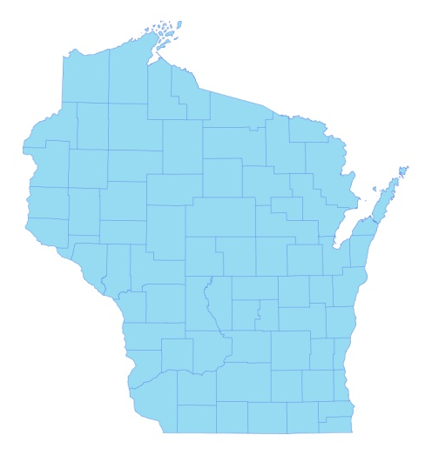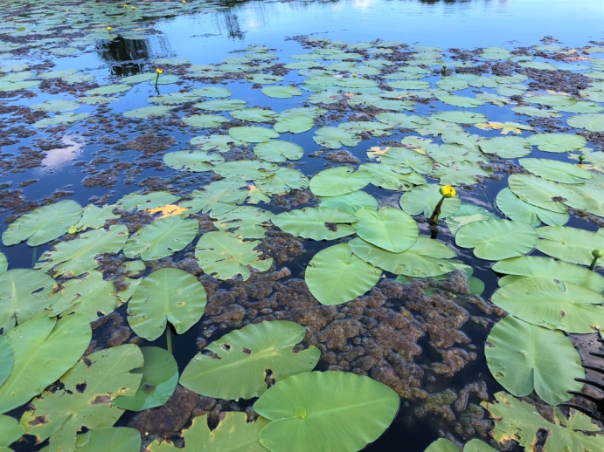
* Granite Lake
Spatterdock with mats of filamentous algae at the inlet 7/31/18

Surveys Conducted by and Report Prepared by:
Endangered Resource Services, LLC
Matthew S. Berg, Research Biologist
St. Croix Falls, Wisconsin
June 4 and 12, and July 31, 2018
TABLE OF CONTENTS

Page
ABSTRACT………………………..……..…………………………………………………….……. ii
LIST OF FIGURES.………………..……..………………………………………………...…….….. iii
LIST OF TABLES…………………..……..………………………………………………..………... iv
INTRODUCTION………….…..……...………………………………………………………..……. 1
BACKGROUND AND STUDY RATIONALE…..……………………………………….………… 1
METHODS.……………………………………………………………….………………………….. 2
DATA ANALYSIS…………………………………………………………………………….…….. 3
RESULTS............................................................................................................................................. 6
Curly-leaf Pondweed Point-intercept Survey......................................................................... 6
Curly-leaf Pondweed Bed Mapping Survey………..……………………………...……….. 7
Descriptions of Curly-leaf Pondweed High Density Areas………………………………… 8
Warm-water Full Point-intercept Macrophyte Survey………………………………….….. 9
Granite Lake Plant Community…………………………………………………..…………. 13
Comparison of Native Macrophyte Species in 2009 and 2018…....……………………….. 19
Comparison of Floristic Quality Indexes in 2009 and 2018.……………………….…….… 28
Comparison of Filamentous Algae in 2009 and 2018…....……………………………...…. 30
Comparison of Midsummer Curly-leaf Pondweed in 2009 and 2018…....………………… 31
Other Exotic Plant Species…………………………....…………………………….……… 32
DISCUSSION AND CONSIDERATIONS FOR MANAGEMENT……………………….……….. 34
LITERATURE CITED……….……………………….…………………………………….……….. 36
APPENDIXES……….…….………………………………………………….…………….……….. 37
I: Survey Sample Points Map.………………………………..…….……..…………………..….. 37
II: Boat and Vegetative Survey Datasheets..……………………………………………………… 39
III: 2009 and 2018 Early-season CLP Density and Distribution and 2018 CLP HDA Maps.….….. 42
IV: Habitat Variable Maps……………………………………...………..……………………........ 46
V: 2009 and 2018 Littoral Zone, Native Species Richness and Total Rake Fullness Maps.……… 49
VI: July 2009 Species Density and Distribution Maps…………...………………………………... 56
VII: Granite Lake Plant Species Accounts……………………………………………………….…. 83
VIII: July 2018 Species Density and Distribution Maps…………………………………...……….. 92
IX: Aquatic Exotic Invasive Plant Species Information…………………….…………………...... 122
X: Glossary of Biological Terms……………….…………...……………………….………........ 131
XI: 2018 Raw Data Spreadsheets.…………………………………………………………………. 135
ABSTRACT
Granite Lake (WBIC 2100800) is a 155 acre stratified drainage lake located in northwest Barron County, WI. Following our original point-intercept surveys in 2009, the Granite Lake Association (GLA) decided against actively managing Curly-leaf pondweed (Potamogeton crispus) (CLP) or any other aquatic plants. Since then, increases in filamentous algae levels prompted the GLA to again consider some form of active management. In 2019 as a prerequisite to developing/updating their Aquatic Plant Management Plan and to compare how the lake’s vegetation had changed since the last point-intercept surveys, the GLA, Lake Education and Planning Services, LLC (LEAPS), and the Wisconsin Department of Natural Resources authorized CLP density and bed mapping surveys on June 4 and June 12, and a full point-intercept survey of all aquatic macrophytes on July 31, 2018. During the initial 2009 early-season survey, we found CLP at one site (0.2% coverage). In 2018, we didn’t find CLP at any survey points. However, we did find and rake remove 16 plants that were loosely clustered within two areas totaling 0.08acre. This suggested <0.01% of the lake had any CLP at all. During the July 2018 full point-intercept survey, we found macrophytes growing at 61 sites which approximated to 12.1% of the entire lake bottom and 53.5% of the 10.0ft littoral zone – in 2009, 61 points with vegetation covered 34.18% of the then 13.0ft littoral zone. Overall diversity was moderately high with a Simpson Index value of 0.89 – nearly identical to 0.88 in 2009. Total richness was low with 22 species in the rake (down from 24 species in 2009). This jumped to 38 species when including visuals and those found growing in and immediately adjacent to the water during the boat survey (up from 34 total species in 2009). There was an average of 2.38 native species/site with native vegetation – a non-significant increase (p=0.10) from 2.03/site in 2009. Total rake fullness experienced a significant decline (p=0.01) from a moderate 2.02 (est.) in 2009 to a low/moderate 1.69 in 2018. Slender naiad (Najas flexilis), Coontail (Ceratophyllum demersum), Small duckweed (Lemna minor), and Muskgrass (Chara sp.) were the most common macrophyte species in 2018. Found at 55.74%, 40.98%, 19.67%, and 14.75% of sites with vegetation, they captured 55.17% of the total relative frequency. In 2009, Slender naiad, Coontail, Spatterdock (Nuphar variegata), and Common waterweed (Elodea canadensis) were the most common species (50.82%, 37.70%, 19.67%, and 18.03% of survey points with vegetation/60.63% of the total relative frequency). Lakewide, from 2009-2018, three species showed significant changes in distribution: Filamentous algae experienced a moderately significant increase, and Small duckweed and Vasey’s pondweed (Potamogeton vaseyi) saw significant increases. The 22 native index species found in the rake during the July 2018 survey (identical to 2009) produced an above average mean Coefficient of Conservatism of 6.3 (up from 6.1 in 2009). The Floristic Quality Index of 29.4 (up from 28.8 in 2009) was also above the median FQI for this part of the state. Filamentous algae were common to abundant throughout the lake. Despite their moderately significant expansion in distribution (p=0.009) from 30 points in 2009 to 44 points in 2018, we documented a moderately significant decline in mean rake fullness (p=0.002) (1.93 in 2009 to 1.36 in 2018). With the exception of a single floating plant, we saw no evidence of Curly-leaf pondweed during the July 2018 survey (down from two points with CLP in 2009). In addition to CLP, we found three other exotic species growing adjacent to Granite Lake: Perhaps 100 Common forget-me-nots (Myosotis scorpioides) were growing next to a cold-water seep south of the boat landing; Reed canary grass (Phalaris arundinacea) was present along shorelines throughout; and we rake removed a single cluster of Purple loosestrife (Lythrum salicaria) along the southeastern shoreline. We encourage the GLA to proactively work to limit nutrients coming into the system as they feed excessive algal growth. Specifically, continuing efforts to educate lakeshore residents on ways to control erosion and nutrient runoff, and potentially working with landowners in the watershed are ideas worth considering. If volunteers area available, manually removing CLP in the spring and both Common forget-me-nots and Purple loosestrife over the summer could also prevent the spread of these potentially invasive exotic species.
LIST OF FIGURES

Page
Figure 1: Granite Lake Bathymetric Map……………………………………..……….…… 1
Figure 2: Rake Fullness Ratings……………………………….…….…………………….. 2
Figure 3: 2009 and 2018 Early-season Curly-leaf Pondweed Density and Distribution..…. 6
Figure 4: 2009 and 2018 Changes in Early-season CLP Rake Fullness..………………….. 7
Figure 5: 2018 Early-season Curly-leaf Pondweed High Density Areas and
Rake Removed CLP – 6/12/18……………………………………………………………... 8

Figure 6: Lake Depth and Bottom Substrate.………………………………………………. 9

Figure 7: 2009 and 2018 Littoral Zone………………………………..…………………… 10
Figure 8: 2009 and 2018 Plant Colonization Depth Chart.………………………….……... 10
Figure 9: 2009 and 2018 Native Species Richness………………………………….……... 12
Figure 10: 2009 and 2018 Total Rake Fullness…………………….……………………… 12
Figure 11: Macrophyte Changes from 2009-2018…………………..…………....………... 20
Figure 12: 2009 and 2018 Slender Naiad Density and Distribution..……….………….….. 25
Figure 13: 2009 and 2018 Coontail Density and Distribution...…………….………….….. 26
Figure 14: 2009 and 2018 Spatterdock Density and Distribution…………………………... 26
Figure 15: 2009 and 2018 Common Waterweed Density and Distribution........................... 27
Figure 16: 2009 and 2018 Large-leaf Pondweed Density and Distribution...……………... 27
Figure 17: 2009 and 2018 Filamentous Algae Density and Distribution.…………………. 30
Figure 18: 2009 and 2018 Midsummer CLP Density and Distribution.…………………… 31
Figure 19: Common Forget-me-not Distribution/Population on Western Shoreline………. 32
Figure 20: Reed Canary Grass Distribution and Typical Growth Form.……………...…… 33
Figure 21: Purple Loosestrife Distribution and Inflorescence..........................……….…… 33

LIST OF TABLES

Page
Table 1: Curly-leaf Pondweed Bed Mapping Summary –
Granite Lake, Barron County – June 12, 2018…………………………………………....... 8

Table 2: Aquatic Macrophyte P/I Survey Summary Statistics –
Granite Lake, Barron County July 28-29, 2009 and July 31, 2018…………..………….…. 11

Table 3: Frequencies and Mean Rake Sample of Aquatic Macrophytes
Granite Lake, Barron County – July 28-29, 2009…………….……………….……………. 21

Table 4: Frequencies and Mean Rake Sample of Aquatic Macrophytes
Granite Lake, Barron County – July 31, 2018……………………………………………… 23

Table 5: Floristic Quality Index of Aquatic Macrophytes –
Granite Lake, Barron County – July 28-29, 2009…………………………………..…......... 28

Table 6: Floristic Quality Index of Aquatic Macrophytes –
Granite Lake, Barron County – July 31, 2018………………………………….................... 29

INTRODUCTION:
Granite Lake (WBIC 2100800) is a 155 acre, stratified, drainage lake located in the Town of Lakeland in northwest Barron County (T36N R13W S29 SE SW). It reaches a maximum depth of 34ft in the north-central basin due west of the east bay and has an average depth of 18ft (WDNR 2018). The lake is eutrophic in nature with Secchi readings from 1994-2018 averaging 5.3ft (WDNR 2018). This poor water clarity produced a littoral zone that reached approximately 10.0ft in 2018. The lake’s bottom substrate is predominantly rock and sand along the central basin with organic muck in the north and south bays as well as the creek inlet/outlet (Figure 1) (Bush et al. 1967).

Figure 1: Granite Lake Bathymetric Map

BACKGROUND AND STUDY RATIONALE:
In 2009, the Granite Lake Association (GLA) and the Wisconsin Department of Natural Resources (WDNR) authorized a series of whole-lake plant surveys as a prerequisite to developing an Aquatic Plant Management Plan (APMP). Although those surveys found that the exotic invasive species Curly-leaf pondweed (Potamogeton crispus) (CLP) occurred in scattered locations throughout the lake’s spring littoral zone, it was decided that the low growth levels did not justify active management.

Following several years of high filamentous algae levels on the lake, the GLA decided to revisit some form of active management. Per WDNR expectations, plant surveys are normally repeated every five to seven years to remain current (Pamela Toshner/Alex Smith, WDNR – pers. comm.). Because of this, the GLA was informed they needed to have the lake resurveyed so they could update their APMP.

In anticipation of updating their plan in 2019, the GLA, under the direction of D. Blumer -Lake Education and Planning Services, LLC (LEAPS), authorized three lakewide surveys on Granite Lake in 2018. On June 4th, we conducted an early-season CLP point-intercept survey. This was followed by a CLP bed mapping survey on June 12th, and a warm-water point-intercept survey of all macrophytes on July 31st. The study objectives were to document the current levels of CLP; determine if Eurasian water-milfoil (Myriophyllum spicatum) or any other new exotic plants had invaded the lake; and to compare data from the original 2009 surveys with the 2018 data to identify any significant changes in the lake’s vegetation over this time. This report is the summary analysis of these three field surveys.
METHODS:
Curly-leaf Pondweed Point-intercept Survey:
Using a standard formula that takes into account the shoreline shape and distance, water clarity, depth, and total acreage, Michelle Nault (WDNR) generated the original 505 point sampling grid for Granite Lake in 2009 (Appendix I). Using this same grid in 2018, we completed a density survey where we sampled for Curly-leaf pondweed at each littoral point in the lake. We located each survey point using a handheld mapping GPS unit (Garmin 76CSx) and used a rake to sample an approximately 2.5ft section of the bottom. When found, CLP was assigned a rake fullness value of 1-3 as an estimation of abundance (Figure 2). We also noted visual sightings of CLP within six feet of the sample point.

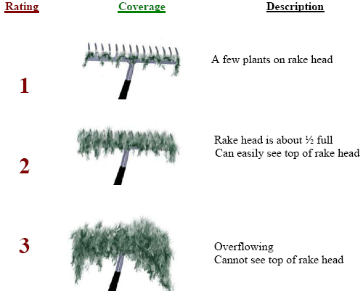
Figure 2: Rake Fullness Ratings (UWEX 2010)

Curly-leaf Pondweed Bed Mapping Survey:
During the bed mapping survey, we searched the lake’s visible littoral zone. By definition, a “bed” was determined to be any area where we visually estimated that CLP made up >50% of the area’s plants, was generally continuous with clearly defined borders, and was canopied, or close enough to being canopied that it would likely interfere with boat traffic. After we located a bed, we motored around the perimeter of the area taking GPS coordinates at regular intervals. We also estimated the rake density range and mean rake fullness of the bed (Figure 2), the maximum depth of the bed, whether it was canopied, and the impact it was likely to have on navigation (none – easily avoidable with a natural channel around or narrow enough to motor through/minor – one prop clear to get through or access open water/moderate – several prop clears needed to navigate through/severe – multiple prop clears and difficult to impossible to row through). These data were then mapped using ArcMap 9.3.1, and we used the WDNR’s Forestry Tools Extension to determine the acreage of each bed to the nearest hundredth of an acre (Table 1).

Warm-water Full Point-intercept Macrophyte Survey:
Prior to beginning the July point-intercept survey, we conducted a general boat survey to regain familiarity with the lake’s macrophytes (Appendix II). All plants found were identified (Voss 1996, Boreman et al. 1997; Chadde 2002; Crow and Hellquist 2009; Skawinski 2014), and a datasheet was built from the species present. We again located each survey point with a GPS, recorded a depth reading with a metered pole rake, and took a rake sample. All plants on the rake, as well as any that were dislodged by the rake, were identified and assigned a rake fullness value of 1-3 as an estimation of abundance (Figure 2). We also recorded visual sightings of all plants within six feet of the sample point not found in the rake. In addition to a rake rating for each species, a total rake fullness value was also noted. Substrate (bottom) type was assigned at each site where the bottom was visible or it could be reliably determined using the rake.

DATA ANALYSIS:
We entered all data collected into the standard APM spreadsheet (Appendix II) (UWEX 2010). From this, we calculated the following:

Total number of sites visited: This included the total number of points on the lake that were accessible to be surveyed by boat.

Total number of sites with vegetation: These included all sites where we found vegetation after doing a rake sample. For example, if 20% of all sample sites have vegetation, it suggests that 20% of the lake has plant coverage.

Total number of sites shallower than the maximum depth of plants: This is the number of sites that are in the littoral zone. Because not all sites that are within the littoral zone actually have vegetation, we use this value to estimate how prevalent vegetation is throughout the littoral zone. For example, if 60% of the sites shallower than the maximum depth of plants have vegetation, then we estimate that 60% of the littoral zone has plants.

Frequency of occurrence: The frequency of all plants (or individual species) is generally reported as a percentage of occurrences within the littoral zone. It can also be reported as a percentage of occurrences at sample points with vegetation.

Frequency of occurrence example:

Plant A is sampled at 70 out of 700 total littoral points = 70/700 = .10 = 10%
This means that Plant A’s frequency of occurrence = 10% when considering the entire
littoral zone.

Plant A is sampled at 70 out of 350 total points with vegetation = 70/350 = .20 = 20%
This means that Plant A’s frequency of occurrence = 20% when only considering the
sites in the littoral zone that have vegetation.

From these frequencies, we can estimate how common each species was at depths
where plants were able to grow, and at points where plants actually were growing.
Note the second value will be greater as not all the points (in this example, only ½)
had plants growing at them.

Simpson’s Diversity Index: A diversity index allows the entire plant community at one location to be compared to the entire plant community at another location. It also allows the plant community at a single location to be compared over time thus allowing a measure of community degradation or restoration at that site. With Simpson’s Diversity Index, the index value represents the probability that two individual plants (randomly selected) will be different species. The index values range from 0 -1 where 0 indicates that all the plants sampled are the same species to 1 where none of the plants sampled are the same species. The greater the index value, the higher the diversity in a given location. Although many natural variables like lake size, depth, dissolved minerals, water clarity, mean temperature, etc. can affect diversity, in general, a more diverse lake indicates a healthier ecosystem. Perhaps most importantly, plant communities with high diversity also tend to be more resistant to invasion by exotic species.

Maximum depth of plants: This indicates the deepest point that vegetation was sampled. In clear lakes, plants may be found at depths of over 20ft, while in stained or turbid locations, they may only be found in a few feet of water. While some species can tolerate very low light conditions, others are only found near the surface. In general, the diversity of the plant community decreases with increased depth.

Mean and median depth of plants: The mean depth of plants indicates the average depth in the water column where plants were sampled. Because a few samples in deep water can skew this data, median depth is also calculated. This tells us that half of the plants sampled were in water shallower than this value, and half were in water deeper than this value.

Number of sites sampled using rope/pole rake: This indicates which rake type was used to take a sample. We use a 20ft pole rake and a 35ft rope rake for sampling.

Average number of species per site: This value is reported using four different considerations. 1) shallower than maximum depth of plants indicates the average number of plant species at all sites in the littoral zone. 2) vegetative sites only indicate the average number of plants at all sites where plants were found. 3) native species shallower than maximum depth of plants and 4) native species at vegetative sites only excludes exotic species from consideration.

Species richness: This value indicates the number of different plant species found in and directly adjacent to (on the waterline) the lake. Species richness alone only counts those plants found in the rake survey. The other two values include those seen at a sample point during the survey but not found in the rake, and those that were only seen during the initial boat survey or inter-point. Note: Per DNR protocol, filamentous algae, freshwater sponges, aquatic moss and the aquatic liverworts Riccia fluitans and Ricciocarpus natans are excluded from these totals.

Average rake fullness: This value is the average rake fullness of all species in the rake. It only takes into account those sites with vegetation (Table 2).

Relative frequency: This value shows a species’ frequency relative to all other species. It is expressed as a percentage, and the total of all species’ relative frequency will add up to 100%. Organizing species from highest to lowest relative frequency value gives us an idea of which species are most important within the macrophyte community (Tables 3 and 4).

Relative frequency example:

Suppose that we sample 100 points and found 5 species of plants with the following results:

Plant A was located at 70 sites. Its frequency of occurrence is thus 70/100 = 70%
Plant B was located at 50 sites. Its frequency of occurrence is thus 50/100 = 50%
Plant C was located at 20 sites. Its frequency of occurrence is thus 20/100 = 20%
Plant D was located at 10 sites. Its frequency of occurrence is thus 10/100 = 10%

To calculate an individual species’ relative frequency, we divide the number of sites a plant is sampled at by the total number of times all plants were sampled. In our example that would be 150 samples (70+50+20+10).

Plant A = 70/150 = .4667 or 46.67%
Plant B = 50/150 = .3333 or 33.33%
Plant C = 20/150 = .1333 or 13.33%
Plant D = 10/150 = .0667 or 6.67%

This value tells us that 46.67% of all plants sampled were Plant A.

Floristic Quality Index (FQI): This index measures the impact of human development on a lake’s aquatic plants. The 124 species in the index are assigned a Coefficient of Conservatism (C) which ranges from 1-10. The higher the value assigned, the more likely the plant is to be negatively impacted by human activities relating to water quality or habitat modifications. Plants with low values are tolerant of human habitat modifications, and they often exploit these changes to the point where they may crowd out other species. The FQI is calculated by averaging the conservatism value for each native index species found in the lake during the point-intercept survey**, and multiplying it by the square root of the total number of plant species (N) in the lake (FQI=(Σ(c1+c2+c3+…cn)/N)*√N). Statistically speaking, the higher the index value, the healthier the lake’s macrophyte community is assumed to be. Nichols (1999) identified four eco-regions in Wisconsin: Northern Lakes and Forests, North Central Hardwood Forests, Driftless Area and Southeastern Wisconsin Till Plain. He recommended making comparisons of lakes within ecoregions to determine the target lake’s relative diversity and health. Granite Lake is in the North Central Hardwood Forests Ecoregion (Tables 5 and 6).

** Species that were only recorded as visuals or during the boat survey, and species found in the rake that are not included in the index are excluded from FQI analysis.

Comparison to Past Surveys: We compared data from our 2009 and 2018 CLP point-intercept surveys (Figure 4) and warm-water point-intercept surveys (Figure 11) (Tables 3 and 4) to see if there were any significant changes in the lake’s vegetation. For individual plant species as well as count data, we used the Chi-square analysis on the WDNR Pre/Post survey worksheet. For comparing averages (mean species/point and mean rake fullness/point), we used t-tests. Differences were considered significant at p<0.05, moderately significant at p<0.01 and highly significant at p<0.001 (UWEX 2010). It should be noted that we used the number of littoral points with plants (61 in both 2009 and 2018) as the basis for “sample points”.

RESULTS:
Curly-leaf Pondweed Point-intercept Survey:
We rake sampled every point in the lake <13ft during the 2018 early-season point-intercept survey. We didn’t find Curly-leaf pondweed at any point, but did find and remove a single plant in 4ft of water on the west shoreline of the south bay. This was similar to 2009 when we found CLP at a single point (0.2% coverage) along the east shoreline of the south bay (Figure 3) (Appendix III). Ultimately, the low number of plants found didn’t allow for statistical comparison (Figure 4).

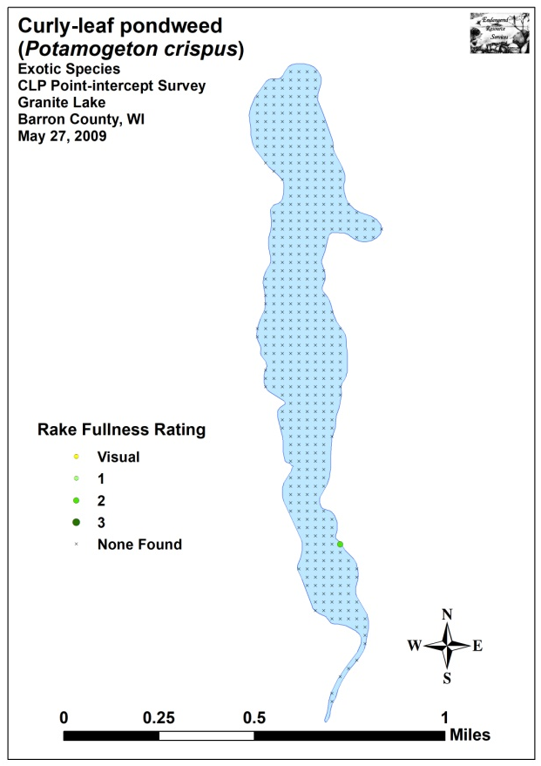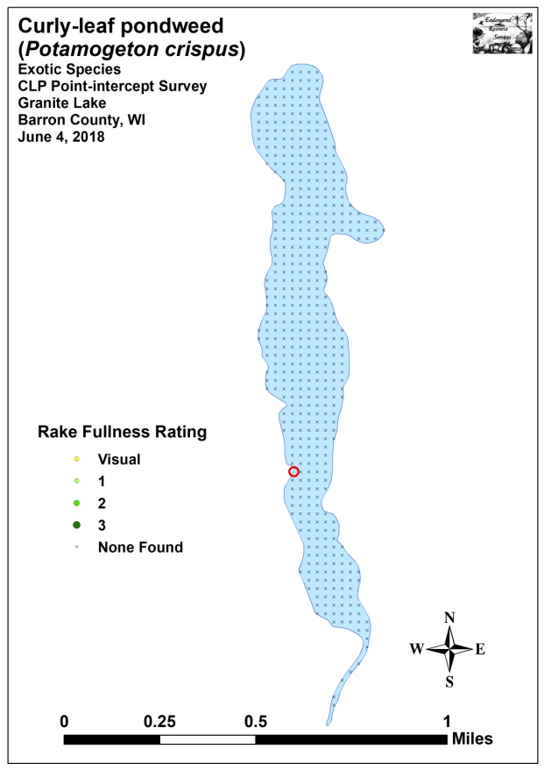
Figure 3: 2009 and 2018 Early-season Curly-leaf Pondweed
Density and Distribution

Significant differences = * p<0.05, ** p<0.01, *** p<0.001
Figure 4: 2009 and 2018 Changes in Early-season CLP Rake Fullness

Curly-leaf Pondweed Bed Mapping Survey:
On June 12th, we returned to the lake to look for any Curly-leaf pondweed that may have canopied since the point-intercept survey. Although we searched over 6.7km (4.2 miles), we only found 16 additional plants all of which we rake removed. These individuals were all located along the eastern shoreline of the south bay (Figure 5) (Appendix III). Neither of the two clusters of plants was a true bed, and we hesitated to even call them “high density areas”. However, we ultimately decided to map the areas so there would be some way to compare with any future surveys that might occur. The combined acreage of these two areas totaled just 0.08 acre and suggested <0.01% of the lake had any CLP at all (Table 1).

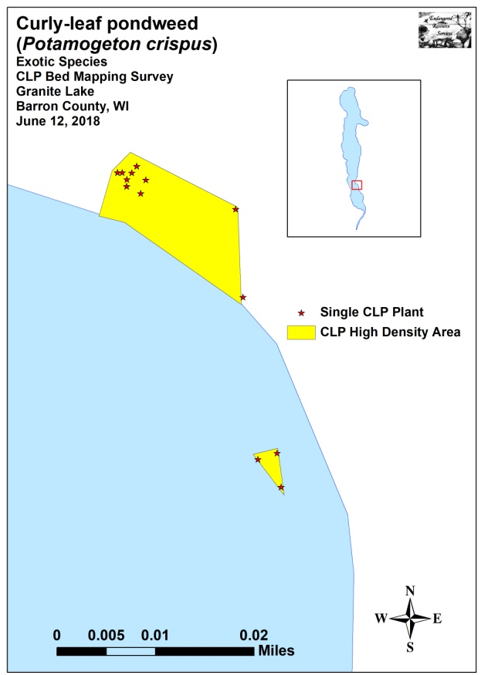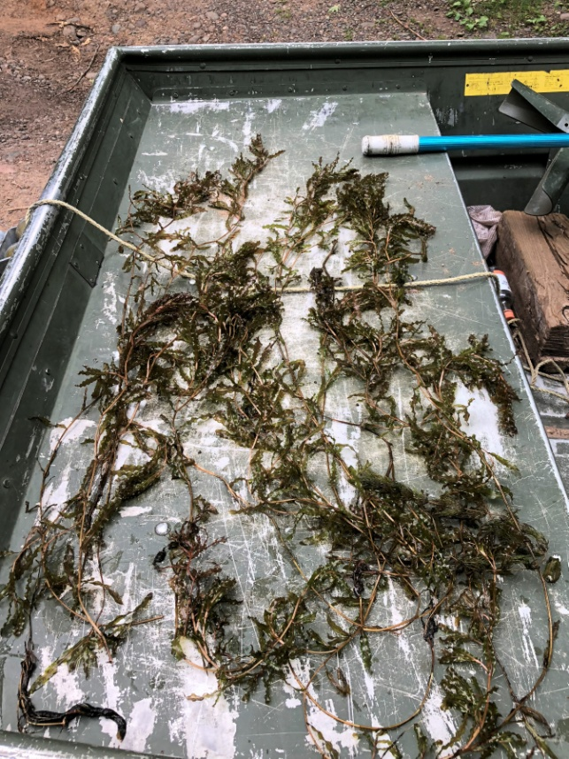
Figure 5: 2018 Early-season Curly-leaf Pondweed High Density Areas and Rake Removed CLP – 6/12/18

Descriptions of Curly-leaf Pondweed High Density Areas:
HDA 1 – A small cluster of Curly-leaf pondweed occurred due east of a dock in an area where the bottom appeared to have been disturbed by watercraft. Almost all plants were scattered among native vegetation, and, although they were nearly canopied, their density was so low that there was no concern with navigation impairment.

HDA 2 – This area was near the end of a boat house and amounted to little more than three mature plants. We noted there were no navigational issues in the area from native or exotic species.

Table 1: Curly-leaf Pondweed Bed Mapping Summary
Granite Lake, Barron County – June 12, 2018

High Density Area Number | 2018 Acreage | Rake Range; Mean Rake | Depth Range; Mean Depth | Potential Navigation Impairment  Level
1 | 0.07 | <<<1-2; <<1 | 2-5; 3 | None
2 | <0.01 | <<<1-1; <<<1 | 3-5; 3 | None
Total Acres | 0.08

Warm-water Full Point-intercept Macrophyte Survey:
Depth readings taken at the lake’s 505 survey points (Appendix I) revealed Granite Lake is a classic narrow glacial “straight lake” running north/south. Both the east and west sides of the main basin have sharp drop-offs into 20ft+ of water, while the north and south ends slope more gradually into deeper water. The lake’s only side bay on the eastern shoreline also drops off rapidly from shore and empties into the deepest point in the lake (Figure 6) (Appendix IV).

Of the 262 points that were shallow enough to take a rake sample, we characterized the lake’s substrate as 44.3% organic and sandy muck (116 points), 35.1% pure sand (92 points), and 20.6% gravel and rock (54 points). Thick nutrient-rich organic muck was most common in the immediate inlet and outlet areas of the north and south bays, while thinner and sandier muck dominated the rest of the bays. Along the immediate shoreline, especially in the central basin, most substrates were pure sand, gravel, or cobble (Figure 6) (Appendix IV).

In July 2018, we found plants growing to 10.0ft (Table 2). The total of 61 points with vegetation (approximately 12.1% of the entire lake bottom and 53.5% of the littoral zone) was identical to the 2009 survey (12.1% of the bottom/34.1% of the then 13.0ft littoral zone) (Figure 7) (Appendix V). Growth in 2018 was slightly skewed to deep water as the mean plant depth of 4.2ft was more than the median depth of 4.0ft. Both of these values were higher than in 2009 when the mean was 3.8ft and the median was 3.5ft (Figure 8).

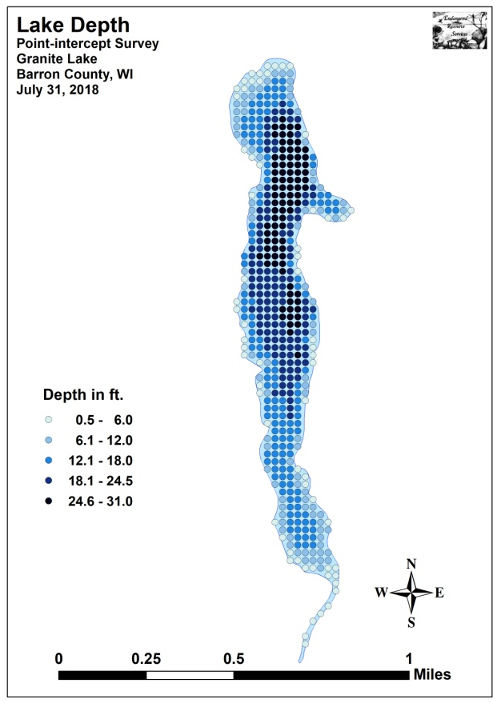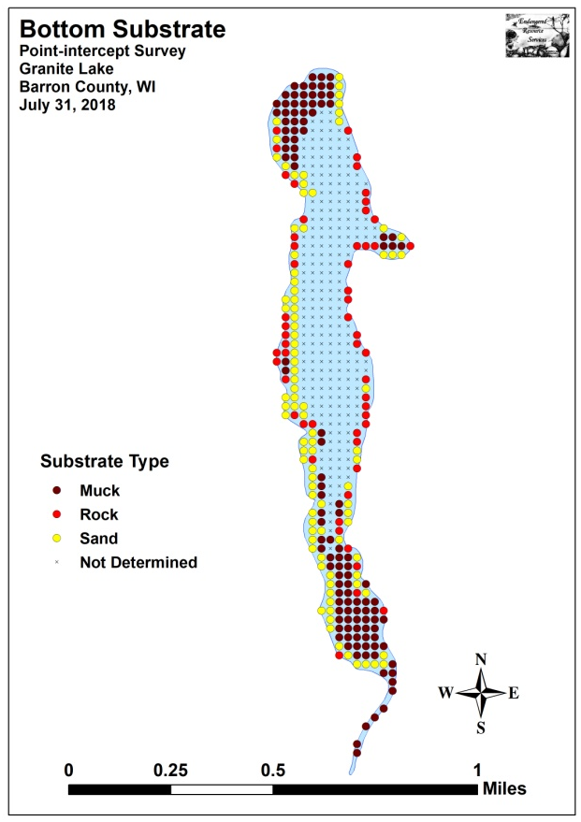
Figure 6: Lake Depth and Bottom Substrate

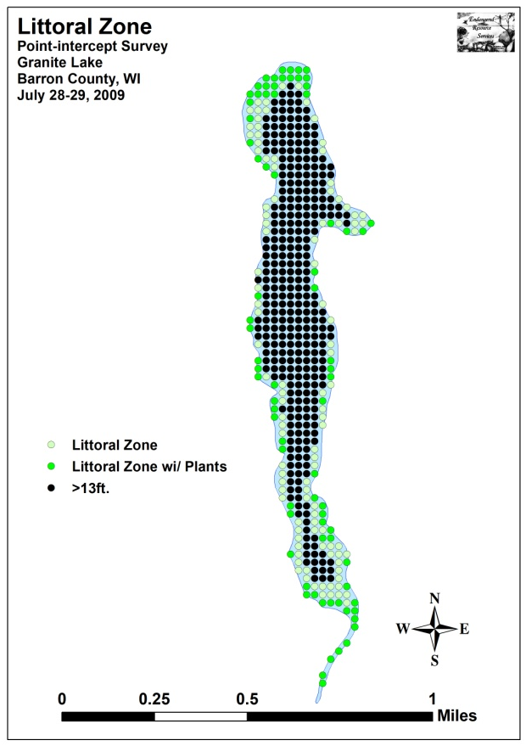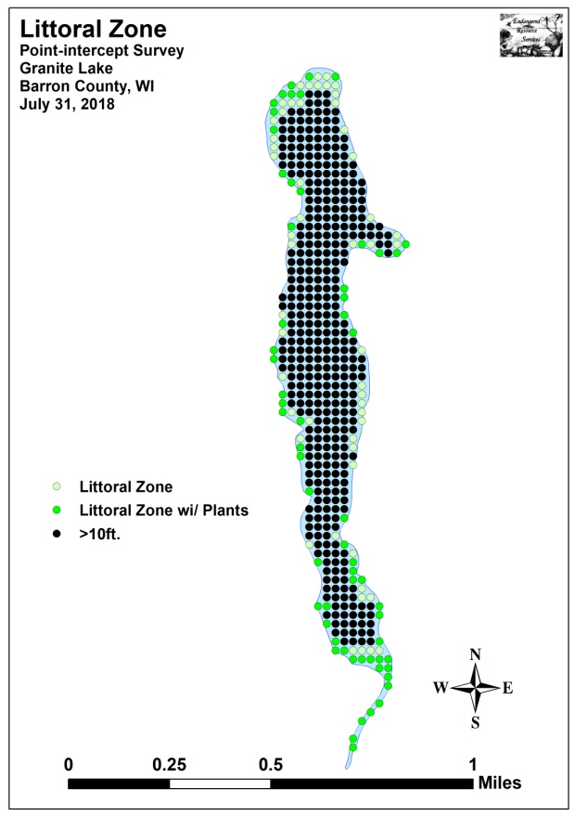
Figure 7: 2009 and 2018 Littoral Zone

Figure 8: 2009 and 2018 Plant Colonization Depth Chart
Table 2: Aquatic Macrophyte P/I Survey Summary Statistics
Granite Lake, Barron County
July 28-29, 2009 and July 31, 2018

Summary Statistics: | 2009 | 2018
Total number of points sampled | 505 | 505
Total number of sites with vegetation | 61 | 61
Total number of sites shallower than the maximum depth of plants | 179 | 114
Frequency of occurrence at sites shallower than maximum depth of plants | 34.1 | 53.5
Simpson Diversity Index | 0.88 | 0.89
Maximum depth of plants (ft) | 13.0 | 10.0
Mean depth of plants (ft) | 3.8 | 4.2
Median depth of plants (ft) | 3.5 | 4.0
Average number of all species per site (shallower than max depth) | 0.71 | 1.27
Average number of all species per site (veg. sites only) | 2.08 | 2.38
Average number of native species per site (shallower than max depth) | 0.69 | 1.27
Average number of native species per site (sites with native veg. only) | 2.03 | 2.38
Species richness | 24 | 22
Species richness (including visuals) | 25 | 28
Species richness (including visuals and boat survey) | 34 | 38
Mean rake fullness (veg. sites only) | Est. 2.02 | 1.69

Plant diversity was moderately high in 2018 with a Simpson Index value of 0.89 – up slightly from 0.88 in 2009. However, total richness was low with just 22 species found in the rake (down from 24 in 2009). This total increased to 38 species when including visuals and plants seen during the boat survey (up from the 34 total species we documented in 2009). Mean native species richness at sites with native vegetation saw a non-significant increase (p=0.10) from 2.03 species/site in 2009 to 2.38/site in 2018 (Figure 9) (Appendix V).

Total rake fullness experienced a significant decline (p=0.01) from a moderate 2.02 (est.) in 2009 to a low/moderate 1.69 in 2018. However, due to a change in the methodology for how rake fullness is calculated since the original survey, we were forced to go back and remove filamentous algae from the rake fullness totals in the 2009 data. Because of this, the mean rake fullness of 2.02 should be viewed as an estimate of the true rake fullness, and the significant decline should be viewed as informative rather than definitive (Figure 10) (Appendix V).

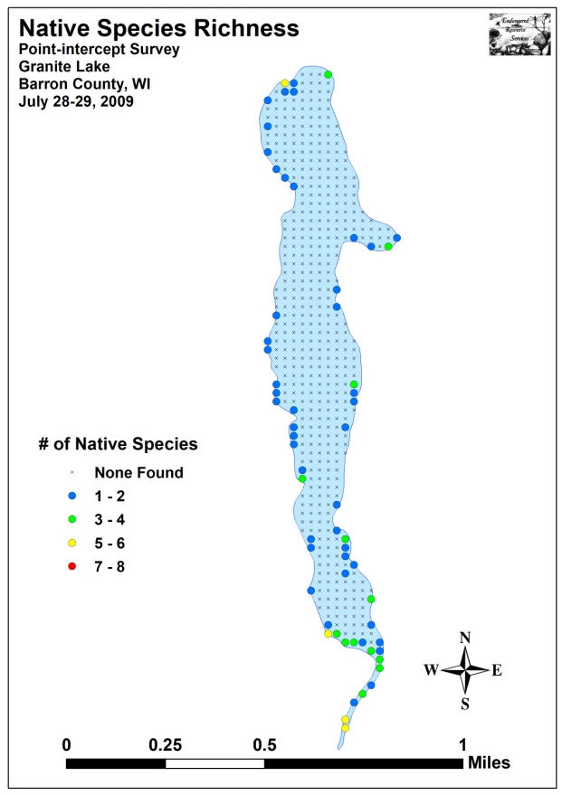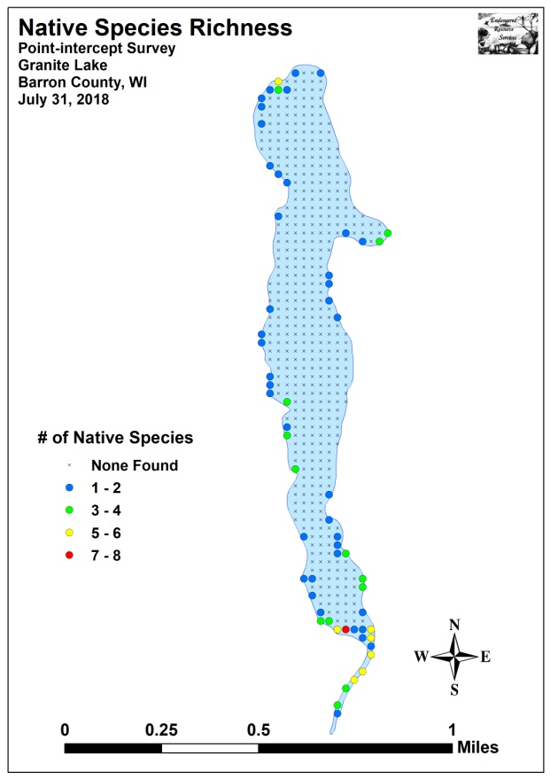
Figure 9: 2009 and 2018 Native Species Richness

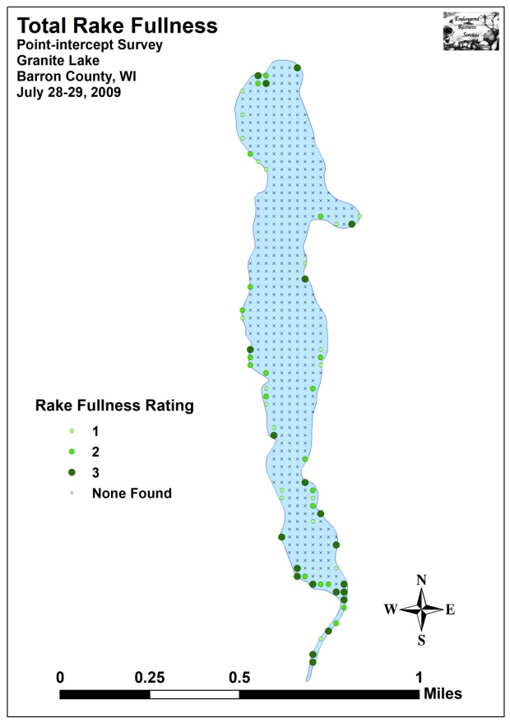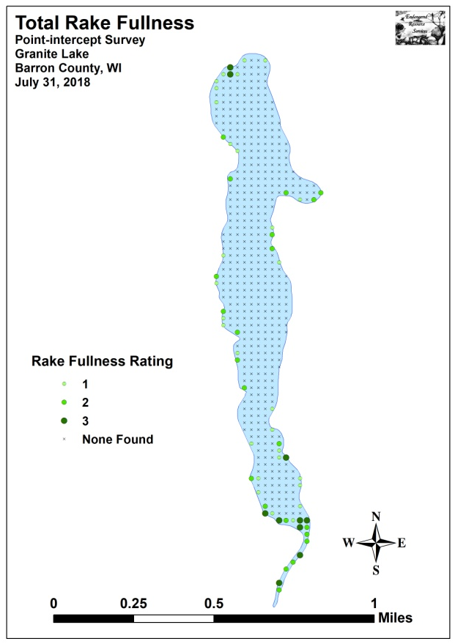
Figure 10: 2009 and 2018 Total Rake Fullness

Granite Lake Plant Community:
The Granite Lake ecosystem is home to a very limited plant community that is typical of moderate-nutrient lakes with fair to poor water clarity. This community can be subdivided into four distinct zones (emergent, shallow submergent, floating-leaf, and deep submergent) with each zone having its own characteristic functions in the aquatic ecosystem. Depending on the local bottom type (sand, rock, sandy muck or nutrient-rich organic muck), these zones often had somewhat different species present.

In shallow areas, beds of emergent plants prevent erosion by stabilizing the lakeshore, break up wave action, provide a nursery for baitfish and juvenile gamefish, offer shelter for amphibians, and give waterfowl and predatory wading birds like herons a place to hunt. These areas also provide important habitat for invertebrates like dragonflies and mayflies.

On exposed sandy and rocky areas at the shoreline, we found scattered patches of River bulrush (Bolboschoenus fluviatilis), Path rush (Juncus tenuis), Purple loosestrife (Lythrum salicaria), Common forget-me-not (Myosotis scorpioides), Reed canary grass (Phalaris arundinacea), and Black bulrush (Scirpus atrovirens). On the margins of the lake’s bays in areas with more organic muck, these species were replaced by Common arrowhead (Sagittaria latifolia), Sessile-fruited arrowhead (Sagittaria rigida), Softstem bulrush (Schoenoplectus tabernaemontani), and Broad-leaved cattail (Typha latifolia). In shallow gravel and sandy areas, we also found a few small beds of sedges (Carex spp.), Water horsetail (Equisetum fluviatile), Pickerelweed (Pontederia cordata), Hardstem bulrush (Schoenoplectus acutus), and Common bur-reed (Sparganium eurycarpum).

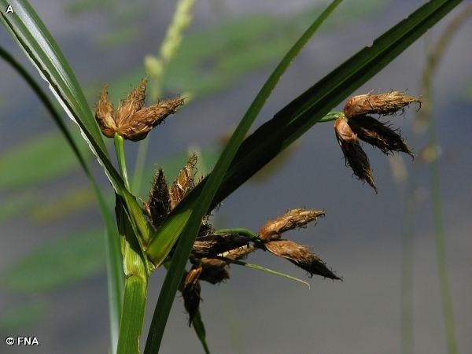
River bulrush (Ratzlaff 2008) Common forget-me-not (Raymond 2011)

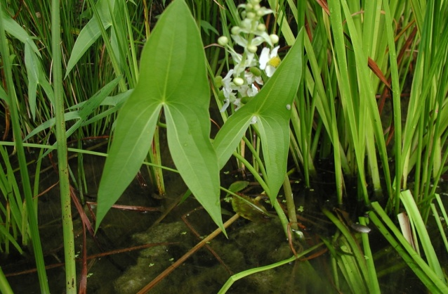
Common arrowhead (Young 2006) Softstem bulrush (Schwarz 2011)
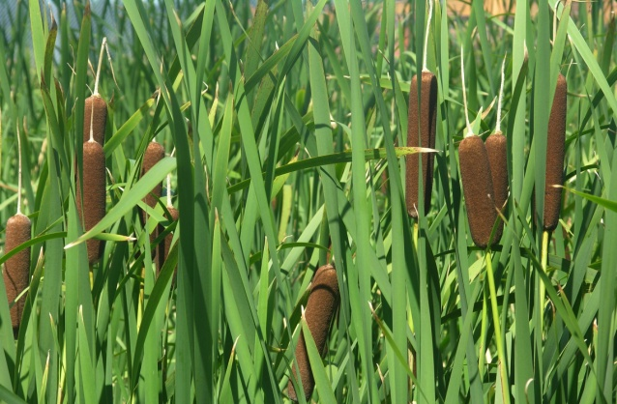
Broad-leaved cattail (Raymond 2011) Common yellow lake sedge (Lavin 2011)

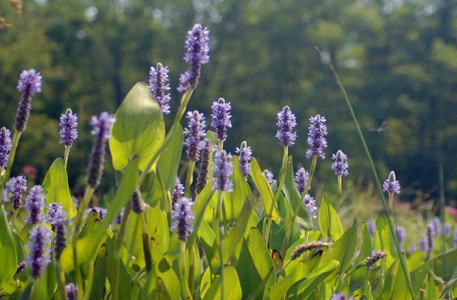
Water horsetail (Elliot 2007) Pickerelweed (Texas A&M 2012)

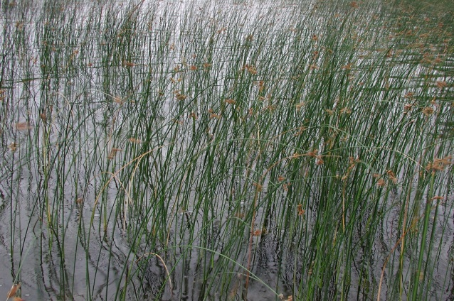
Hardstem bulrush (Per 2002) Common bur-reed (Raymond 2011)

Just beyond the emergents, in sheltered muck-bottomed areas in up to 4ft of water, the floating-leaf species Spatterdock (Nuphar variegata) and White-water lily (Nymphaea odorata) were scattered throughout the lake. We also found a limited number of Large-leaf pondweed (Potamogeton amplifolius), Floating-leaf pondweed (Potamogeton natans), Spiral-fruited pondweed (Potamogeton spirillus), and Vasey’s pondweed (Potamogeton vaseyi). The canopy cover these species provides is often utilized by panfish and bass for protection.

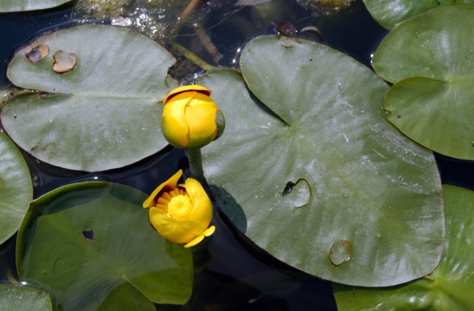
White water lily (Falkner 2009) Spatterdock (CBG 2014)

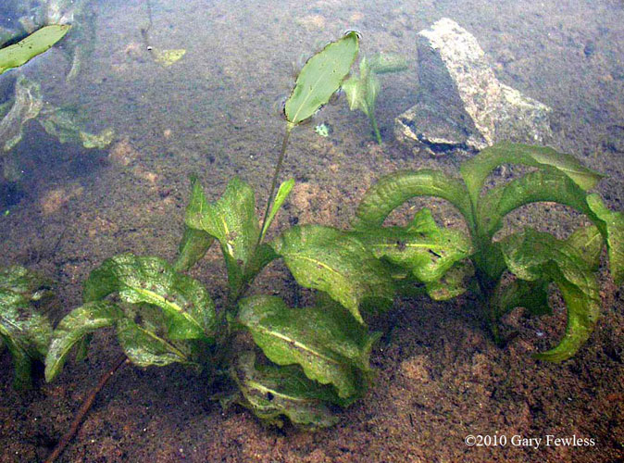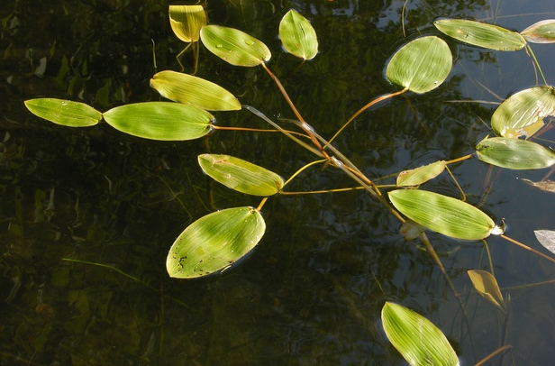
Large-leaf pondweed (Fewless 2010) Floating-leaf pondweed (Sein 2013)

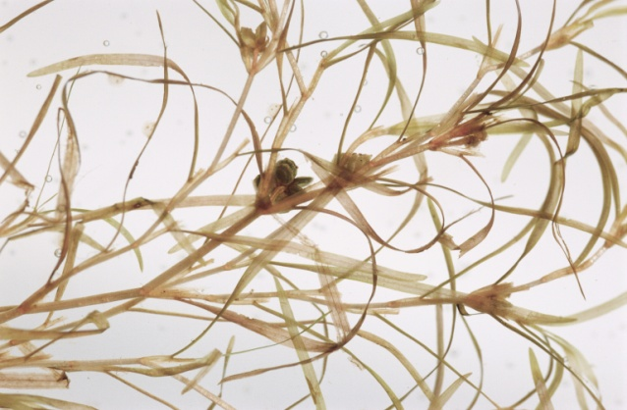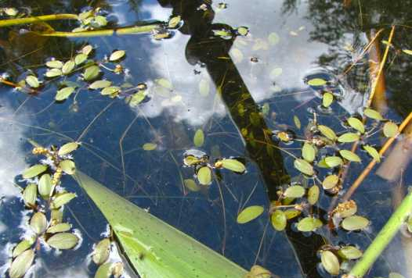
Spiral-fruited pondweed (Koshere 2002) Vasey’s pondweed (Skawinski 2010)

Growing amongst the floating-leaf species, we also encountered the submergent species Coontail (Ceratophyllum demersum), Common waterweed (Elodea canadensis), Leafy pondweed (Potamogeton foliosus), Blunt-leaf pondweed (Potamogeton obtusifolius), and Small pondweed (Potamogeton pusillus).

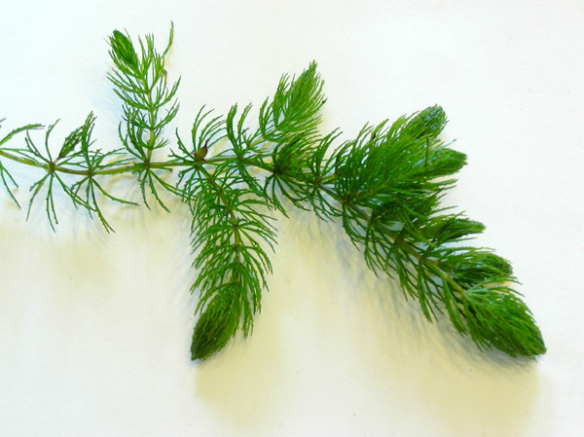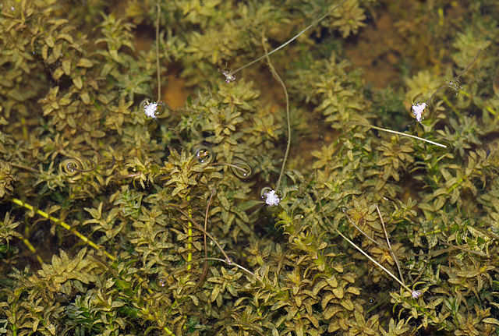
Coontail (Hassler 2011) Common waterweed (Fischer 2009)

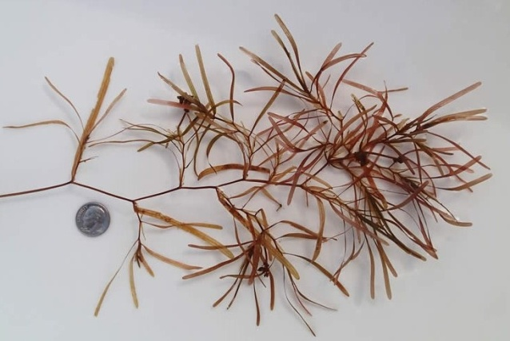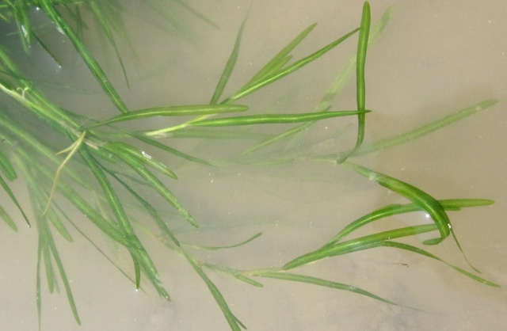
Blunt-leaf pondweed (Djuik 2013) Small pondweed (Villa 2011)

In addition to these plants, we found scattered “duckweeds” floating among the lilypads and emergents. They including Large duckweed (Spirodela polyrhiza), Small duckweed (Lemna minor), and Common watermeal (Wolffia columbiana).

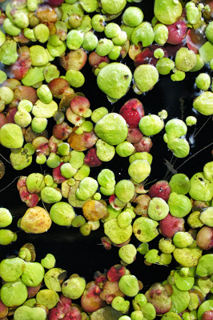
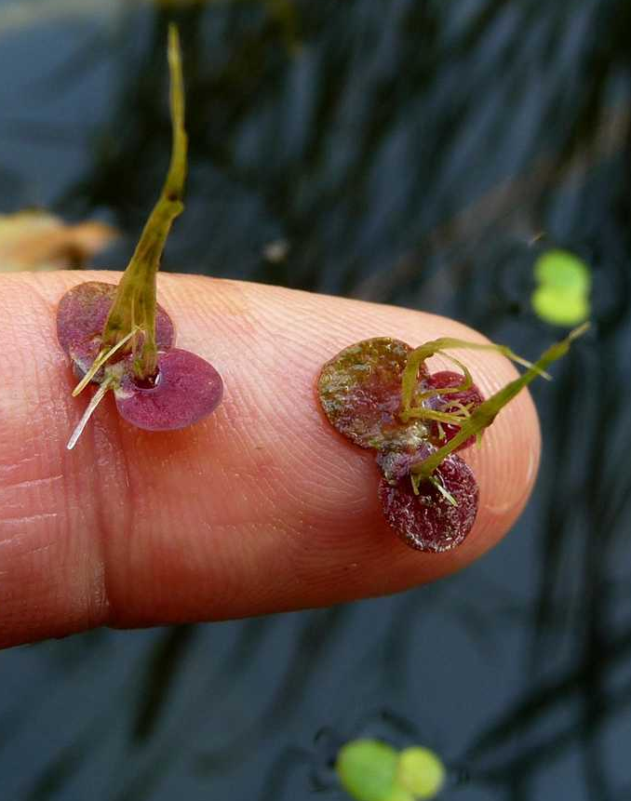
Small duckweed and Common watermeal (Kieron 2009) Large duckweed (Thomas 2018)

Near the outlet, we also found a few Common bladderworts (Utricularia vulgaris). Rather than drawing nutrients up through roots like other plants, bladderworts trap zooplankton and minute insects in their bladders, digest their prey, and use the nutrients to further their growth.

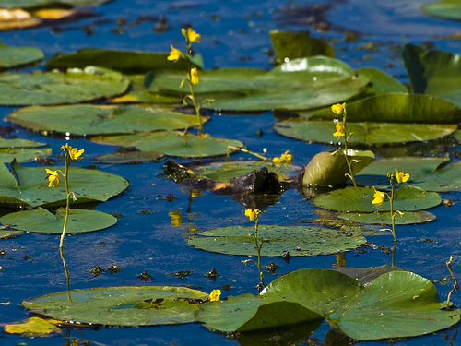
Common bladderwort flowers among lilypads (Hunt 2010) Bladders for catching plankton and insect larvae (Wontolla 2007)

Shallow rocky and sandy areas were almost entirely devoid of plants, and, even when present, these nutrient-poor substrates tended to have low total biomass as they provide habitat most suited to fine-leaved species. Growing in this environment, in water from 2-5ft deep, we found limited numbers of Muskgrass (Chara sp.), Water star-grass (Heteranthera dubia), Slender naiad (Najas flexilis), and Crested arrowhead (Sagittaria cristata). The roots, shoots, and seeds of these plants are heavily utilized by waterfowl for food. They also provide important habitat for the lake’s fish throughout their lifecycles, as well as a myriad of invertebrates like scuds, dragonfly and mayfly nymphs, and snails.

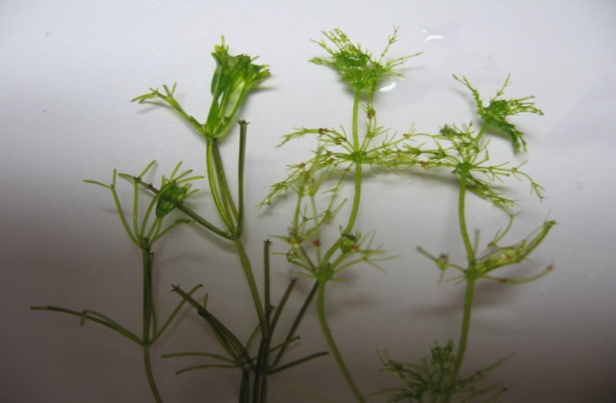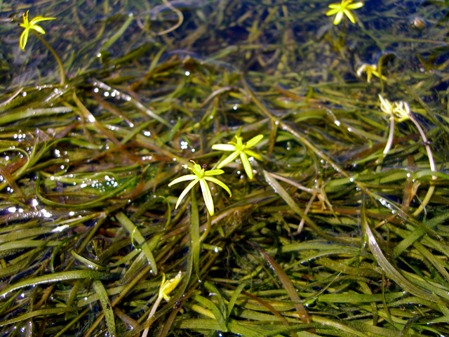
Muskgrass (Penuh 2008) Water star-grass (Mueller 2009)

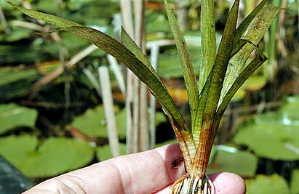
Slender naiad (Apipp 2009) Crested arrowhead (Fewless 2004)

Organic muck areas in water greater than 5ft were dominated by Large-leaf pondweed. We also found scattered patches of Coontail, Common waterweed, Small pondweed, Fern pondweed (Potamogeton robbinsii), Flat-stem pondweed (Potamogeton zosteriformis), and, in the early spring, Curly-leaf pondweed. Predatory fish like the lake’s pike are often found along the edges of these deep beds waiting in ambush.

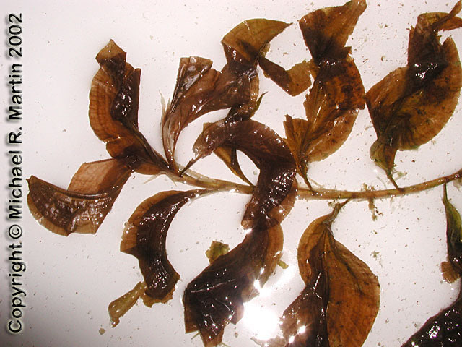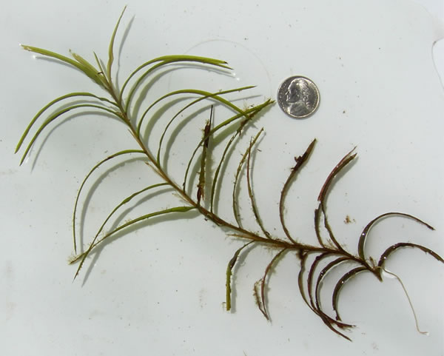
Large-leaf pondweed (Martin 2002) Fern pondweed (Apipp 2011)

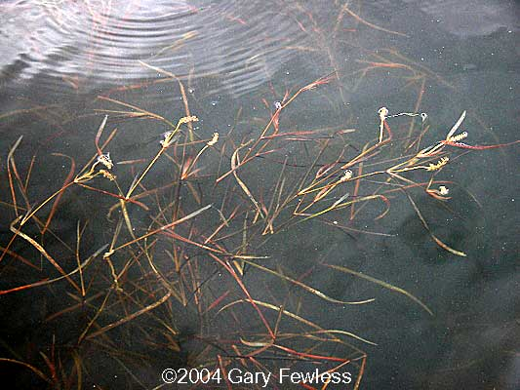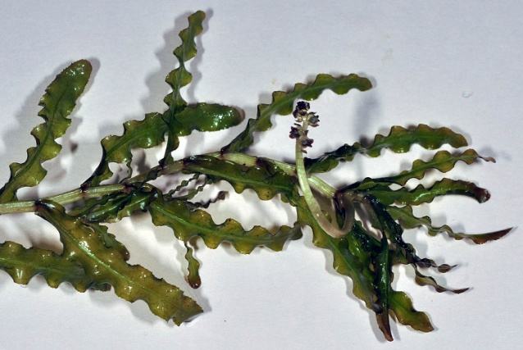
Flat-stem pondweed (Fewless 2004) Curly-leaf pondweed (USGS 2018)

Comparison of Native Macrophyte Species in 2009 and 2018:
In July 2009, Slender naiad, Coontail, Spatterdock, and Common waterweed were the most common macrophyte species (Table 3). They were present at 50.82%, 37.70%, 19.67%, and 18.03% of survey points with vegetation respectively and accounted for 60.63% of the total relative frequency. Large-leaf pondweed (5.51%) and Small pondweed (4.72%) also had relative frequencies over 4.0% (Maps for all species found in July 2009 are located in Appendix VI).

In 2018, Slender naiad, Coontail, Small duckweed, and Muskgrass were the most common macrophytes. We found them at 55.74%, 40.98%, 19.67%, and 14.75% of sites with vegetation (Table 4), and they captured 55.17% of the total relative frequency. Common waterweed (5.52%), Spatterdock (5.52%), Large-leaf pondweed (4.83%), Water star-grass (4.14), White water lily (4.14), and Spiral-fruited pondweed (4.14%) also had relative frequencies over 4.0% (Species accounts for all macrophytes found in 2009 and 2018, and maps for all plants found in July 2018 can be found in Appendixes VII and VIII).

Lakewide, three species showed significant changes in distribution from 2009 to 2018 (Figure 11). Filamentous algae experienced a moderately significant increase; and Small duckweed and Vasey’s pondweed saw significant increases.
+*
+**
+*
Significant differences = * p<0.05, ** p<0.01, *** p<0.001
Figure 11: Macrophyte Changes from 2009-2018

Table 3: Frequencies and Mean Rake Sample of Aquatic Macrophytes
Granite Lake, Barron County
July 28-29, 2009

Species | Common Name | Total  Sites | Relative Freq. | Freq. in Veg. | Freq. in Lit. | Mean Rake | Visual  Sight.
Najas flexilis | Slender naiad | 31 | 24.41 | 50.82 | 17.32 | 1.55 | 0
 | Filamentous algae | 30 | * | 49.18 | 16.76 | 1.93 | 0
Ceratophyllum demersum | Coontail | 23 | 18.11 | 37.70 | 12.85 | 1.83 | 0
Nuphar variegata | Spatterdock | 12 | 9.45 | 19.67 | 6.70 | 2.50 | 6
Elodea canadensis | Common waterweed | 11 | 8.66 | 18.03 | 6.15 | 1.91 | 0
Potamogeton amplifolius | Large-leaf pondweed | 7 | 5.51 | 11.48 | 3.91 | 1.57 | 2
Potamogeton pusillus | Small pondweed | 6 | 4.72 | 9.84 | 3.35 | 1.17 | 0
Chara sp. | Muskgrass | 4 | 3.15 | 6.56 | 2.23 | 1.25 | 0
Nymphaea odorata | White water lily | 4 | 3.15 | 6.56 | 2.23 | 1.25 | 4
Potamogeton natans | Floating-leaf pondweed | 4 | 3.15 | 6.56 | 2.23 | 1.50 | 0
Lemna minor | Small duckweed | 3 | 2.36 | 4.92 | 1.68 | 1.00 | 0
Pontederia cordata | Pickerelweed | 3 | 2.36 | 4.92 | 1.68 | 1.33 | 3
Potamogeton epihydrus | Ribbon-leaf pondweed | 3 | 2.36 | 4.92 | 1.68 | 2.33 | 1
Potamogeton zosteriformis | Flat-stem pondweed | 3 | 2.36 | 4.92 | 1.68 | 2.00 | 0
Potamogeton crispus | Curly-leaf pondweed | 2 | 1.57 | 3.28 | 1.12 | 1.00 | 0
Schoenoplectus acutus | Hardstem bulrush | 2 | 1.57 | 3.28 | 1.12 | 2.50 | 0
Equisetum fluviatile | Water horsetail | 1 | 0.79 | 1.64 | 0.56 | 2.00 | 0
Heteranthera dubia | Water star-grass | 1 | 0.79 | 1.64 | 0.56 | 1.00 | 1
Phalaris arundinacea | Reed canary grass | 1 | 0.79 | 1.64 | 0.56 | 2.00 | 4
Potamogeton foliosus | Leafy pondweed | 1 | 0.79 | 1.64 | 0.56 | 1.00 | 0
Potamogeton obtusifolius | Blunt-leaf pondweed | 1 | 0.79 | 1.64 | 0.56 | 1.00 | 1
Potamogeton spirillus | Spiral-fruited pondweed | 1 | 0.79 | 1.64 | 0.56 | 2.00 | 2
Sagittaria rigida | Sessile-fruited arrowhead | 1 | 0.79 | 1.64 | 0.56 | 1.00 | 1
Schoenoplectus tabernaemontani | Softstem bulrush | 1 | 0.79 | 1.64 | 0.56 | 2.00 | 0
Spirodela polyrhiza | Large duckweed | 1 | 0.79 | 1.64 | 0.56 | 1.00 | 0

* Excluded from relative frequency analysis
Table 3 (cont’): Frequencies and Mean Rake Sample of Aquatic Macrophytes
Granite Lake, Barron County
July 28-29, 2009

Species | Common Name | Total  Sites | Relative Freq. | Freq. in Veg. | Freq. in Lit. | Mean Rake | Visual  Sight.
Carex lacustris | Lake sedge | ** | ** | ** | ** | ** | 1
Bolboschoenus fluviatilis | River bulrush | *** | *** | *** | *** | *** | ***
Dulichium arundinaceum | Three-way sedge | *** | *** | *** | *** | *** | ***
Juncus tenuis | Path rush | *** | *** | *** | *** | *** | ***
Lythrum salicaria | Purple loosestrife | *** | *** | *** | *** | *** | ***
Sagittaria cristata | Crested arrowhead | *** | *** | *** | *** | *** | ***
Sagittaria latifolia | Common arrowhead | *** | *** | *** | *** | *** | ***
Scirpus atrovirens | Black bulrush | *** | *** | *** | *** | *** | ***
Sparganium eurycarpum | Common bur-reed | *** | *** | *** | *** | *** | ***
Typha latifolia | Broad-leaved cattail | *** | *** | *** | *** | *** | ***

** Visual only *** Boat survey only

Table 4: Frequencies and Mean Rake Sample of Aquatic Macrophytes
Granite Lake, Barron County
July 31, 2018

Species | Common Name | Total  Sites | Relative Freq. | Freq. in Veg. | Freq. in Lit. | Mean Rake | Visual  Sight.
 | Filamentous algae | 44 | * | 72.13 | 38.60 | 1.36 | 0
Najas flexilis | Slender naiad | 34 | 23.45 | 55.74 | 29.82 | 1.38 | 1
Ceratophyllum demersum | Coontail | 25 | 17.24 | 40.98 | 21.93 | 1.40 | 3
Lemna minor | Small duckweed | 12 | 8.28 | 19.67 | 10.53 | 1.00 | 1
Chara sp. | Muskgrass | 9 | 6.21 | 14.75 | 7.89 | 1.00 | 0
Elodea canadensis | Common waterweed | 8 | 5.52 | 13.11 | 7.02 | 1.50 | 3
Nuphar variegata | Spatterdock | 8 | 5.52 | 13.11 | 7.02 | 2.13 | 6
Potamogeton amplifolius | Large-leaf pondweed | 7 | 4.83 | 11.48 | 6.14 | 1.29 | 7
Heteranthera dubia | Water star-grass | 6 | 4.14 | 9.84 | 5.26 | 1.33 | 3
Nymphaea odorata | White water lily | 6 | 4.14 | 9.84 | 5.26 | 2.00 | 7
Potamogeton spirillus | Spiral-fruited pondweed | 6 | 4.14 | 9.84 | 5.26 | 1.00 | 5
Potamogeton pusillus | Small pondweed | 5 | 3.45 | 8.20 | 4.39 | 1.00 | 0
Potamogeton vaseyi | Vasey's pondweed | 5 | 3.45 | 8.20 | 4.39 | 1.80 | 2
Potamogeton obtusifolius | Blunt-leaf pondweed | 4 | 2.76 | 6.56 | 3.51 | 1.25 | 4
Equisetum fluviatile | Water horsetail | 2 | 1.38 | 3.28 | 1.75 | 1.00 | 0
Pontederia cordata | Pickerelweed | 1 | 0.69 | 1.64 | 0.88 | 3.00 | 5
Potamogeton foliosus | Leafy pondweed | 1 | 0.69 | 1.64 | 0.88 | 2.00 | 2
Potamogeton natans | Floating-leaf pondweed | 1 | 0.69 | 1.64 | 0.88 | 2.00 | 0
Potamogeton robbinsii | Fern pondweed | 1 | 0.69 | 1.64 | 0.88 | 1.00 | 3
Potamogeton zosteriformis | Flat-stem pondweed | 1 | 0.69 | 1.64 | 0.88 | 1.00 | 7
Schoenoplectus acutus | Hardstem bulrush | 1 | 0.69 | 1.64 | 0.88 | 1.00 | 0
Spirodela polyrhiza | Large duckweed | 1 | 0.69 | 1.64 | 0.88 | 1.00 | 0
Wolffia columbiana | Common watermeal | 1 | 0.69 | 1.64 | 0.88 | 1.00 | 0

*Excluded from relative frequency analysis
Table 4 (cont’): Frequencies and Mean Rake Sample of Aquatic Macrophytes
Granite Lake, Barron County
July 31, 2018

Species | Common Name | Total  Sites | Relative Freq. | Freq. in Veg. | Freq. in Lit. | Mean Rake | Visual  Sight.
Carex lacustris | Lake sedge | ** | ** | ** | ** | ** | 1
Carex utriculata | Common yellow lake sedge | ** | ** | ** | ** | ** | 1
Myosotis scorpioides | Common forget-me-not | ** | ** | ** | ** | ** | 1
Phalaris arundinacea | Reed canary grass | ** | ** | ** | ** | ** | 1
Schoenoplectus tabernaemontani | Softstem bulrush | ** | ** | ** | ** | ** | 2
Utricularia vulgaris | Common bladderwort | ** | ** | ** | ** | ** | 1
Bolboschoenus fluviatilis | River bulrush | *** | *** | *** | *** | *** | ***
Dulichium arundinaceum | Three-way sedge | *** | *** | *** | *** | *** | ***
Juncus tenuis | Path rush | *** | *** | *** | *** | *** | ***
Lythrum salicaria | Purple loosestrife | *** | *** | *** | *** | *** | ***
Potamogeton crispus | Curly-leaf pondweed | *** | *** | *** | *** | *** | ***
Sagittaria cristata | Crested arrowhead | *** | *** | *** | *** | *** | ***
Sagittaria latifolia | Common arrowhead | *** | *** | *** | *** | *** | ***
Scirpus atrovirens | Black bulrush | *** | *** | *** | *** | *** | ***
Sparganium eurycarpum | Common bur-reed | *** | *** | *** | *** | *** | ***
Typha latifolia | Broad-leaved cattail | *** | *** | *** | *** | *** | ***

** Visual only *** Boat survey only

Found throughout the lake’s nearshore environment, Slender naiad was the most common species in both 2009 and 2018. Neither its increase in overall distribution (31 points in 2009/34 in 2018), nor its decline in density (mean rake fullness of 1.55 in 2009/1.38 in 2018) were statistically significant (p=0.59/p=0.12) (Figure 12).

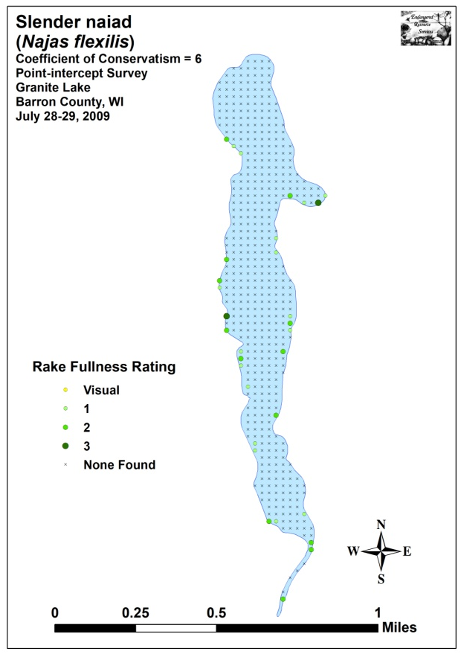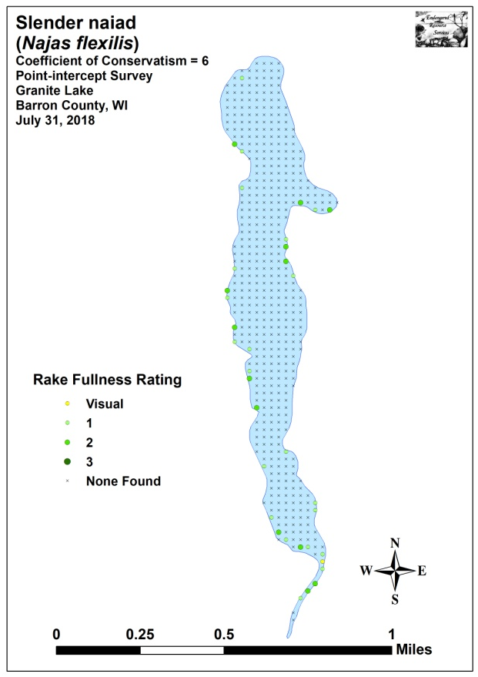
Figure 12: 2009 and 2018 Slender Naiad Density and Distribution

Coontail was the second most common species during each survey. Although its total distribution (23 sites in 2009/25 in 2018) was essentially unchanged, its density (mean rake fullness of 1.83 in 2009/1.40 in 2018) experienced a significant decline (p=0.02). This loss was especially evident in the south bay and in the outlet channel (Figure 13).

Spatterdock, the dominant floating-leaf species, was the third most common plant in 2009 (12 sites) and the fifth most common in 2018 (eight sites). Neither the decrease in distribution, nor the accompanying decline in density from a mean rake of 2.50 in 2009 to a mean of 2.13 in 2018 were significant (p=0.33/p=0.14) (Figure 14).

We found Common waterweed (fourth most common species) throughout the lake in 2009 (11 sites/mean rake of 1.91), and it was especially dense over organic substrates in the north and south bays. Surprisingly, in 2018, we found no evidence of this species in the north bay, and it declined to a fifth place tie in the community rank (eight sites/mean rake 1.50). However, neither of these losses were significant (p=0.45/p=0.10) (Figure 15).

Large-leaf pondweed (the fifth most common species in 2009 and the seventh most common in 2018) was unchanged in distribution (seven sites each year). Like many other species, it also declined in density from a mean rake of 1.57 in 2009 to a mean rake of 1.29 in 2018, although this was again not significant (p=0.22) (Figure 16).
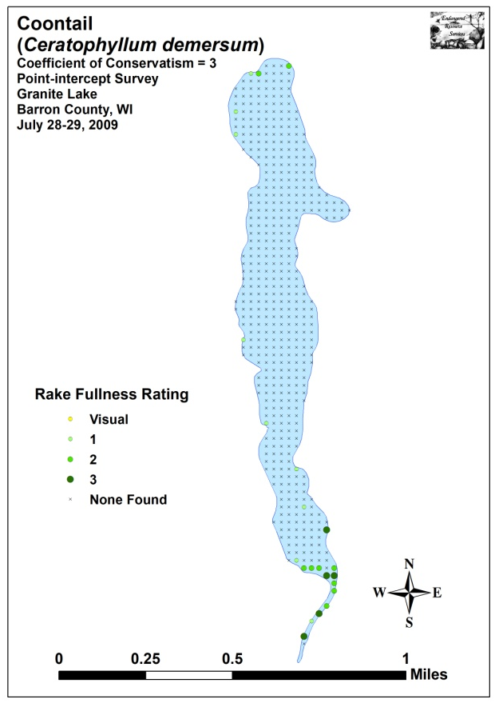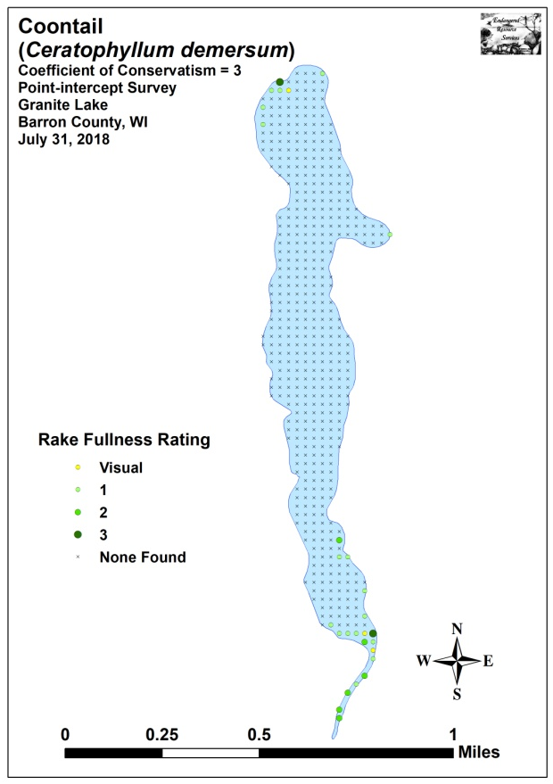
Figure 13: 2009 and 2018 Coontail Density and Distribution

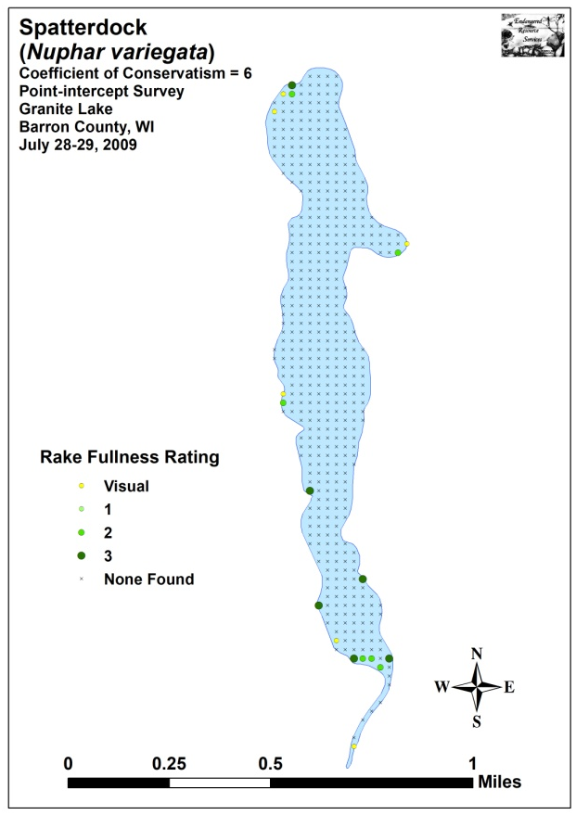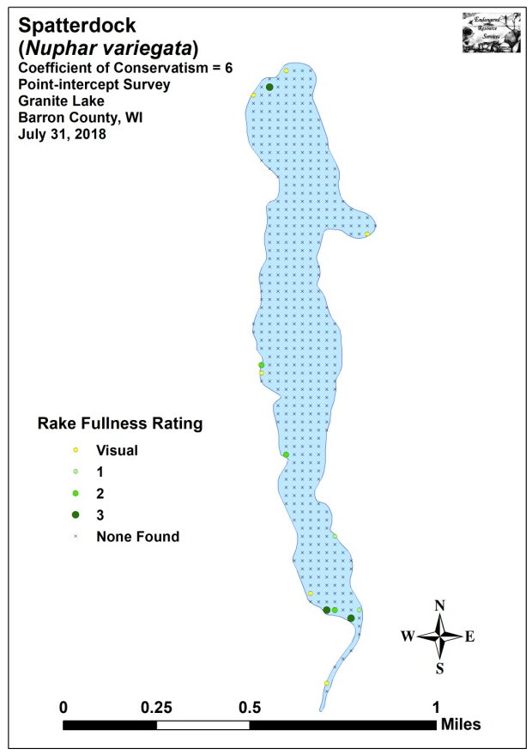
Figure 14: 2009 and 2018 Spatterdock Density and Distribution

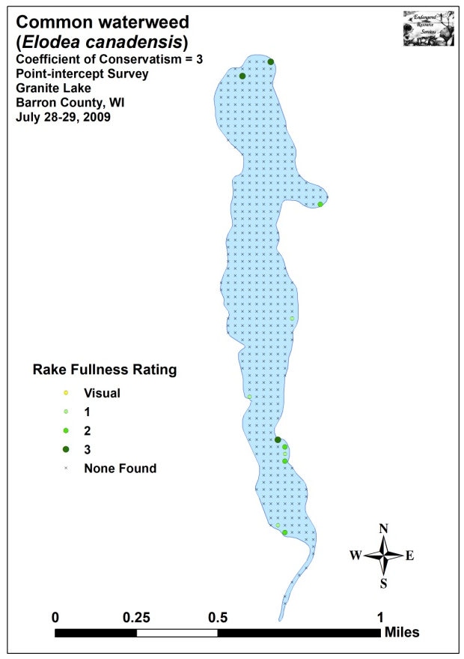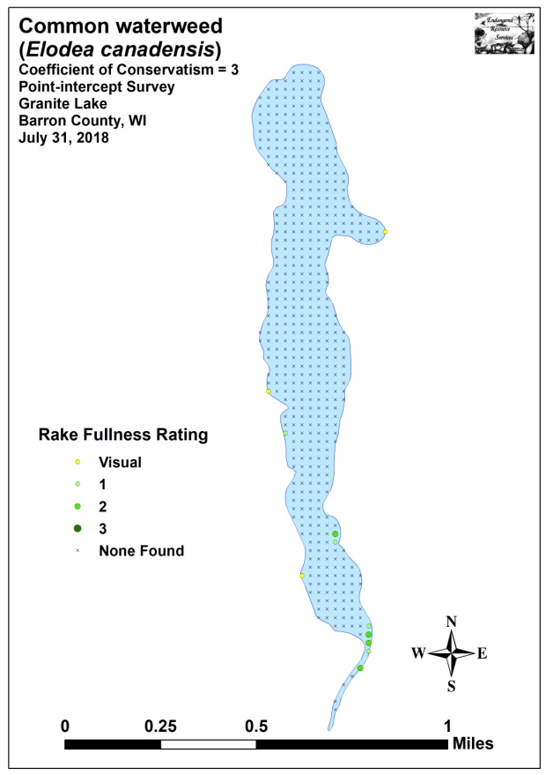
Figure 15: 2009 and 2018 Common Waterweed Density and Distribution

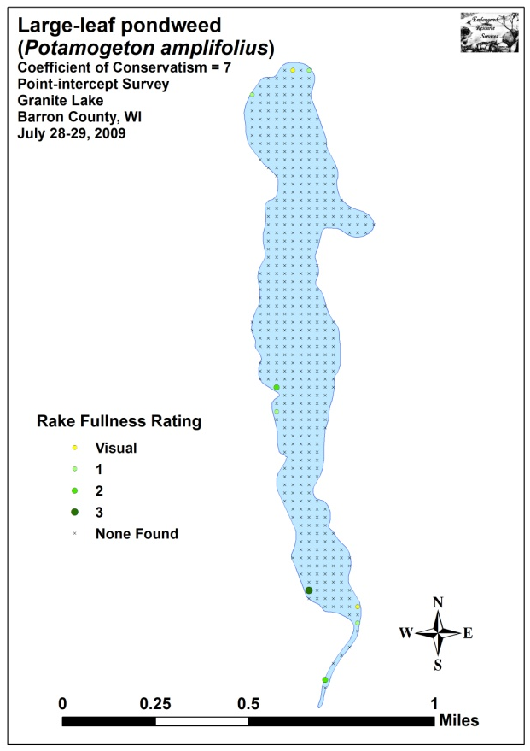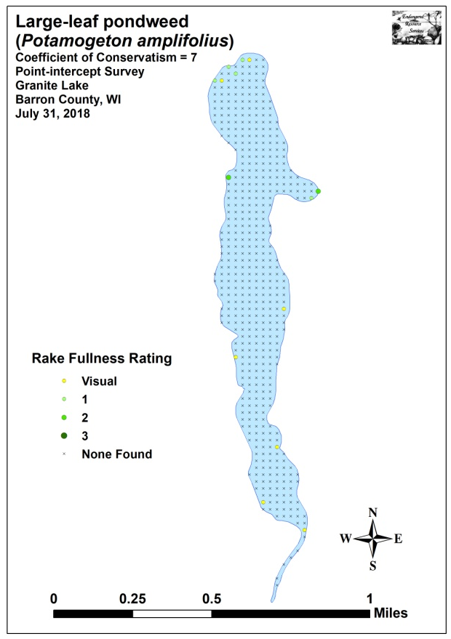
Figure 16: 2009 and 2018 Large-leaf Pondweed Density and Distribution

Comparison of Floristic Quality Indexes in 2009 and 2018:
In 2009, we identified a total of 22 native index species in the rake during the point-intercept survey (Table 5). They produced a mean Coefficient of Conservatism of 6.1 and a Floristic Quality Index of 28.8.

Table 5: Floristic Quality Index of Aquatic Macrophytes
Granite Lake, Barron County
July 28-29, 2009

Species | Common Name | C
Ceratophyllum demersum | Coontail | 3
Chara sp. | Muskgrass | 7
Elodea canadensis | Common waterweed | 3
Equisetum fluviatile | Water horsetail | 7
Heteranthera dubia | Water star-grass | 6
Lemna minor | Small duckweed | 4
Najas flexilis | Slender naiad | 6
Nuphar variegata | Spatterdock | 6
Nymphaea odorata | White water lily | 6
Pontederia cordata | Pickerelweed | 8
Potamogeton amplifolius | Large-leaf pondweed | 7
Potamogeton epihydrus | Ribbon-leaf pondweed | 8
Potamogeton foliosus | Leafy pondweed | 6
Potamogeton natans | Floating-leaf pondweed | 5
Potamogeton obtusifolius | Blunt-leaf pondweed | 9
Potamogeton pusillus | Small pondweed | 7
Potamogeton spirillus | Spiral-fruited pondweed | 8
Potamogeton zosteriformis | Flat-stem pondweed | 6
Sagittaria rigida | Sessile-fruited arrowhead | 8
Schoenoplectus acutus | Hardstem bulrush | 6
Schoenoplectus tabernaemontani | Softstem bulrush | 4
Spirodela polyrhiza | Large duckweed | 5
N |  | 22
Mean C |  | 6.1
FQI |  | 28.8

During the 2018 survey, we found a total of 22 native index plants in the rake during the point-intercept survey. They produced a mean Coefficient of Conservatism of 6.3 and a Floristic Quality Index of 29.4 (Table 6). Nichols (1999) reported an average mean C for the North Central Hardwood Forests Region of 5.6 putting Granite Lake well above average for this part of the state. The FQI was also significantly above the median FQI of 20.9 for the North Central Hardwood Forests (Nichols 1999).

Table 6: Floristic Quality Index of Aquatic Macrophytes
Granite Lake, Barron County
July 31, 2018

Species | Common Name | C
Ceratophyllum demersum | Coontail | 3
Chara sp. | Muskgrass | 7
Elodea canadensis | Common waterweed | 3
Equisetum fluviatile | Water horsetail | 7
Heteranthera dubia | Water star-grass | 6
Lemna minor | Small duckweed | 4
Najas flexilis | Slender naiad | 6
Nuphar variegata | Spatterdock | 6
Nymphaea odorata | White water lily | 6
Pontederia cordata | Pickerelweed | 8
Potamogeton amplifolius | Large-leaf pondweed | 7
Potamogeton foliosus | Leafy pondweed | 6
Potamogeton natans | Floating-leaf pondweed | 5
Potamogeton obtusifolius | Blunt-leaf pondweed | 9
Potamogeton pusillus | Small pondweed | 7
Potamogeton robbinsii | Fern pondweed | 8
Potamogeton spirillus | Spiral-fruited pondweed | 8
Potamogeton vaseyi | Vasey's pondweed | 10
Potamogeton zosteriformis | Flat-stem pondweed | 6
Schoenoplectus acutus | Hardstem bulrush | 6
Spirodela polyrhiza | Large duckweed | 5
Wolffia columbiana | Common watermeal | 5
N |  | 22
Mean C |  | 6.3
FQI |  | 29.4

Comparison of Filamentous Algae in 2009 and 2018:
Filamentous algae, normally associated with excessive nutrients in the water column, were common to abundant throughout the lake during each survey (Figure 17). In 2009, we found these algae at 30 points with a mean rake fullness of 1.93. During the 2018 survey, we documented a moderately significant expansion in distribution to 44 points (p=0.009), but a moderately significant decline in mean rake fullness to 1.36 (p=0.002).

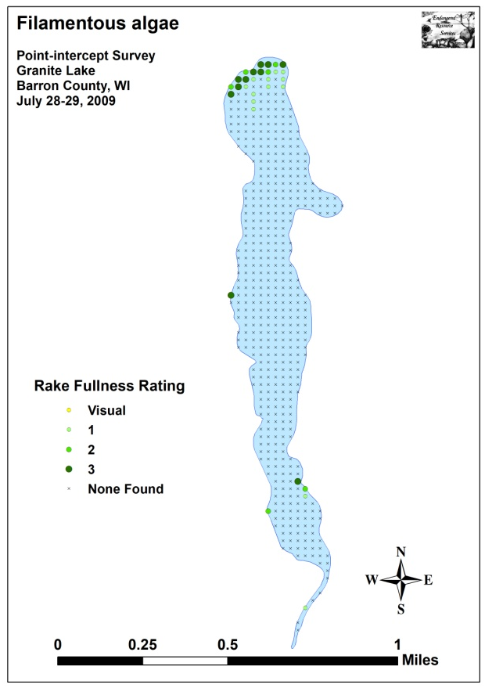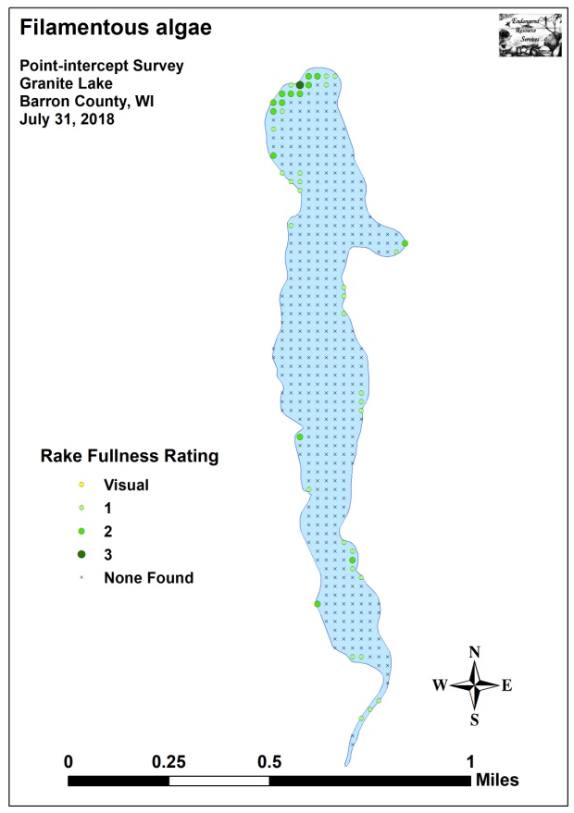
Figure 17: 2009 and 2018 Filamentous Algae Density and Distribution

Comparison of Midsummer Curly-leaf Pondweed in 2009 and 2018:
Curly-leaf pondweed normally completes its annual life cycle by late June, and most plants have set turions and senesced by early July. During our 2009 survey, CLP was still present at two points (mean rake fullness 1.00). However, in 2018, we didn’t document CLP in the rake at any point (Figure 18). We also didn’t record it as a visual or see any evidence of rooted CLP inter-point, although we did find a single floating plant during the shoreline boat survey.

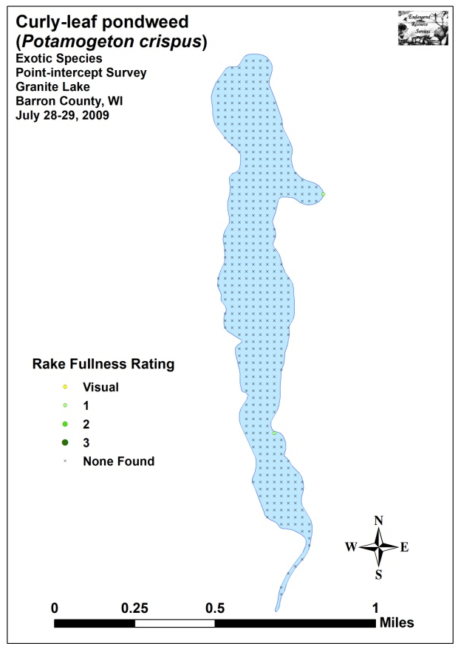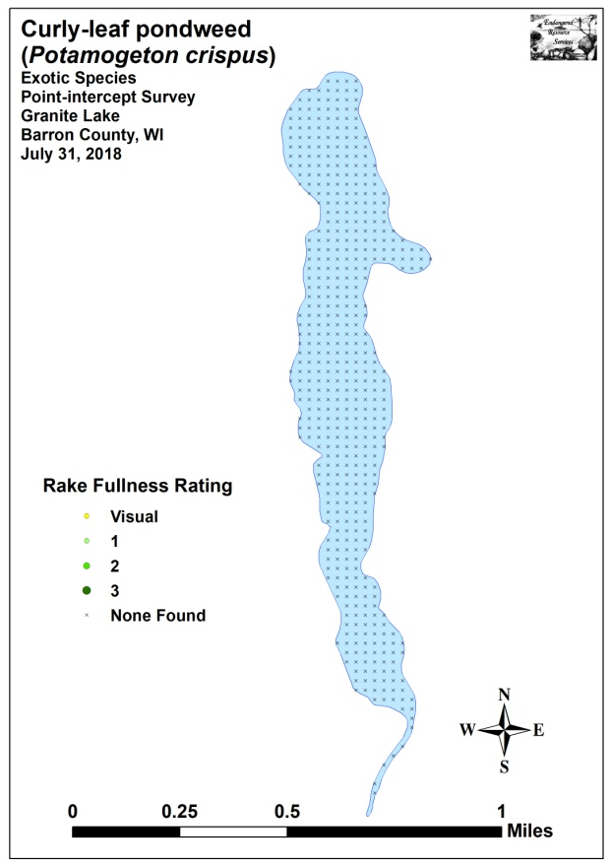
Figure 18: 2009 and 2018 Midsummer CLP Density and Distribution

Other Exotic Plant Species:
We did NOT find any evidence or Eurasian water-milfoil in Granite Lake during any of our surveys. However, in addition to Curly-leaf pondweed, we documented three other exotic species growing around the lake: Common forget-me-not, Reed canary grass and Purple loosestrife.

Common forget-me-not was present at a single point just south of the public boat landing on the western shoreline. Although we only saw plants at this point, there were perhaps a hundred plants on either side of a dock in an area that appeared to have a seep entering the lake (Figure 19).

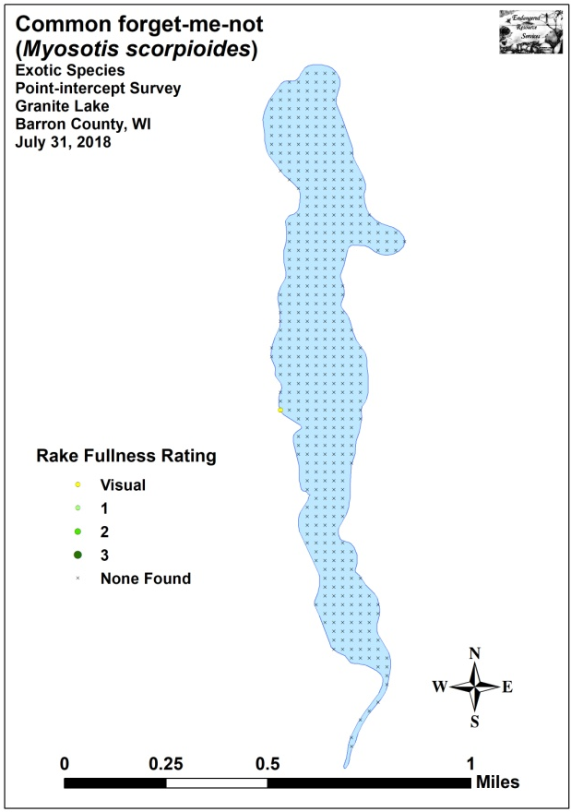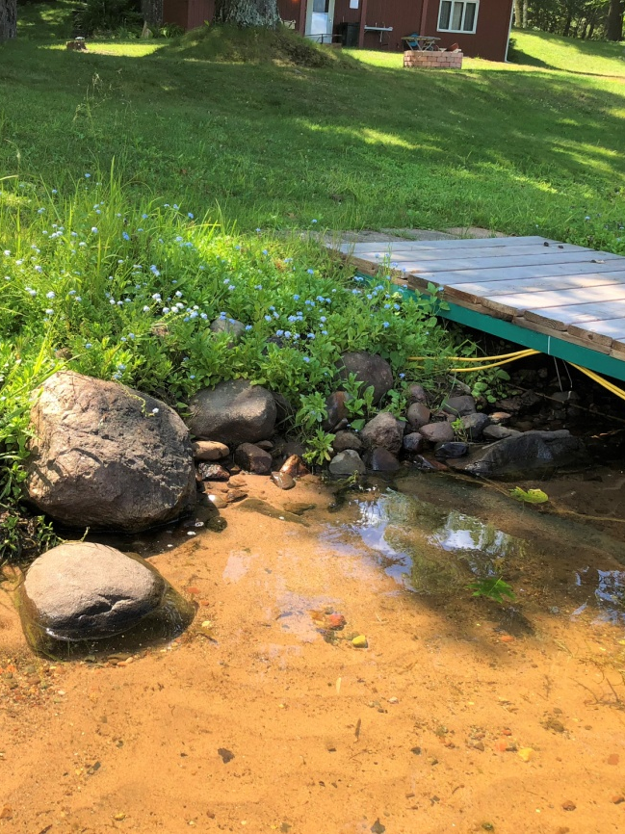
Figure 19: Common Forget-me-not Distribution/
Population on Western Shoreline

Despite only being recorded as a visual at a single point (Figure 20), Reed canary grass was not uncommon in mowed or otherwise disturbed shoreline areas. A ubiquitous plant in the state, there’s likely little that can be done about it.

In addition to CLP and RCG, we also found and removed a single cluster of Purple loosestrife plants along the eastern shoreline of the southern bay (Figure 21). This was similar to 2009 when we found and removed scattered PL plants in this general vicinity (For more information on a sampling of aquatic exotic invasive plant species, see Appendix IX).

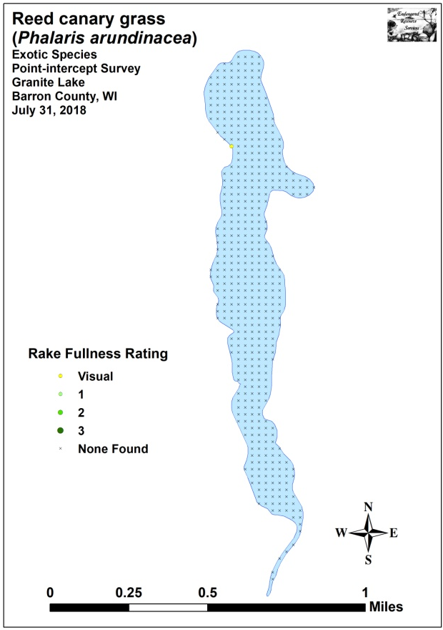
Figure 20: Reed Canary Grass Distribution and Typical Growth Form

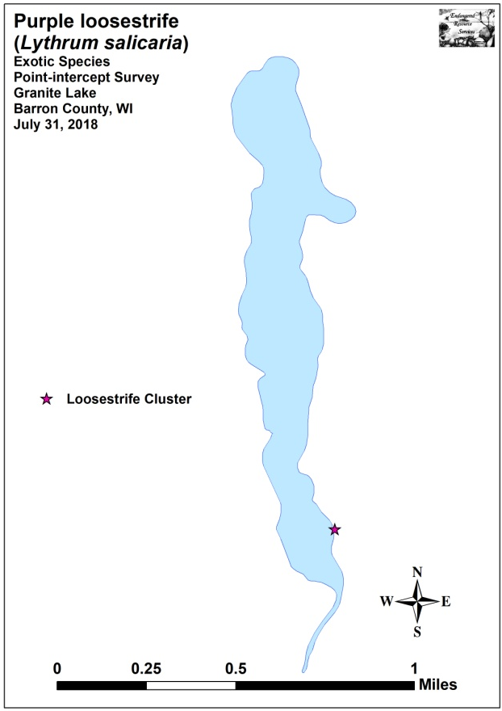
Figure 21: Purple Loosestrife Distribution and Inflorescence

DISCUSSION AND CONSIDERATIONS FOR MANAGEMENT:
Water Clarity, Nutrient Inputs, and the Role of Native Macrophytes:
Like trees in a forest, a lake’s native plants are the basis of the aquatic ecosystem. They capture the sun’s energy and turn it into usable food, “clean” the water of excess nutrients, and provide habitat for other organisms like aquatic invertebrates and the lake’s fish populations. Because of this, preserving them is critical to maintaining the lake’s overall health. Unfortunately, when phosphorus and nitrogen levels exceed what the lake’s macrophytes can utilize, it tends to promote algae blooms which impact these sensitive species as well as general lake esthetics.

Although upstream agricultural runoff can be a major contributor to a lake’s overall nutrient load, soil erosion and nutrient inputs from along the immediate lakeshore can also have significant impacts. Because of this, all lake residents have the opportunity to help reduce runoff by evaluating how their shoreline practices may be affecting the lake. Simple things like establishing or maintaining their own buffer strip of native vegetation along the lake shore to prevent erosion, building rain gardens, bagging grass clippings, switching to a phosphorus-free fertilizer or preferably eliminating fertilizer near the lake altogether, collecting pet waste, and disposing of the ash from fire pits away from the lakeshore can all significantly reduce the amount of nutrients entering the ecosystem. Hopefully, a greater understanding of how all property owners can have lakewide impacts will result in more people taking appropriate conservation actions to not only help improve water clarity and quality, but also to benefit the lake’s important habitat producing native plant species.

Curly-leaf Pondweed Management:
During both our 2009 and 2018 early-season Curly-leaf pondweed surveys, we found that CLP was present in Granite Lake’s south bay but occurred at such low levels that it was unlikely to cause any navigation impairment. Because of this, it appears that active management of CLP is unnecessary at this time. However, because plants were so rare and concentrated in shallow water, it would likely be possible to rake remove the few plants that do exist with a single annual shoreline transect survey in late spring. If desired and if volunteers are available, they could put a significant dent in the CLP population while simultaneously having minimal impact on the lake’s limited native plant community – a win/win from both an ecological and economic perspective.

Common Forget-me-not Management:
Although this cold-water obligate probably has limited habitat to expand into around the lake, it likely wouldn’t take a lot of effort for the landowner or volunteers with access permission to remove the 100 or so plants that occur by the boat landing. As a seed bank is likely established, annually revisiting the spot for several years would be necessary to eliminate the population.

Purple Loosestrife Management:
Purple loosestrife also occurs at very low levels on Granite Lake. Because of this, it is unlikely there are enough plants to support a loosestrife beetle (Galerucella spp.) population at this time. However, if monitoring shows an increase in plants, a beetle release could be considered in the future. In the meantime, residents should be on the lookout for and remove any PL plants they find on their property in August/September when the bright fuchsia candle-shaped flower spikes are easily seen and before they can set seed. Alternatively, if residents granted permission, volunteers could annually tour the shoreline and remove any PL found. Regardless of who digs out the plants, PL should be bagged and disposed of well away from any wetland. Also, because the plants have an extensive root system, care should be taken to remove the entire plant as even small root fragments can survive and produce new plants the following year. Volunteers could also look for and remove forget-me-not at the same time.

LITERATURE CITED

Borman, S., R. Korth, and J. Temte 1997. Through the Looking Glass…A Field Guide to Aquatic Plants. Wisconsin Lakes Partnership. DNR publication FH-207-97.

Busch, C, G. Winter, L. Sather, and J. Roth. 1967. Granite Lake Map. Available from https://dnr.wi.gov/lakes/maps/DNR/2100800a.pdf (2018, December).

Chadde, Steve W. 2002. A Great Lakes Wetland Flora: A complete guide to the aquatic and wetland plants of the Upper Midwest. Pocketflora Press; 2nd edition

Crow, G. E., C. B. Hellquist. 2009. Aquatic and Wetland Plants of Northeastern North America, Volume I + II: A Revised and Enlarged Edition of Norman C. Fassett's A Manual of Aquatic Plants. University of Wisconsin Press.

Nichols, Stanley A. 1999. Floristic Quality Assessment of Wisconsin Lake Plant communities with Example Applications. Journal of Lake and Reservoir Management 15 (2): 133-141.

Skawinski, Paul. 2014. Aquatic Plants of the Upper Midwest: A photographic field guide to our underwater forests. 2nd Edition, Wausau, WI.

Sullman, Josh. [online] 2010. Sparganium of Wisconsin Identification Key and Description. Available from University of Wisconsin-Madison http://www.botany.wisc.edu/jsulman/Sparganium%20identification%20key%20and%20description.htm (2016, July).

UWEX Lakes Program. [online]. 2010. Pre/Post Herbicide Comparison. Available from http://www.uwsp.edu/cnr-ap/UWEXLakes/Documents/ecology/Aquatic%20Plants/Appendix-D.pdf (2018, November).

Voss, Edward G. 1996. Michigan Flora Vol I-III. Cranbrook Institute of Science and University of Michigan Herbarium.

WDNR. [online]. 2018. Citizen Lake Monitoring Water Quality Data Report for Granite Lake. https://dnr.wi.gov/lakes/waterquality/Station.aspx?id=033177 (2018, December)

WDNR. [online]. 2010. Curly-leaf pondweed fact sheet. http://dnr.wi.gov/invasives/fact/curlyleaf_pondweed.htm (2010, August).

WDNR. [online]. 2010. Eurasian Water-milfoil fact sheet. http://dnr.wi.gov/invasives/fact/milfoil.htm (2010, August).

WDNR. [online]. 2018. Lake Information Pages for Granite Lake. https://dnr.wi.gov/lakes/lakepages/LakeDetail.aspx?wbic=2100800 (2018, December)

WDNR. [online]. 2010. Purple loosestrife fact sheet. http://dnr.wi.gov/invasives/fact/loosestrife.htm (2010, August).

WDNR. [online]. 2010. Reed canary grass fact sheet. http://dnr.wi.gov/invasives/fact/reed_canary.htm (2010, August).

Appendix I: Survey Sample Points Map
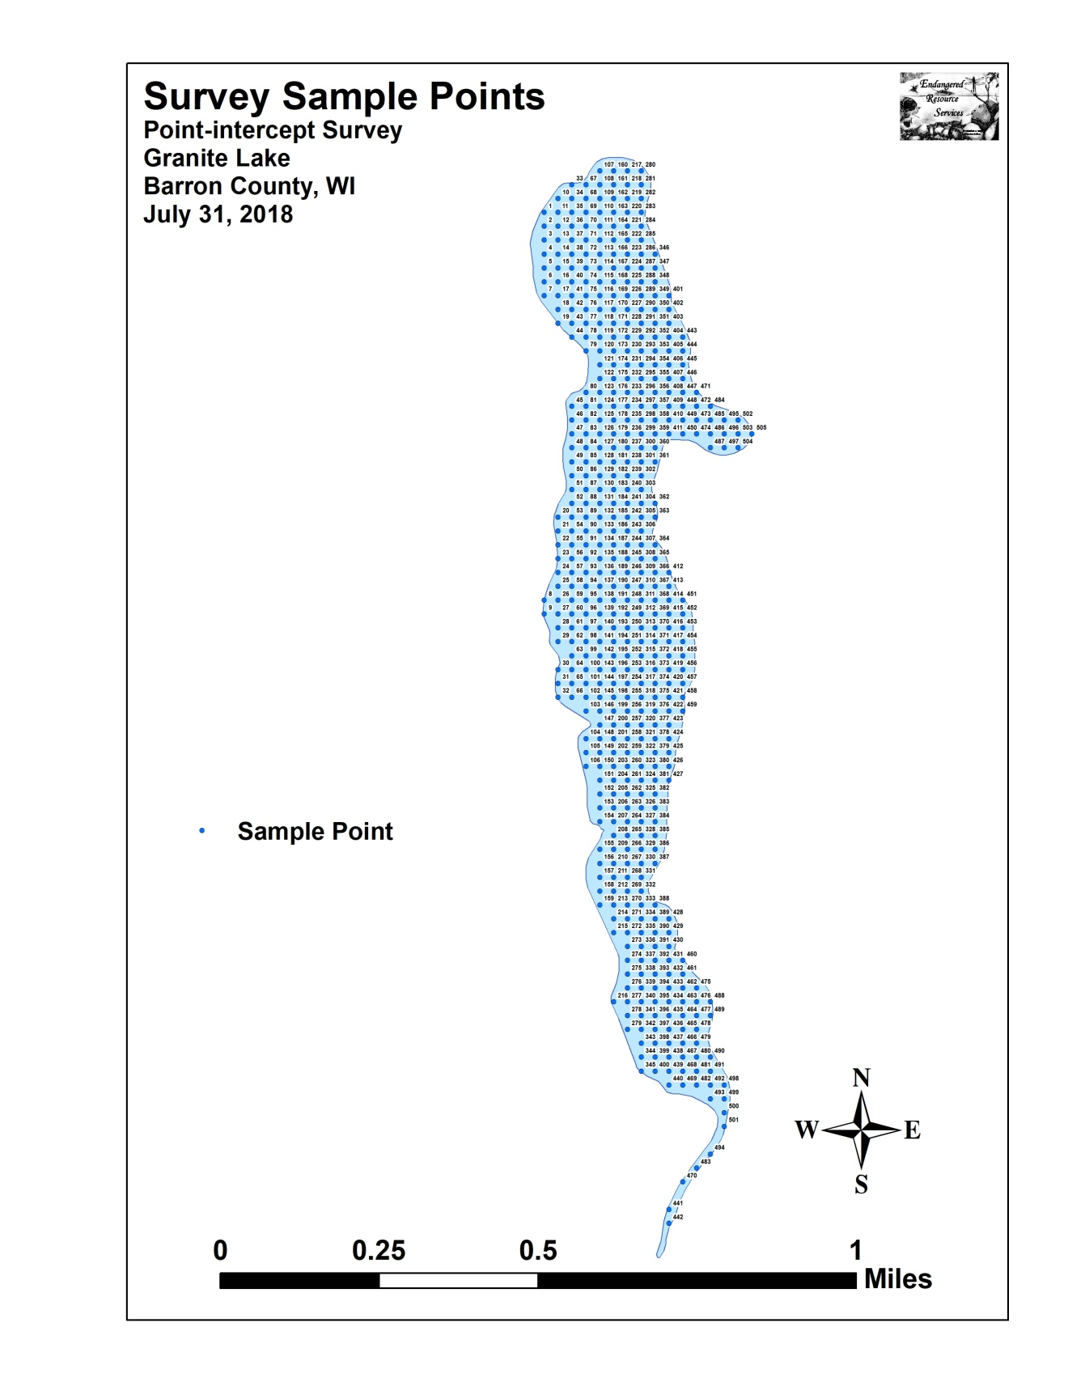

Appendix II: Boat and Vegetative Survey Datasheets

Boat Survey
Lake Name
County
WBIC
Date of Survey
(mm/dd/yy)
workers
Nearest Point | Species seen, habitat information

Observers for this lake: names and hours worked by each:
Lake: |  |  |  |  |  |  |  |  | WBIC |  |  |  |  |  |  |  |  | County |  |  |  |  |  | Date:
Site # | Depth (ft) | Muck (M), Sand (S), Rock (R) | Rake pole (P) or rake rope (R) | Total Rake Fullness | EWM | CLP | 1 | 2 | 3 | 4 | 5 | 6 | 7 | 8 | 9 | 10 | 11 | 12 | 13 | 14 | 15 | 16 | 17 | 18 | 19
1
2
3
4
5
6
7
8
9
10
11
12
13
14
15
16
17
18
19
20

Appendix III: 2009 and 2018 Early-season
CLP Density and Distribution and 2018 CLP High Density Area Maps
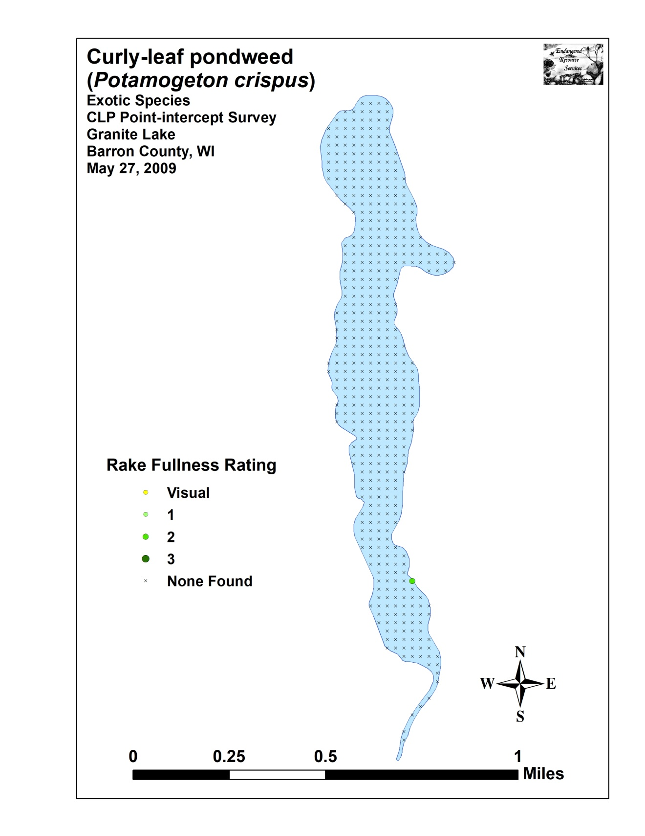
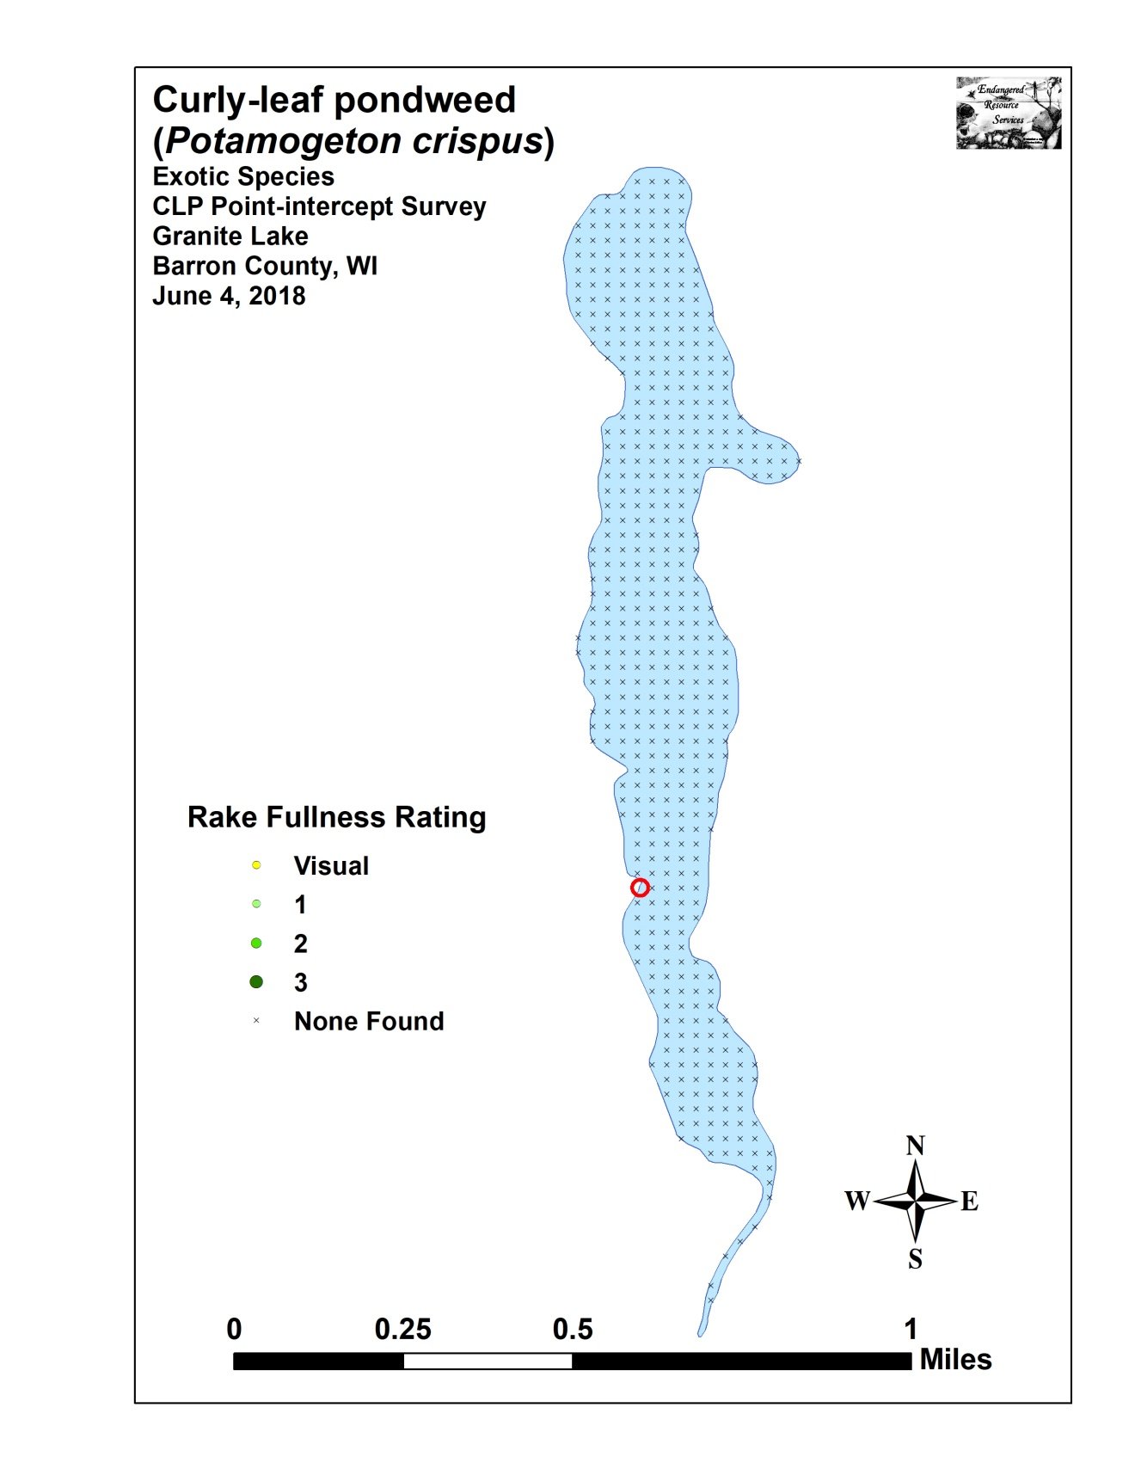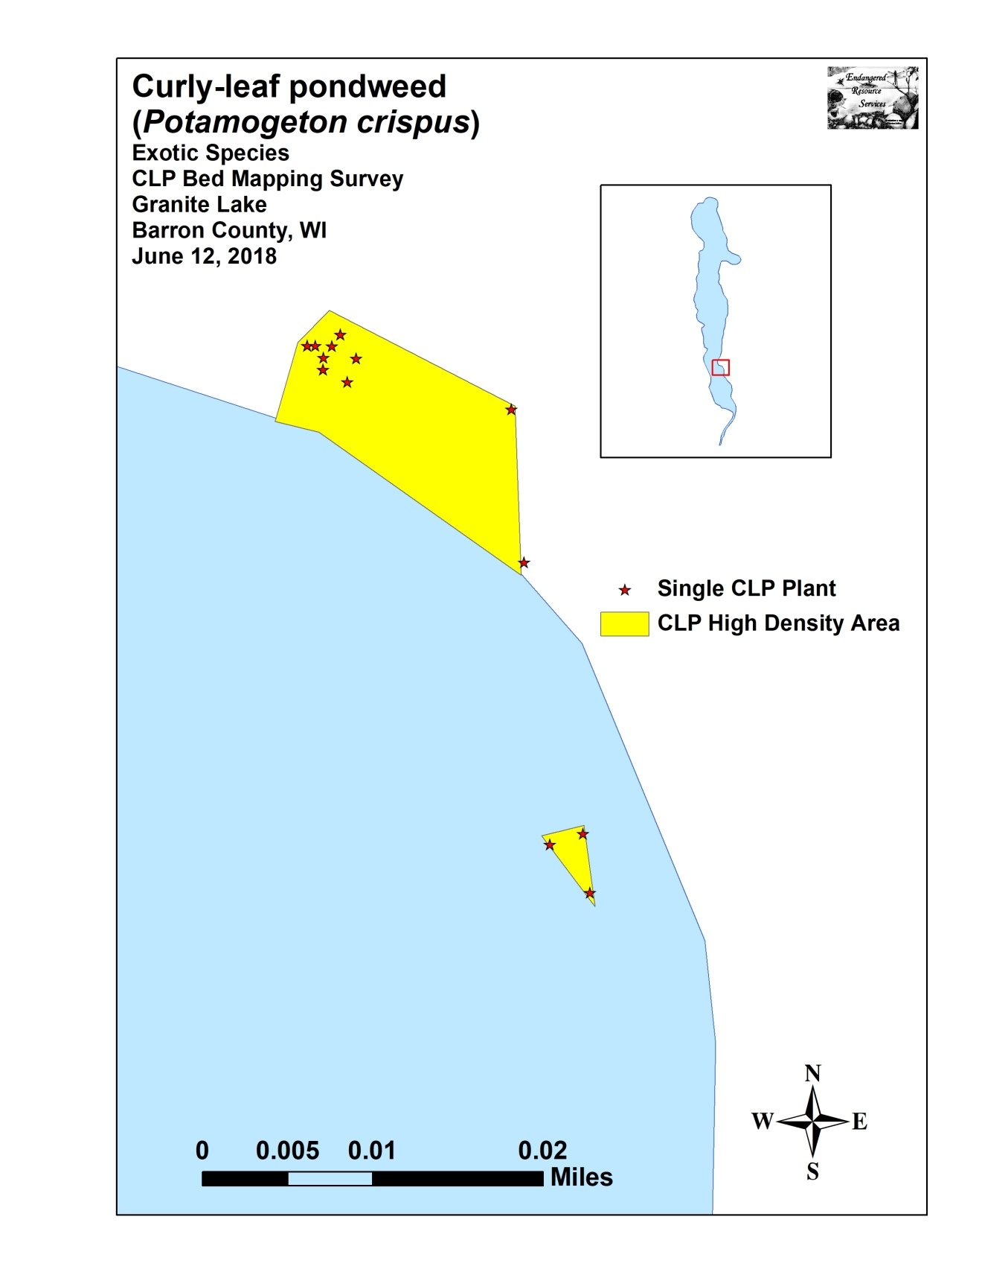

Appendix IV: Habitat Variable Maps
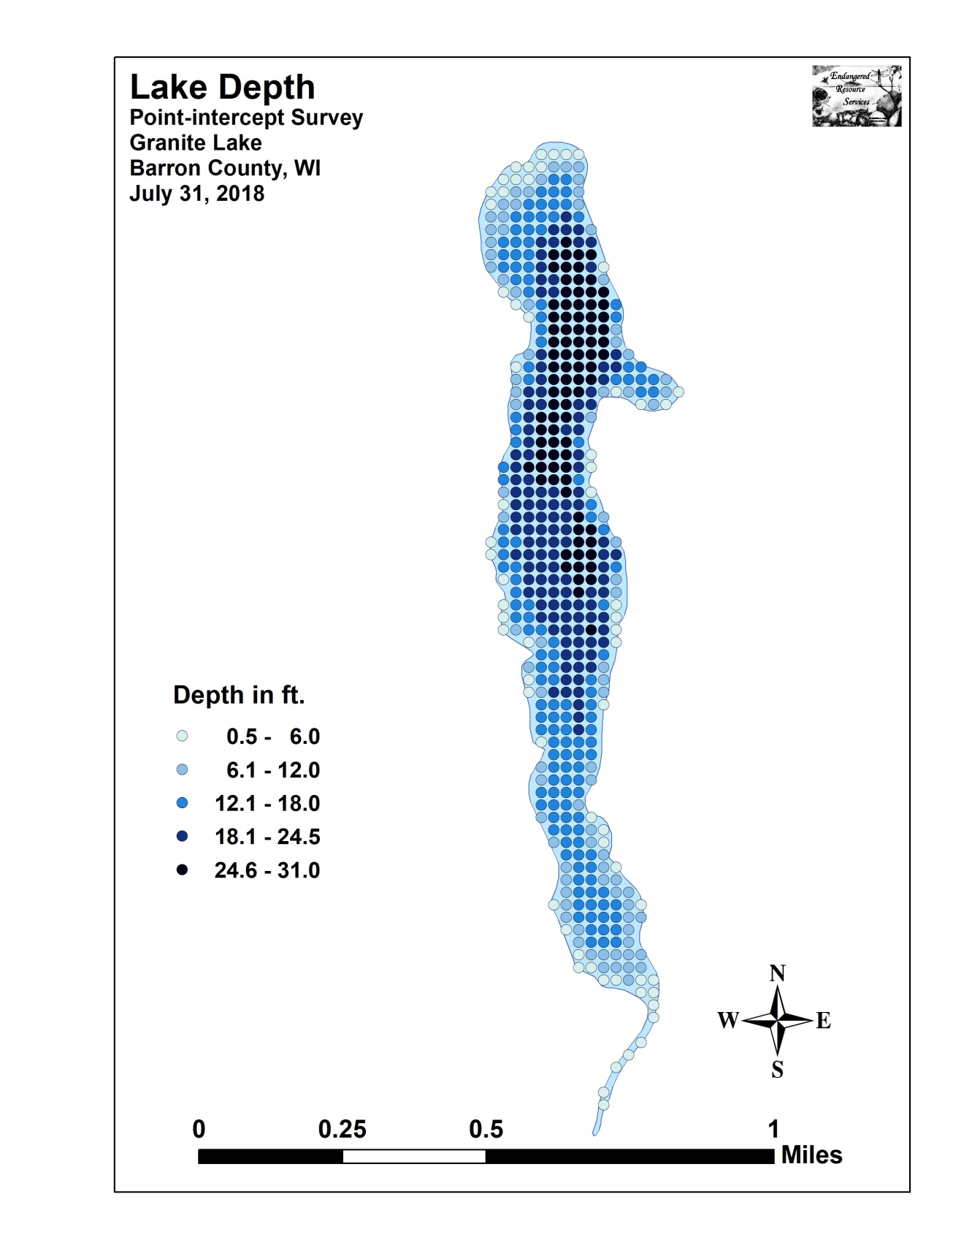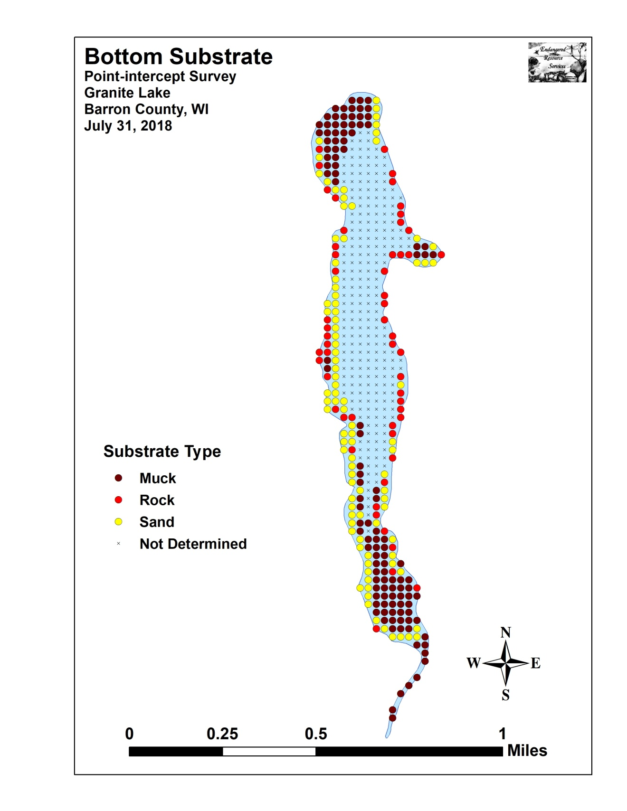

Appendix V: 2009 and 2018 Littoral Zone, Native Species Richness and Total Rake Fullness Maps

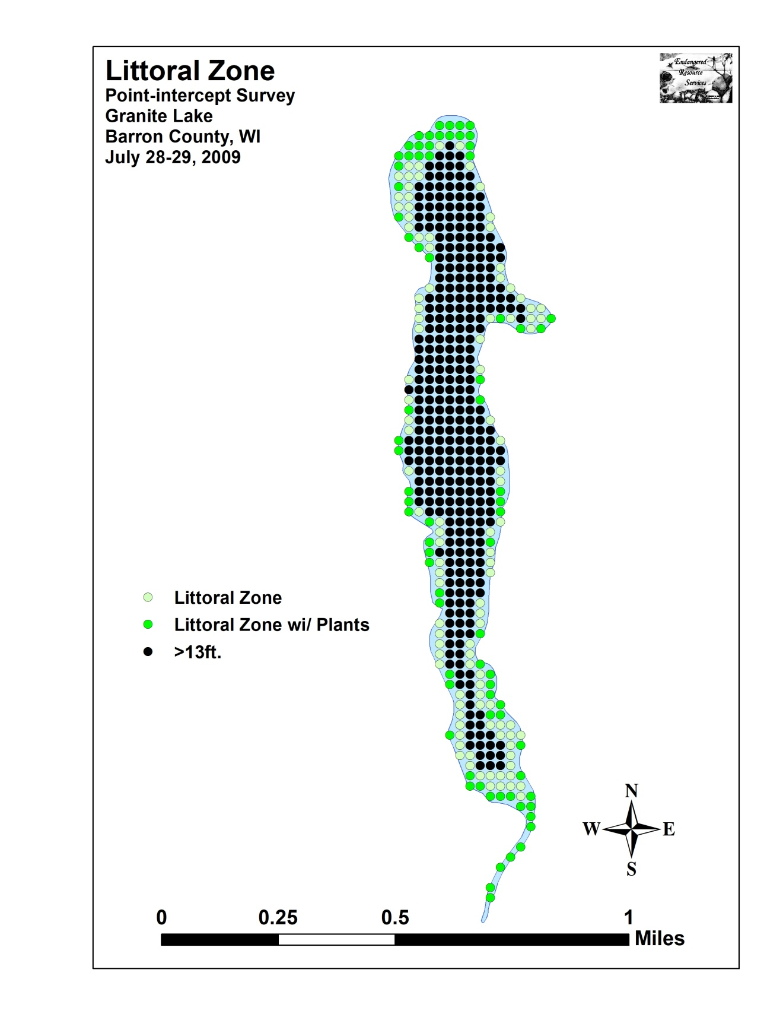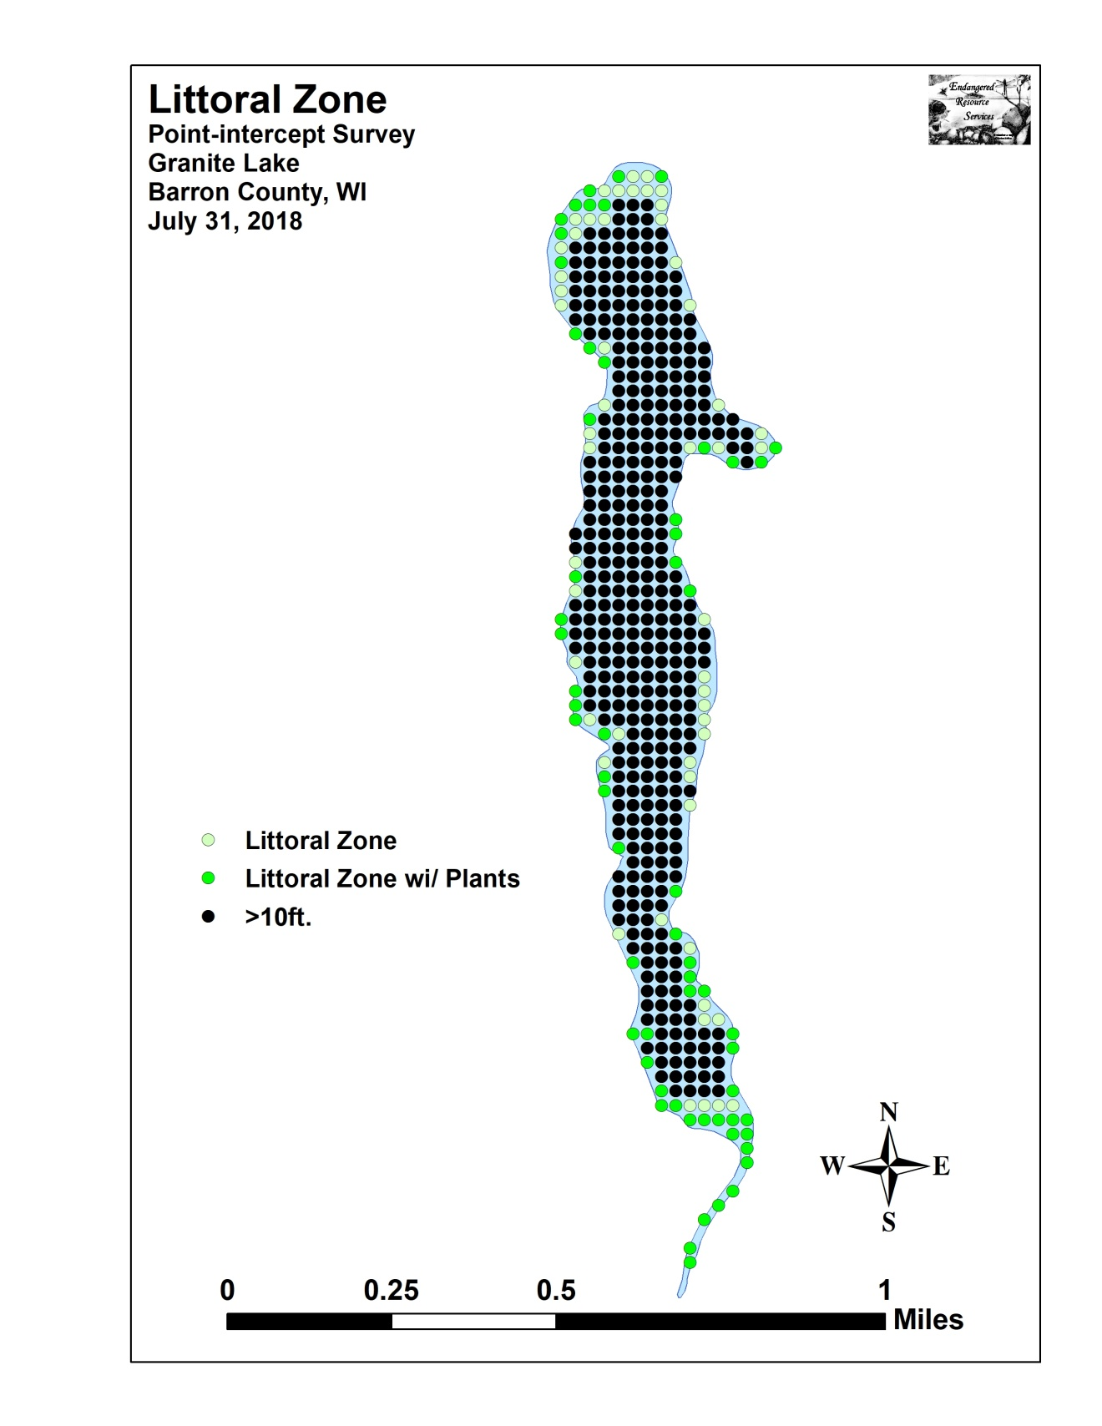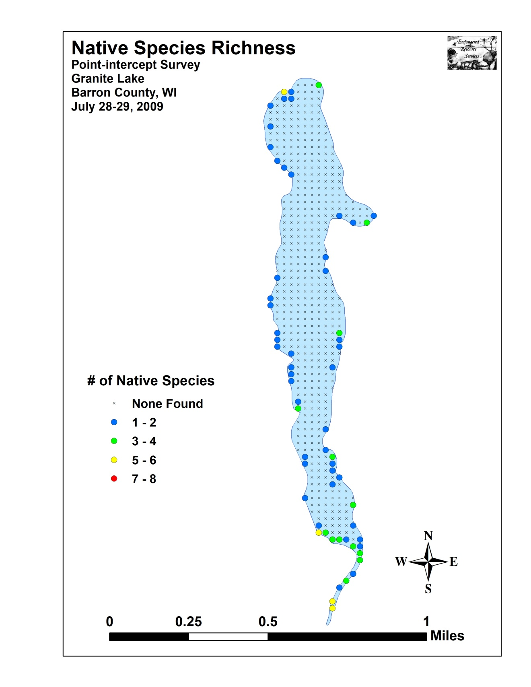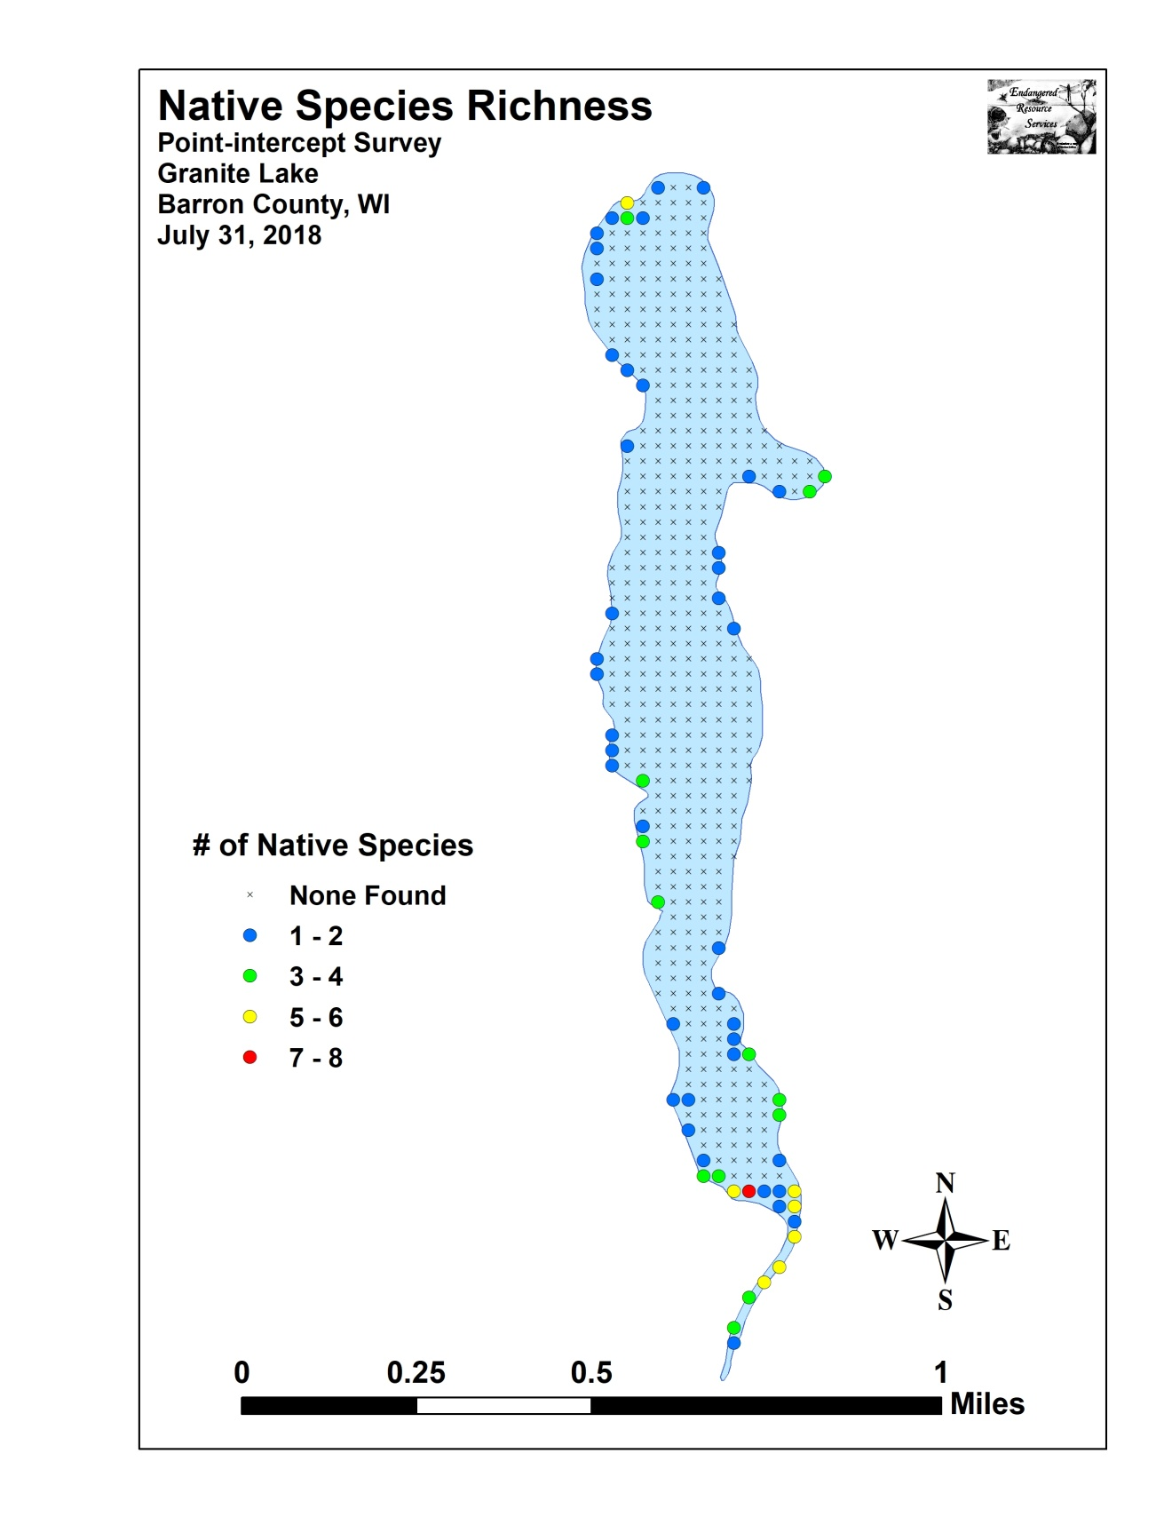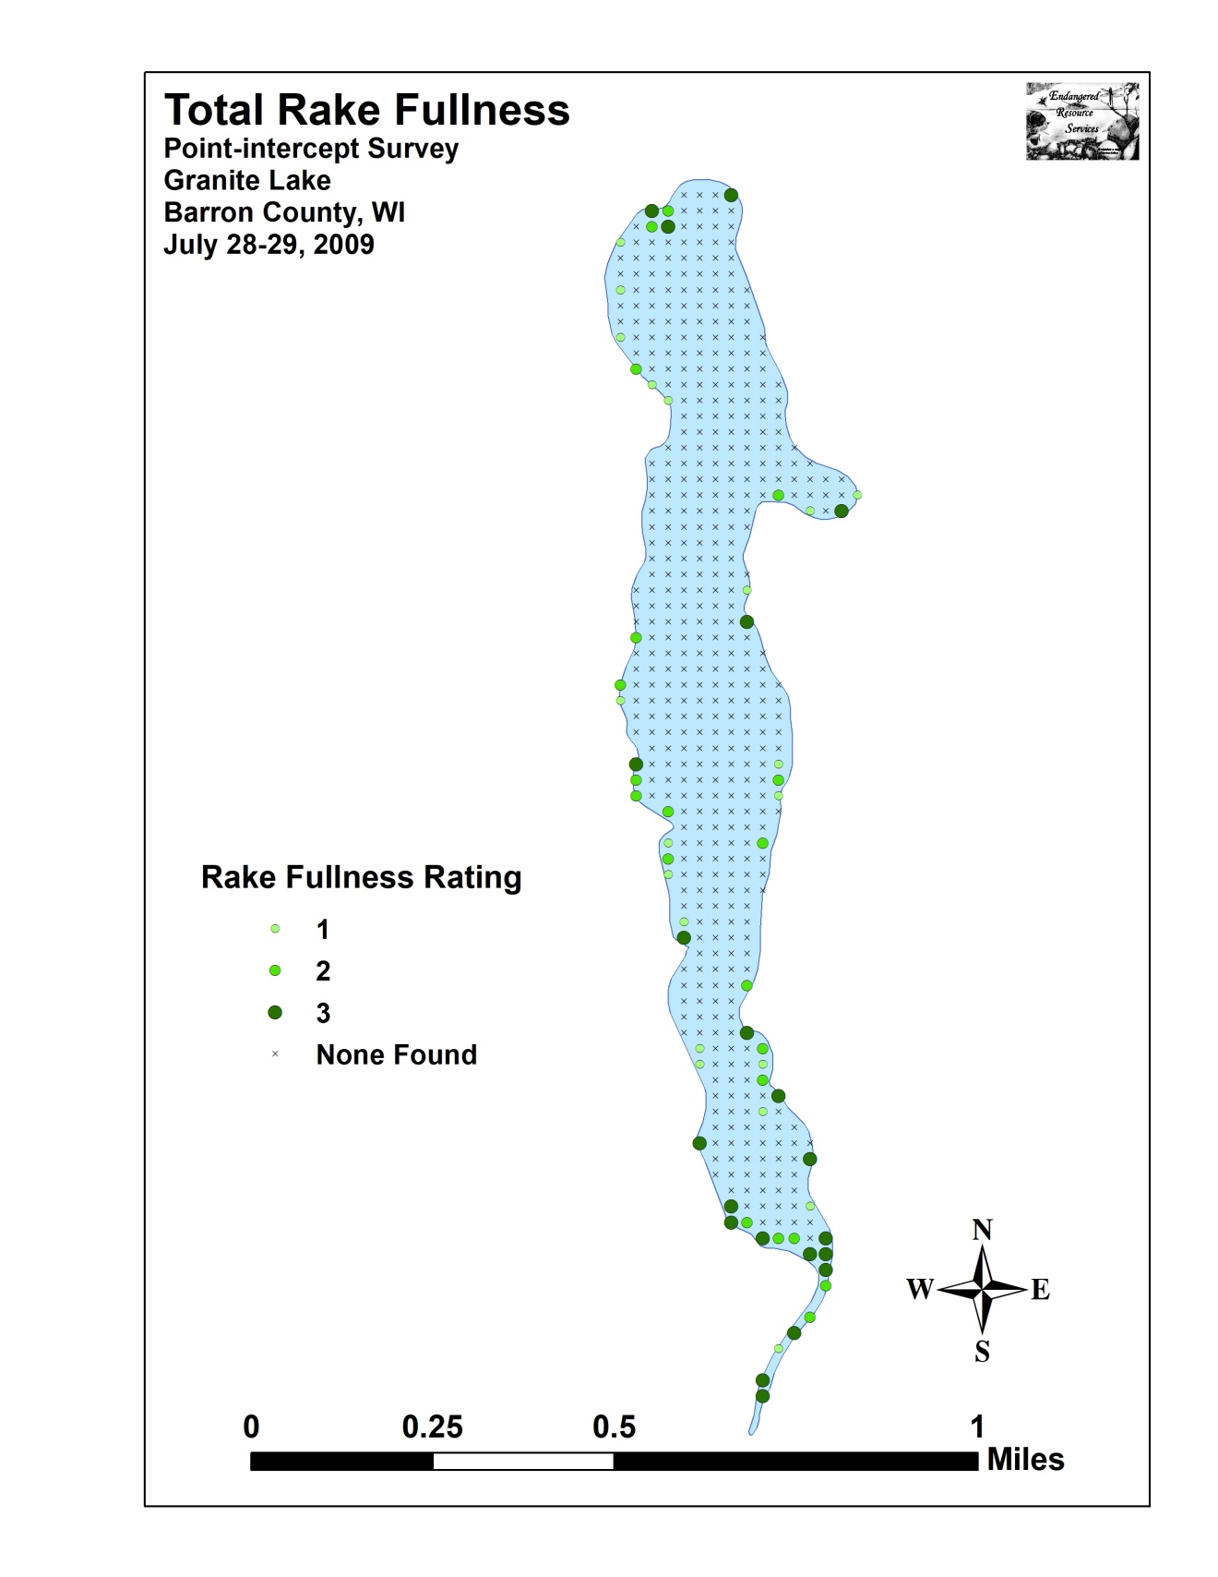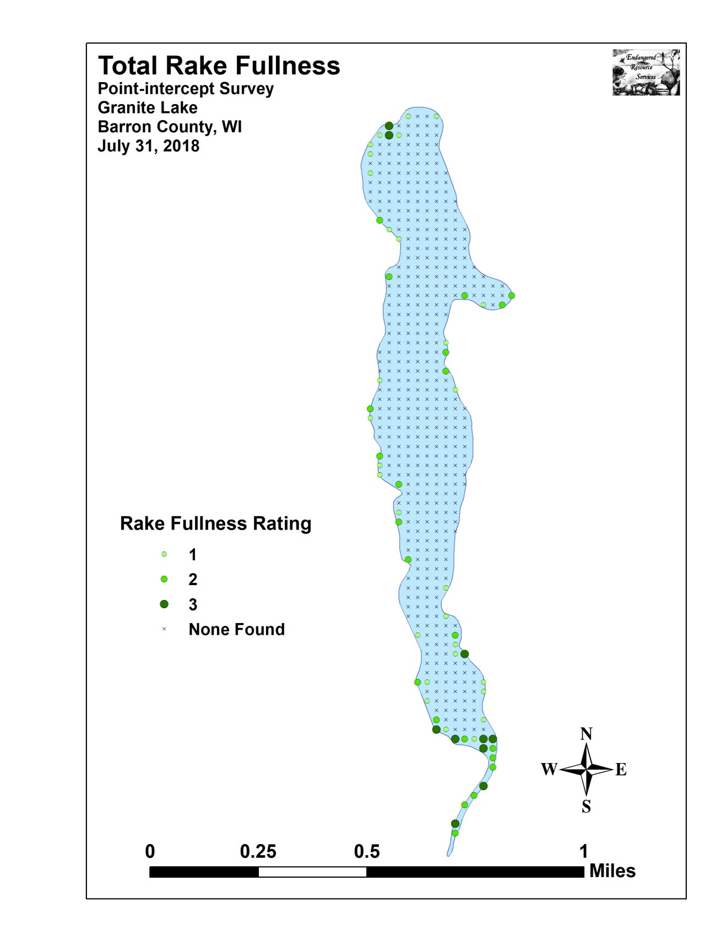

Appendix VI: July 2009 Species Density and Distribution Maps
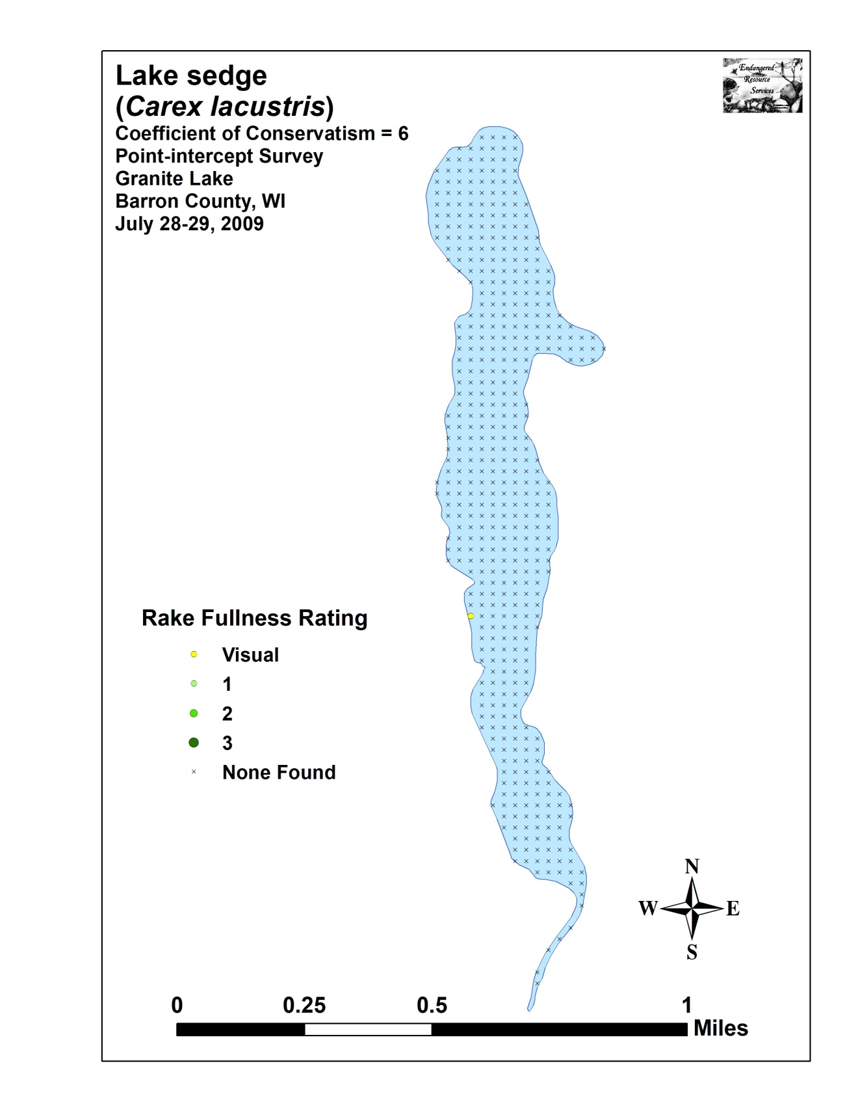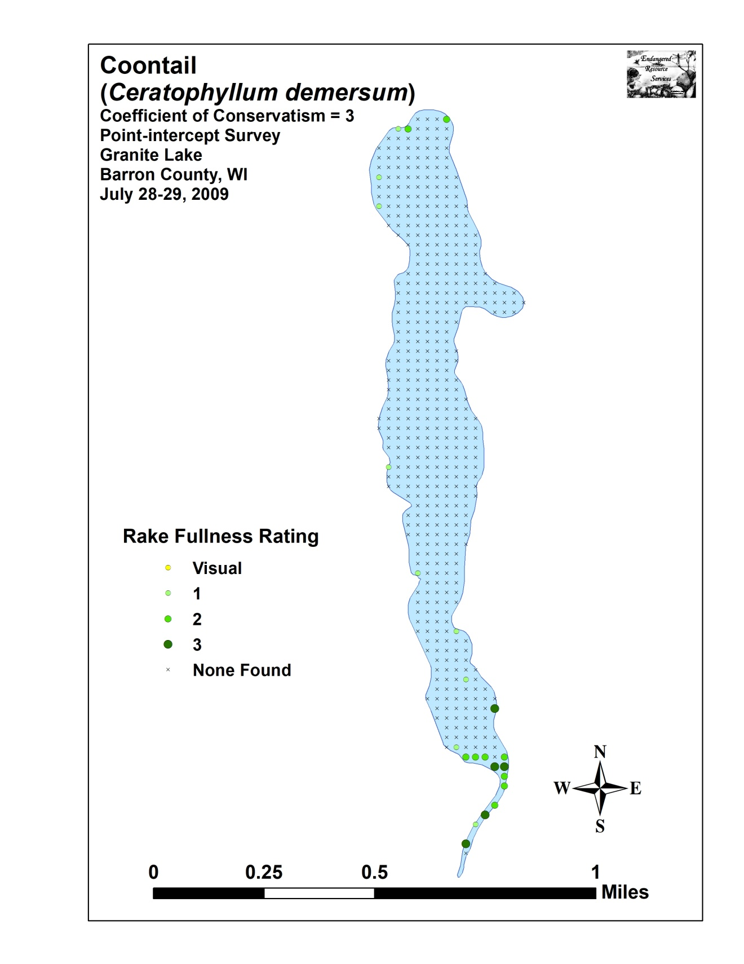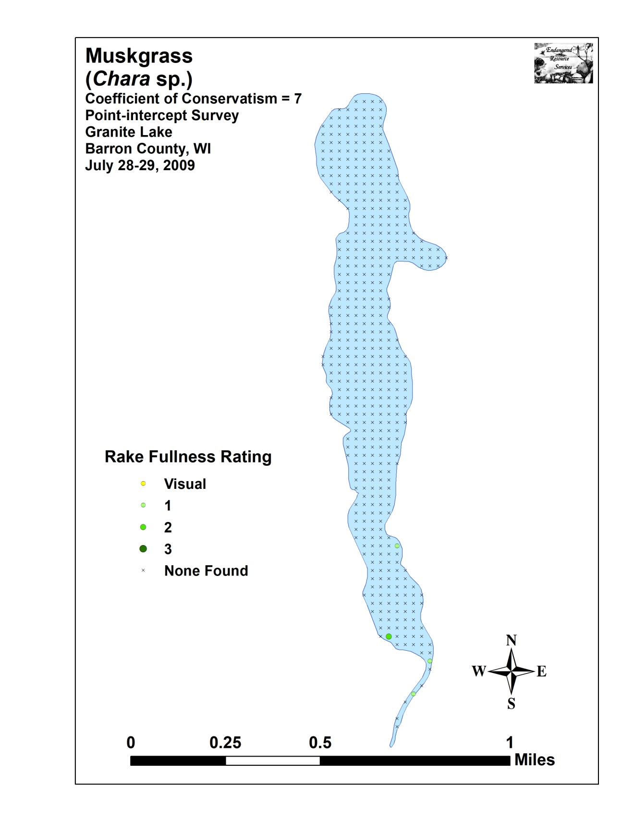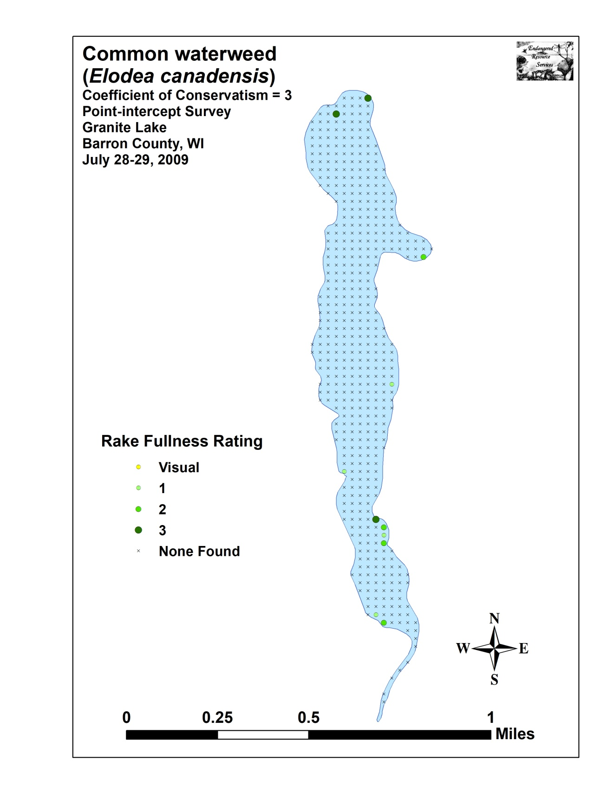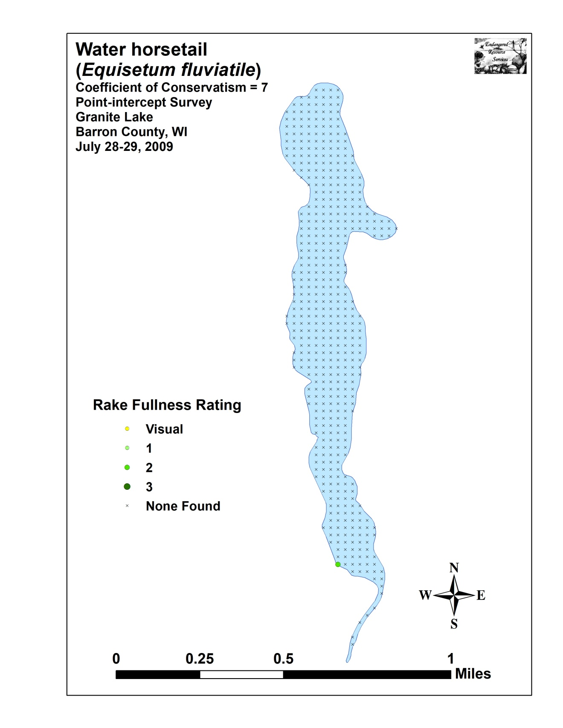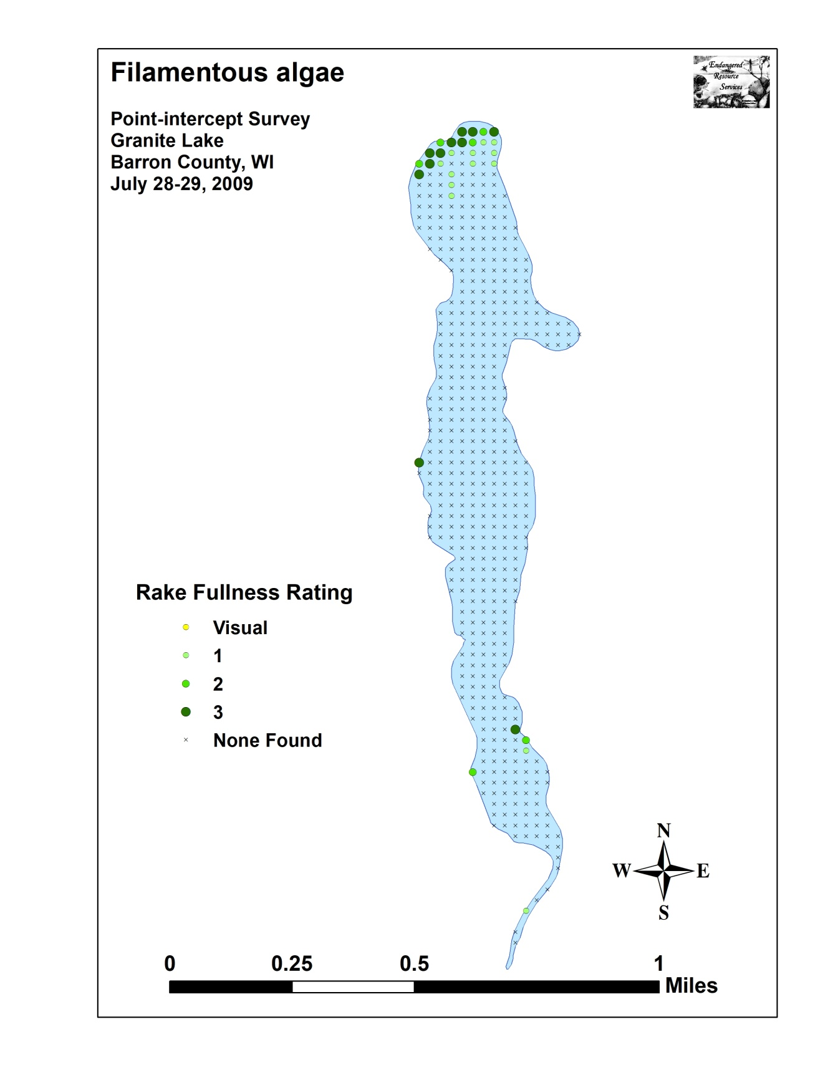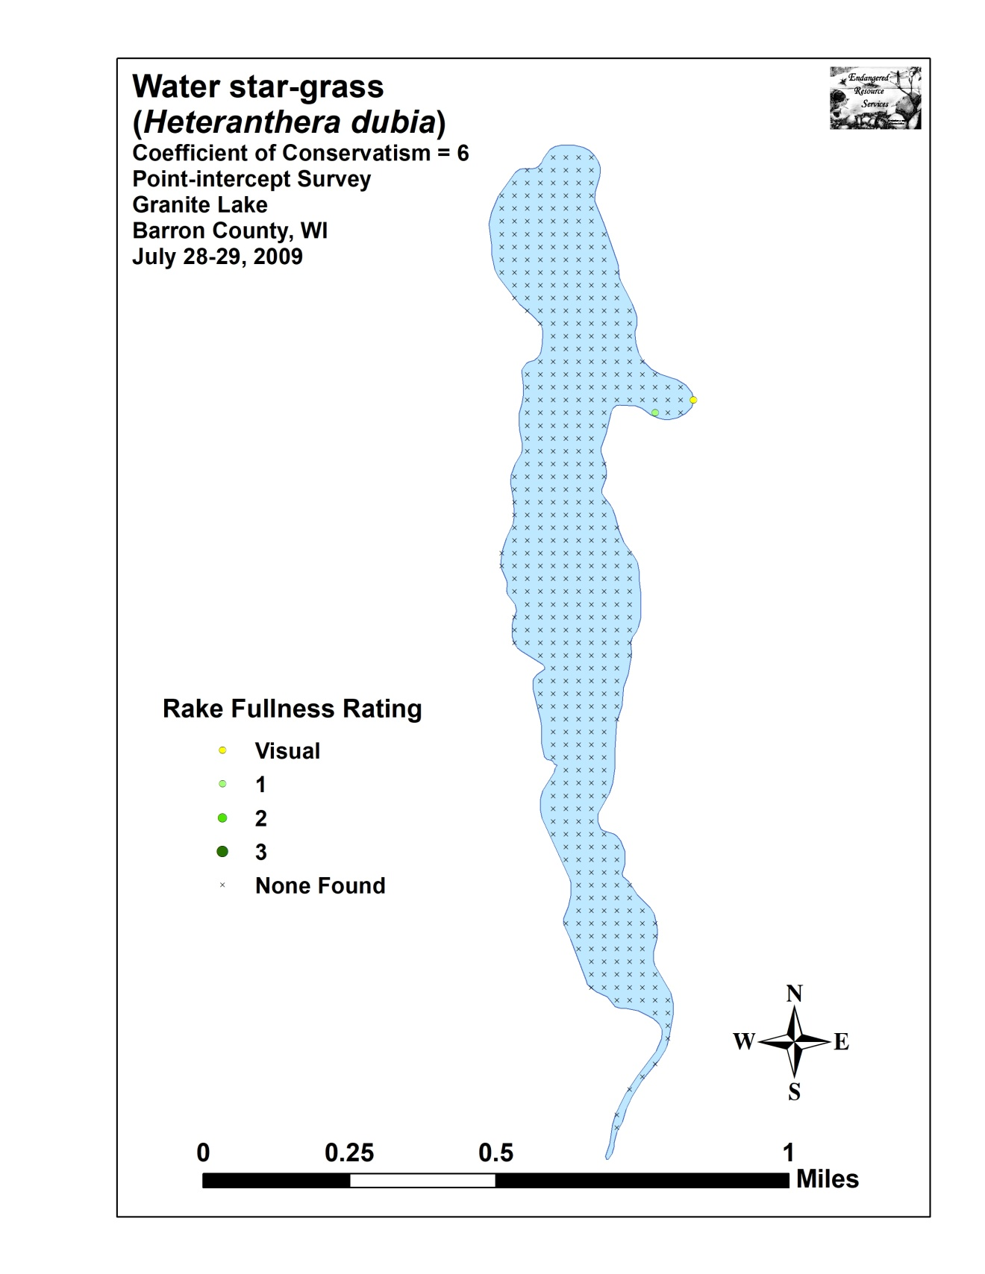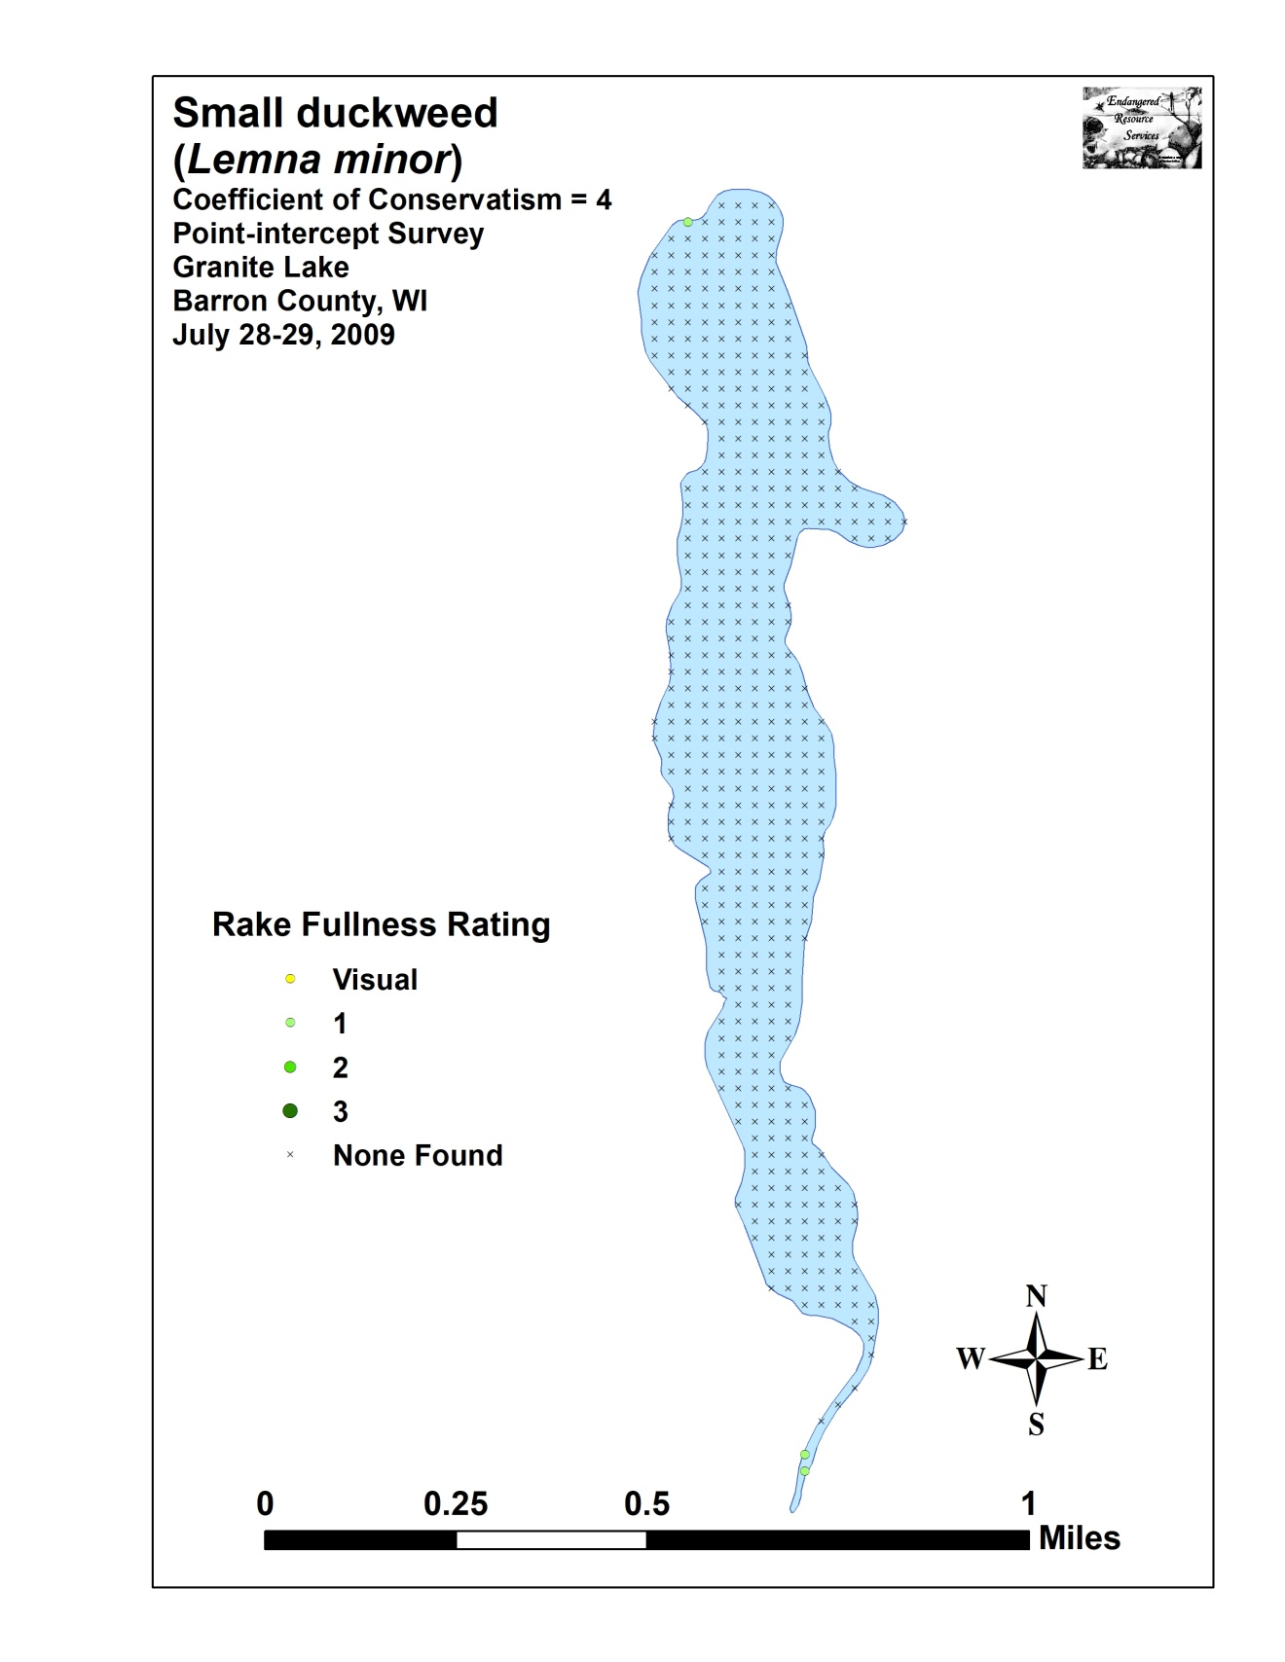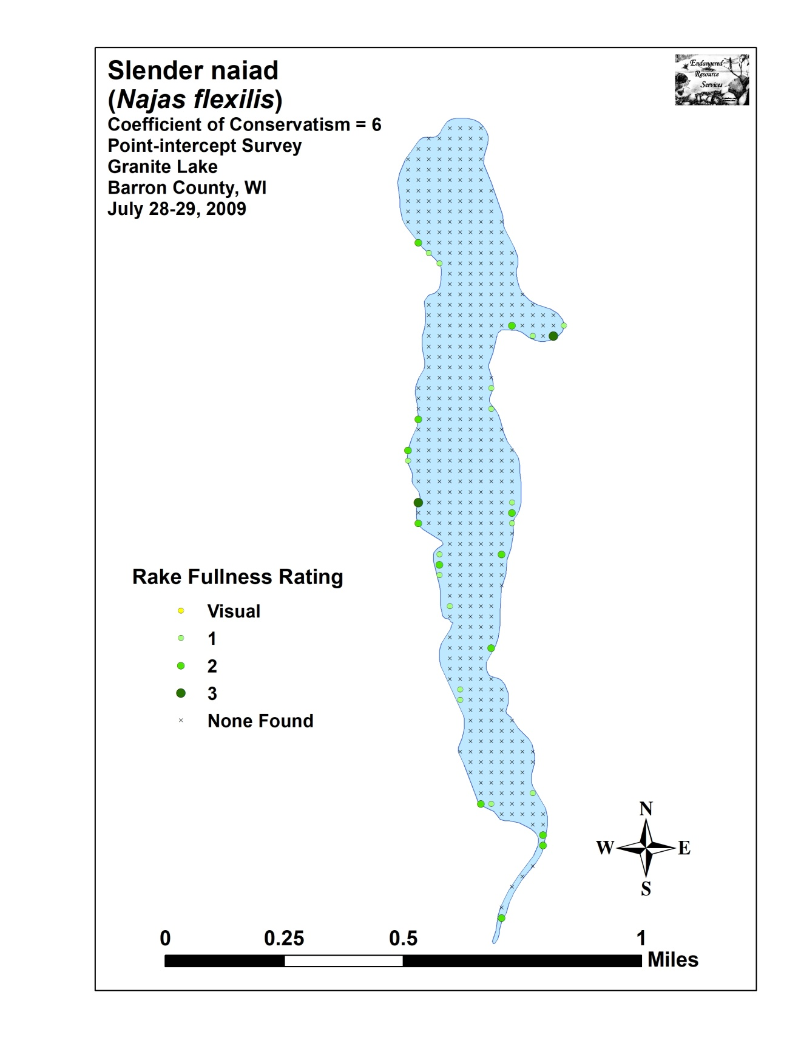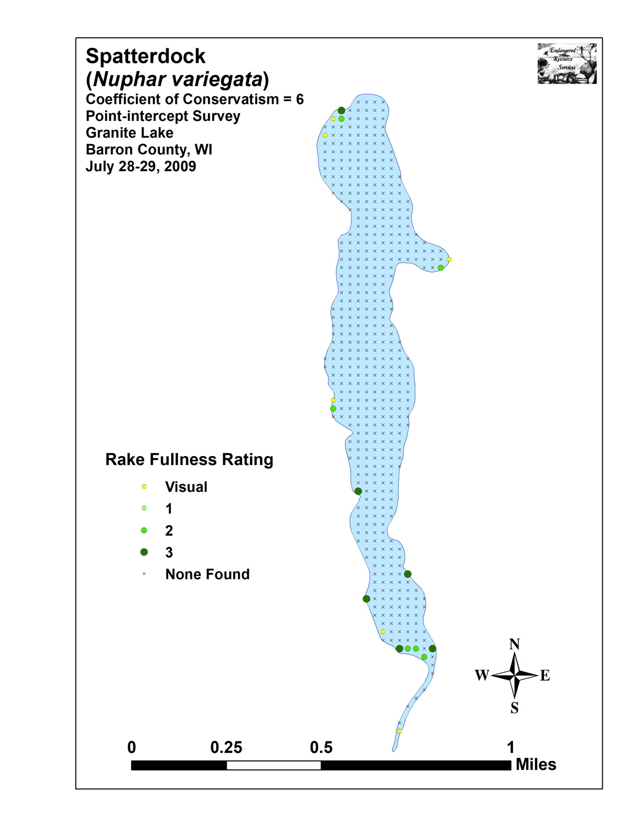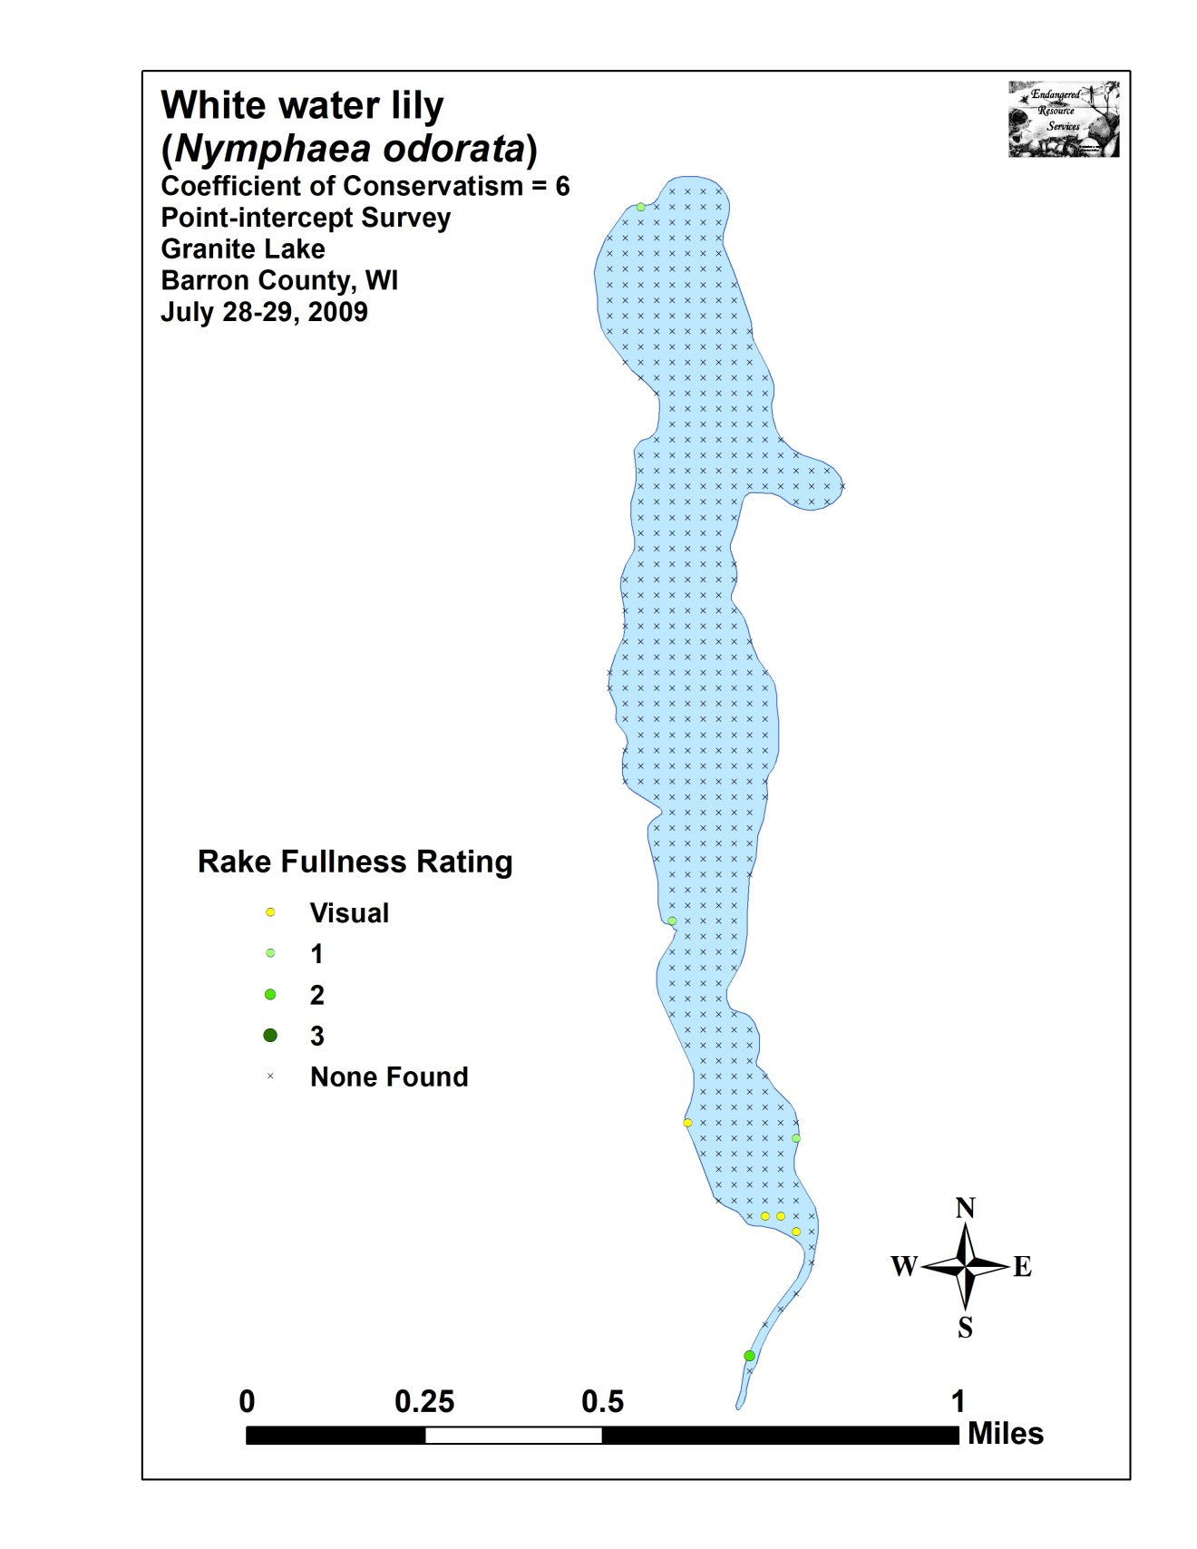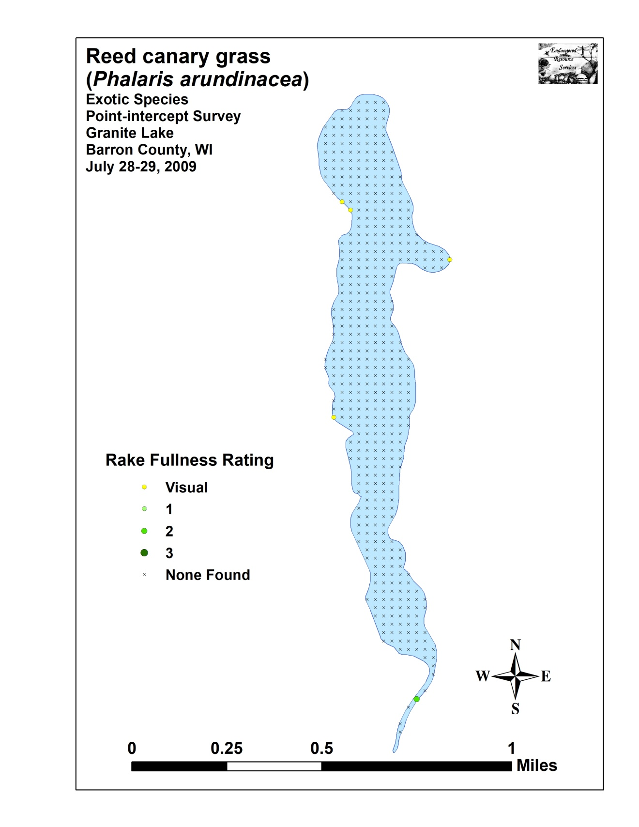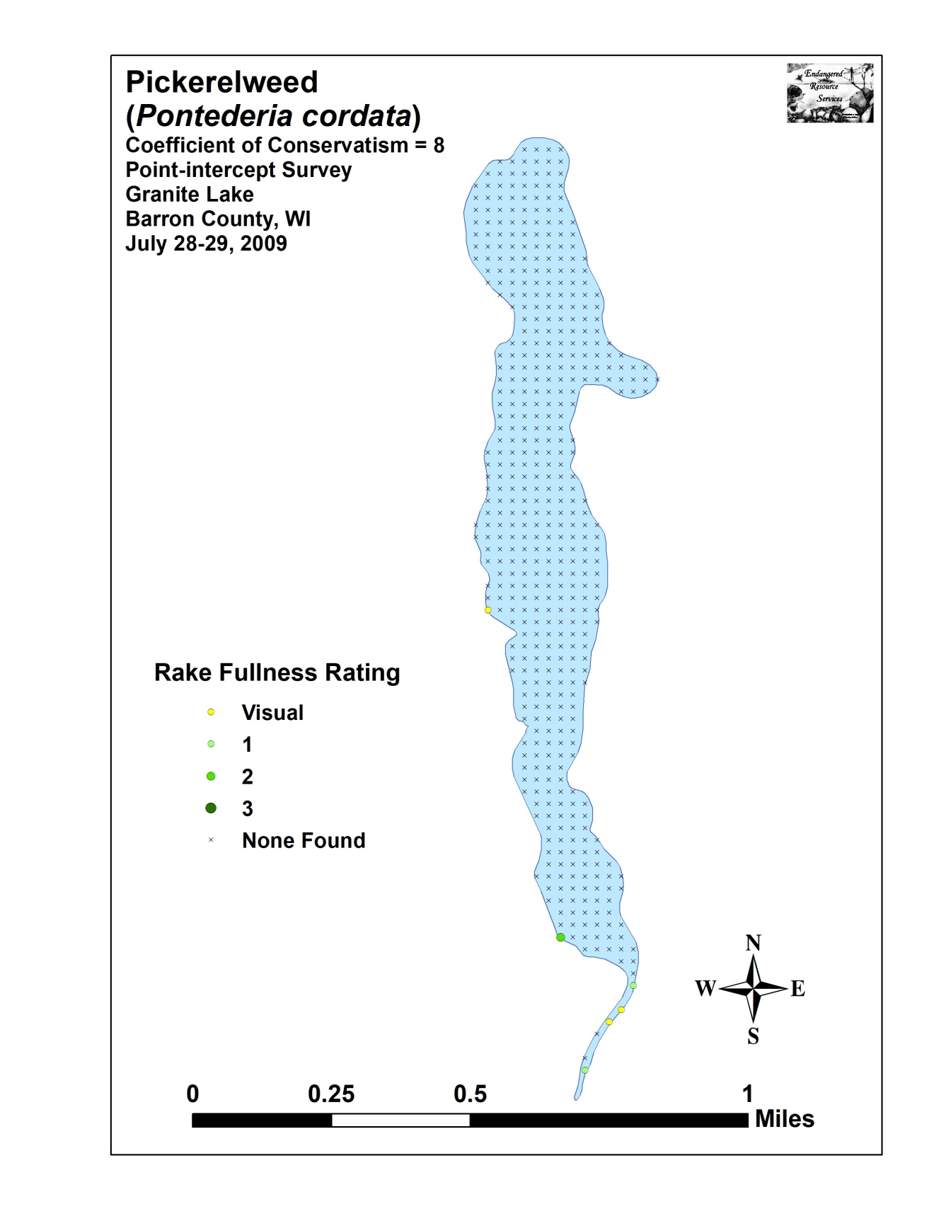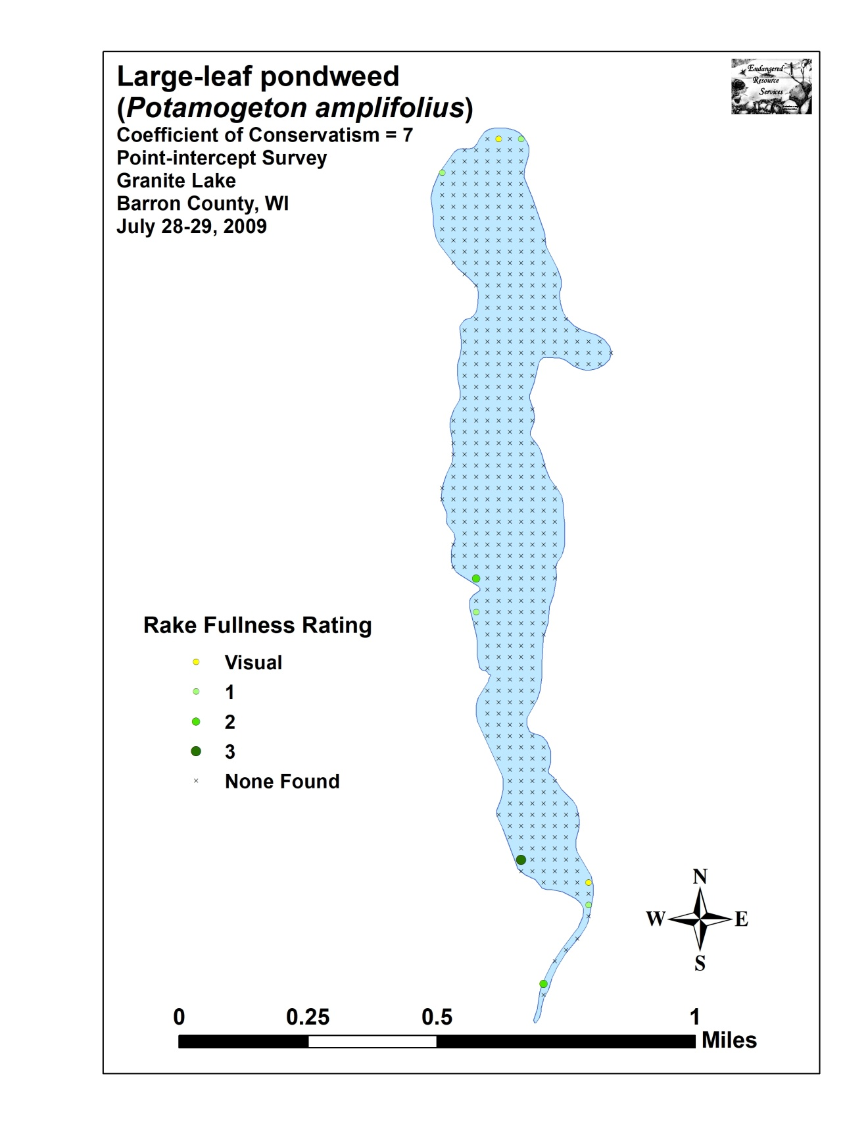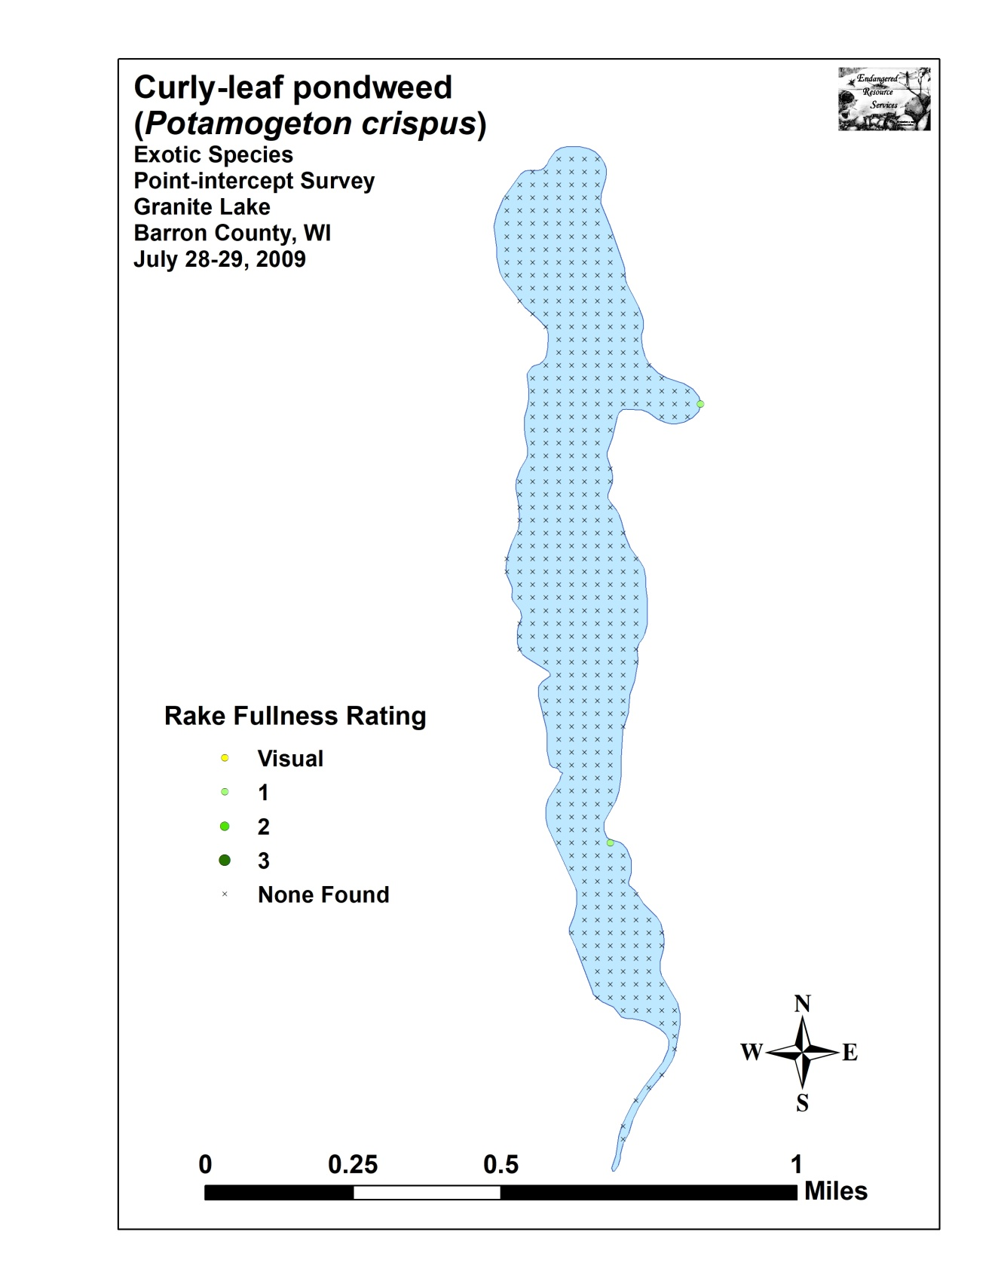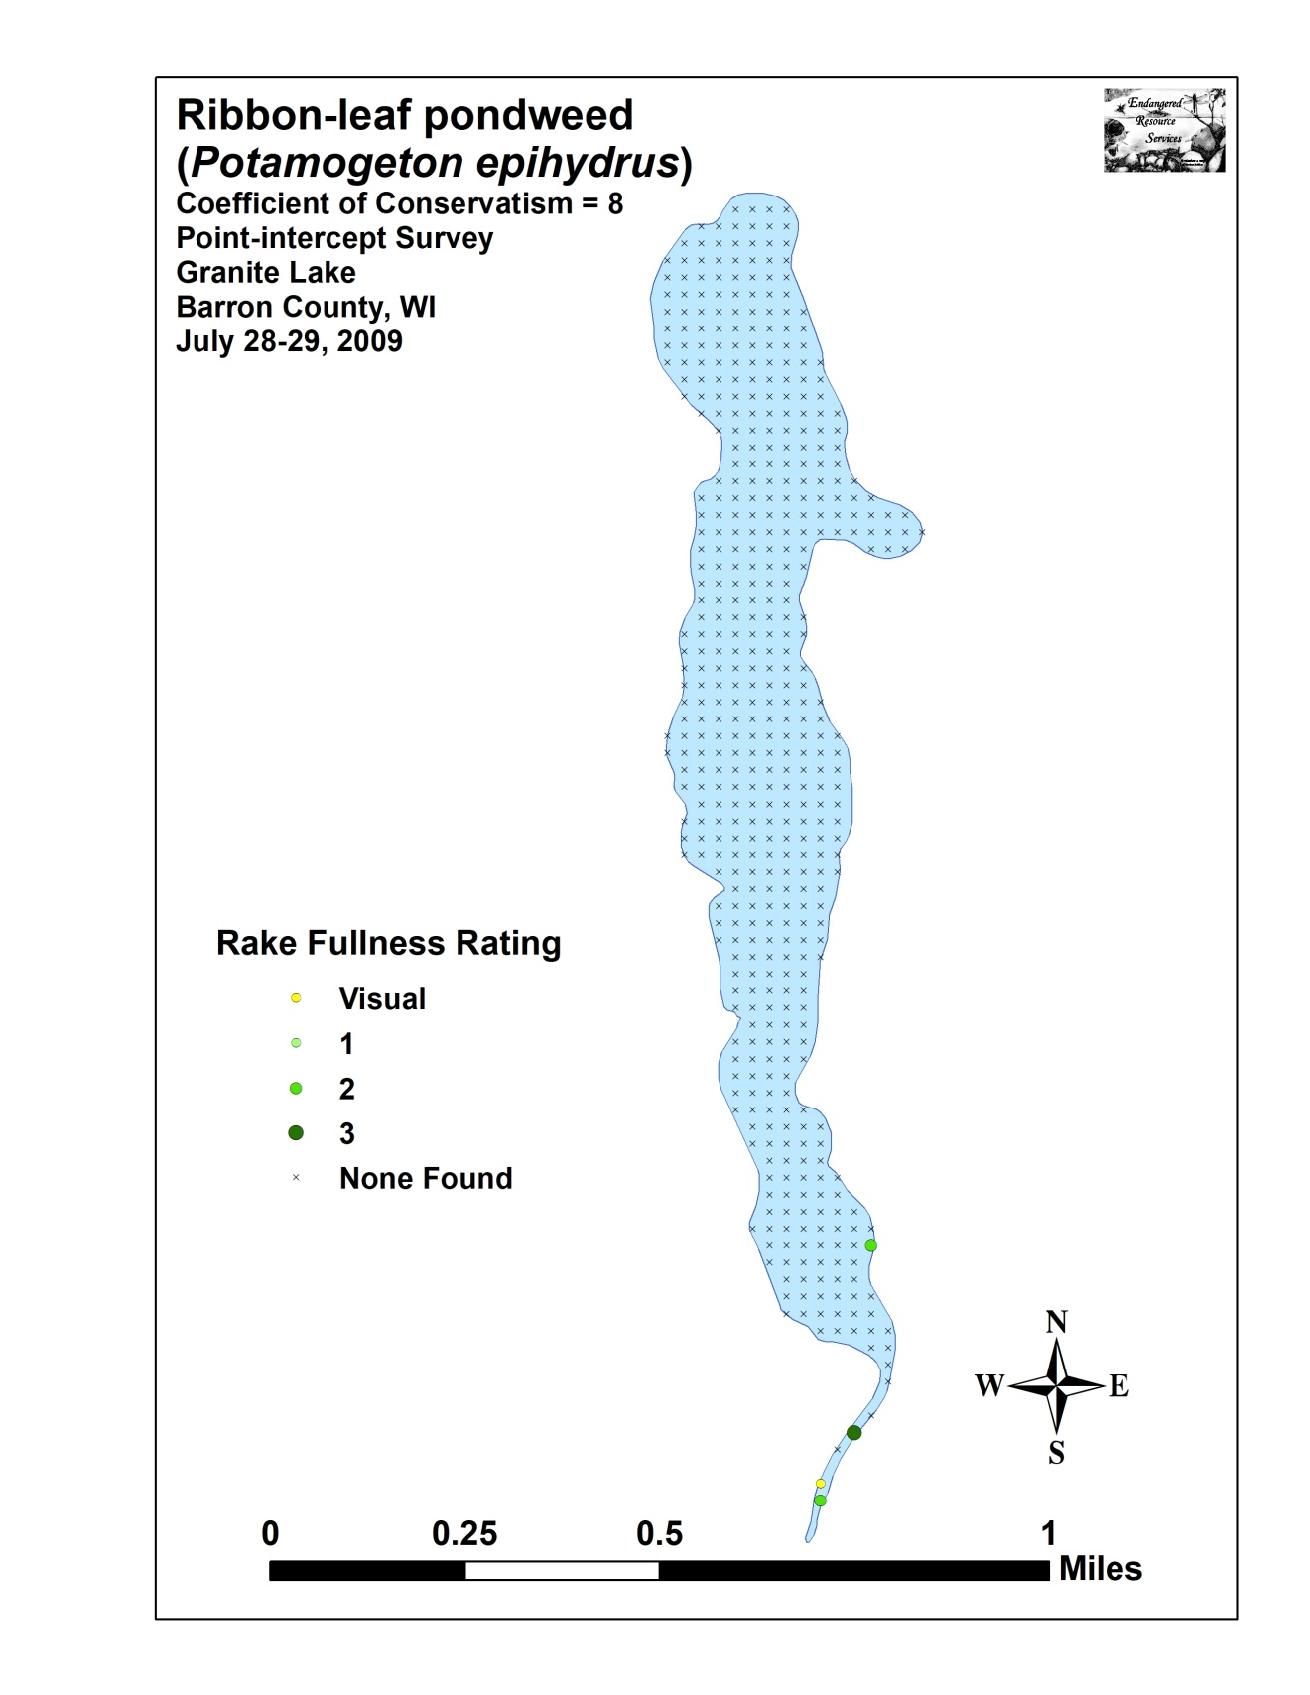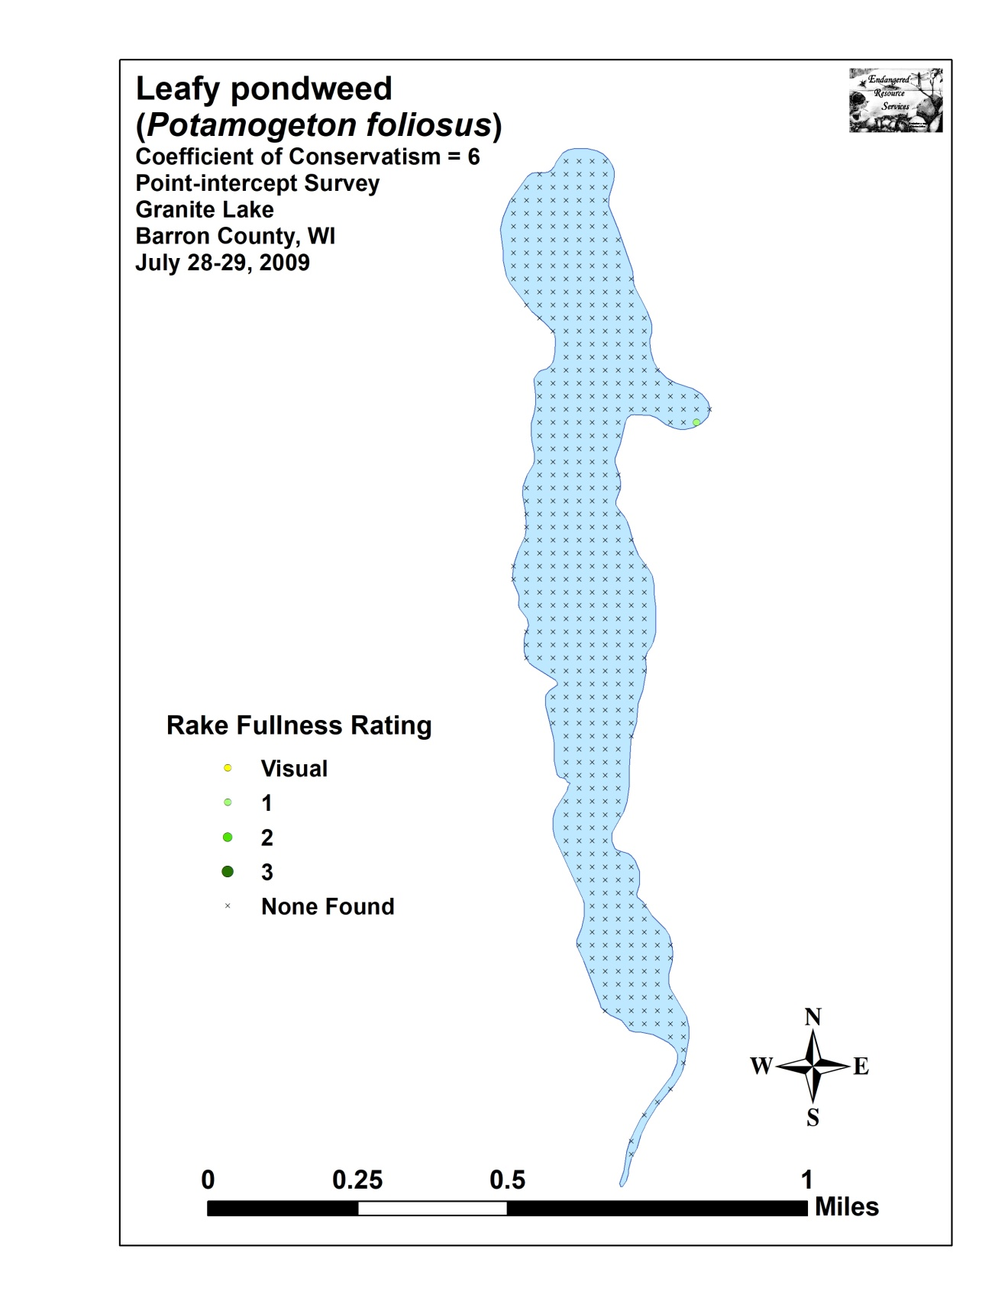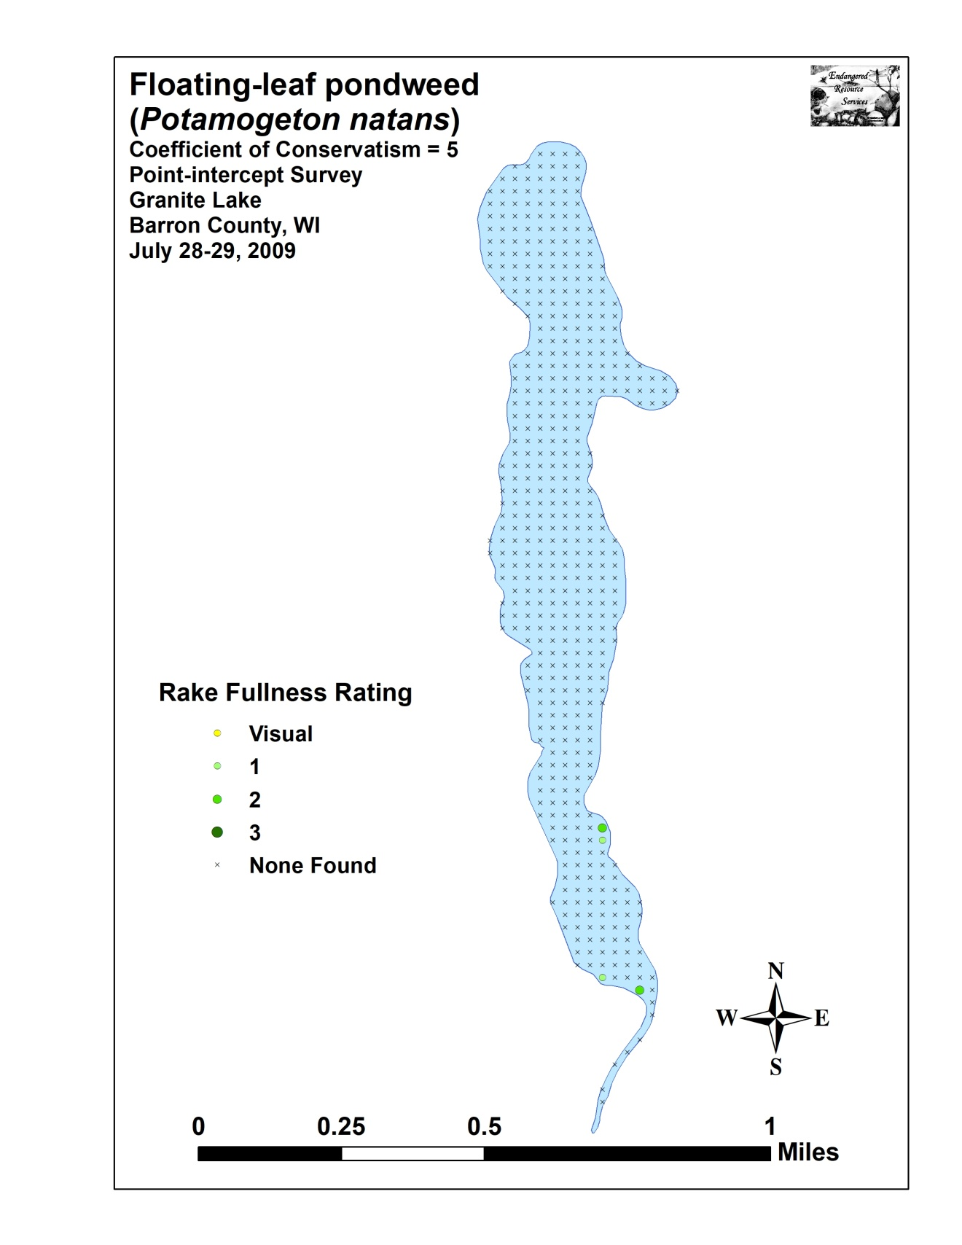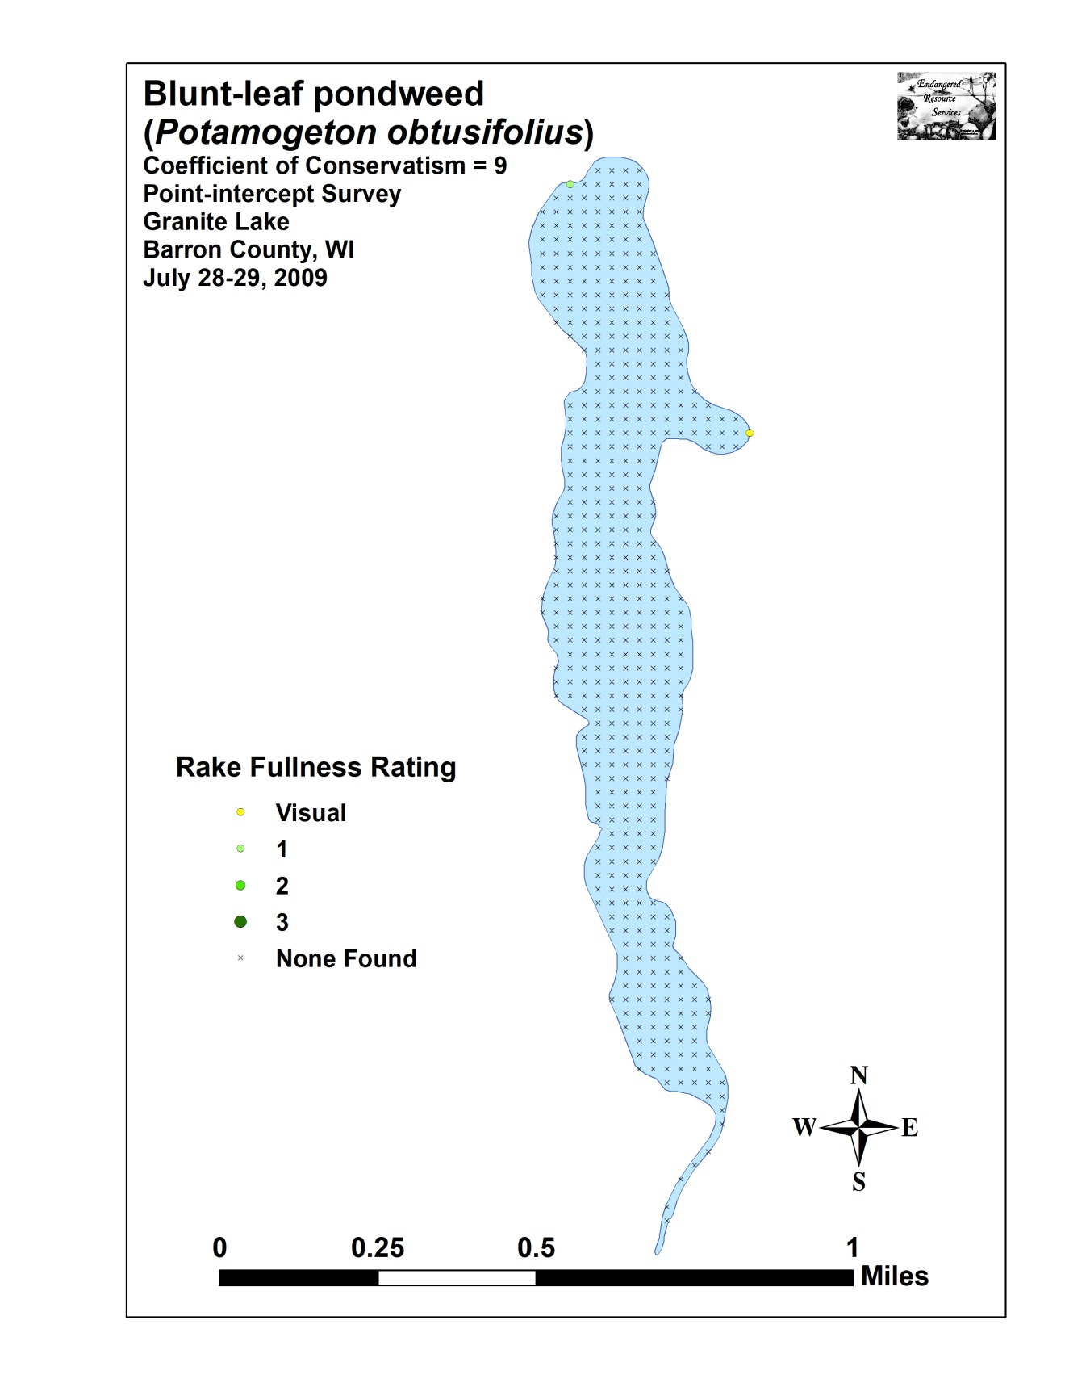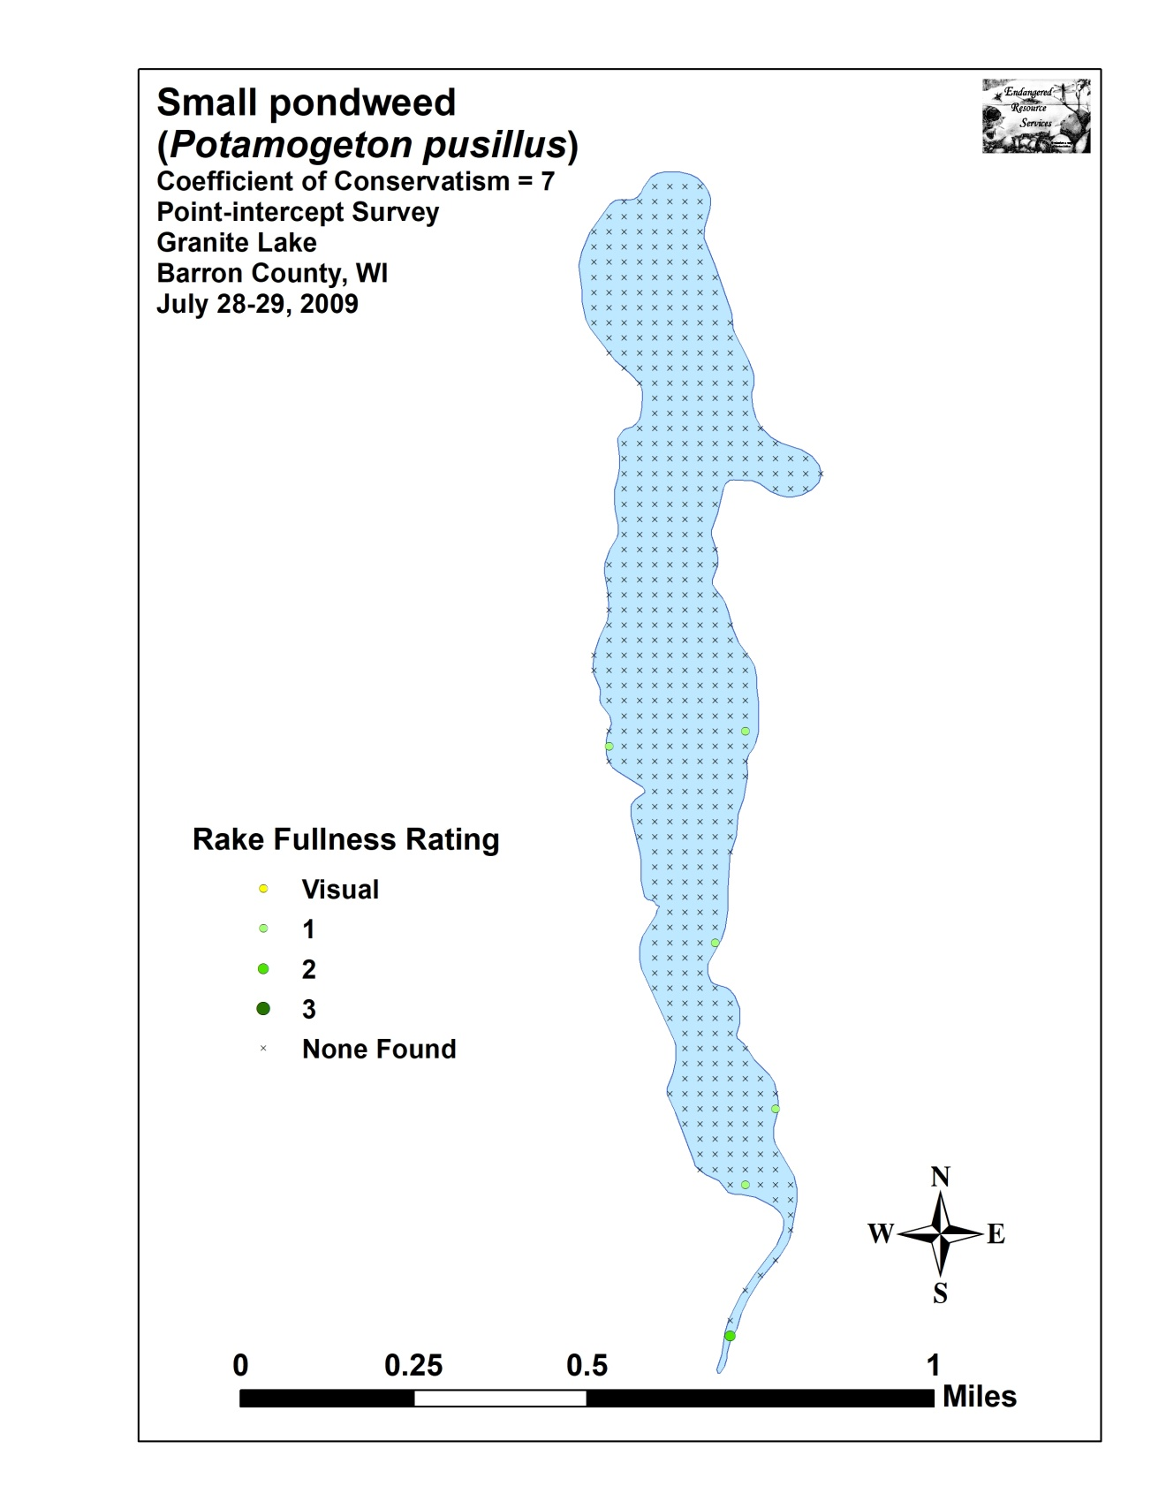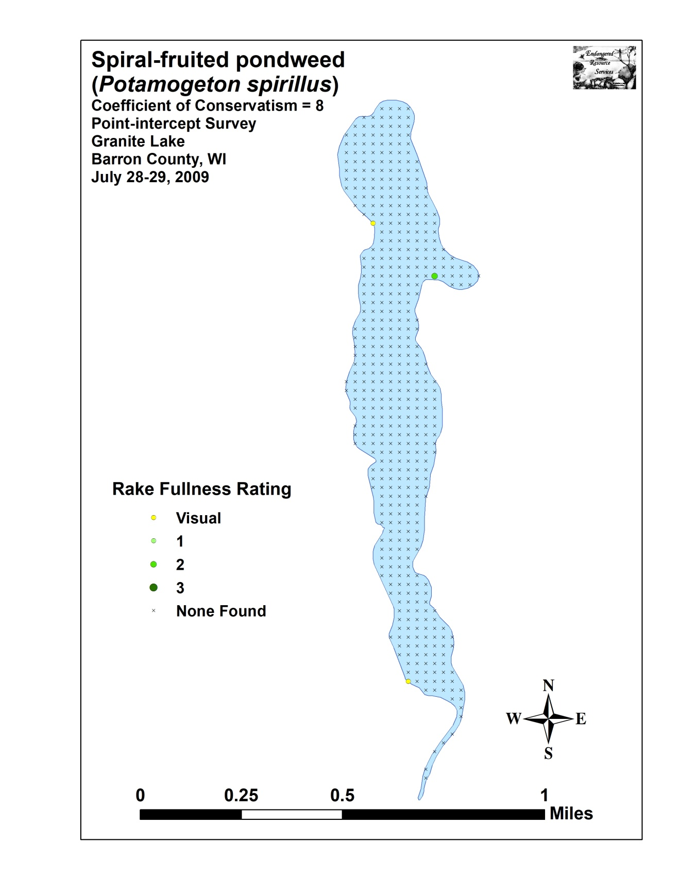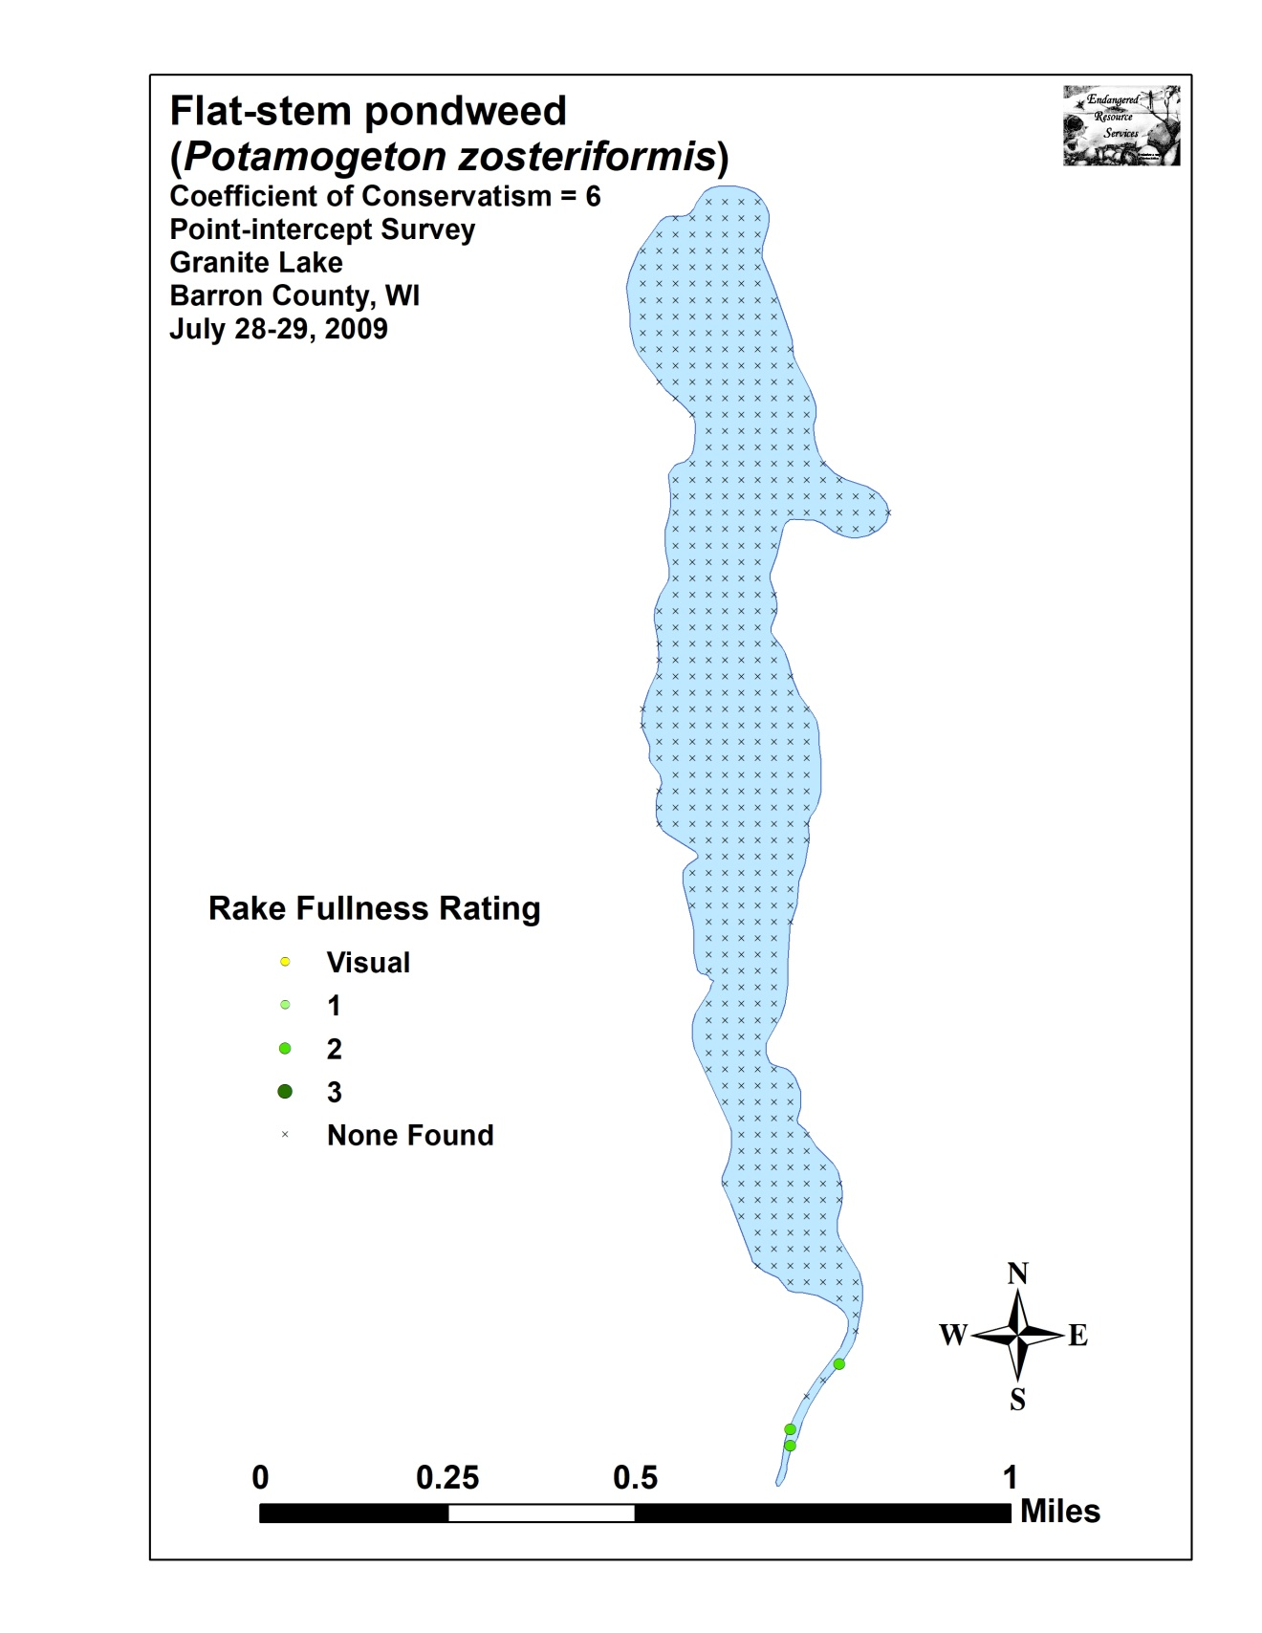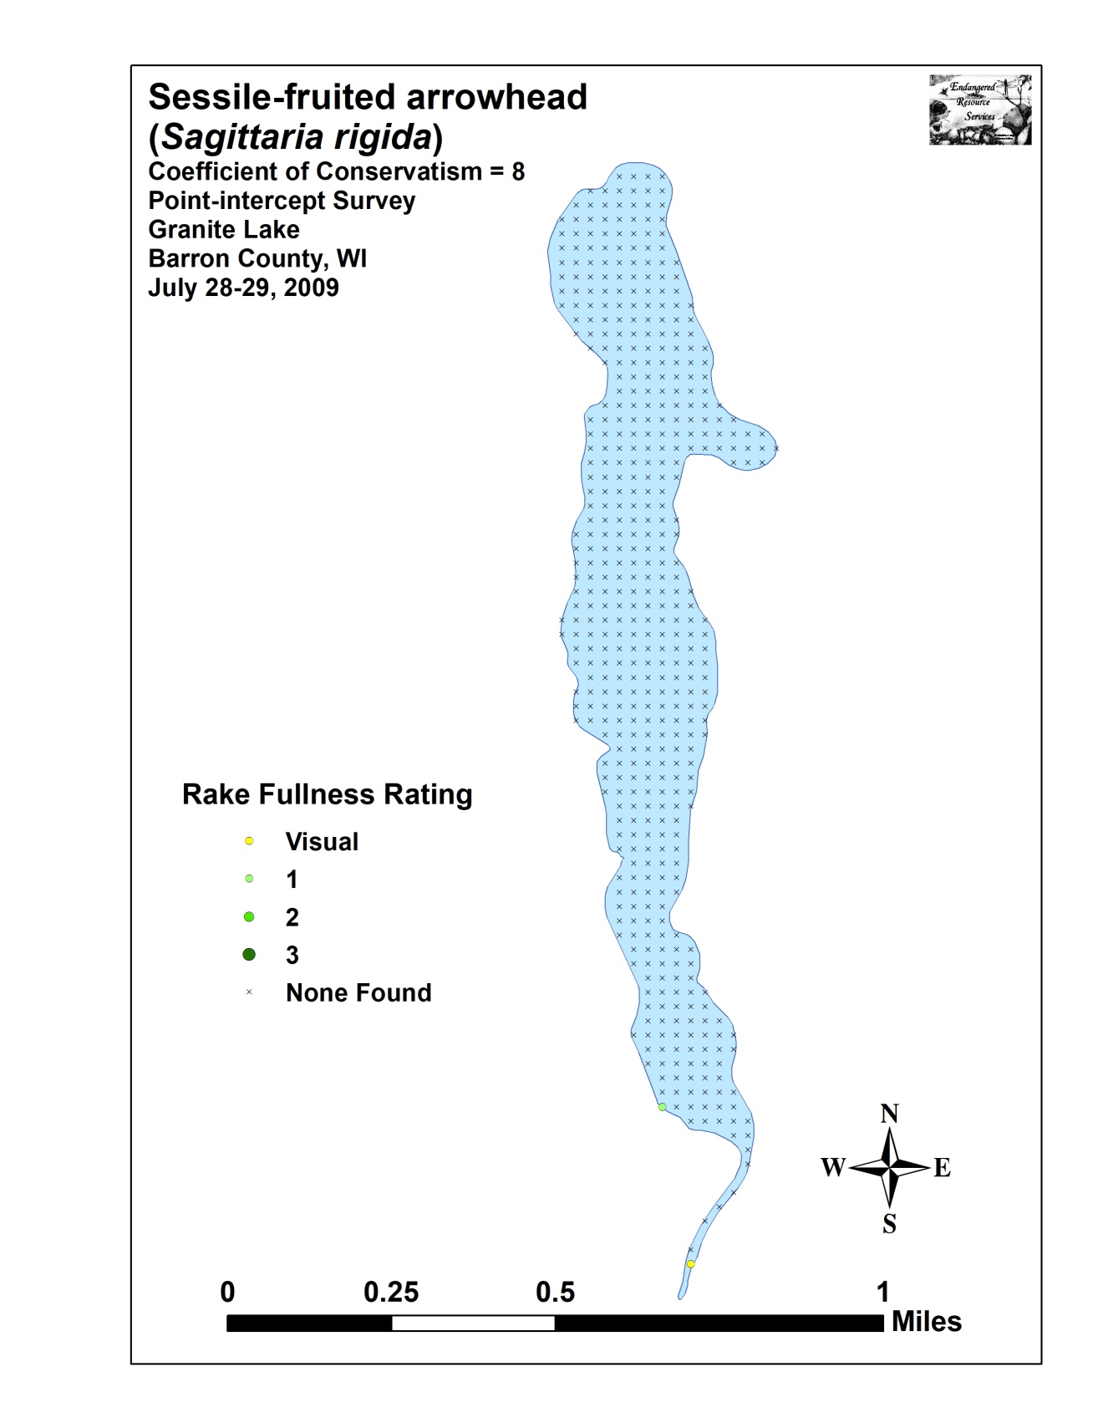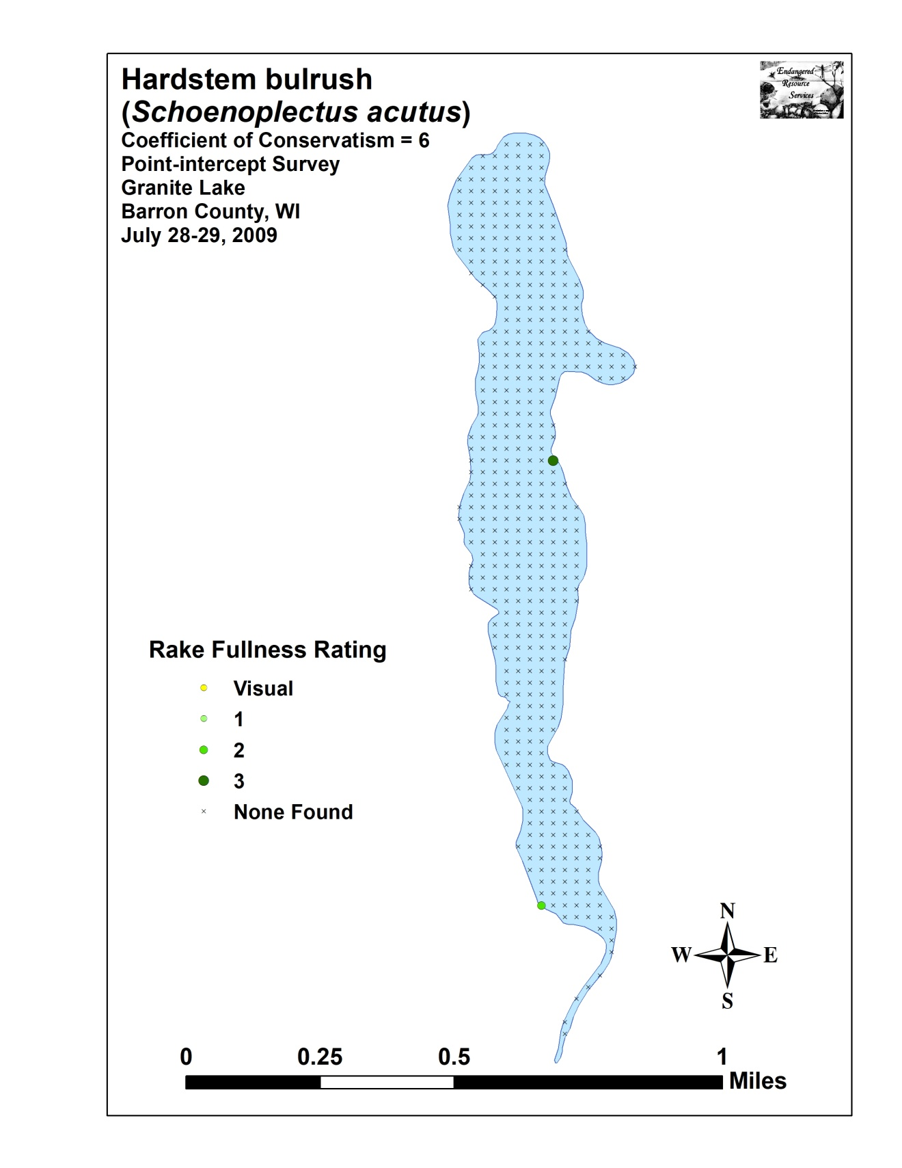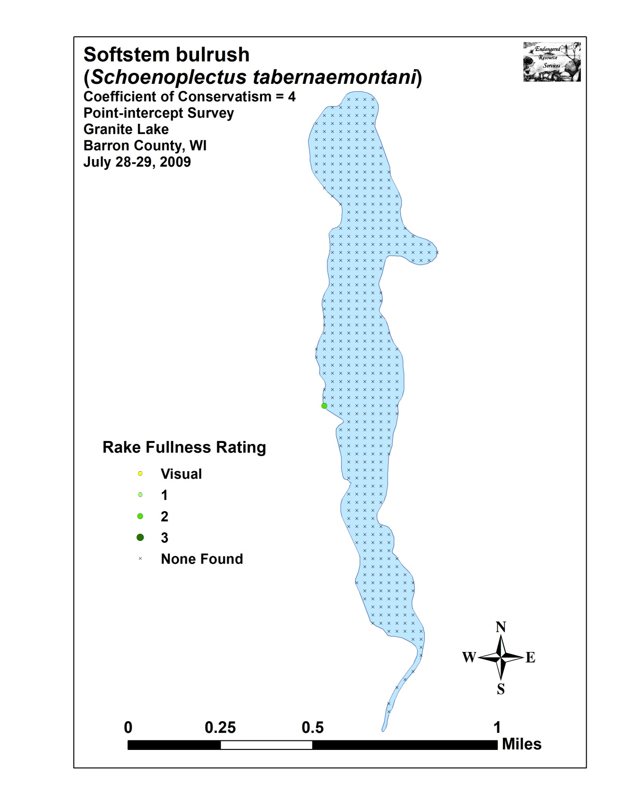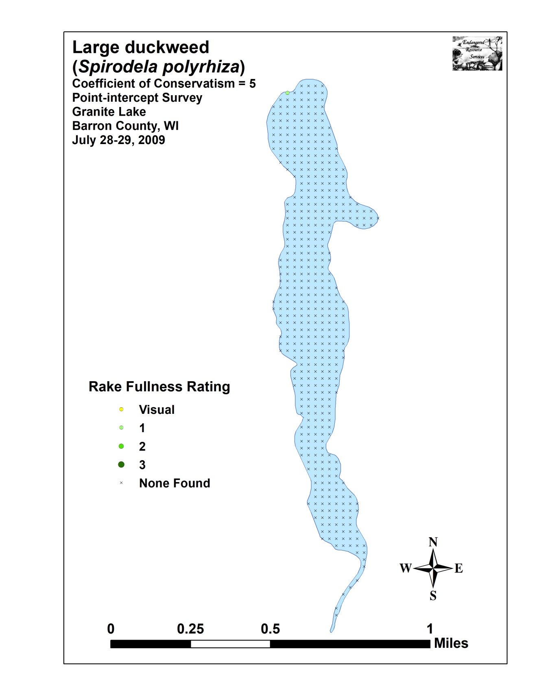

Appendix VII: Granite Lake Plant Species Accounts

County/State: Barron County, Wisconsin Date: 7/28/09
Species: (Bolboschoenus fluviatilis) River bulrush
Specimen Location: Granite Lake; N45.57704°, W92.00505°
Collected/Identified by: Matthew S. Berg Col. #: MSB-2009-228
Habitat/Distribution: Uncommon in scattered muck locations along primarily the western shoreline and at the creek inlet and outlet.
Common Associates: (Phalaris arundinacea) Reed canary grass, (Sparganium eurycarpum) Common bur-reed

County/State: Barron County, Wisconsin Date: 7/28/09
Species: (Carex lacustris) Lake sedge
Specimen Location: Granite Lake; N45.57612°, W92.00809°
Collected/Identified by: Matthew S. Berg Col. #: MSB-2009-229
Habitat/Distribution: Single large bed of plants found growing in .25 meters of water from the point to the shoreline.
Common Associates: (Nuphar variegata) Spatterdock, (Najas flexilis) Slender naiad, (Eleocharis palustris) Creeping spikerush, (Sparganium eurycarpum) Common bur-reed

County/State: Barron County, Wisconsin Date: 7/31/18
Species: (Carex utriculata) Common yellow lake sedge
Specimen Location: Granite Lake; N45.57612°, W92.00809°
Collected/Identified by: Matthew S. Berg Col. #: MSB-2018-229B
Habitat/Distribution: Mixed in with Carex lacustris.
Common Associates: (Nuphar variegata) Spatterdock, (Najas flexilis) Slender naiad, (Eleocharis palustris) Creeping spikerush, (Sparganium eurycarpum) Common bur-reed

County/State: Barron County, Wisconsin Date: 7/28/09
Species: (Ceratophyllum demersum) Coontail
Specimen Location: Granite Lake; N45.58933°, W92.00901°
Collected/Identified by: Matthew S. Berg Col. #: MSB-2009-230
Habitat/Distribution: Most common over muck bottoms in 0-3 meters. Widespread, but only abundant in the south bay and in the creek outlet.
Common Associates: (Nuphar variegata) Spatterdock, (Nymphaea odorata) White water lily, (Elodea canadensis) Common waterweed

County/State: Barron County, Wisconsin Date: 7/28/09
Species: (Dulichium arundinaceum) Threeway sedge
Specimen Location: Granite Lake; N45.56705°, W92.00418°
Collected/Identified by: Matthew S. Berg Col. #: MSB-2009-231
Habitat/Distribution: Muck bottom along the shoreline. Scattered locations in the lake outlet.
Common Associates: (Phalaris arundinacea) Reed canary grass, (Sparganium eurycarpum) Common bur-reed, (Sagittaria latifolia) Common arrowhead

County/State: Barron County, Wisconsin Date: 7/28/09
Species: (Eleocharis palustris) Creeping spikerush
Specimen Location: Granite Lake; N45.57174°, W92.00690°
Collected/Identified by: Matthew S. Berg Col. #: MSB-2009-232
Habitat/Distribution: Firm muck/sand bottom along the shoreline. A few plants were present at widely scattered locations, but the only sizable bed was at the point.
Common Associates: (Sparganium eurycarpum) Common bur-reed, (Schoenoplectus acutus) Hardstem bulrush, (Bolboschoenus fluviatilis) River bulrush, (Carex lacustris) Lake sedge
County/State: Barron County, Wisconsin Date: 7/28/09
Species: (Elodea canadensis) Common waterweed
Specimen Location: Granite Lake; N45.58903°, W92.00855°
Collected/Identified by: Matthew S. Berg Col. #: MSB-2009-233
Habitat/Distribution: Variable bottom in 1-2 meters of water.
Relative common and widespread throughout. A depauperate ecotype likely due to the scarcity of its normal preferred habitat of organic muck. Most terminal leaves were crowded, between 1.6 and 2.3mm wide and had length/width ratios that were mostly < 4:1.
Common Associates: (Ceratophyllum demersum) Coontail, (Nuphar variegata) Spatterdock, (Najas flexilis) Slender naiad

County/State: Barron County, Wisconsin Date: 7/28/09
Species: (Equisetum fluviatile) Water horsetail
Specimen Location: Granite Lake; N45.56922°, W92.00605°
Collected/Identified by: Matthew S. Berg Col. #: MSB-2009-234
Habitat/Distribution: Found in mucky sand over gravel in 0-1 meters of water. A few large patches were scattered in the south bay.
Common Associates: (Pontederia cordata) Pickerelweed, (Schoenoplectus acutus) Hardstem bulrush, (Nuphar variegata) Spatterdock, (Najas flexilis) Slender naiad, (Potamogeton natans) Floating-leaf pondweed

County/State: Barron County, Wisconsin Date: 7/28/09
Species: (Glyceria borealis) Northern manna grass
Specimen Location: Granite Lake; N45.57084°, W92.00387°
Collected/Identified by: Matthew S. Berg Col. #: MSB-2009-235
Habitat/Distribution: A small stand was located in from the point in water <.25m deep over firm sand/rock substrate.
Common Associates: (Najas flexilis) Slender naiad

County/State: Barron County, Wisconsin Date: 7/29/09
Species: (Heteranthera dubia) Water star-grass
Specimen Location: Granite Lake; N45.58343°, W92.00432°
Collected/Identified by: Matthew S. Berg Col. #: MSB-2009-236
Habitat/Distribution: Firm mucky/sand bottoms in water < 1 meter deep. Only a handful of individuals were found in the east bay and directly across from the bay on the western shore.
Common Associates: (Najas flexilis) Slender naiad

County/State: Barron County, Wisconsin Date: 7/28/09
Species: (Juncus tenuis) Path rush
Specimen Location: Granite Lake; N45.57824°, W92.00930°
Collected/Identified by: Matthew S. Berg Col. #: MSB-2009-237
Habitat/Distribution: A few individuals were located at the boat landing in firm muck just away from the water’s edge.
Common Associates: (Phalaris arundinacea) Reed canary grass, (Sagittaria rigida) Sessile-fruited arrowhead, (Scirpus atrovirens) Black bulrush

County/State: Barron County, Wisconsin Date: 7/28/09
Species: (Lemna minor) Small duckweed
Specimen Location: Granite Lake; N45.58933°, W92.00901°
Collected/Identified by: Matthew S. Berg Col. #: MSB-2009-238
Habitat/Distribution: Located floating at or just under the surface in sheltered areas. Scattered individuals found interspersed between the lilypads in the north and south bays and in the creek inlet/outlet.
Common Associates: (Nymphaea odorata) White water lily, (Nuphar variegata) Spatterdock, (Spirodela polyrhiza) Large duckweed

County/State: Barron County, Wisconsin Date: 7/28/09
Species: (Lythrum salicaria) Purple loosestrife
Specimen Location: Granite Lake; N45.57084°, W92.00387°
Collected/Identified by: Matthew S. Berg Col. #: MSB-2009-239
Habitat/Distribution: Uncommon but widely distributed in muck soil at the lakeshore. Most plants were scattered along the southeast shoreline.
Common Associates: (Typha latifolia) Broad-leaved cattail, (Phalaris arundinacea) Reed canary grass

County/State: Barron County, Wisconsin Date: 7/31/18
Species: (Myosotis scorpioides) Common forget-me-not
Specimen Location: Granite Lake; N45.57677°, W92.00905°
Collected/Identified by: Matthew S. Berg Col. #: MSB-2018-239B
Habitat/Distribution: A patch of perhaps 100 plants was scattered around an apparent cold-water seep in the bay directly south of the western public boat landing.
Common Associates: (Phalaris arundinacea) Reed canary grass

County/State: Barron County, Wisconsin Date: 7/28/09
Species: (Najas flexilis) Slender naiad
Specimen Location: Granite Lake; N45.57768°, W92.00905°
Collected/Identified by: Matthew S. Berg Col. #: MSB-2009-240
Habitat/Distribution: Found in almost any bottom conditions, but grows best in rock/ sand bottoms in 0.5-1.5 meters of water. The most common species in the lake, it was widely distributed throughout, but seldom abundant.
Common Associates: (Potamogeton pusillus) Small pondweed, (Potamogeton spirillus) Spiral-fruited pondweed, (Schoenoplectus acutus) Hardstem bulrush

County/State: Barron County, Wisconsin Date: 7/28/09
Species: (Nitella sp.) Nitella
Specimen Location: Granite Lake; N45.56923°, W92.00561°
Collected/Identified by: Matthew S. Berg Col. #: MSB-2009-241
Habitat/Distribution: Muck bottom area in water generally less than 2 meters deep. Rare and widely scattered.
Common Associates: (Ceratophyllum demersum) Coontail, (Elodea canadensis) Common waterweed, (Najas flexilis) Slender naiad

County/State: Barron County, Wisconsin Date: 7/28/09
Species: (Nuphar variegata) Spatterdock
Specimen Location: Granite Lake; N45.58933°, W92.00901°
Collected/Identified by: Matthew S. Berg Col. #: MSB-2009-242
Habitat/Distribution: Muck bottom in 0-2 meters of water where it often forms dense canopies. Common in the north, south and mid lay bays. It prefers a firmer bottom than (Nymphaea odorata).
Common Associates: (Nymphaea odorata) White water lily, (Potamogeton natans) Floating-leaf pondweed, (Pontederia cordata) Pickerelweed, (Ceratophyllum demersum) Coontail, (Elodea canadensis) Common waterweed

County/State: Barron County, Wisconsin Date: 7/28/09
Species: (Nymphaea odorata) White water lily
Specimen Location: Granite Lake; N45.58933°, W92.00901°
Collected/Identified by: Matthew S. Berg Col. #: MSB-2009-243
Habitat/Distribution: Muck bottom in 0-2 meters where it forms dense canopies. Common in the lake’s north and south bays – scattered elsewhere.
Common Associates: (Nuphar variegata) Spatterdock, (Ceratophyllum demersum) Coontail

County/State: Barron County, Wisconsin Date: 7/28/09
Species: (Phalaris arundinacea) Reed canary grass
Specimen Location: Granite Lake; N45.57824°, W92.00930°
Collected/Identified by: Matthew S. Berg Col. #: MSB-2009-244
Habitat/Distribution: Common but not abundant. Prefers thick muck soil in and out of water <0.25 meters. Primarily found on shore in undeveloped low areas.
Common Associates: (Lythrum salicaria) Purple loosestrife, (Typha latifolia) Broad-leaved cattail, (Sagittaria latifolia) Common arrowhead, (Dulichium arundinaceum) Threeway sedge

County/State: Barron County, Wisconsin Date: 7/28/09
Species: (Pontederia cordata) Pickerelweed
Specimen Location: Granite Lake; N45.57824°, W92.00930°
Collected/Identified by: Matthew S. Berg Col. #: MSB-2009-245
Habitat/Distribution: Silt to muck bottom over firm substrate in 0-1 meter of water. Common in emergent beds scattered throughout the lake; especially in sheltered bays.
Common Associates: (Nymphaea odorata) White water lily, (Nuphar variegata) Spatterdock, (Equisetum fluviatile) Water horsetail, (Sagittaria rigida) Sessile-fruited arrowhead

County/State: Barron County, Wisconsin Date: 7/28/09
Species: (Potamogeton amplifolius) Large-leaf pondweed
Specimen Location: Granite Lake; N45.56609°, W92.00505°
Collected/Identified by: Matthew S. Berg Col. #: MSB-2009-246
Habitat/Distribution: Relatively common and widely distributed throughout where it formed patchy beds over muck and sandy muck areas. One of the few broad-leaved plants in the lake, amplifolius provides some of Granite’s best fish habitat.
Common Associates: (Najas flexilis) Slender naiad, (Ceratophyllum demersum) Coontail

County/State: Barron County, Wisconsin Date: 5/27/09
Species: (Potamogeton crispus) Curly-leaf pondweed
Specimen Location: Granite Lake; N45.57177°, W92.00480°
Collected/Identified by: Matthew S. Berg Col. #: MSB-2009-247
Habitat/Distribution: Found in mucky bottom areas in water from 1-2.5m deep. Rare with a total of 8 plants seen in the lake during the CLP and warm water P/I survey. A few additional plants were located in the lake outlet.
Common Associates: (Elodea canadensis) Common waterweed, (Ceratophyllum demersum) Coontail

County/State: Barron County, Wisconsin Date: 7/28/09
Species: (Potamogeton epihydrus) Ribbon-leaf pondweed
Specimen Location: Granite Lake; N45.56609°, W92.00505°
Collected/Identified by: Matthew S. Berg Col. #: MSB-2009-248
Habitat/Distribution: Found in sand - muck bottom conditions in shallow water 0.5-1.0 meter deep. Scattered locations in the south bay and in the lake outlet. It was more common in May. Perhaps grazed by Carp?
Common Associates: (Potamogeton pusillus) Small pondweed, (Elodea canadensis) Common waterweed, (Ceratophyllum demersum) Coontail, (Potamogeton zosteriformis) Flat-stem pondweed

County/State: Barron County, Wisconsin Date: 7/29/09
Species: (Potamogeton foliosus) Leafy pondweed
Specimen Location: Granite Lake; N45.58345°, W92.00342°
Collected/Identified by: Matthew S. Berg Col. #: MSB-2009-249
Habitat/Distribution: Variable substrate in 0-2 meters of water. Rare being found at only one point and seen in two other locations. May be more common than survey indicated. Keeled fruits and a lack of nodal glands were needed to separate plants from the very similar P. pusillus. Few individuals were in fruit so we erred on the side of caution and called them small if there was uncertainty.
Common Associates: (Elodea canadensis) Common waterweed, (Nuphar variegata) Spatterdock

County/State: Barron County, Wisconsin Date: 7/28/09
Species: (Potamogeton natans) Floating-leaf pondweed
Specimen Location: Granite Lake; N45.56892°, W92.00515°
Collected/Identified by: Matthew S. Berg Col. #: MSB-2009-250
Habitat/Distribution: Muck and sand bottom in 1meter of water. Restricted to the south bay. Especially common near the outlet.
Common Associates: (Ceratophyllum demersum) Coontail, (Potamogeton amplifolius) Large-leaf pondweed, (Elodea canadensis) Common waterweed, (Nymphaea odorata) White water lily, (Nuphar variegata) Spatterdock, (Pontederia cordata) Pickerelweed

County/State: Barron County, Wisconsin Date: 7/28/09
Species: (Potamogeton obtusifolius) Blunt-leaf pondweed
Specimen Location: Granite Lake; N45.58933°, W92.00901°
Collected/Identified by: Matthew S. Berg Col. #: MSB-2009-251
Habitat/Distribution: Uncommon in thick muck bottom areas near the creek inlet on the north side in shallow water 0.5-1 meter deep. A few stunted individuals were also found in the far end of the east bay.
Common Associates: (Ceratophyllum demersum) Coontail, (Potamogeton amplifolius) Large-leaf pondweed, (Nuphar variegata) Spatterdock, (Nymphaea odorata) White water lily
County/State: Barron County, Wisconsin Date: 7/28/09
Species: (Potamogeton pusillus) Small pondweed
Specimen Location: Granite Lake; N45.57768°, W92.00905°
Collected/Identified by: Matthew S. Berg Col. #: MSB-2009-252
Habitat/Distribution: Found in almost any bottom conditions, but grew best in muck bottoms in 1-2 meters of water. It was widely distributed but uncommon except for a few places in the south bay. Plants were especially depauperate and looked very similar to foliosus. We separated by the faint nodal glands and winter buds that were common and small, but pusillus like. No plants were in fruit.
Common Associates: (Ceratophyllum demersum) Coontail, (Elodea canadensis) Common waterweed

County/State: Barron County, Wisconsin Date: 7/28/09
Species: (Potamogeton robbinsii) Fern pondweed
Specimen Location: Granite Lake; N45.58955°, W92.00335°
Collected/Identified by: Matthew S. Berg Col. #: MSB-2009-251
Habitat/Distribution: Uncommon in thick muck bottom areas near the creek inlet on the north side in shallow water 0.5-1 meter deep. A few stunted individuals were also found in the far end of the east bay.
Common Associates: (Ceratophyllum demersum) Coontail, (Potamogeton amplifolius) Large-leaf pondweed, (Nuphar variegata) Spatterdock, (Potamogeton pusillus) Small pondweed, (Elodea canadensis) Common waterweed, (Potamogeton zosteriformis) Flat-stem pondweed

County/State: Barron County, Wisconsin Date: 7/28/09
Species: (Potamogeton spirillus) Spiral-fruited pondweed
Specimen Location: Granite Lake; N45.56922°, W92.00605°
Collected/Identified by: Matthew S. Berg Col. #: MSB-2009-253
Habitat/Distribution: Found in rock/ sand bottoms in 0-1 meter of water. Uncommon, but widely distributed throughout the lake. Its coiled seeds and curled leaves make it easy to separate from other thin leaved pondweeds.
Common Associates: (Najas flexilis) Slender naiad

County/State: Barron County, Wisconsin Date: 7/31/18
Species: (Potamogeton vaseyi) Vasey’s pondweed
Specimen Location: Granite Lake; N45.56609°, W92.00505°
Collected/Identified by: Matthew S. Berg Col. #: MSB-2019-253B
Habitat/Distribution: Abundant in the lake outlet where it mixed with P. pusillus. Likely overlooked in 2009 as most plants lacked floating leaves, and we had to search hard for a voucher that had them present.
Common Associates: (Potamogeton pusillus) Small pondweed, (Elodea canadensis) Common waterweed, (Ceratophyllum demersum) Coontail, (Potamogeton zosteriformis) Flat-stem pondweed

County/State: Barron County, Wisconsin Date: 7/28/09
Species: (Potamogeton zosteriformis) Flat-stem pondweed
Specimen Location: Granite Lake; N45.56609°, W92.00505°
Collected/Identified by: Matthew S. Berg Col. #: MSB-2009-254
Habitat/Distribution: Rare; found only in the lake outlet growing over thick organic muck in <1.5m of water.
Common Associates: (Ceratophyllum demersum) Coontail, (Potamogeton epihydrus) Ribbon-leaf pondweed, (Pontederia cordata) Pickerelweed
County/State: Barron County, Wisconsin Date: 7/31/18
Species: (Sagittaria cristata) Crested arrowhead
Specimen Location: Granite Lake; N45.57824°, W92.00930°
Collected/Identified by: Matthew S. Berg Col. #: MSB-2018-254B
Habitat/Distribution: Emergent plants were present along the shoreline near the west side public boat landing.
Common Associates: (Najas flexilis) Slender naiad

County/State: Barron County, Wisconsin Date: 7/28/09
Species: (Sagittaria latifolia) Common arrowhead
Specimen Location: Granite Lake; N45.56705°, W92.00418°
Collected/Identified by: Matthew S. Berg Col. #: MSB-2009-255
Habitat/Distribution: Emergent plants were present along the shoreline of the lake outlet.
Common Associates: (Lythrum salicaria) Purple loosestrife, (Typha latifolia) Broad-leaved cattail, (Dulichium arundinaceum) Threeway sedge

County/State: Barron County, Wisconsin Date: 7/28/09
Species: (Sagittaria rigida) Sessile-fruited arrowhead
Specimen Location: Granite Lake; N45.57824°, W92.00930°
Collected/Identified by: Matthew S. Berg Col. #: MSB-2009-256
Habitat/Distribution: Emergent plants were present in scattered mucky shoreline locations to a depth of .5 meters.
Common Associates: (Schoenoplectus acutus) Hardstem bulrush, (Bolboschoenus fluviatilis) River bulrush, (Pontederia cordata) Pickerelweed, (Najas flexilis) Slender naiad, (Equisetum fluviatile) Water horsetail

County/State: Barron County, Wisconsin Date: 7/28/09
Species: (Schoenoplectus acutus) Hardstem bulrush
Specimen Location: Granite Lake; N45.57824°, W92.00930°
Collected/Identified by: Matthew S. Berg Col. #: MSB-2009-257
Habitat/Distribution: A number of reed beds were located at rocky points throughout.
Common Associates: (Najas flexilis) Slender naiad, (Nuphar variegata) Spatterdock, (Sagittaria rigida) Sessile-fruited arrowhead

County/State: Barron County, Wisconsin Date: 7/28/09
Species: (Schoenoplectus tabernaemontani) Softstem bulrush
Specimen Location: Granite Lake; N45.57768°, W92.00905°
Collected/Identified by: Matthew S. Berg Col. #: MSB-2009-258
Habitat/Distribution: Firm muck bottoms in 0-.5 meter of water. Scattered individuals were interspersed with other emergents in the outlet and a monotypic bed was located at the point.
Common Associates: (Dulichium arundinaceum) Threeway sedge, (Sagittaria latifolia) Common arrowhead, (Phalaris arundinacea) Reed canary grass

County/State: Barron County, Wisconsin Date: 7/28/09
Species: (Scirpus atrovirens) Black bulrush
Specimen Location: Granite Lake; N45.57824°, W92.00930°
Collected/Identified by: Matthew S. Berg Col. #: MSB-2009-259
Habitat/Distribution: A single fruiting specimen was collected at the boat landing.
Common Associates: (Phalaris arundinacea) Reed canary grass, (Sagittaria rigida) Sessile-fruited arrowhead, (Juncus tenuis) Path rush

County/State: Barron County, Wisconsin Date: 7/28/09
Species: (Sparganium eurycarpum) Common bur-reed
Specimen Location: Granite Lake; N45.57174°, W92.00690°
Collected/Identified by: Matthew S. Berg Col. #: MSB-2009-260
Habitat/Distribution: Muck bottom along the shoreline. A few scattered beds were located on the southwest and south shorelines.
Common Associates: (Eleocharis palustris) Creeping spikerush, (Bolboschoenus fluviatilis) River bulrush

County/State: Barron County, Wisconsin Date: 7/28/09
Species: (Spirodela polyrhiza) Large duckweed
Specimen Location: Granite Lake; N45.58933°, W92.00901°
Collected/Identified by: Matthew S. Berg Col. #: MSB-2009-261
Habitat/Distribution: Located floating at or just under the surface. Rare; only a few scattered individuals occurred interspersed between the lilypads near the creek inlet on the north side of the lake.
Common Associates: (Nymphaea odorata) White water lily, (Nuphar variegata) Spatterdock, (Lemna minor) Small duckweed, (Potamogeton obtusifolius) Blunt-leaf pondweed

County/State: Barron County, Wisconsin Date: 7/28/09
Species: (Typha latifolia) Broad-leaved cattail
Specimen Location: Granite Lake; N45.56609°, W92.00505°
Collected/Identified by: Matthew S. Berg Col. #: MSB-2009-262
Habitat/Distribution: Thick muck soil in and out of water <0.25 meters. Found in undeveloped shoreline areas primarily near the lake outlet.
Common Associates: (Schoenoplectus tabernaemontani) Softstem bulrush, (Sagittaria latifolia) Common arrowhead, (Lythrum salicaria) Purple loosestrife, (Phalaris arundinacea) Reed canary grass

County/State: Barron County, Wisconsin Date: 7/31/18
Species: (Utricularia vulgaris) Common bladderwort
Specimen Location: Granite Lake; N45.56609°, W92.00505°
Collected/Identified by: Matthew S. Berg Col. #: MSB-2018-262B
Habitat/Distribution: Shallow water over thick muck soil in the lake outlet.
Common Associates: (Potamogeton epihydrus) Ribbon-leaf pondweed, (Potamogeton pusillus) Small pondweed, (Elodea canadensis) Common waterweed, (Ceratophyllum demersum) Coontail, (Potamogeton zosteriformis) Flat-stem pondweed

County/State: Barron County, Wisconsin Date: 7/31/18
Species: (Wolffia columbiana) Common watermeal
Specimen Location: Granite Lake; N45.58933°, W92.00901°
Collected/Identified by: Matthew S. Berg
Habitat/Distribution: Located floating at or just under the surface. Rare; only a few scattered individuals occurred interspersed between the lilypads near the creek inlet on the north side of the lake.
Common Associates: (Nymphaea odorata) White water lily, (Nuphar variegata) Spatterdock, (Lemna minor) Small duckweed, (Potamogeton obtusifolius) Blunt-leaf pondweed

Appendix VIII: July 2018 Species Density and Distribution Maps

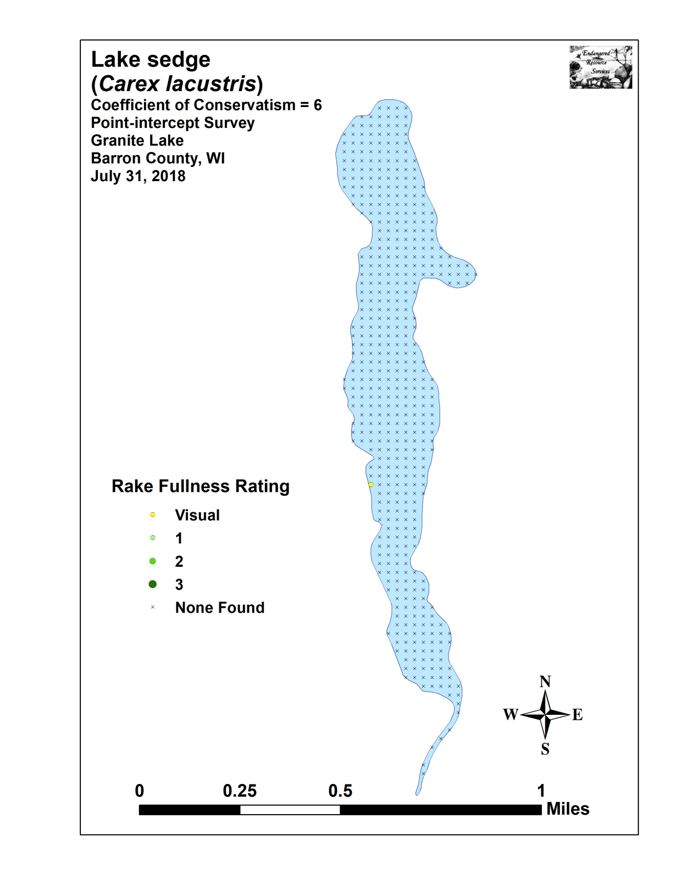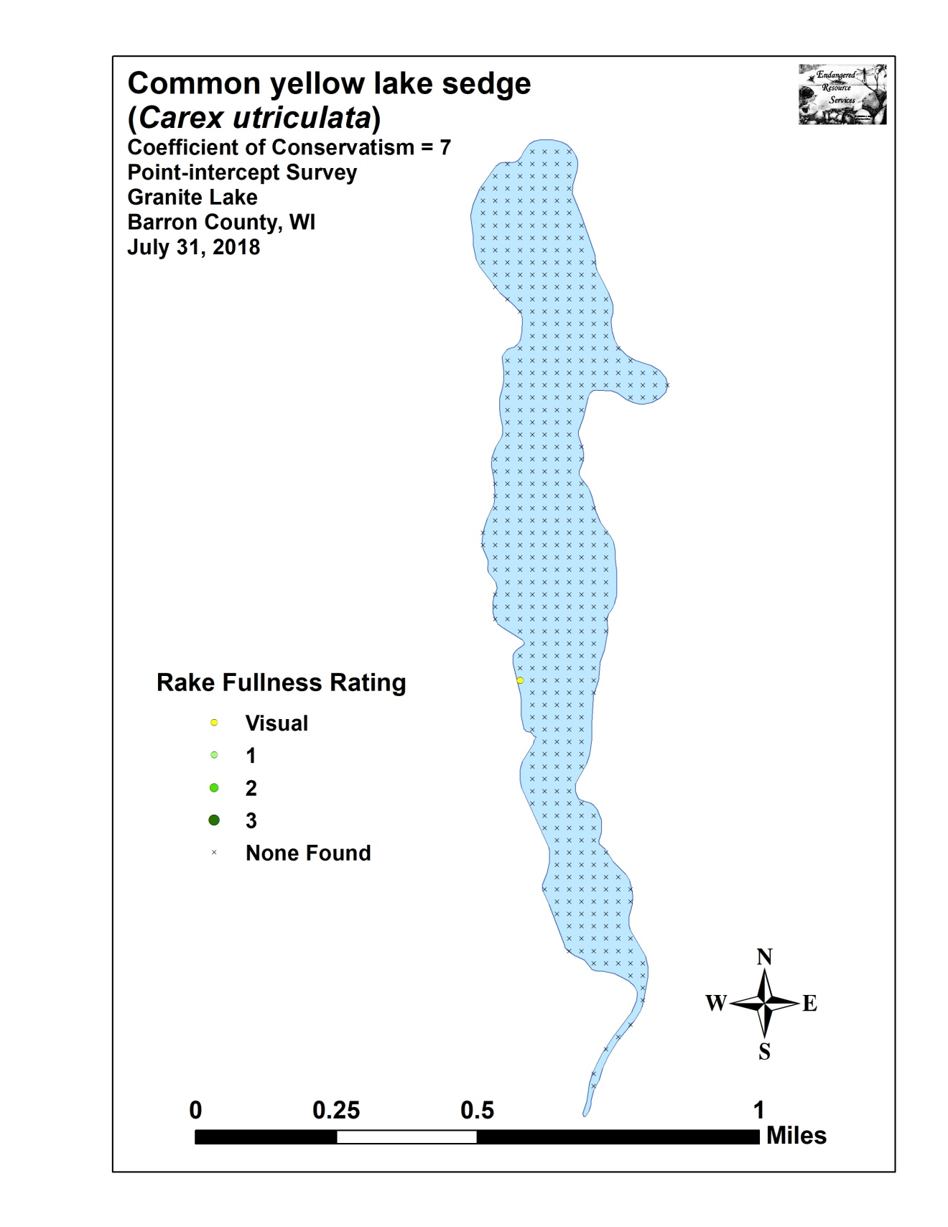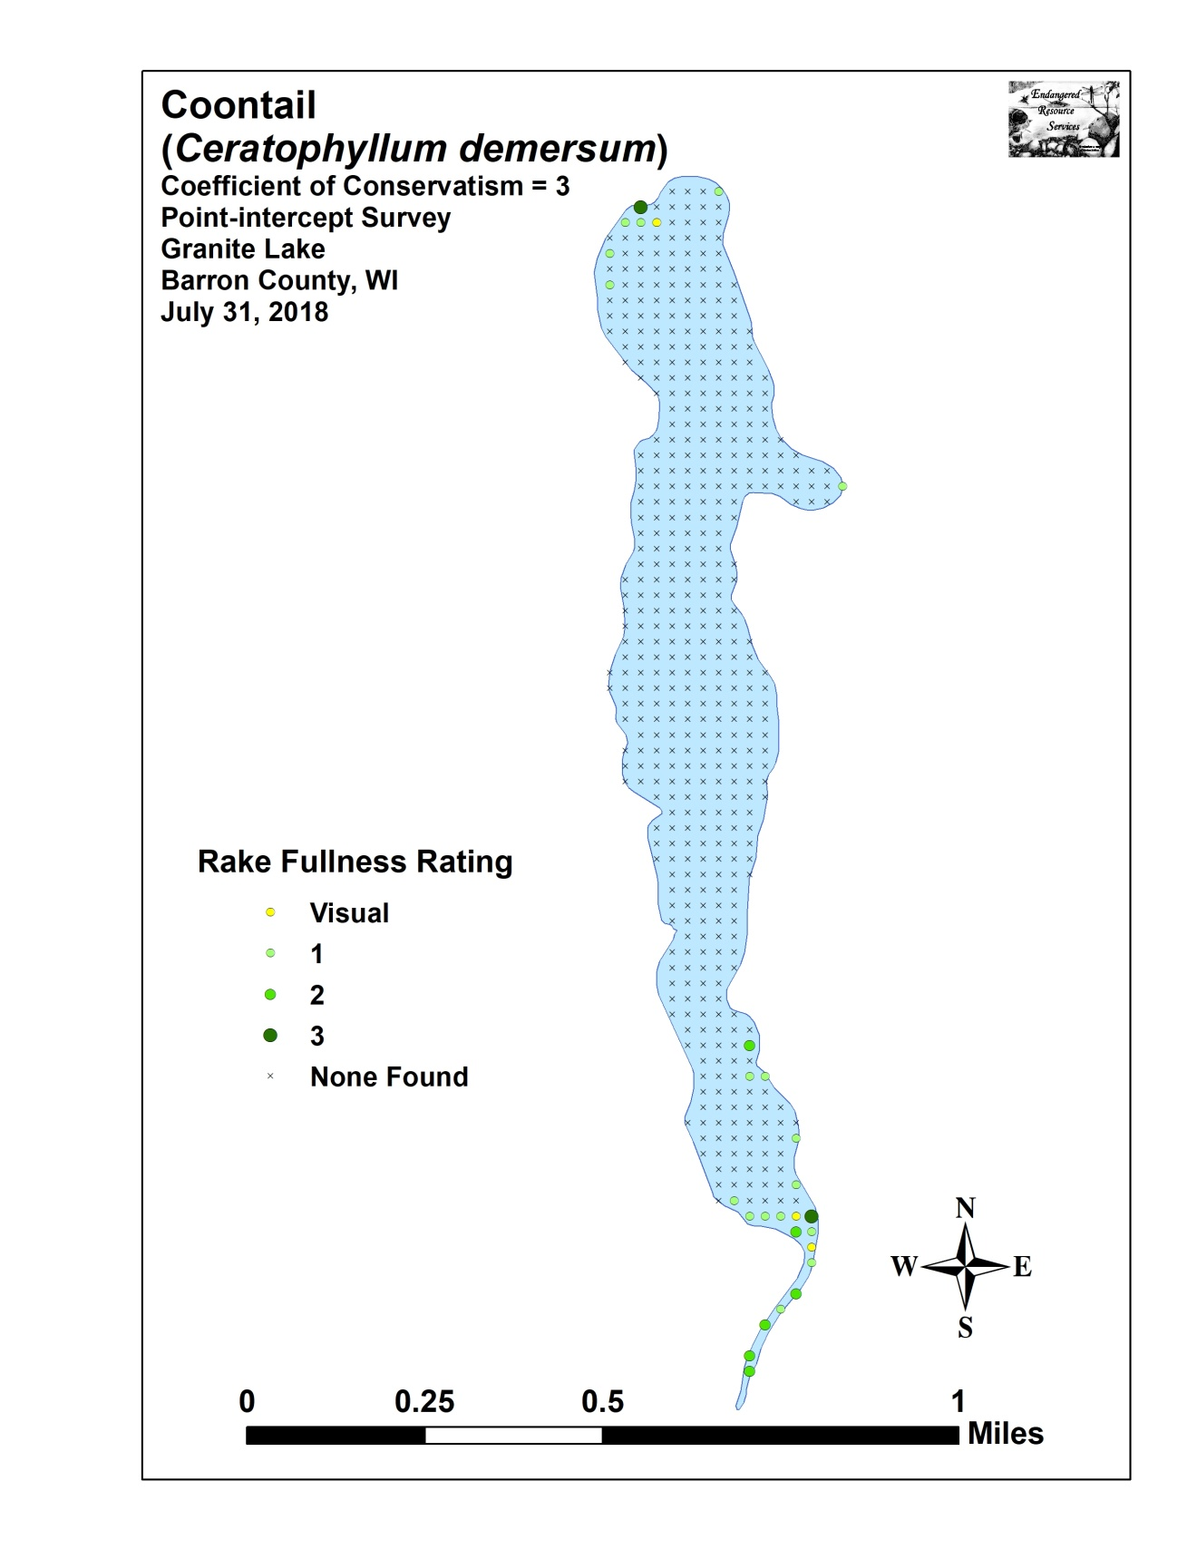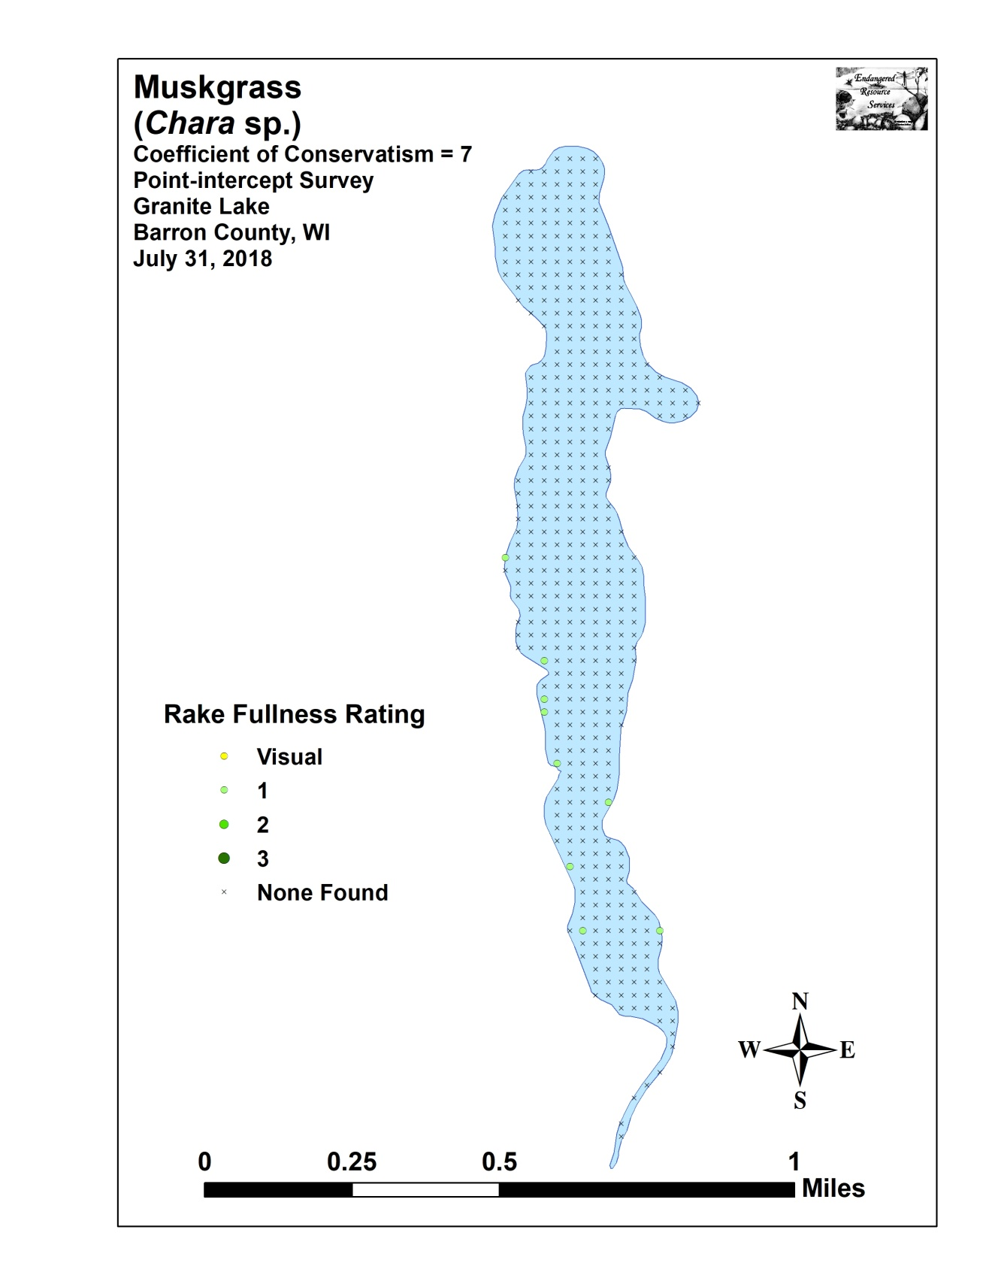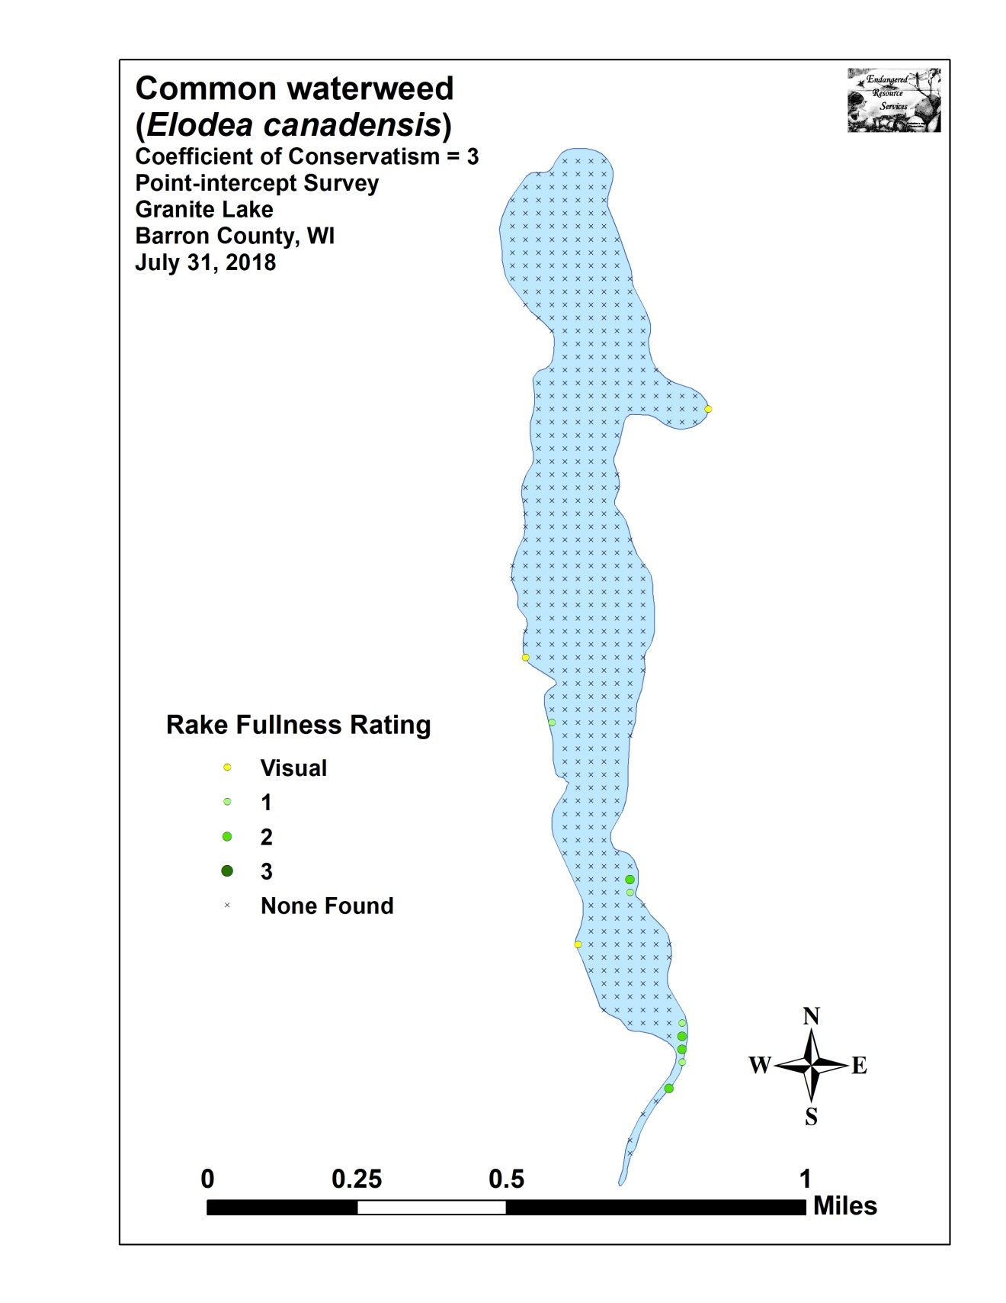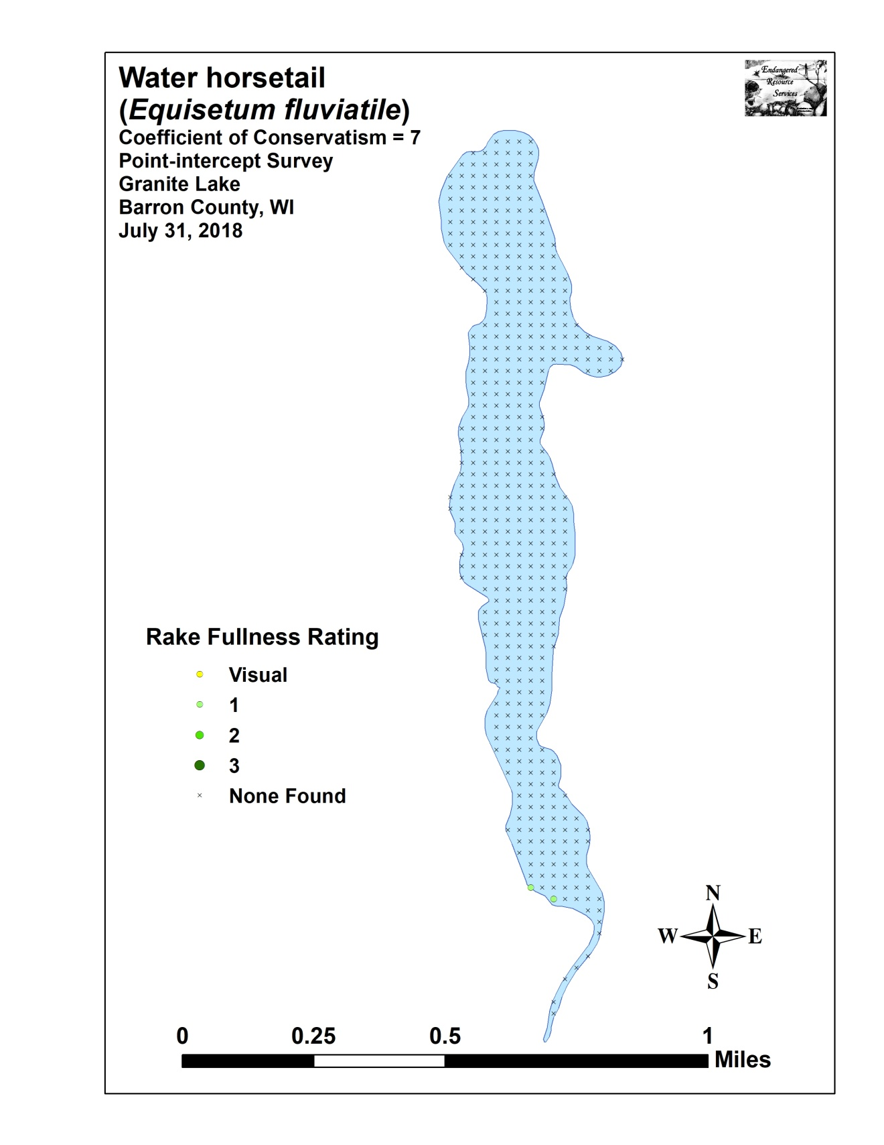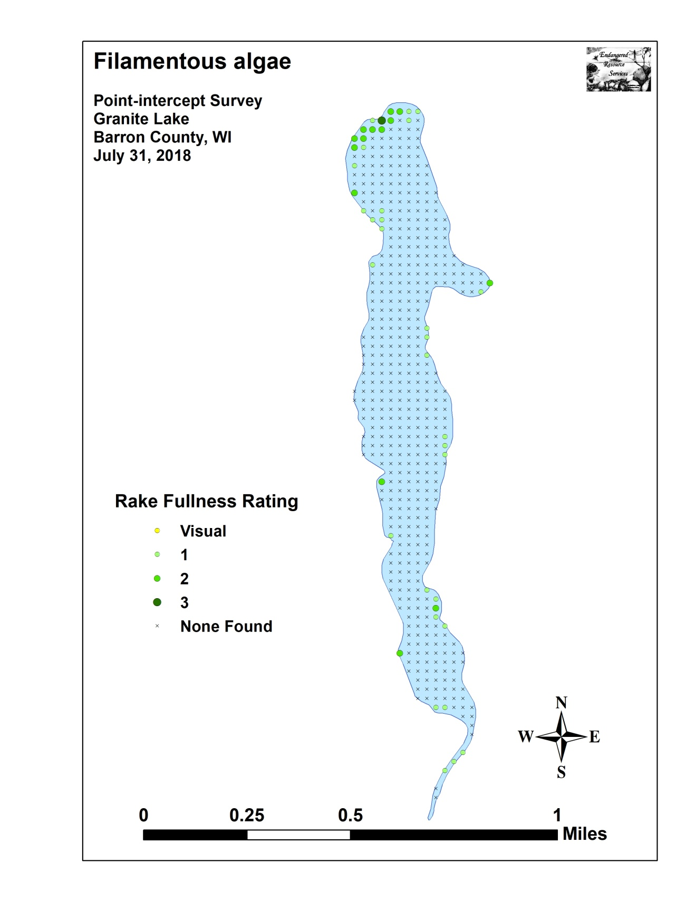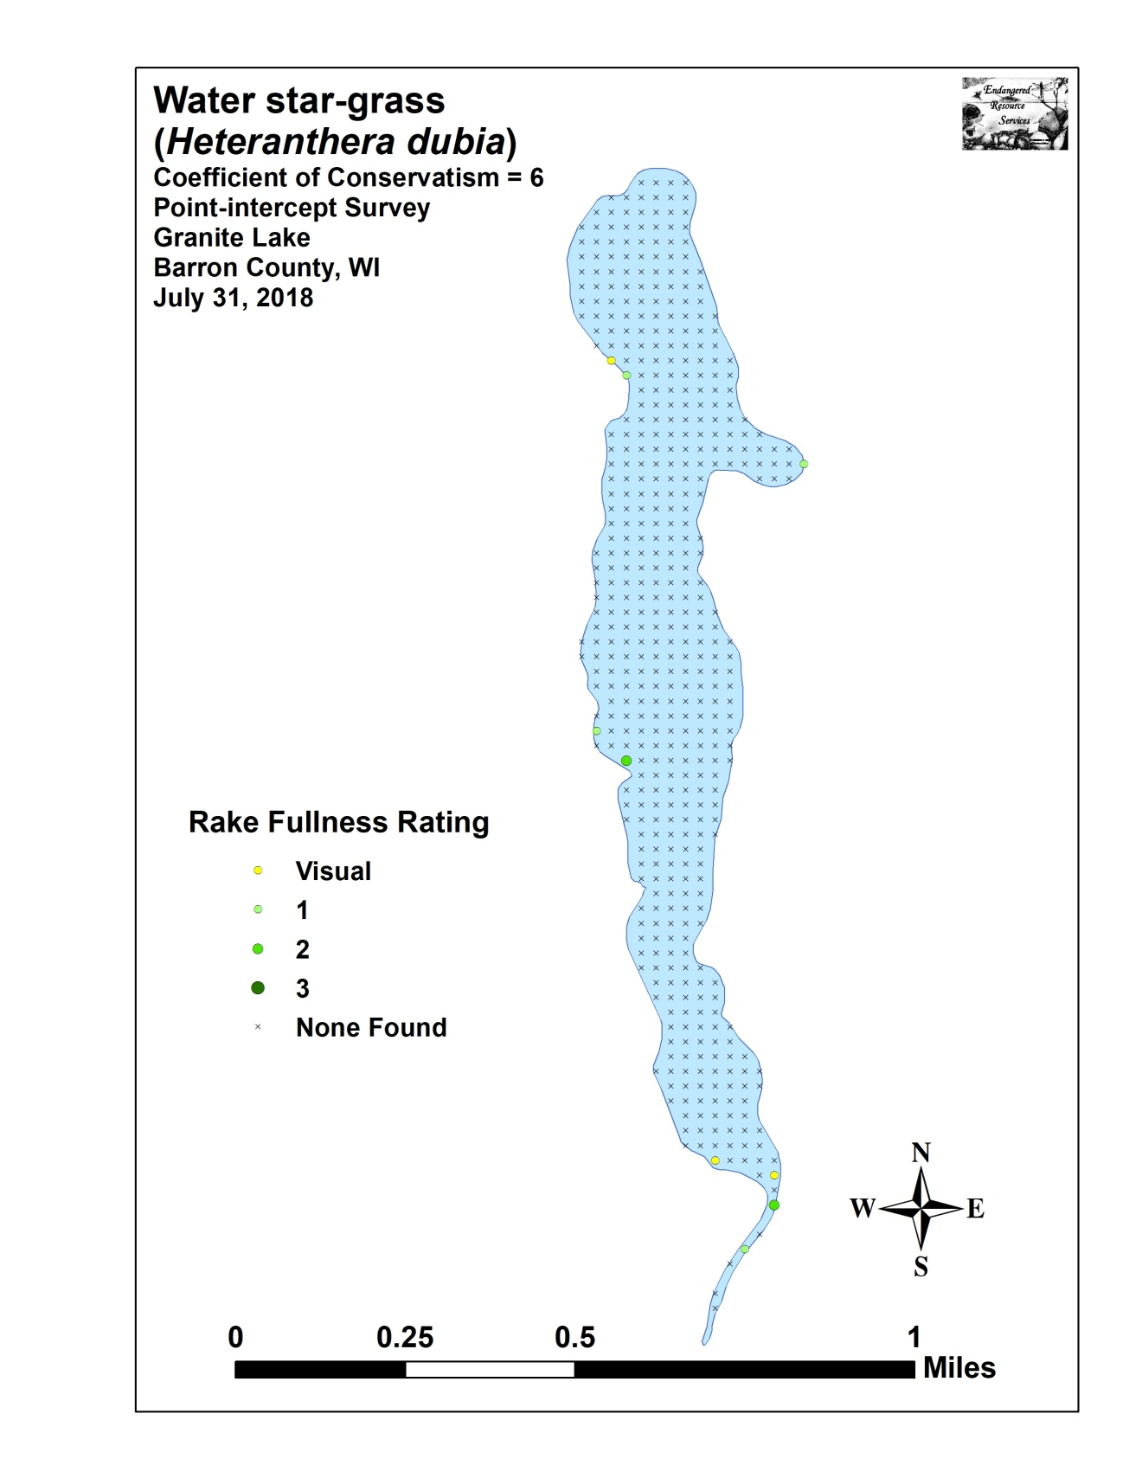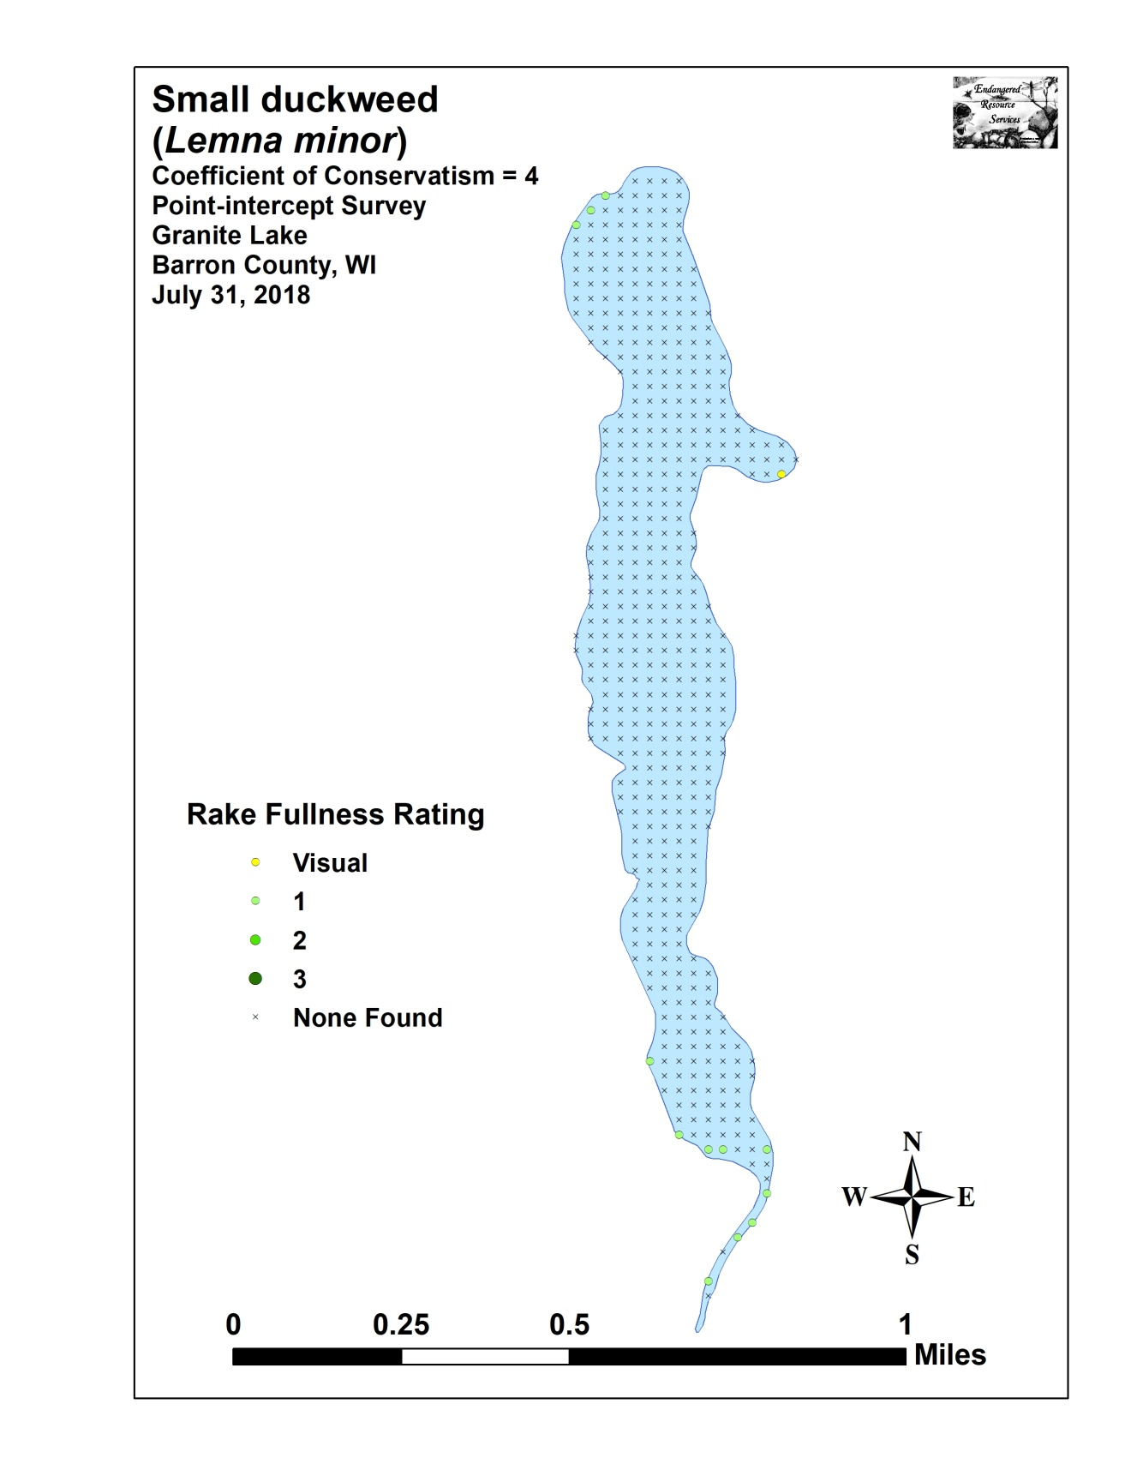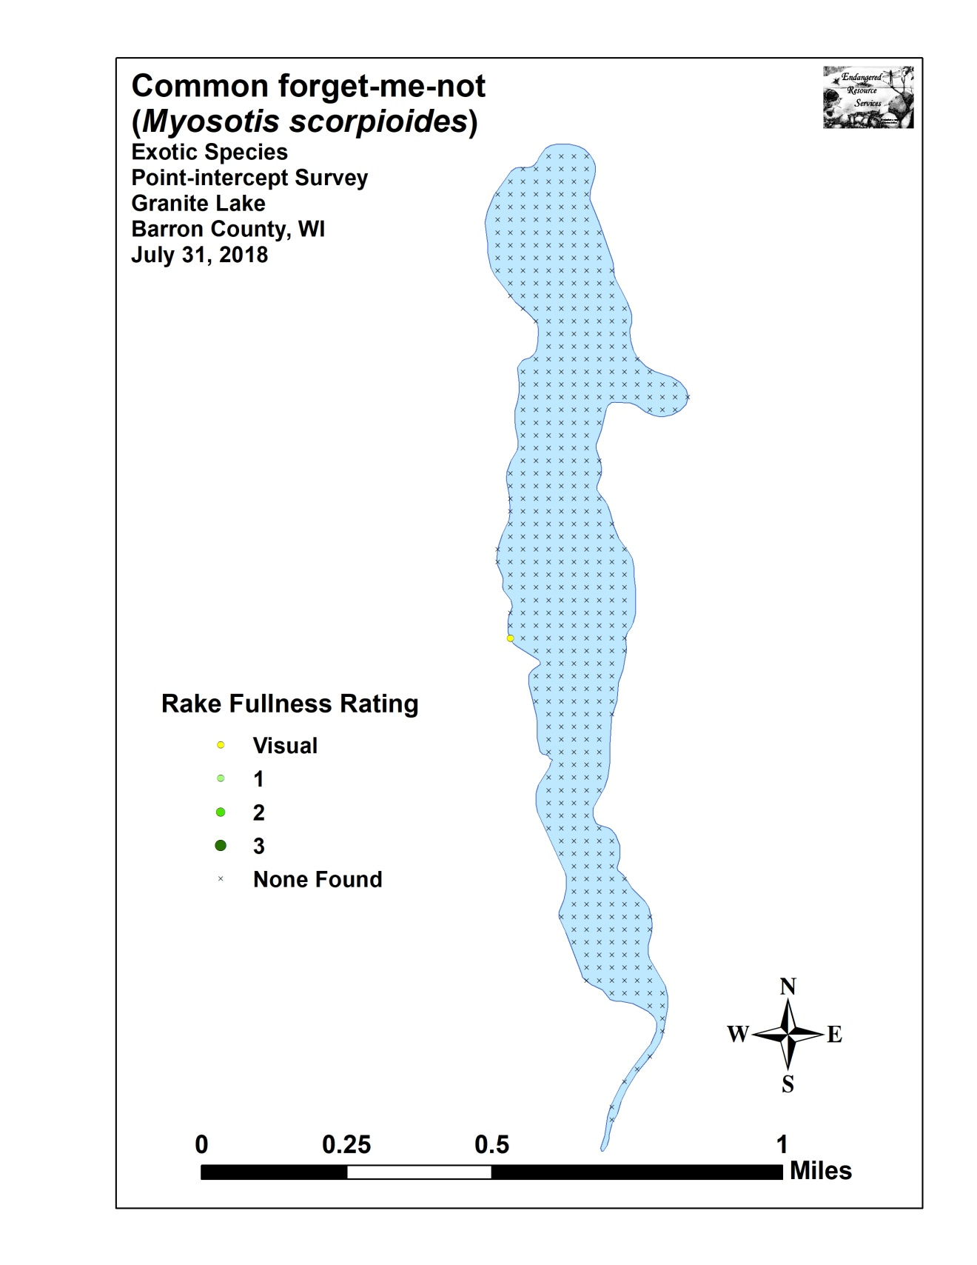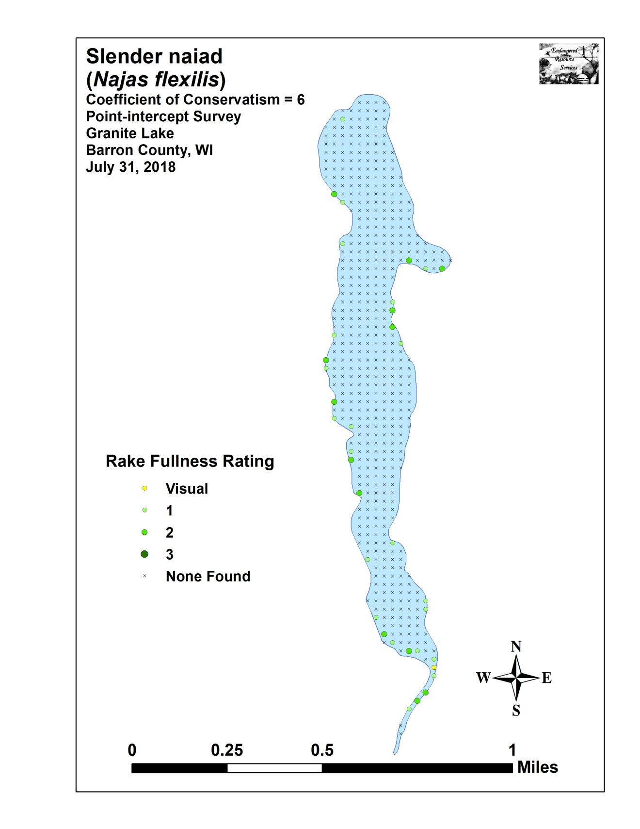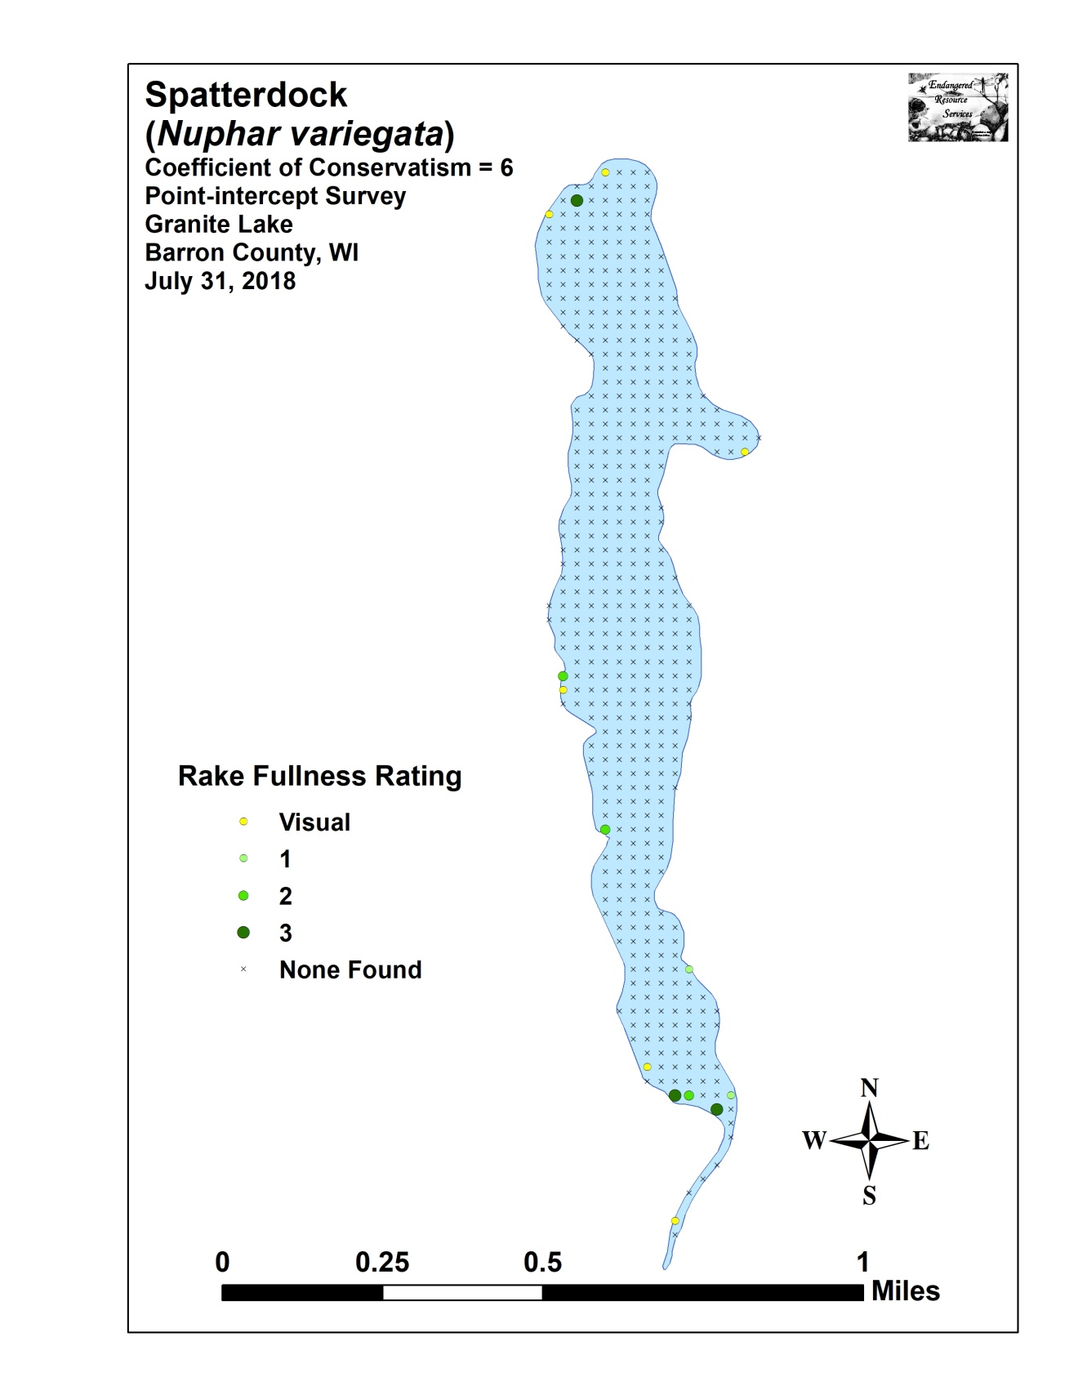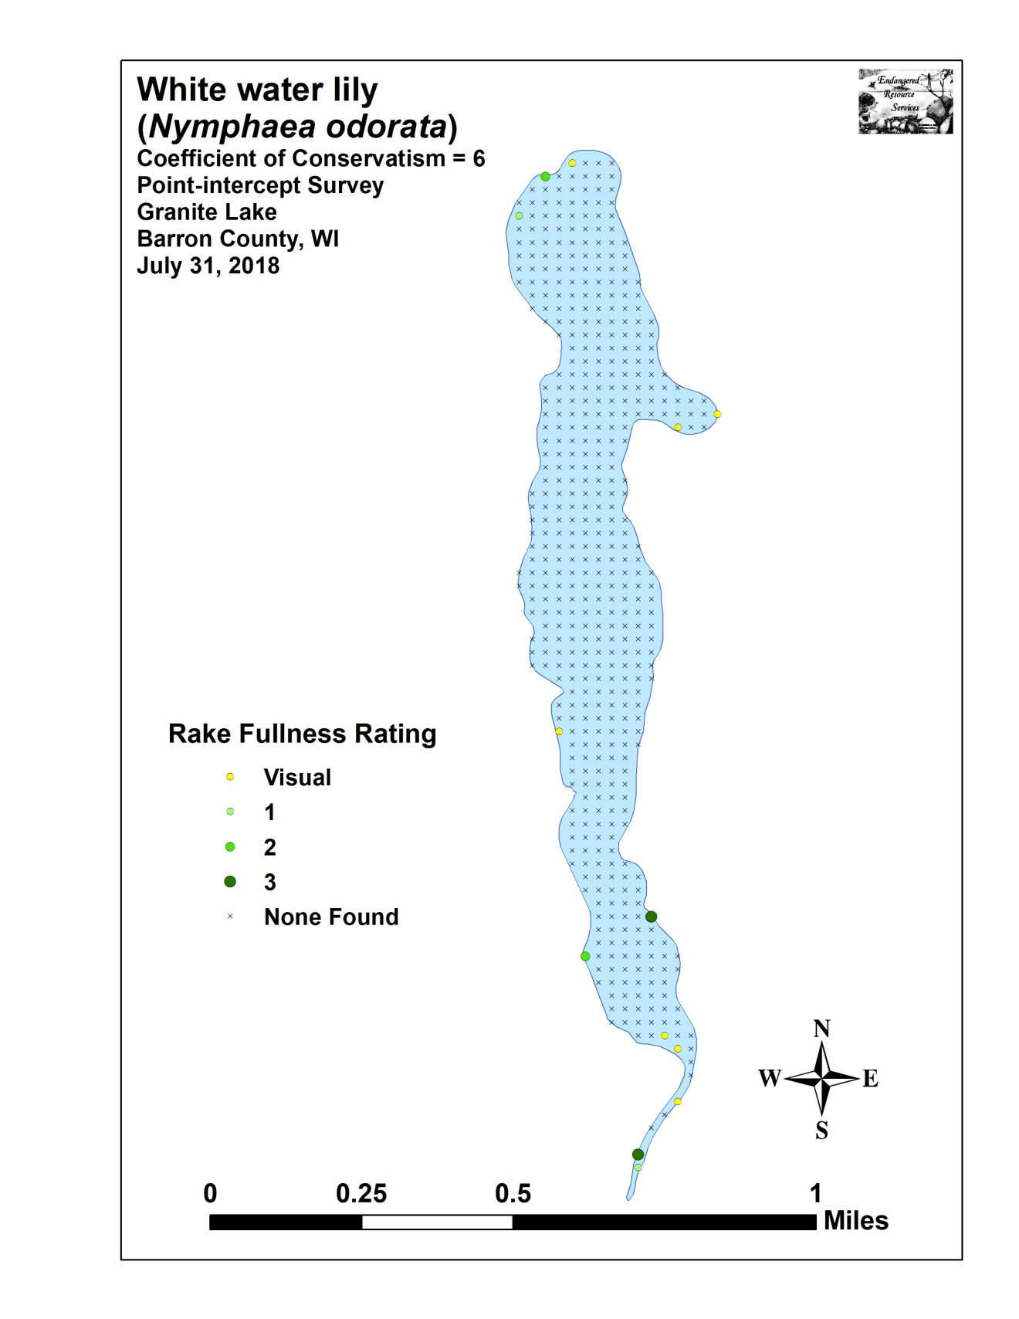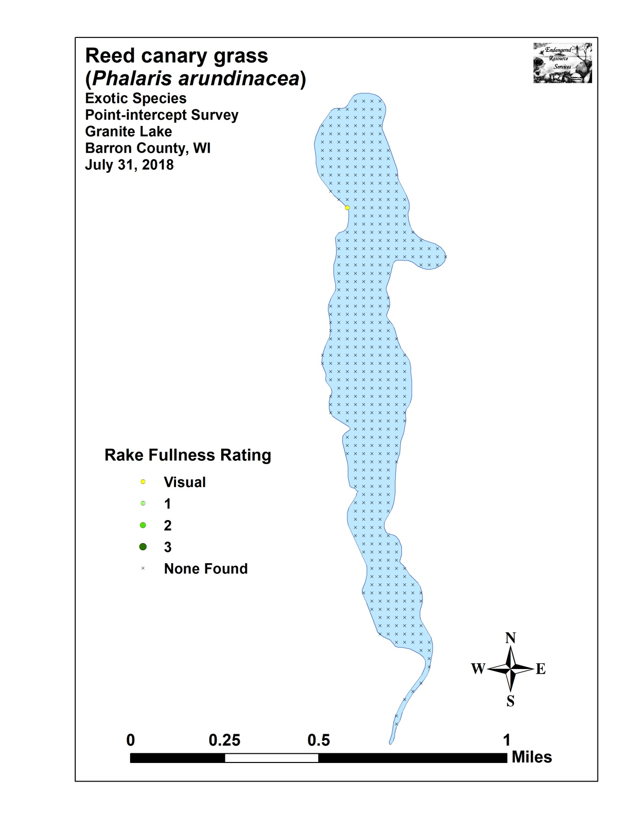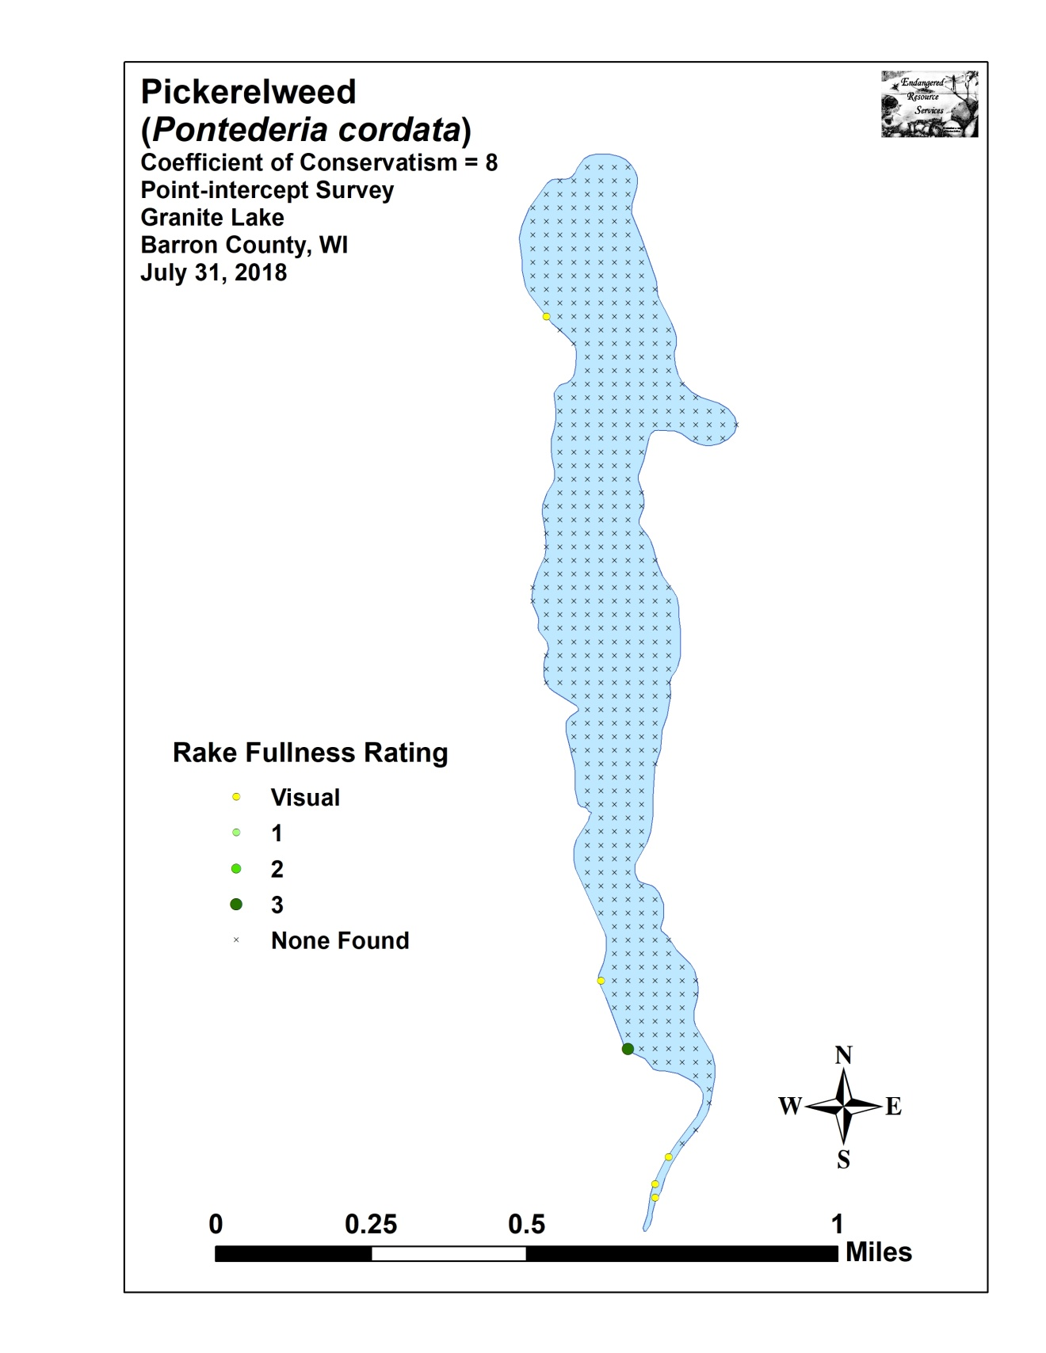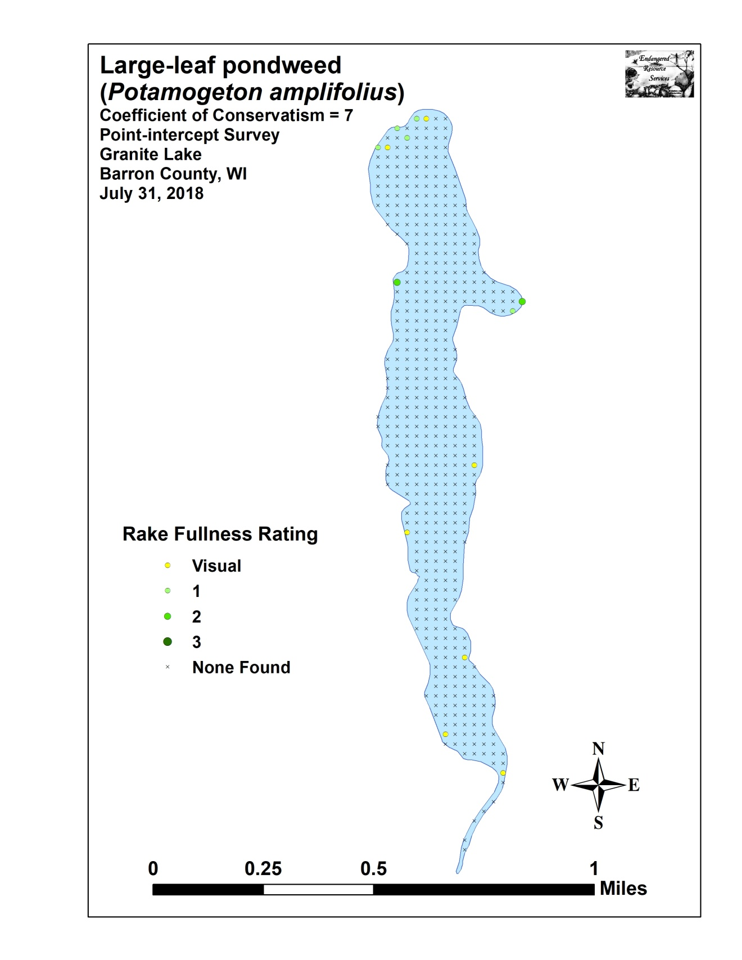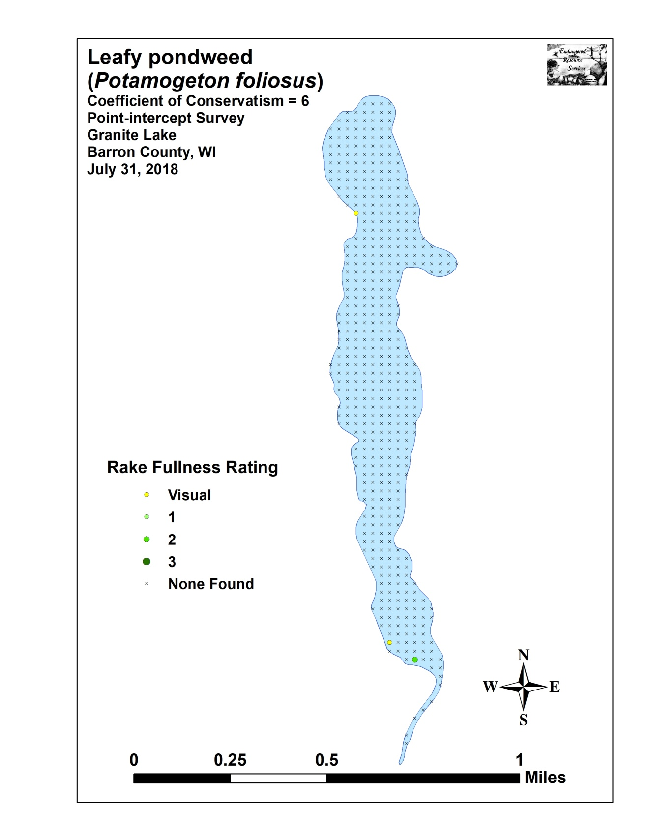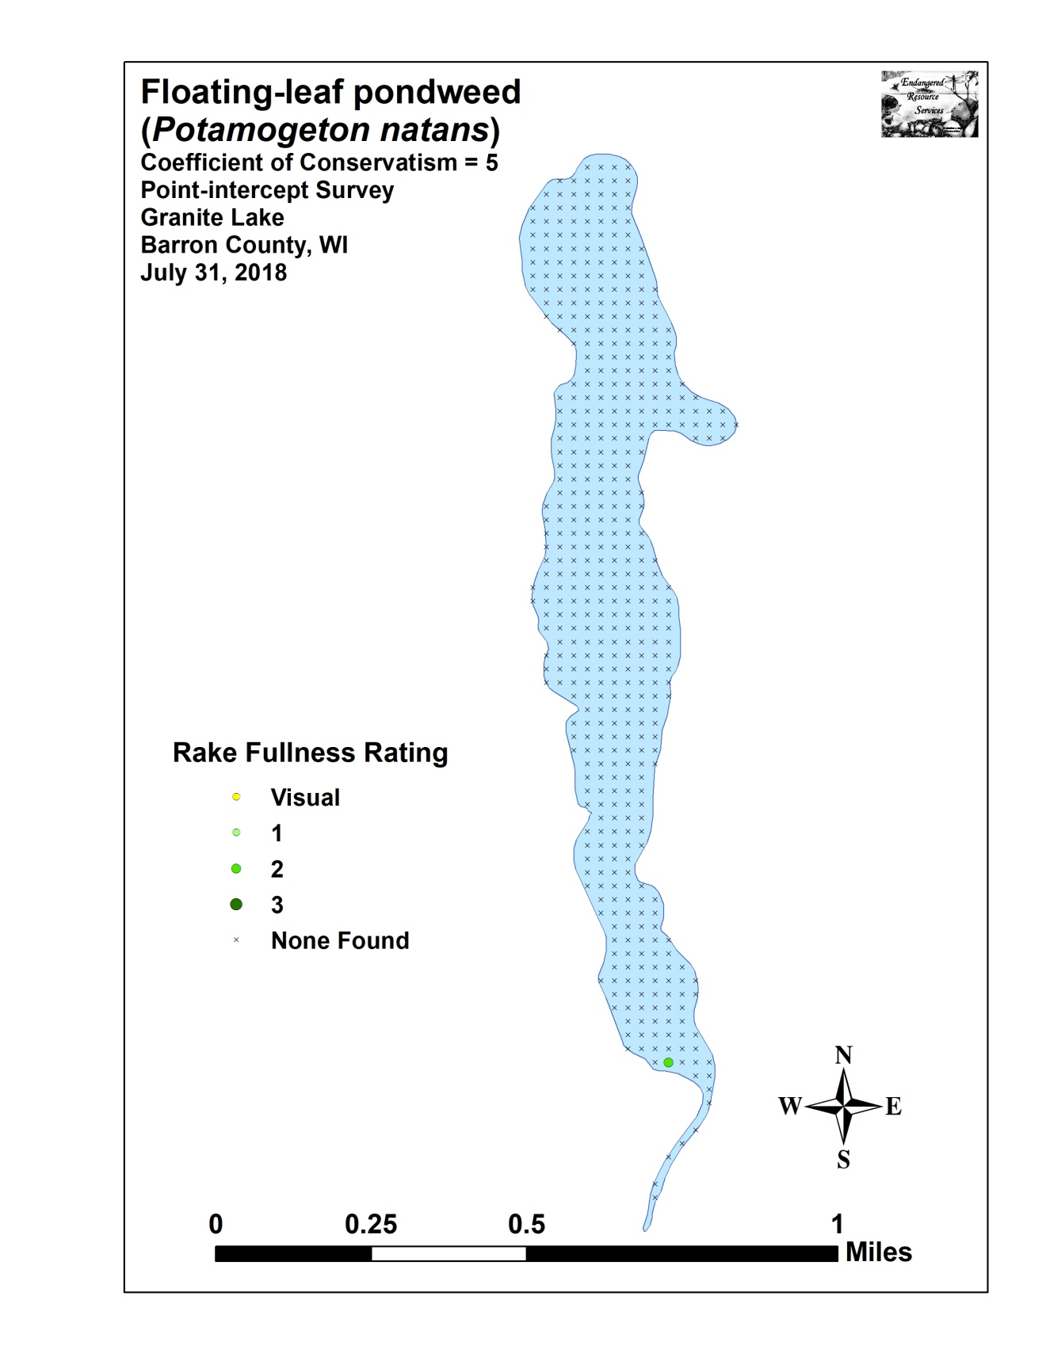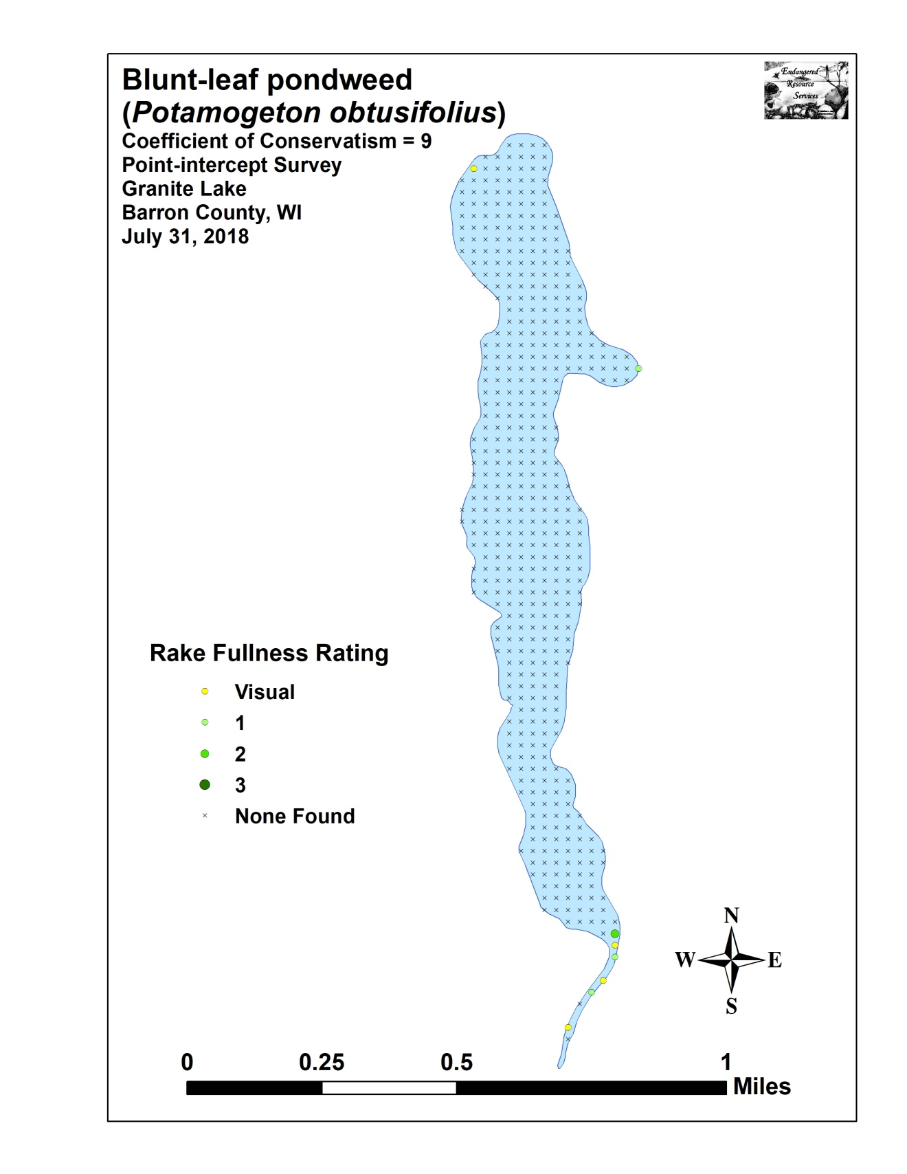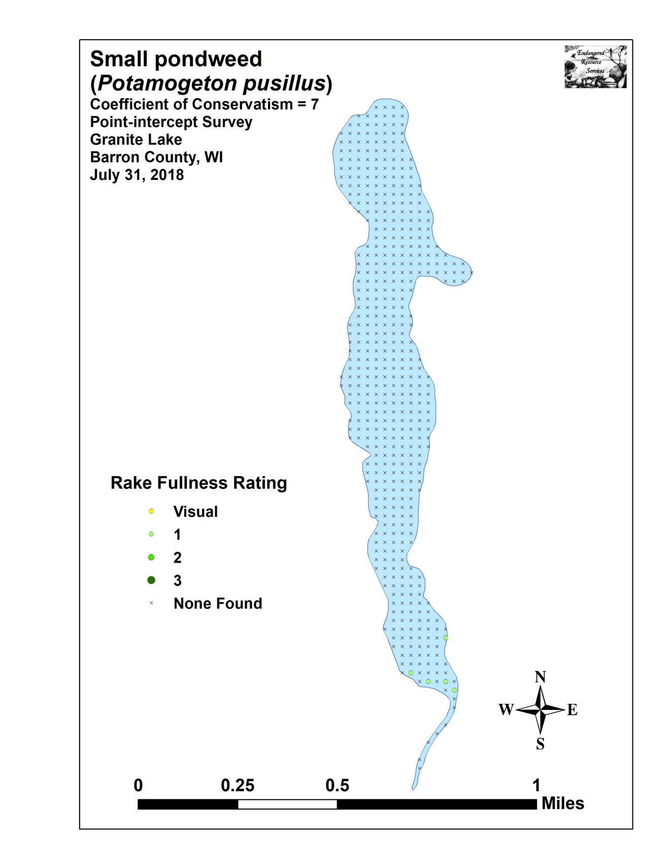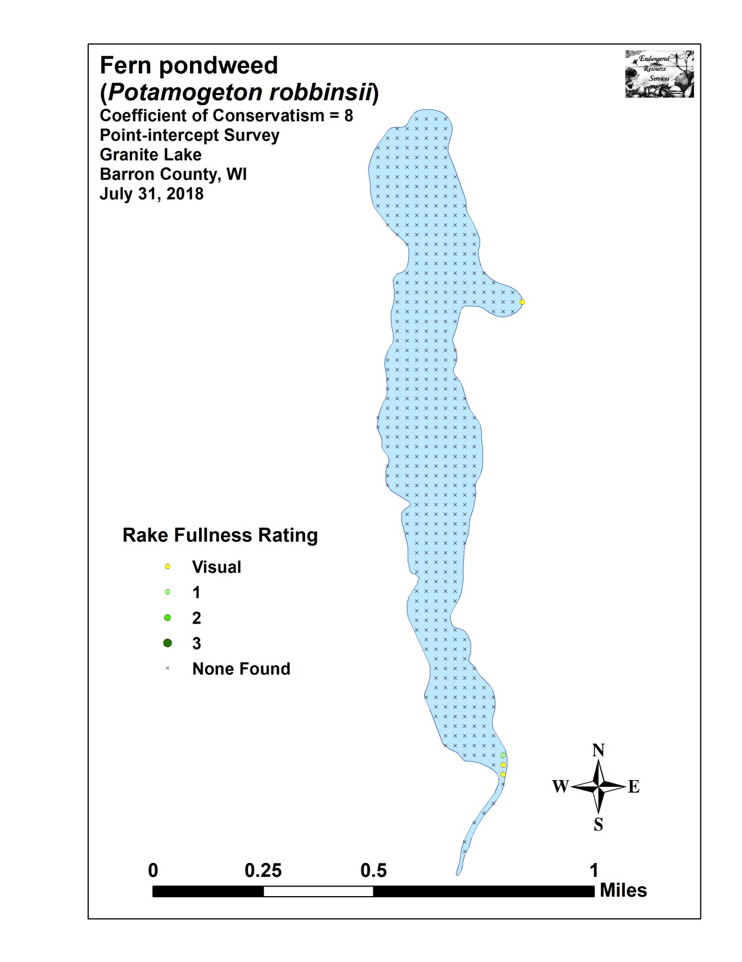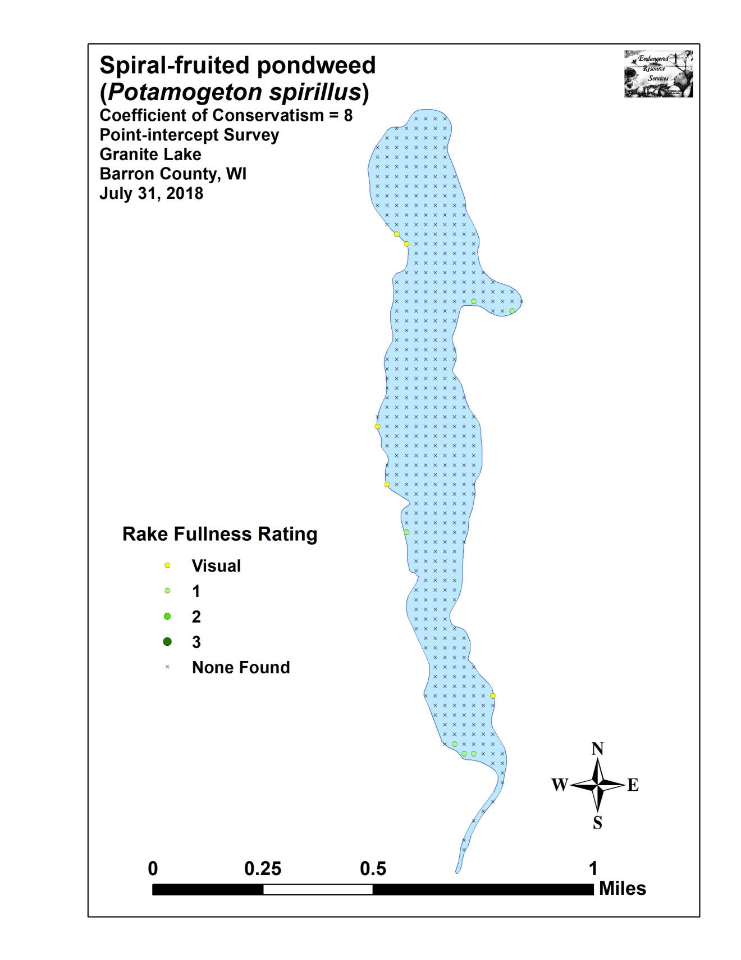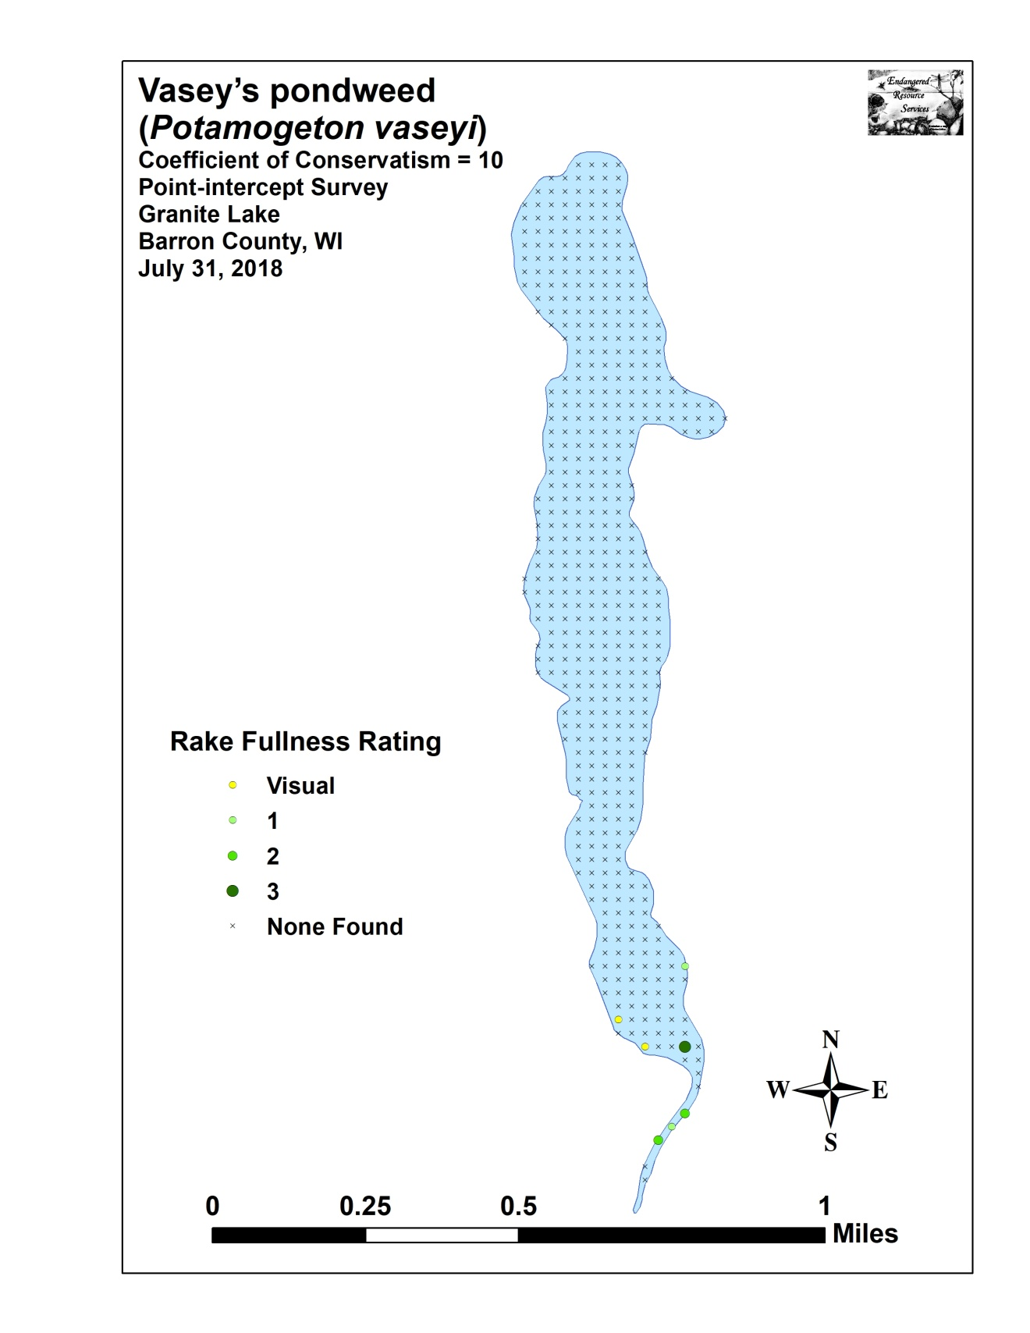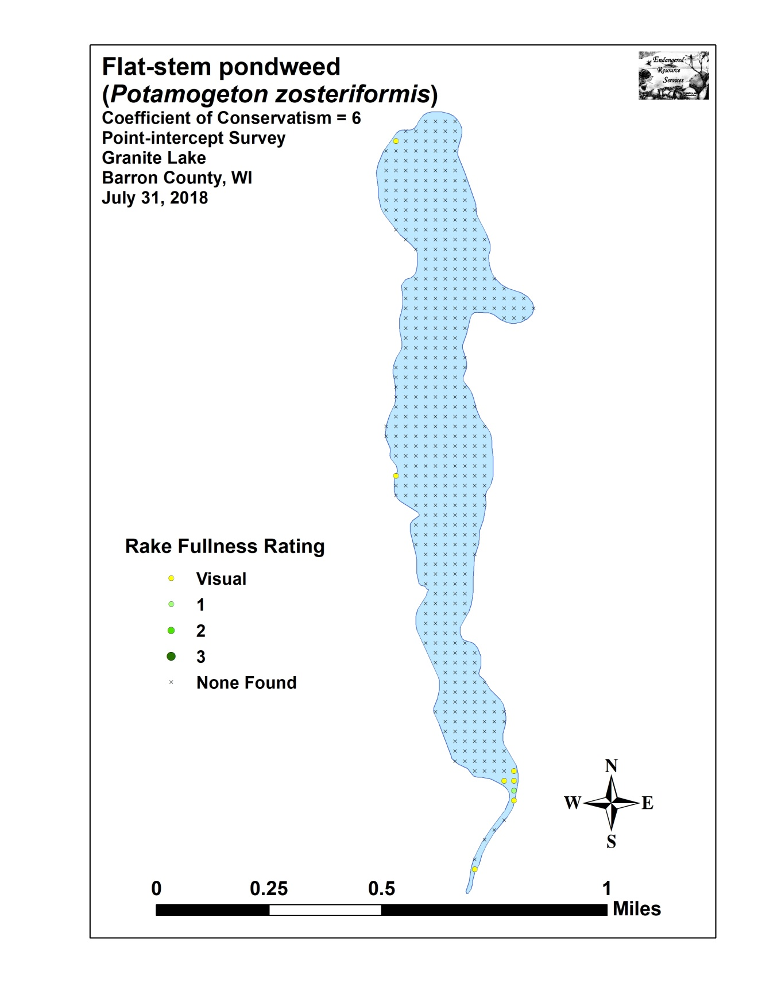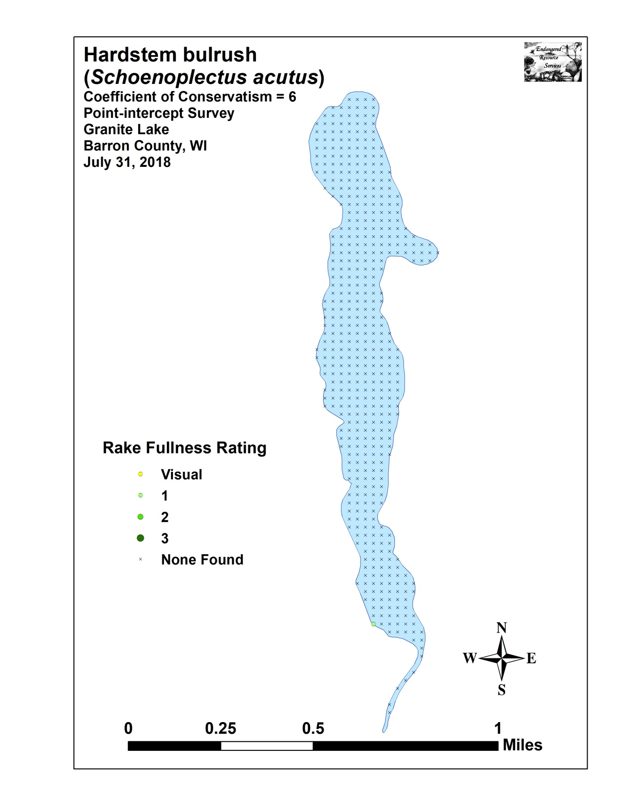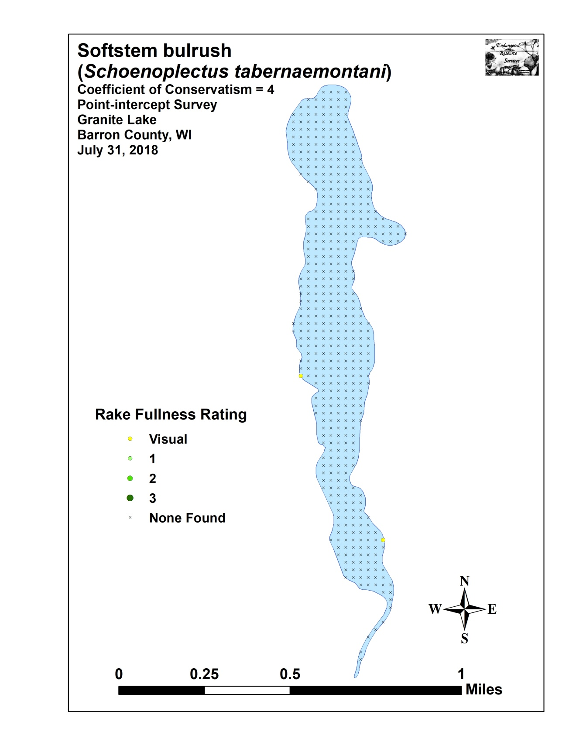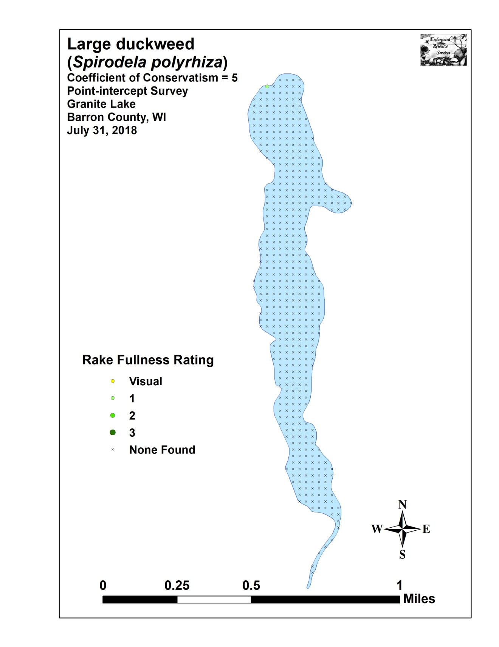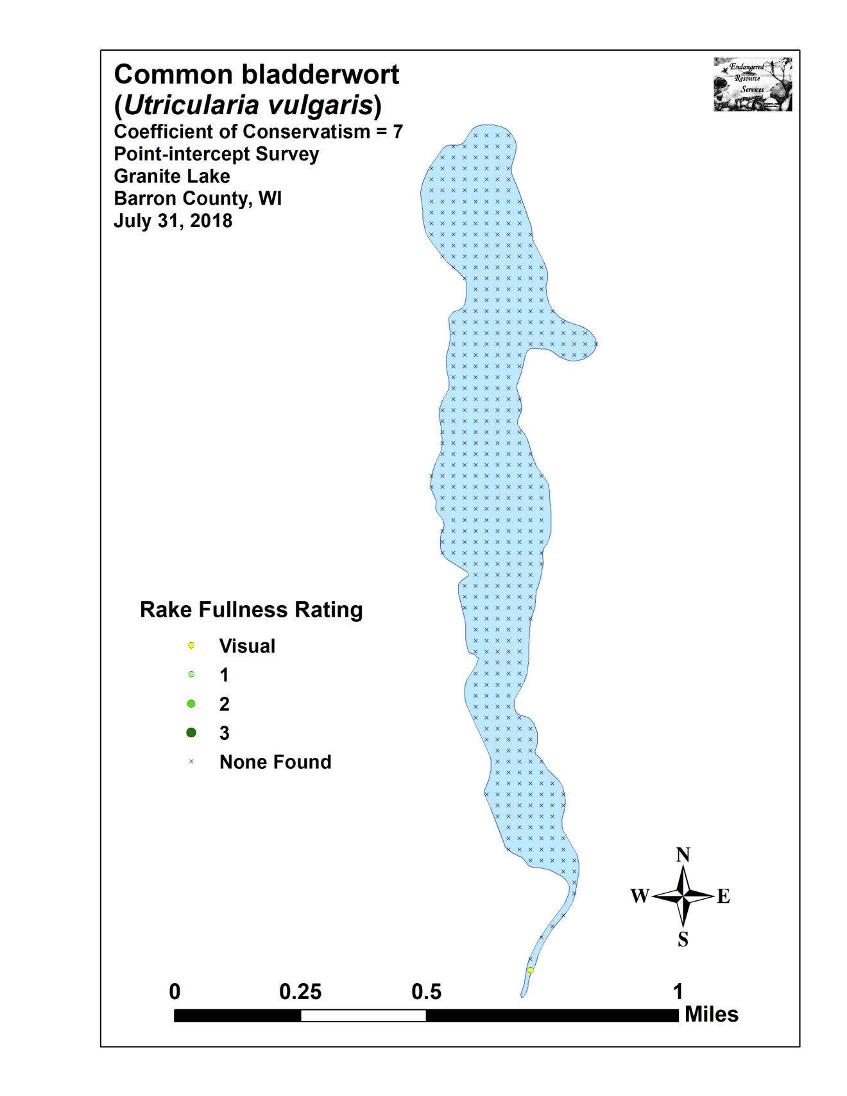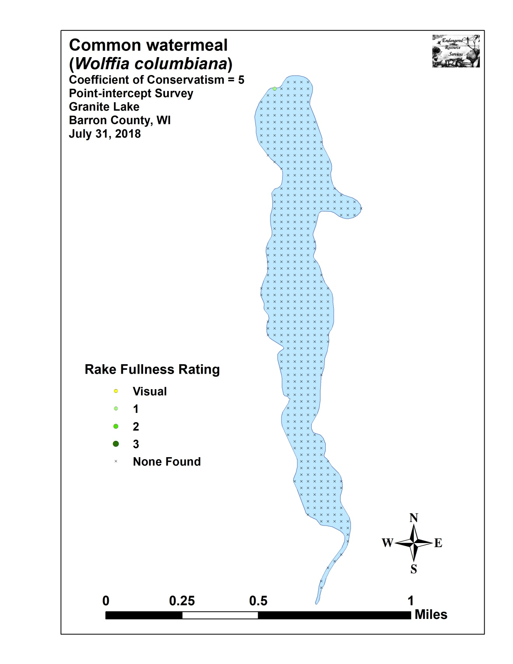

Appendix IX: Aquatic Exotic Invasive Plant Species Information

Eurasian Water-milfoil
DESCRIPTION: Eurasian Water-milfoil is a submersed aquatic plant native to Europe, Asia, and northern Africa. It is the only non-native milfoil in Wisconsin. Like the native milfoils, the Eurasian variety has slender stems whorled by submersed feathery leaves and tiny flowers produced above the water surface. The flowers are located in the axils of the floral bracts, and are either four-petaled or without petals. The leaves are threadlike, typically uniform in diameter, and aggregated into a submersed terminal spike. The stem thickens below the inflorescence and doubles its width further down, often curving to lie parallel with the water surface. The fruits are four-jointed nut-like bodies. Without flowers or fruits, Eurasian Water-milfoil is nearly impossible to distinguish from Northern Water-milfoil. Eurasian Water-milfoil has 9-21 pairs of leaflets per leaf, while Northern milfoil typically has 7-11 pairs of leaflets. Coontail is often mistaken for the milfoils, but does not have individual leaflets.
DISTRIBUTION AND HABITAT: Eurasian milfoil first arrived in Wisconsin in the 1960's. During the 1980's, it began to move from several counties in southern Wisconsin to lakes and waterways in the northern half of the state. As of 1993, Eurasian milfoil was common in 39 Wisconsin counties (54%) and at least 75 of its lakes, including shallow bays in Lakes Michigan and Superior and Mississippi River pools.
Eurasian Water-milfoil grows best in fertile, fine-textured, inorganic sediments. In less productive lakes, it is restricted to areas of nutrient-rich sediments. It has a history of becoming dominant in eutrophic, nutrient-rich lakes, although this pattern is not universal. It is an opportunistic species that prefers highly disturbed lake beds, lakes receiving nitrogen and phosphorous-laden runoff, and heavily used lakes. Optimal growth occurs in alkaline systems with a high concentration of dissolved inorganic carbon. High water temperatures promote multiple periods of flowering and fragmentation.
LIFE HISTORY AND EFFECTS OF INVASION: Unlike many other plants, Eurasian Water-milfoil does not rely on seed for reproduction. Its seeds germinate poorly under natural conditions. It reproduces vegetatively by fragmentation, allowing it to disperse over long distances. The plant produces fragments after fruiting once or twice during the summer. These shoots may then be carried downstream by water currents or inadvertently picked up by boaters. Milfoil is readily dispersed by boats, motors, trailers, bilges, live wells, or bait buckets, and can stay alive for weeks if kept moist.
Once established in an aquatic community, milfoil reproduces from shoot fragments and stolons (runners that creep along the lake bed). As an opportunistic species, Eurasian Water-milfoil is adapted for rapid growth early in spring. Stolons, lower stems, and roots persist over winter and store the carbohydrates that help milfoil claim the water column early in spring, photosynthesize, divide, and form a dense leaf canopy that shades out native aquatic plants. Its ability to spread rapidly by fragmentation and effectively block out sunlight needed for native plant growth often results in monotypic stands. Monotypic stands of Eurasian milfoil provide only a single habitat, and threaten the integrity of aquatic communities in a number of ways; for example, dense stands disrupt predator-prey relationships by fencing out larger fish, and reducing the number of nutrient-rich native plants available for waterfowl.
Dense stands of Eurasian Water-milfoil also inhibit recreational uses like swimming, boating, and fishing. Some stands have been dense enough to obstruct industrial and power generation water intakes. The visual impact that greets the lake user on milfoil-dominated lakes is the flat yellow-green of matted vegetation, often prompting the perception that the lake is "infested" or "dead". Cycling of nutrients from sediments to the water column by Eurasian Water-milfoil may lead to deteriorating water quality and algae blooms of infested lakes. (Taken in its entirety from WDNR, 2009 http://www.dnr.state.wi.us/invasives/fact/milfoil.htm)

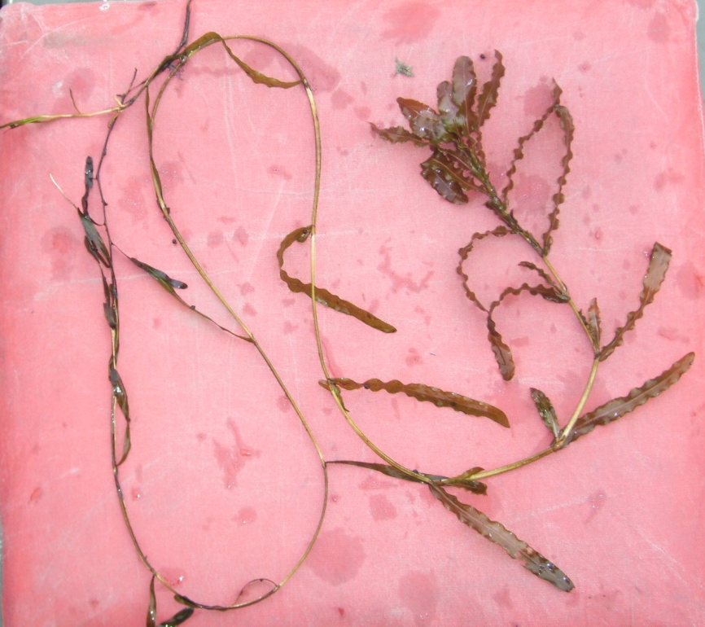
Curly-leaf pondweed
DESCRIPTION: Curly-leaf pondweed is an invasive aquatic perennial that is native to Eurasia, Africa, and Australia. It was accidentally introduced to United States waters in the mid-1880s by hobbyists who used it as an aquarium plant. The leaves are reddish-green, oblong, and about 3 inches long, with distinct wavy edges that are finely toothed. The stem of the plant is flat, reddish-brown and grows from 1 to 3 feet long. The plant usually drops to the lake bottom by early July.
DISTRIBUTION AND HABITAT: Curly-leaf pondweed is commonly found in alkaline and high nutrient waters, preferring soft substrate and shallow water depths. It tolerates low light and low water temperatures. It has been reported in all states but Maine.
LIFE HISTORY AND EFFECTS OF INVASION: Curly-leaf pondweed spreads through burr-like winter buds (turions), which are moved among waterways. These plants can also reproduce by seed, but this plays a relatively small role compared to the vegetative reproduction through turions. New plants form under the ice in winter, making curly-leaf pondweed one of the first nuisance aquatic plants to emerge in the spring.
It becomes invasive in some areas because of its tolerance for low light and low water temperatures. These tolerances allow it to get a head start on and out compete native plants in the spring. In mid-summer, when most aquatic plants are growing, curly-leaf pondweed plants are dying off. Plant die-offs may result in a critical loss of dissolved oxygen. Furthermore, the decaying plants can increase nutrients which contribute to algal blooms, as well as create unpleasant stinking messes on beaches. Curly-leaf pondweed forms surface mats that interfere with aquatic recreation. (Taken in its entirety from WDNR, 2009 http://www.dnr.state.wi.us/invasives/fact/curlyleaf_pondweed.htm)
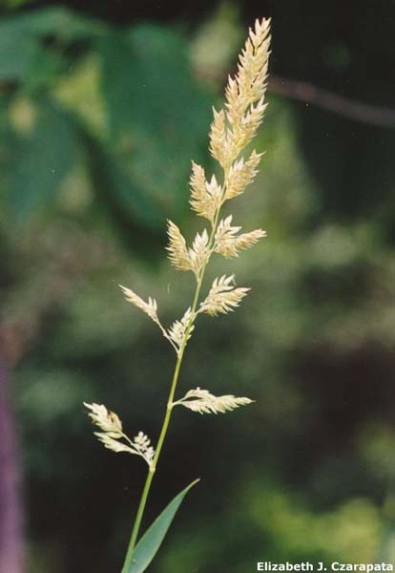
Reed canary grass
DESCRIPTION: Reed canary grass is a large, coarse grass that reaches 2 to 9 feet in height. It has an erect, hairless stem with gradually tapering leaf blades 3 1/2 to 10 inches long and 1/4 to 3/4 inch in width. Blades are flat and have a rough texture on both surfaces. The lead ligule is membranous and long. The compact panicles are erect or slightly spreading (depending on the plant's reproductive stage), and range from 3 to 16 inches long with branches 2 to 12 inches in length. Single flowers occur in dense clusters in May to mid-June. They are green to purple at first and change to beige over time. This grass is one of the first to sprout in spring, and forms a thick rhizome system that dominates the subsurface soil. Seeds are shiny brown in color.
Both Eurasian and native ecotypes of reed canary grass are thought to exist in the U.S. The Eurasian variety is considered more aggressive, but no reliable method exists to tell the ecotypes apart. It is believed that the vast majority of our reed canary grass is derived from the Eurasian ecotype. Agricultural cultivars of the grass are widely planted.
Reed canary grass also resembles non-native orchard grass (Dactylis glomerata), but can be distinguished by its wider blades, narrower, more pointed inflorescence, and the lack of hairs on glumes and lemmas (the spikelet scales). Additionally, bluejoint grass (Calamagrostis canadensis) may be mistaken for reed canary in areas where orchard grass is rare, especially in the spring. The highly transparent ligule on reed canary grass is helpful in distinguishing it from the others. Ensure positive identification before attempting control.

DISTRIBUTION AND HABITAT: Reed canary grass is a cool-season, sod-forming, perennial wetland grass native to temperate regions of Europe, Asia, and North America. The Eurasian ecotype has been selected for its vigor and has been planted throughout the U.S. since the 1800's for forage and erosion control. It has become naturalized in much of the northern half of the U.S., and is still being planted on steep slopes and banks of ponds and created wetlands.
Reed canary grass can grow on dry soils in upland habitats and in the partial shade of oak woodlands, but does best on fertile, moist organic soils in full sun. This species can invade most types of wetlands, including marshes, wet prairies, sedge meadows, fens, stream banks, and seasonally wet areas; it also grows in disturbed areas such as bergs and spoil piles.
LIFE HISTORY AND EFFECTS OF INVASION: Reed canary grass reproduces by seed or creeping rhizomes. It spreads aggressively. The plant produces leaves and flower stalks for 5 to 7 weeks after germination in early spring, then spreads laterally. Growth peaks in mid-June and declines in mid-August. A second growth spurt occurs in the fall. The shoots collapse in mid to late summer, forming a dense, impenetrable mat of stems and leaves. The seeds ripen in late June and shatter when ripe. Seeds may be dispersed from one wetland to another by waterways, animals, humans, or machines.
This species prefers disturbed areas, but can easily move into native wetlands. Reed canary grass can invade a disturbed wetland in less than twelve years. Invasion is associated with disturbances including ditching of wetlands, stream channelization, deforestation of swamp forests, sedimentation, and intentional planting. The difficulty of selective control makes reed canary grass invasion of particular concern. Over time, it forms large, monotypic stands that harbor few other plant species and are subsequently of little use to wildlife. Once established, reed canary grass dominates an area by building up a tremendous seed bank that can eventually erupt, germinate, and recolonize treated sites. (Taken in its entirety from WDNR, 2009 http://www.dnr.state.wi.us/invasives/fact/reed_canary.htm)
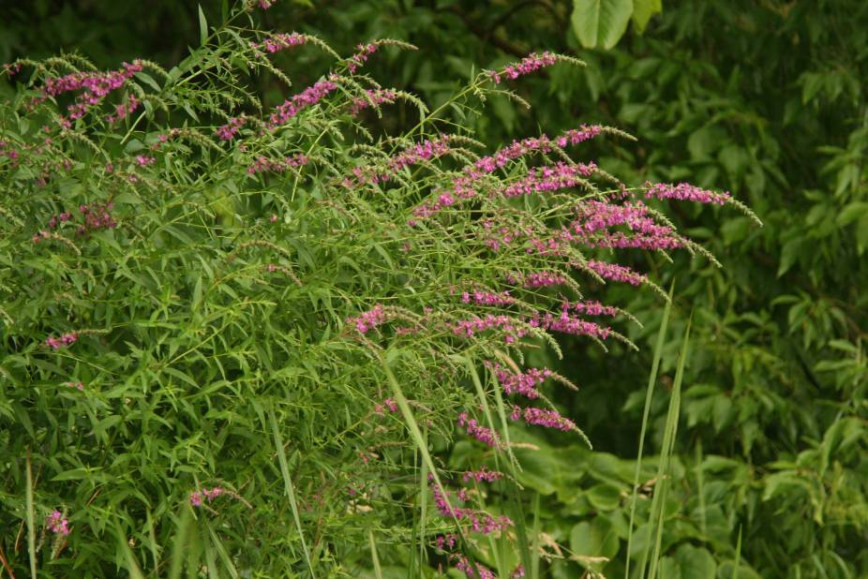
Purple loosestrife
(Photo Courtesy Brian M. Collins)
DESCRIPTION: Purple loosestrife is a perennial herb 3-7 feet tall with a dense bushy growth of 1-50 stems. The stems, which range from green to purple, die back each year. Showy flowers vary from purple to magenta, possess 5-6 petals aggregated into numerous long spikes, and bloom from August to September. Leaves are opposite, nearly linear, and attached to four-sided stems without stalks. It has a large, woody taproot with fibrous rhizomes that form a dense mat.
This species may be confused with the native wing-angled loosestrife (Lythrum alatum) found in moist prairies or wet meadows. The latter has a winged, square stem and solitary paired flowers in the leaf axils. It is generally a smaller plant than the Eurasian loosestrife.
By law, purple loosestrife is a nuisance species in Wisconsin. It is illegal to sell, distribute, or cultivate the plants or seeds, including any of its cultivars.

Distribution and Habitat: Purple loosestrife is a wetland herb that was introduced as a garden perennial from Europe during the 1800's. It is still promoted by some horticulturists for its beauty as a landscape plant, and by beekeepers for its nectar-producing capability. Currently, about 24 states have laws prohibiting its importation or distribution because of its aggressively invasive characteristics. It has since extended its range to include most temperate parts of the United States and Canada. The plant's reproductive success across North America can be attributed to its wide tolerance of physical and chemical conditions characteristic of disturbed habitats, and its ability to reproduce prolifically by both seed dispersal and vegetative propagation. The absence of natural predators, like European species of herbivorous beetles that feed on the plant's roots and leaves, also contributes to its proliferation in North America.
Purple loosestrife was first detected in Wisconsin in the early 1930's, but remained uncommon until the 1970's. It is now widely dispersed in the state, and has been recorded in 70 of Wisconsin's 72 counties. Low densities in most areas of the state suggest that the plant is still in the pioneering stage of establishment. Areas of heaviest infestation are sections of the Wisconsin River, the extreme southeastern part of the state, and the Wolf and Fox River drainage systems.
This plant's optimal habitat includes marshes, stream margins, alluvial flood plains, sedge meadows, and wet prairies. It is tolerant of moist soil and shallow water sites such as pastures and meadows, although established plants can tolerate drier conditions. Purple loosestrife has also been planted in lawns and gardens, which is often how it has been introduced to many of our wetlands, lakes, and rivers.

Life History and Effects of Invasion: Purple loosestrife can germinate successfully on substrates with a wide range of pH. Optimum substrates for growth are moist soils of neutral to slightly acidic pH, but it can exist in a wide range of soil types. Most seedling establishment occurs in late spring and early summer when temperatures are high.
Purple loosestrife spreads mainly by seed, but it can also spread vegetatively from root or stem segments. A single stalk can produce from 100,000 to 300,000 seeds per year. Seed survival is up to 60-70%, resulting in an extensive seed bank. Mature plants with up to 50 shoots grow over 2 meters high and produce more than two million seeds a year. Germination is restricted to open, wet soils and requires high temperatures, but seeds remain viable in the soil for many years. Even seeds submerged in water can live for approximately 20 months. Most of the seeds fall near the parent plant, but water, animals, boats, and humans can transport the seeds long distances. Vegetative spread through local perturbation is also characteristic of loosestrife; clipped, trampled, or buried stems of established plants may produce shoots and roots. Plants may be quite large and several years old before they begin flowering. It is often very difficult to locate non-flowering plants, so monitoring for new invasions should be done at the beginning of the flowering period in mid-summer.

Any sunny or partly shaded wetland is susceptible to purple loosestrife invasion. Vegetative disturbances such as water drawdown or exposed soil accelerate the process by providing ideal conditions for seed germination. Invasion usually begins with a few pioneering plants that build up a large seed bank in the soil for several years. When the right disturbance occurs, loosestrife can spread rapidly, eventually taking over the entire wetland. The plant can also make morphological adjustments to accommodate changes in the immediate environment; for example, a decrease in light level will trigger a change in leaf morphology. The plant's ability to adjust to a wide range of environmental conditions gives it a competitive advantage; coupled with its reproductive strategy, purple loosestrife tends to create monotypic stands that reduce biotic diversity.
Purple loosestrife displaces native wetland vegetation and degrades wildlife habitat. As native vegetation is displaced, rare plants are often the first species to disappear. Eventually, purple loosestrife can overrun wetlands thousands of acres in size, and almost entirely eliminate the open water habitat. The plant can also be detrimental to recreation by choking waterways. (Taken in its entirety from WDNR, 2009 http://www.dnr.state.wi.us/invasives/fact/loosestrife.htm)

Appendix X: Glossary of Biological Terms
(Adapted from UWEX 2009)

Aquatic:
organisms that live in or frequent water.

Cultural Eutrophication:
accelerated eutrophication that occurs as a result of human activities in the watershed that increase nutrient loads in runoff water that drains into lakes.

Dissolved Oxygen (DO):
the amount of free oxygen absorbed by the water and available to aquatic organisms for respiration; amount of oxygen dissolved in a certain amount of water at a particular temperature and pressure, often expressed as a concentration in parts of oxygen per million parts of water.

Diversity:
number and evenness of species in a particular community or habitat.

Drainage lakes:
Lakes fed primarily by streams and with outlets into streams or rivers. They are more subject to surface runoff problems but generally have shorter residence times than seepage lakes. Watershed protection is usually needed to manage lake water quality.

Ecosystem:
a system formed by the interaction of a community of organisms with each other and with the chemical and physical factors making up their environment.

Eutrophication:
the process by which lakes and streams are enriched by nutrients, and the resulting increase in plant and algae growth. This process includes physical, chemical, and biological changes that take place after a lake receives inputs for plant nutrients--mostly nitrates and phosphates--from natural erosion and runoff from the surrounding land basin. The extent to which this process has occurred is reflected in a lake's trophic classification: oligotrophic (nutrient poor), mesotrophic (moderately productive), and eutrophic (very productive and fertile).

Exotic:
a non-native species of plant or animal that has been introduced.

Habitat:
the place where an organism lives that provides an organism's needs for water, food, and shelter. It includes all living and non-living components with which the organism interacts.

Limnology:
the study of inland lakes and waters.

Littoral:
the near shore shallow water zone of a lake, where aquatic plants grow.

Macrophytes:
Refers to higher (multi-celled) plants growing in or near water. Macrophytes are beneficial to lakes because they produce oxygen and provide substrate for fish habitat and aquatic insects. Overabundance of such plants, especially problem species, is related to shallow water depth and high nutrient levels.

Nutrients:
elements or substances such as nitrogen and phosphorus that are necessary for plant growth. Large amounts of these substances can become a nuisance by promoting excessive aquatic plant growth.

Organic Matter:
elements or material containing carbon, a basic component of all living matter.

Photosynthesis:
the process by which green plants convert carbon dioxide (CO2) dissolved in water to sugar and oxygen using sunlight for energy. Photosynthesis is essential in producing a lake's food base, and is an important source of oxygen for many lakes.

Phytoplankton:
microscopic plants found in the water. Algae or one-celled (phytoplankton) or multicellular plants either suspended in water (Plankton) or attached to rocks and other substrates (periphyton). Their abundance, as measured by the amount of chlorophyll a (green pigment) in an open water sample, is commonly used to classify the trophic status of a lake. Numerous species occur. Algae are an essential part of the lake ecosystem and provides the food base for most lake organisms, including fish. Phytoplankton populations vary widely from day to day, as life cycles are short.

Plankton:
small plant organisms (phytoplankton and nanoplankton) and animal organisms (zooplankton) that float or swim weakly though the water.

ppm:
parts per million; units per equivalent million units; equal to milligrams per liter (mg/l)

Richness:
number of species in a particular community or habitat.

Rooted Aquatic Plants:
(macrophytes) Refers to higher (multi-celled) plants growing in or near water. Macrophytes are beneficial to lakes because they produce oxygen and provide substrate for fish habitat and aquatic insects. Overabundance of such plants, especially problem species, is related to shallow water depth and high nutrient levels.

Runoff:
water that flows over the surface of the land because the ground surface is impermeable or unable to absorb the water.

Secchi Disc:
An 8-inch diameter plate with alternating quadrants painted black and white that is used to measure water clarity (light penetration). The disc is lowered into water until it disappears from view. It is then raised until just visible. An average of the two depths, taken from the shaded side of the boat, is recorded as the Secchi disc reading. For best results, the readings should be taken on sunny, calm days.

Seepage lakes:
Lakes without a significant inlet or outlet, fed by rainfall and groundwater. Seepage lakes lose water through evaporation and groundwater moving on a down gradient. Lakes with little groundwater inflow tend to be naturally acidic and most susceptible to the effects of acid rain. Seepage lakes often have long, residence times. and lake levels fluctuate with local groundwater levels. Water quality is affected by groundwater quality and the use of land on the shoreline.

Turbidity:
degree to which light is blocked because water is muddy or cloudy.

Watershed:
the land area draining into a specific stream, river, lake or other body of water. These areas are divided by ridges of high land.

Zooplankton:
Microscopic or barely visible animals that eat algae. These suspended plankton are an important component of the lake food chain and ecosystem. For many fish, they are the primary source of food.

Appendix XI: 2018 Raw Data Spreadsheets

