Hybrid Eurasian X Northern water-milfoil (Myriophyllum spicatum X Myriophyllum sibiricum)
Late-summer Bed Mapping Survey
Horseshoe Lake - WBIC: 2630100
Polk/Barron Counties, Wisconsin

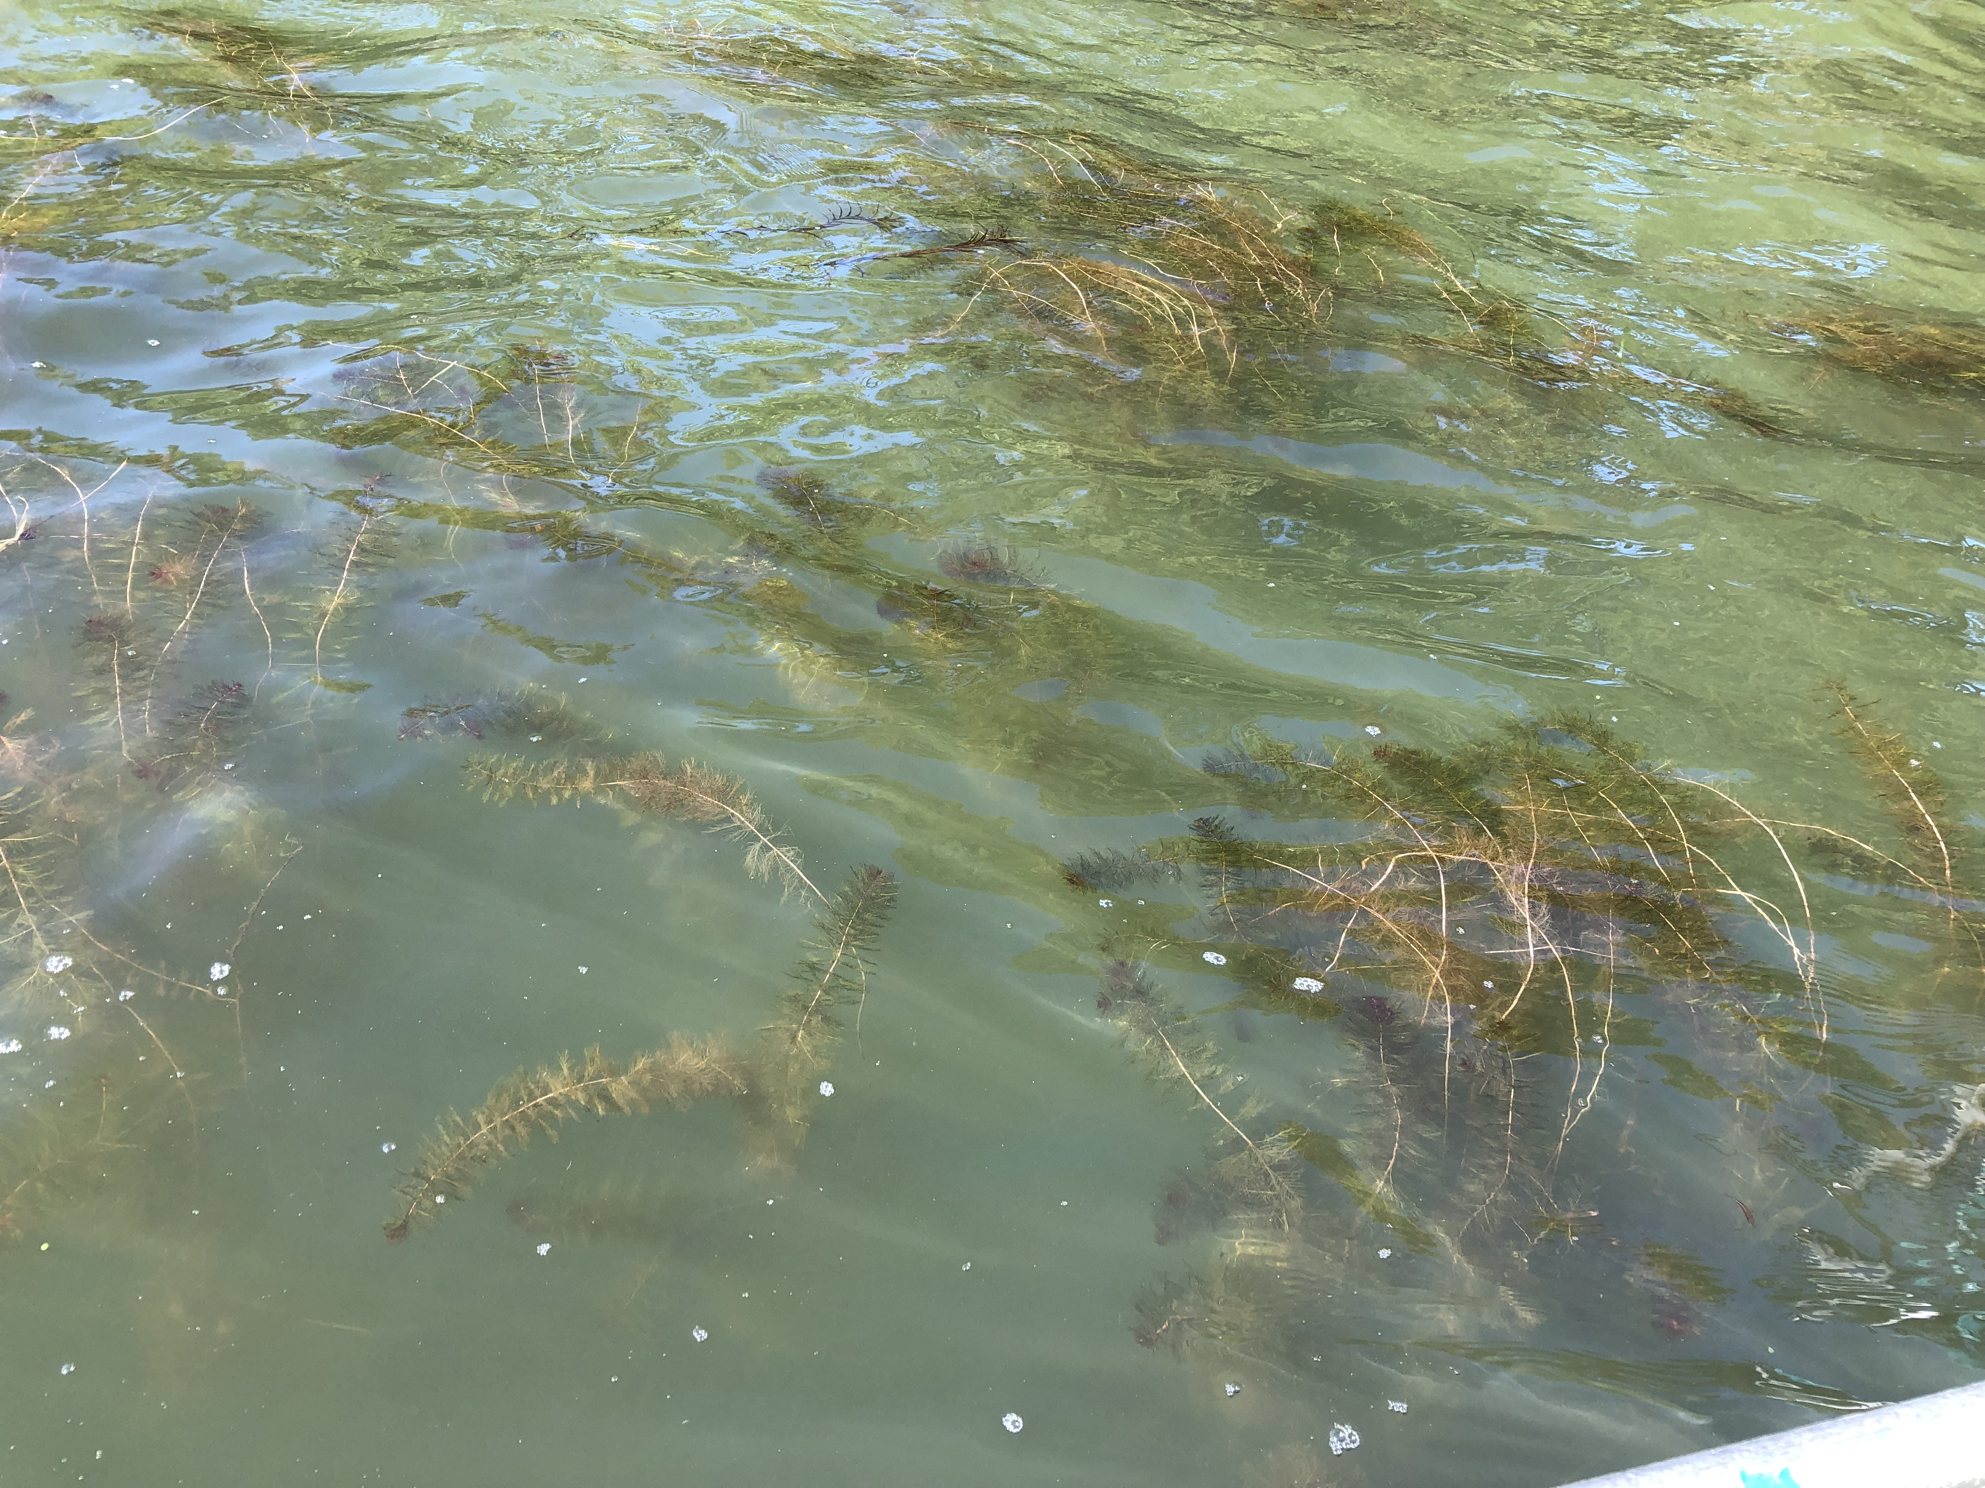
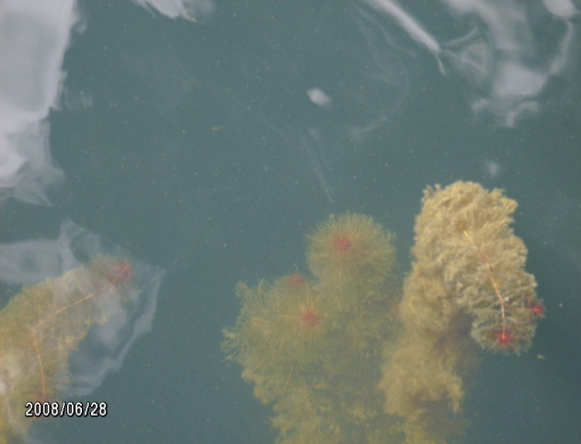
Hybrid Water-milfoil (C. Nackerud) Canopied HWM in Area 6 near the entrance to Mud Lake 9/18/21

Project Initiated by:
Horseshoe Lake Improvement Association, Lake Education and Planning Services, LLC, and the Wisconsin Department of Natural Resources

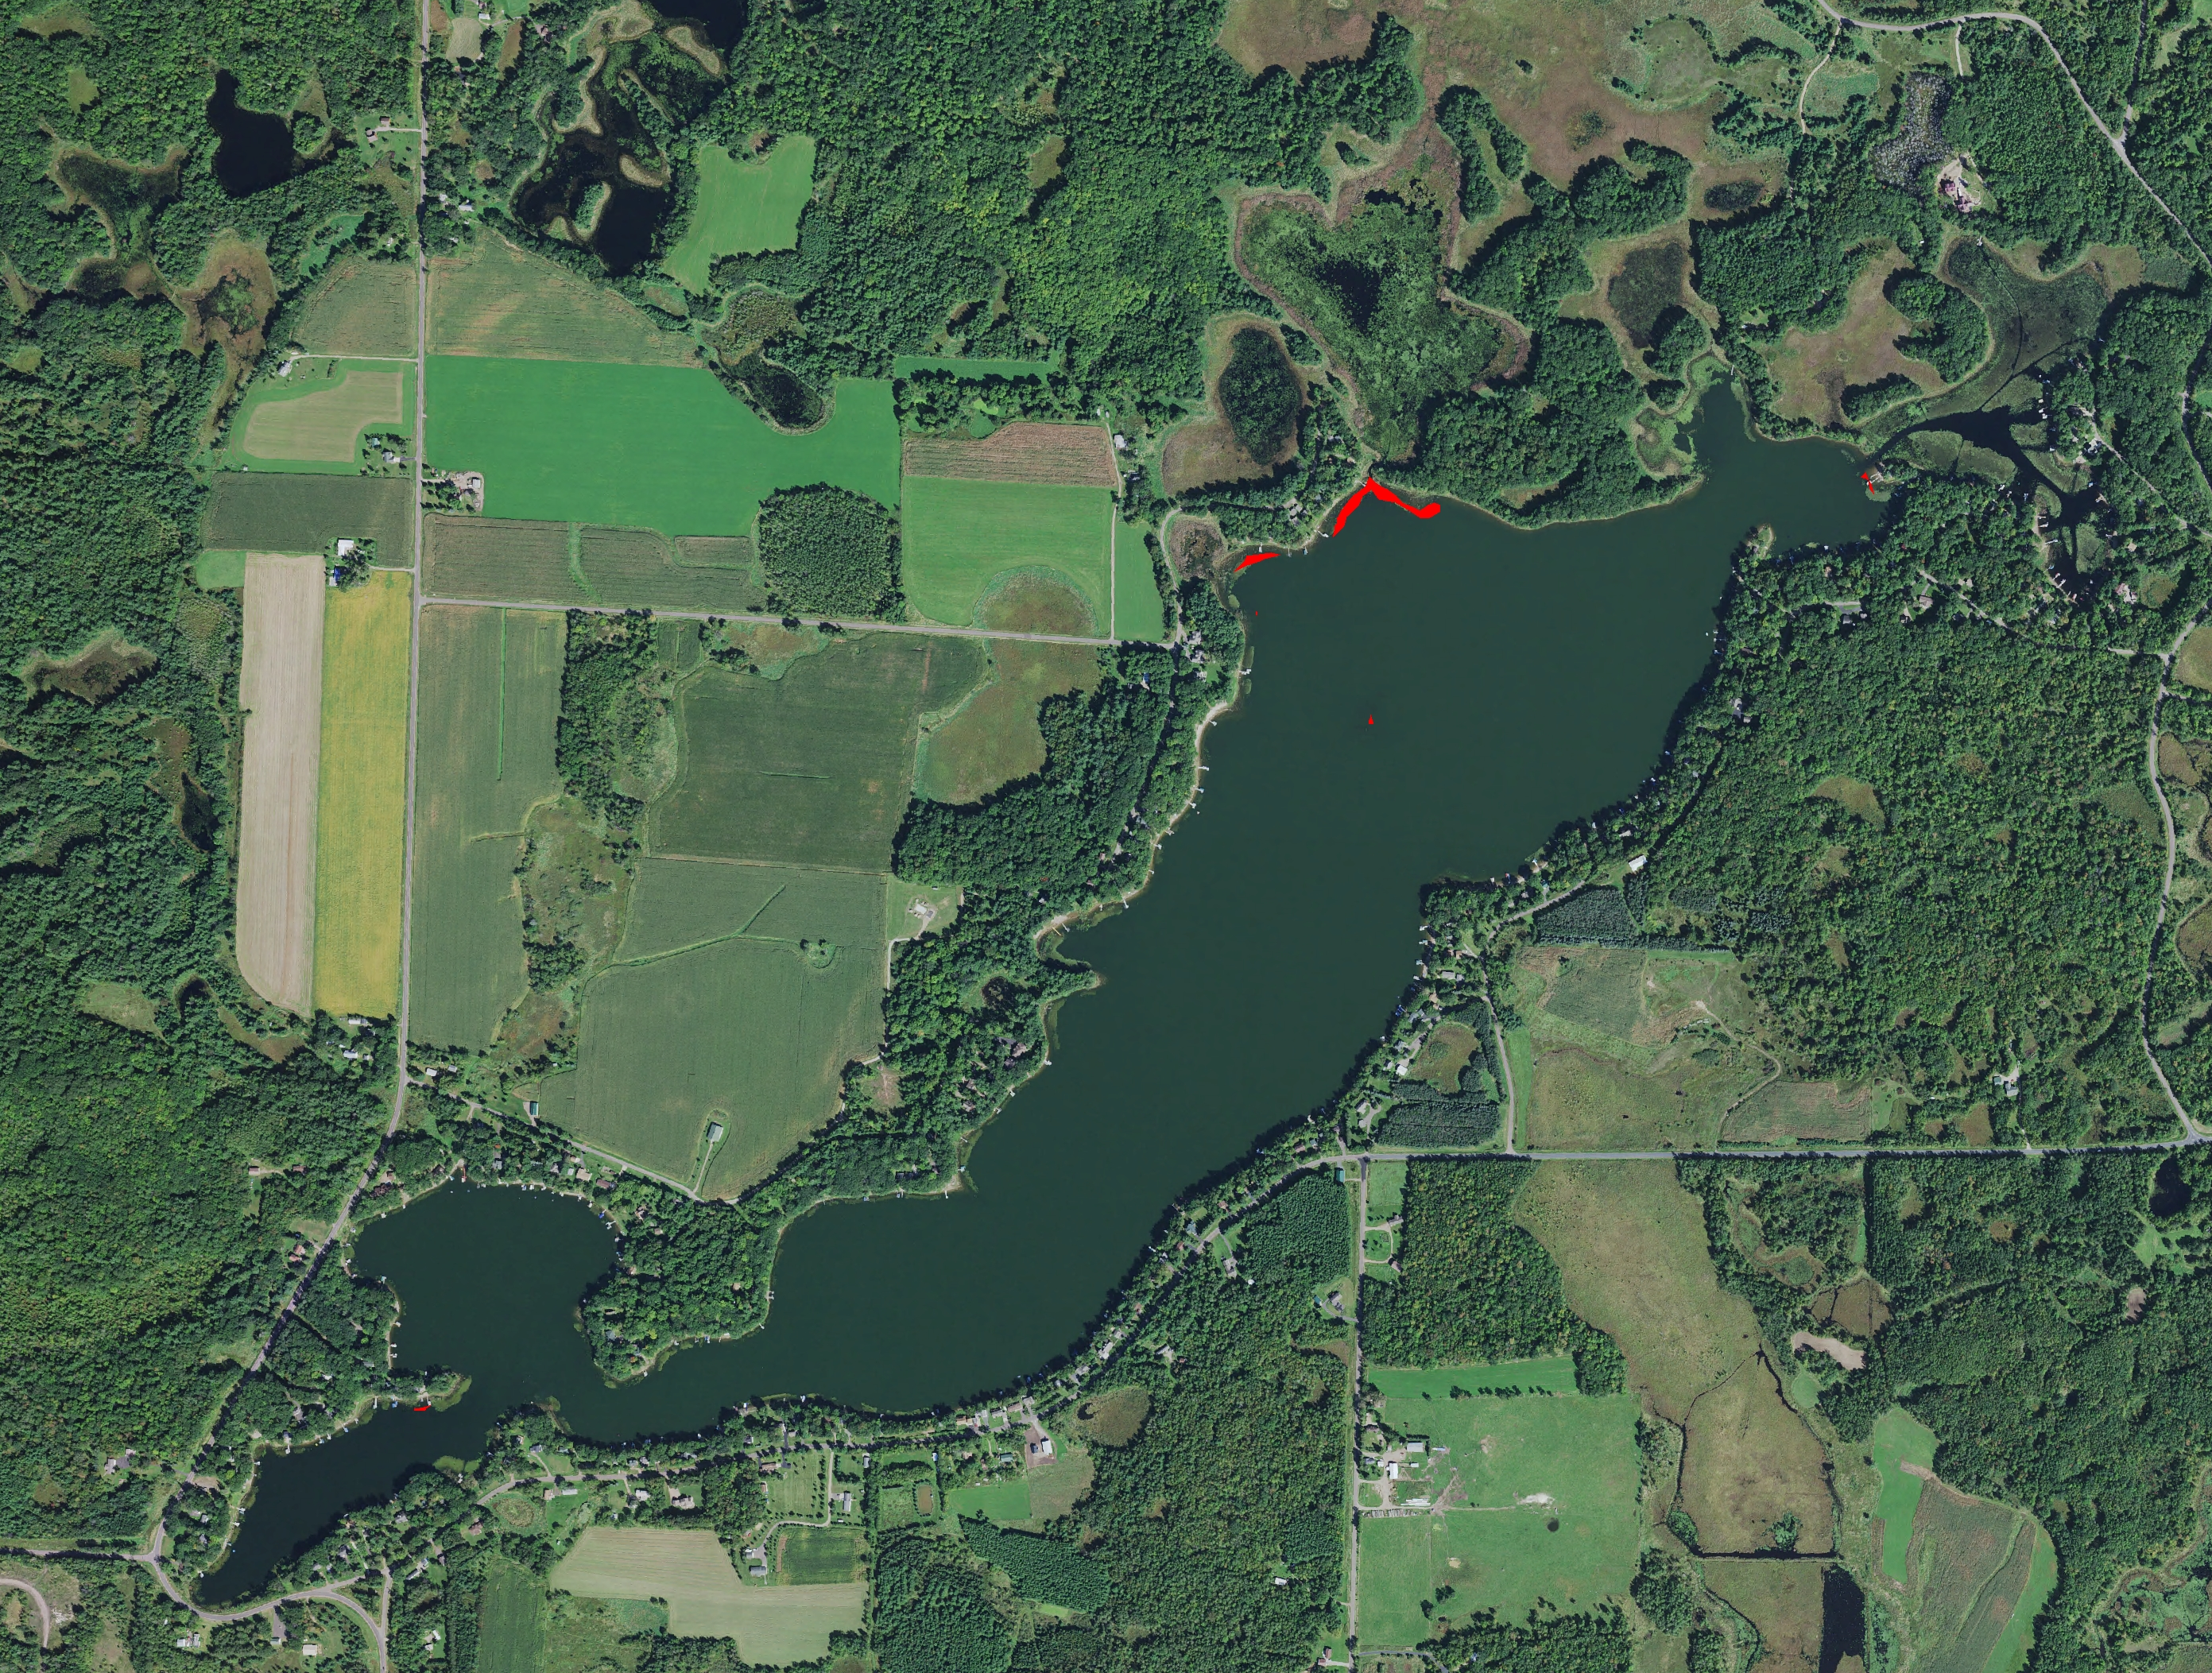
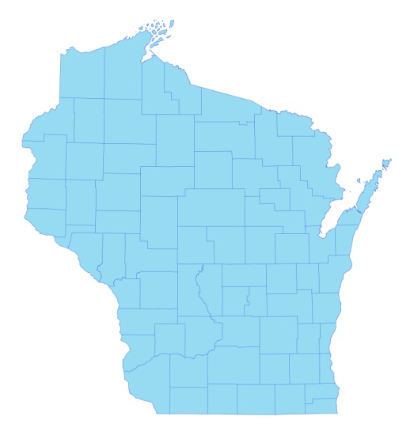

* Horseshoe Lake
Late-summer 2021 (red) Hybrid Water-milfoil High Density Areas

Survey Conducted by and Report Prepared by:
Endangered Resource Services, LLC
Matthew S. Berg, Research Biologist
St. Croix Falls, Wisconsin
September 18, 2021
TABLE OF CONTENTS

Page #

LIST OF FIGURES AND TABLES.………………………………………………………. ii

INTRODUCTION.…………………………………………………………………………. 1

BACKGROUND AND STUDY RATIONALE …………………………………………… 1

METHODS.………………………………………………………………………………… 2

RESULTS AND DISCUSSION.…………………………………………………………… 3

Late-summer Hybrid Water-milfoil Bed Mapping Survey..………………………. 3

Descriptions of Current and Former HWM Beds/High Density Areas.…………… 6

DISCUSSION AND CONSIDERATIONS FOR MANAGEMENT. ……….……………... 8
LITERATURE CITED….………………………………………………………………….. 8

APPENDIXES.……………………………………………………………………………... 9

I: 2020 and 2021 Late-summer HWM Survey Maps ..…………………………………. 9

LIST OF FIGURES AND TABLES

Page
Figure 1: Horseshoe Lake Bathymetric Map………………………………………….…… 1
Figure 2: Rake Fullness Ratings……………………………….…….…………………….. 2
Figure 3: September 18, 2021 HWM Littoral Zone Survey – GPS Tracks………………... 3
Figure 4: Late-summer 2021 Hybrid Water-milfoil High Density Areas.…..…………… .. 3
Table 1: Late-summer Hybrid Water-milfoil High Density Areas Mapping Summary
Horseshoe Lake, Polk/Barron Counties – September 18, 2021…………………………….. 4

Table 2: Historical Late-summer/Fall Hybrid Water-milfoil High Density Areas
Mapping Summary - Horseshoe Lake, Polk/Barron Counties – 2013-2021……….………. 5

Figure 5: Late-summer 2021 Hybrid Water-milfoil – West End..……………..…………... 6
Figure 6: Late-summer 2021 Hybrid Water-milfoil – East End …….……………………... 7

INTRODUCTION:
Horseshoe Lake (WBIC 2630100) is a 398-acre mesotrophic trending towards eutrophic stratified seepage lake located on the border of Polk and Barron Counties in northwest Wisconsin in the Towns of Beaver/Almena (T34N R14/15W). The lake reaches a maximum depth of 57ft in the central basin and has an average depth of approximately 25ft under normal water conditions. The bottom is predominately sand and rock on the margins of the central basin before transitioning to nutrient-poor sandy muck with increased depth. Nutrient-rich organic muck occurs in the lake’s sheltered bays on the northeast end (Holt et al. 1968) (Figure 1). From 1995-2020 (the most recent year available), mean summer Secchi readings have averaged 8.0ft (WDNR 2021). This fair to good water clarity produced a littoral zone that extended to at least 18.0ft in 2021.

Figure 1: Horseshoe Lake Bathymetric Map

BACKGROUND AND STUDY RATIONALE:
In 2006, the Wisconsin Department of Natural Resources identified the presence of Hybrid water-milfoil (HWM) – a cross between Northern and Eurasian water-milfoils (Myriophyllum sibiricum X Myriophyllum spicatum) in the lake, and the Horseshoe Lake Improvement Association (HLIA) has been actively working to control this invasive exotic species with herbicides and manual removal since 2008. Following analysis of the 2017 and 2018 fall HWM bed mapping surveys, the HLIA, under the direction of D. Blumer - Lake Education and Planning Services, LLC (LEAPS), decided to chemically treat nine areas totaling 1.83 acres (0.46% of the lake’s surface area) in 2018 and five areas totaling 7.10 acres (1.78% of the lake’s surface area) in 2019 with 2, 4-D.

The LEAPS fall 2019 bed mapping survey found eight HWM beds that covered 1.04 acres (0.26% surface area), and our 2020 survey located just five microbeds totaling 0.09 acre (0.02% surface area). Due to these small totals, the HLIA, LEAPS, and the WDNR decided NOT to treat HWM in 2020 or 2021 and focus on manual removal. In order to see how HWM responded to another year without chemical control, we were asked to conduct a bed mapping survey on September 18, 2021 to determine where HWM control might be considered in 2022. This report is the summary analysis of that field survey.
METHODS:
Late-summer Hybrid Water-milfoil Bed Mapping Survey:
During the bed mapping survey, we searched the lake’s visible littoral zone and mapped all known beds of Hybrid water-milfoil. A “bed” was determined to be any area where we visually estimated that HWM made up >50% of the area’s plants and was generally continuous with clearly defined borders. After we located a bed, we recorded the mean depth, estimated the rake range and mean rake fullness of HWM (Figure 2), and noted whether the HWM was canopied and likely to interfere with watercraft navigation. We then motored around the perimeter of the area and took GPS coordinates at regular intervals. After uploading these coordinates, we used the WDNR’s Forestry Tool’s Extension to ArcGIS 9.3.1 to generate bed shapefiles and determine the acreage of the beds to the nearest hundredth of an acre. We also GPS marked additional individual HWM plants that occurred outside of the beds as they were generally few in number. If these plants were isolated, we did our best to rake remove them.

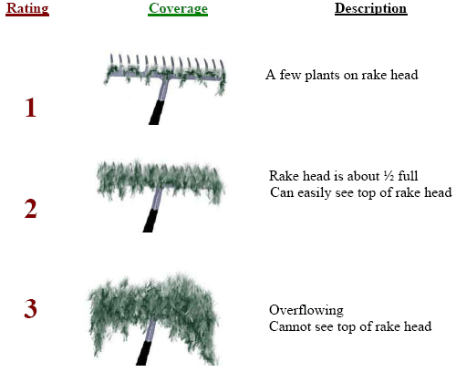
Figure 2: Rake Fullness Ratings

RESULTS AND DISCUSSION:
Late-summer Hybrid Water-milfoil Bed Mapping Survey:
During the September 18, 2021 survey, the lake was experiencing an algal bloom, and we could only see down in the water column approximately 3-4ft. This made it possible to see most, but not all of the rooted littoral zone. As in the past, we found few areas that met the true definition of a “bed” where HWM was canopied, continuous, and dominated the plant community; rather, most mapped areas were better defined as “High Density Areas” where HWM was canopied and regular, but not a solid mat or completely excluding native plant species. After searching along 17.7km (11.0 miles) of transects throughout the lake’s visible littoral zone (Figure 3) and using these expanded criteria, we mapped six areas that totaled 1.05 acres (0.26% of the lake’s surface area). They ranged in size from <0.01 acre (HDA 5A) to 0.80 acre (HDA 6). This was a 0.96-acre increase (+1,066%) from the five areas totaling 0.09 acre (0.02% coverage) that we mapped in 2020 (Table 1). However, it was almost identical to the 1.04 acres mapped in 2019 by LEAPS (Table 2). Outside of these areas, we located just eight additional HWM plants all of which we cleanly rake removed. Because the density was so low in HDA's B, 4, and 12, we rake removed all visible plants there as well. (Figure 4) (Appendix I).

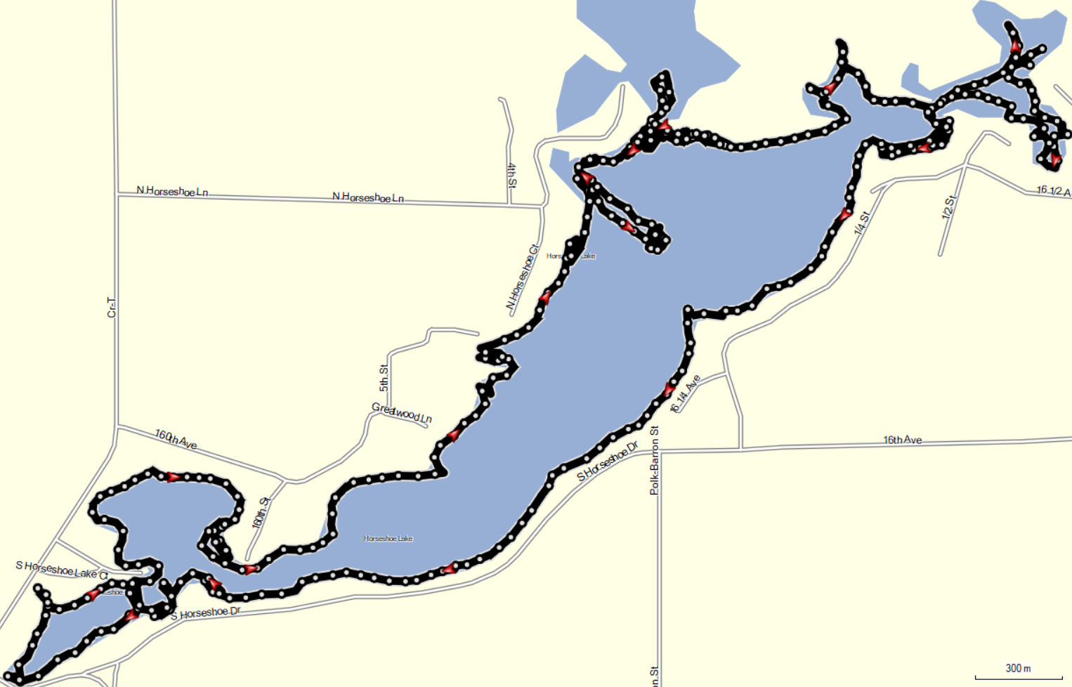
Figure 3: September 18, 2021 HWM Littoral Zone Survey – GPS Tracks

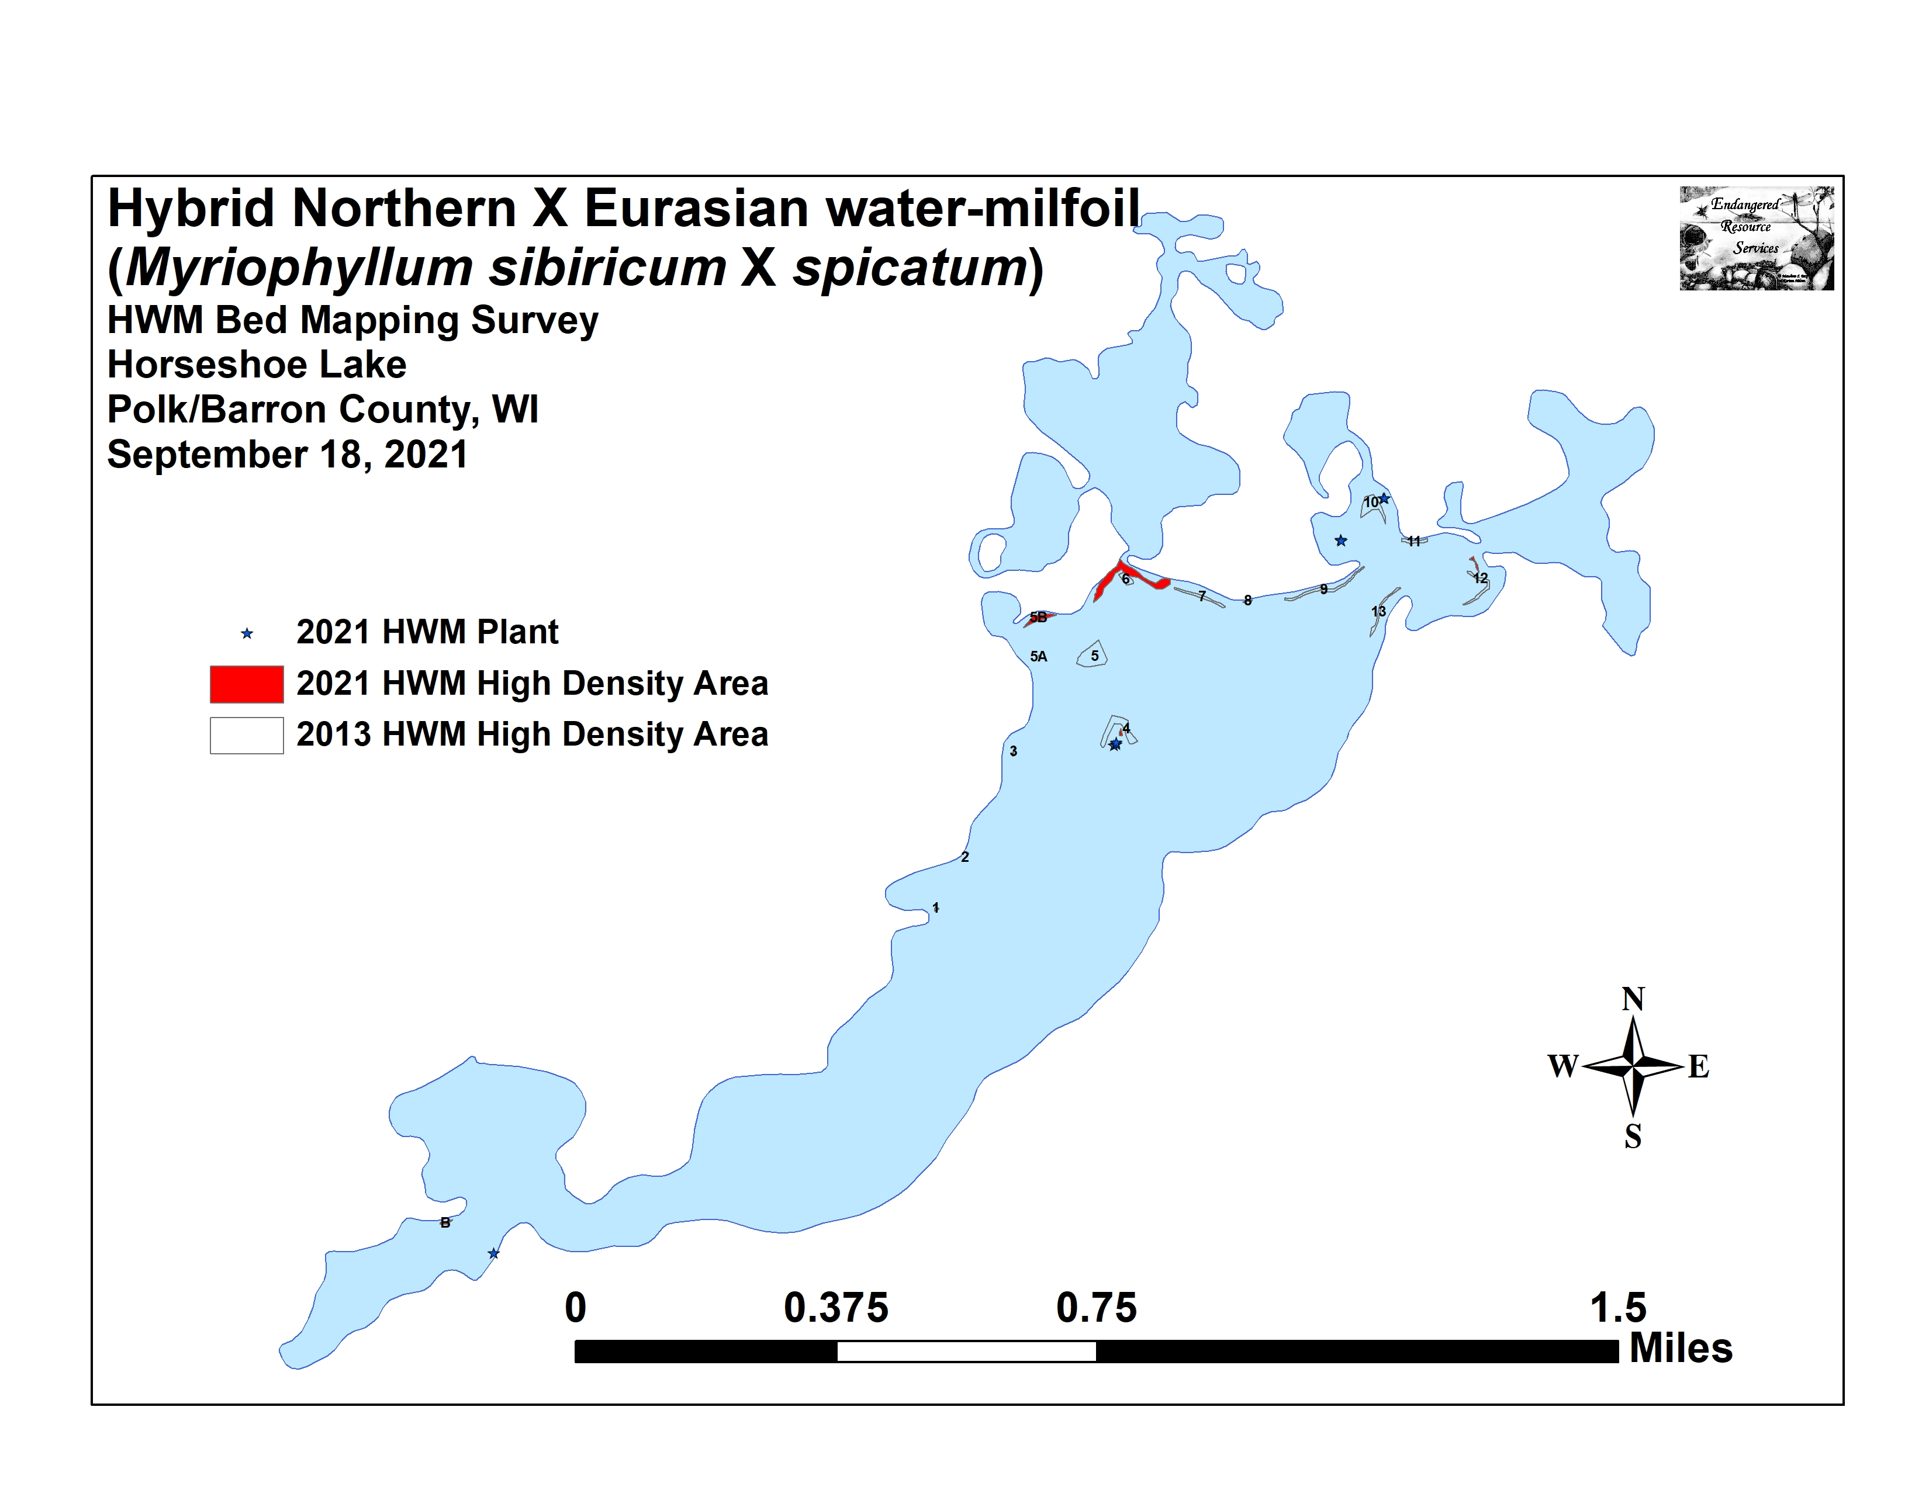
Figure 4: Late-summer 2021 Hybrid Water-milfoil High Density Areas

Table 1: Late-summer Hybrid Water-milfoil High Density Areas Mapping Summary
Horseshoe Lake, Polk/Barron Counties
September 18, 2021
HDA | 2021 Area in Acres | 2020 Area in Acres | 2021  Change in  Acreage | Rake Range;  Mean Rake Fullness | Depth Range; Mean Depth | Navigation Impairment | 2021  Field Notes
AA | 0 | 0 | 0 | - | - | None | No HWM found.
A | 0 | 0 | 0 | - | - | None | No HWM found.
B | 0.03 | 0 | 0.03 | <<<1-3; 1 | 3-7; 5 | Minor | Rake removed 22 clusters of plants.
C | 0 | 0 | 0 | - | - | None | No HWM found.
D | 0 | 0 | 0 | - | - | None | No HWM found.
E | 0 | 0 | 0 | - | - | None | No HWM found.
F | 0 | 0 | 0 | - | - | None | No HWM found.
FF | 0 | 0 | 0 | - | - | None | No HWM found.
G | 0 | 0 | 0 | - | - | None | No HWM found.
1 | 0 | 0 | 0 | - | - | None | No HWM found.
1A | 0 | 0 | 0 | - | - | None | No HWM found.
1AA | 0 | 0 | 0 | - | - | None | No HWM found.
2 | 0 | 0 | 0 | - | - | None | No HWM found.
3 and 3B | 0 | 0 | 0 | - | - | None | No HWM found.
4 | 0.02 | 0 | 0.02 | <<<1-1<<1 | 3-5; 4 | None | 9 HWM plants rake removed.
5 | 0 | 0 | 0 | - | - | None | No HWM found.
5A and 5B | 0.17 | <0.01 | 0.17 | <<<1-2; <<1 | 4-6; 5 | None | Open HDA with 10’s of plants in each area.
6 (A, B, C) | 0.80 | 0.07 | 0.73 | <<<1-3; 1 | 3-5; 4 | Minor | Many small but dense canopied micro-clusters.
7 | 0 | 0 | 0 | - | - | None | No HWM found.
8 | 0 | 0 | 0 | - | - | None | No HWM found.
9 | 0 | 0 | 0 | - | - | None | No HWM found.
9B | 0 | <0.01 | -<0.01 | <<<1 | 4-5; 5 | None | 2 HWM plants rake removed.
10 | 0 | 0 | 0 | <<<1 | 4-5; 5 | None | 2 HWM plants rake removed.
11 | 0 | 0 | 0 | - | - | None | No HWM found.
11AA-C | 0 | 0 | 0 | - | - | None | No HWM found.
12 | 0.04 | 0 | 0.04 | <<<1-1; <<1 | 3-5; 4 | None | 14 HWM plants rake removed.
13 | 0 | 0 | 0 | - | - | None | No HWM found.
Total Acres | 1.05 | 0.09 | +0.96
Table 2: Historical Late-summer/Fall Hybrid Water-milfoil High Density Areas Mapping Summary
Horseshoe Lake, Polk/Barron Counties – 2013-2021

HDA | 2021 Area in Acres | 2020 Area in Acres | 2019  Area in Acres | 2018  Area in Acres | 2017  Area in Acres | 2016  Area in Acres | 2015 Area in Acres | 2014  Area in Acres | 2013  Area in Acres
AA | 0 | 0 | 0 | 0 | <0.01 | 0.07 | 0 | 0 | 0
A | 0 | 0 | 0 | 0 | 0 | 0.12 | 0 | 0.13 | 0
B | 0.03 | 0 | 0 | 0.56 | <0.01 | 0 | 0 | 0.17 | 0
C | 0 | 0 | 0 | 0.02 | 0 | 0 | 0 | <0.01 | 0
D | 0 | 0 | 0 | 0 | 0 | 0 | 0 | 0.04 | 0
E and EE | 0 | 0 | 0 | 0.27 | 0 | 0 | 0 | 0.03 | 0
F | 0 | 0 | 0 | 0 | 0 | 0 | 0 | 0.01 | 0
FF | 0 | 0 | 0 | 0 | 0.09 | 0 | 0 | 0 | 0
G | 0 | 0 | 0 | 0 | 0 | 0 | 0 | <0.01 | 0
1 | 0 | 0 | 0 | 0.25 | 0.05 | 0.03 | 0 | <0.01 | 0.01
1A | 0 | 0 | 0 | 0 | 0.16 | 0 | 0 | 0 | 0
1AA | 0 | 0 | 0 | 0 | 0.04 | 0 | 0 | 0 | 0
2 | 0 | 0 | 0 | 0 | 0 | 0 | 0 | 0 | 0.01
3 and 3B | 0 | 0 | 0 | 0 | 0.35 | 0.03 | 0 | 0.01 | 0.01
4 | 0.02 | 0 | 0 | 0.51 | 0.29 | 0.12 | 0 | 0 | 0.48
5 | 0 | 0 | 0 | Merged | 0 | 0 | 0 | 0 | 0.65
5A and 5B | 0.17 | <0.01 | 0.16 | 4.82 | 0.35 | 0.12 | 0 | 0 | 0
6 (A, B, C) | 0.80 | 0.07 | 0.33 | Merged | 0.24 | 1.12 | 0.24 | 0.29 | 0.13
7 | 0 | 0 | 0 | 0 | 0 | 0 | 0 | 0 | 0.15
8 | 0 | 0 | 0 | 0 | 0 | 0 | 0 | 0 | 0.01
9 | 0 | 0 | 0 | 0 | 0 | 0 | 0 | 0.01 | 0.26
9B | <0.01 | <0.01 | 0 | 1.06 | 0 | 0.25 | 0 | 0.16 | 0
10 | 0 | 0 | 0.17 | 0.33 | 0.02 | 0.06 | 0.02 | 0.25 | 0.39
11 | 0 | 0 | 0 | 0 | 0 | <0.01 | 0 | 0 | 0.11
11AA-C | 0 | 0 | 0.27 | 0.07 | 0.01 | 0 | 0 | 0 | 0
12 | 0.04 | 0 | 0.11 | 0 | 0 | 0 | 0 | 0 | 0.17
13 | 0 | 0 | 0 | 0 | 0 | 0 | 0 | <0.01 | 0.15
Total Acres | 1.05 | 0.09 | 1.04 | 7.88 | 1.60 | 1.93 | 0.26 | 1.13 | 2.54

Descriptions of Current and Former HWM Beds/High Density Areas:
West End of the Lake: We found and rake removed 22 Hybrid water-milfoil plants and clusters in HDA B just west of the point in the southwest bay. We also removed a single rooted HWM plant along the southeast shoreline of the bay immediately southeast of HDA B (Figure 5) (Appendix I). Other than a few floating fragments, we saw no other evidence of HWM anywhere else in the west end of the lake.

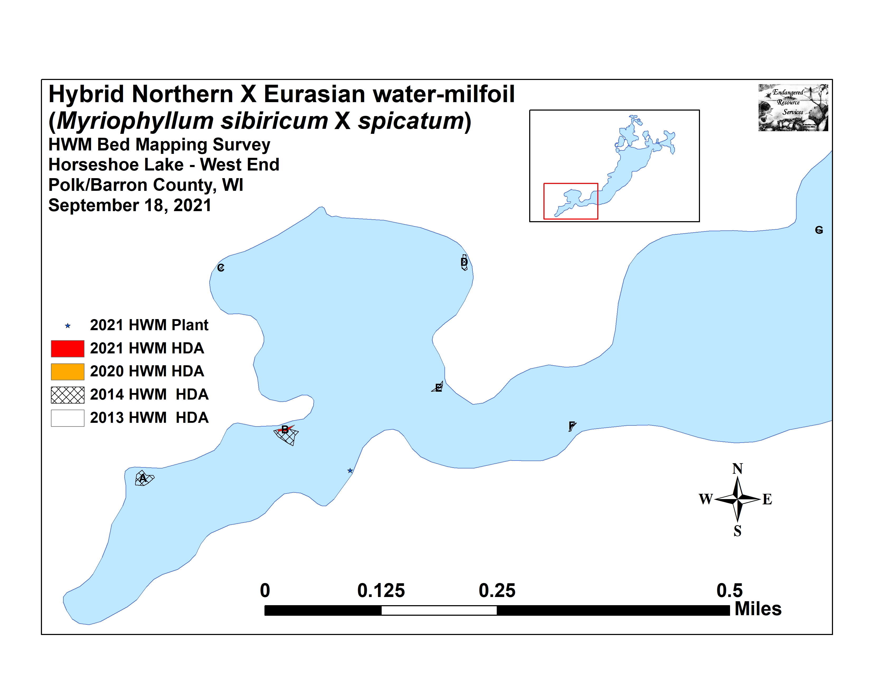
Figure 5: Late-summer 2021 Hybrid Water-milfoil – West End

East End of the Lake: We mapped five microbeds/high density areas on the rock island, along the shorelines near the Mud Lake outlet, and in the bays northwest and southwest of the channel to Buckwald Bay (Figure 6) (Appendix I). Outside these areas, we marked and rake remove seven additional plants.

HDAs 1-3, 5, and 7-9 – We found no evidence of HWM anywhere in these historic areas.

HDA 4 – Three canopied single plants occurred on the west side of the “rock island” and six additional plants/clusters were found growing on the east side. Although we rake removed each of them, their roots were impacted in the gravel which likely means some stems will survive. Assuming manual removal will occur again in 2022, this area should be a priority to search as plants in this location appears to “seed” the bays to the north and west with fragments.

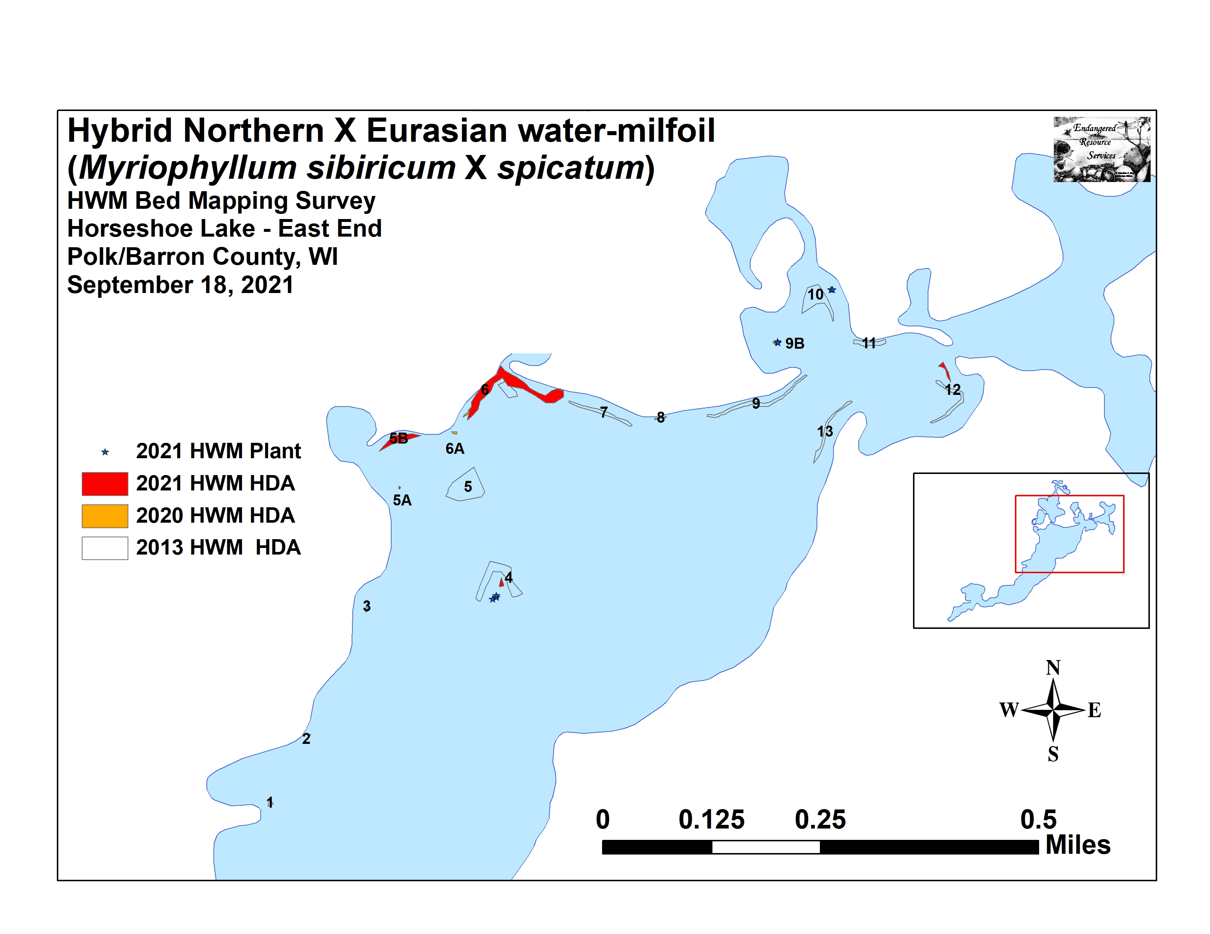
Figure 6: Late-summer 2021 Hybrid Water-milfoil – East End

HDAs 5A and 5B – Each of these areas had 10’s not 100’s of plants. Due to its small size, we were able to rake remove most individuals in 5A. Unfortunately, 5B had so many plants that this wasn’t possible despite HWM’s low overall density.

HDAs 6 – Near the Mud Lake inlet, canopied patches of HWM were merging into a true bed. Extending away from the core, plants became more scattered on the east and southwest lobe of the bed where they were nearly continuous with HDA 5B. This was easily the worst area on the lake, and we saw floating fragments throughout the bay. If chemical control occurs anywhere in 2022, this bay is likely the best candidate.

HDA 9B and 10 – We found and rake removed four HWM plants scattered around the bay northwest of the channel to Buckwald Bay. This area appears to have few enough plants that manual removal is working to maintain HWM at low levels.

HDAs 11 and 11AA-C (Buckwald Bay) – We saw no evidence of HWM along the shoreline northwest of Buckwald Bay’s channel or anywhere in the bay itself.

HDA 12 – In the bay southwest of the Buckwald Bay channel, we rake removed 14 scattered plants. This is another area where manual removal may be appropriate in 2022.

HDA 13 and the south shoreline – We saw no evidence of HWM anywhere along the lake’s south shoreline other than one plant previously mention in the bay southeast of HDA B.

DISCUSSION AND CONSIDERATIONS FOR MANAGEMENT:
Hybrid water-milfoil currently occupies a small percentage of Horseshoe Lake’s surface area, but it is well-established making eradication an unrealistic expectation. Active management has reduced the levels of HWM from 13 areas totaling 2.54 acres (0.64% of the lake’s surface area) in 2013 to 1.05 acres (0.26% coverage) in 2021 – a decline of -58.66%.

Managing Hybrid water-milfoil has come at a high economic cost, and, as herbicides are non-selective, it has likely also had significant impacts on the aquatic plant community. In the future, maintaining HWM at its current low levels using targeted manual removal and chemical applications will likely continue to produce satisfactory control while simultaneously minimizing financial and ecological costs. Ultimately, the amount of HWM growth the HLIA is comfortable with will determine how much, if any, management occurs on Horseshoe Lake in 2022.

LITERATURE CITED

Holt, C., S. Busch, C., R. Kerr, and S. Johannes. [online]. 1968. Horseshoe Lake Map. Available from http://dnr.wi.gov/lakes/maps/DNR/2630100a.pdf (2021, November).

UWEX Lakes Program. [online]. 2010. Aquatic Plant Management in Wisconsin. Available from http://www.uwsp.edu/cnr-ap/UWEXLakes/Pages/ecology/aquaticplants/default.aspx (2021, November).

WDNR. [online]. 2021. Horseshoe Lake - Citizen Lake Water Quality Monitoring Database. Available from http://dnr.wi.gov/lakes/waterquality/Station.aspx?id=493139 (2021, November).

Appendix I: 2020 and 2021 Late-summer HWM Survey Maps
