Bass and Hemlock Lakes
Barron County
Shoreline Habitat Assessment
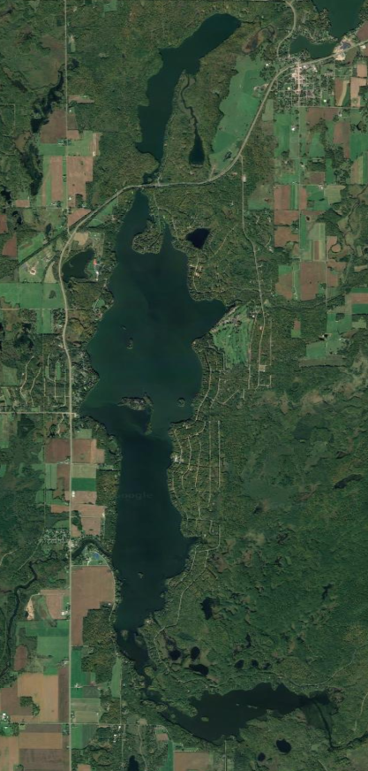
Red Cedar Lakes Association
Summer 2021
Bass and Hemlock Lakes
Shoreline Habitat Assessment

Prepared by:

Dave Blumer, Project Manager/Lakes Scientist
Megan Mader, Aquatic Biologist
Lake Education and Planning Services LLC
PO Box 26
Cameron, WI 54822

Acknowledgements:
Members of the Red Cedar Lakes Association who contributed volunteer hours and helpful discussions in performing these assessments.

Table of Contents
Overview……………………………………………………………………………………….……..……4
Protocol…………………………………………………………………….…………….…….…..4
Habitat Improvement Potential Ranking Parameters………………………………..…………….4
Healthy Lakes Initiative Management Projects……………..……………………………………..……6
Fish Sticks……………………………………………………………………………………….....6
Rain Gardens…………………………………………………………………………………….....6
Native Plantings………...……………………………………………………………………….....7
Diversions……………………………………………………………………………………….....7
Rock Infiltrations.………………………………………………………………………………….8
Example Parcels………………………………………………………………………………….………..9
Parcel Potential Assessment…………………………….……………………………………………….10
Bass Lake Moderate Potential Parcels….….………………………………………………………...…11
Hemlock Lake Moderate Potential Parcels…………………………….………………………………15
Index of Parcel Numbers and Owners………………...……………………………………………..…21

Overview
Protocol
The protocol used in this survey was developed by the Wisconsin Department of Natural Resources (WDNR) as a way to evaluate shoreline habitat. This survey is intended to provide management recommendations to individual property owners based on an evaluation of their property. This protocol involves surveying the riparian land use for each parcel and photographing each parcel from the lake. For this survey, the riparian zone is defined as 35 feet inland from the water’s edge. The land use information includes the number of human structures in the riparian zone and various other runoff concerns, as well as natural cover of trees, shrubs, and ground cover.

Habitat Improvement Potential Ranking Parameters
The potential rankings that accompany each parcel evaluation were developed by LEAPS in order to determine the needs of each lake with concern to the projects that could realistically be completed on each parcel. The parameters used to determine the potential were considered to be those that would have the biggest impact on rainwater runoff and habitat quality. This includes percentage of canopy cover, as well as the percentage of undisturbed vegetation and a summed percentage of manicured lawn, impervious surfaces, and easily eroded surfaces such as exposed soil. Additional consideration was given to the number of buildings present in the riparian zone and the presence or absence of lawns that sloped directly to the lake. There are value ranges assigned to each parameter which determine the parcel priority ranking (Table 1). The points are then summed and the properties sorted based on the point range for the entire lake (Table 2; Figure 1).

Table 1: Values for point assignments of each parameter.
Parameter | 2 Points | 1 Point | 0 Points
Percent canopy cover | 0-33% | 34-66% | >66%
Percent shrub and herbaceous (undisturbed) | 0-33% | 34-66% | >66%
Percent lawn, impervious, and other surfaces | >66% | 34-66% | 0-33%
Number of buildings and other human structures | >1 | 1 | 0
Presence/ Absence of lawn or soil sloping to lake | N/A | 1 (Present) | 0 (Absent)
Presence/Absence of bare soil | 1 (Present) | N/A | 0 (Absent)
Presence/Absence of sand deposits | N/A | 1 (Present) | 0 (Absent)

Table 2: Score ranges and project potential rankings for parcels surrounding the lakes
Project Potential | Overall Score | Big Trade | Little Trade
High | 8-10 Points | 15 | 6
Moderate | 5-7 Points | 56 | 8
Low | 2-4 Points | 36 | 18
No Concern | 0-1 Points | 39 | 41

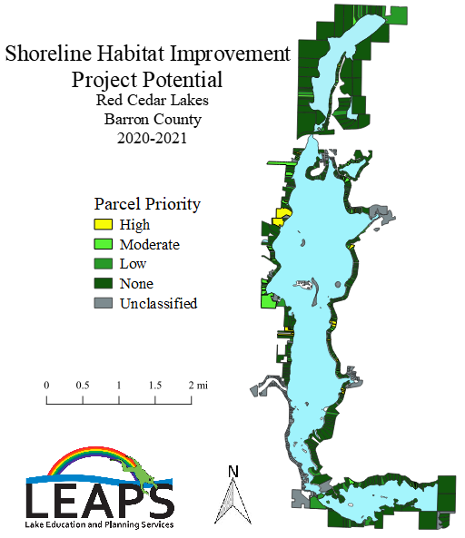
Figure 1. Lake-wide shoreline habitat assessment results for the Red Cedar Lakes
Healthy Lakes Initiative Management Projects

The Healthy Lakes Initiative is a WDNR program meant to provide information and grant funding for small scale projects designed to help individual property owners improve both shoreline habitat and lake health. The grants available for these projects are intended for fairly small, inexpensive projects, so there is $1000 limit in grant funding per project. The projects that qualify for these grants are installing fish sticks, rain gardens, native plantings, diversions, and rock infiltrations. Many of the high and moderate potential properties would benefit from these projects because they provide habitat for fish and wildlife, offer protection from shoreline erosion, and help improve the overall quality of the lake.

Fish sticks (Figure 2) installs trees across the shoreline and into the water to mimic naturally fallen trees that provide habitat for fish and other wildlife as well as protection from shoreline erosion. The trees are secured to the shore with cables for approximately 3 years. Fish sticks project costs range anywhere from $100 to $1000, averaging about $500. These are very low maintenance because the only upkeep is occasionally checking that the cables are secure. This practice would work well for almost any of the developed parcels on the lakes.

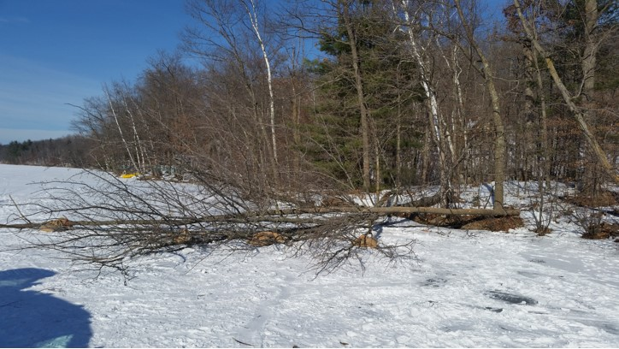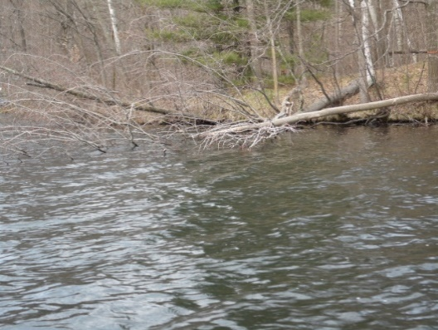
Figure 2: Fish sticks installation (left) and after ice out (right).

Rain gardens (Figure 3) are meant to capture runoff and naturally filter the water with plants and appropriate soils instead of flowing directly into the lake. Rain gardens are designed to allow the rainwater to soak into the ground within 1-2 days. The project costs for rain gardens range anywhere from $500 to $9,500, but this is highly dependent on the size of the rain garden. The maintenance is fairly low, only requiring watering for about two weeks until the plants have established, and weeding is occasionally needed during the first year. This project is best suited to parcels on a smaller incline to catch rainwater runoff that would otherwise run into the lake.

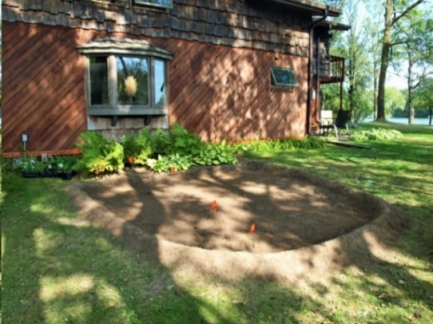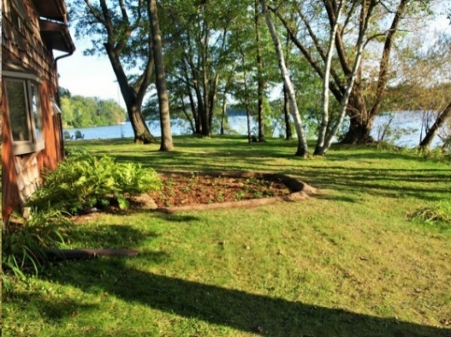
Figure 3: Rain garden installation (left) and completed rain garden (right)
Native plantings (Figure 4) are intended to establish a buffer zone between the developed portion of a parcel and the lake to help filter and slow rainwater runoff. This buffer zone is created by changing a strip of turf grass, at least ten feet wide, along the shoreline to a natural area composed of native shoreline plants. Similar to rain gardens, these are fairly low maintenance, requiring watering only until the plants have become established. The only ongoing maintenance is the removal of any invasive species that find their way into the planting. On average, native plantings cost around $1000. This project will work for almost any developed parcel that does not have a sand beach as the primary frontage.

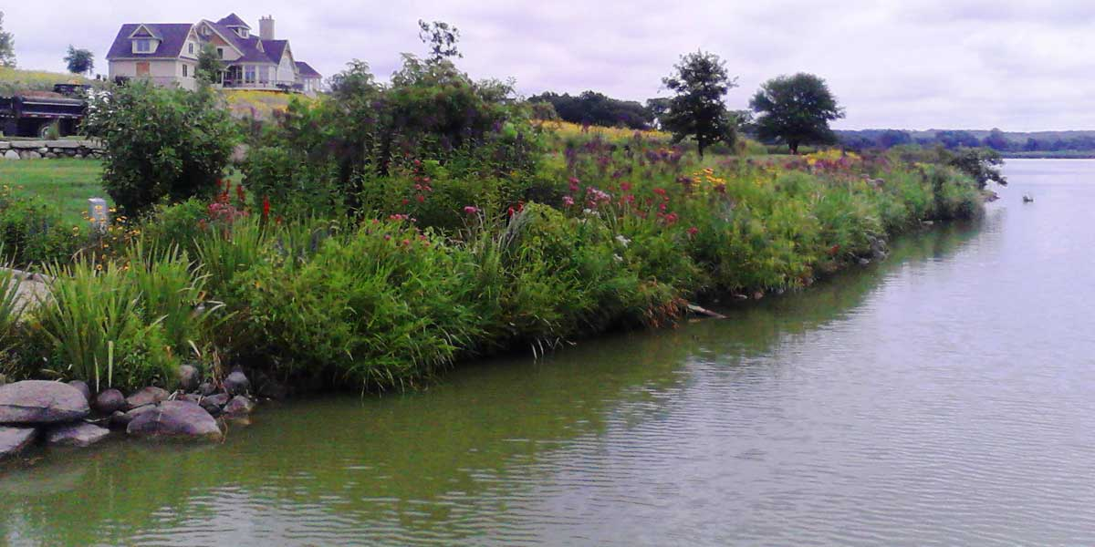
Figure 4: Completed native planting (Photo from HealthyLakesWI.com)

Diversions (Figure 5) are placed across a sloping path or driveway to divert runoff water to an area where it can be absorbed into the ground instead of flowing directly into the lake. In addition to helping improve lake health, these can also reduce the effects of erosion on the paths that the diversions are installed on. Diversions are created by entrenching a log or creating a small earthen berm approximately 30 degrees from the angle of the slope. The cost of these range anywhere from $25 to $3,750, but the average diversion costs $200. These are very low maintenance, and only require some debris removal that could get stuck in the diversion and occasionally ensuring everything is still secure and in place. This practice does not work well for the purposes of this particular survey, but it is mentioned here as a nod to projects that could be completed further inland than this survey was meant to assess.

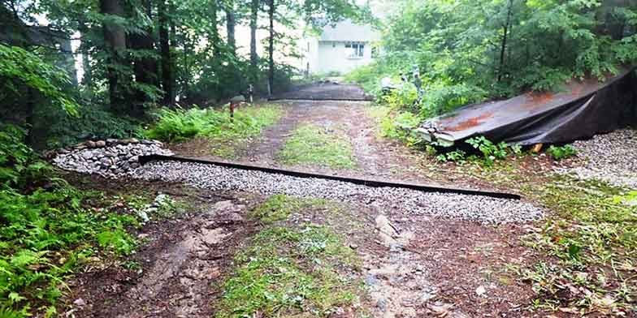
Figure 5: Completed diversion (Photo from HealthyLakesWI.com)

Rock infiltrations (Figure 6) are meant for relatively low traffic areas as a way to catch rainwater runoff and divert it into the ground. These consist of a pit no more than five feet deep lined with filter fabric and filled with small rock. More filter fabric is placed on top and larger rock is then placed over that to hold everything in place. These range in price from $500 to $9,500, on average costing $3800. This requires some maintenance to function properly. It is necessary to remove any debris such as leaves or pine needles that may collect. It is also necessary to occasionally clean out the rock as it collects sediment. This works well around buildings in the riparian zone where rain water comes from gutters or runs off the roof.

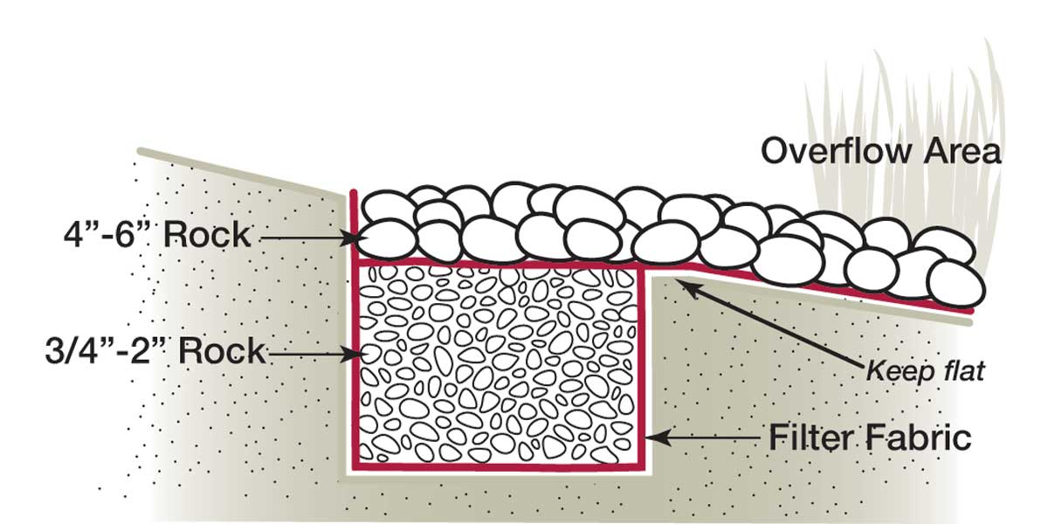
Figure 6: Rock infiltration design

Example Parcels (Not from the Red Cedar Lakes)
These parcels are simply meant to give property owners an idea of property owners who are able to make the most of their lakefront property while still having very little negative impact on the lake itself.

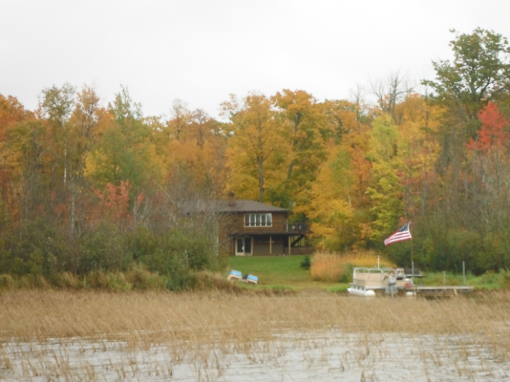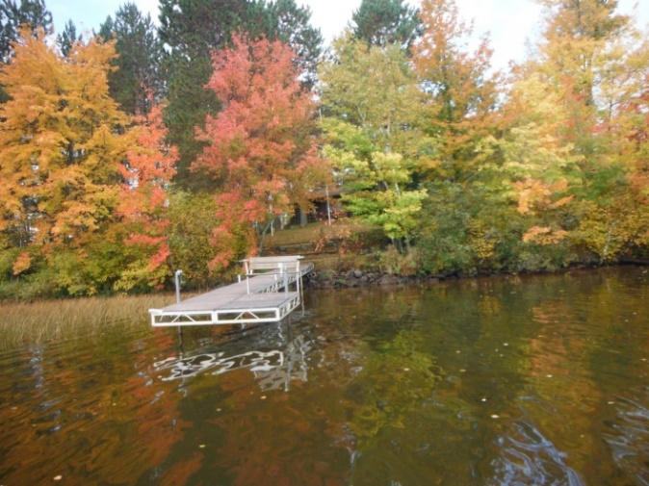
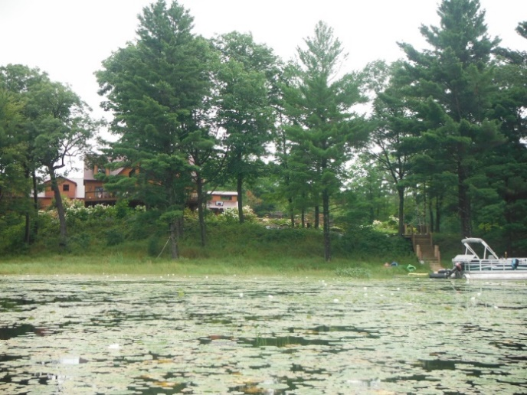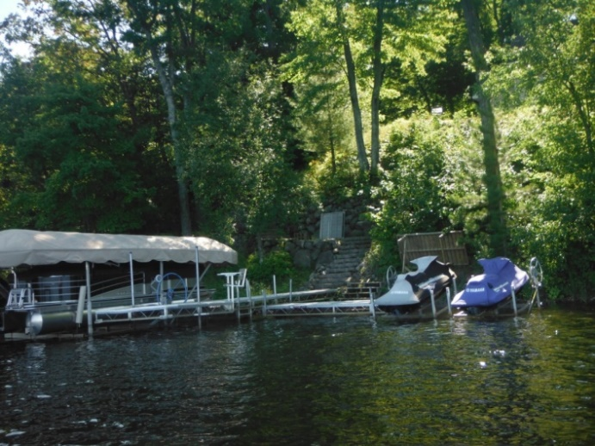
Figure 7: Developed Parcels with a "No Potential" Ranking

The properties shown in Figure 7 have been assessed with the same protocol as the properties surrounding Big and Little Trade and have received potential rankings of ‘No Potential.’ In each parcel, the majority of the land within the riparian zone is comprised of undisturbed, native vegetation. The parcels that are level have some manicured lawn within that zone, but this is treated more like a well-maintained trail. For parcels with a steep slope, having a trail or stairway down to the lake while leaving the rest of the area as native vegetation works best. Not only is this the most lake-friendly approach, but the maintenance and general upkeep of this area becomes much safer, easier, and cost effective.

Parcel Potential Assessment

The following pages are the summarized evaluations of each parcel in Bass and Hemlock Lakes (Red Cedar, Balsam, and Mud were completed in 2020) that were found to have high or moderate project potential. These assessments include the values used to determine the overall score as well as a photograph, and management recommendations based on Healthy Lakes Initiative projects. Photos are intended to provide reference for individual property owners and have been matched to the correct properties to the best of our ability. It is important to note that while ranking each parcel ONLY the 35-ft along the shoreline was considered. The photos were not used to assess properties and can be misleading for certain parameters, particularly canopy cover. For example, some parcels appear mostly shaded, but only have 15% canopy cover. This is likely because the assessment only considered 35-ft back from the shoreline and the canopy cover started beyond that mark. Additionally, there are other considerations such as camera angle, time of day, etc. All evaluations were done in the field to prevent any misdirection that would have been caused by using photos to assess the properties. For the Red Cedar Lake Shoreline Habitat Assessment results, please contact Dave Blumer at dbleaps@gmail.com or (715) 642-0635.

Bass Lake

Moderate Potential Parcels
010417821000
010417822000
010417828000

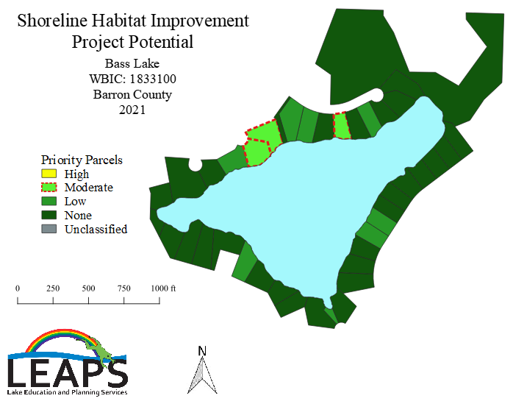

Parcel Number: 010417822000

Total Score: 6

Potential: Moderate

Parameter | Property value | Point value
Percent canopy cover | 95 | 0
Percent shrub and herbaceous (undisturbed) | 30 | 2
Percent lawn, impervious, and other surfaces | 70 | 2
Number of buildings and other human structures | 1 | 1
Presence/Absence of lawn or soil sloping to lake | 1 | 1
Presence/Absence of bare soil deposits | 0 | 0
Presence/Absence of sand deposits | 0 | 0

Management Recommendations:
Increase native, undisturbed vegetation in the understory with native plantings. Maintain canopy cover and shoreline buffer strip.

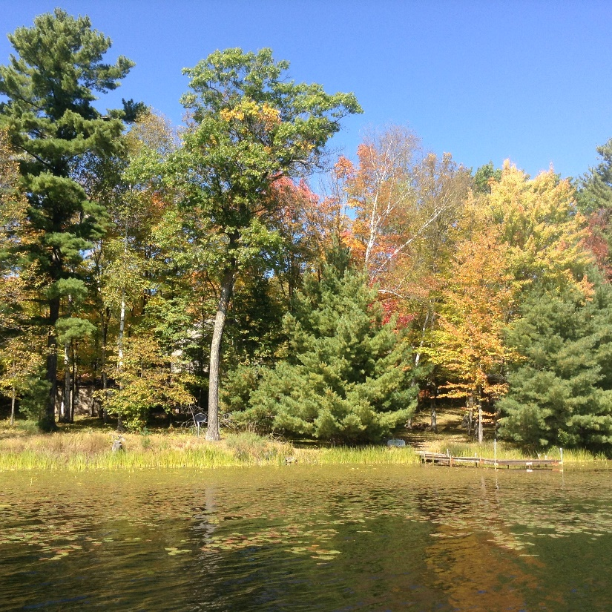

Parcel Number: 010417821000

Total Score: 5

Potential: Moderate

Parameter | Property value | Point value
Percent canopy cover | 85 | 0
Percent shrub and herbaceous (undisturbed) | 20 | 2
Percent lawn, impervious, and other surfaces | 60 | 2
Number of buildings and other human structures | 0 | 0
Presence/Absence of lawn or soil sloping to lake | 1 | 1
Presence/Absence of bare soil deposits | 0 | 0
Presence/Absence of sand deposits | 0 | 0

Management Recommendations:
Increase native, undisturbed vegetation in the understory with native plantings.

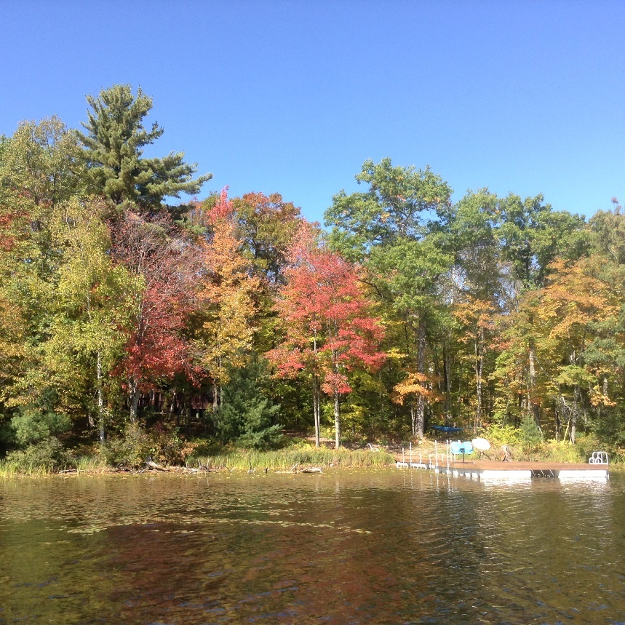

Parcel Number: 010417828000

Total Score: 5

Potential: Moderate

Parameter | Property value | Point value
Percent canopy cover | 80 | 0
Percent shrub and herbaceous (undisturbed) | 30 | 2
Percent lawn, impervious, and other surfaces | 70 | 2
Number of buildings and other human structures | 0 | 0
Presence/Absence of lawn or soil sloping to lake | 1 | 1
Presence/Absence of bare soil deposits | 0 | 0
Presence/Absence of sand deposits | 0 | 0

Management Recommendations:
Increase native, undisturbed vegetation in the understory with native plantings and reduced lawn. Maintain canopy cover and shoreline buffer strip.

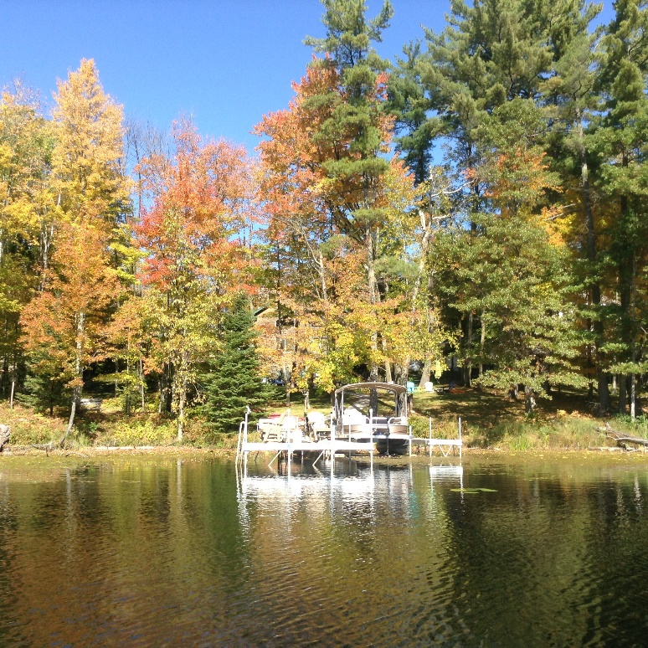

Hemlock Lake

Moderate Potential Parcels
010260010022
010409009000
010409008000
010409007000
010409006000

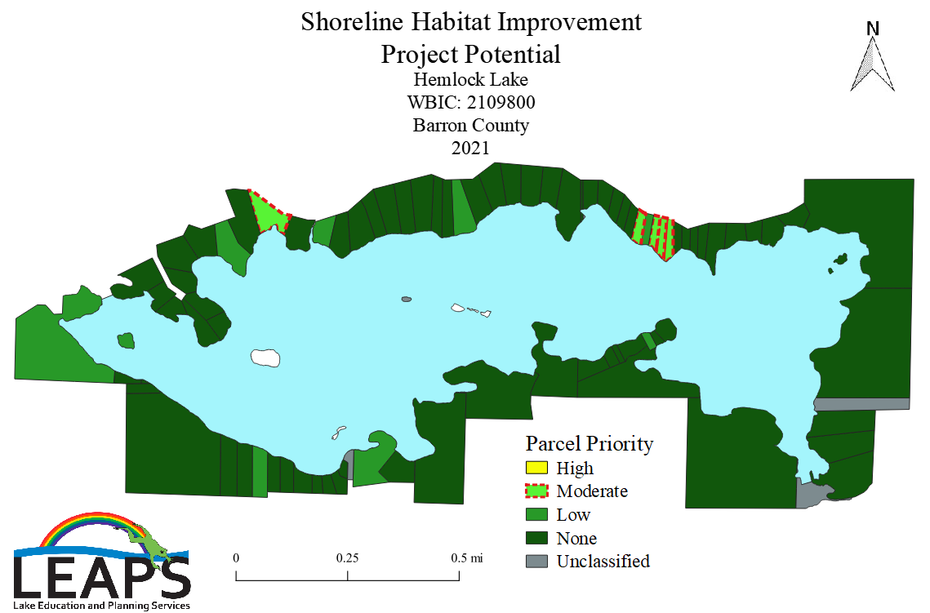

Parcel Number: 010260010022

Total Score: 6

Potential: Moderate

Parameter | Property value | Point value
Percent canopy cover | 50 | 1
Percent shrub and herbaceous (undisturbed) | 30 | 2
Percent lawn, impervious, and other surfaces | 70 | 2
Number of buildings and other human structures | 0 | 0
Presence/Absence of lawn or soil sloping to lake | 1 | 1
Presence/Absence of bare soil deposits | 0 | 0
Presence/Absence of sand deposits | 0 | 0

Management Recommendations:
Increase native, undisturbed vegetation in the understory with native plantings. Reduce lawn coverage with a buffer strip of native vegetation along the shoreline.

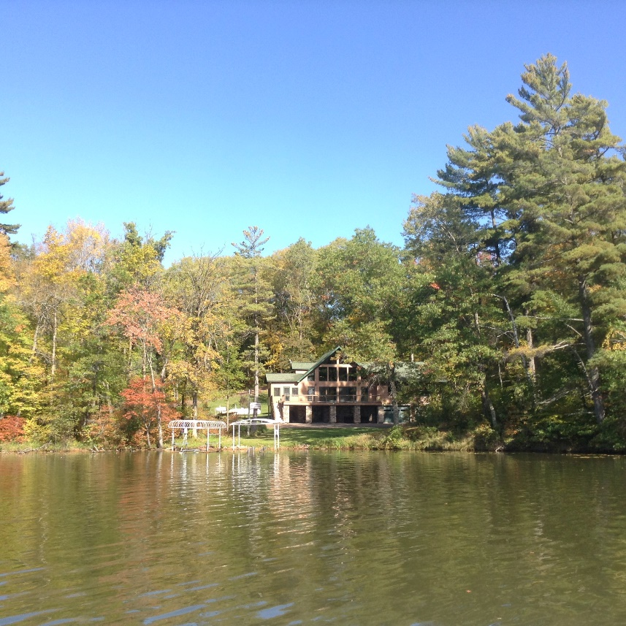
Parcel Number: 010409009000

Total Score: 4

Potential: Moderate

Parameter | Property value | Point value
Percent canopy cover | 80 | 0
Percent shrub and herbaceous (undisturbed) | 5 | 2
Percent lawn, impervious, and other surfaces | 95 | 2
Number of buildings and other human structures | 0 | 0
Presence/Absence of lawn or soil sloping to lake | 0 | 0
Presence/Absence of bare soil deposits | 0 | 0
Presence/Absence of sand deposits | 0 | 0

Management Recommendations:
Increase native, undisturbed vegetation in the understory with native plantings.

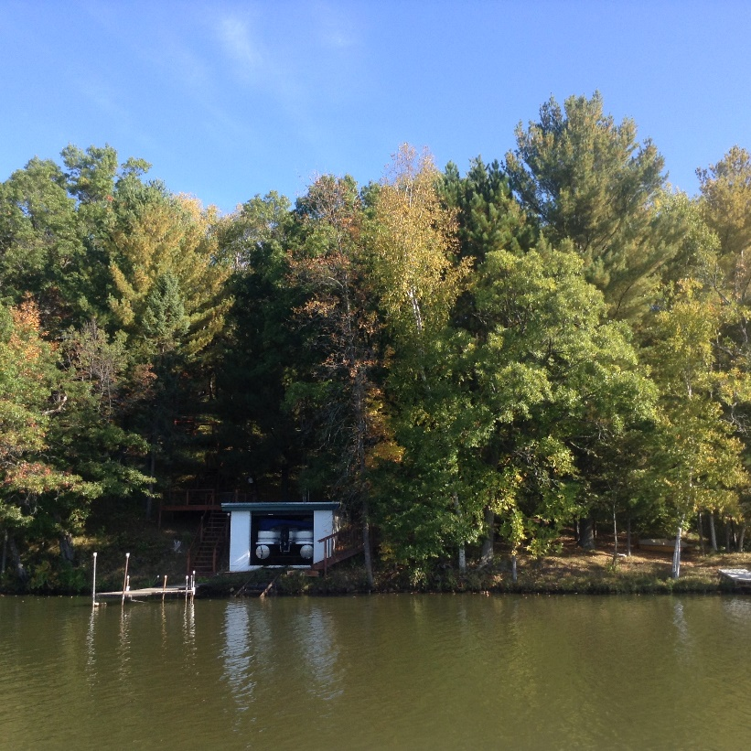

Parcel Number: 010409008000

Total Score: 5

Potential: Moderate

Parameter | Property value | Point value
Percent canopy cover | 85 | 0
Percent shrub and herbaceous (undisturbed) | 5 | 2
Percent lawn, impervious, and other surfaces | 95 | 2
Number of buildings and other human structures | 0 | 0
Presence/Absence of lawn or soil sloping to lake | 1 | 1
Presence/Absence of bare soil deposits | 0 | 0
Presence/Absence of sand deposits | 0 | 0

Management Recommendations:
Increase native, undisturbed vegetation in the understory with native plantings. Reduce lawn coverage with a buffer strip of native vegetation along the shoreline.

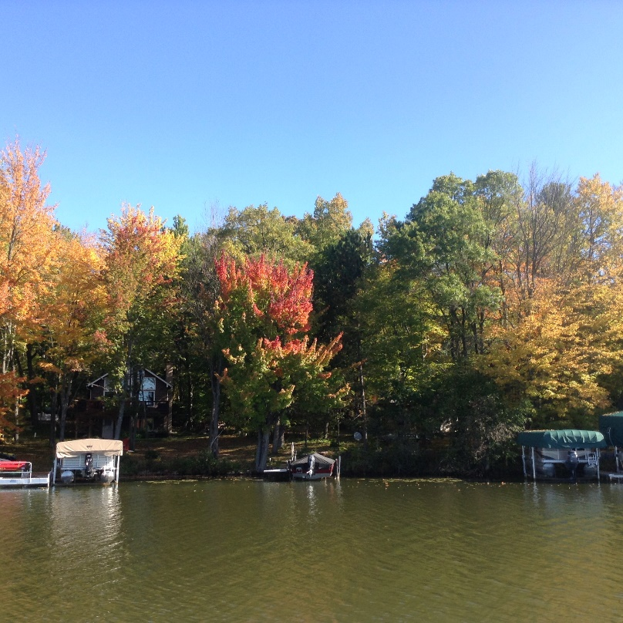

Parcel Number: 010409007000

Total Score: 5

Potential: Moderate

Parameter | Property value | Point value
Percent canopy cover | 98 | 0
Percent shrub and herbaceous (undisturbed) | 5 | 2
Percent lawn, impervious, and other surfaces | 95 | 2
Number of buildings and other human structures | 0 | 0
Presence/Absence of lawn or soil sloping to lake | 1 | 1
Presence/Absence of bare soil deposits | 0 | 0
Presence/Absence of sand deposits | 0 | 0

Management Recommendations:
Increase native, undisturbed vegetation in the understory with native plantings. Reduce lawn coverage with a buffer strip of native vegetation along the shoreline. Maintain canopy coverage.

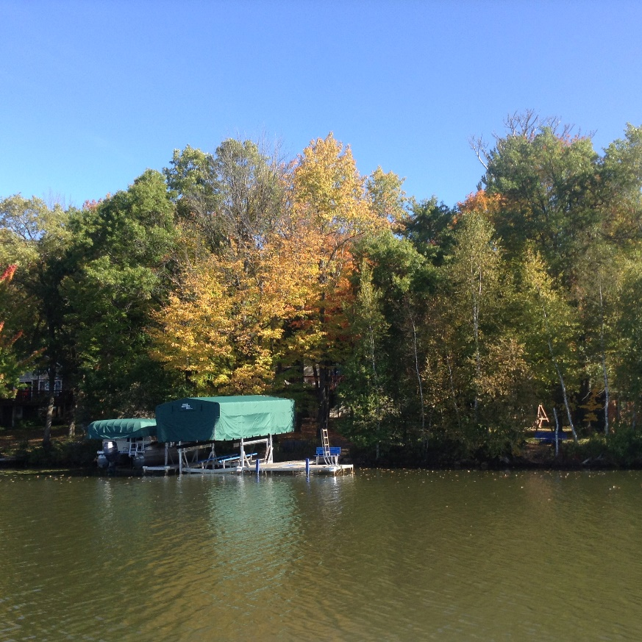
Parcel Number: 010409006000

Total Score: 5

Potential: Moderate

Parameter | Property value | Point value
Percent canopy cover | 85 | 0
Percent shrub and herbaceous (undisturbed) | 30 | 2
Percent lawn, impervious, and other surfaces | 70 | 2
Number of buildings and other human structures | 0 | 0
Presence/Absence of lawn or soil sloping to lake | 1 | 1
Presence/Absence of bare soil deposits | 0 | 0
Presence/Absence of sand deposits | 0 | 0

Management Recommendations:
Increase native, undisturbed vegetation in the understory with native plantings. Reduce lawn coverage with a larger buffer strip of native vegetation along the shoreline. Maintain canopy coverage.

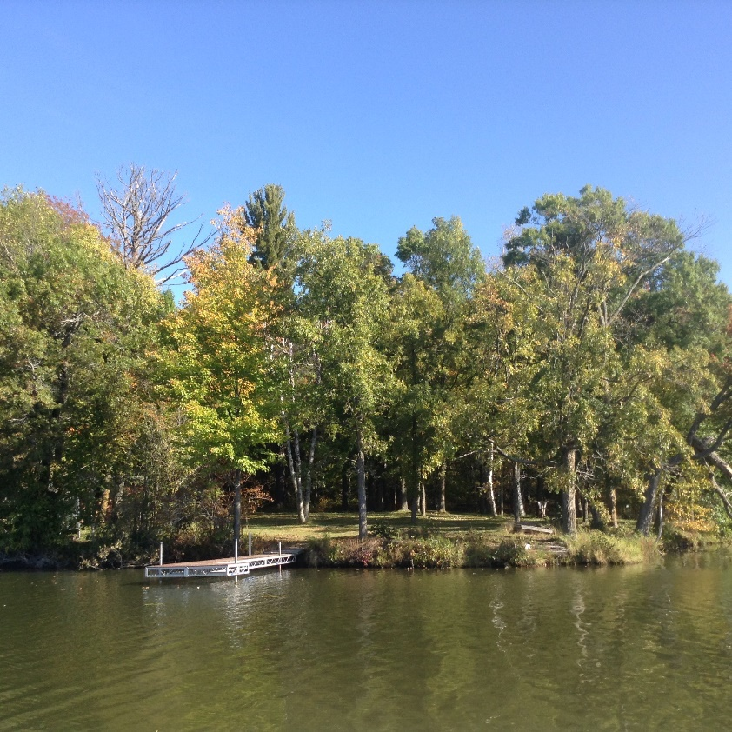
Bass Lake Property Owner Index

PARCELID | OWNERNME1 | OWNERNME2
10406893000 | LOCH LOMOND BEACH CLUB INC
10406878000 | THOMAS J & JENELLE F LEE
10406888000 | JUSTAN A & TARA M DUDEN
10406877000 | CYNTHIA K GOODWIN TRUST
10406889000 | JUSTAN A & TARA M DUDEN
10406869000 | CYNTHIA K GOODWIN TRUST
10406894000 | BARRON COUNTY
10451578000 | CYNTHIA K GOODWIN TRUST
10417802000 | RUSSELL T & CINDY RICH
10451579000 | RICHARD J & CHERI L WEINGARTNER JOINT REVOCABLE TRUST
10417804000 | RUSSELL T & CINDY RICH
10417807000 | RODNEY G & CAROLYN S STOYKE
10417805000 | MARK R & DEBRA J GARSON
10417806000 | RODNEY G & CAROLYN S STOYKE
10451580000 | CONNIE P SCHULLO | JESSE T NOVAK
10417882000 | LOCH LOMOND BEACH CLUB INC
10451581000 | TIMOTHY A & KIMBERLY K WILL
10451582000 | RUSSELL M & WANDA A SWAGGER
10417808000 | STEVEN D & PAMELA J CRAKER
10451583000 | PAULA L CRAMER
10417815000 | STEVE D & PAMELA J CRAKER
10451584000 | ADOLPH JAMES JR & JILL I LAVIGNE
10417817000 | JAMES G FREDERIXON TRUSTEE
10451585000 | ERNEST H MATTILA | DEBORAH A MCCOLLOW
10417820000 | JANET L MC NINCH | ELIZABETH A DREW
10451586000 | CHRISTOPHER S GORAL | CHARISSA K GORAL
10417821000 | DEBRA S MAGERKURTH REVOCABLE TRUST
10451587000 | CHRISTOPHER S GORAL | CHARISSA K GORAL
10417822000 | BONITA BASTY
10451588000 | LOCH LOMOND LOTS LLC
10417827000 | JOHN G & KATHRYN A SERIER II
10417828000 | DENNIS A & TAMMY L KENNEN
10417829000 | DOMMINICK D KENNEN
10417826000 | LEO J DIEHL
10417830000 | SARA J KENNEN
10417831000 | DAVID M & BONNIE J MEYER
10417825000 | BRADLEY J KVANBEK | MARIA LAURA MARTINEZ-KVANBEK
10417883000 | LOCH LOMOND BEACH CLUB INC
10417832000 | DAVID M & BONNIE J MEYER
10417833000 | DAVID M & BONNIE J MEYER
10417884000 | LOCH LOMOND BEACH CLUB INC

Hemlock Lake Property Owner Index
PARCELID | OWNERNME1 | OWNERNME2
10350011000 | GARY AARON STRAND
10350010000 | GARY AARON STRAND
10350009000 | GARY AARON STRAND
10350012000 | GARY A & BARBARA B STRAND
10350008000 | GARY AARON STRAND
10350013000 | KEVIN & LISA HERTLE
10350014000 | ROBERT D LANDES
10350004011 | KIM J & HEATHER GRZENIA
10350007000 | JEFFREY J & JESSICA M QUINN
10350007010 | BRADLEY L SIMON
10360006001 | PAUL E & BARBARA M LEMLER
10350020000 | RALPH H BAUCH
10350004000 | SHEILA M PLUNKETT | JULIA ELIZABETH ANDERSON
10360004000 | DOUGLAS M GRENNAN | KAREL L ISELY
10360004001 | DANIEL R & MADELEINE C HASELMAN
10350019000 | JAMES DONALD SCHOPPENHORST TRUST | MICHAEL A CUSTER
10350004001 | GARY ROHOLT
10350018000 | JOHN P & SONJA R ENGLAND
10360010000 | HEMLOCK OF RICE LAKE LLC
10260012000 | JOHN P & SONJA R ENGLAND
10260011000 | CURTIS J THAYER
10260013001 | FOSTER S FRIESS REVOCABLE TRUST | LYNNETTE E FRIESS REVOCABLE TRUST
10250016000 | HEMLOCK OF RICE LAKE LLC
10250017000 | CYNTHIA J TRACZYK | CYNTHIA J TRACZYK TRUST
10250015000 | HEMLOCK OF RICE LAKE LLC
10250018000 | HEMLOCK OF RICE LAKE LLC
10270023001 | JAMES M LARSEN
10250022000 | HERMAN A & JUDITH M FRIESS | FOSTER S FRIESS REVOCABLE TRUST
10250019000 | ELTON O & KEREN MUELLER JORDE
10250020000 | JOY L BISPING REVOCABLE TRUST | JON R & JANE SKAAR
10260013000 | FOSTER S FRIESS REVOCABLE TRUST | LYNNETTE E FRIESS REVOCABLE TRUST
10260010111 | DAVID ALAN DIKKEN
10250021000 | DAVID H & ELIZABETH J MUELLER
10260010122 | DAVID ALAN DIKKEN
10260010130 | DAVID ALAN DIKKEN
10260015000 | NONEXEMPT MARITAL TRUST UA CHARLIE POOCH IV TRUST
10260010101 | DAVID ALAN DIKKEN
10270023000 | MICHAEL ROBERT TRAWIN | STEVE FOX
10260010135 | DAVID ALAN DIKKEN
10250025000 | BARRON COUNTY
10260010099 | RAY C & JENNIFER L PING
10260010125 | MITCHELL J & JEANNE FARRELL
10260010008 | STEVEN F & KAREN T LUCAS
10260010005 | BARBARA JEAN HANKEE TRUST
10260010066 | THOMAS JAMES CONLIN | KATHLEEN A MARRON-CONLIN
10409003000 | JOHN P & TRACY J NIELSEN | PATRICIA L NIELSEN RICCHIO
10409004000 | DEBORAH D FRANKS
10260010011 | LEONARD A & DORIS L CHRISTIANSON
10260009001 | JAMIE D & KATIE D RICHARDSON
10409002000 | JOHN P & TRACY J NIELSEN | PATRICIA L NIELSEN RICCHIO
10250010000 | JOHN P NIELSEN
10250011000 | PAUL LEMLER
10409005000 | DEBORAH D FRANKS
10260009011 | NONEXEMPT MARITAL TRUST UA CHARLIE POOCH IV TRUST
10409006000 | BERNARD D & ANDREA H LAPACINSKI
10250012000 | JEFFREY A & LISA A REITEN
10409007000 | BARSNESS REVOCABLE TRUST
10409008000 | STEVEN W TRONSTAD | PATRICE GILBERTSON TRONSTAD
10409009000 | ERIC J & GINA P BUSS
10250013000 | BRADY LEE WOLFF
10409010000 | HIRST LIVING TRUST
10260004088 | NONEXEMPT MARITAL TRUST UA CHARLIE POOCH IV TRUST
10260010022 | MICHAEL & MARY NEARY REVOCABLE TRUST
10409011000 | HIRST LIVING TRUST
10250014000 | DAVID PEIL
10260010044 | GERALD LEE
10260004077 | NONEXEMPT MARITAL TRUST UA CHARLIE POOCH IV TRUST
10409012000 | BERNARD D & ANDREA H LAPACINSKI
10260004066 | S J AND SONS LLC
10409013000 | ALAN B DE LAITSCH | DE LAITSCH LIVING TRUST
10260004055 | NONEXEMPT MARITAL TRUST UA CHARLIE POOCH IV TRUST
10260004022 | MURPHY HEMLOCK CABIN LLC
10260004033 | MURPHY HEMLOCK CABIN LLC
10409016000 | NONEXEMPT MARITAL TRUST UA CHARLIE POOCH IV TRUST
10409015000 | DAVID FAMILY REVOCABLE TRUST
10409014000 | DAVID FAMILY REVOCABLE TRUST
10260004039 | LUANN E MCCANNEL
10260004044 | LUANN E MCCANNEL
10260004011 | BEEBE FAMILY TRUST
10250024000 | BARRON COUNTY
10260005011 | NONEXEMPT MARITAL TRUST UA CHARLIE POOCH IV TRUST
10260005001 | NONEXEMPT MARITAL TRUST UA CHARLIE POOCH IV TRUST
10260005044 | NONEXEMPT MARITAL TRUST UA CHARLIE POOCH IV TRUST
10260005022 | RYAN & AMY SUEMNICHT
10260005033 | RICK L & CAROL M RICHARDSON REVOCABLE TRUST

