Eurasian water-milfoil (Myriophyllum spicatum)
Late-summer Bed Mapping Survey
Mud Lake (WBIC: 2434800)
Sawyer County, Wisconsin

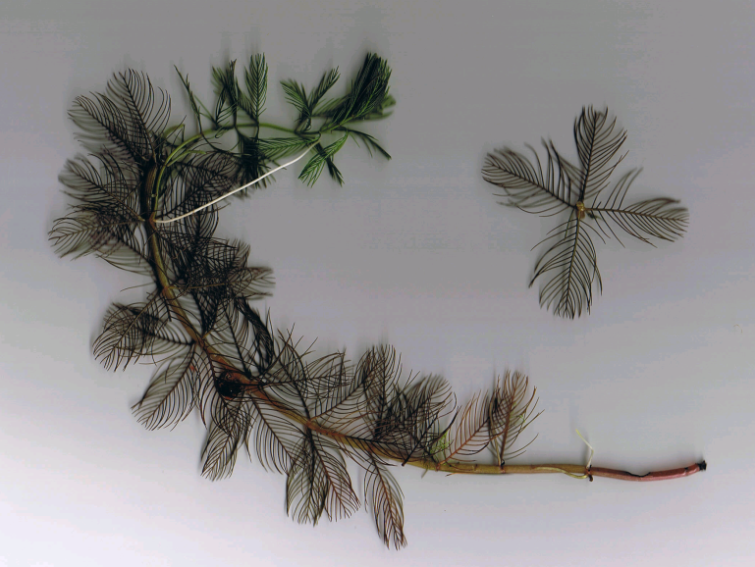
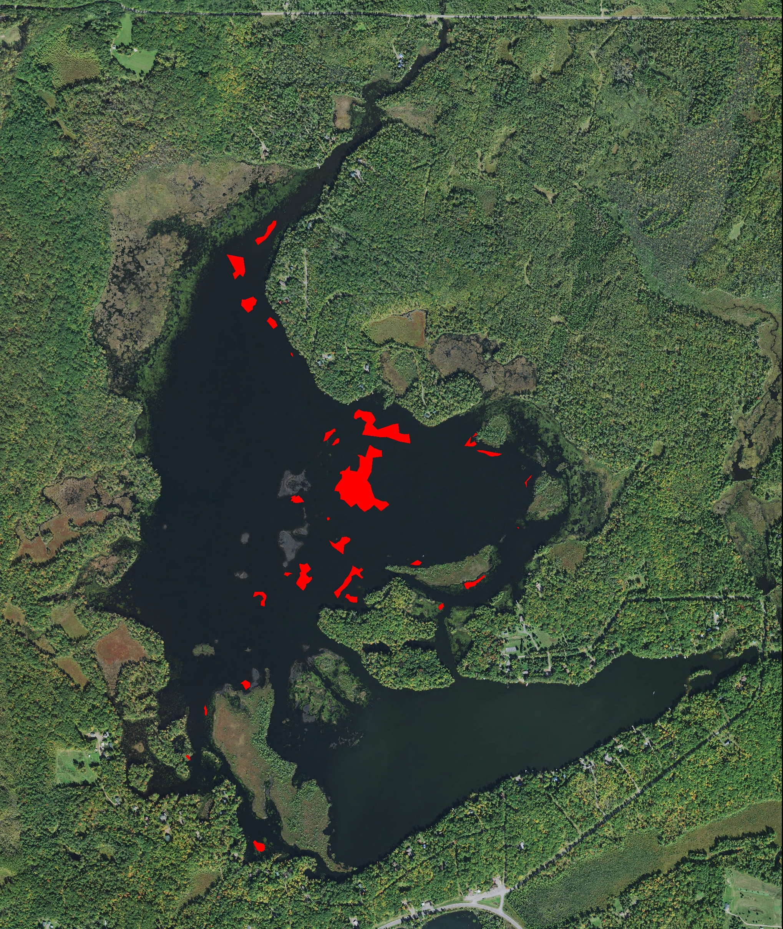
EWM beds on Mud Lake 9/12/21 Eurasian water-milfoil (Berg 2007)

Project Initiated by:
The Callahan and Mud Lakes Protective Association,
Lake Education and Planning Services, LLC, and the
Wisconsin Department of Natural Resources (Grant AEPP-610-20)

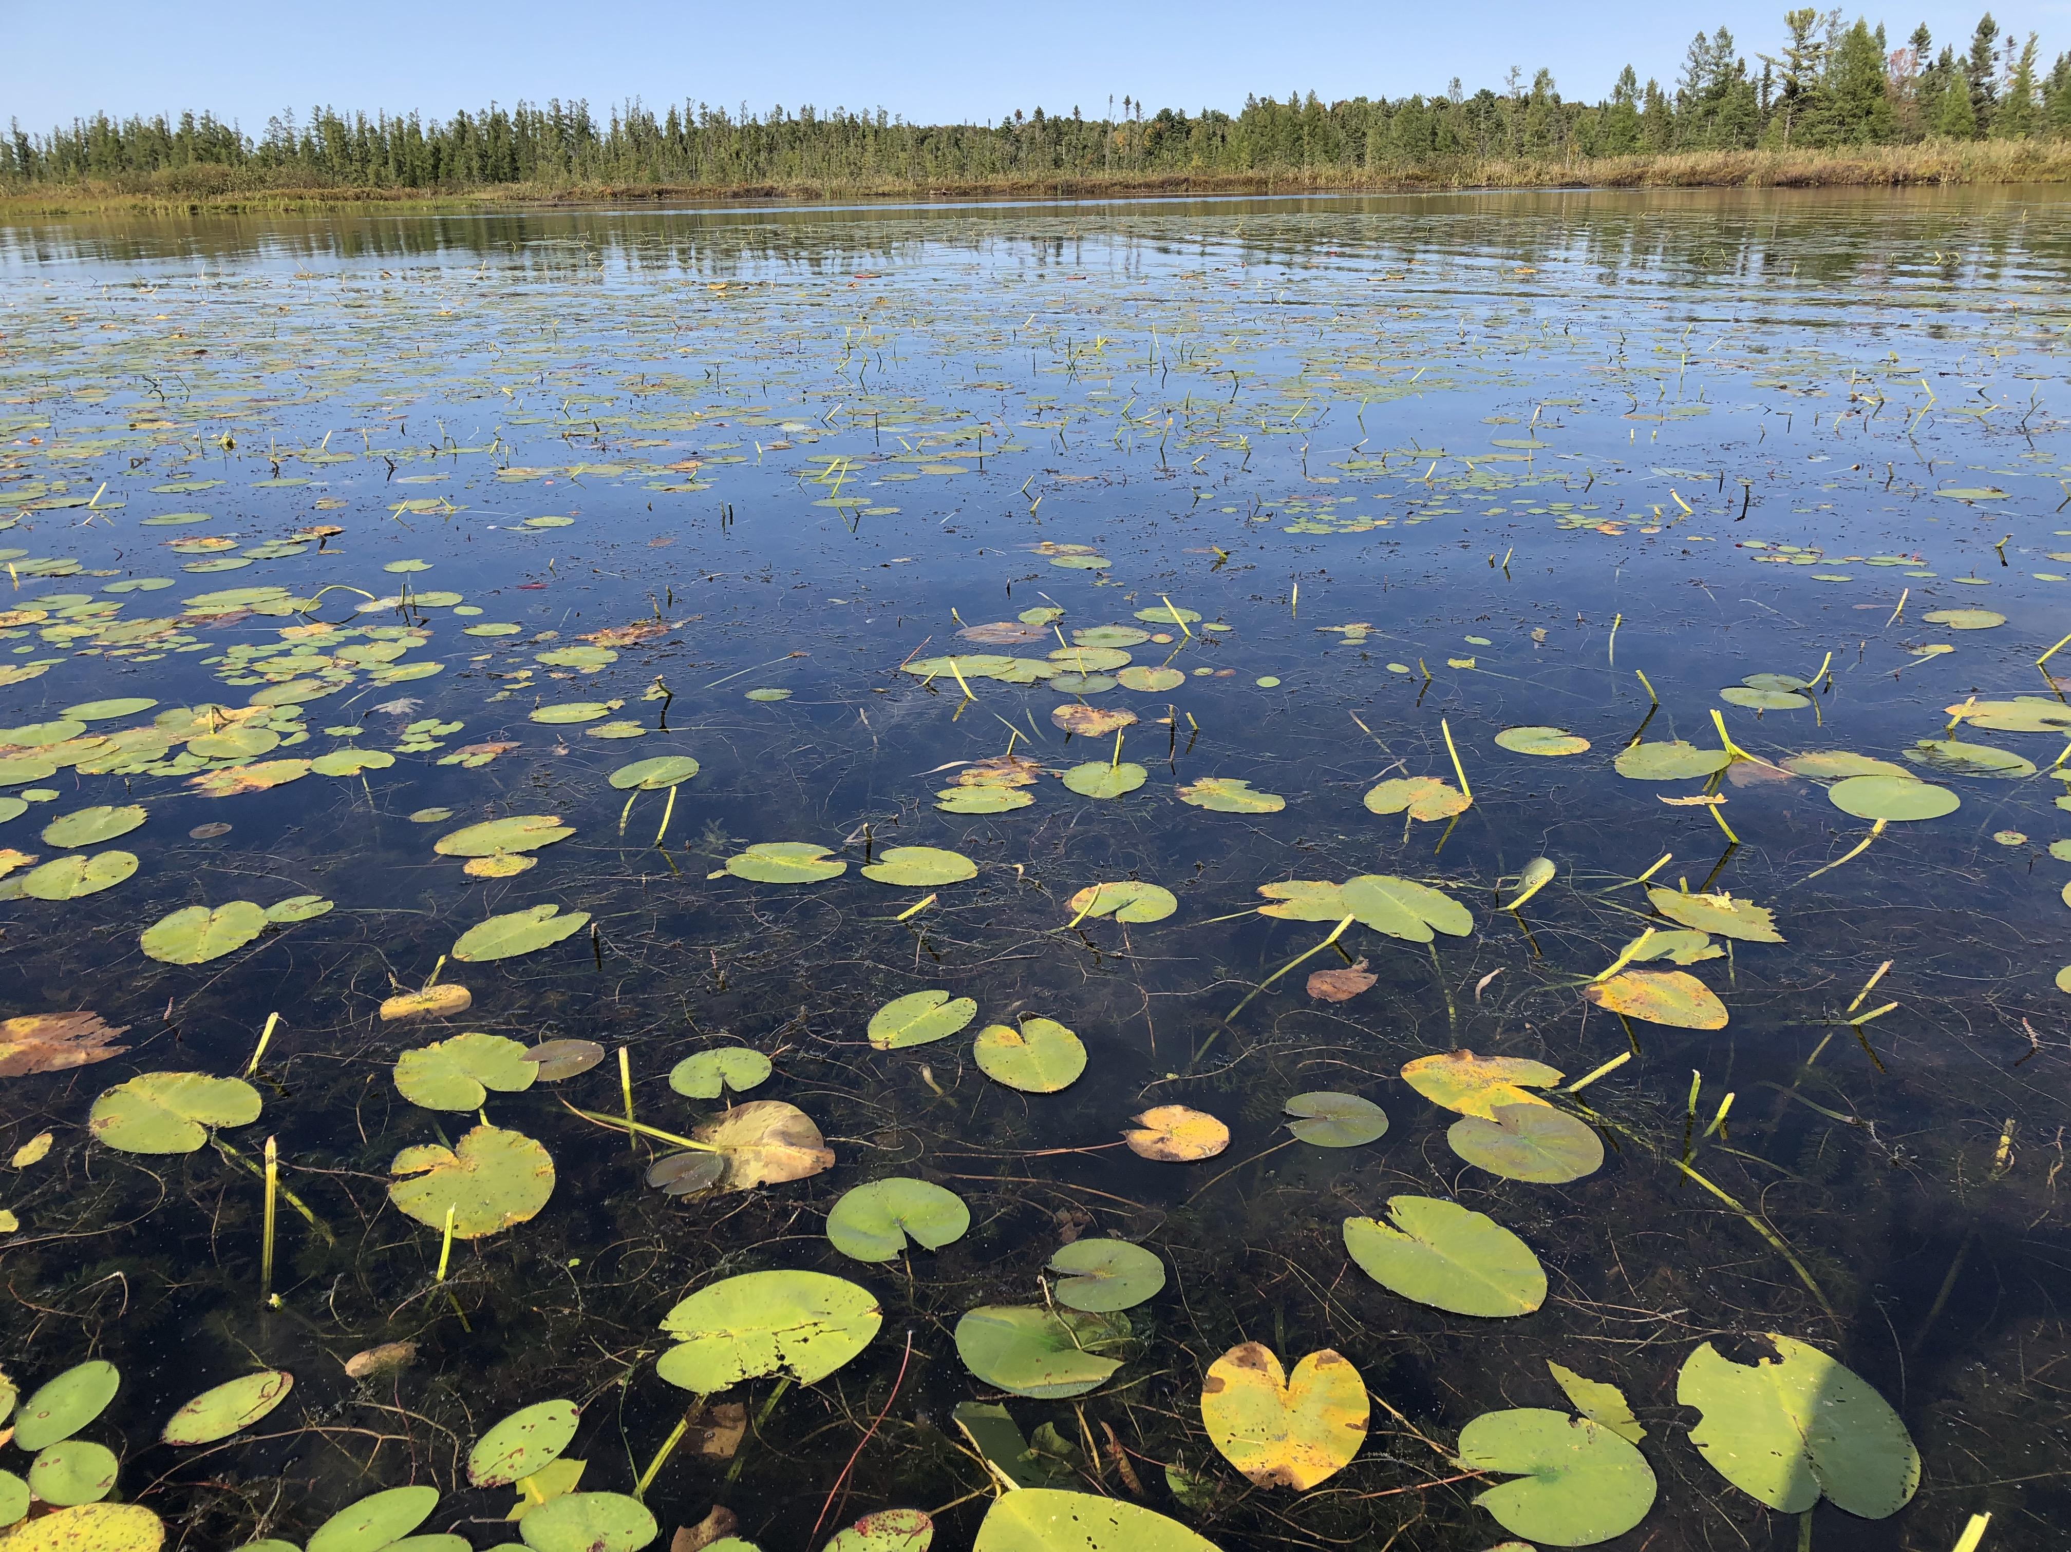
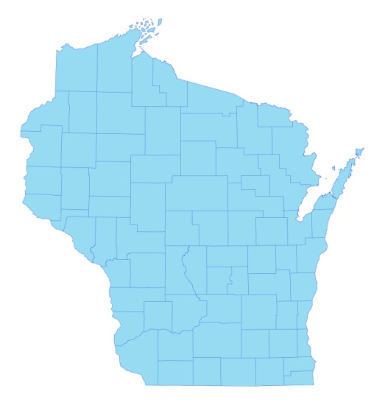

* Mud
Lake

Canopied Eurasian water-milfoil among Spatterdock - Mud Lake 9/5/20

Survey Conducted by and Report Prepared by:
Endangered Resource Services, LLC
Matthew S. Berg, Research Biologist
Saint Croix Falls, Wisconsin
September 12, 2021
TABLE OF CONTENTS

LIST OF FIGURES AND TABLES ……………………………………………….. ii
INTRODUCTION………………………………………………………………….. 1
STUDY BACKGROUND AND RATIONALE …………………………………… 1
METHODS………………..……………………………………….……………….. 2
RESULTS..……………………..………………………………………….……….. 3
Late-summer Eurasian Water-milfoil Bed Mapping Survey……………….. 3
Descriptions of Past and Present Eurasian Water-milfoil Beds…………….. 6
DISCUSSION AND CONSIDERATIONS FOR MANAGEMENT ………………. 8
LITERATURE CITED……………….…………………………………….………. 8
APPENDIX ………………………………………………………………………… 9
I: 2020 and 2021 Eurasian Water-milfoil Bed Maps…………………………… 9

LIST OF FIGURES AND TABLES

Page
Figure 1: Mud Lake Bathymetric Map...……………….……….….………….…... 1
Figure 2: Rake Fullness Ratings……………………………….…….…………….. 2
Figure 3: September 12, 2021 EWM Littoral Zone Survey – GPS Tracks ..………. 3
Figure 4: September 12, 2021 Eurasian Water-milfoil Bed Map .....………………. 3
Table 1: Late-summer Eurasian Water-milfoil Bed Mapping Summary –
Mud Lake, Sawyer County – September 12, 2021…… ……………………………. 4

INTRODUCTION:
Mud Lake (WBIC 2434800) is a 464-acre drainage lake created by an 8ft dam on the north fork of the Chief River in north-central Sawyer County, Wisconsin in the Town of Round Lake (T41N R7W S27/28 and 33/34). It has a maximum depth of 15ft and an average depth of 6ft. The lake is mesotrophic in nature, and water clarity is good with summer Secchi readings averaging 9.1ft in 2021 (WDNR 2021). The lake’s bottom substrate is primarily sand along the shoreline before transitioning to a sandy muck at most depths over 7ft (Bush et al. 1968) (Figure 1).

Figure 1: Mud Lake Bathymetric Map

STUDY BACKGROUND AND RATIONALE:
Eurasian water-milfoil (Myriophyllum spicatum) (EWM) is an exotic invasive plant species that was first identified in Mud Lake in the fall of 2005. Following an initial whole lake point-intercept survey in 2008 (J. Williamson), the Callahan and Mud Lakes Protective Association (CMLPA) and the Sawyer County Land and Water Conservation Department (SCLWC - K. Maki) used a 2009 Wisconsin Department of Natural Resources (WDNR) rapid response grant (AIRR-060-09) to hire Ayres Associates to write the lakes’ original Aquatic Plant Management Plan (APMP) that outlined herbicide applications to control the infestation (Kleczewski 2009). Since the APMP’s approval by the WDNR, these small-scale treatments have occurred periodically based on low intensity delineation surveys by the applicator and/or the SCLWC.

Per WDNR expectations (Pamela Toshner/Alex Smith, WDNR – pers. comm.), whole-lake plant surveys on actively managed lakes are normally repeated every five to seven years to remain current. In anticipation of updating their plan in 2021, the CMLPA – under the direction of Dave Blumer (Lake Education and Planning Services, LLC - LEAPS) – applied for and receive a WDNR planning grant (AEPP-61020) to help cover the cost of surveys and to update the APMP. In order to determine the current level of infestation, in addition to the point-intercept survey, the CMLPA, LEAPS, and the WDNR requested we complete a late-summer EWM bed mapping survey of the lake’s visible littoral zone in both 2020 and 2021. These data will be used to determine the acreage and density of EWM to help guide any future management. This report is the summary analysis of our September 12, 2021 field survey.
METHODS:
Late-summer Eurasian Water-milfoil Bed Mapping Survey:
During the survey, we searched the visible littoral zone of the lake. By definition, a “bed” was determined to be any area where we visually estimated that EWM made up >50% of the area’s plants, was generally continuous with clearly defined borders, and was canopied or close enough to being canopied that it would likely interfere with boat traffic. After we located a bed, we motored around the perimeter taking GPS coordinates at regular intervals. We also estimated the rake density range and mean rake fullness of the bed (Figure 2), the range and mean depth of the bed, whether it was canopied, and the impact it was likely to have on navigation (none – easily avoidable with a natural channel around or narrow enough to motor through/minor – one prop clear to get through or access open water/moderate – several prop clears needed to navigate through/severe – multiple prop clears and difficult to impossible to row through). These data were then mapped using ArcMap 9.3.1, and we used the WDNR’s Forestry Tools Extension to determine the acreage of each bed to the nearest hundredth of an acre. We also GPS marked additional individual EWM plants that occurred outside of the beds as they were generally few in number.

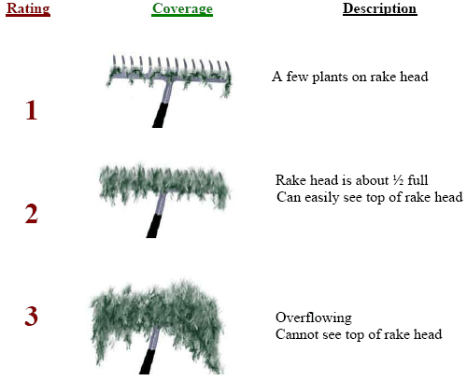
Figure 2: Rake Fullness Ratings (UWEX 2010)

RESULTS:
Late-summer Eurasian Water-milfoil Bed Mapping Survey:
On September 12, 2021, we searched 32.8km (22.9 miles) of transects throughout the lake’s visible littoral zone (Figure 3). Collectively, we mapped 29 beds that covered 13.01 acres (2.80% of the lake’s surface area) (Table 1). Outside of these areas, we marked 37 additional isolated plants (Figure 4) (Appendix I).

Figure 3: September 12, 2021 EWM Littoral Zone Survey – GPS Tracks

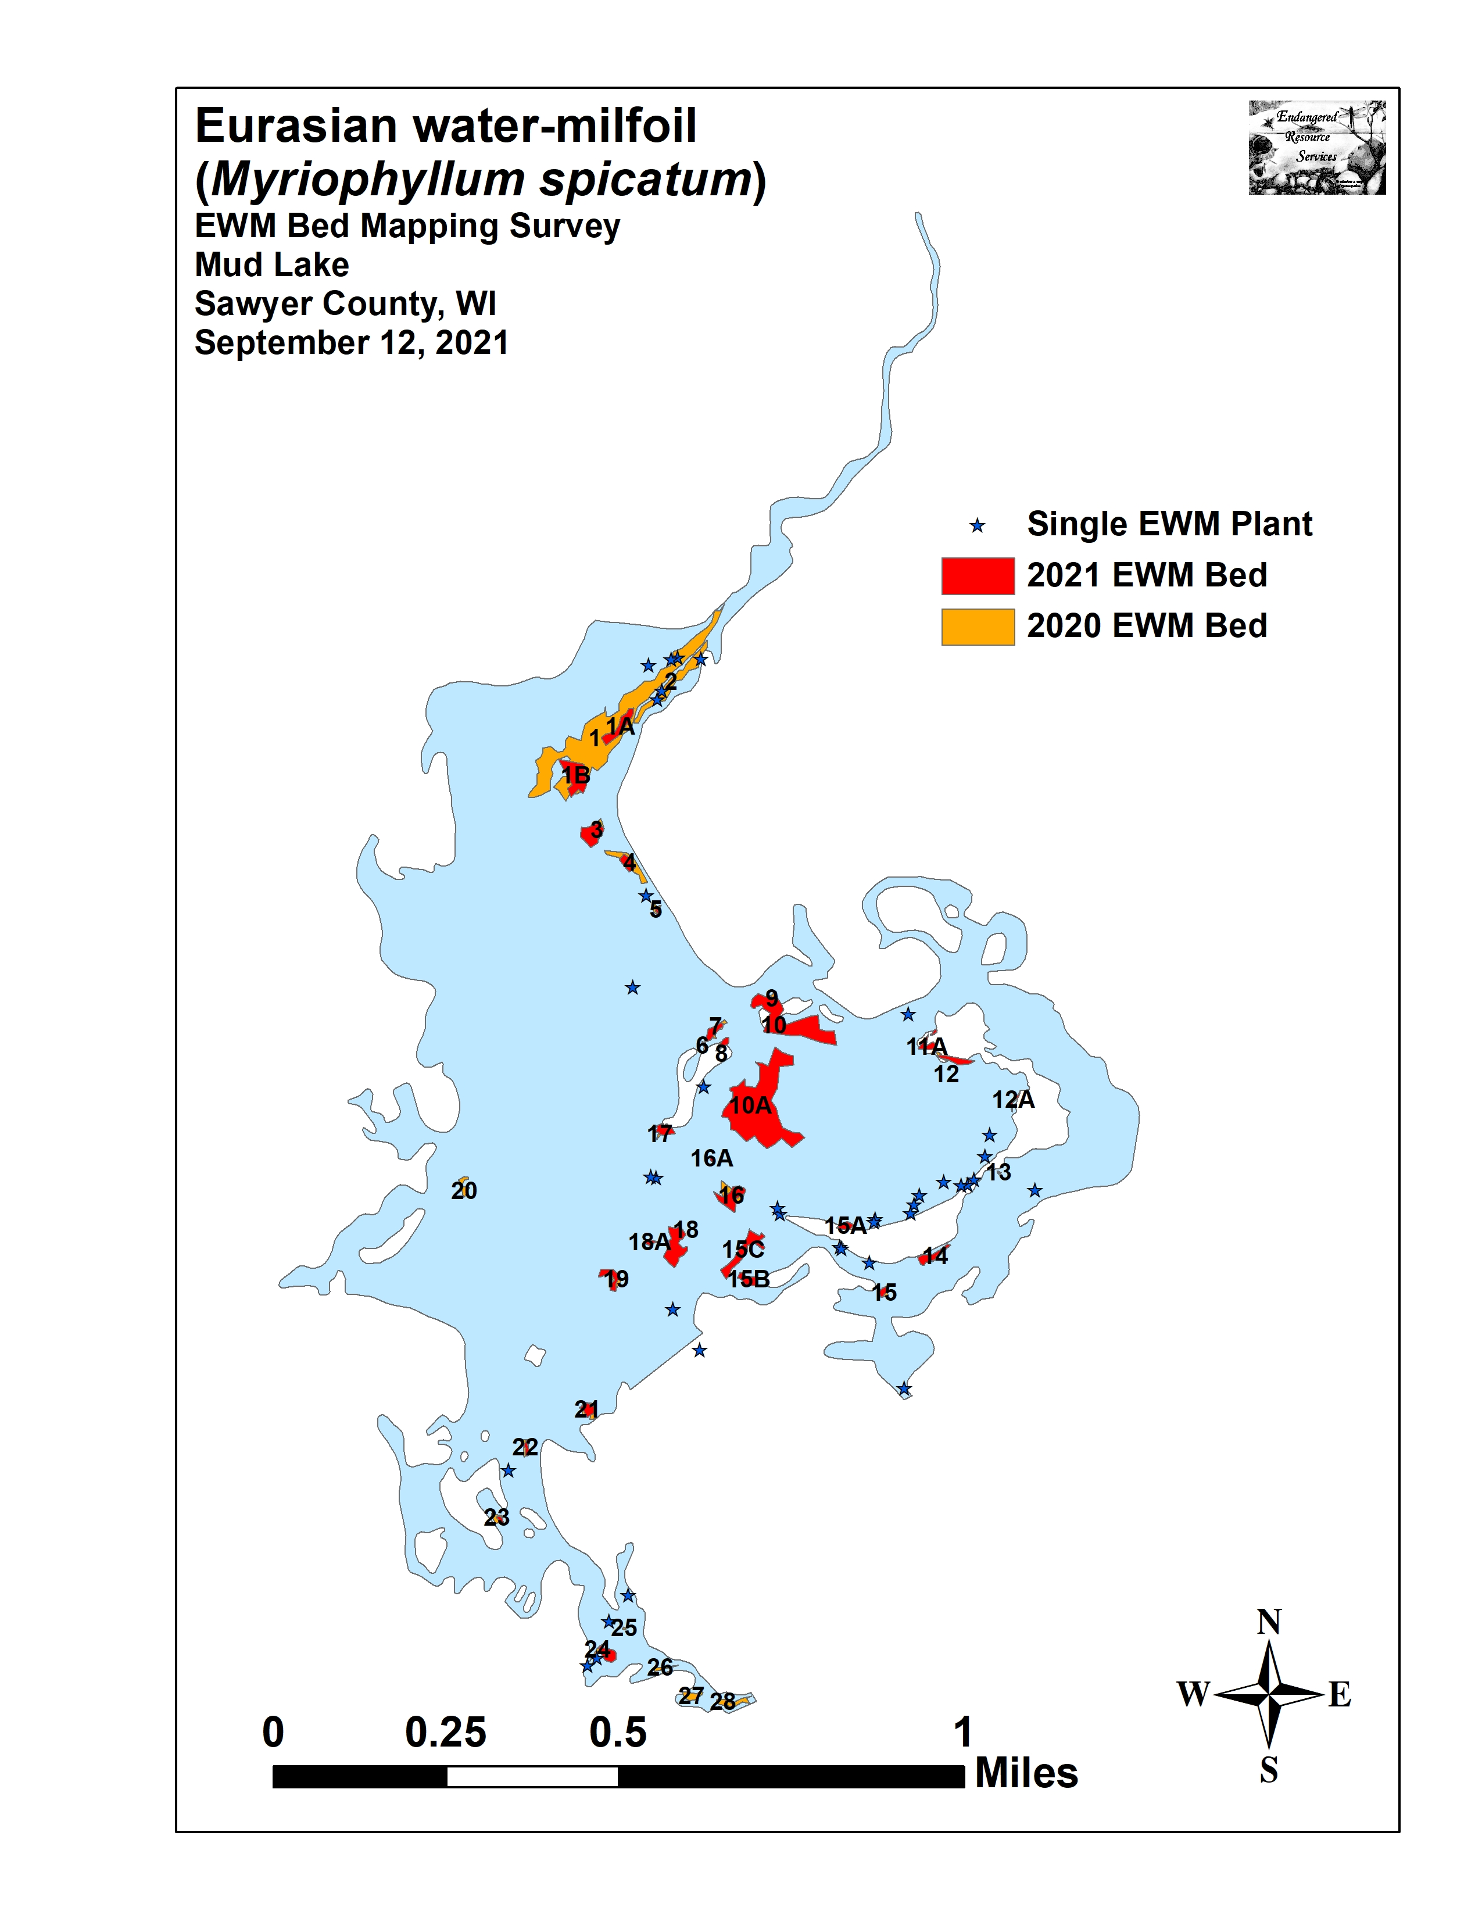
Figure 4: September 12, 2021 Eurasian Water-milfoil Bed Map

Table 1: Late-summer Eurasian Water-milfoil Bed Mapping Summary
Mud Lake, Sawyer County
September 12, 2021

Bed Number | 2021  Acreage | 2020  Acreage | Change in  Acreage | Rake Range and Mean Rake Fullness | Depth Range and Mean Depth | Canopied | Navigation Impairment | 2021 Field Notes
1 (A + B) | 1.19 | 7.18 | -5.99 | <<<1-1; <1 | 4-6; 5 | Yes | None | Prop-clipped plants among WWM
2 | 0 | 0.92 | -0.92 | <<<1 | 2-4; 3 | Yes | None | Three total EWM plants seen
3 | 0.46 | 0.23 | 0.23 | <<<1-2; 1 | 4-6; 5 | Yes | Minor | Low-density bed
4 | 0.20 | 0.48 | -0.28 | <<<1-1; <1 | 3-5; 4 | Near | None | Scattered regular individuals
5 | 0.02 | 0.07 | -0.05 | <<<1-2; 1 | 3-5; 4 | Yes | Minor | Small open bed
6 and 7 | 0.19 | 0.18 | 0.01 | <<1-3; 2 | 4-8; 6 | Yes | Moderate | Deep water bed
8 | 0.08 | 0.07 | 0.01 | <<1-3; 1 | 4-8; 6 | Yes | Minor | Nearly continuous with Bed 7
9 and 10 | 2.08 | 0.15 | 1.93 | <<<1-3; 1 | 4-9; 7 | Yes | Minor | Deep water bed
10A | 4.88 | 0 | 4.88 | <<<1-3; 1 | 7-11; 9 | No | Minor | Open low-density deep water bed
11 | 0.02 | <0.01 | 0.02 | 1-3; 2 | 4-7; 6 | Yes | Moderate | Small dense bed
11A | 0.15 | 0 | 0.15 | <1-3; 2 | 4-7; 6 | Yes | Moderate | Small dense bed
12 | 0.21 | 0.09 | 0.12 | <<1-3; 2 | 4-8; 6 | Yes | Moderate | Narrow dense bed
12A | 0.04 | 0 | 0.04 | <<<1-1; <<1 | 4-8; 6 | Yes | None | Small open bed with regular individuals
13 | <0.01 | 0.01 | -<0.01 | <<1-2; 1 | 2-5; 4 | Yes | Minor | Small open bed
14 | 0.26 | 0.05 | 0.21 | <<<1-2; <1 | 2-4; 3 | Yes | None | Small open bed with regular individuals
15 | 0.07 | 0.06 | 0.01 | <1-2; 2 | 2-4; 3 | Yes | Moderate | Small bed off the main channel
15A | 0.11 | 0 | 0.11 | <<<1-1; <1 | 4-6; 5 | Yes | None | Open bed with regular indiv. more HDA
15B | 0.20 | 0 | 0.20 | <<<1-2; 1 | 4-6; 5 | Yes | Minor | Open bed with regular individuals
15C | 0.63 | 0 | 0.63 | <<<1-1; <1 | 4-6; 5 | Yes | None | Open bed with regular indiv. more HDA
16 | 0.47 | 0.45 | 0.02 | <<<1-2; 1 | 2-6; 4 | Yes | Minor | Open bed
16A | 0.02 | 0 | 0.02 | 1-3; 2 | 5-7; 6 | Yes | Moderate | Small but dense bed
17 | 0.21 | 0.03 | 0.18 | <<1-2; 1 | 2-5; 3 | Yes | Minor | Small open bed
18 | 0.73 | 0.02 | 0.71 | <<1-3; 2 | 2-6; 4 | Yes | Moderate | Spreading bed
18A | 0.06 | 0 | 0.04 | <<<1-2; 1 | 2-5; 3 | Yes | Minor | Small open bed
19 | 0.24 | 0.09 | 0.15 | <<<1-2; 1 | 2-6; 4 | Yes | Minor | Small open bed

Table 1 (continued): Late-summer Eurasian Water-milfoil Bed Mapping Summary
Mud Lake, Sawyer County
September 12, 2021

Bed Number | 2021  Acreage | 2020  Acreage | Change in  Acreage | Rake Range and Mean Rake Fullness | Depth Range and Mean Depth | Canopied | Navigation Impairment | 2021 Field Notes
20 | 0 | 0.12 | -0.12 | <<<1 | 1-4; 3 | Yes | None | Two total EWM plants seen
21 | 0.16 | 0.21 | -0.05 | <<<1-2; 1 | 3-5; 4 | Near | Minor | Open low-density bed
22 | 0.06 | 0.10 | -0.04 | <<<1-1; <1 | 4-6; 5 | Near | None | Low-density, but regular plants
23 | 0.04 | 0.08 | -0.04 | <<<1-1; <1 | 4-5; 5 | Yes | None | Handful of scattered plants
24 | 0.23 | 0.04 | 0.19 | <<1-3; 2 | 3-5; 4 | Yes | Moderate | Mixed with floating-leaf native species.
25 | 0 | 0.01 | -0.01 | - | - | - | None | No plants seen.
26 | 0 | 0.06 | -0.06 | - | - | - | None | No plants seen.
27 | 0 | 0.15 | -0.15 | - | - | - | None | No plants seen.
28 | 0 | 0.20 | -0.20 | - | - | - | None | No plants seen.
Total Acres | 13.01 | 11.06 | +1.95

Descriptions of Past and Present Eurasian Water-milfoil Beds:
Beds 1-2 – The two large, canopied Eurasian water-milfoil beds at the river inlet were almost eliminated by the 2020 and 2021 treatments. Fortunately, timely treatment seems to have preserved most native milfoils in the area as we again found Whorled water-milfoil (Myriophyllum verticillatum) and Northern water-milfoil (Myriophyllum sibiricum) bordering the main navigation channel as well as scattered Various-leaved water-milfoil (Myriophyllum heterophyllum) in boggy shallow areas. The remnants of Bed 1 were two small areas that contained a sting of prop-clipped plants at low to very low density. In Bed 2, we only saw three total EWM plants.

Beds 3-5 – These “High Density Areas” had regular but not truly continuous plants. They appeared to be in the “outwash” from Beds 1 and 2; and, although Bed 3 doubled in size compared to its area in 2020, each of the others shrank. These changes were potentially due to residual control from herbicides moving downstream.

Beds 6-8 – Located around floating mud bog islands, these three beds were unlikely to cause significant navigation impairment unless boaters motored right through them. Plants were well-established and canopied or near canopy in up to 8ft of water. Despite this, the isolated nature of these beds may reduce their management priority.

Beds 9/10 and 10A – In 2020, we found that the stained water in the system seemed to largely restrict EWM from growing in areas deeper than 7ft. During the 2021 growing season, low water levels and improved clarity appear to have allowed EWM to expand into deeper areas. These giant beds had continuous low-density plants that were approaching canopy in up to 11ft. In shallower areas, EWM was forming dense canopied mats. Although the majority of the area was still only a minor impairment, this was clearly the worst place on the lake.

Beds 11/11A and 12/12A – These beds were mostly canopied mats, and they would likely have caused moderate impairment if people motored right through them. However, because they were all narrow and occurred along isolated bog islands, they are not likely to be high management priorities.

Beds 13 and 14 – These open beds occurred along the east shoreline of the crescent bog islands. Because of their low density, nearness to shore, and low potential for impairment, they are likely also low management priorities.

Bed 15 – Located along a bog island on the north end of the eastern channel to Callahan Lake, this small bed was moderately dense and would have caused impairment for boaters trying to go through it. Although there was some prop-clipping, most people seemed to be avoiding it, and this likely means it’s not a high priority for management either unless there is concern about fragments flowing through and seeding Callahan.

Bed 15A – This open bed was established just north of the southwest tip of the crescent island. More of a “High-Density Area” than a true bed, it appeared unlikely to impair navigation and is likely a low priority for management.
Beds 15B and 15C – Most plants in these two areas appeared to have been recently established. Although EWM was already canopied, the beds were not dense, and the area was likely not more than a minor navigation impairment.

Beds 16/16A, 17, 18/18A, and 19 – These beds were scattered along the edges of floating mud bogs. Each was larger than they had been in 2020, and we found they were expanding away from the bogs into deeper water; especially Bed 18 which now likely posed a minor to moderate navigation impairment if boats motored right through it. Based on this, it’s likely an area to consider for active management in the near future.

Bed 20 – This isolated former bed on the lake’s west central shoreline was almost completely out of water on a mud bog that had broken free of the bottom. Collectively, we saw just two EWM plants in the entire area.

Beds 21-23 – These three small, low-density beds were scattered throughout the main southwest channel. For no discernable reason, each appeared to have shrunk slightly compared to 2020. Beds 21 and 23 were isolated along forested and bog islands in areas that were unlikely to interfere with boat traffic. Bed 22 was in the center of the channel, but it was more a collection of regular plants than a true bed or navigation impairment.

Bed 24 – This moderately dense bed was a potential navigation impairment although residents appeared to be motoring around it rather than through it. EWM was mixed with Watershield (Brasenia schreberi), White water lily (Nymphaea odorata), and Spatterdock (Nuphar variegata) – see front cover of the report.

Beds 25-28 – We saw no evidence of EWM in these areas of the southwest channels. In the fall of 2020, each of these areas were little more than low density patches of plants so it’s possible that there was residual control from the treated bed just to the east.

DISCUSSION AND CONSIDERATIONS FOR MANAGEMENT:
Eurasian water-milfoil currently occupies a small percentage of Mud Lake’s surface area, but it is well established making eradication an unrealistic expectation. Although the species grows well in the Mud/Callahan system, active management has dramatically reduced the levels of EWM from an estimated 109 acres covering 23.49% of the lake’s surface area in 2008 (Kleczewski 2009) to 13.01 acres (2.80% of the lake’s surface area) in 2021 – a decline of -88.06%. Although still low by historical standards, the 2021 total acreage was an increase of +17.63% compared to the 11.06 acres (2.38% coverage) we mapped in 2020.

Reducing Eurasian water-milfoil in Mud Lake has come at a high economic cost, and, as herbicides are non-selective, has also likely had significant impacts on the aquatic plant community. In the future, maintaining EWM at its current low levels using targeted management will likely continue to produce satisfactory control while simultaneously minimizing financial and ecological costs. Ultimately, the amount of EWM growth the CMLPA is comfortable with will determine how much, if any, management occurs in Mud Lake in 2022.

LITERATURE CITED

Busch, C., E. Johnson, and C. Holt. [online]. 1968. Mud Lake Map.
Available from https://dnr.wi.gov/lakes/maps/DNR/2434800a.pdf (2021 September).

Kleczewski, T. 2009. Callahan and Mud Lakes Aquatic Plant Management Plan. Ayres Associates. Eau Claire, WI

WDNR. [online]. 2021. Mud Lake - Citizen Lake Water Quality Monitoring Database. Available from https://dnr.wi.gov/lakes/waterquality/Station.aspx?id=583216 (2021 September).

WDNR. [online]. 2021. Mud Lake - Wisconsin Lakes Information. Available from https://dnr.wi.gov/lakes/lakepages/LakeDetail.aspx?wbic=2434800 (2021 September).

Appendix I: 2020 and 2021 Eurasian Water-milfoil Bed Map
