Eurasian water-milfoil (Myriophyllum spicatum)
Pre/Posttreatment and Bed Mapping Surveys
Red Lake (WBIC: 2492100)
Douglas County, Wisconsin

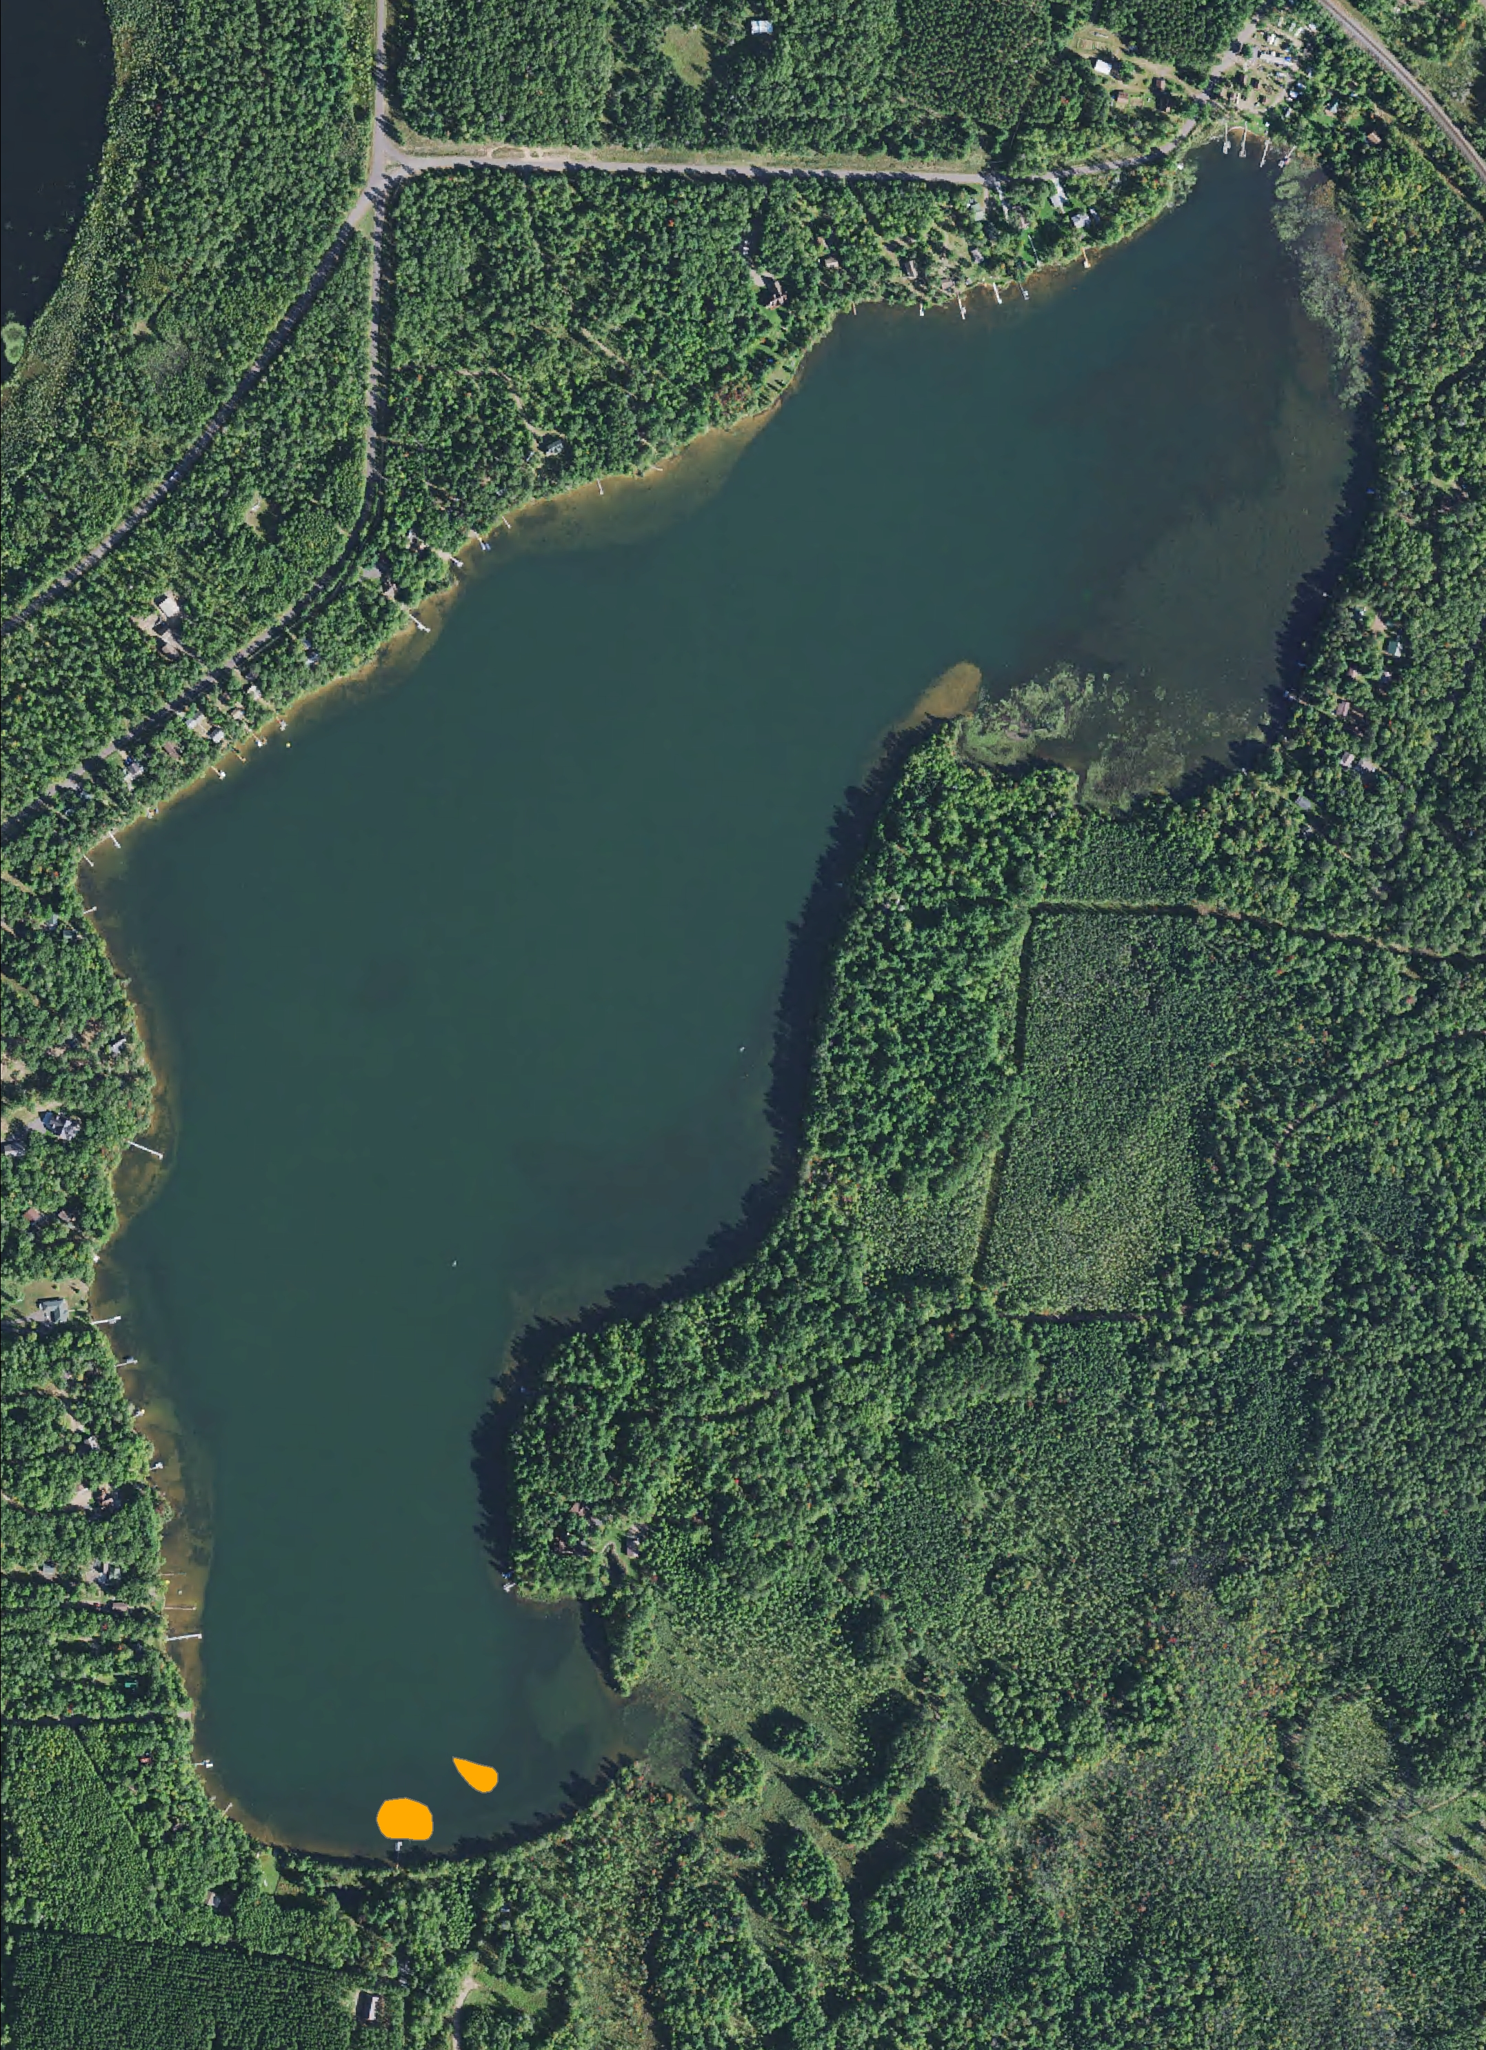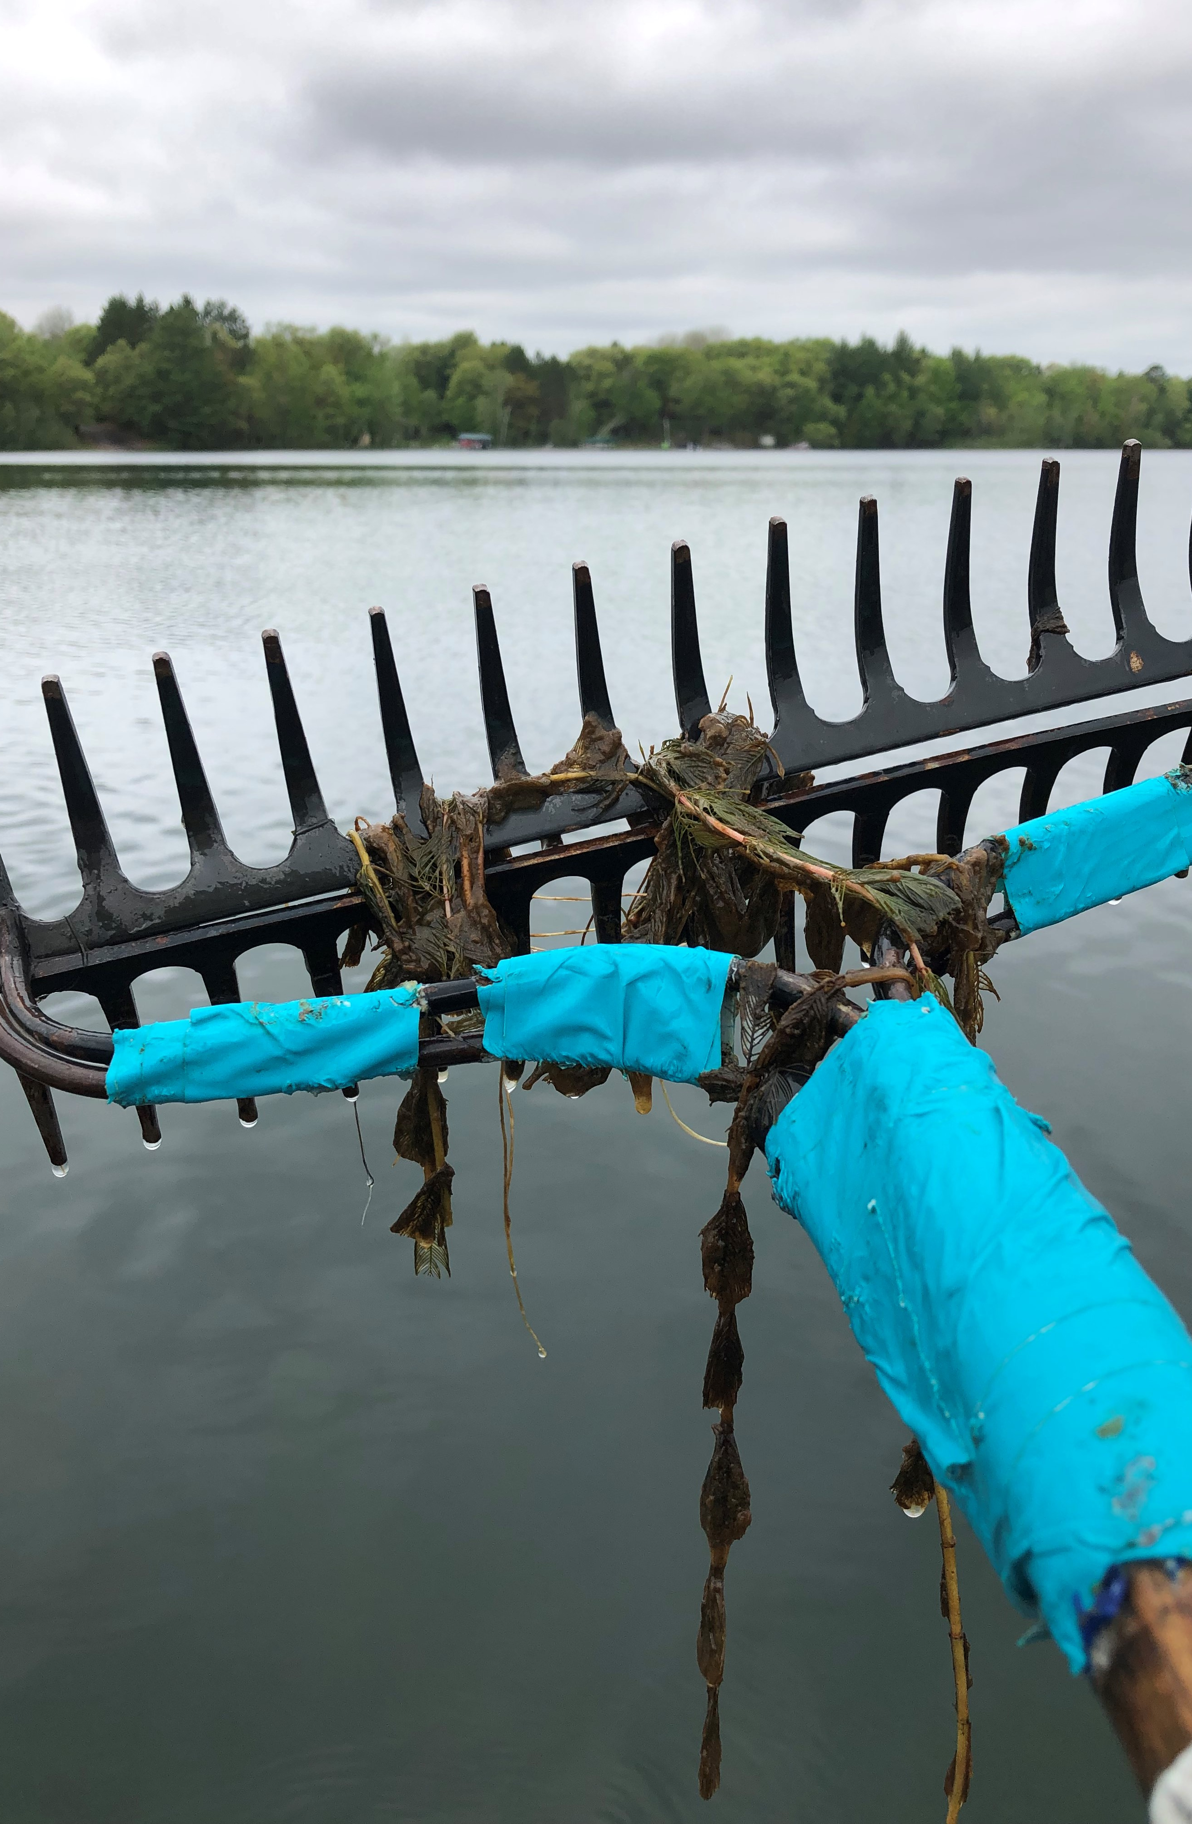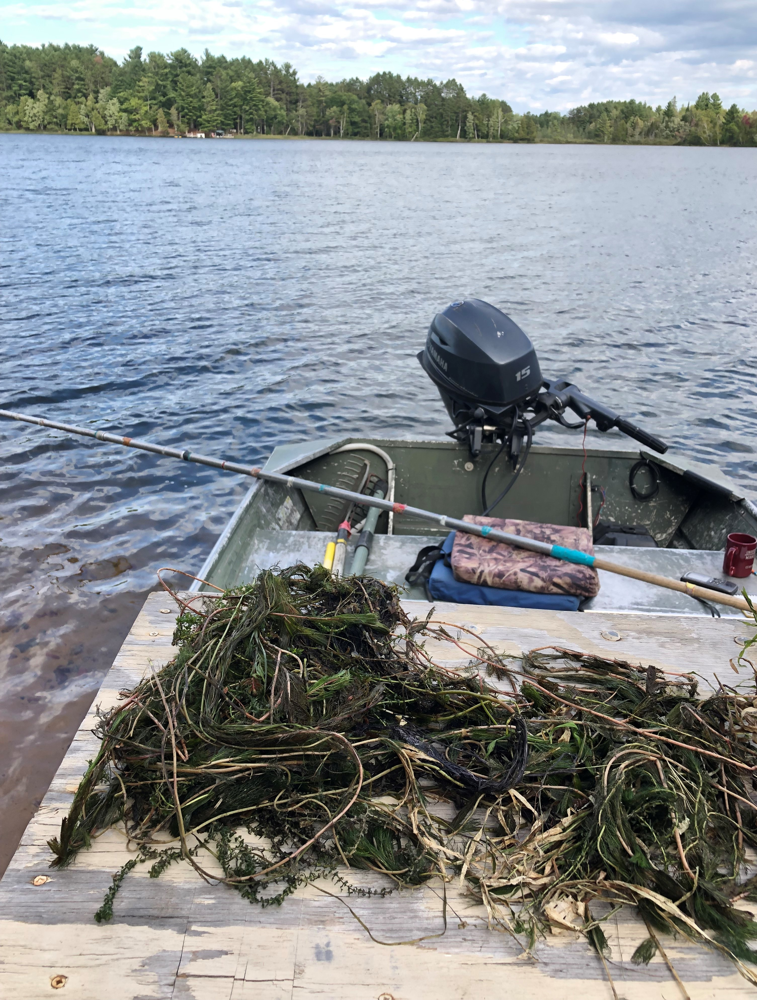
Red Lake 2021 treatment areas Slime covered pretreatment EWM 5/22/21 Rake removed EWM 9/5/21

Project Initiated by:
The Red Lake Association, Lake Education and Planning Services, LLC and the Wisconsin Department of Natural Resources (Grant #AIRR25720)

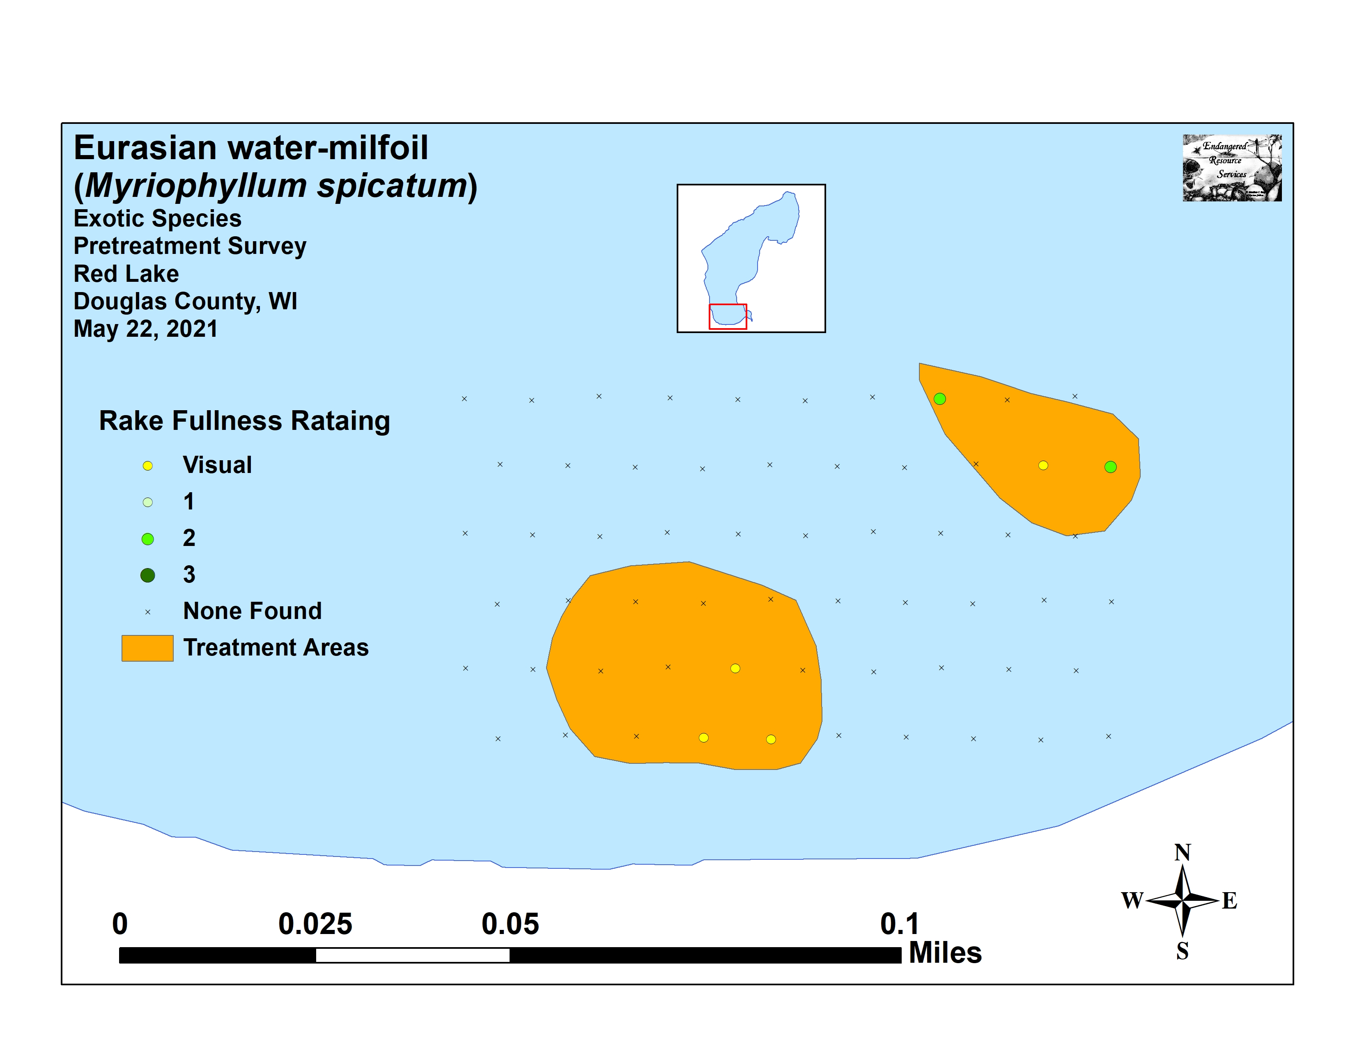
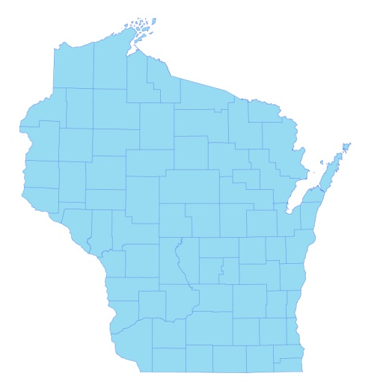
* Red Lake
2021 Pretreatment EWM Density and Distribution

Surveys Conducted by and Report Prepared by:
Endangered Resource Services, LLC
Matthew S. Berg, Research Biologist
St. Croix Falls, Wisconsin
May 22, July 7, and September 5, 2021
TABLE OF CONTENTS

Page
LIST OF FIGURES ………………………………………………………………………… ii

LIST OF TABLES ………………………………………………………………………….. iii

INTRODUCTION………………………………………………………………………….. 1

BACKGROUND AND STUDY RATIONALE …………………………………………… 1

METHODS…………………………………………………………………………………. 2

RESULTS AND DISCUSSION……………………………………………………………. 4

Finalization of Treatment Areas…..…………….……………………………………… 4

Eurasian Water-milfoil Pre/Post Herbicide Surveys …………………………………… 5

September EWM Rake Removal and Bed Mapping Survey.…………………..…….… 13

Descriptions of Past and Present EWM Beds…….…………………………….…….… 16

CONSIDERATIONS FOR MANAGEMENT..……………………………………………. 16

LITERATURE CITED.……………………….……………………………………………. 19

APPENDIXES…………….………………………………………………………………... 20

I: EWM Pre/Post Survey Sample Points and Treatment Areas..………………………... 20

II: Vegetative Survey Datasheet……………………………………………………….… 23

III: Pre/Post Habitat Variables……………………...…………………………………….. 25

IV: Pre/Post Littoral Zone, Native Species Richness and Total Rake Fullness.…………. 28

V: EWM Pre/Posttreatment Density and Distribution …………………………………… 35

VI: Pretreatment Native Species Density and Distribution.…..…….……………………. 38

VII: Posttreatment Native Species Density and Distribution……………………………... 51

VIII: 2020 and 2021 EWM Rake Removal and Bed Maps..………………………………. 66

LIST OF FIGURES

Page
Figure 1: Red Lake Bathymetric Map ……………………………………………………... 1
Figure 2: Rake Fullness Ratings…..………………….…….……………………................ 2
Figure 3: Pre/Post Survey Points and EWM Treatment Areas…..………..…………….…. 4
Figure 4: Treatment Area Depths and Bottom Substrate....….………….…. ……………… 5
Figure 5: Pre/Posttreatment Littoral Zone.…………....….……..……..…………………... 6
Figure 6: Pre/Posttreatment Native Species Richness…………………….……………..… 6
Figure 7: Pre/Posttreatment Total Rake Fullness……………………..………………….... 6
Figure 8: Pre/Posttreatment EWM Density and Distribution.……………….…………...... 7
Figure 9: Changes in Eurasian Water-milfoil Rake Fullness ……………………………… 7
Figure 10: Pre/Posttreatment Fern Pondweed Density and Distribution…..…………….… 8
Figure 11: Pre/Posttreatment Large-leaf Pondweed Density and Distribution ……………. 8

Figure 12: Pre/Posttreatment White-stem Pondweed Density and Distribution ………….. 11

Figure 13: Pre/Posttreatment Common Waterweed Density and Distribution…..………… 11

Figure 14: Pre/Posttreatment Macrophyte Changes……………………………………….. 12
Figure 15: September 2021 Littoral Zone EWM Survey Transects ……………………….. 13

Figure 16: 2020 August and 2021 September EWM Bed Maps …………………………... 14
Figure 17: EWM and Northern Water-milfoil Identification………………………….…... 17
Figure 18: Limp Nature of EWM Leaflets along Stem –
Stiff Nature of NWM Leaflets along Stem and Overwintering Turions..…………….……. 18

LIST OF TABLES

Page
Table 1: Spring EWM Treatment Summary –
Red Lake, Douglas County June 1, 2021 …………………………………………………… 4

Table 2: Pre/Posttreatment Surveys Summary Statistics –
Red Lake, Douglas County May 22 and July 7, 2021 ……………………………..……….. 5

Table 3: Frequencies and Mean Rake Sample of Aquatic Macrophytes
Pretreatment Survey – Red Lake, Douglas County May 22, 2021 ……………..………….. 9

Table 4: Frequencies and Mean Rake Sample of Aquatic Macrophytes
Posttreatment Survey – Red Lake, Douglas County July 7, 2021 ………………………..… 10

Table 5: Eurasian Water-milfoil Bed Mapping Summary –
Red Lake, Douglas County – September 5, 2021…………………………………………... 15

INTRODUCTION:
Red Lake (WBIC 2492100) is a 253-acre stratified seepage lake located in the Town of Wascott in south-central/southeastern Douglas County (T43N R11W S21/28/29/32). It reaches a maximum depth of 37ft in the deep hole on the south end of the central basin and has an average depth of 11ft (WDNR 2021). The lake is mesotrophic in nature, and water clarity is good with Secchi readings averaging 11.0ft from 1993-2021 (WDNR 2021). The shoreline is dominated by sand with most areas transitioning to sandy muck at depths beyond 10ft. The lake’s only nutrient-rich organic muck occurs in areas adjacent to the tamarack bogs near the small bay in the far southeast corner and on the north and south ends of the northeast bay (Holt et al. 1973) (Figure 1).
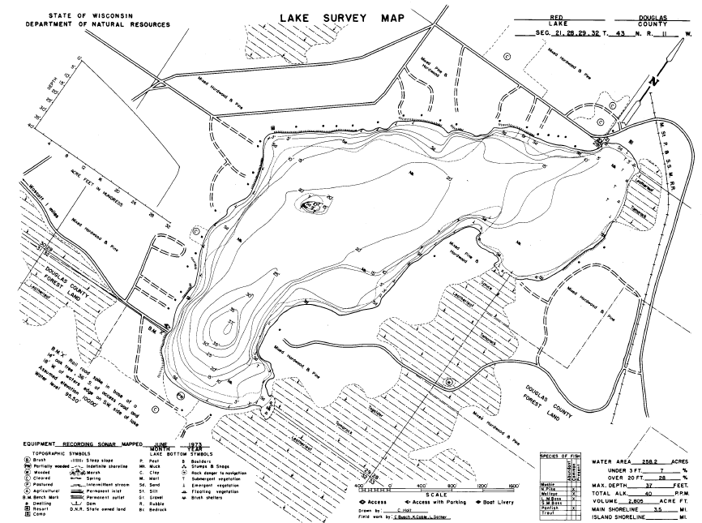
Figure 1: Red Lake Bathymetric Map

BACKGROUND AND STUDY RATIONALE:
On July 25, 2013, at the request of the Red Lake Association (RLA) and the Wisconsin Department of Natural Resources (WDNR), we conducted the original warm-water point-intercept survey of all aquatic plants in Red Lake. This extensive study established base-line data on the richness, diversity, abundance, and distribution of the lake’s aquatic macrophyte populations. At that time, we found no evidence of Eurasian water-milfoil (Myriophyllum spicatum) (EWM), an invasive exotic aquatic plant, anywhere in the lake.

Unfortunately, in July 2016, biologists from the Great Lakes Indian Fish & Wildlife Commission (GLIFWC) found a few EWM plants near the public boat landing on the lake’s southwest side and near the Red Lake Resort in the northeast bay. A follow-up survey by the WDNR also located plants in these areas, and our lakewide EWM bed mapping survey on October 2, 2016 found ten separate beds totaling 1.18 acres.
The RLA’s WDNR approved Aquatic Plant Management Plan has outlined manual removal by both volunteers and professionals as well as limited herbicide applications to control the infestation; and these small scale treatments have occurred annually since 2017. Following our 2020 late summer bed mapping survey, the RLA and Lake Education and Planning Services, LLC (LEAPS – D. Blumer) decided to treat two beds in 2021. Although pre and posttreatment surveys have not been conducted in the past due to the small size of the treatments and limited budgets, because ProcellaCor (a relatively new herbicide that specifically targets milfoil) was used, pre and posttreatment surveys were required by the WDNR. We were also asked to search the lake for surviving EWM in September, and, if possible, remove any plants found. This report is the summary analysis of these three field surveys.

METHODS:
Pre/Post Herbicide Surveys:
LEAPS provided treatment area shapefiles, and we generated pre/post survey points based on the size and shape of the proposed treatment and buffer areas. The 60-point offset sampling grid at 14m resolution approximated to 24 pts/acre – well above the minimum of 4 pts/acre required by WDNR protocol for pre/post treatment surveys (Appendix I).

These points were uploaded to a handheld mapping GPS (Garmin 76CSx) and located on the lake. At each point, we recorded the depth and bottom substrate and used a rake to sample an approximately 2.5ft section of the bottom. EWM was assigned a rake fullness value of 1-3 as an estimation of abundance (Figure 2), and we also recorded visual sightings of EWM within six feet of the sample point. Because visual sightings are not calculated into the pre/post statistical formulas, we only assigned a rake fullness value for non-EWM plants. A cumulative rake fullness value was also noted.

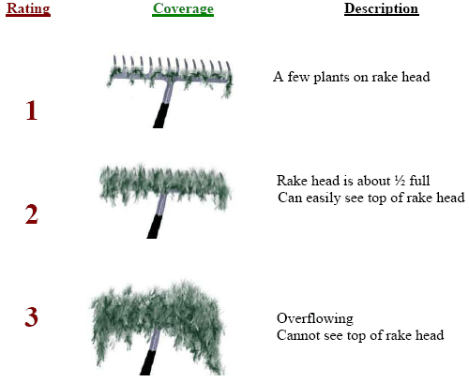
Figure 2: Rake Fullness Ratings
We entered all data collected into the standard WDNR APM spreadsheet (Appendix II). Data was analyzed using the linked statistical summary sheet and the WDNR pre/post analysis worksheet (UWEX 2010). For pre/post differences of individual plant species as well as count data, we used the Chi-square analysis on the WDNR pre/post survey worksheet. For comparing averages (mean species/point and mean rake fullness/point), we used t-tests. Differences were determined to be significant at p<0.05, moderately significant at p<0.01 and highly significant at p<0.001.

Eurasian Water-milfoil Bed Mapping Survey:
During the September survey, we searched the lake’s visible littoral zone for Eurasian water-milfoil. When found, we used a telescopic rake to remove EWM plants by their roots and logged the location with a GPS waypoint. We also took extra care to gather any fragments that broke off of the plants. If we found a “bed” where we estimated that EWM made up >50% of the plants and was generally continuous with clearly defined borders; we motored around the perimeter of the area, took GPS coordinates at regular intervals, documented the rake range and depth range of plants, and estimated the average rake fullness rating and depth of EWM within the bed. Using the WDNR’s Forestry Tool’s Extension to ArcGIS 9.3.1, we used these coordinates to generate bed shapefiles and determine the acreage to the nearest hundredth of an acre.

RESULTS AND DISCUSSION:
Finalization of Treatment Areas:
The two proposed treatment areas totaled 0.74 acres (0.29% of the lake’s total surface area) (Figure 3) (Appendix I). Because the May 22nd pretreatment survey found Eurasian water-milfoil was present in each area, the RLA decided to go ahead with the treatment as originally planned.

Treatment occurred on June 1st with Northern Aquatic Services (Dale Dressel - Dresser, WI) applying ProcellaCor at a rate of 6-8 pdu/acre ft. (32.76 total pdus – at 3.17 fl. oz./pdu) (Table 1). At the time of treatment, the reported water temperature was 68°F and the air temperature was 70°F. Wind speeds were clocked at 2-3mph out of the west.

Table 1: Spring EWM Treatment Summary
Red Lake, Douglas County
June 1, 2021

Bed Number | Final Treatment Area  (acres) | Chemical, Rate, and  Total Volume
14 | 0.57 | ProcellaCor – 6pdu – 20.52pdu
15 | 0.17 | ProcellaCor – 8pdu – 12.24pdu
Total | 0.74 | ProcellaCor – 6-8pdu– 32.76pdu

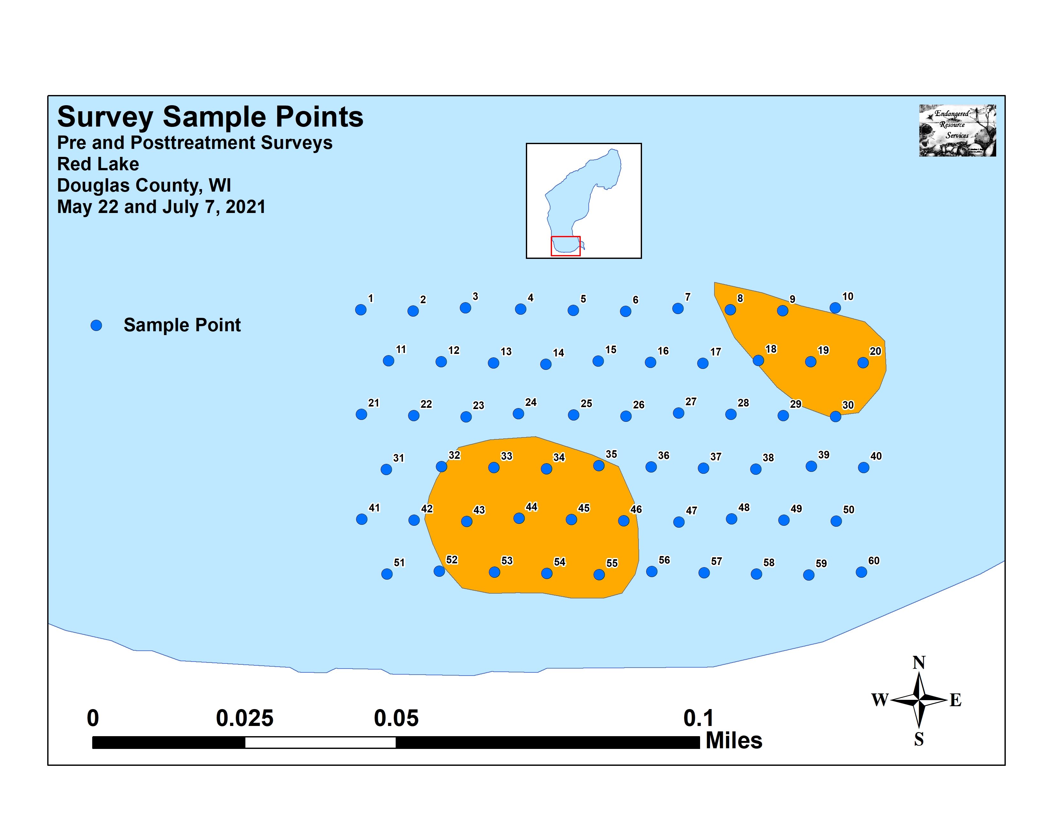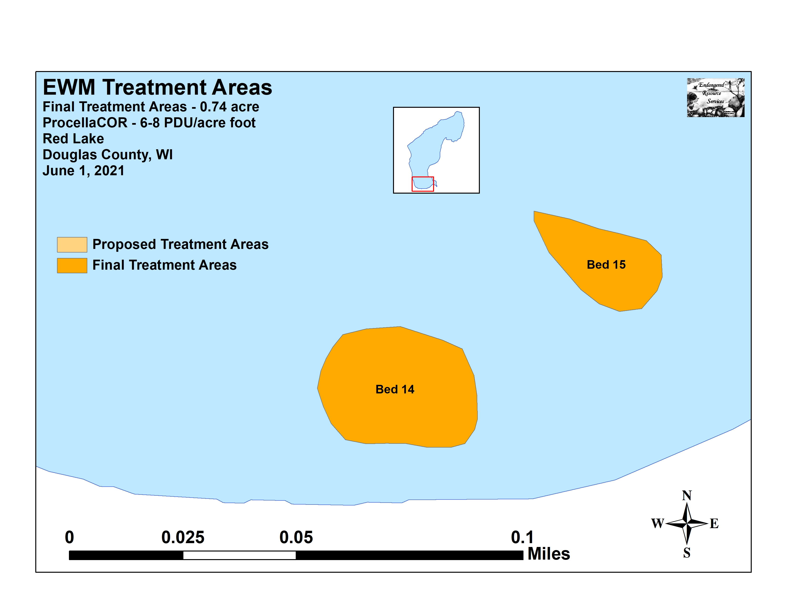
Figure 3: Pre/Post Survey Points and EWM Treatment Areas

Eurasian Water-milfoil Pre/Post Herbicide Surveys:
All survey points occurred in areas between 4.5ft and 14.0ft of water. Within the beds, plants grew at a mean and median depth of 6.9ft and 6.5ft respectively during both the pre and posttreatment surveys (Table 2). Nearshore, plants were established over pure sand, but this transitioned to a nutrient-poor sandy muck at most depths over 5.0ft (Figure 4) (Appendix III).

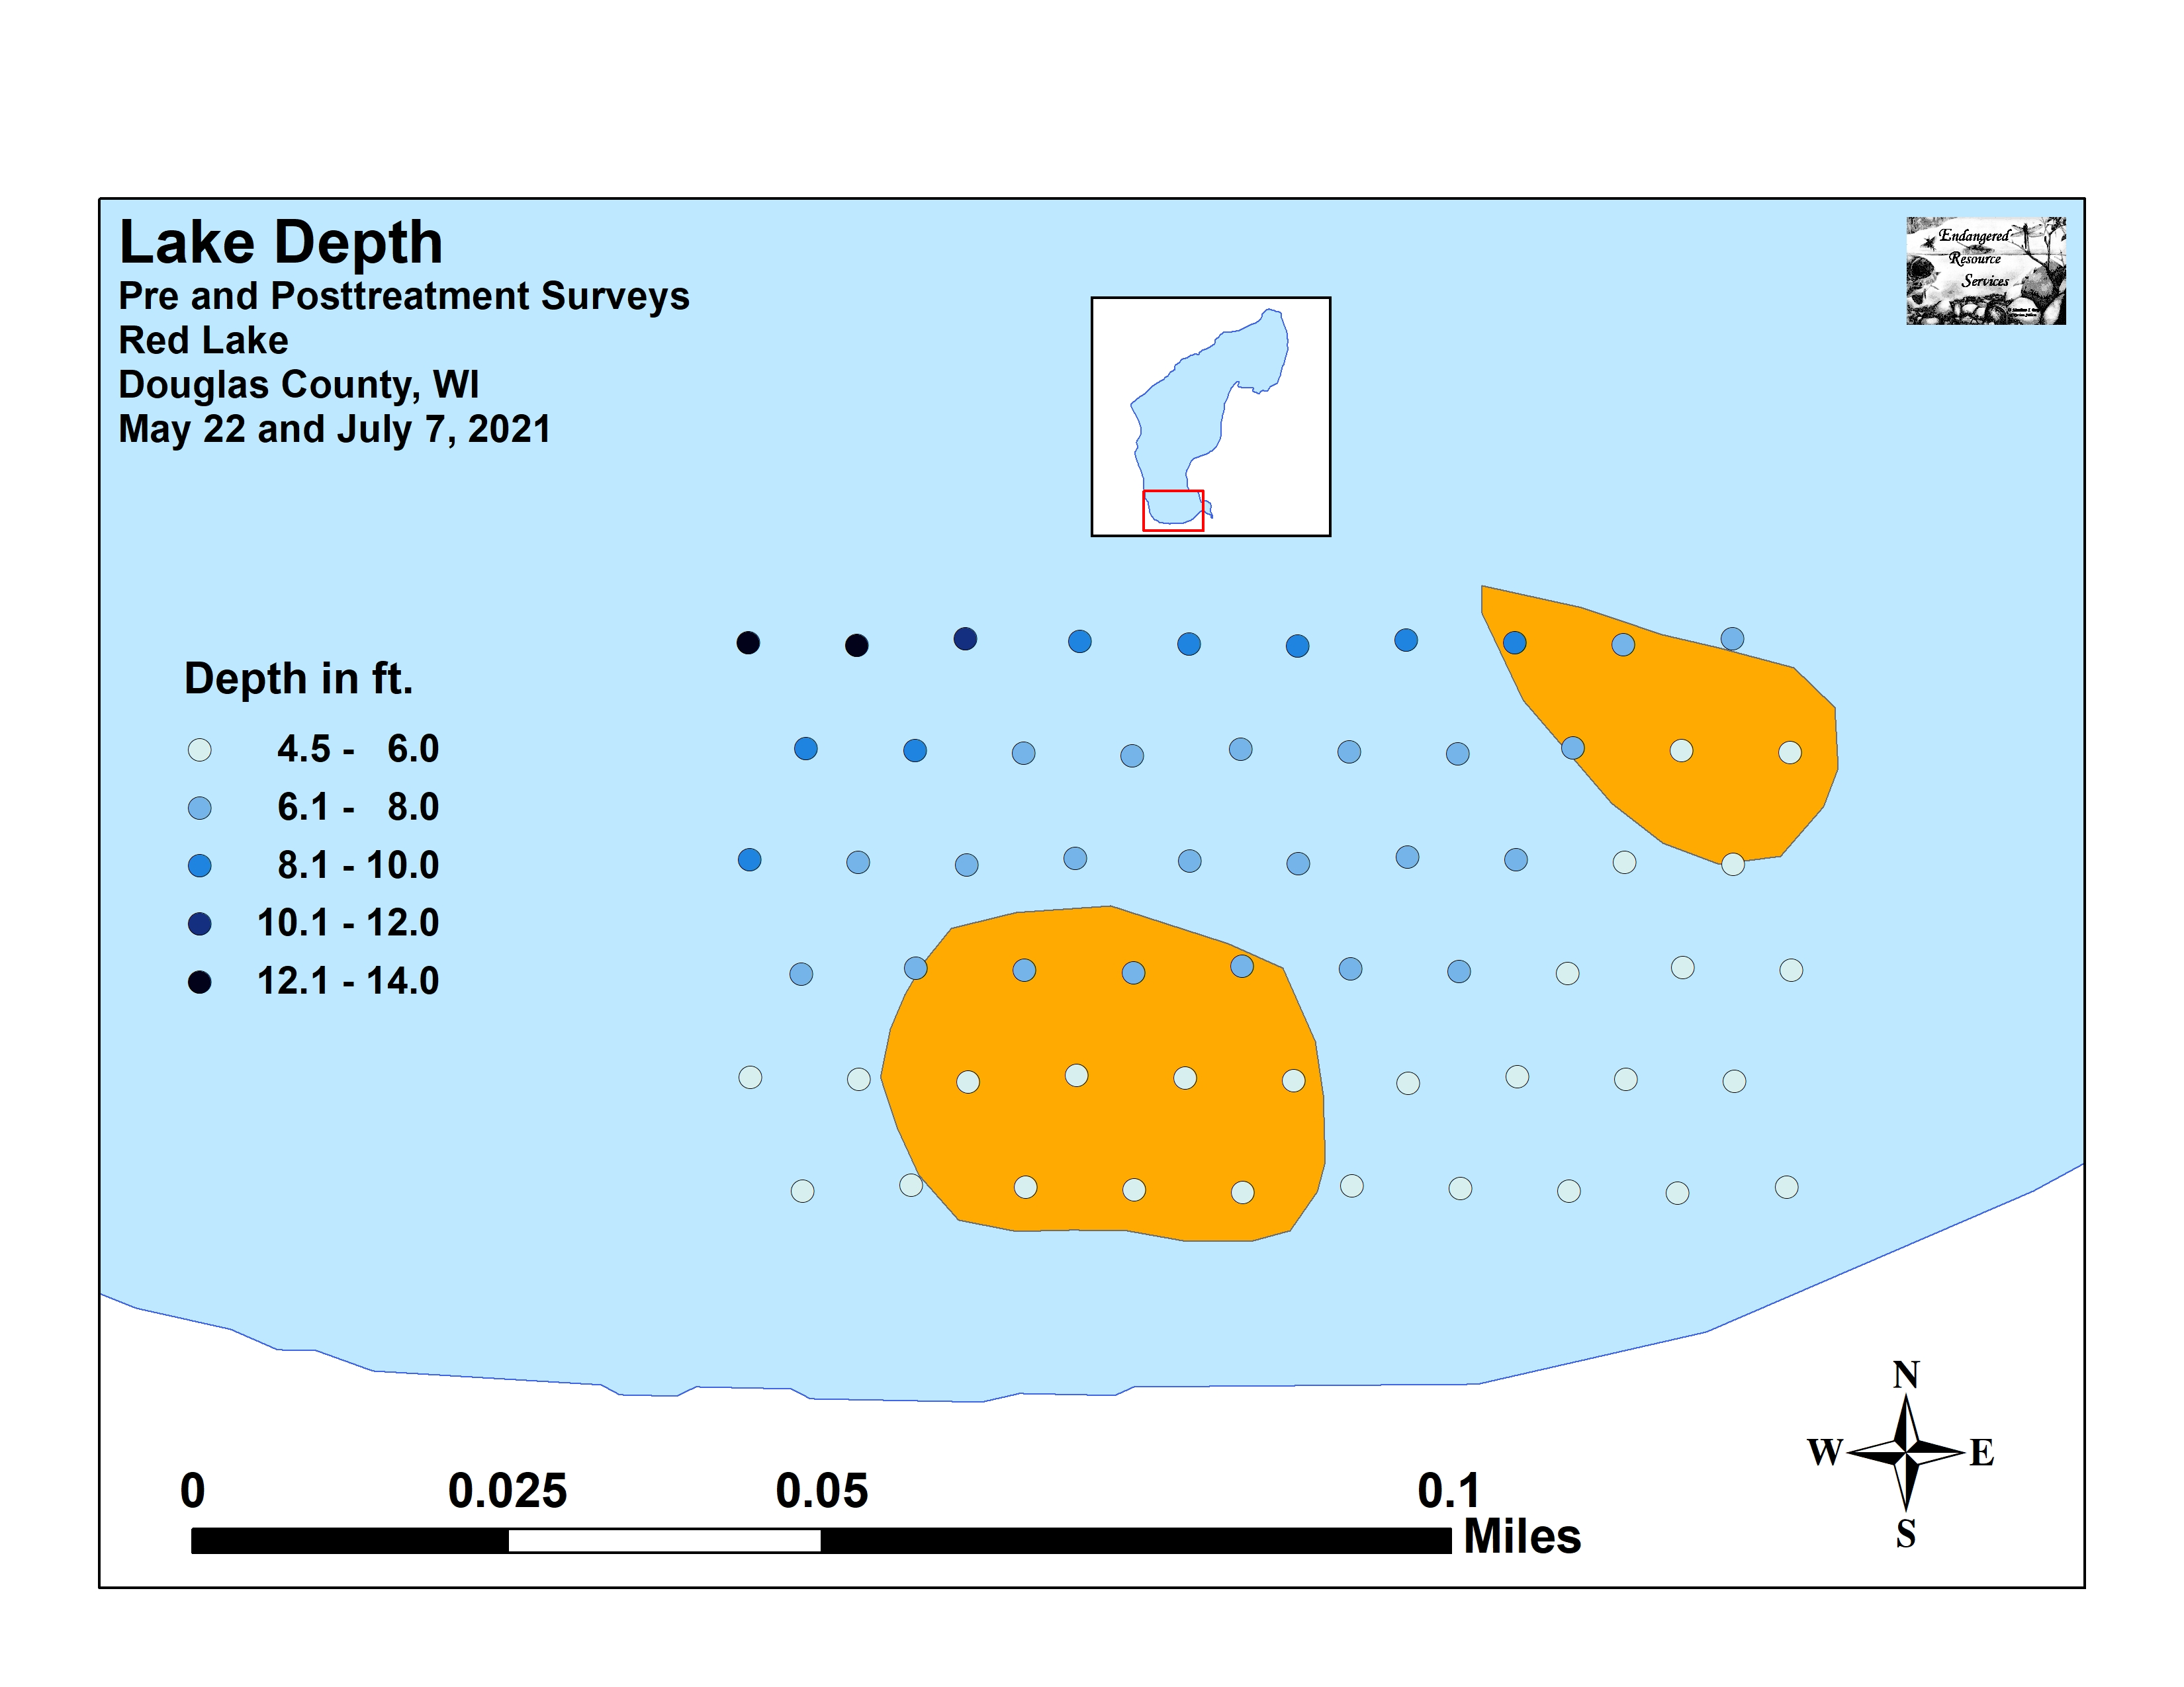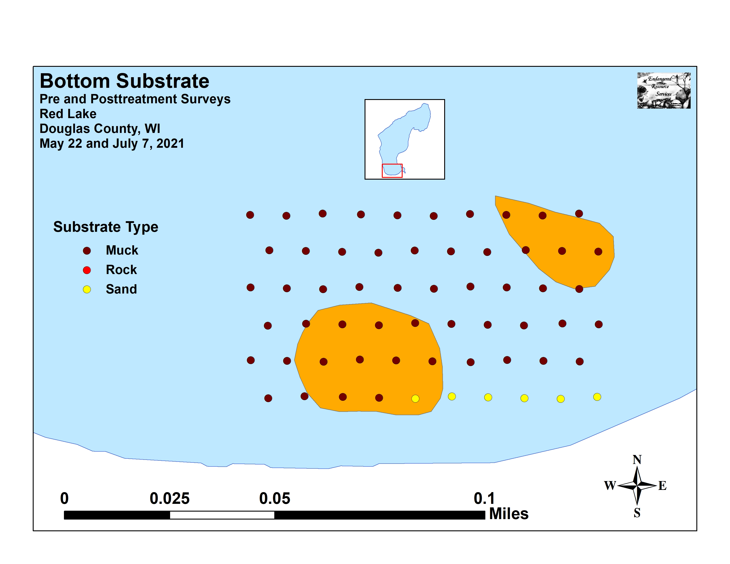
Figure 4: Treatment Area Depths and Bottom Substrate

Table 2: Pre/Posttreatment Surveys Summary Statistics
Red Lake, Douglas County
May 22 and July 7, 2021
Summary Statistics: | Pre | Post
Total number of points sampled | 60 | 60
Total number of sites with vegetation | 60 | 59
Total number of sites shallower than the maximum depth of plants | 60 | 60
Freq. of occur. at sites shallower than max. depth of plants (in percent) | 100 | 98.3
Simpson Diversity Index | 0.82 | 0.86
Mean Coefficient of Conservatism | 6.8 | 6.5
Floristic Quality Index | 23.7 | 25.3
Maximum depth of plants (ft) | 13.5 | 13.0
Mean depth of plants (ft) | 6.9 | 6.9
Median depth of plants (ft) | 6.5 | 6.5
Average number of all species per site (shallower than max depth) | 2.60 | 3.08
Average number of all species per site (veg. sites only) | 2.60 | 3.14
Average number of native species per site (shallower than max depth) | 2.57 | 3.08
Average number of native species per site (sites with native veg. only) | 2.57 | 3.14
Species Richness | 13 | 15
Mean Rake Fullness (veg. sites only) | 1.87 | 2.14

The entire treatment area fell within the littoral zone. Plants were present at all points during the pretreatment survey and all but one point posttreatment (Figure 5) (Appendix IV). Total richness increased from 13 species pretreatment to 15 species posttreatment; and the Simpson’s Diversity Index also rose from a high pretreatment value of 0.82 to 0.86 posttreatment. The Floristic Quality Index (another measure of native plant community health) also increased from 23.7 pretreatment to 25.3 posttreatment.
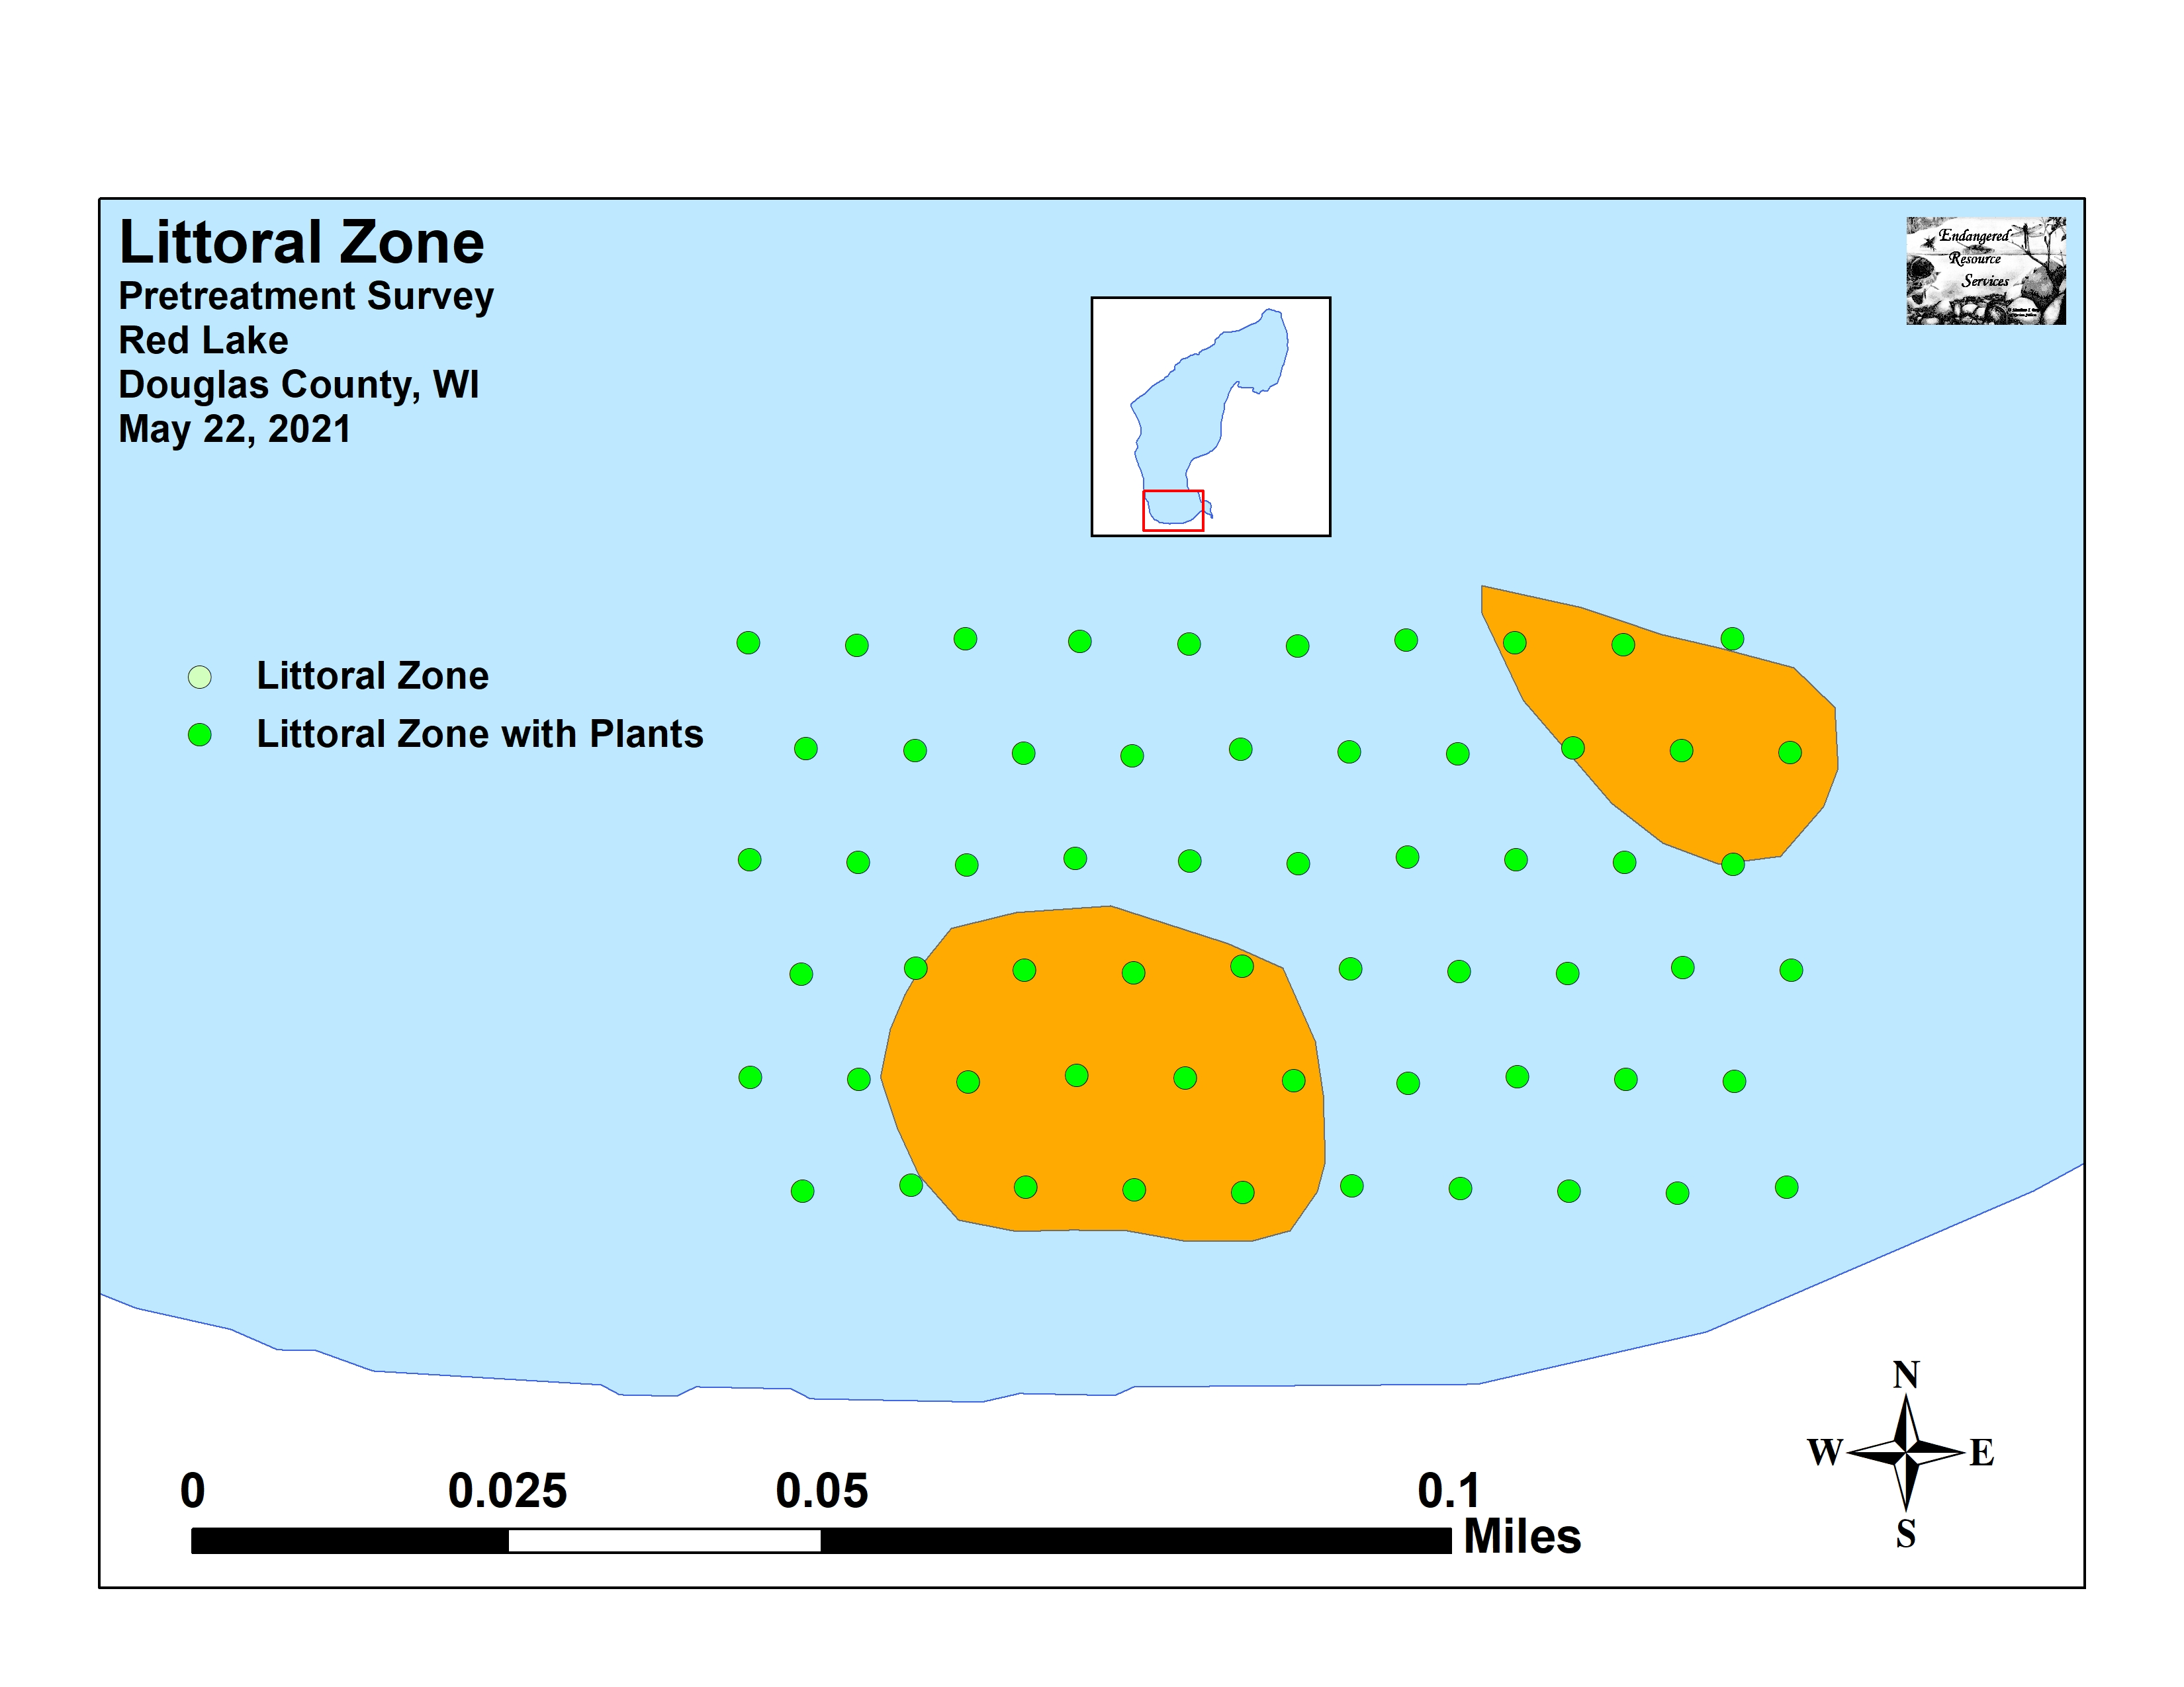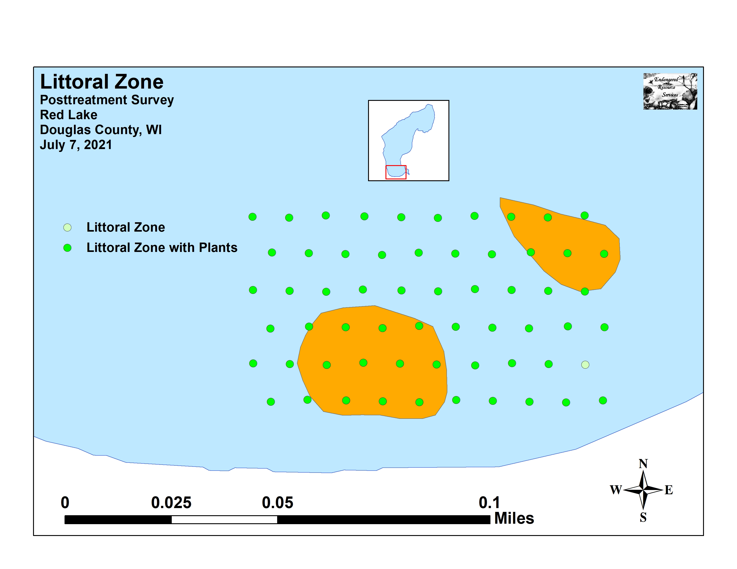
Figure 5: Pre/Posttreatment Littoral Zone

Mean native species richness at points with native vegetation demonstrated a moderately significant increase (p=0.002) from 2.57 species/point pretreatment to 3.14/point posttreatment (Figure 6). Total mean rake fullness underwent a highly significant increase (p<0.001) from a moderate 1.87 pretreatment to 2.14 posttreatment (Figure 7) (Appendix IV).

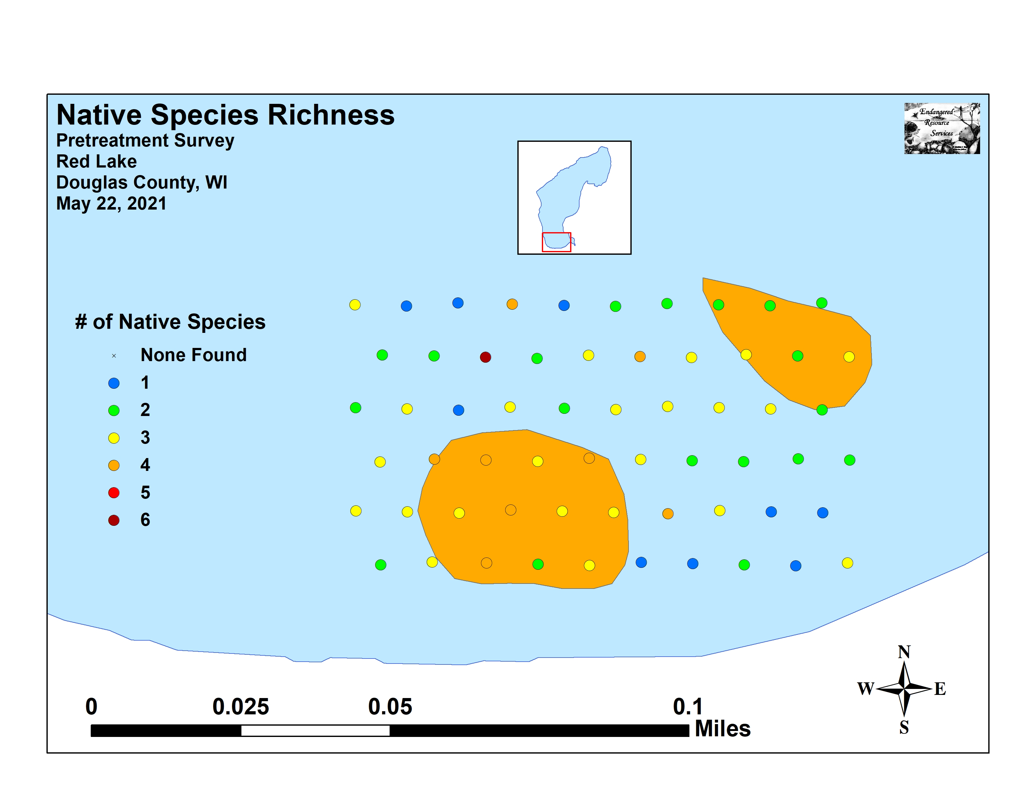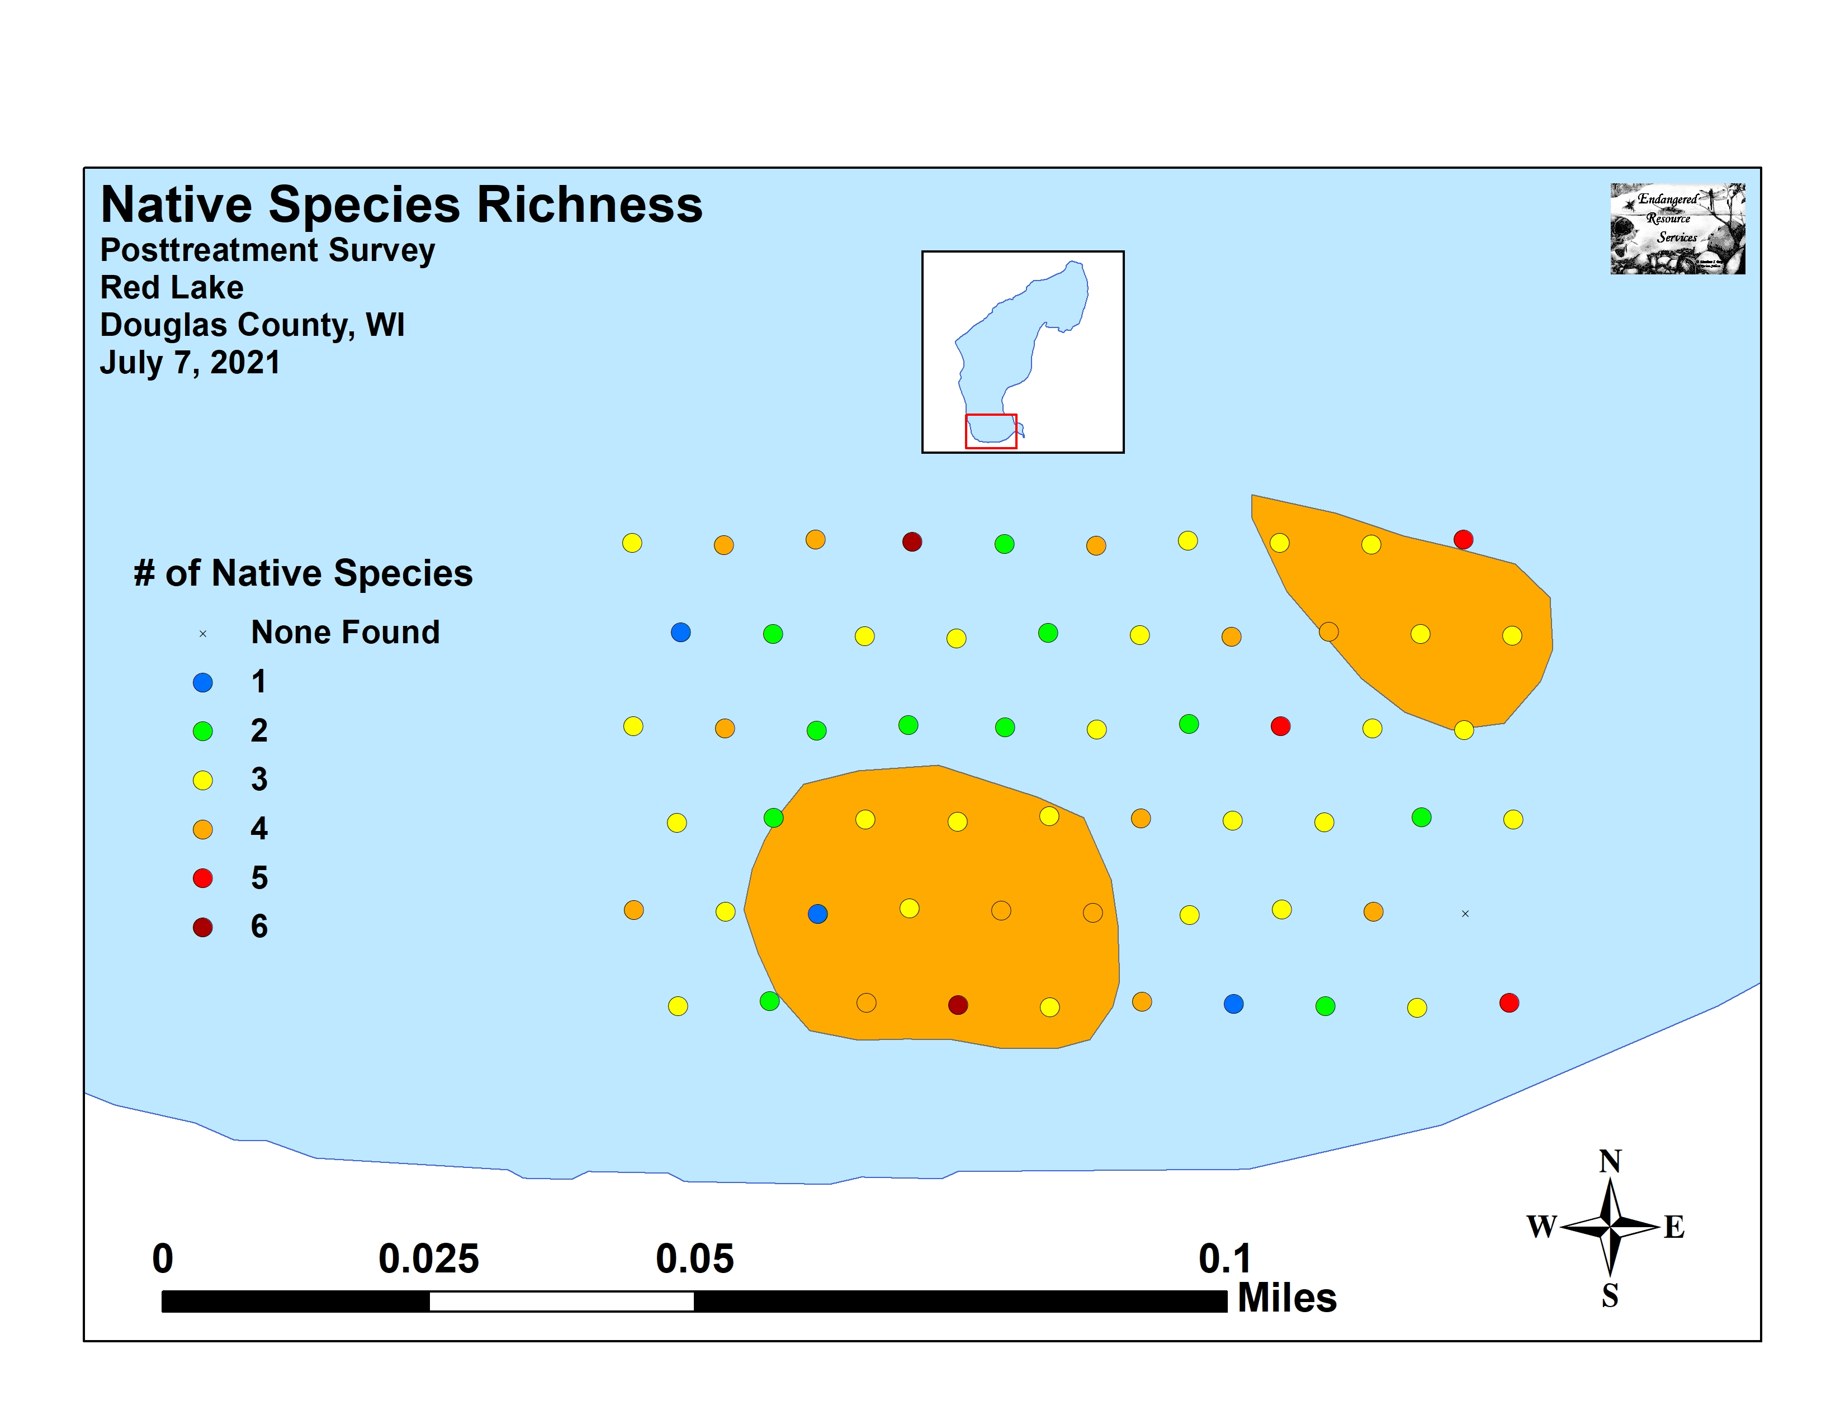
Figure 6: Pre/Posttreatment Native Species Richness

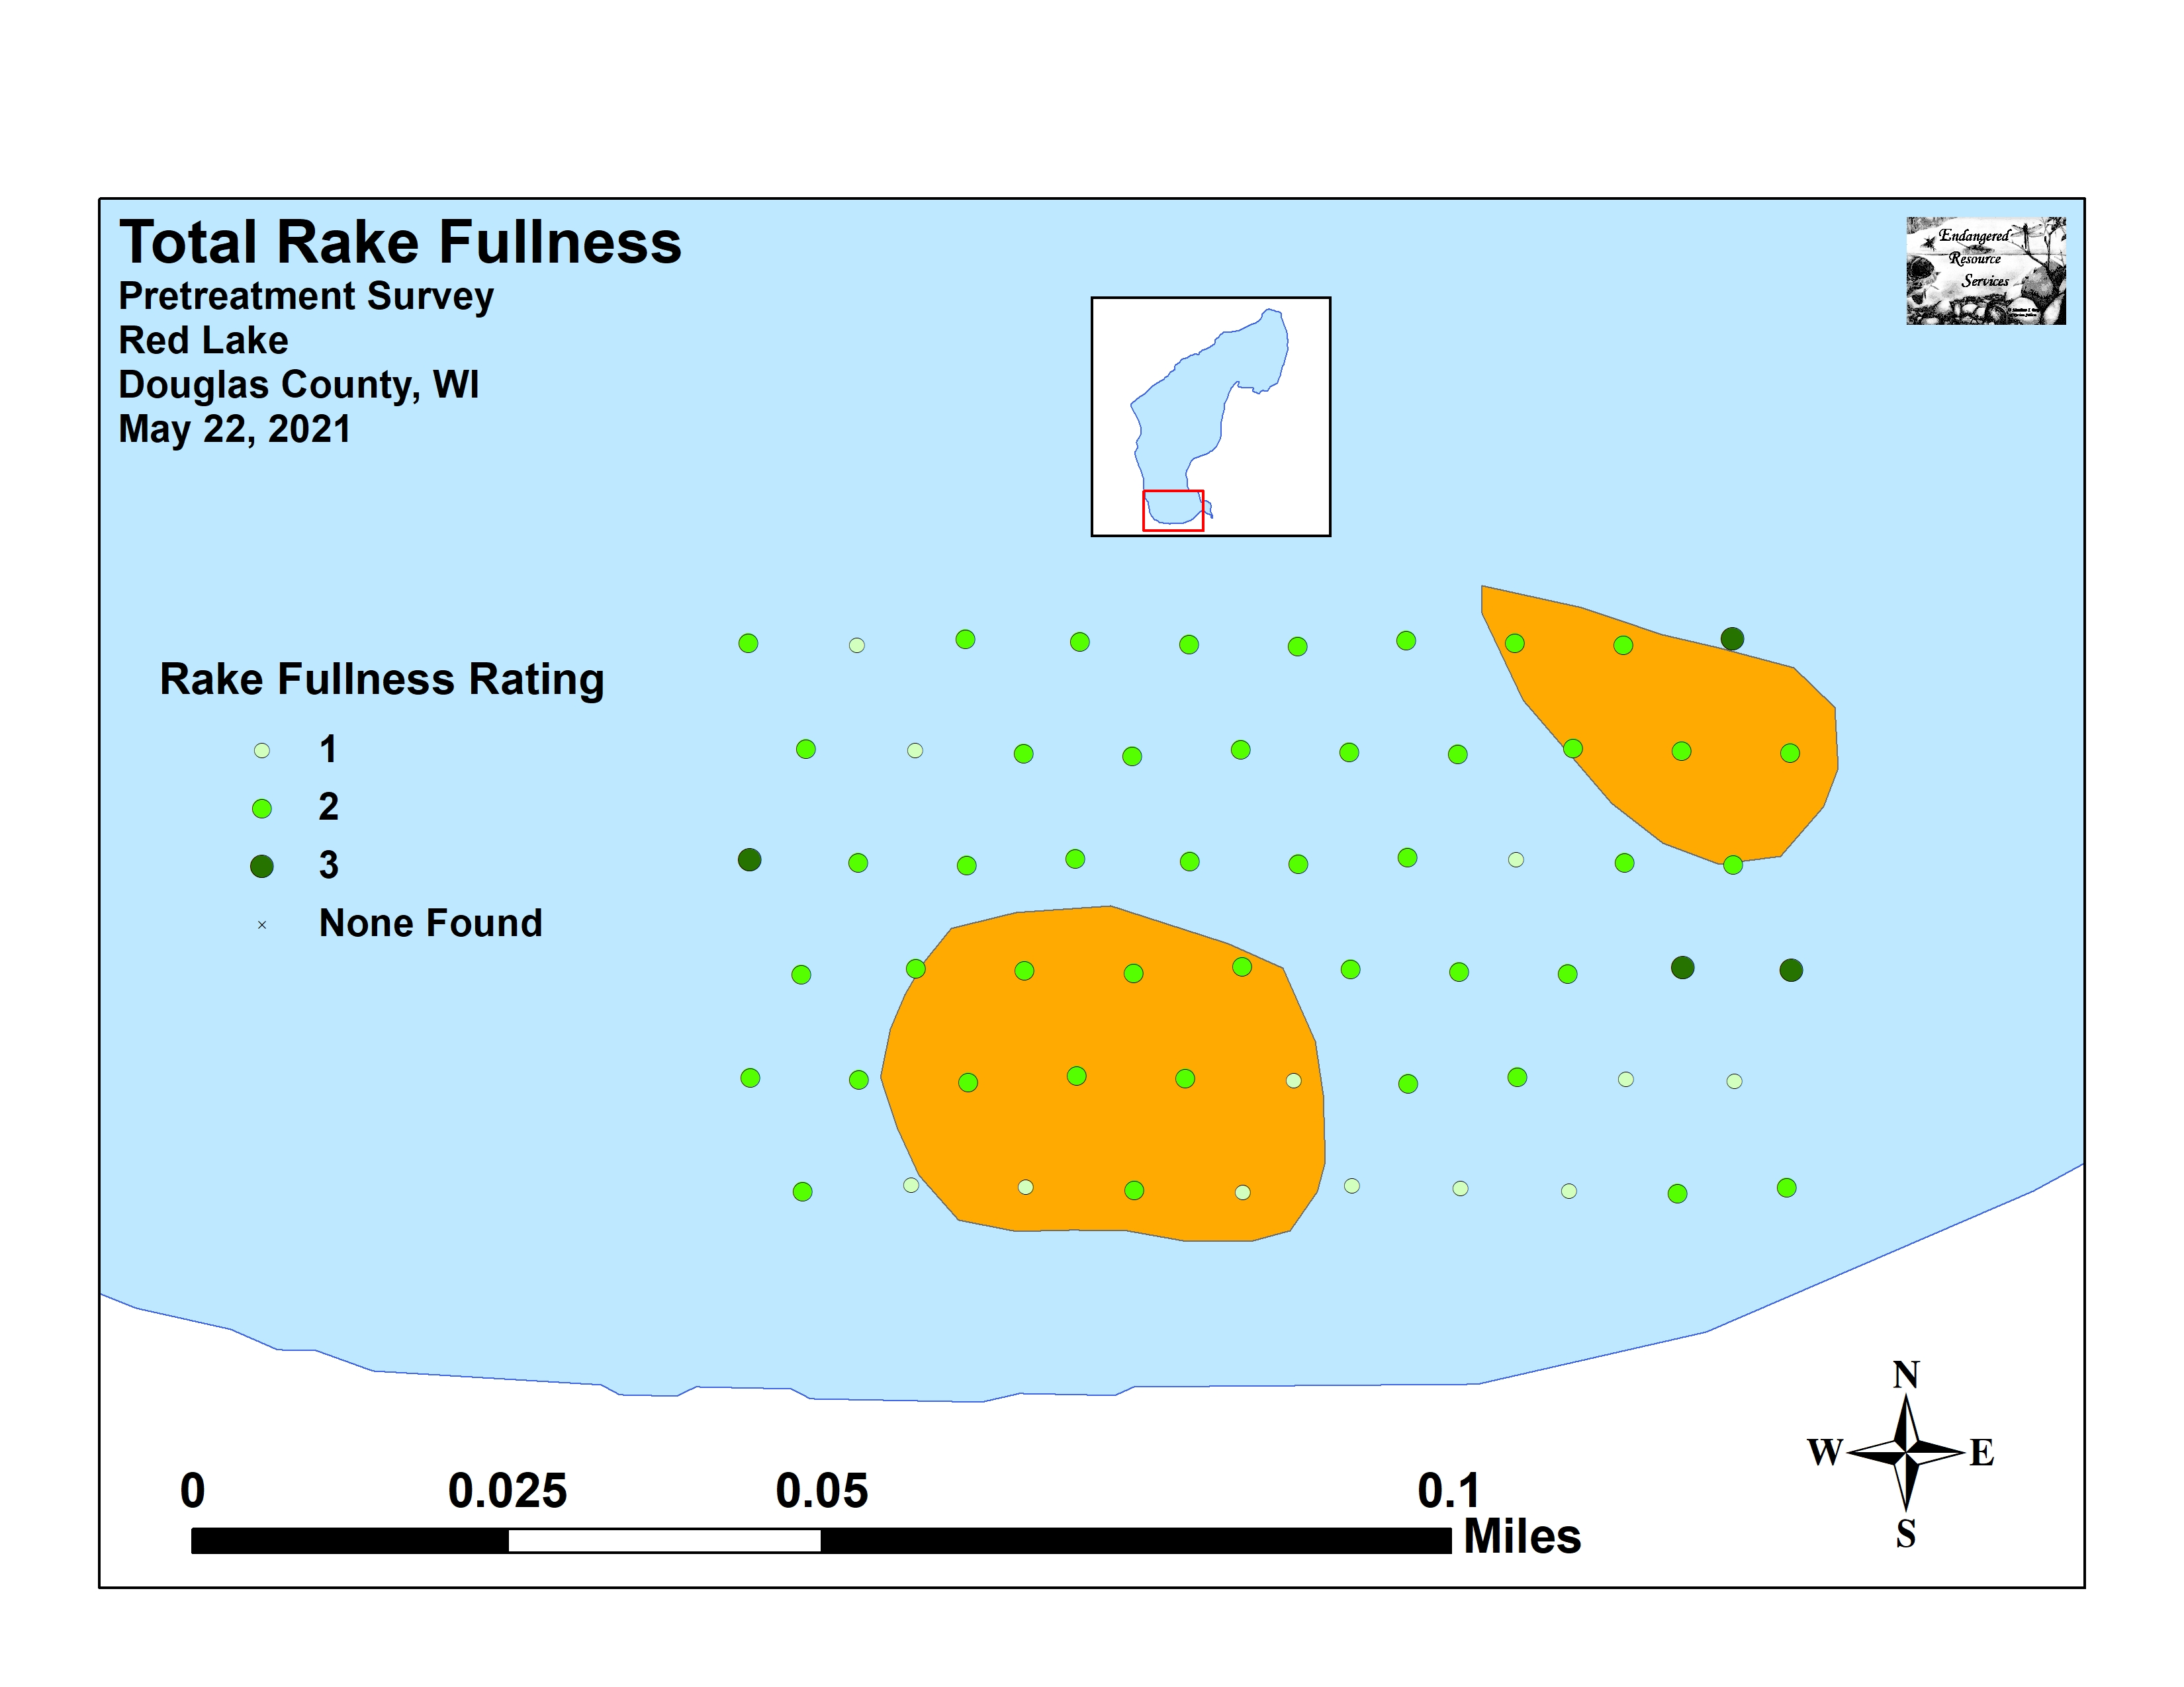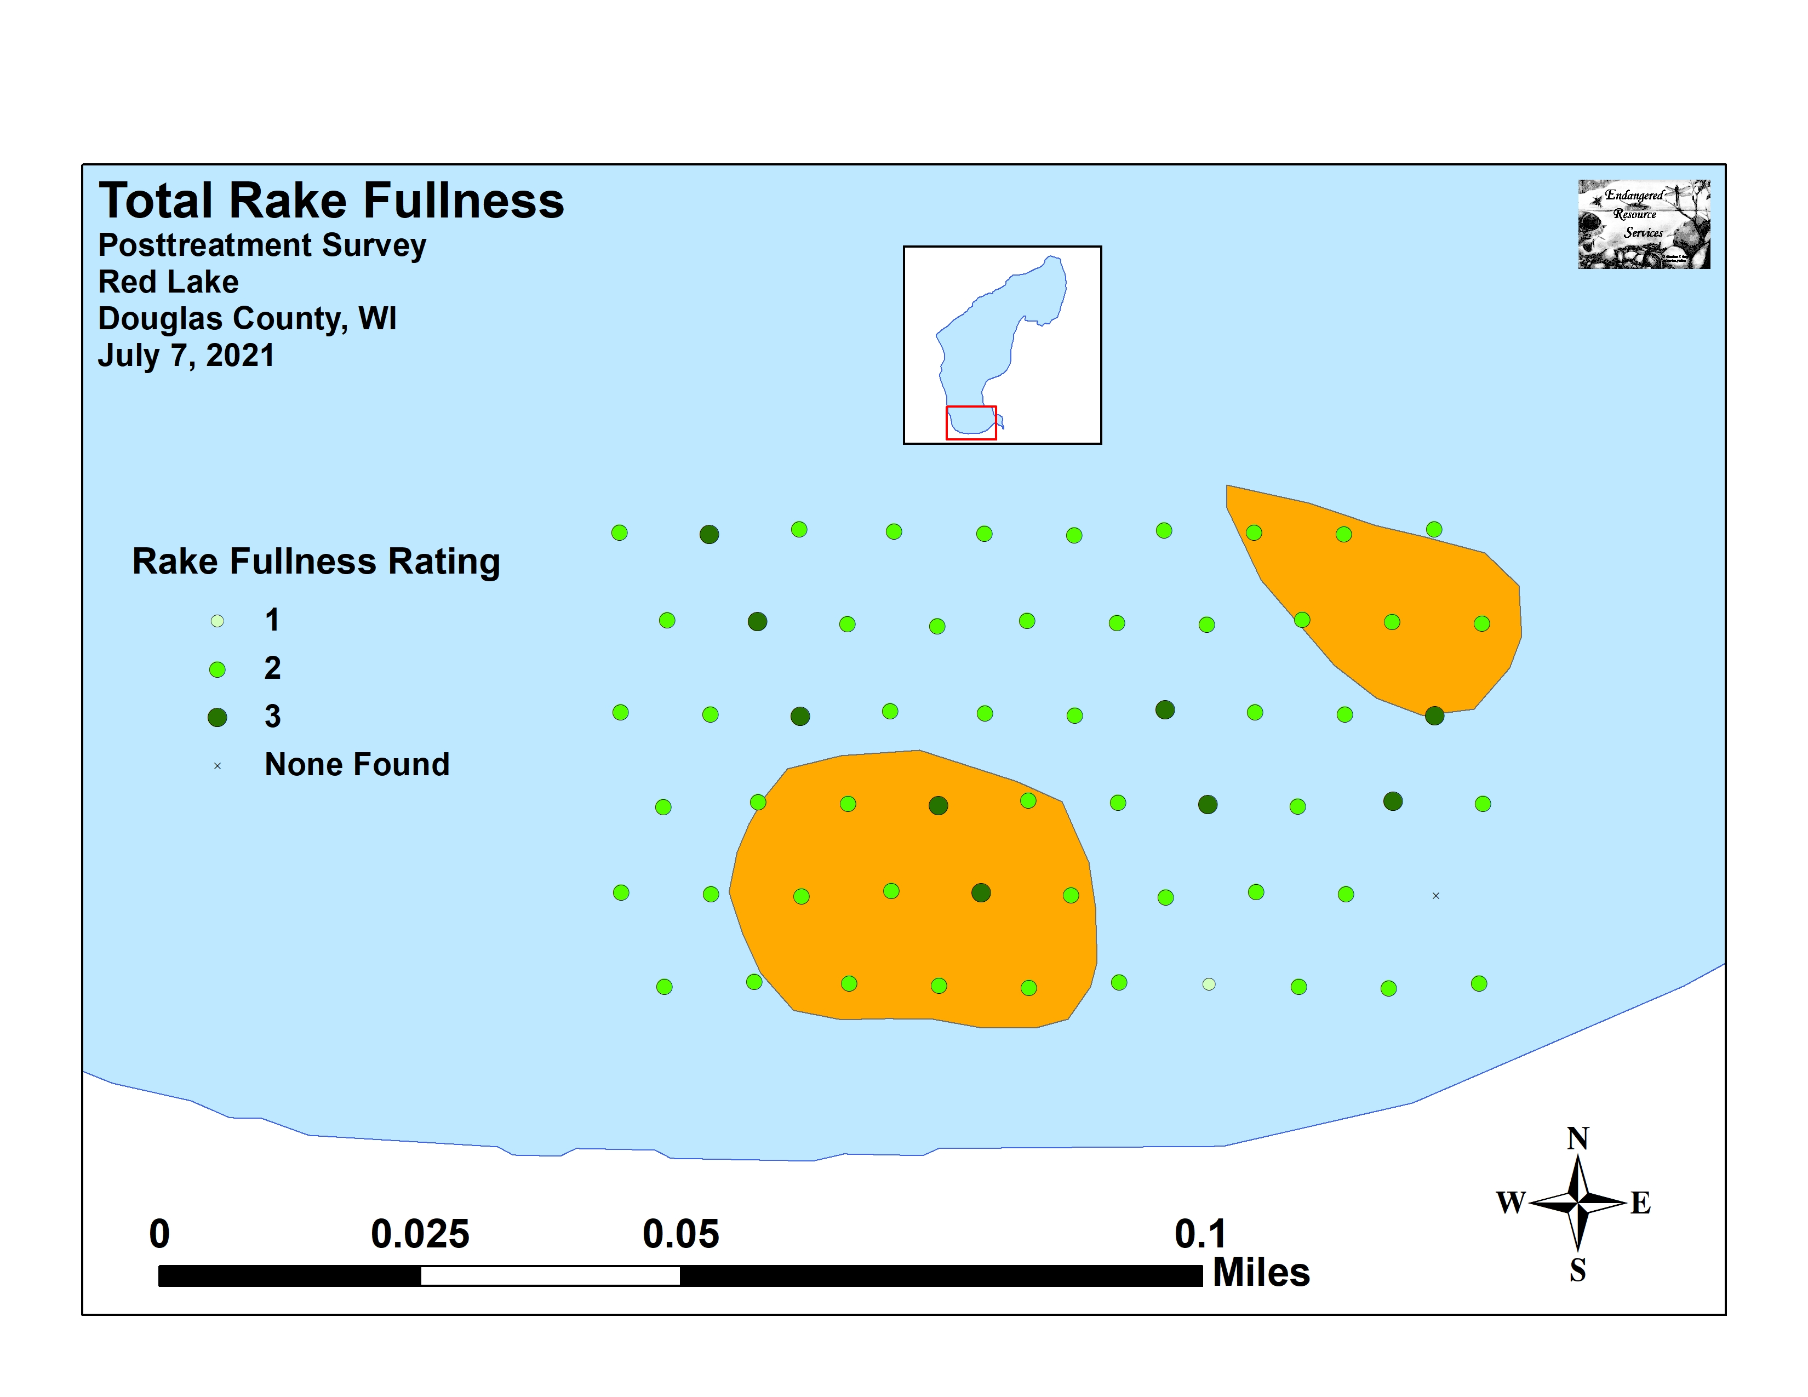
Figure 7: Pre/Posttreatment Total Rake Fullness

We found Eurasian water-milfoil occurred in scattered clusters within the treatment areas. During the pretreatment survey, it was present in the rake at two points (rake fullness of 2 at each), and we also recorded it as a visual at four points (Figure 8) (Appendix V). Posttreatment, we saw no evidence of EWM anywhere in the treatment areas. Due to the small number of pretreatment detections, only the decline in visual sightings was significant (p=0.04) (Figure 9).

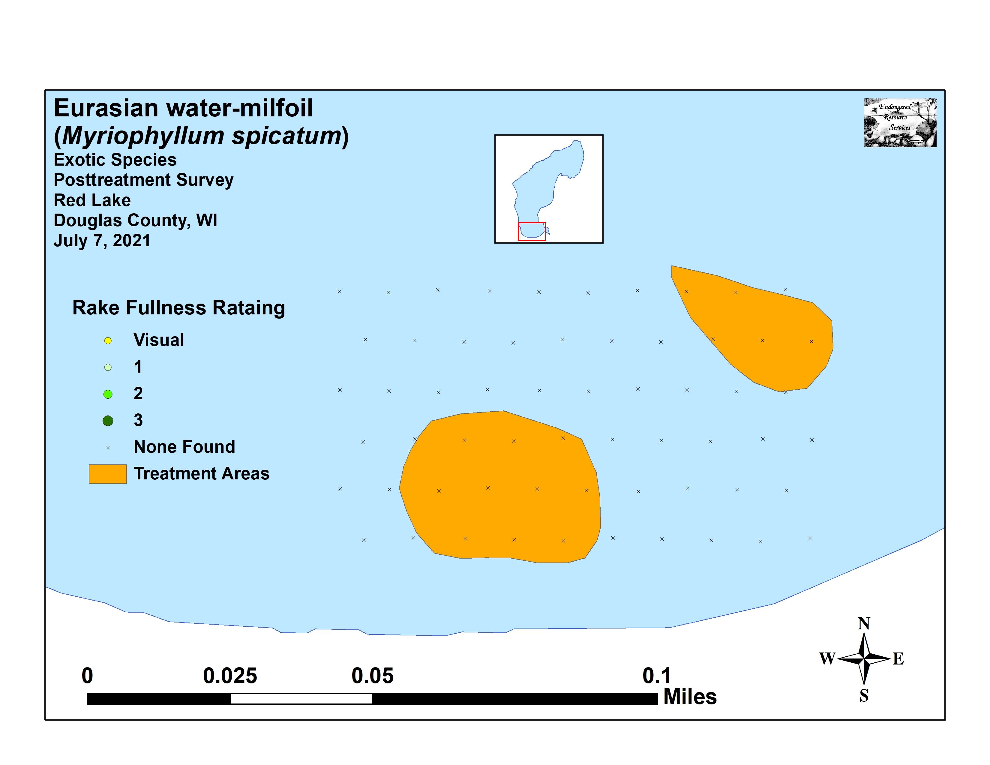
Figure 8: Pre/Posttreatment EWM Density and Distribution

-*
Significant differences = * p<0.05, ** p<0.01, *** p<0.001
-*
Figure 9: Changes in Eurasian Water-milfoil Rake Fullness

Fern pondweed (Potamogeton robbinsii) was the most widely distributed native species in both the pretreatment and posttreatment surveys (Figure 10) (Tables 3 and 4). Neither its declined in distribution (48 sites pretreatment/44 sites posttreatment) nor its increase in density (mean rake fullness of 1.79 pretreatment/1.89 posttreatment) were significant (p=0.39/p=0.20).

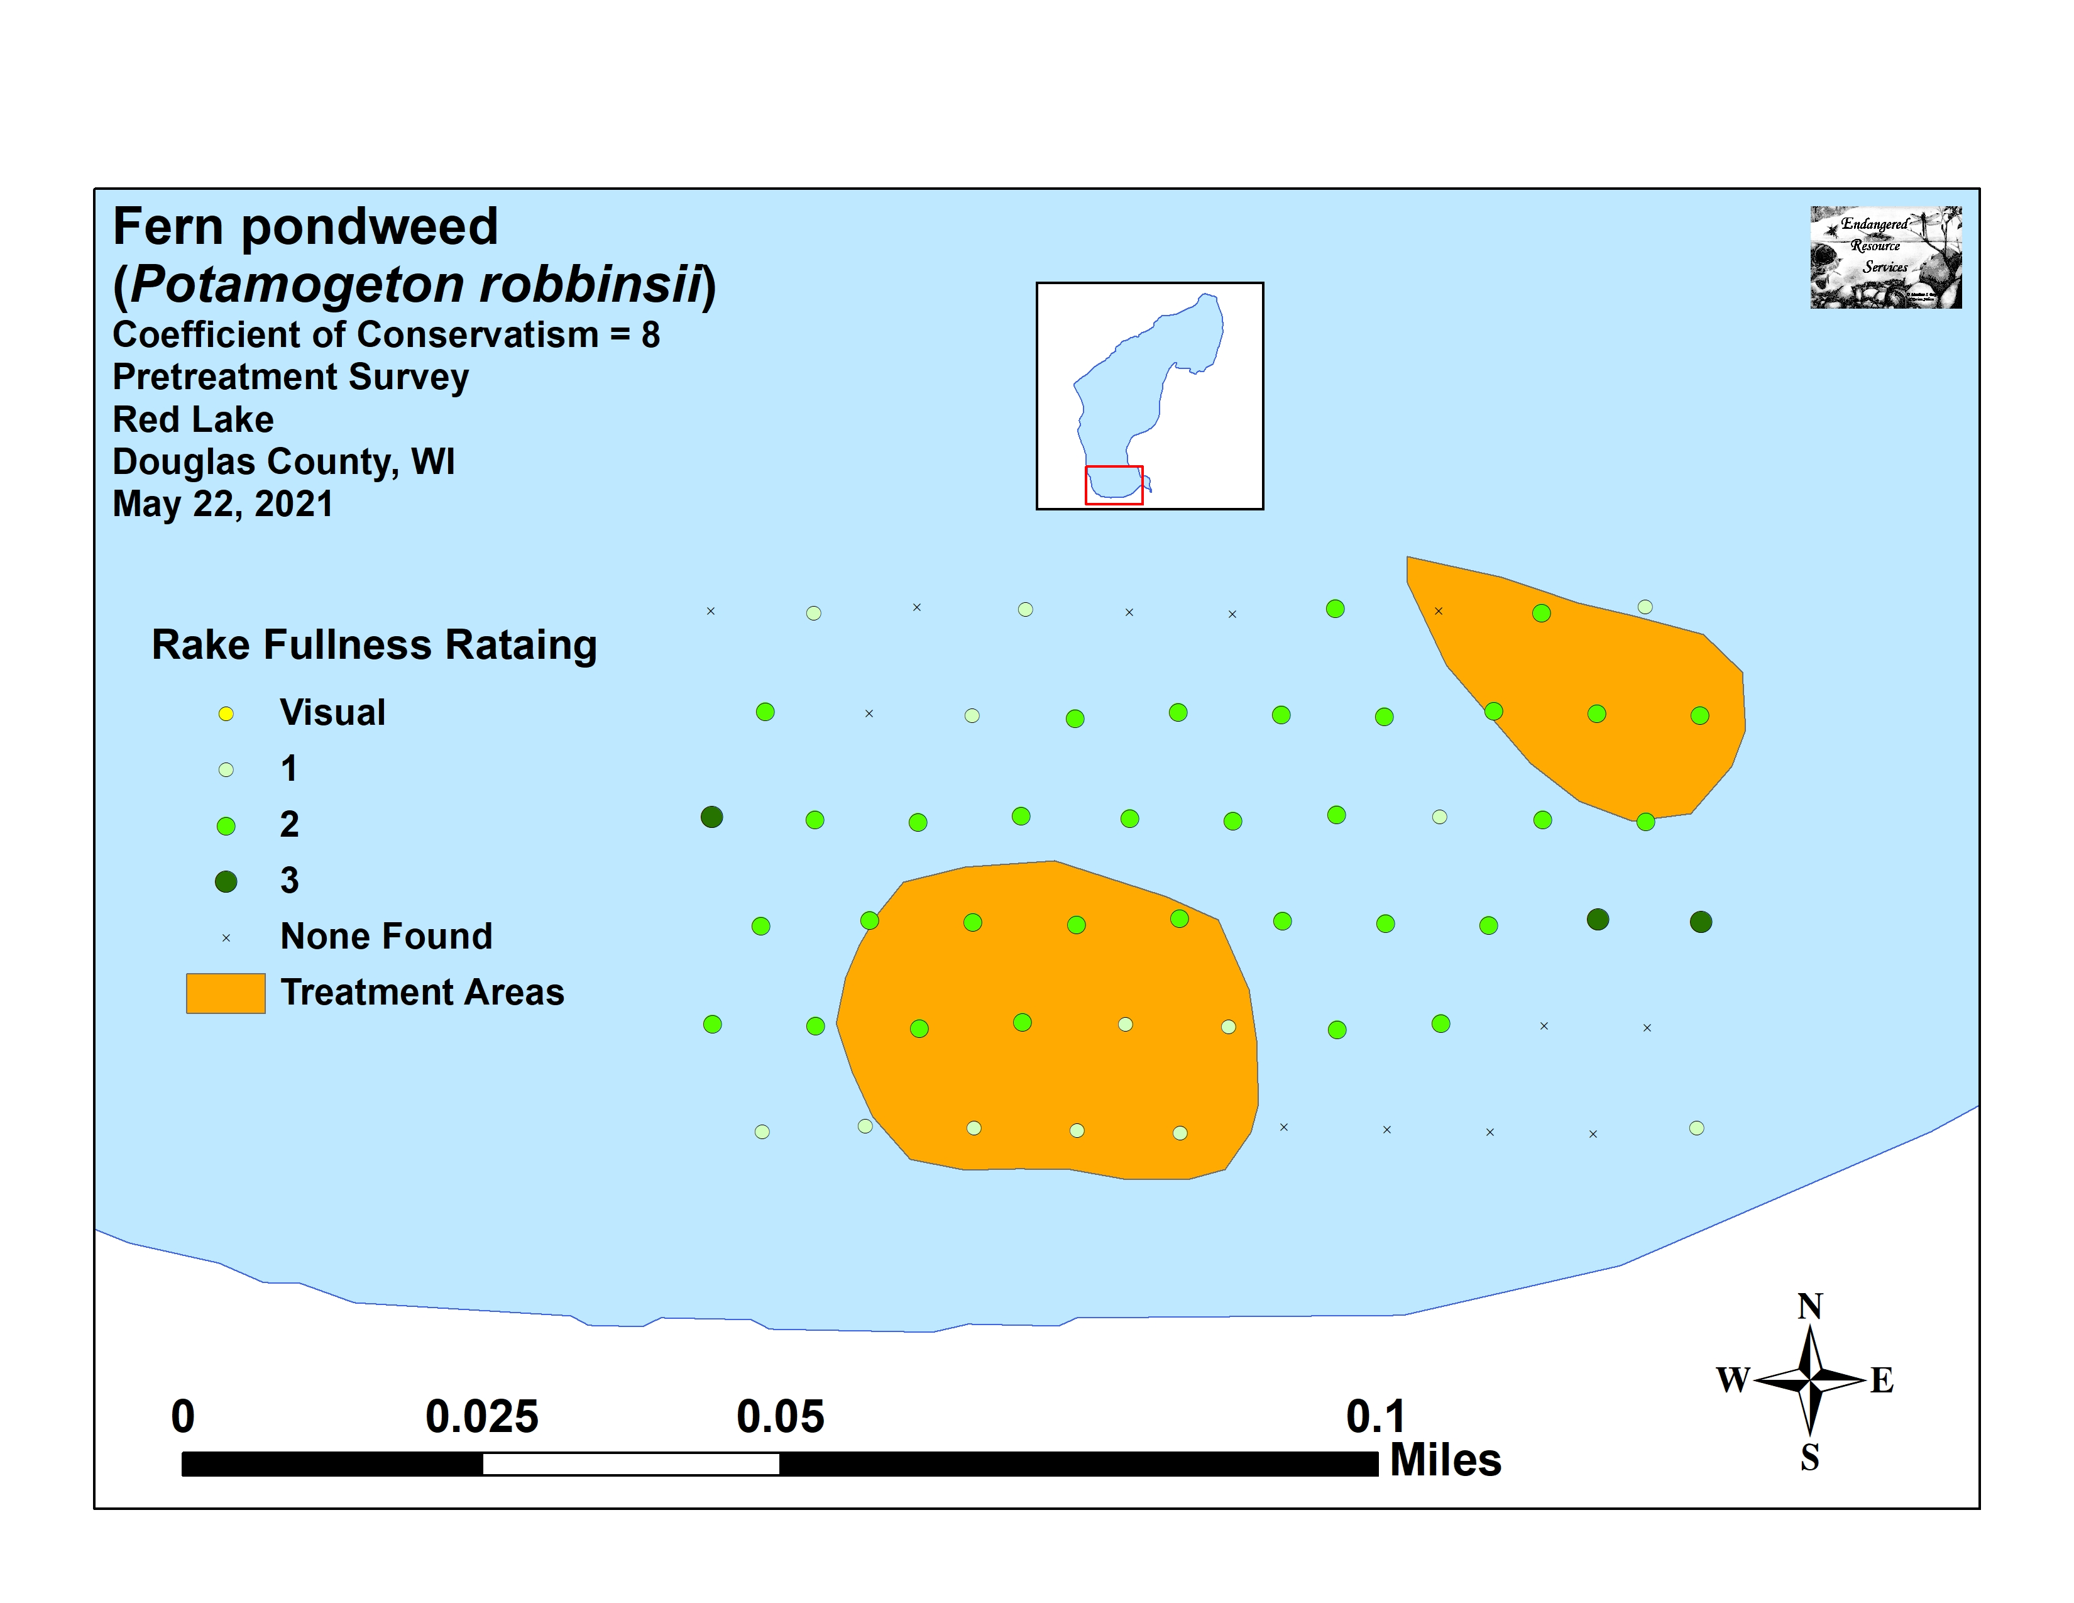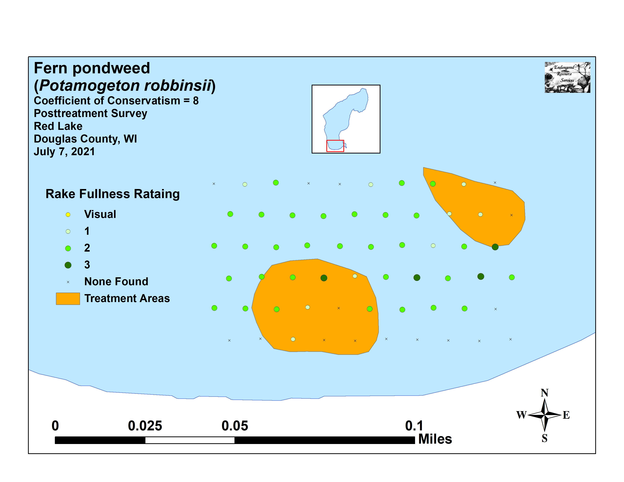
Figure 10: Pre/Posttreatment Fern Pondweed Density and Distribution

Large-leaf pondweed (Potamogeton amplifolius) was the second most common species pretreatment and the third most common posttreatment. In May, it was present at 30 sites with a mean rake fullness of 1.07 (Figure 11). Similar to Fern pondweed, it also saw a non-significant decline (p=0.36) in distribution and a non-significant increase (p=0.08) in density to 25 sites with a mean rake of 1.20 posttreatment.

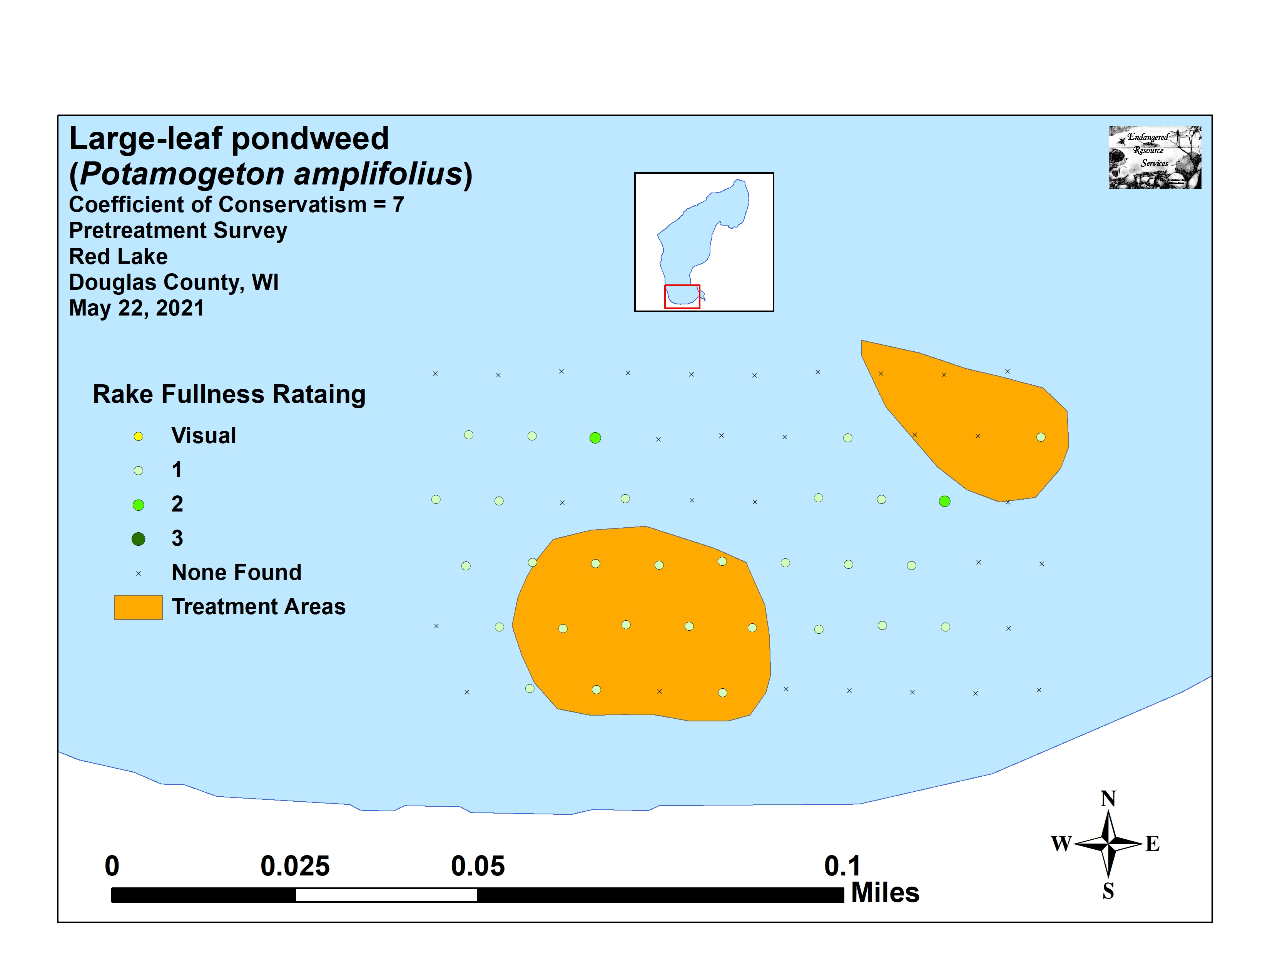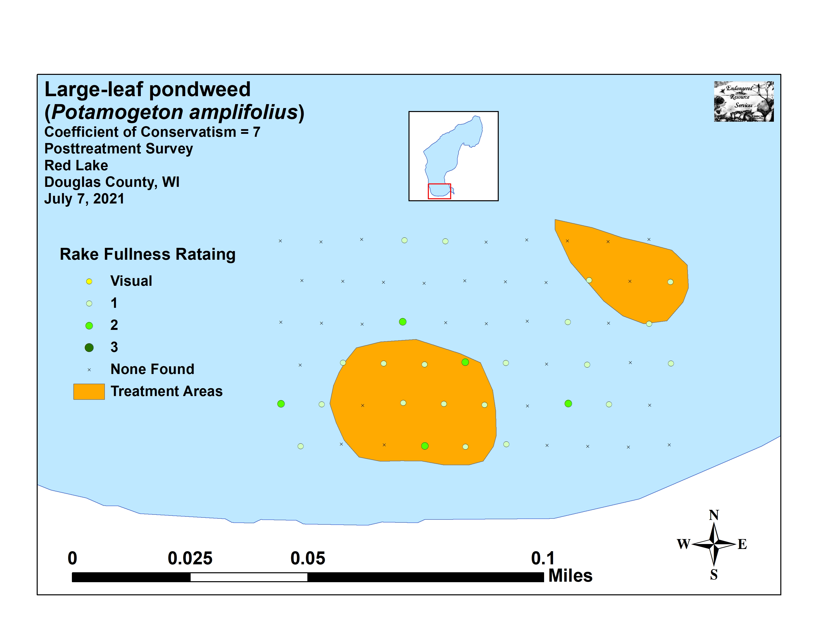
Figure 11: Pre/Posttreatment Large-leaf Pondweed
Density and Distribution

Table 3: Frequencies and Mean Rake Sample of Aquatic Macrophytes
Pretreatment Survey - Red Lake, Douglas County
May 22, 2021

Species | Common Name | Total  Sites | Relative Freq. | Freq. in Veg. | Freq. in Lit. | Mean Rake | Visual Sites
Potamogeton robbinsii | Fern pondweed | 48 | 30.77 | 80.00 | 80.00 | 1.79 | 0
Potamogeton amplifolius | Large-leaf pondweed | 30 | 19.23 | 50.00 | 50.00 | 1.07 | 0
Potamogeton praelongus | White-stem pondweed | 27 | 17.31 | 45.00 | 45.00 | 1.48 | 0
Elodea canadensis | Common waterweed | 14 | 8.97 | 23.33 | 23.33 | 1.14 | 0
Chara sp. | Muskgrass | 11 | 7.05 | 18.33 | 18.33 | 1.36 | 0
Myriophyllum sibiricum | Northern water-milfoil | 8 | 5.13 | 13.33 | 13.33 | 1.13 | 0
Bidens beckii | Water marigold | 7 | 4.49 | 11.67 | 11.67 | 1.00 | 0
Potamogeton gramineus | Variable pondweed | 3 | 1.92 | 5.00 | 5.00 | 1.00 | 0
Myriophyllum spicatum | Eurasian water-milfoil | 2 | 1.28 | 3.33 | 3.33 | 2.00 | 4
Potamogeton illinoensis | Illinois pondweed | 2 | 1.28 | 3.33 | 3.33 | 1.00 | 0
Potamogeton pusillus | Small pondweed | 2 | 1.28 | 3.33 | 3.33 | 1.00 | 0
Potamogeton zosteriformis | Flat-stem pondweed | 1 | 0.64 | 1.67 | 1.67 | 2.00 | 0
Utricularia resupinata | Small purple bladderwort | 1 | 0.64 | 1.67 | 1.67 | 1.00 | 0

Table 4: Frequencies and Mean Rake Sample of Aquatic Macrophytes
Posttreatment Survey - Red Lake, Douglas County
July 7, 2021

Species | Common Name | Total  Sites | Relative Freq. | Freq. in Veg. | Freq. in Lit. | Mean Rake | Visual Sites
Potamogeton robbinsii | Fern pondweed | 44 | 23.78 | 74.58 | 73.33 | 1.89 | 0
Potamogeton praelongus | White-stem pondweed | 39 | 21.08 | 66.10 | 65.00 | 1.67 | 0
Potamogeton amplifolius | Large-leaf pondweed | 25 | 13.51 | 42.37 | 41.67 | 1.20 | 0
Elodea canadensis | Common waterweed | 22 | 11.89 | 37.29 | 36.67 | 1.36 | 0
Bidens beckii | Water marigold | 10 | 5.41 | 16.95 | 16.67 | 1.50 | 0
Chara sp. | Muskgrass | 10 | 5.41 | 16.95 | 16.67 | 1.80 | 0
Najas flexilis | Slender naiad | 7 | 3.78 | 11.86 | 11.67 | 1.14 | 0
Vallisneria americana | Wild celery | 7 | 3.78 | 11.86 | 11.67 | 1.00 | 0
Myriophyllum sibiricum | Northern water-milfoil | 6 | 3.24 | 10.17 | 10.00 | 1.17 | 0
Potamogeton gramineus | Variable pondweed | 4 | 2.16 | 6.78 | 6.67 | 1.25 | 0
Potamogeton pusillus | Small pondweed | 4 | 2.16 | 6.78 | 6.67 | 1.50 | 0
Eleocharis acicularis | Needle spikerush | 2 | 1.08 | 3.39 | 3.33 | 1.00 | 0
Potamogeton zosteriformis | Flat-stem pondweed | 2 | 1.08 | 3.39 | 3.33 | 1.00 | 0
Utricularia resupinata | Small purple bladderwort | 2 | 1.08 | 3.39 | 3.33 | 2.00 | 0
Potamogeton richardsonii | Clasping-leaf pondweed | 1 | 0.54 | 1.69 | 1.67 | 1.00 | 0

White-stem pondweed (Potamogeton praelongus) was the third most common species in the pretreatment survey (27 sites/mean rake 1.48). We documented a significant increase (p=0.03) in distribution to 39 sites posttreatment as it became the second most common species in the community. The corresponding increase in density to a mean rake of 1.67 was, however, not significant (p=0.12) (Figure 12).

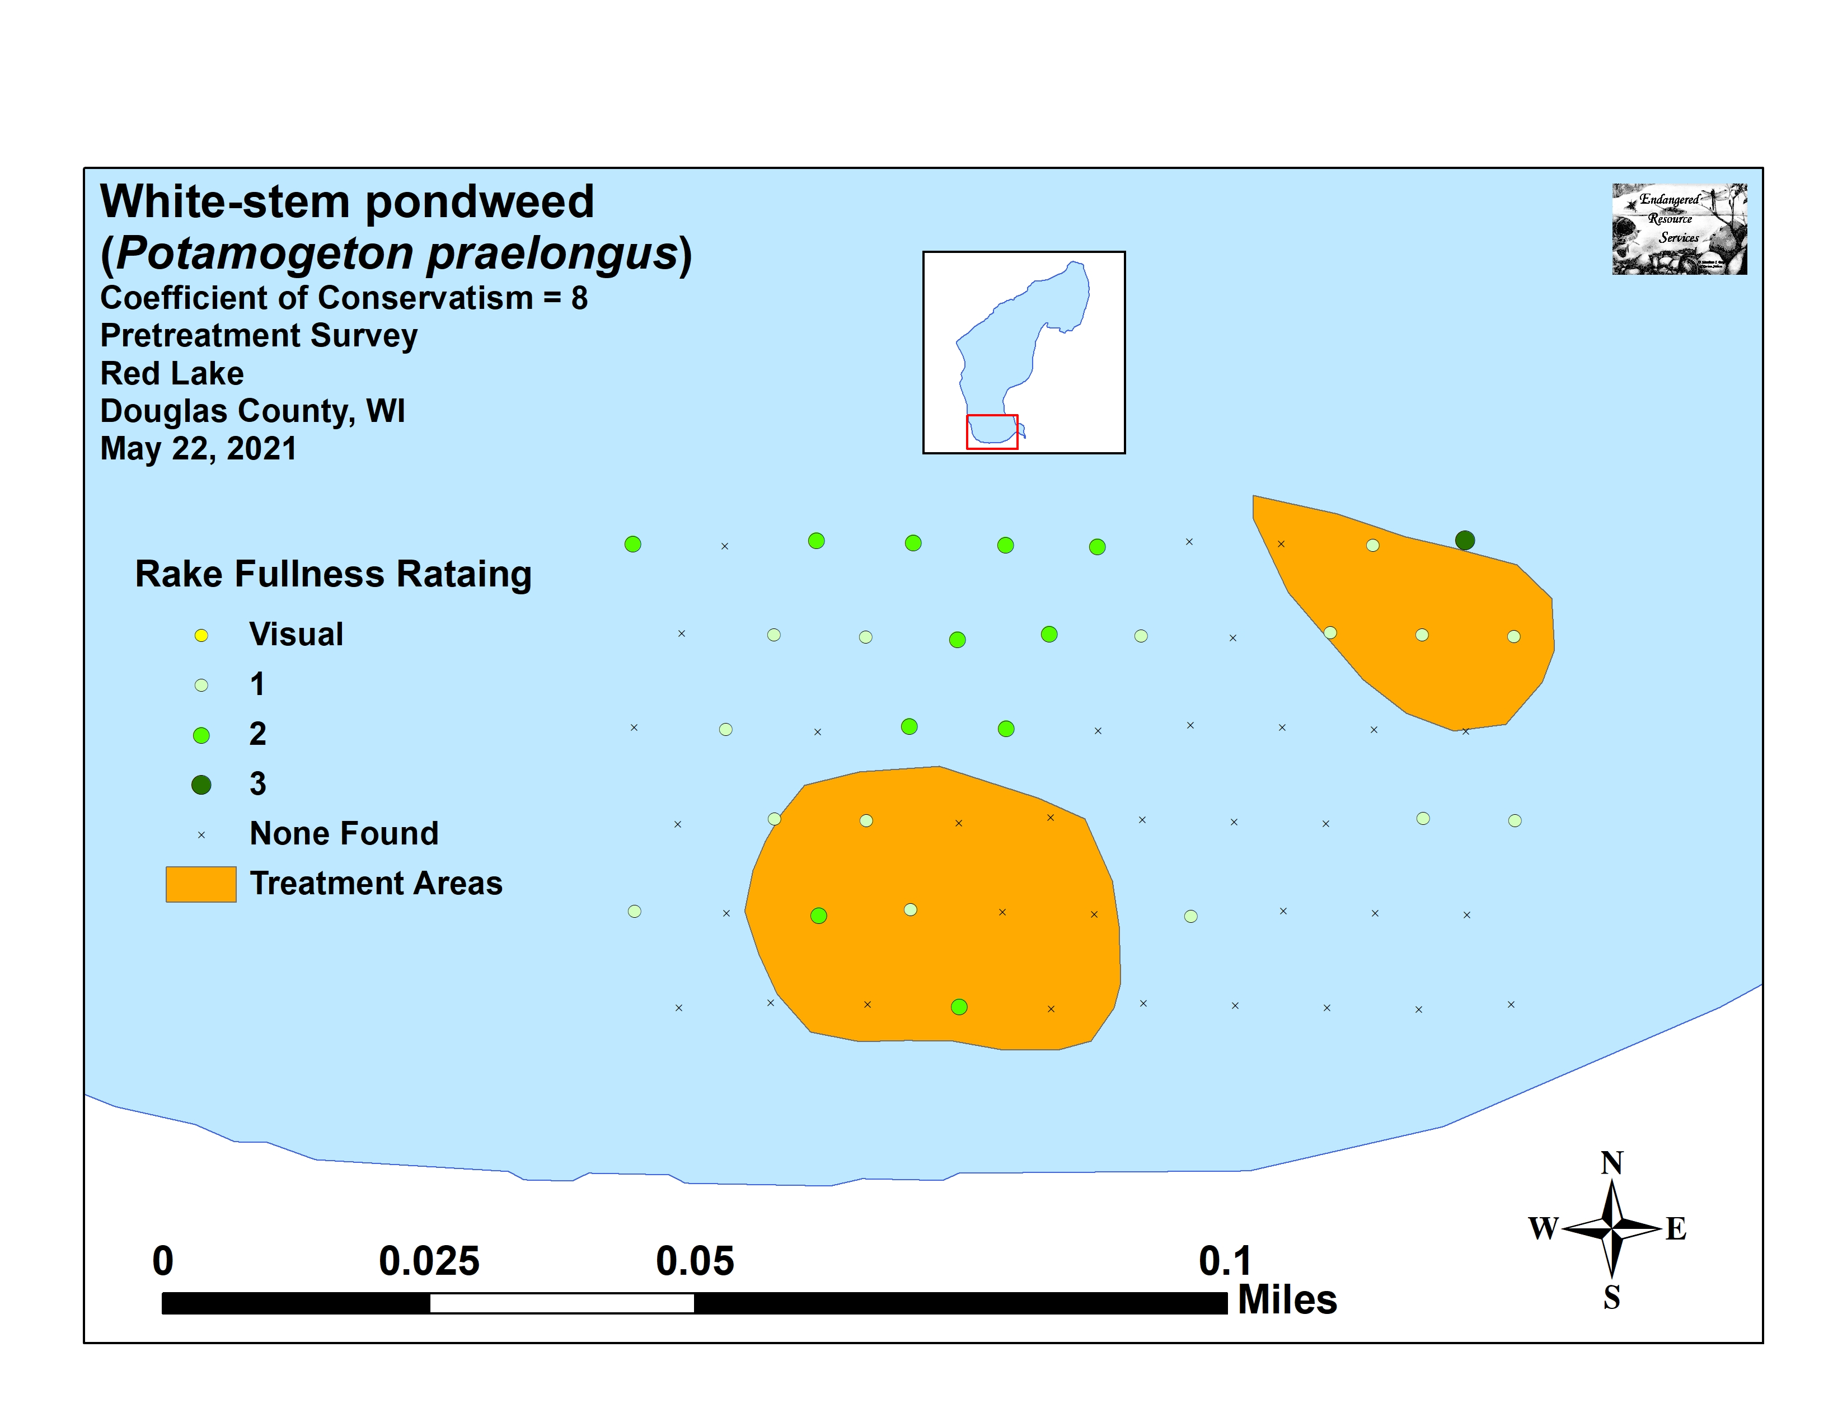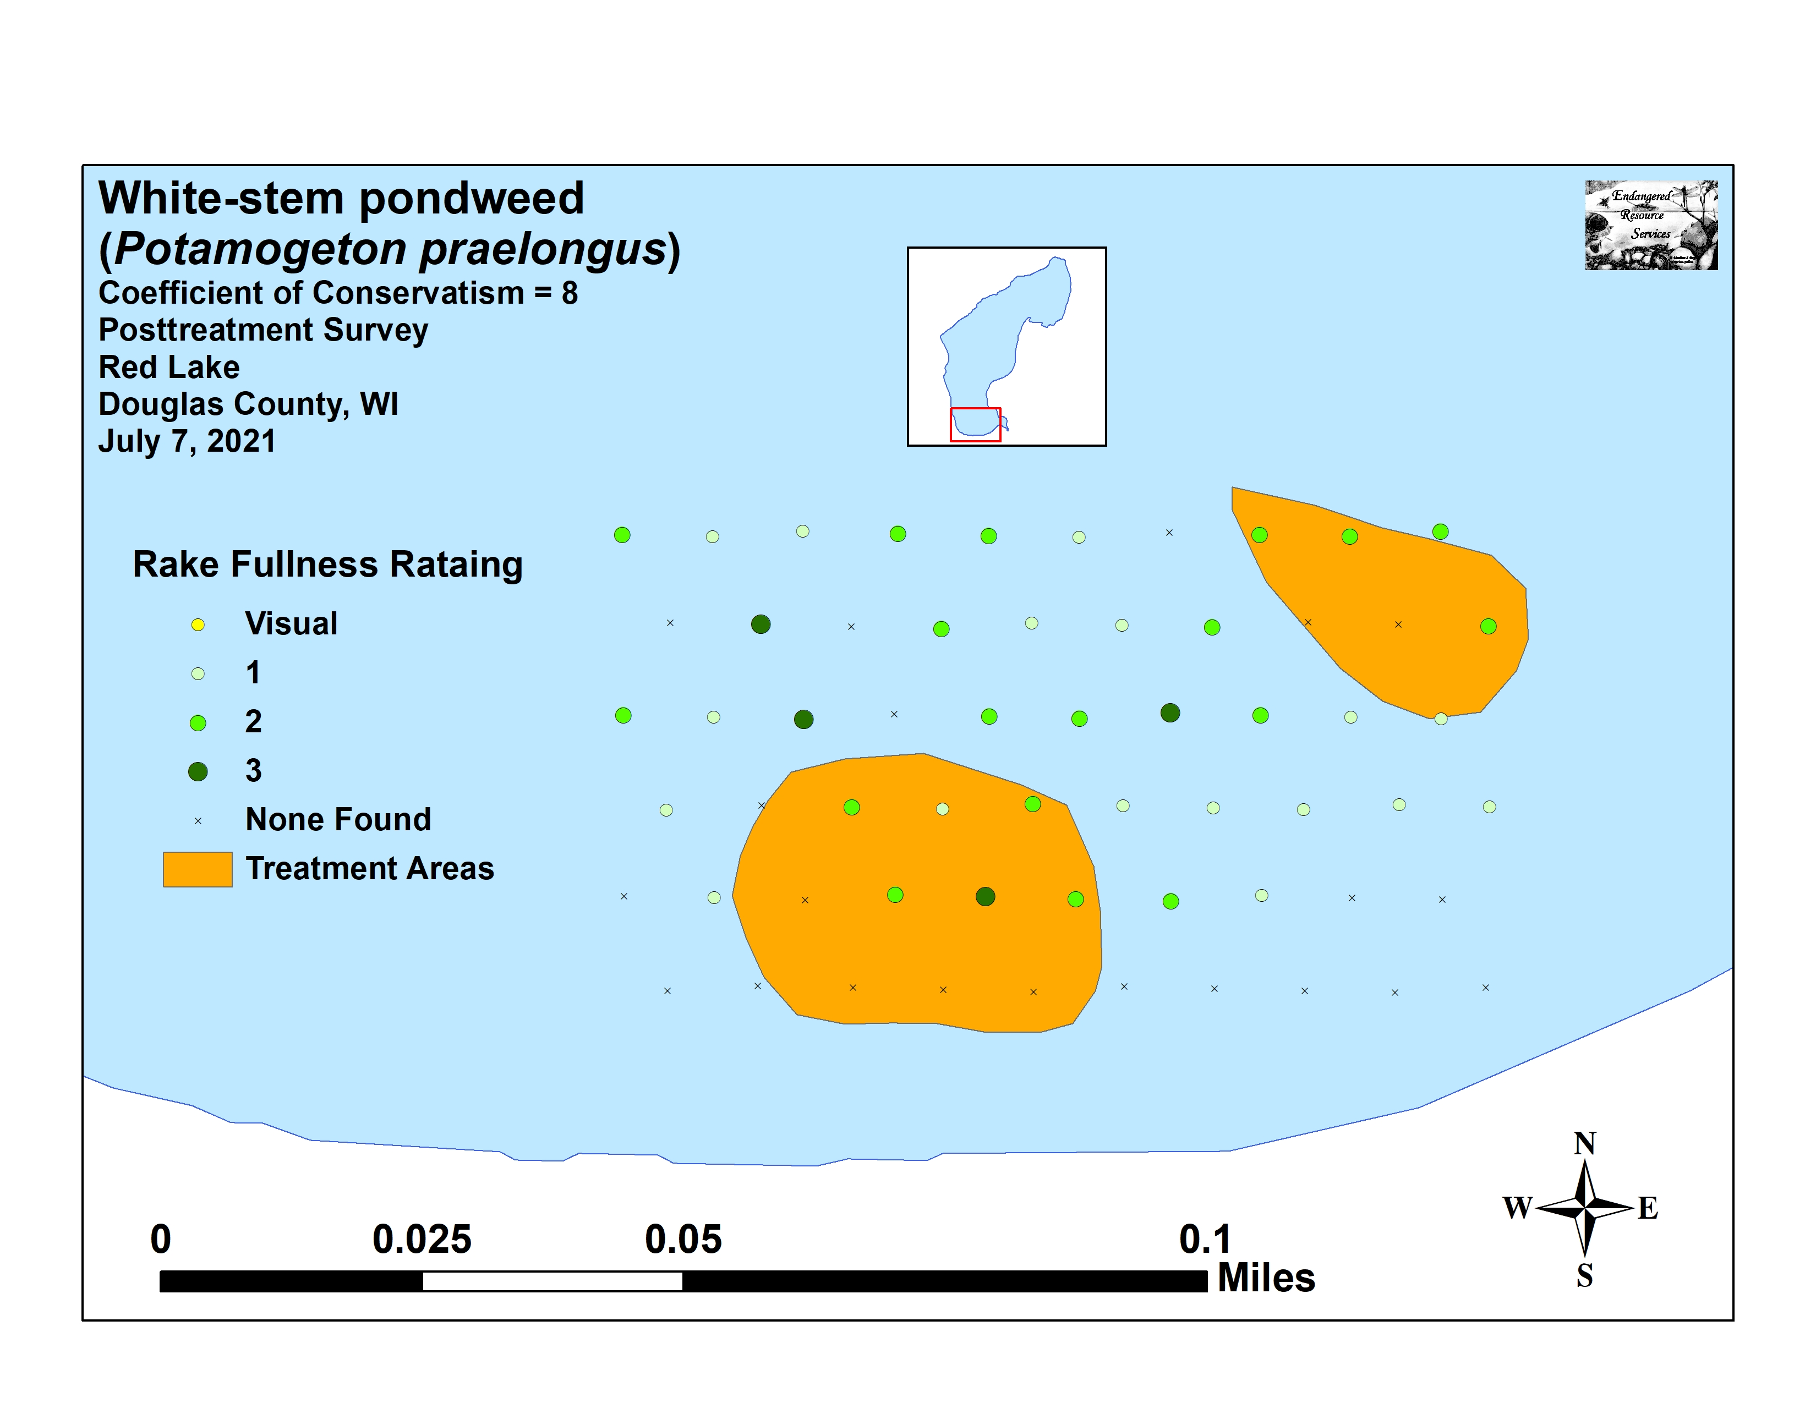
Figure 12: Pre/Posttreatment White-stem Pondweed
Density and Distribution

Common waterweed (Elodea canadensis) was the fourth most widely distributed species in both surveys (14 sites pretreatment/22 sites posttreatment) (Figure 13). Neither the increase in distribution nor its increase in mean rake fullness from 1.14 pretreatment to 1.36 posttreatment were significant (p=0.11/p=0.07).

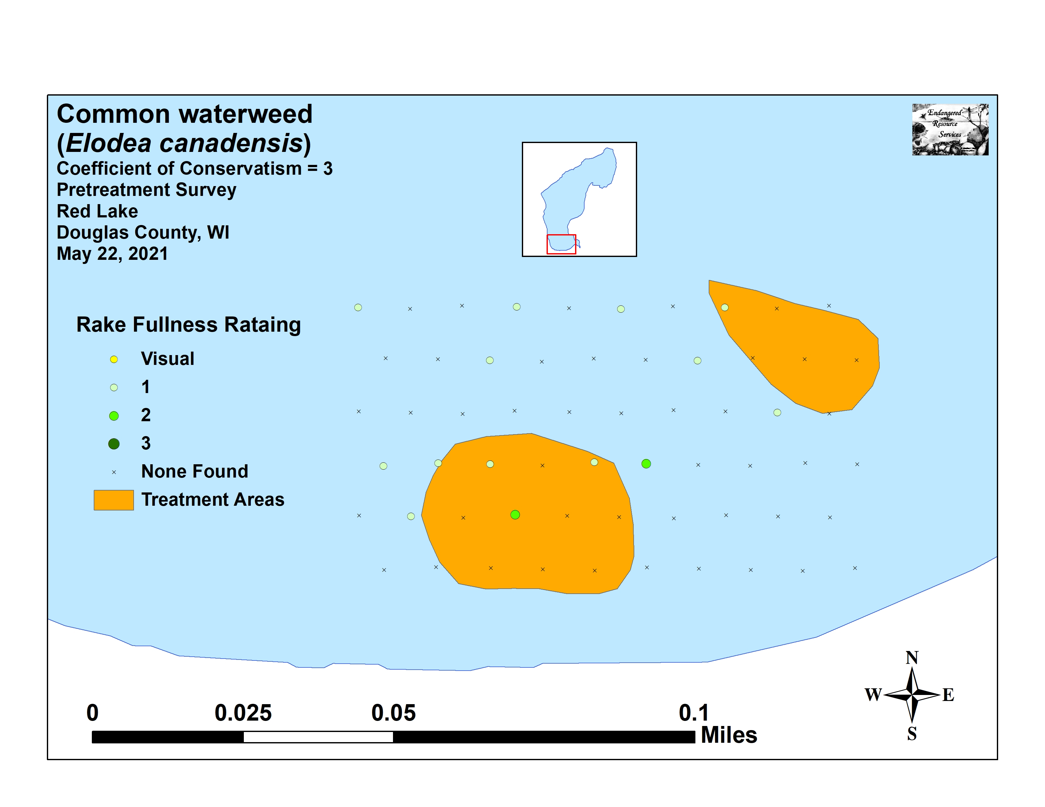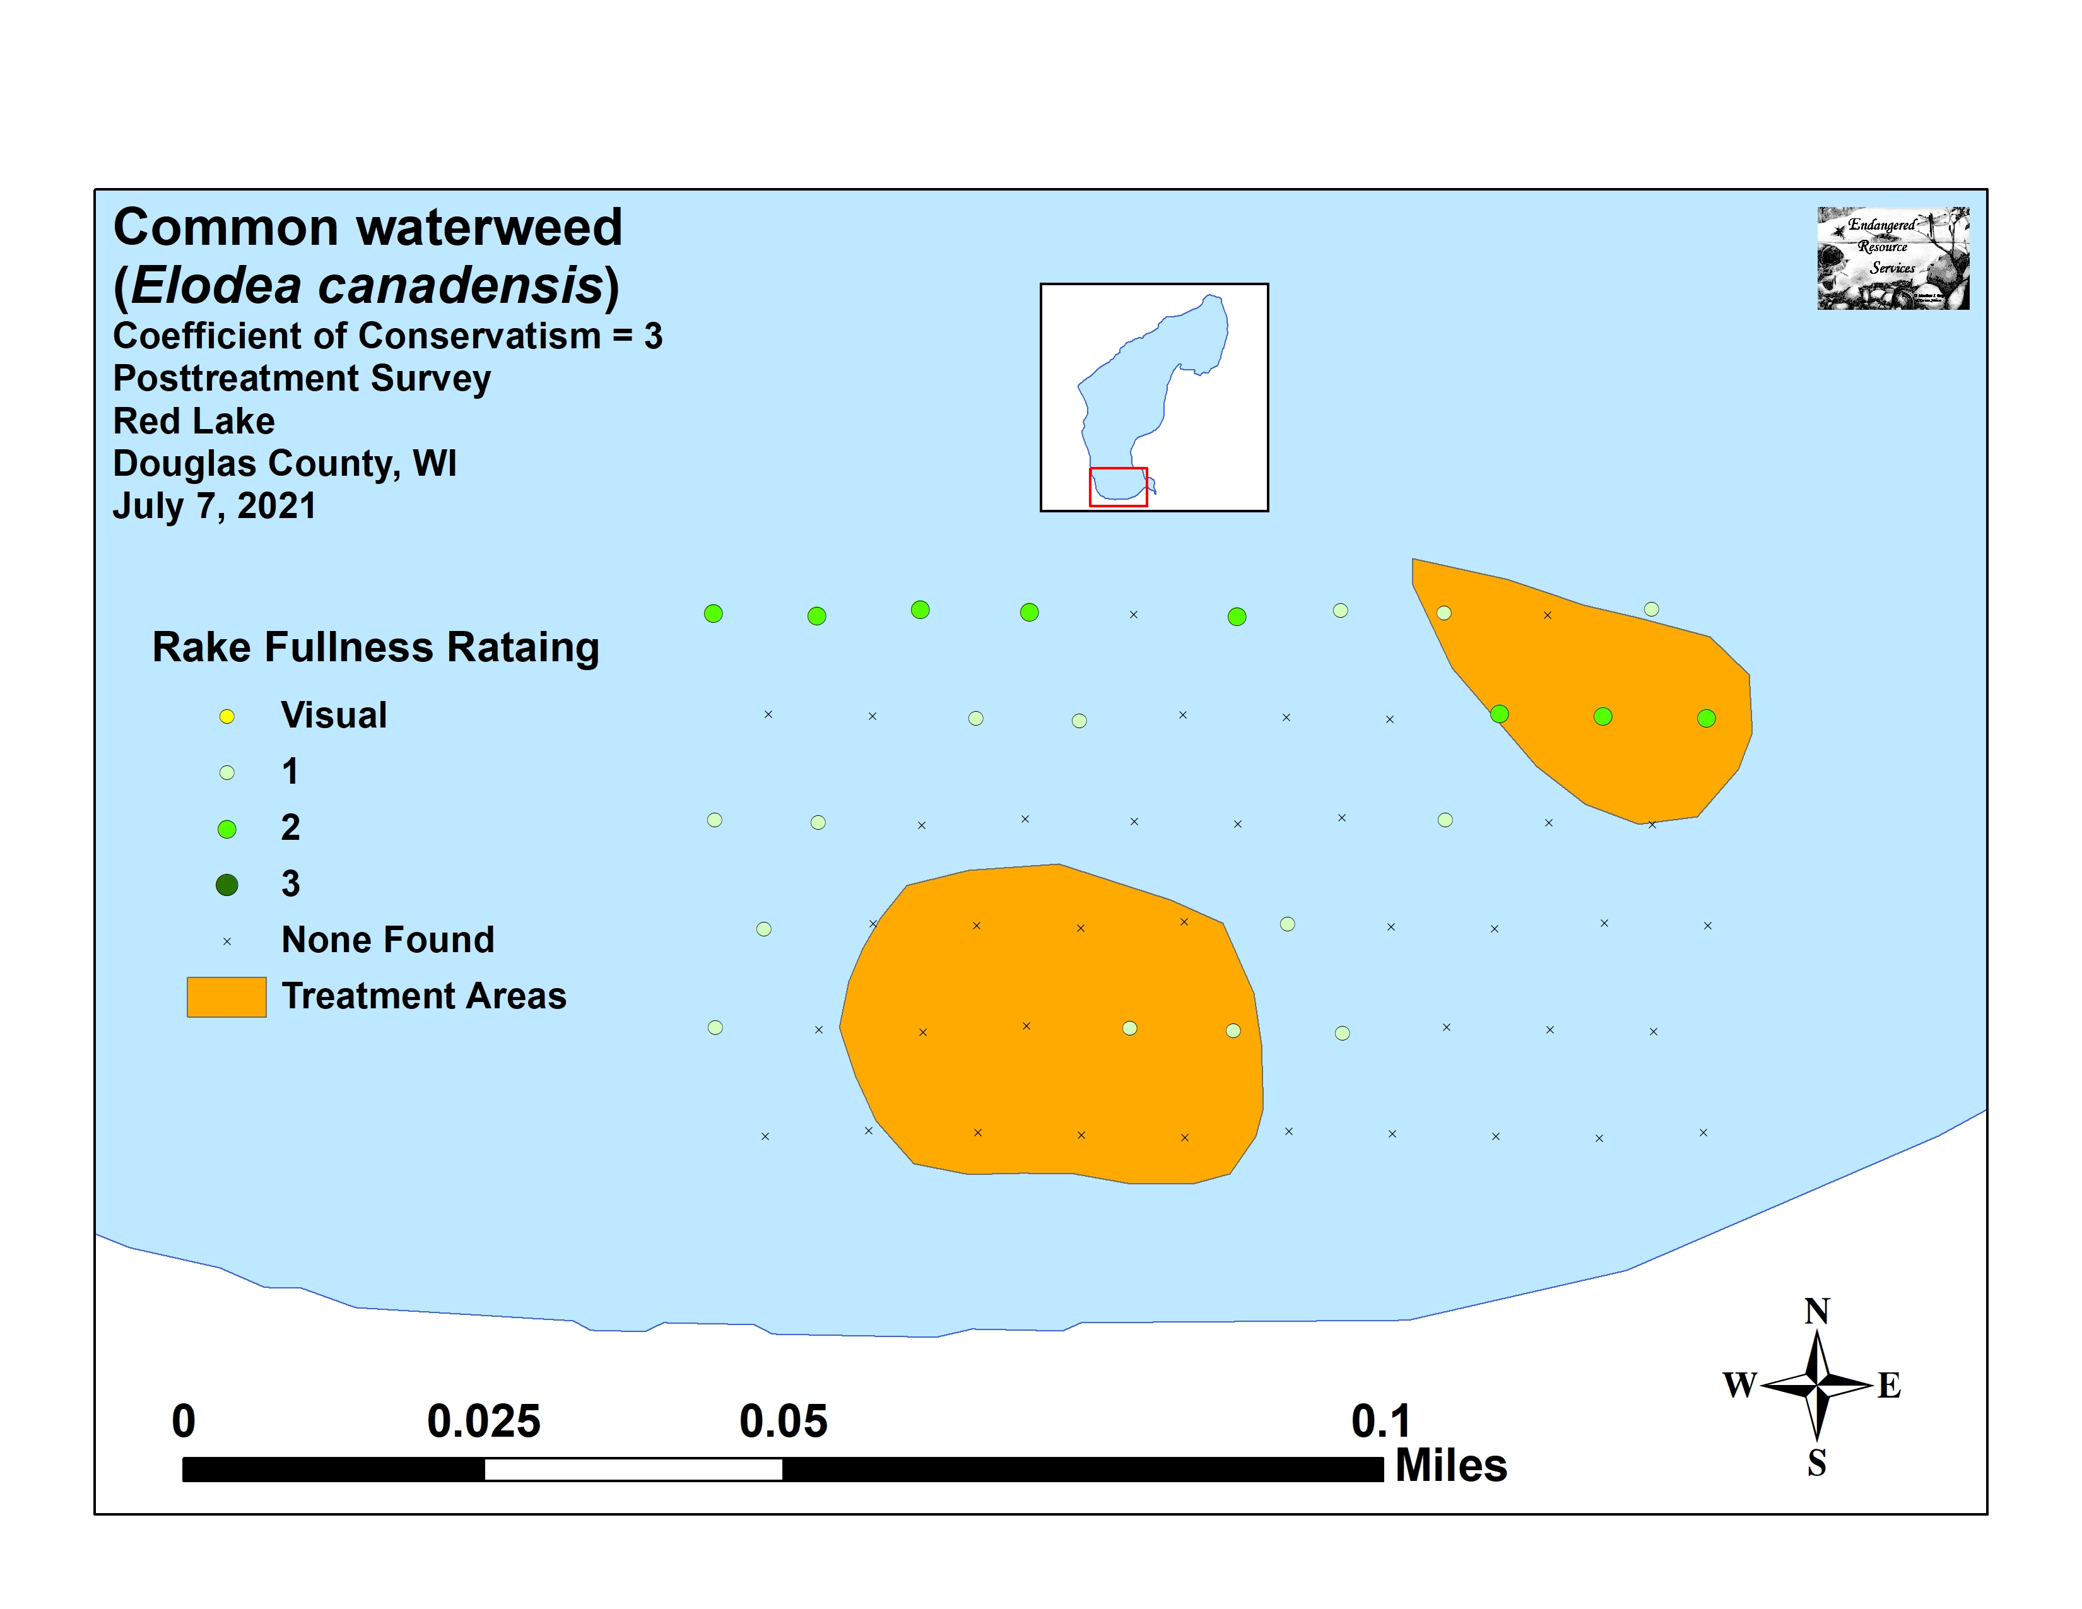
Figure 13: Pre/Posttreatment Common Waterweed
Density and Distribution

No species showed significant declines in distribution posttreatment. However, in addition to White-stem pondweed, Slender naiad (Najas flexilis) and Wild celery (Vallisneria americana) demonstrated moderately significant increases in distribution (Figure 14) (Maps for all native species from the pre and posttreatment surveys can be found in Appendixes VI and VII).

+**
+**
+*
Significant differences = * p<0.05, ** p<0.01, *** p<0.001

Figure 14: Pre/Posttreatment Macrophyte Changes

September EWM Rake Removal and Bed Mapping Survey:
On September 5th, we surveyed transects covering 22.8km (14.2 miles) spending extra time in the 2021 treatment areas, looking at all areas that previously supported EWM beds, and searching in the northeast bay were fragments from elsewhere would likely be blown by the prevailing winds (Figure 15). We had mostly sunny skies and calm winds which allowed us to see down 5-6ft into the water column – slightly less than in the past due to “milky” water coloration. We did NOT find any evidence of Eurasian water-milfoil within or around the 2021 treatment areas, and raking at the core of these former beds didn’t produce any surviving plants either. Somewhat surprisingly, test raking along the western shoreline where we had mapped a small bed in 2020 also failed to produce any EWM.

Figure 15: September 2021 Littoral Zone EWM Survey Transects

All Eurasian water-milfoil found during the fall survey occurred along the north shoreline. We located three plants near the area formerly occupied by Bed 6, one plant between the docks at the Red Lake Resort, and a small bed covering 0.01 acre in Bed 11 that also had three satellite plants (Figure 16) (Appendix VIII). We rake removed all the individual plants and many plants from the bed. Unfortunately, most of them were in deep water and they were actively fragmenting. Because of this, it’s likely additional plants will be found in this area in the spring of 2022. Although the presence of this bed might seem disappointing, its small size represented a decline of 0.62 acres (-98.4%) from the 0.63 acre mapped in 2020, and a further decline from the 1.93 acres mapped in 2019 (estimation based on treatment areas) (Table 5).

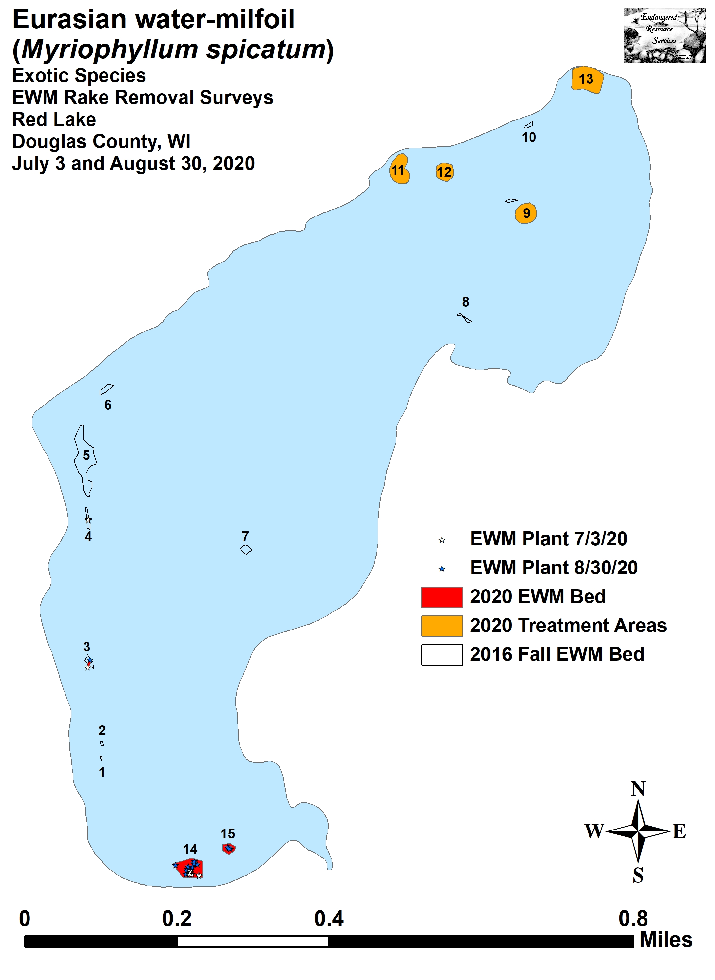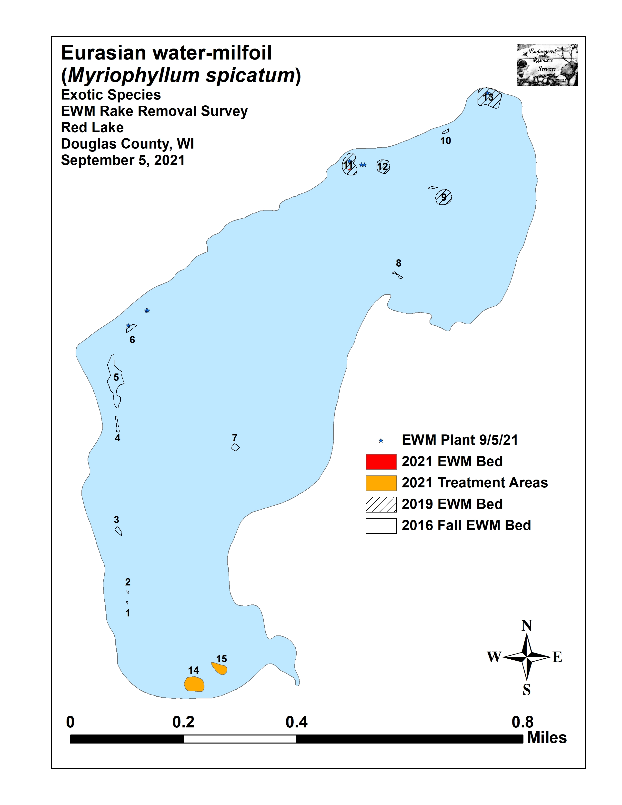
Figure 16: 2020 August and 2021 September EWM Bed Maps

Table 5: Eurasian Water-milfoil Bed Summary
Red Lake, Douglas County
September 5, 2021

Bed Number | 2021 Area in Acres | 2020 Area in Acres | 2019** Area in Acres | 2018  Area in Acres | 2017  Area in Acres | 2016  Area in Acres | Change in Acreage | Rake Range and Mean  Rake Fullness | Field Notes
1 | 0 | 0 | 0 | 0 | 0 | <0.01 | 0 | 0 | No EWM seen.
2 | 0 | 0 | 0 | 0 | 0 | <0.01 | 0 | 0 | No EWM seen.
3 | 0 | 0.03 | 0 | 0 | 0 | 0.06 | -0.03 | 0 | No EWM seen.
4 | 0 | <0.01 | 0 | 0 | 0 | 0.06 | -<0.01 | 0 | No EWM seen.
5 | 0 | 0 | 0 | 0.01 | 0.09 | 0.83 | 0 | 0 | No EWM seen.
6 | 0 | 0 | 0 | 0 | 0 | 0.07 | 0 | <<<1-1; <<<1 | 3 plants raked out.
7 | 0 | 0 | 0 | 0.04 | 0 | 0.07 | 0 | 0 | No EWM seen.
8 | 0 | 0 | 0 | 0 | 0 | 0.03 | 0 | 0 | No EWM seen.
9 | 0 | 0 | 0.39 | 0 | 0 | 0.03 | 0 | 0 | No EWM seen.
10 | 0 | 0 | 0 | 0 | 0 | 0.03 | 0 | 0 | No EWM seen.
11 | 0.01 | 0 | 0.49 | 0 | 0 | 0 | 0 | 1-3; 3 | Scattered clusters.
12 | 0 | 0 | 0.29 | 0 | 0 | 0 | 0.01 | 0 | No EWM seen.
13 | 0 | 0 | 0.76 | 0 | 0 | 0 | 0 | <<<1-1; <<<1 | 1 plant raked out.
14 | 0 | 0.49 | 0 | 0 | 0 | 0 | -0.49 | 0 | No EWM seen.
15 | 0 | 0.11 | 0 | 0 | 0 | 0 | -0.11 | 0 | No EWM seen.
Total | 0.01 | 0.63 | 1.93 | 0.05 | 0.09 | 1.18 | -0.62

**We did not survey in 2019 so treatment areas were used as an estimate
Descriptions of Past and Present EWM Beds:
Beds 1-4 – Despite extensive searching in the 8-11ft bathy ring, we were unable to relocate any plants within these narrow littoral areas. Additionally, we found no EWM despite rake searching in areas of Beds 3 and 4 where we removed a small number of plants in 2020.

Beds 5, 7-10, and 12 – We found no evidence of EWM plants or fragments in any of these former beds.

Bed 6 – We found and rake removed three single-stemmed plants in 7-10ft of water in and near this former bed. Plants were not canopied and barely visible so there may be more in the area that we simply couldn’t see.

Bed 11 – Several large, canopied clusters of plants were merging into solid beds at the core of this area, and it was not possible to rake remove them all. These plants were actively fragmenting, and we also found and rake removed three additional satellite plants. Because of this, we believe it is likely there will be additional plants found in this area in 2022.

Bed 13 – We found and removed a single plant among the docks at the Red Lake Resort.

Beds 14 and 15 – We saw no evidence of EWM anywhere in the 2021 treatment areas.

CONSIDERATIONS FOR MANAGEMENT:
Future Active Management:
Eurasian water-milfoil continues to occupy only a small percentage of the lake’s surface area, but it is widely-established making eradication an unrealistic expectation. With this in mind, continuing to work to control its spread in the most cost effective manner possible, while simultaneously minimizing its impact on the lake’s aquatic ecosystem will likely continue to be important goals for the lake association moving forward.

ProcellaCor is expensive relative to other herbicide options, but it has produced impressive results in apparently eliminating EWM from areas where it has been used on Red Lake over the past two years. Because even “spot” treatment areas of <0.50 acre have resulted in complete control, it may be worth considering one or two small treatments along the north shoreline in Bed 6 and Bed 11 in 2022.

Locating Newly Established EWM:
Annual surveys by professionals to locate and, if possible, rake remove Eurasian water-milfoil may be desired in the future to quickly identify and manage newly established beds. Residents on the lake can assist with these efforts by watching the area around their docks for newly established EWM beds. Residents should know that Red Lake has a significant amount of the very similar looking Northern water-milfoil (NWM) – a valuable native plant that provides important fish habitat (Figure 17). NWM is widely distributed throughout the lake’s rooted littoral zone, but does best over sandy and organic muck often just inshore from EWM in 6-8ft of water. Despite its superficial resemblance to EWM, NWM can be told apart by its leaflets numbering <24 that are usually held rigidly at 90 degree angles off the stem when out of water. Conversely, EWM normally has >26 leaflets that fall limp against the stem when out of water. EWM also tends to have a bright red growth tip on the top of the plant whereas NWM has a bright lime green growth tip. NWM on Red Lake is often mixed with other plants, is seldom bed-forming, and rarely canopies on the surface; whereas EWM is often found in nearly monotypic beds that exclude most native species, and it frequently canopies even in deep water. In the fall, NWM also forms over wintering turions on the tips of shoots whereas EWM has none. These turions of densely packed leaflets are readily visible on most plants after September 15 (Figure 18).

If residents find a plant or bed of plants that looks suspicious, they are encouraged to promptly contact us (saintcroixdfly@gmail.com and/or 715-338-7502) with a picture, specimen, description of, and/or preferably GPS coordinates. These locations could then be added to the existing map for management consideration and help keep small beds from becoming large ones. Texting pictures from a smartphone is actually ideal as it gives immediate feedback. Likewise, we are happy to identify ANY plant a lake resident finds that they may want identified.

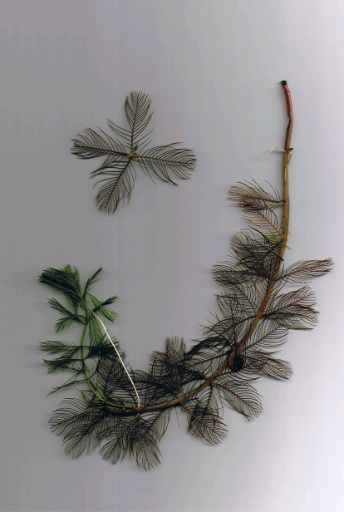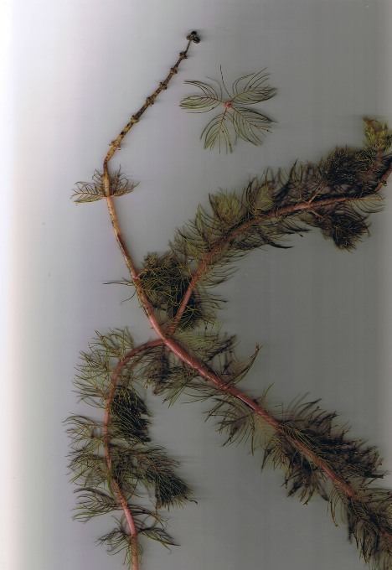
Eurasian water-milfoil
Northern water-milfoil
Figure 17: EWM and Northern Water-milfoil Identification (Berg 2007)

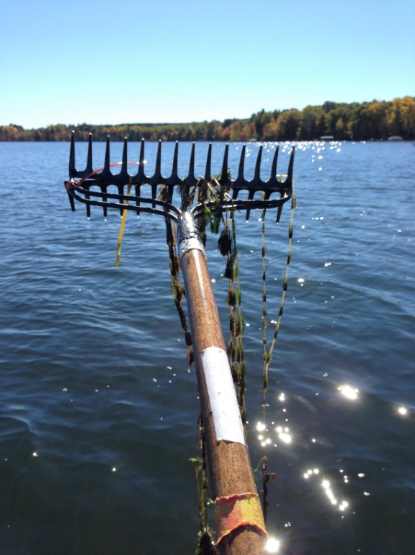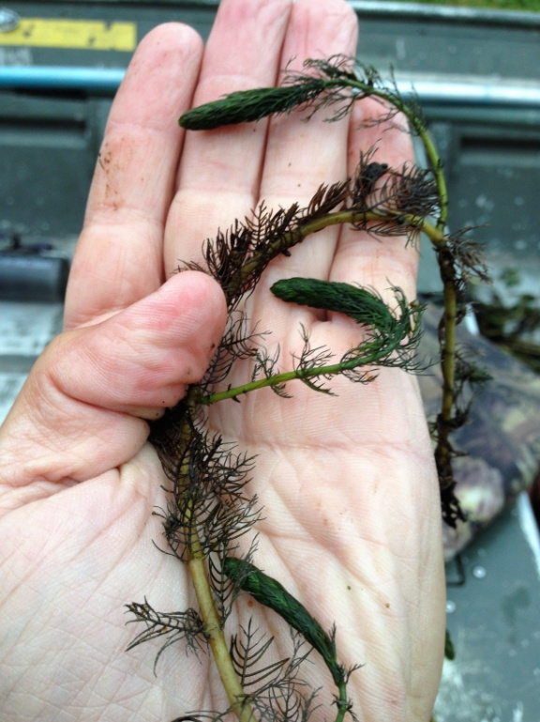
Figure 18: Limp Nature of EWM Leaflets along Stem –
Stiff Nature of NWM Leaflets along Stem and Overwintering Turions

LITERATURE CITED

Holt, C, C. Busch, K. Cable, and L. Sather. [online]. 1973. Red Lake Bathymetric Map. http://dnr.wi.gov/lakes/maps/DNR/2492100a.pdf (2021 September).

UWEX Lakes Program. [online]. 2010. Aquatic Plant Management in Wisconsin. Available from http://www.uwsp.edu/cnr-ap/UWEXLakes/Pages/ecology/aquaticplants/default.aspx (2021 June).

UWEX Lakes Program. [online]. 2010. Pre/Post Herbicide Comparison. Available from http://www.uwsp.edu/cnr-ap/UWEXLakes/Documents/ecology/Aquatic%20Plants/Appendix-D.pdf (2021 June).

WDNR. [online]. 2021. Wisconsin Lake Citizen Monitoring Data for Red Lake – Douglas County. Available from http://dnr.wi.gov/lakes/waterquality/Station.aspx?id=163383 (2021 September).

WDNR. [online]. 2021. Wisconsin Lakes Information – Red Lake – Douglas County. http://dnr.wi.gov/lakes/lakepages/LakeDetail.aspx?wbic=2492100 (2021 September).

Appendix I: EWM Pre/Post Survey Sample Points and
Treatment Areas

Appendix II: Vegetative Survey Datasheet

Observers for this lake: names and hours worked by each:
Lake: |  |  |  |  |  |  |  |  | WBIC |  |  |  |  |  |  |  |  | County |  |  |  |  |  | Date:
Site # | Depth (ft) | Muck (M), Sand (S), Rock (R) | Rake pole (P) or rake rope (R) | Total Rake Fullness | EWM | EWM | 1 | 2 | 3 | 4 | 5 | 6 | 7 | 8 | 9 | 10 | 11 | 12 | 13 | 14 | 15 | 16 | 17 | 18 | 19
1
2
3
4
5
6
7
8
9
10
11
12
13
14
15
16
17
18
19
20

Appendix III: Pre/Post Habitat Variables

Appendix IV: Pre/Post Littoral Zone, Native Species Richness and
Total Rake Fullness

Appendix V: EWM Pre/Posttreatment Density and Distribution

Appendix VI: Pretreatment Native Species Density and Distribution

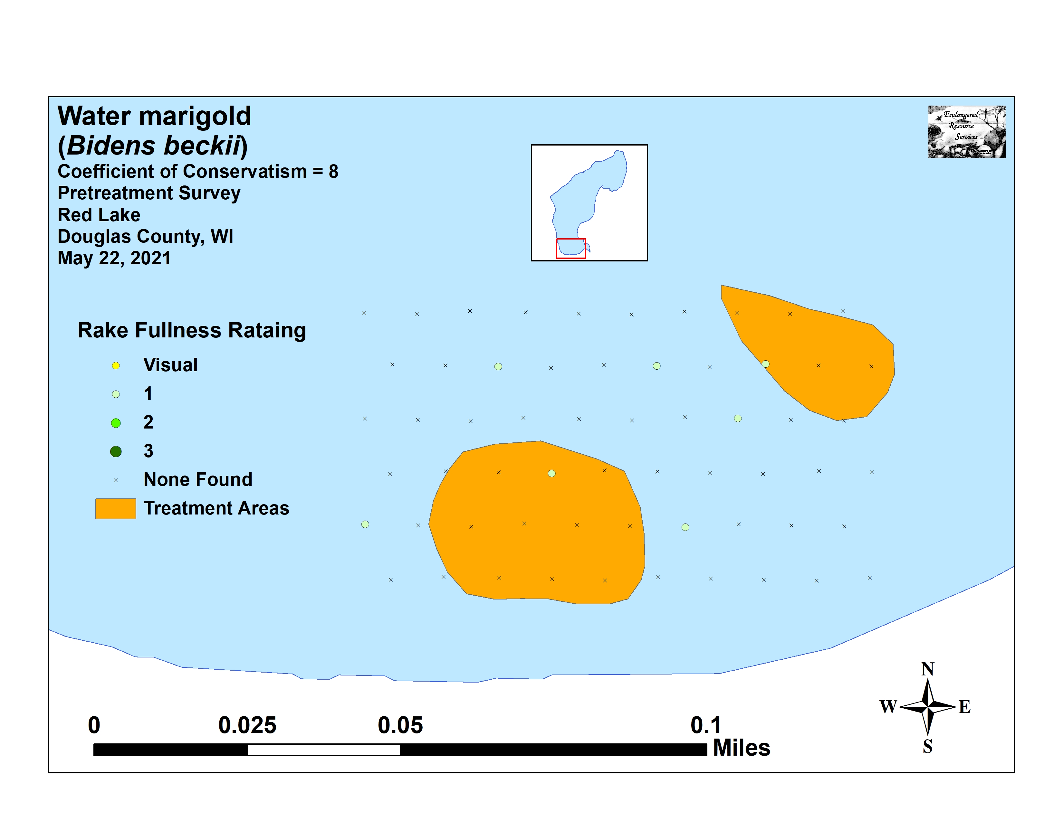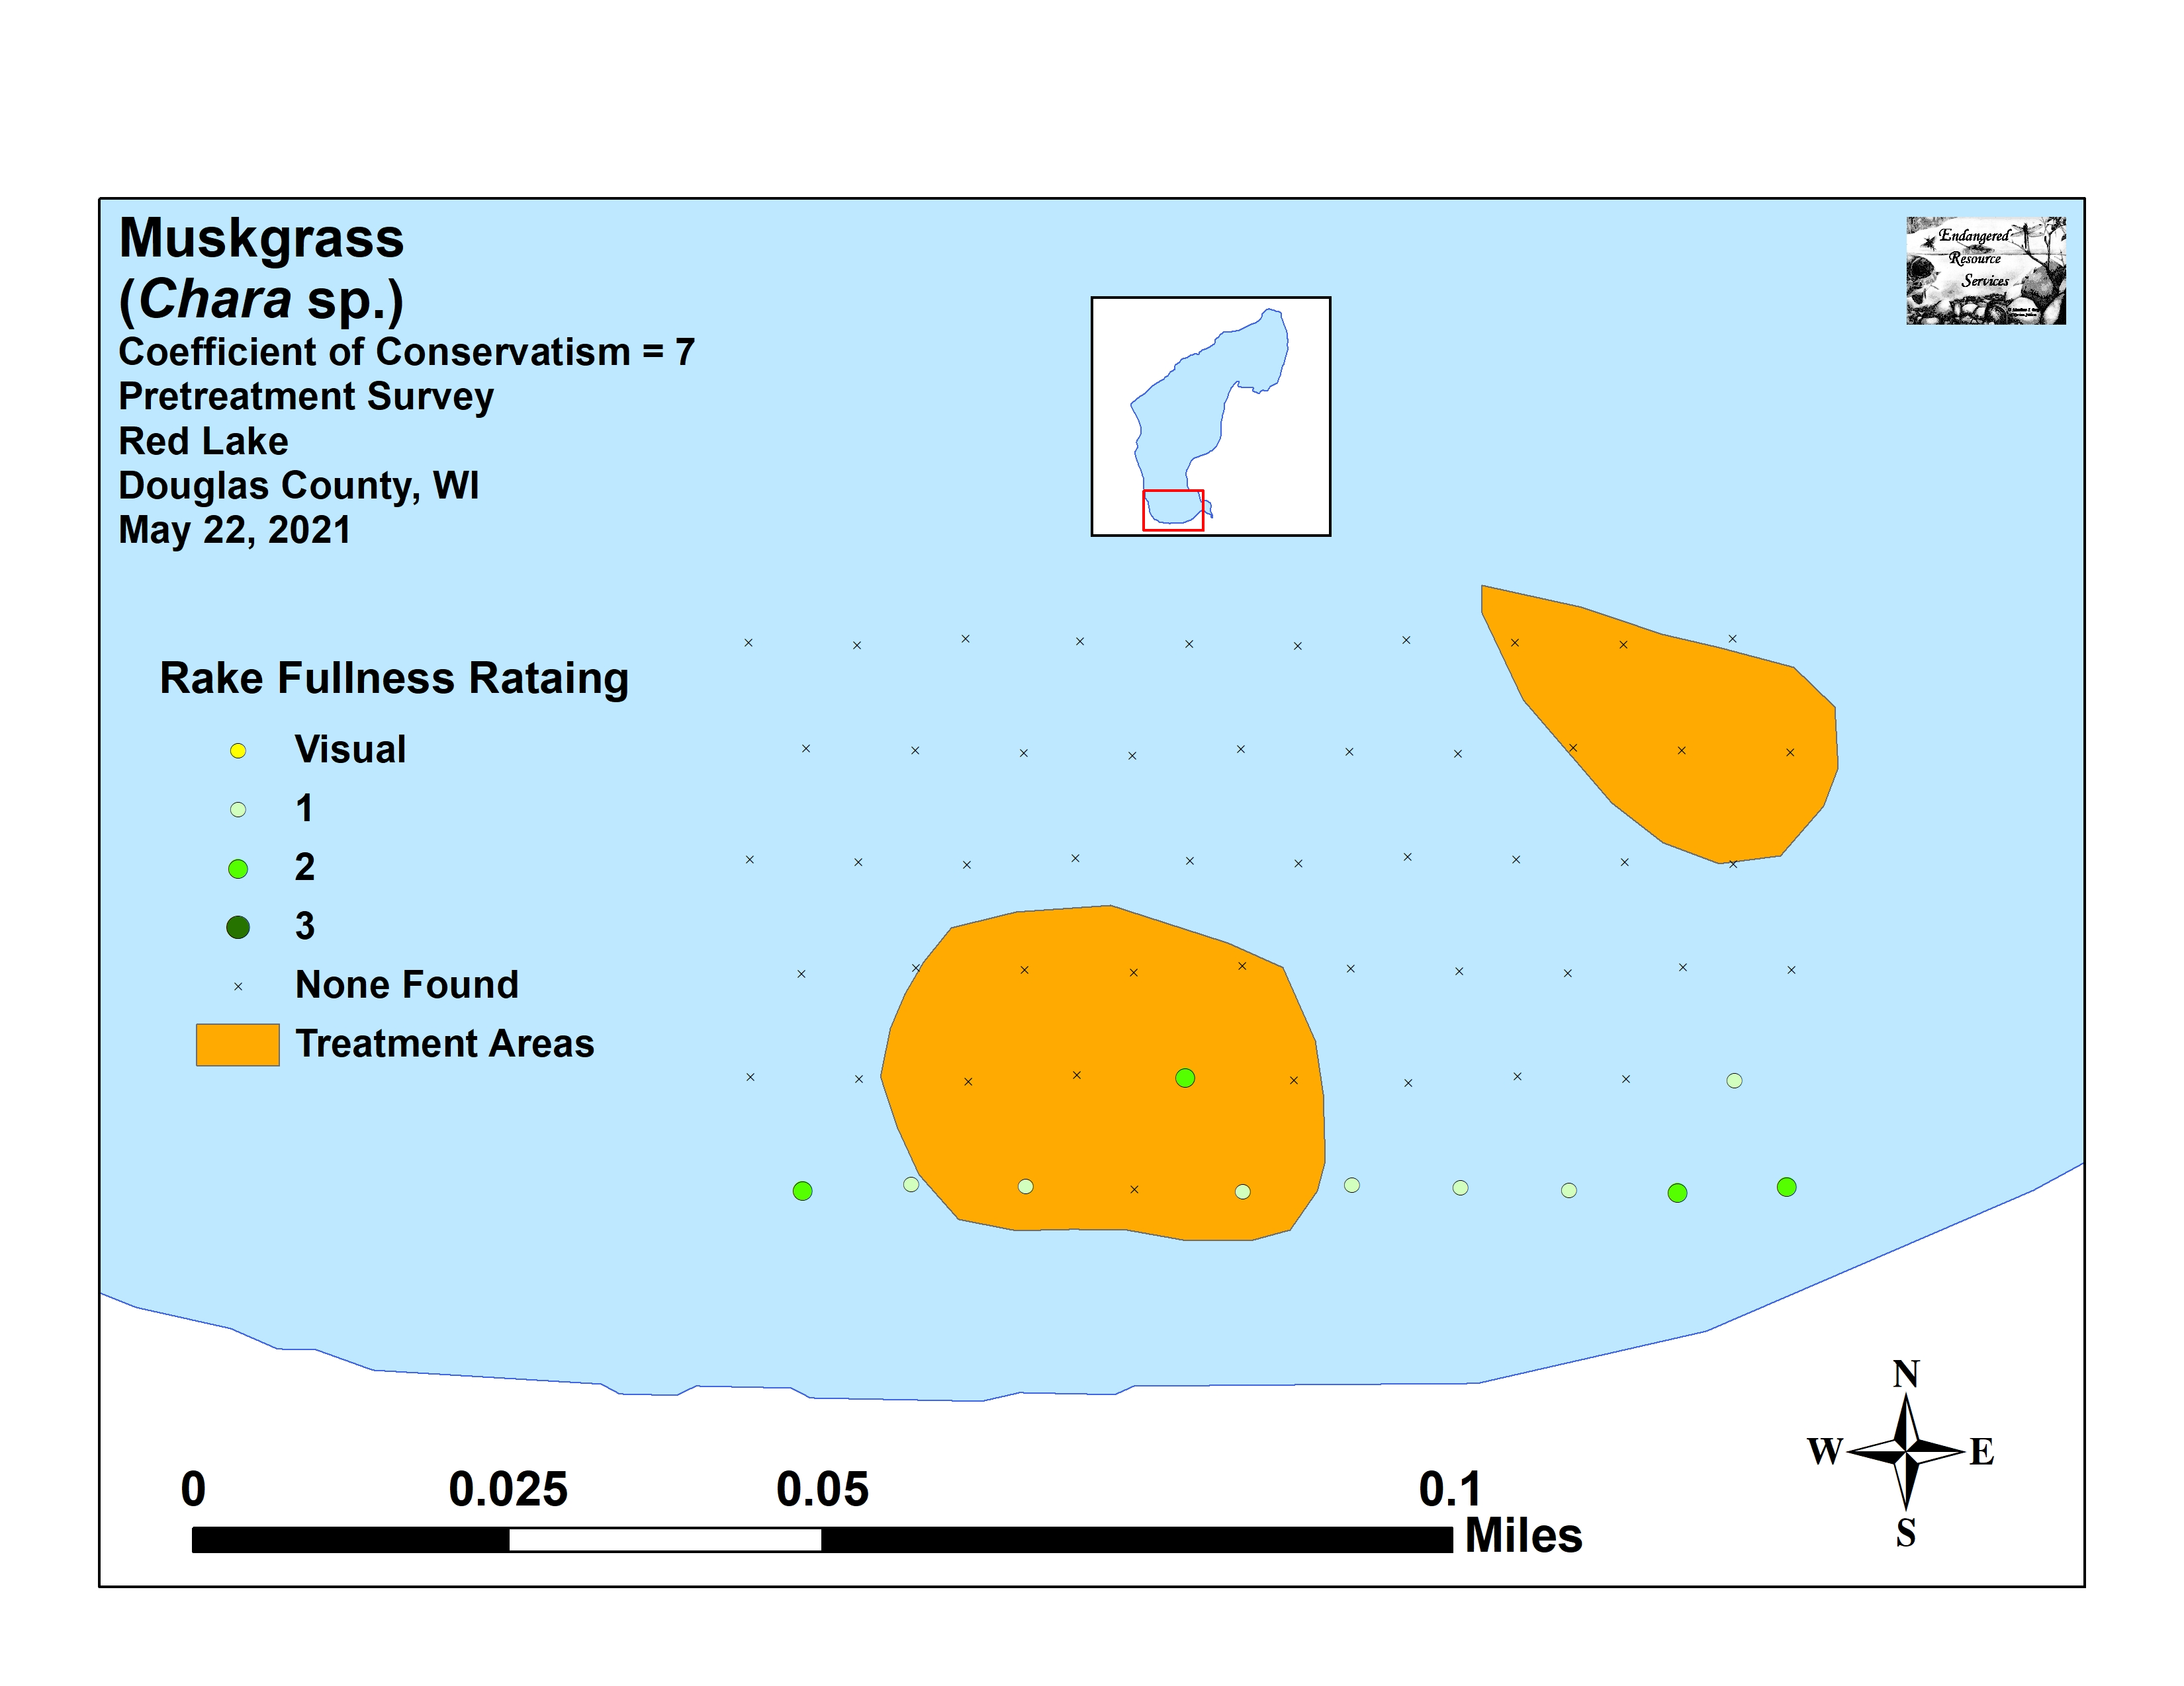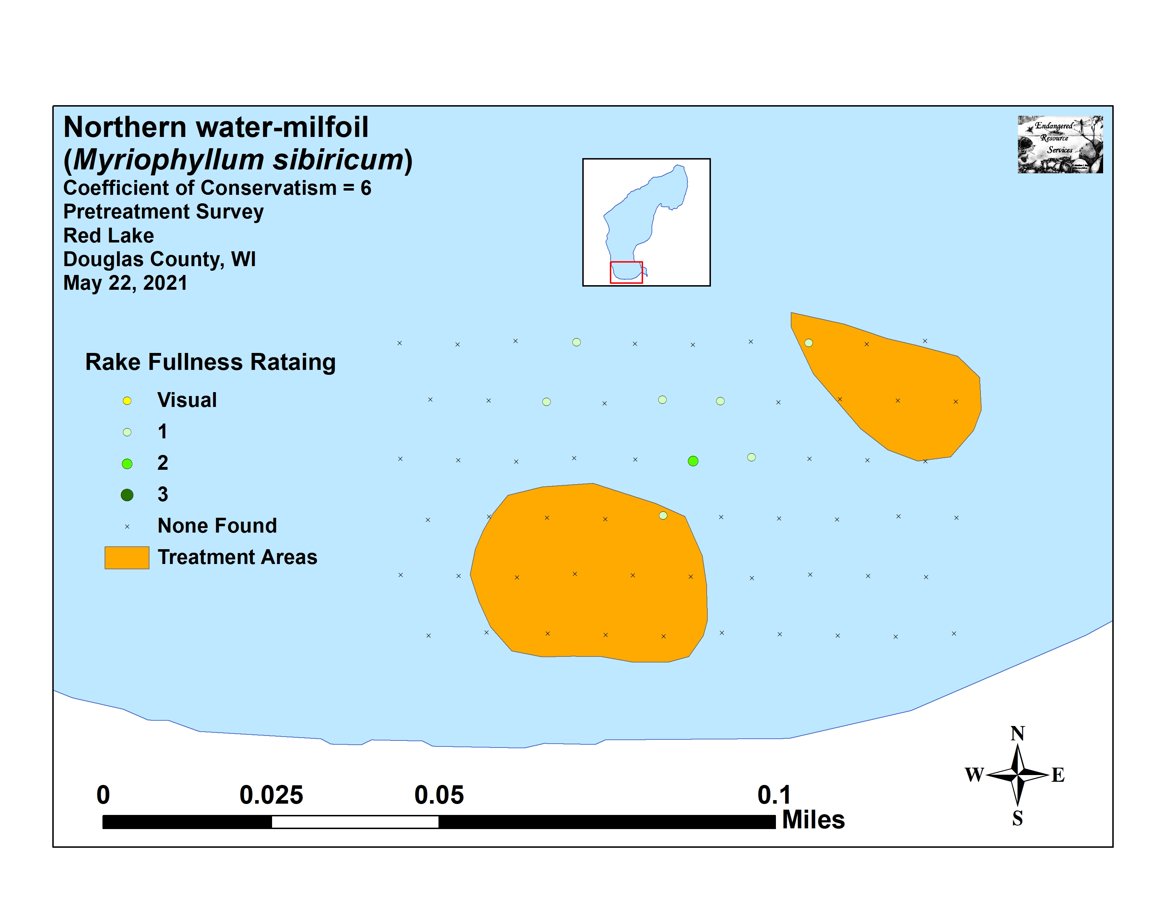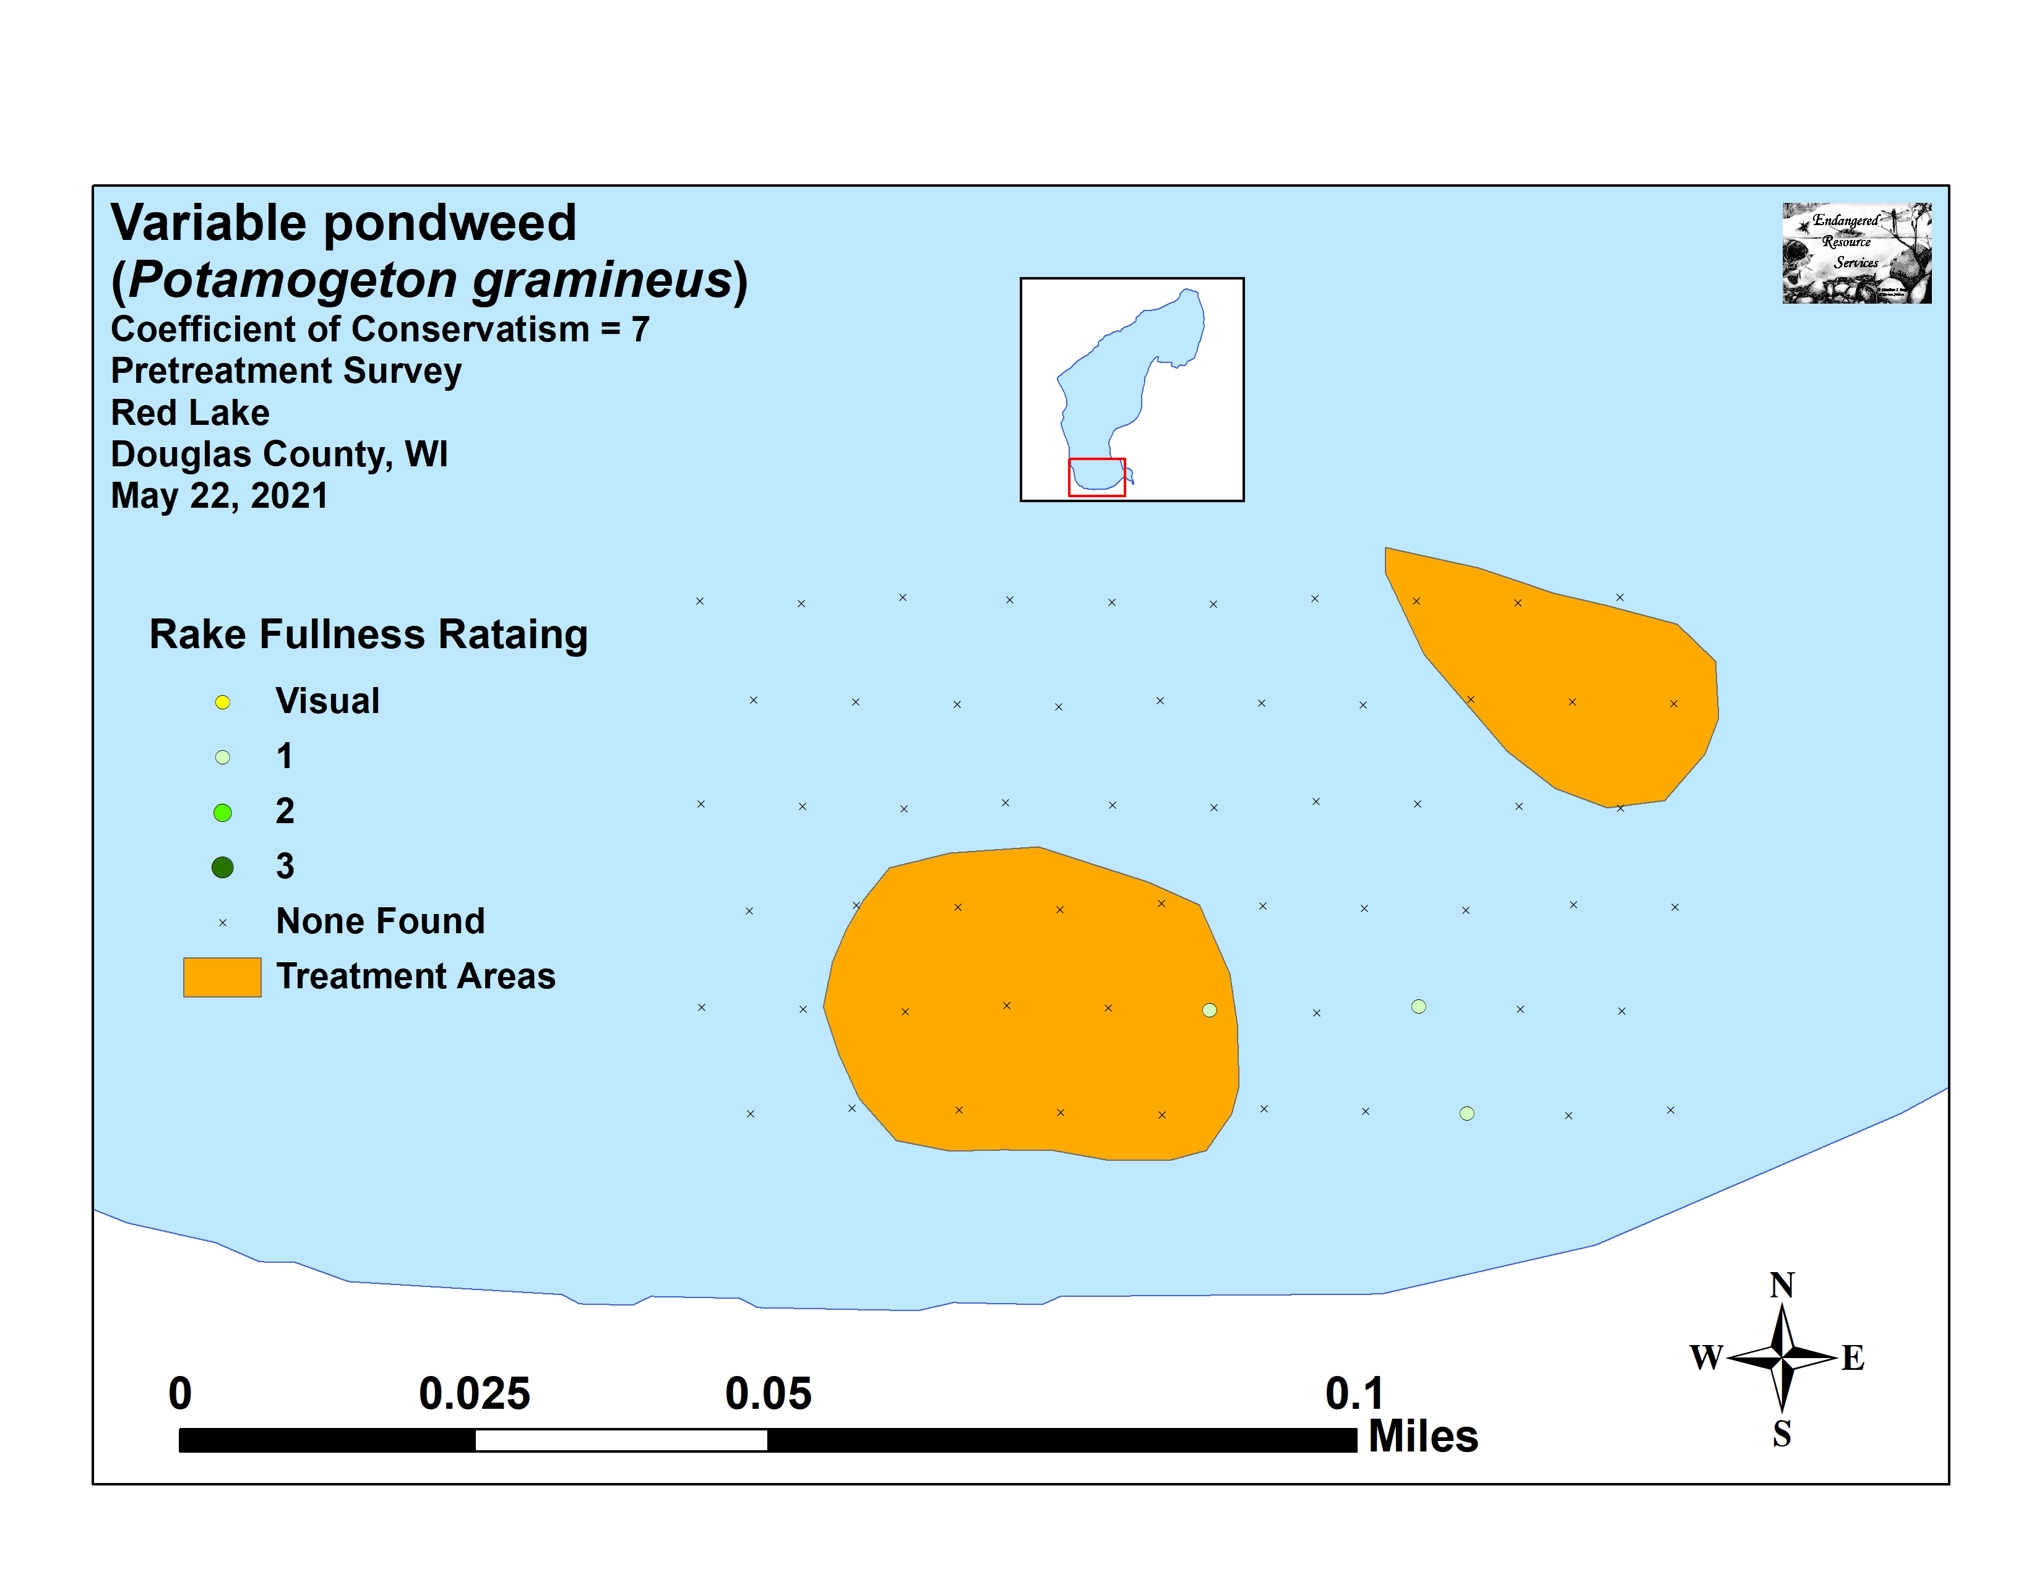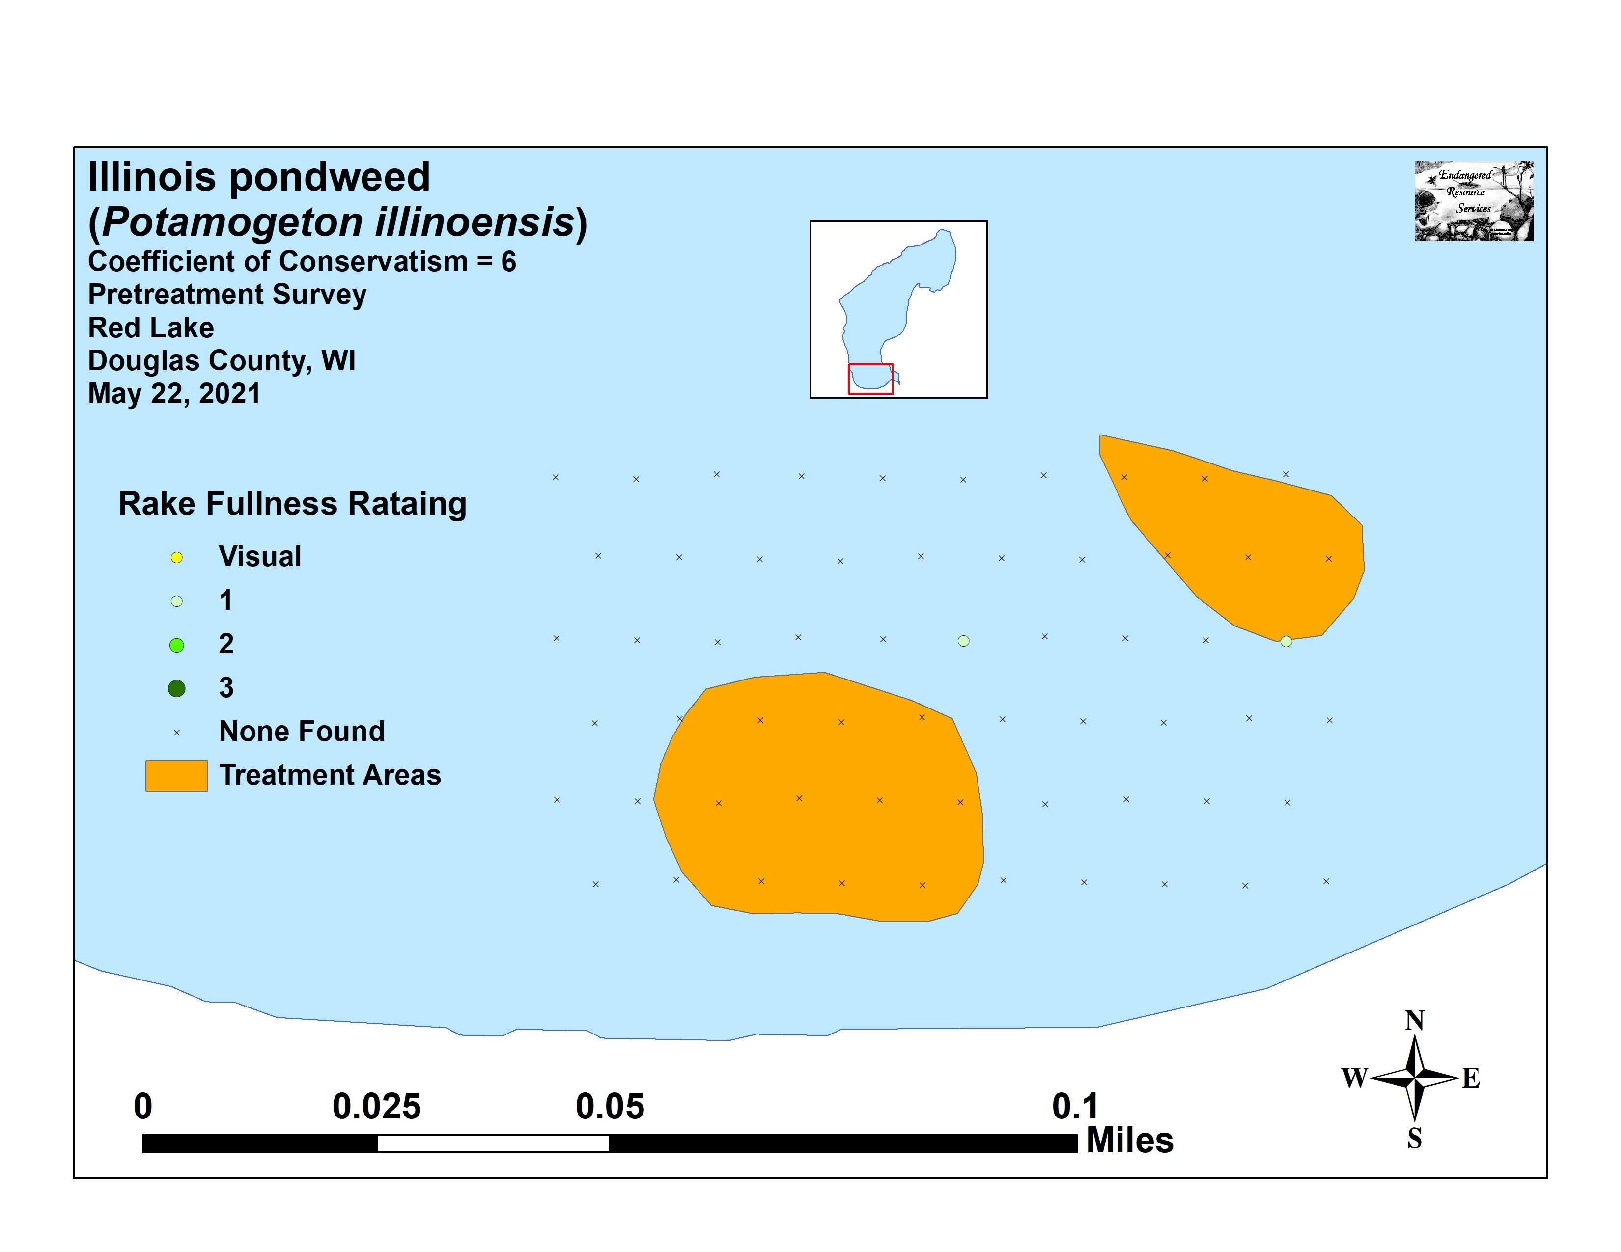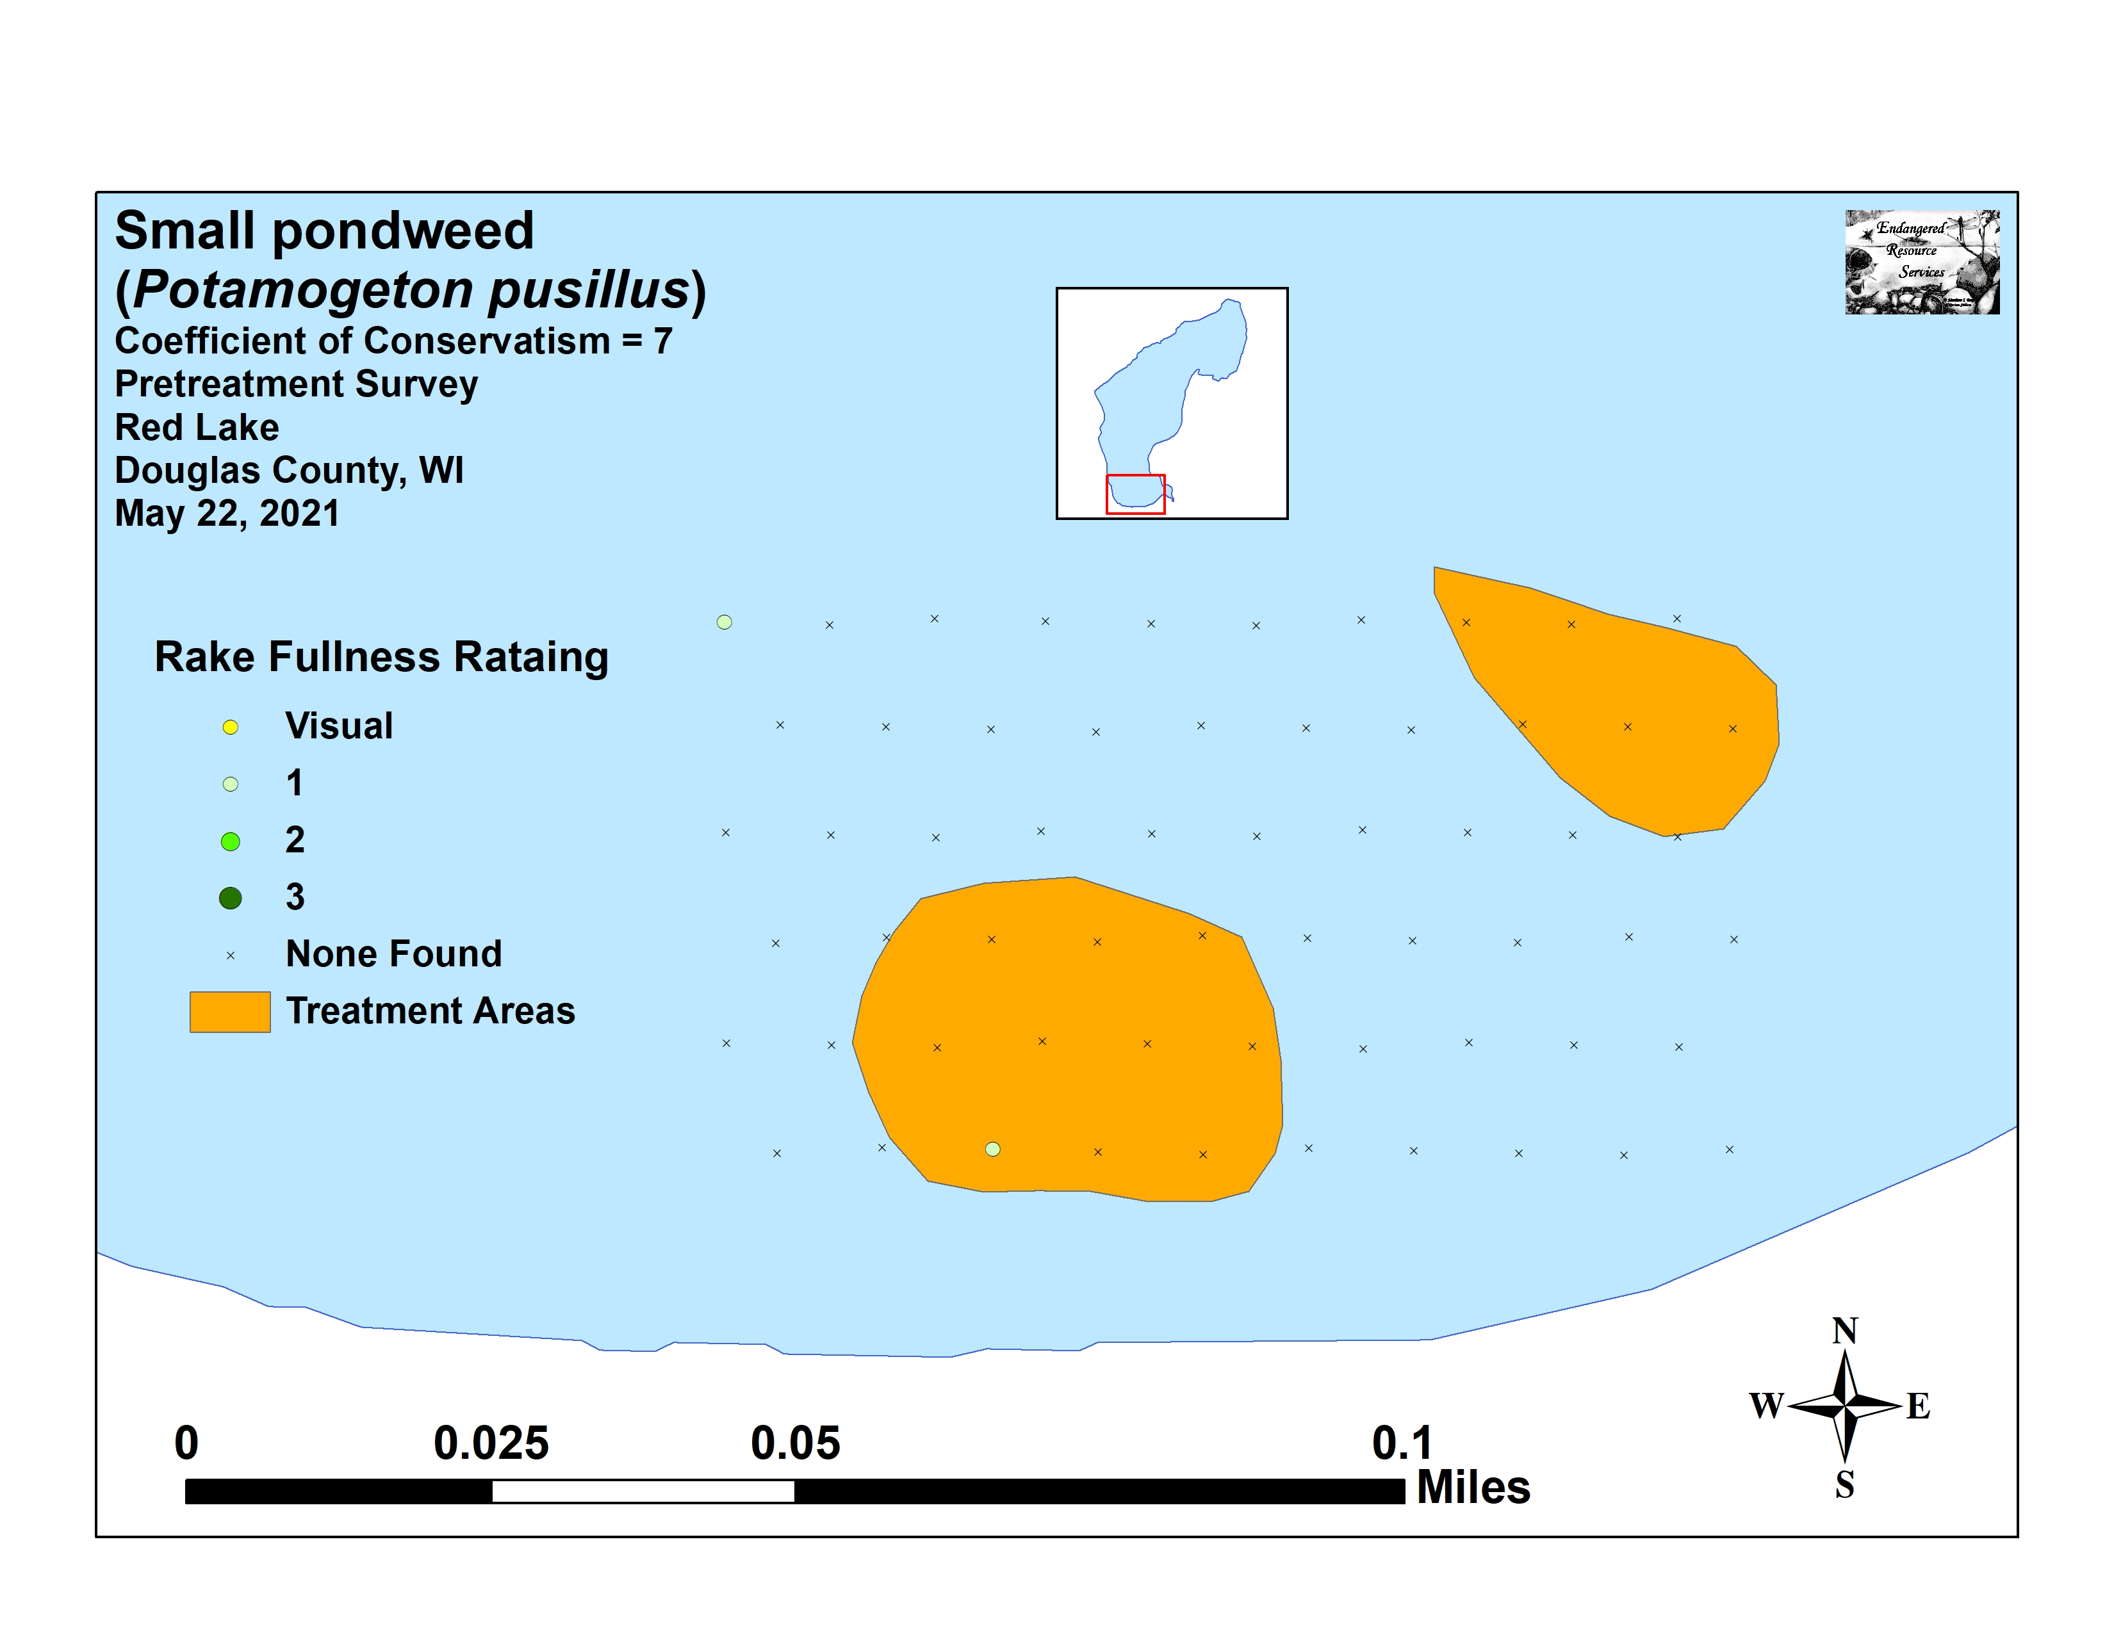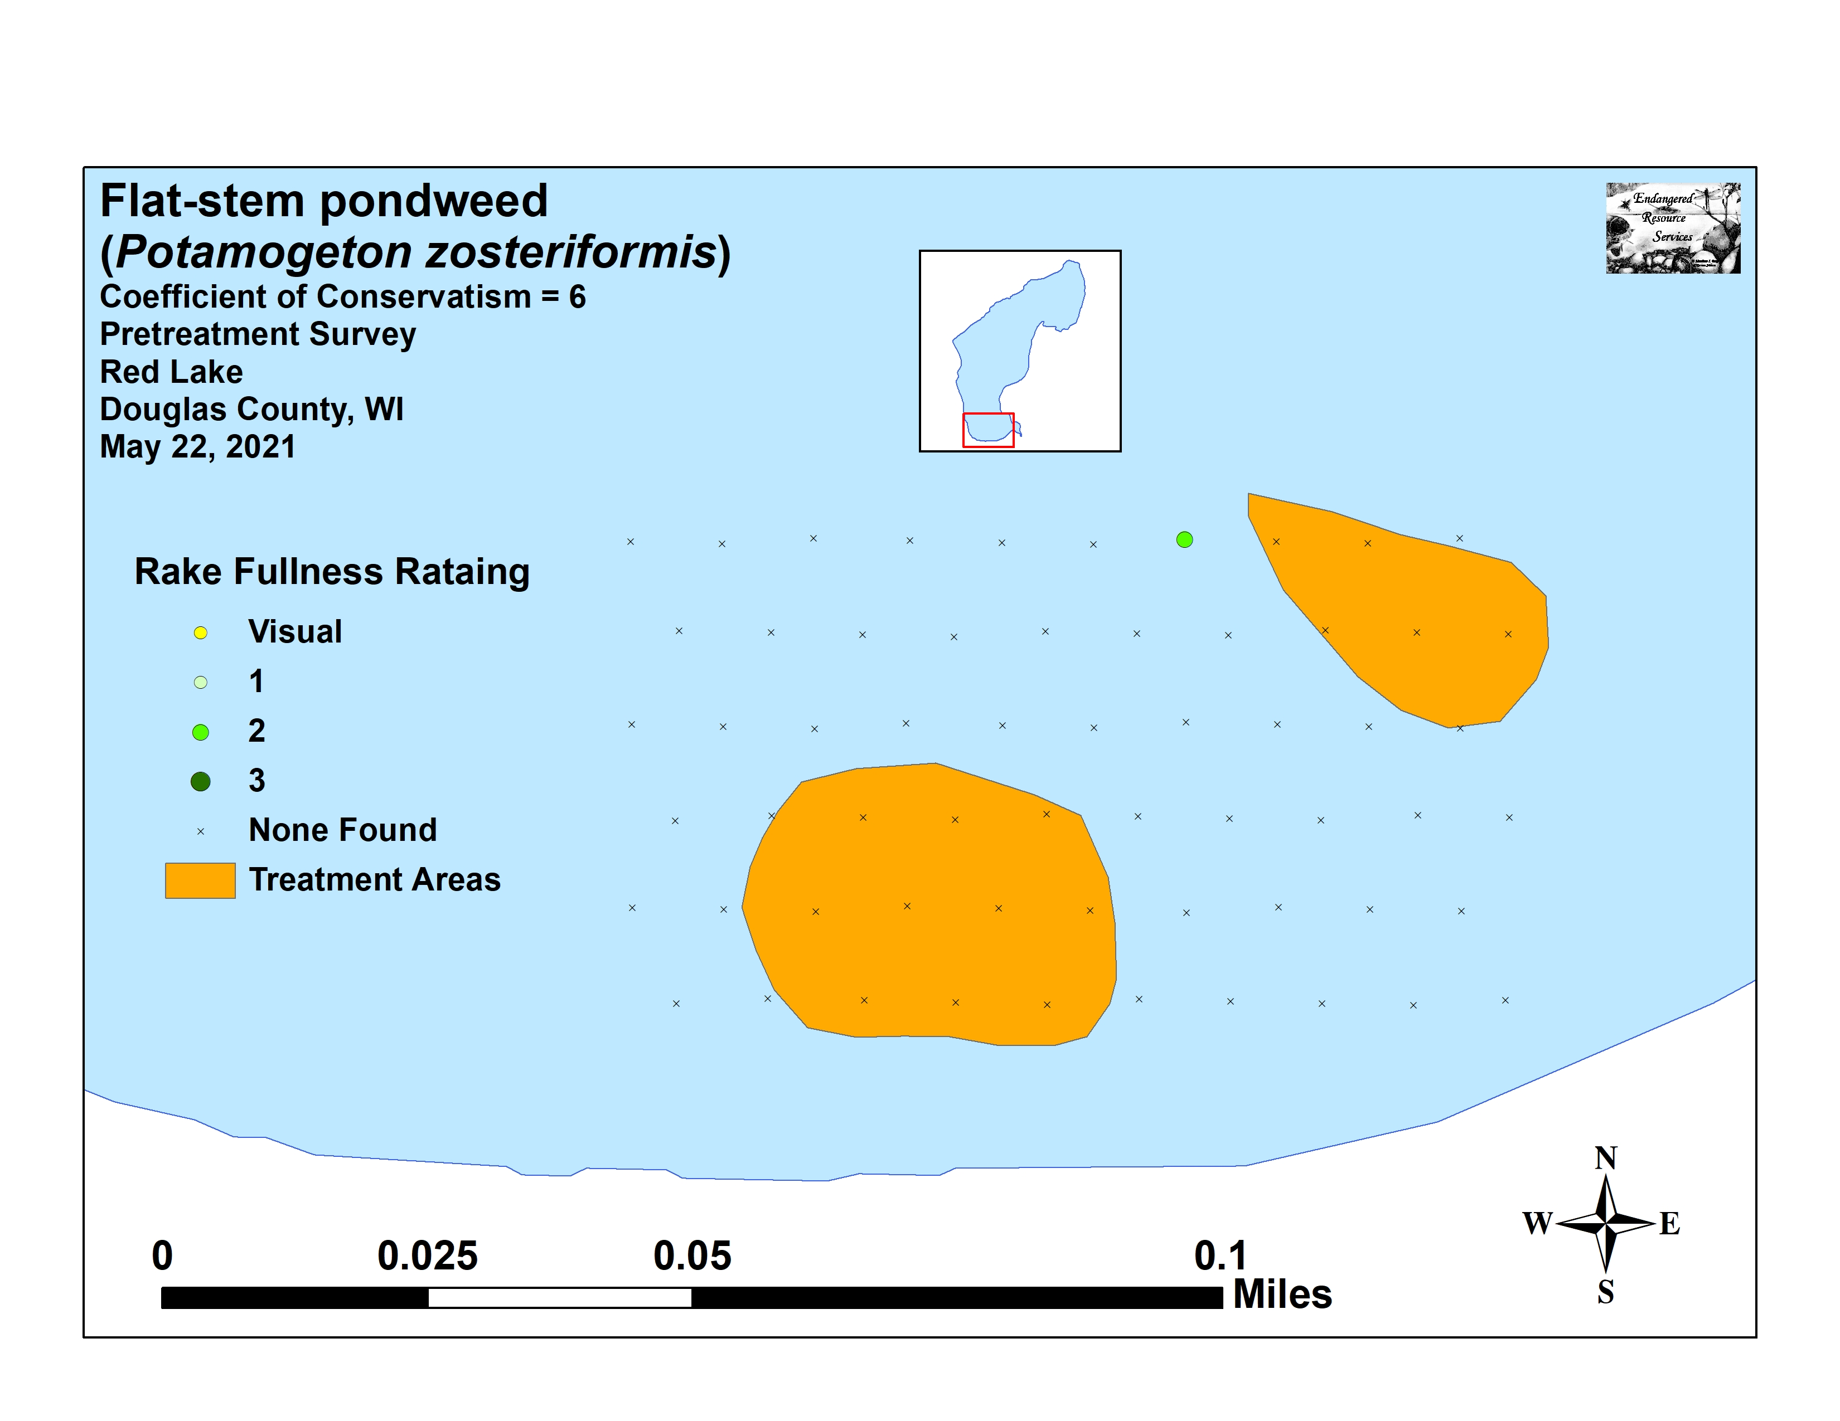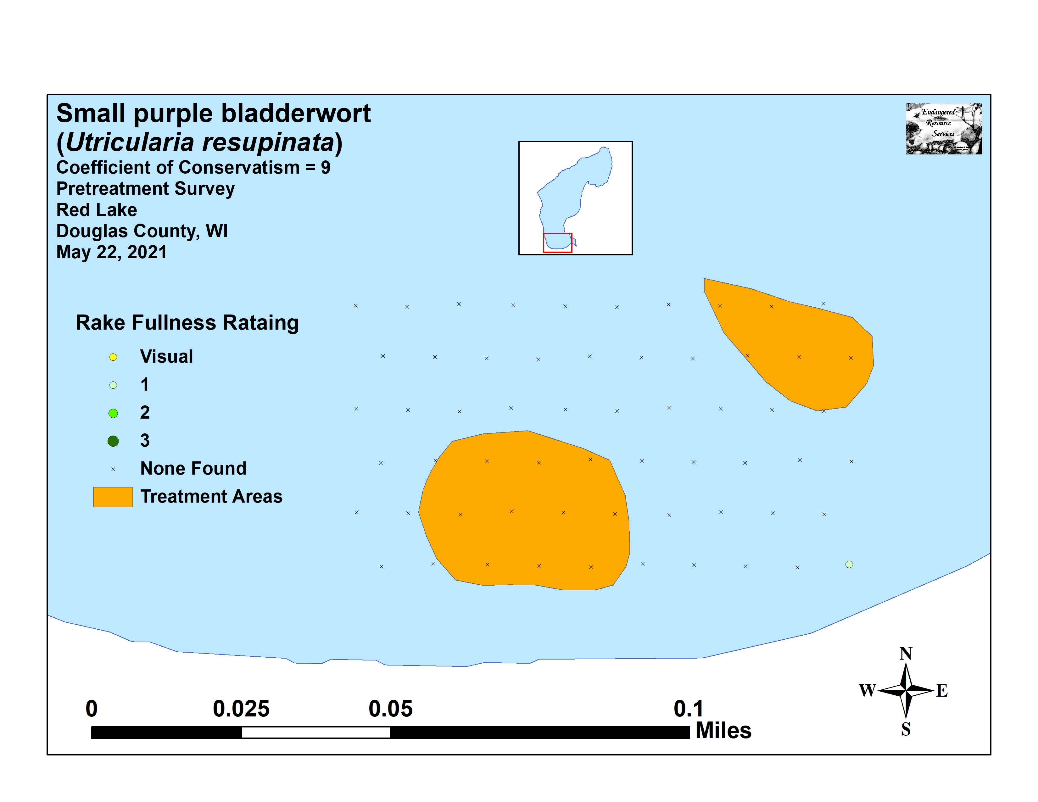

Appendix VII: Posttreatment Native Species Density and Distribution
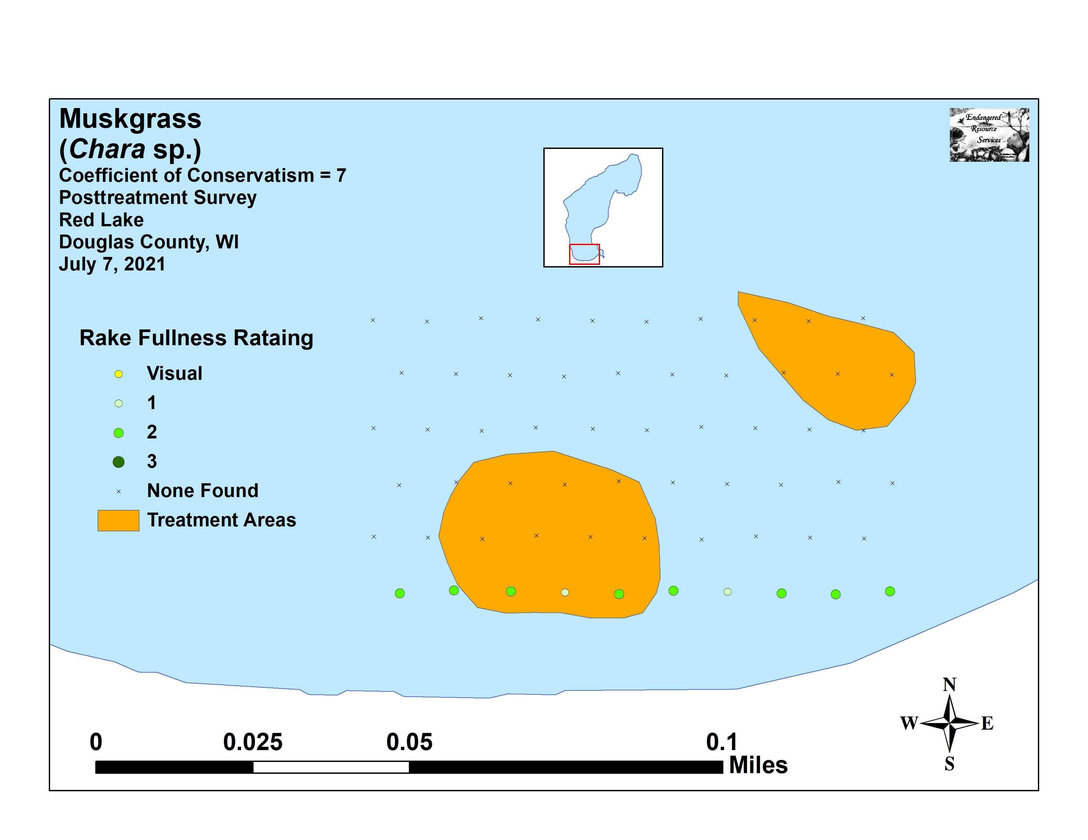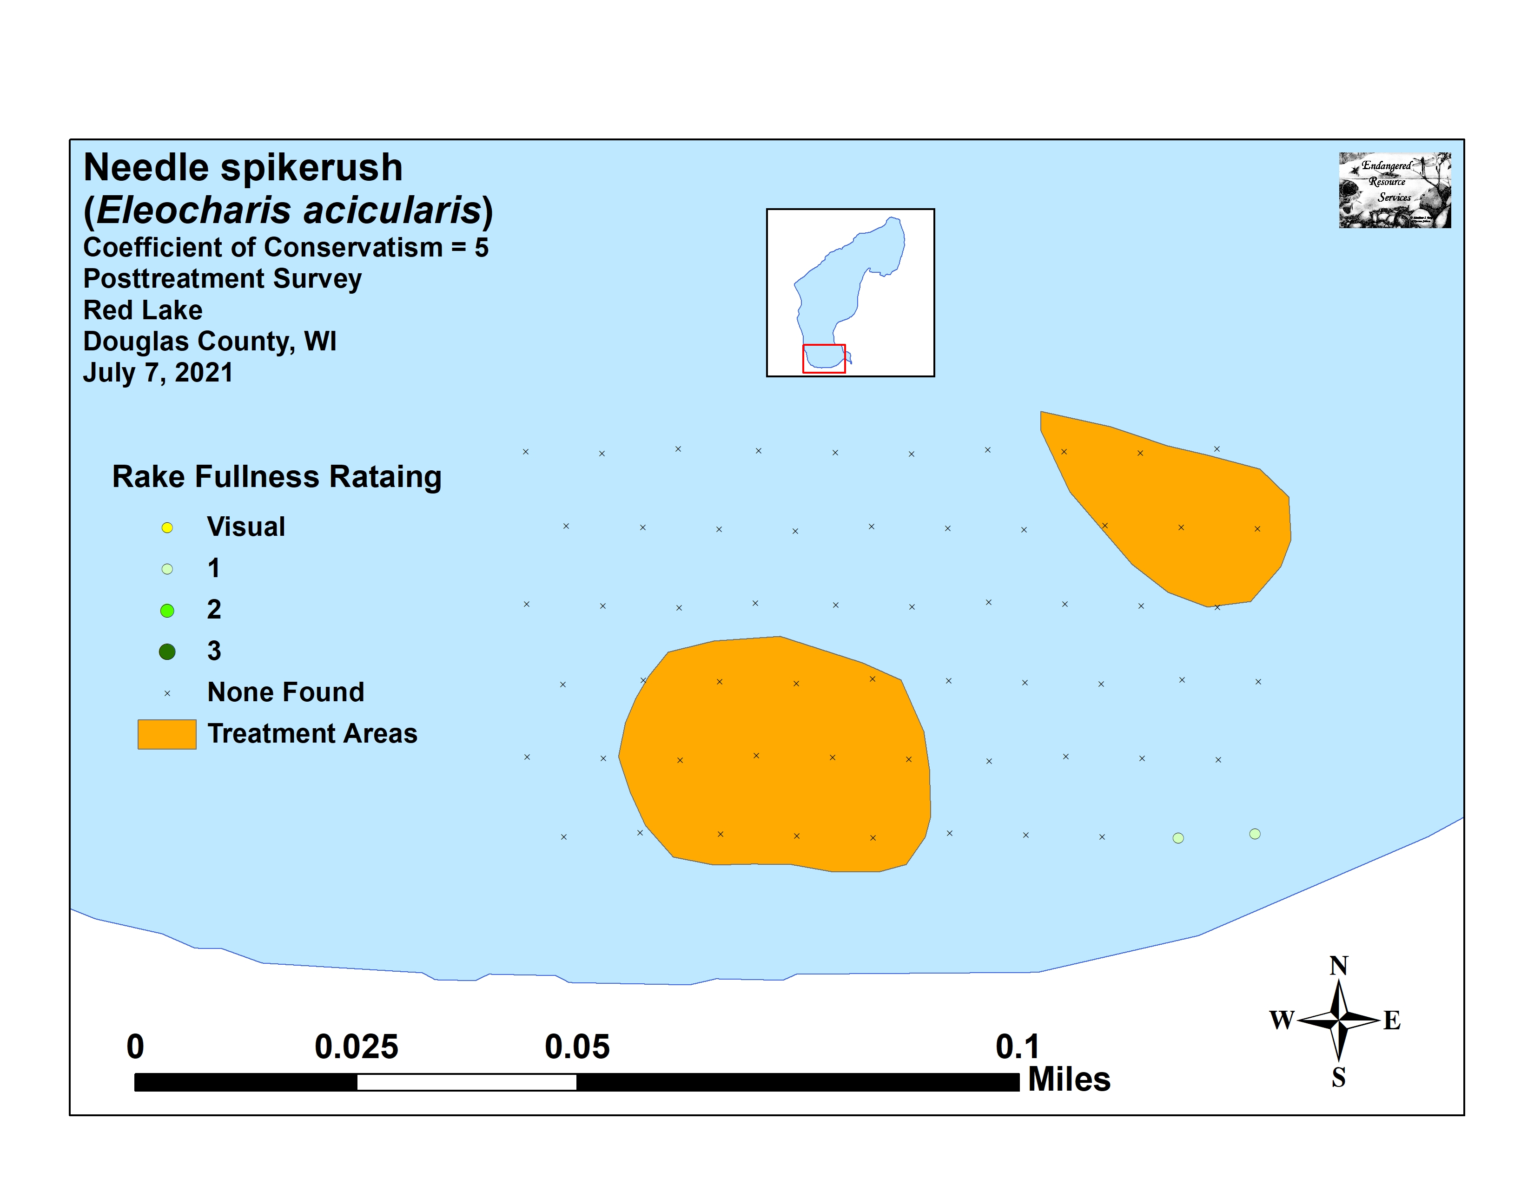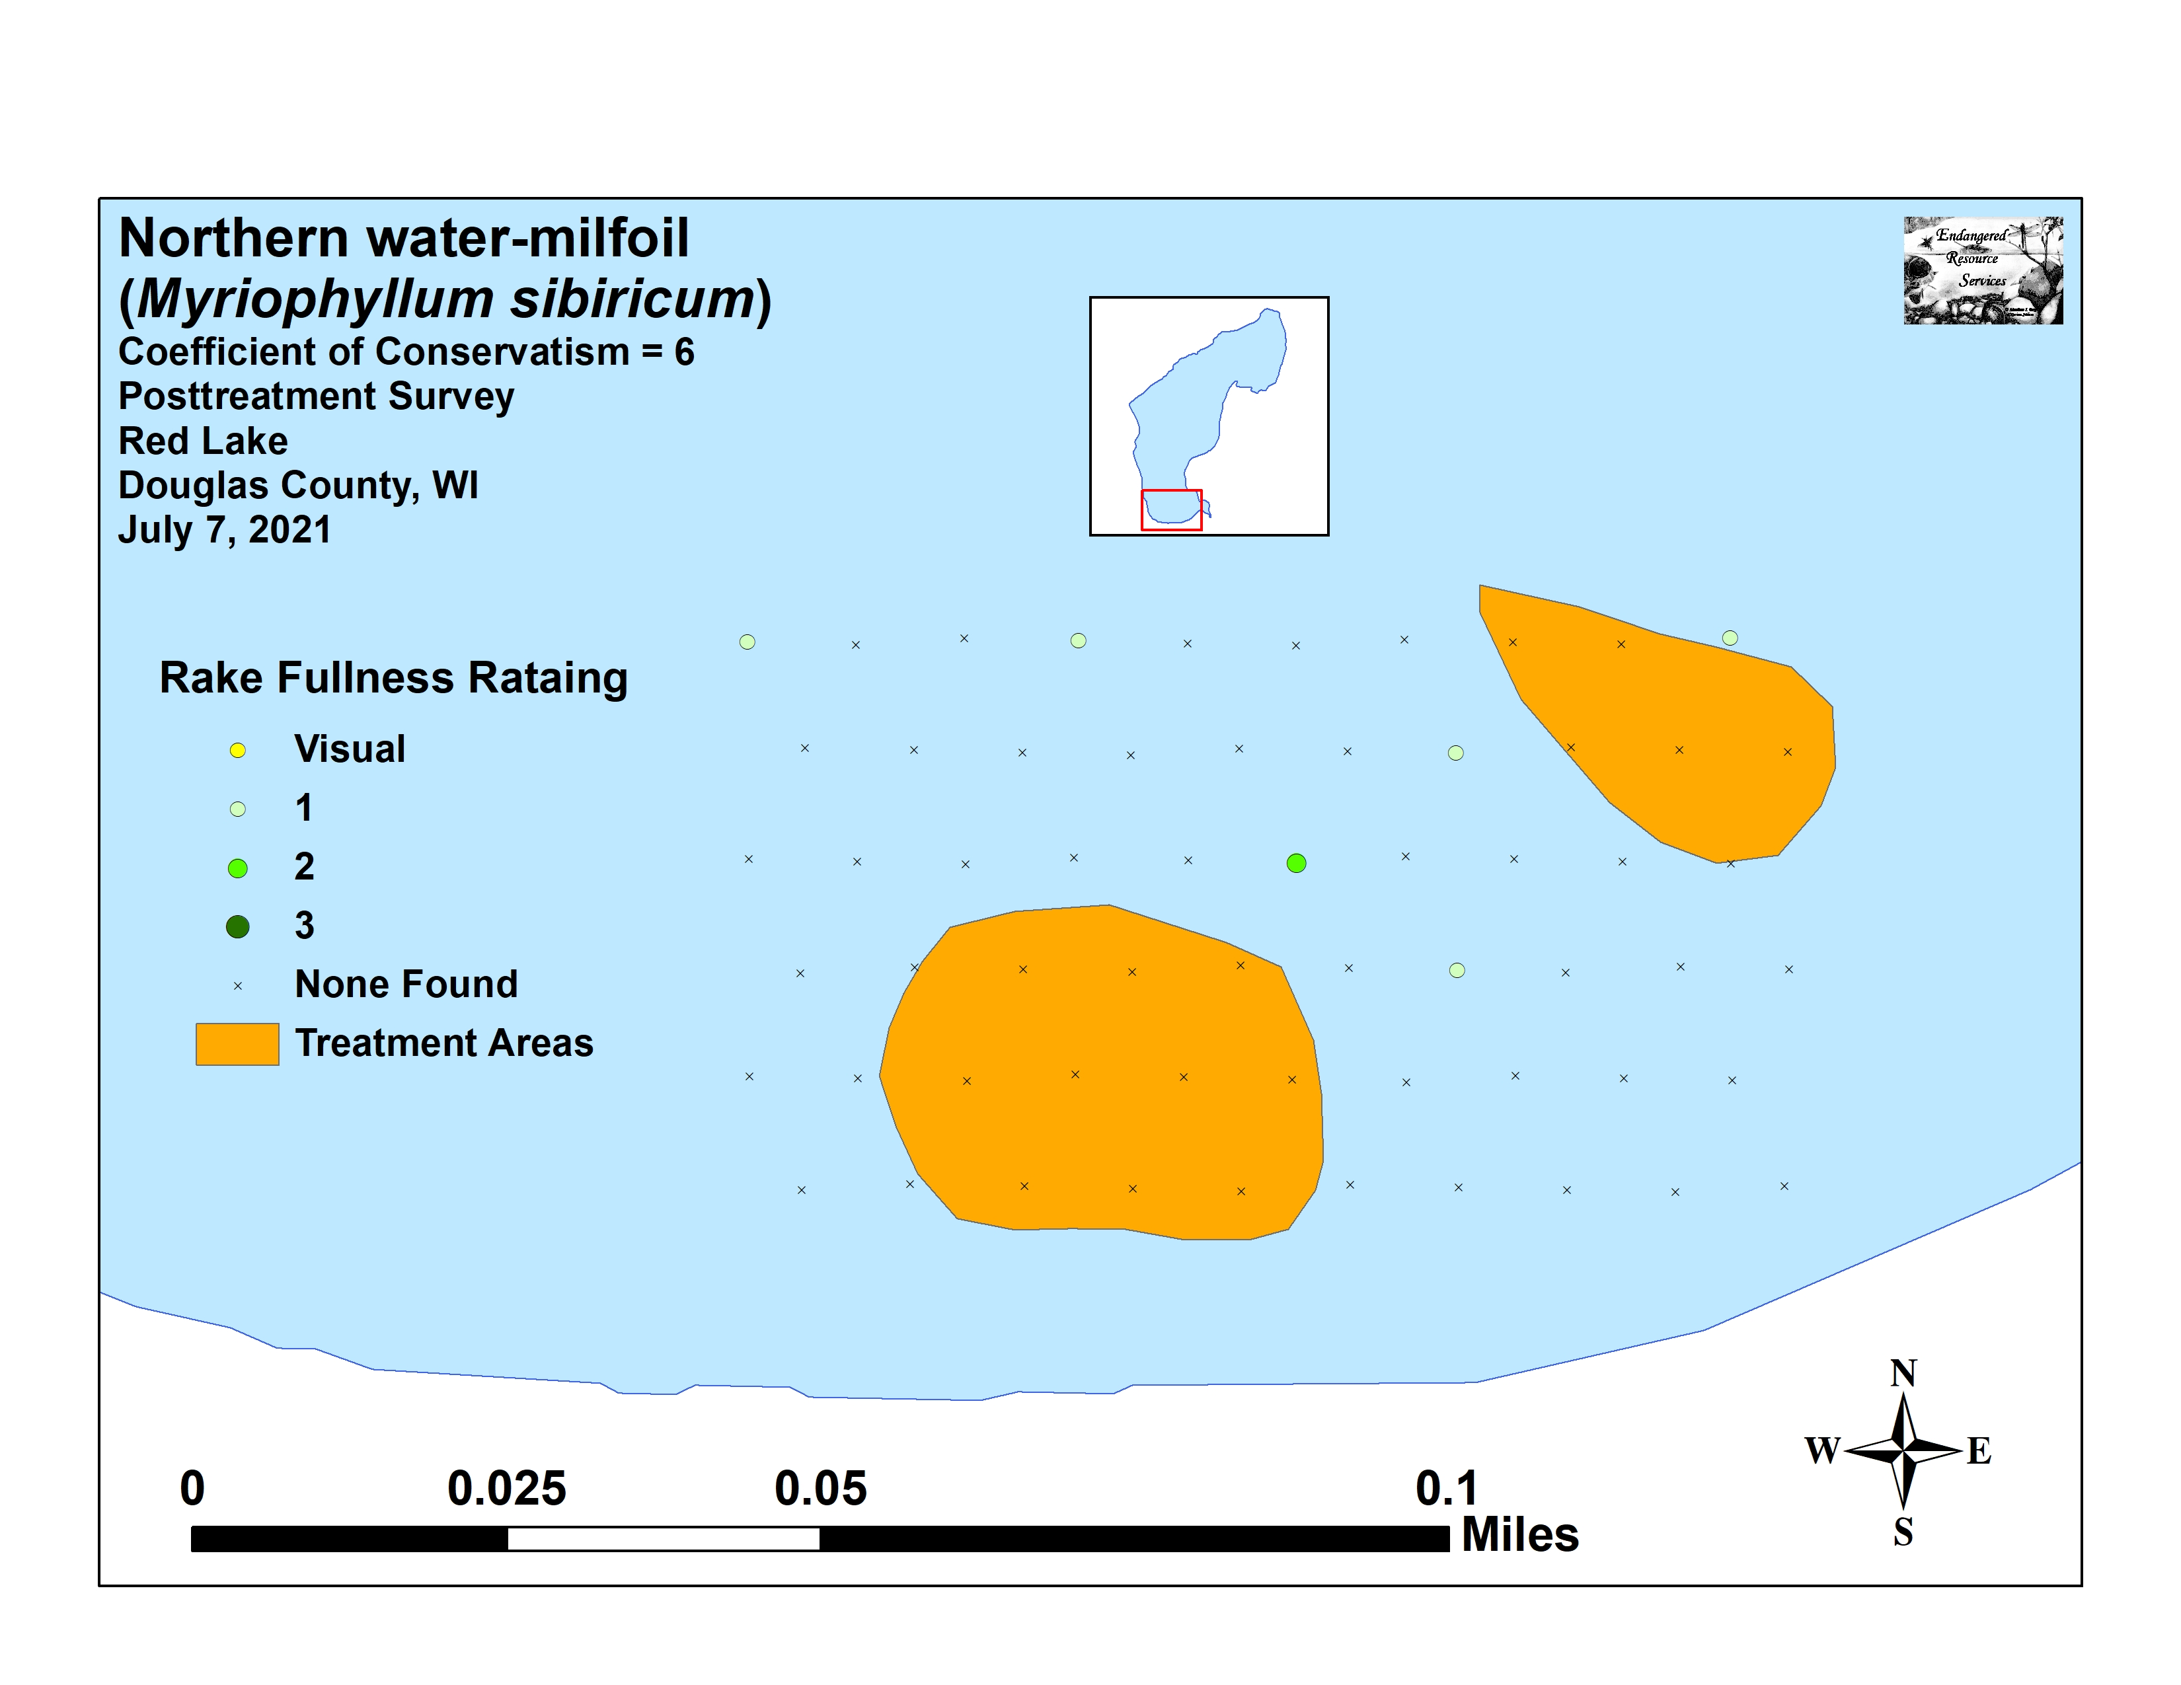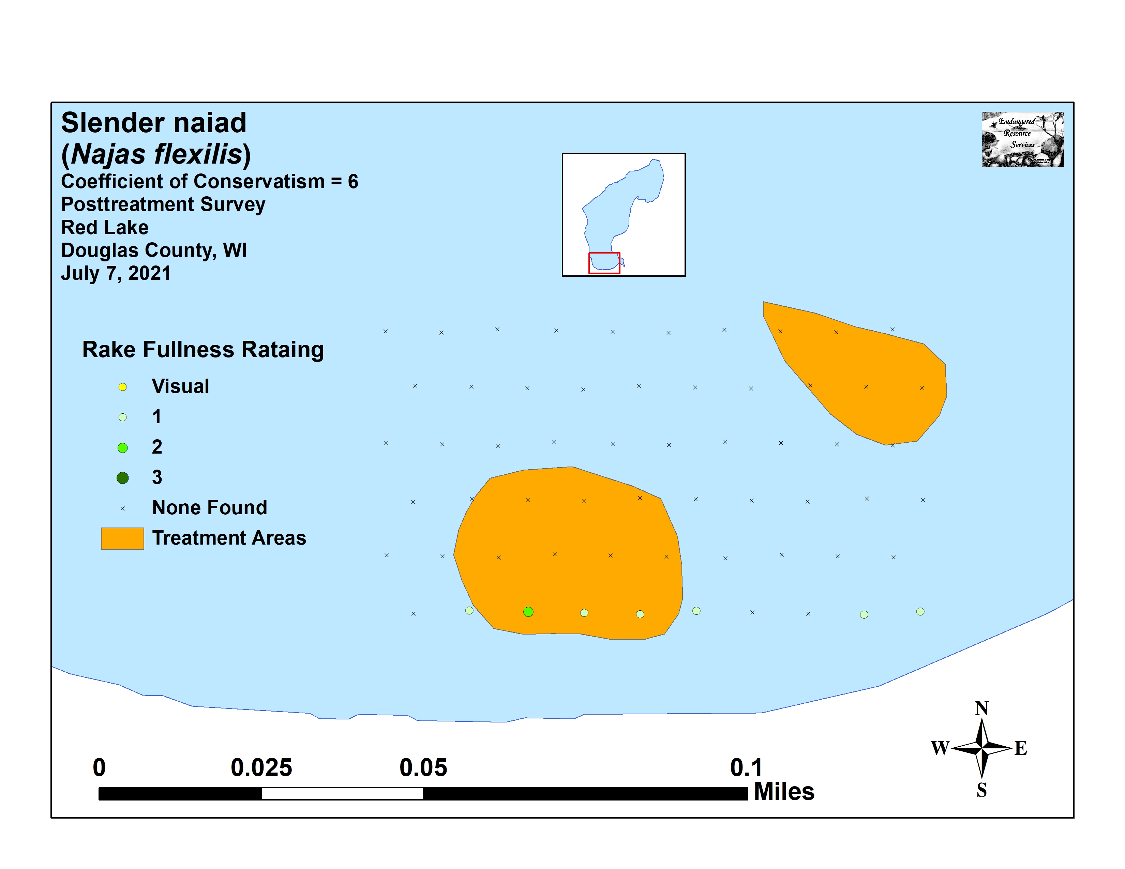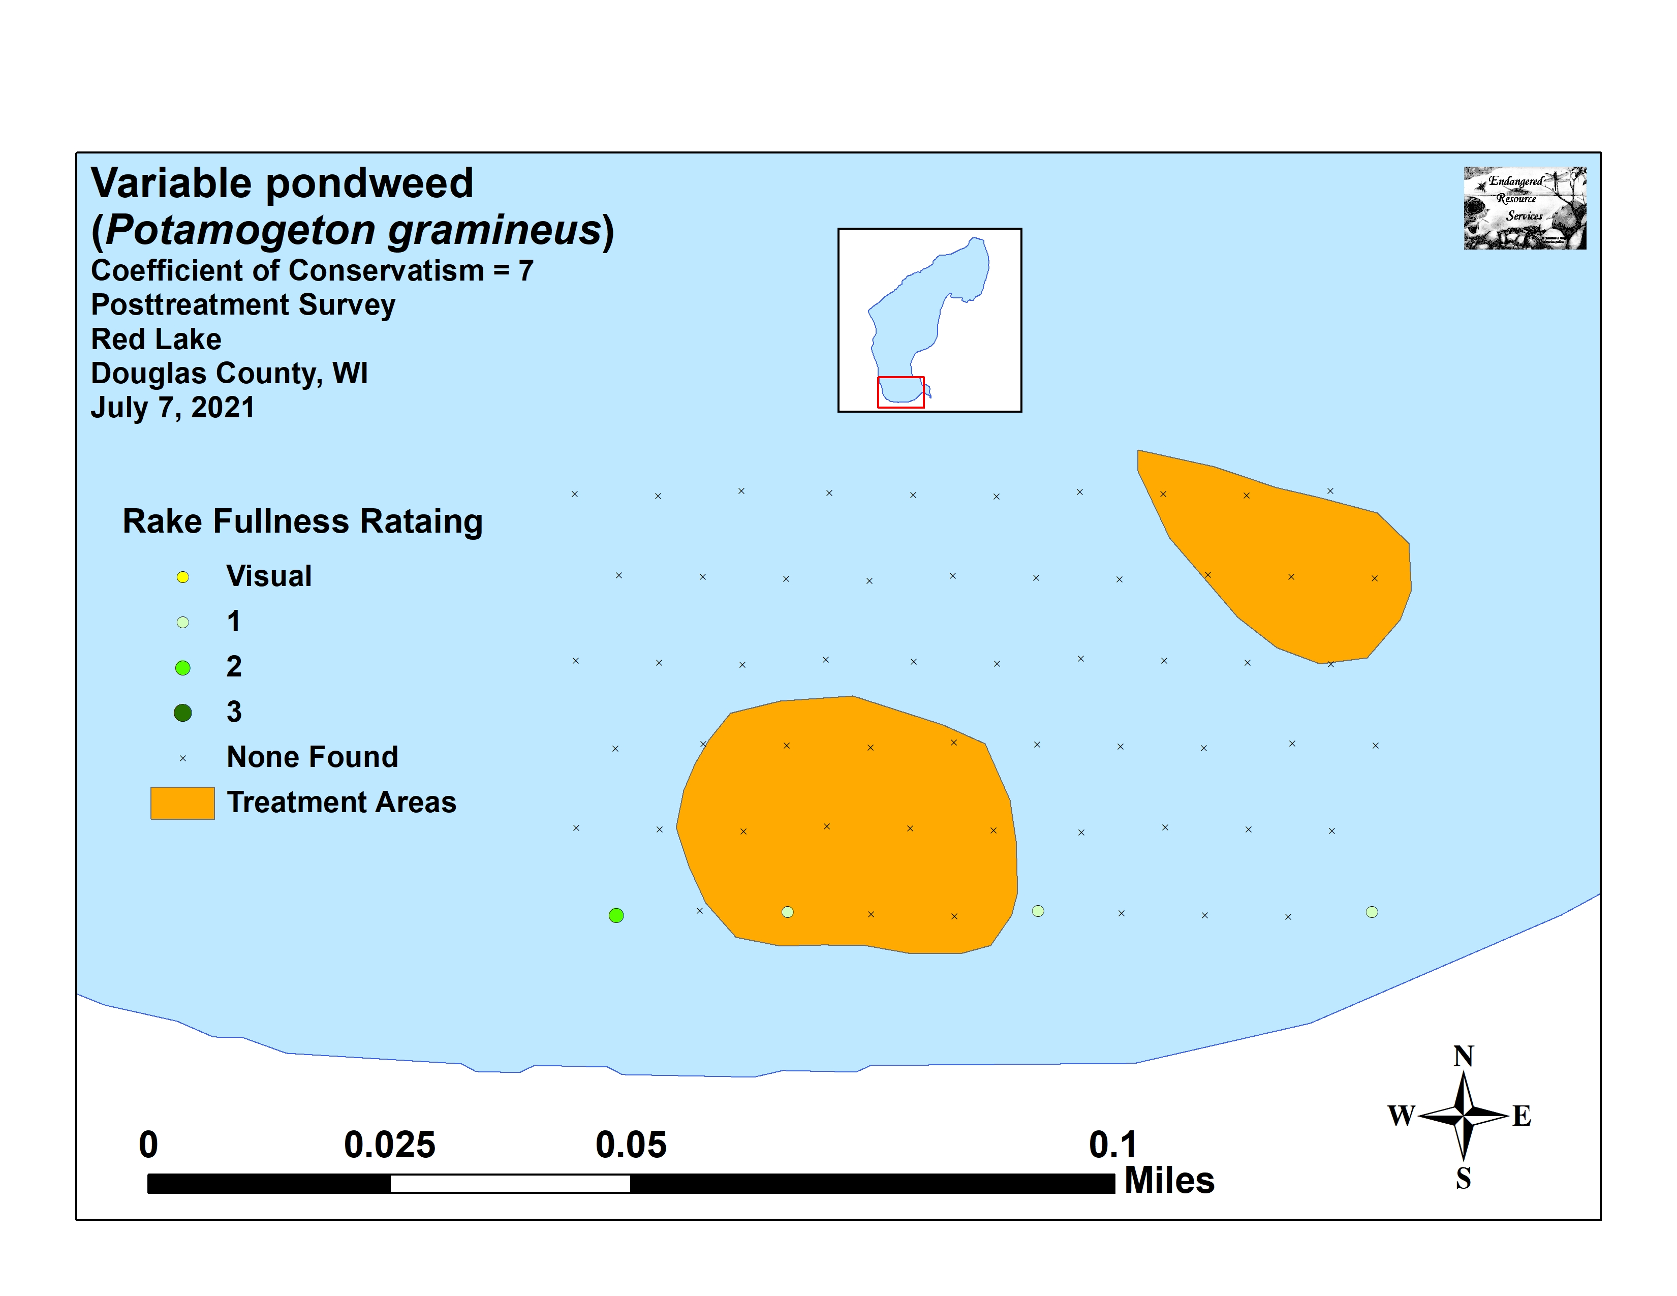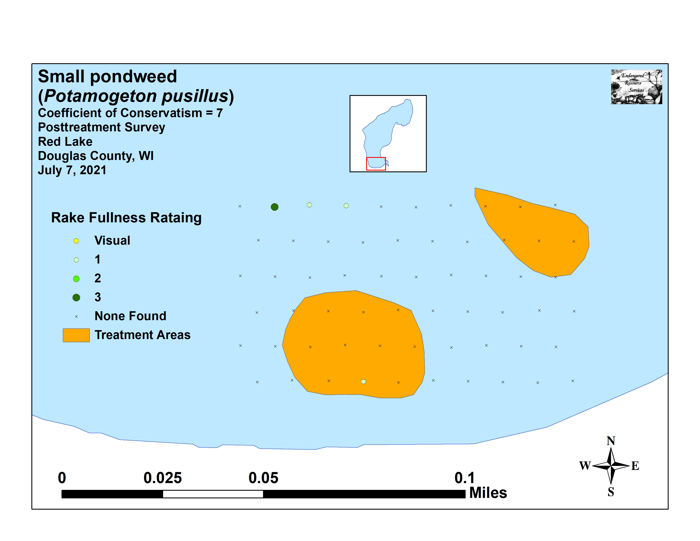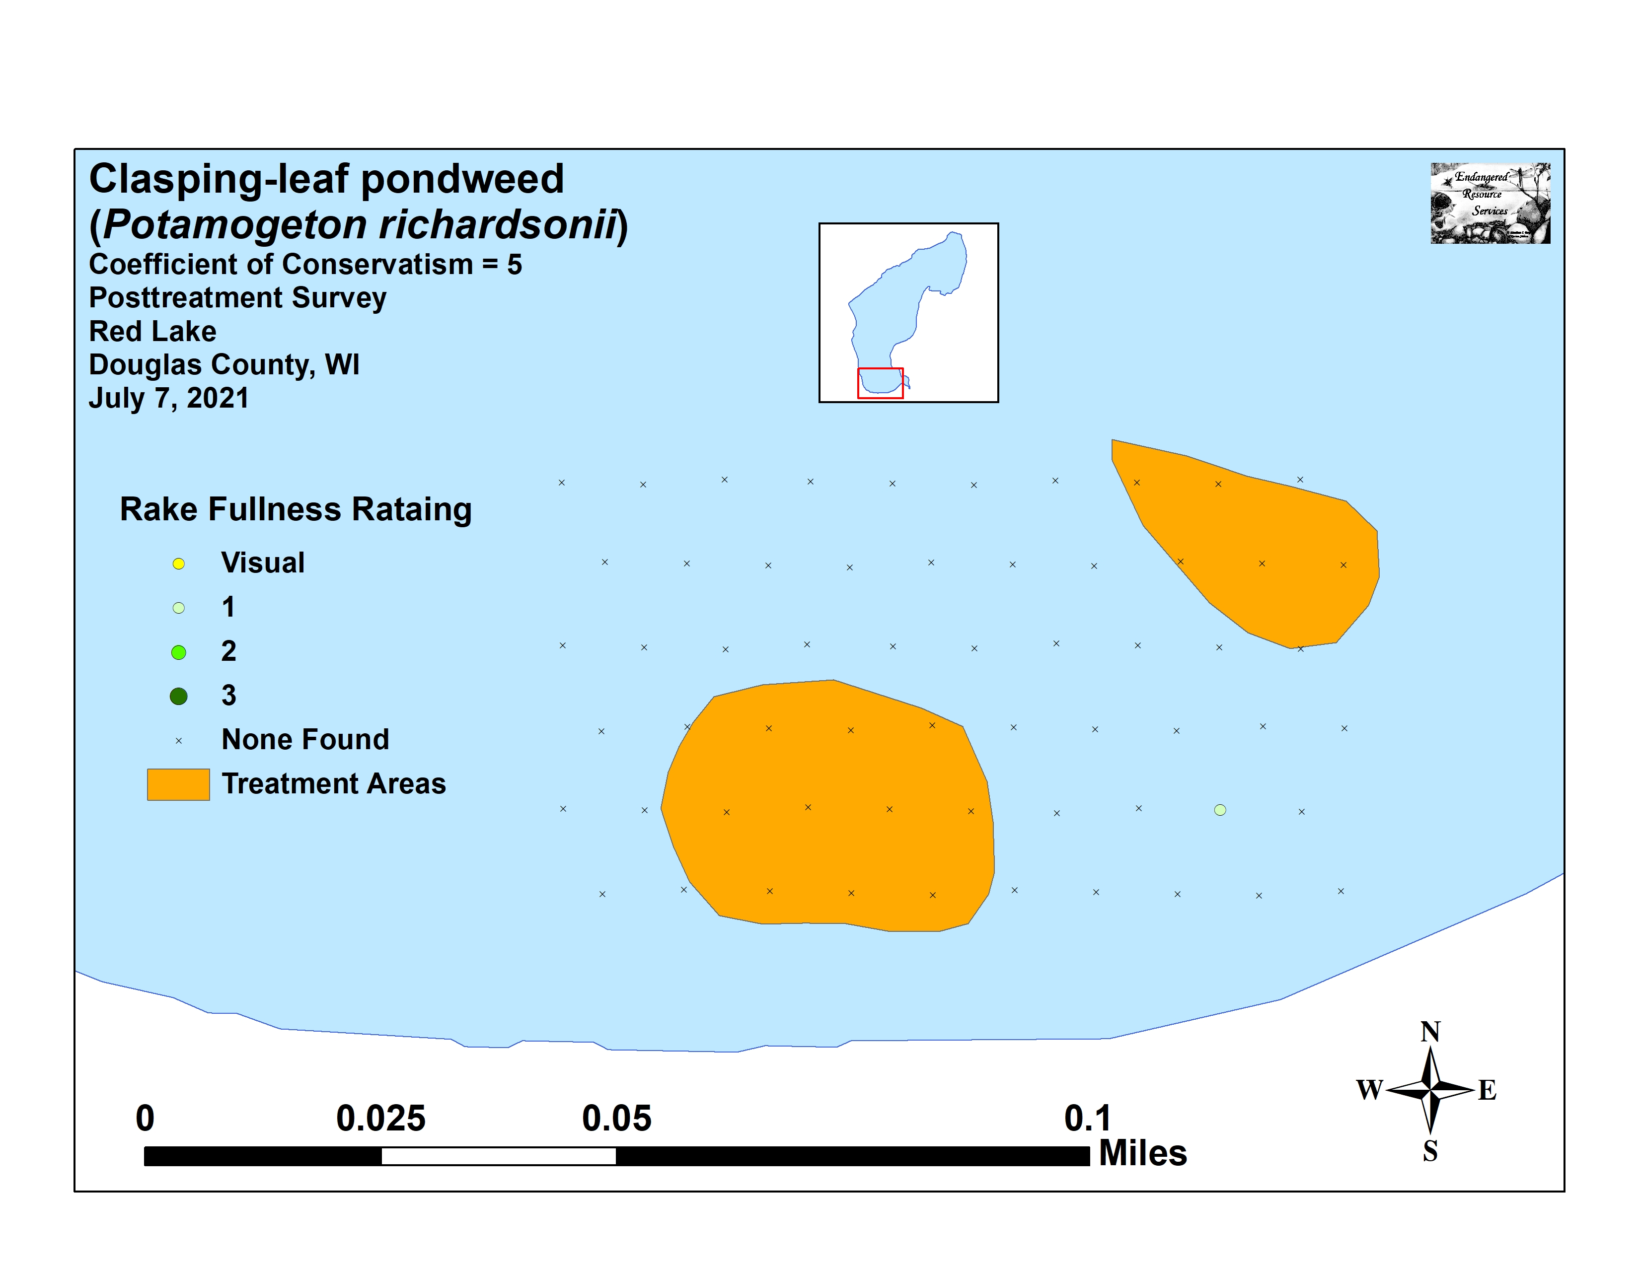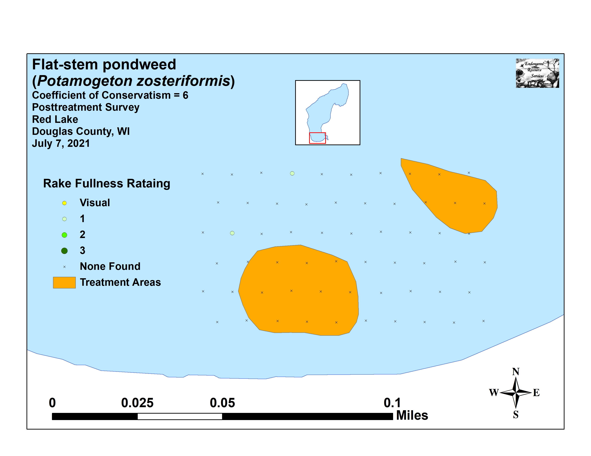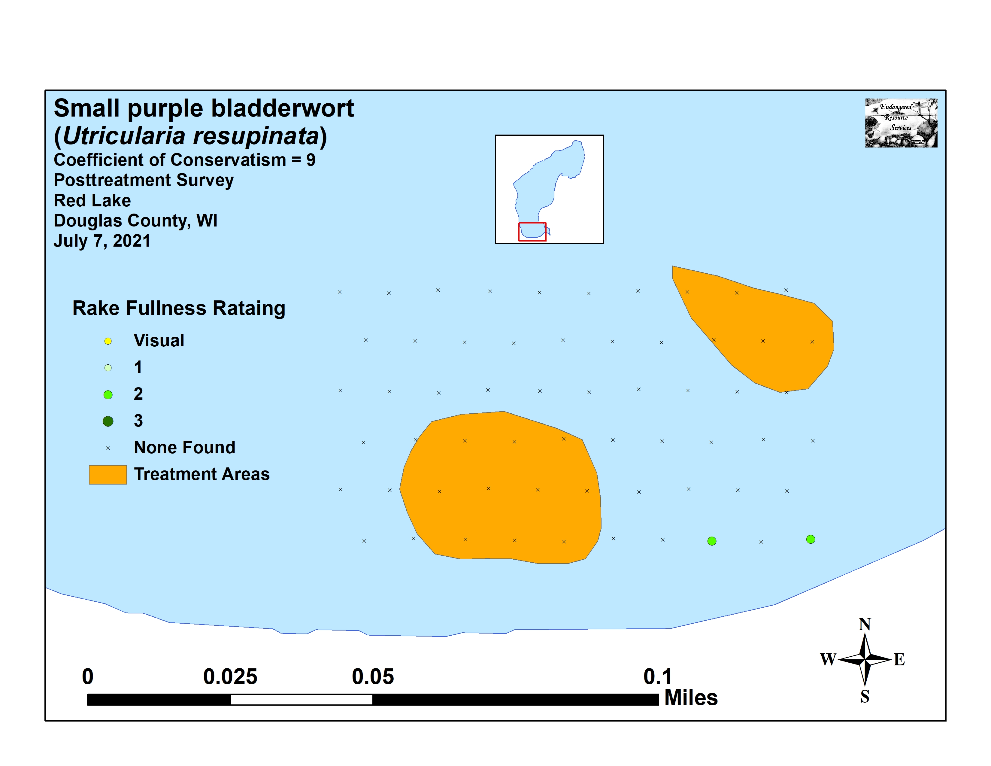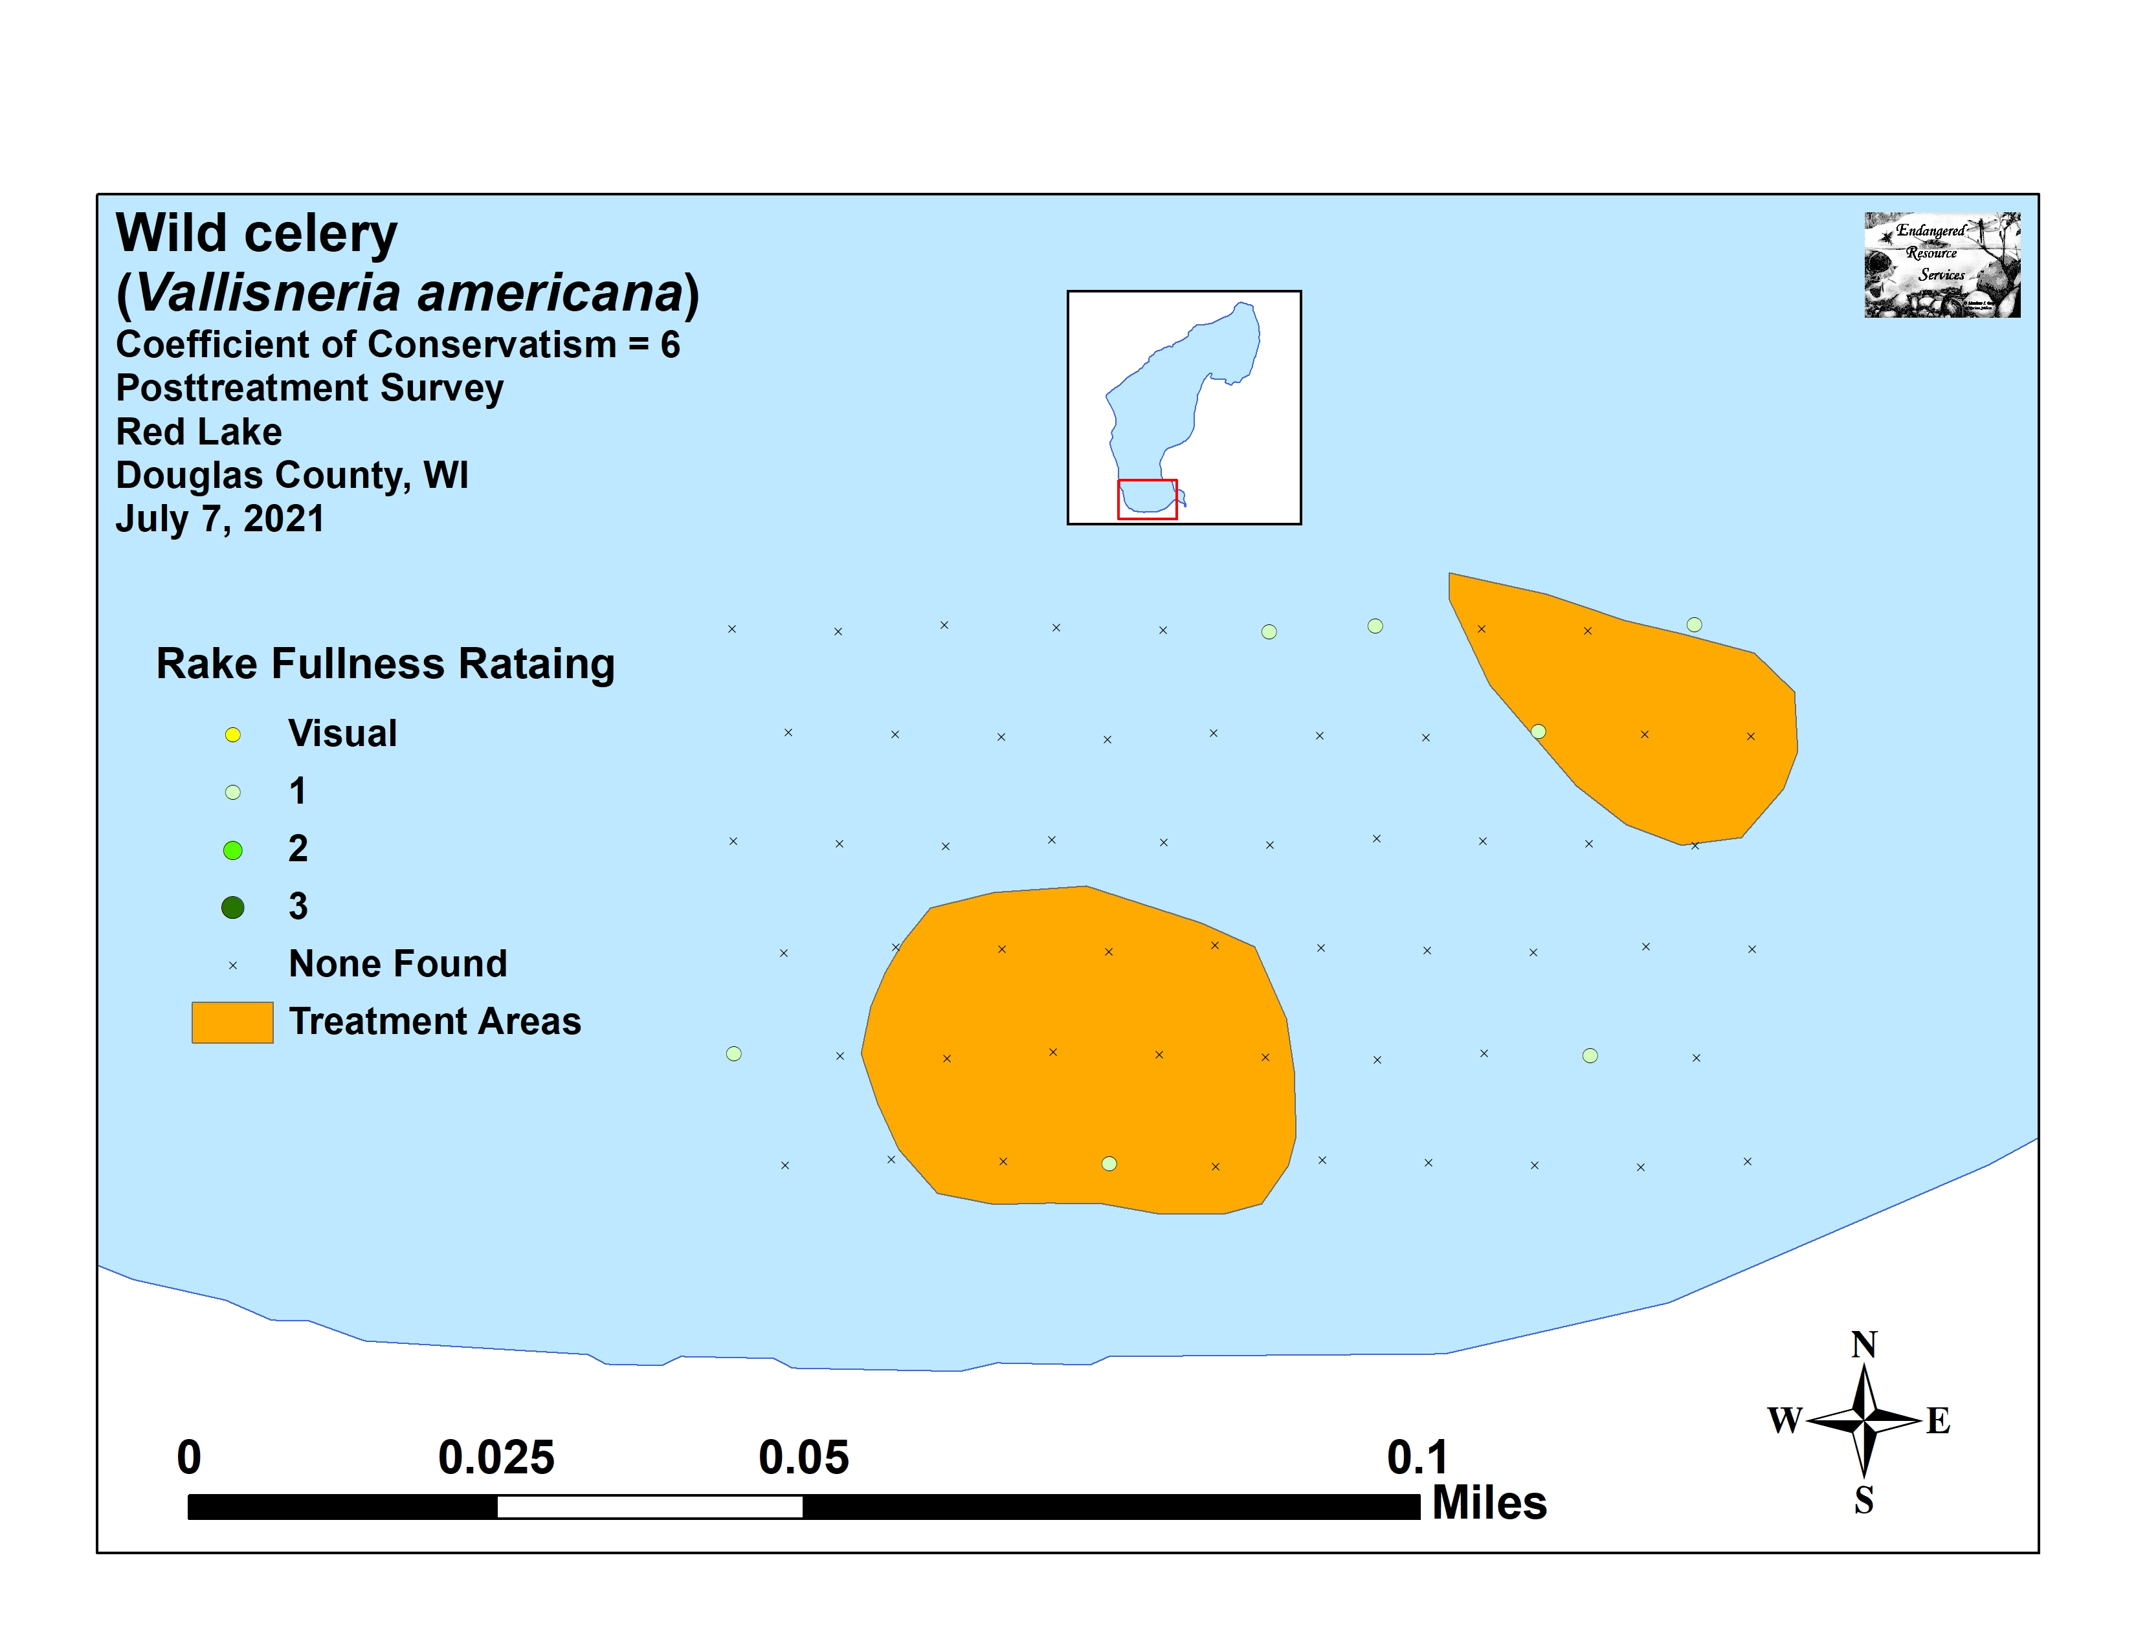

Appendix VIII: 2020 and 2021 EWM Rake Removal and Bed Maps
